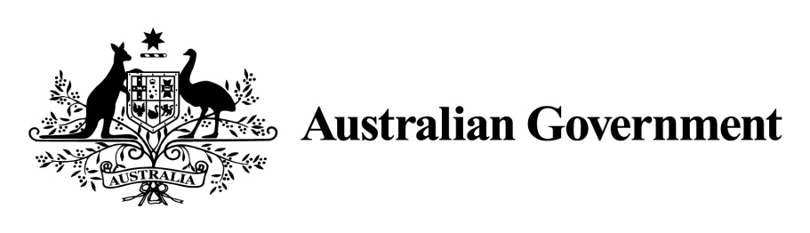

National Land Transport Act 2014

VARIATION OF THE ROADS TO RECOVERY LIST 2014

Instrument No. 2016/1
I, Gregory john Moxon, A/g General Manager, South East Roads, Department of Infrastructure and Regional Development, under section 88(1) of the National Land Transport Act 2014 (the Act), vary the Roads to Recovery List 2014 which was made by the Minister on 12 September 2014, and amended by Instrument No. 2015/1 made on 24 March 2015, Instrument No. 2015/2 made on 2 April 2015 and Instrument No. 2015/3 made on 12 August 2015, as follows:

- Name of variation

This variation instrument is the Roads to Recovery List 2014 Variation Instrument No. 2016/1.

- Variation

(a) In Schedule 1 of the List, in the part relating to New South Wales:
omit the named funding recipient ‘Parramatta City Council’ at item 107 in Column 1 of Schedule 1 and replace with ‘City of Parramatta Council’;

insert the funding recipient names ‘Armidale Regional Council’, ‘Canterbury-Bankstown Council’, ‘Central Coast Council’, Edward River Council’, ‘Federation Council’, ‘Georges River Council’, ‘Gundagai Council’, ‘Hilltops Council’, ‘Inner West Council’, ‘Mid-Coast Council’, ‘Murray River Council’, ‘Murrumbidgee Council’, ‘Northern Beaches Council’, Queanbeyan-Palerang Regional Council’, ‘Snowy Monaro Regional Council’, ‘Snowy Valleys Council’, ‘Western Plains Regional Council’ in Column 1 of Schedule 1.
(b) In Schedule 1 of the List, in the part relating to Western Australia:
omit the named funding recipient ‘Shire of Narrogin’ in Column 1 of Schedule 1 and replace with ‘Shire of Narrogin (pre-amalgamation)’.
(c) In Schedule 1 of the List, in the part relating to Western Australia:
omit the named funding recipient ‘Town of Narrogin’ in Column 1 of Schedule 1 and replace with ‘Shire of Narrogin’.
(d) In Schedule 1 of the List, in the part relating to New South Wales:
omit the amount specified in Column 2 of Schedule 1 to the List for each applicable person or body named in Column 1 of the schedule to this instrument and replace the omitted amount with the amount specified for that person or body in Column 2 of the schedule to this instrument.
(e) In Schedule 1 of the List, in the part relating to Western Australia:
omit the amount specified in Column 2 of Schedule 1 to the List for each applicable person or body named in Column 1 of the schedule to this instrument and replace the omitted amount with the amount specified for that person or body in Column 2 of the schedule to this instrument.

- Commencement

This instrument commences on 1 August 2016.

Dated: 12 July 2016

GREGORY MOXON
Delegate of the Minister for Infrastructure and Regional Development

Schedule to Instrument 2016/1
New South Wales
Column 1 | Column 2
Armidale Dumaresq Council | $1,741,000
Armidale Regional Council | $6,689,614
Ashfield Council | $594,630
Auburn City Council | $1,088,779
Bankstown City Council | $2,763,263
Bombala Shire Council | $1,168,029
Boorowa Council | $1,201,402
Canterbury City Council | $2,014,022
Canterbury-Bankstown Council | $6,173,269
Central Coast Council | $10,924,427
Conargo Shire Council | $2,102,530
Cooma-Monaro Shire Council | $1,833,799
Cootamundra Shire Council | $1,258,482
Corowa Shire Council | $2,494,029
Deniliquin Council | $475,133
Dubbo City Council | $3,162,714
Edward River Council | $3,541,628
Federation Council | $5,264,223
Georges River Council | $2,649,281
Gloucester Shire Council | $1,558,994
Gosford City Council | $3,803,405
Great Lakes Council | $2,889,303
Greater Taree City Council | $4,262,461
Gundagai Council | $3,968,356
Gundagai Shire Council | $1,110,029
Guyra Shire Council | $1,470,837
Harden Shire Council | $1,458,705
Hilltops Council | $7,033,650
Holroyd City Council | $2,052,326
Hurstville City Council | $1,123,732
Inner West Council | $3,158,719
The Council of the Shire of Jerilderie | $1,730,736
Kogarah City Council | $803,928
Leichhardt Municipal Council | $802,510
Manly Council | $687,239
Council of the Municipality of Marrickville | $1,043,648
Mid-Coast Council | $12,735,292
Murray River Council | $6,738,477
Murray Shire Council | $2,619,340
Murrumbidgee Council | $3,812,779
Murrumbidgee Shire Council | $1,044,275
Northern Beaches Council | $5,190,206
Palerang Council | $2,394,757
Pittwater Council | $1,107,381
Queanbeyan City Council | $1,608,138
Queanbeyan-Palerang Regional Council | $5,478,586
Snowy Monaro Regional Council | $6,680,900
Snowy River Shire Council | $1,559,278
Snowy Valleys Council | $3,687,408
Tumbarumba Shire Council | $987,251
Tumut Shire Council | $1,052,102
Urana Shire Council | $1,337,424
Council of the Shire of Wakool | $2,667,955
Warringah Council | $2,382,131
Wellington Council | $2,349,021
Western Plains Regional Council | $7,557,099
Wyong Shire Council | $3,648,147
Shire of Young | $1,626,870

Western Australia
Shire of Narrogin | $1,724,069
Shire of Narrogin (pre-amalgamation) | $758,137

