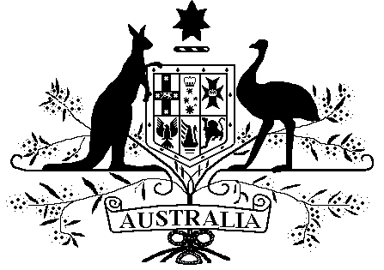

Veterans’ Entitlements Act 1986

Veterans’ Entitlements (Income Exempt Lump Sum – South Australian Stolen Generations Reparations Scheme) Determination 2016

Instrument 2016 No. R44

I, LUKE BROWN, delegate of the Repatriation Commission, make the following determination under paragraph 5H(12)(c) of the Veterans’ Entitlements Act 1986 (VEA).

Dated this 15 day of July 2016

Luke Brown
…………………………………………………………
LUKE BROWN, Acting Assistant Secretary, Rehabilitation and Support, Department of Veterans’ Affairs

1 Name
This determination is the Veterans’ Entitlements (Income Exempt Lump Sum –South Australian Stolen Generations Reparations Scheme) Determination 2016.
2 Commencement
This determination is taken to have commenced on 31 March 2016.
3 Interpretation
In this determination:

“income support supplement” means the payment called the income support supplement payable under Part IIIA of the VEA.

“South Australian Stolen Generations Reparations Scheme” means the scheme operated by the South Australian Government to provide one-off ex gratia lump sum payments to Aboriginal persons who were removed from their parents or family as children before 31 December 1975 without a court order and whose usual place of residence when removed was South Australia or who were removed by South Australian authorities.
“reparation payment” means a payment made by the South Australian Government in accordance with the South Australian Stolen Generations Reparations Scheme.
“service pension” has the meaning given to service pension in subsection 5Q(1) of the VEA.
4 Reparation Payments – exempt lump sums

For paragraph 5H(12)(c) of the VEA, if a person (or a person’s partner) receives a reparation payment and the person is eligible for, or in receipt of a service pension or income support supplement, then the amount of the reparation payment received by the person (or the person’s partner) is an exempt lump sum.

