***Australian Film, Television and Radio School Act 1973***

# **DETERMINATION OF DEGREES, DIPLOMAS AND CERTIFICATES No. 2016/3**

I, **Julianne Schultz**, Chair of the Council of the Australian Film, Television and Radio School, on behalf of the Australian Film, Television and Radio School, make a determination under section 6A of the *Australian Film, Television and Radio School Act 1973* (AFTRS Act) specifying the following degrees, diplomas and certificates for the purposes of paragraph 5(1)(g) of the Act.

Diploma in Digital Content - Radio

Advanced Diploma in Creative Producing

Bachelor of Arts Screen: Production

Graduate Certificate Screen: Business

Graduate Certificate Screen: Cinematography

Graduate Certificate Screen: Documentary

Graduate Certificate Screen: Creative Producing

Graduate Certificate Screen: Directing

Graduate Certificate Screen: Editing

Graduate Certificate Screen: Music

Graduate Certificate Screen: Screenwriting

Master of Arts Screen: Business and Leadership

This Determination comes into effect on the day after it is registered on the Federal Register of Legislative Instruments.

Dated: 2 November 2016

Signed:

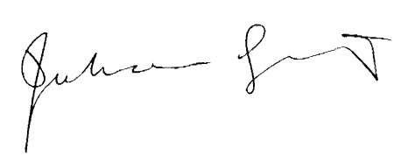

Professor Julianne Schultz AM FAHA  
Chair of Council

Australian Film, Television and Radio School