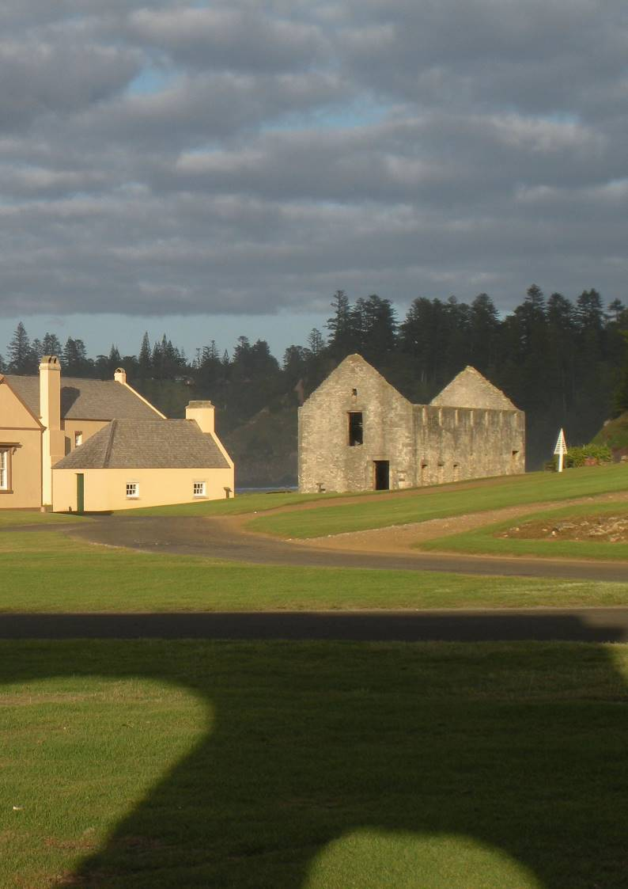

**Section 9:** Priority Programs

**129**

**9.1 Priority Setting**

Effective implementation of this Heritage Management Plan (HMP) will require committed leadership with a strong focus on major priority areas. This section of the HMP identifies the major programs that will apply the strategic management principles and implement the conservation policies. These programs and actions include some relevant recommendations from Section 10. This section of the HMP seeks to distil the implementation process into a series of practical actions with associated priorities and target timeframes.

Under each of the five strategic principle areas, priority programs and the actions needed to implement them are identified. As this HMP is a strategic document, further work will be required to scope, plan, resource, implement and monitor these programs. The nominated priorities and timing may be affected by other events and circumstances, and may therefore change over time.

For convenience, within each strategic principle, the relevant conservation and management policies are identified; some policies apply to more than one principle. The proposed programs are summarised in the diagram on the following page. For each individual activity, priority and suggested timing are as follows:



**Priority:**

*Essential = Fundamental High = Necessary Medium = Desirable*

for the conservation and management of the KAVHA site in accordance with this HMP

**Timing:**

The date range given provides indicative commencement and completion targets.

Priority

**Action**

Timing

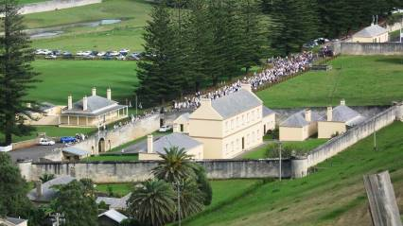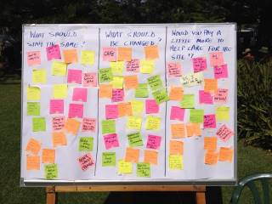

**Priority Programs**

**Heritage**

**Conservation**

**Life in the**

**Community**

**Sustainable**

**Tourism**

**Education and**

**Information**

**Governance and**

**Capacity**

**Policy 1:**

Natural Environment

**Policy 5:**

Living Cultural Traditions and Community

Connections

**Policy 6:**

Sustainable Development

**Policy 8:**

Education and Interpretation

**Policy 9:**

Governance and Capacity

**Policy 2:**

Cultural Landscape

**Policy 7:**

Tourism

**Policy 3:**

Structures and Objects

**Policy 6:**

Sustainable Development

**Policy 10: Policy 10:**

Communication and Communication and Engagement Engagement

**Policy 8:**

Education and Interpretation

**Policy 4:**

Archaeology

**Policy 10:**

Communication and Engagement

**Policy 6:**

Sustainable Development



|  |  |  |  |  |
| --- | --- | --- | --- | --- |
|  | **Water Quality and Canal Works**  Essential 2016 | | | |
|  | |  |  | |
| **KAVHA Site Masterplan**  Essential 2016–2017 | | | |  |

|  |  |  |
| --- | --- | --- |
| **KAVHA Site Operations Manual**  High 2016–2018 | | |
|  |  |  |
| **Skills and People Succession Plan**  High 2017 | | |

|  |  |  |
| --- | --- | --- |
| **KAVHA Board**  Essential 2016 | | |
|  |  |  |
| **Use and Development Guidelines**  High 2017 | | |
|  | | |
| **Community Partnerships**  High 2016–2018 | | |
|  |  |  |
| **Events Calendar**  Medium 2016 | | |

|  |  |  |  |
| --- | --- | --- | --- |
| **Tourism Industry Consultative Group**  High 2016 | | |  |
|  |  |  | |
| **Tourism Industry Support**  High 2016 | | |  |
|  |  |  | |
| **Commercial Development EOI Process**  Medium 2016–2017 | | | |
|  |  |  | |
| **New Tourism Products**  Medium 2017–2018 | | | |

|  |  |  |
| --- | --- | --- |
| **Website**  High 2016 | | |
|  |  |  |
| **Consultation Forums**  High 2016 | | |
|  |  |  |
| **Museum and Research Centre**  High 2017 | | |
|  |  |  |
| **Interpretation Plan**  Medium 2016–2018 | | |

|  |  |  |
| --- | --- | --- |
| **Government Agreement**  Essential 2016–2017 | | |
|  |  |  |
| **KAVHA Manager and Team Restructure**  Essential 2016–2017 | | |
|  |  |  |
| **Resources**  High 2016–2019 | | |
|  |  |  |
| **Funding Sources**  High 2016–2019 | | |

**Environmental management and physical works should ensure an appropriate level of water quality in Watermill Valley and throughout the KAVHA site, while conserving heritage values.**

* Finalise and implement KAVHA Water Quality and Sewerage Infrastructure Management Strategy.
* Implement recommendations of Bounty Street Bridge Structural Report.
* Review arrangements for cattle access to public reserves.
* Consider introduction of agricultural crops within the Watermill Valley.
* Renew and, where necessary, upgrade sewerage infrastructure for all occupied buildings.

**Informed by this HMP and its management principles, a new Masterplan for the KAVHA site should be prepared to guide future planning, uses, new development and interpretation.**

* Collate and review existing data, particularly the 2007 Draft Conservation Management Plan.
* Conduct consultative process to identify issues, opportunities and aspirations—particularly consider future interpretation and potential development.
* Consider potential for changes to current conservation works and maintenance techniques, as well as potential for different uses and new development.
* Prepare project scope and brief for review by KAVHA Advisory Committee.
* Seek project-specific funding assistance.
* Commission external consultant team to work collaboratively with KAVHA staff.

**Existing KAVHA site management documentation should be reviewed and amalgamated into an overall Site Operations Manual to facilitate values-based, consistent and transparent conservation and management in accordance with this HMP.**

* Collate existing site management documents, including staff manuals, methods statements, position statements, delegations and procedures.
* Convene KAVHA staff working group to review this documentation to identify gaps, requirements for revision and consistency with HMP strategic principles and policies.
* Appoint small working group to prepare new Site Operations Manual.
* Revise staff position descriptions and written delegations accordingly.

**Adequate heritage trade and professional skills should be available for the conservation of the KAVHA site, both now and in the future.**

* Conduct skills and needs audit for the KAVHA site.
* Convene KAVHA staff working group to prepare forward prospectus.
* Review external training courses and potential internal training programs, and arrange for participation by relevant KAVHA staff.
* Instigate recruitment and apprenticeship program.

**9.2 Heritage Conservation**

**Policy 1:** The natural environment of the KAVHA site will be conserved, protected and managed to sustain natural systems and heritage values.

**Policy 2:** The KAVHA site’s historic cultural landscape will be conserved and managed to transmit its values, recognising its authenticity as evolved and as part of the life of the community.

**Policy 3:** The fabric and layered heritage values attributed to the buildings, structures, ruins, movable items and objects will continue to be conserved, managed and transmitted.

**Policy 4:** The archaeological resources of the KAVHA site will be managed to retain their cultural heritage values and realise their research potential.

**Policy 6:** The heritage values of the KAVHA site will be sustainably managed and utilised to meet the needs of present and future generations.



**Water Quality and**

**Canal Works**

Essential

2016

**KAVHA Site**

**Masterplan**

Essential

2016–2017

**KAVHA Site**

**Operations Manual**

High

2016–2018

**Skills and People**

**Succession Plan**

High

2017



**Use and**

**Development Guidelines**

High

2017

**Community**

**Partnerships**

High

2016–2018

**Events Calendar**

Medium

2016

|  |  |  |  |
| --- | --- | --- | --- |
| **9.3 Life in the Community** | | | |
| **Policy 5:** Knowledge and living cultural traditions will be respected and celebrated as an integral and significant aspect of the KAVHA site’s heritage value.  **Policy 6:** The heritage values of the KAVHA site will be sustainably managed and utilised to meet the needs of present and future generations.  **Policy 10:** Effective and inclusive communication with the community and stakeholders will foster information sharing and support for a common vision for the conservation of the KAVHA site. | | | |
|  | **KAVHA Advisory Committee**  Essential 2016 |  | **Conservation and management of the KAVHA site should be informed through an advisory group which includes both representative interests and appropriate skills.** |
| * Australian Government and Norfolk Island administration to establish a new KAVHA Advisory Committee, including both local representation and relevant expertise. * KAVHA Advisory Committee to include Norfolk Island community members, landholder representation, and skills in place management, heritage, cultural tourism and/or collections. * KAVHA Advisory Committee to provide advice to KAVHA Manager, Norfolk Island administration and, if necessary, the Australian Government. * KAVHA management to be open and accountable, actively engaging with the Norfolk Island community. |
|  | | |
| **The KAVHA site is at the heart of Norfolk Island community life and there should be clear, consistent and transparent understanding of the rules and processes that apply to site use or new development.** |
| * Assemble and review relevant documentation relating to land use, and development controls, guidelines and processes. * Identify areas of inconsistency or ambiguity and methods to resolve them. * Conduct an open consultative process to identify landholder and community issues and aspirations. * Provide advice to the Australian Government and Norfolk Island administration on desirable regulatory changes. * Consider KAVHA site planning controls and potential heritage incentives as part of the next review of the Norfolk Island Plan. * Prepare, publish and distribute a written and graphic Development Control Plan (DCP) which provides use and development guidelines for the KAVHA site, in hardcopy and digital form. * Apply these guidelines and the associated controls and processes equally and equitably to every person, property and organisation. |
| **Communication, collaboration and partnerships with the Norfolk Island community should guide management of the KAVHA site.** |
| * Open up communication channels between those employed to manage the KAVHA site and the wider Norfolk Island community using creative and engaging methods. * Consider establishing a regular landholder forum and/or community consultative committee. * Invite volunteer community participation in on-site activities and works programs. * Draw community expertise into site management and interpretation by inviting advice and welcoming knowledge. * Share learnings that arise from site management with the community through forums, open days, hands-on skills sharing and in other ways. |
| **Traditional cultural practices within the KAVHA site should be supported and encouraged through publication of an events calendar.** |
| * Identify existing cultural traditions and uses of the KAVHA site which are important to Norfolk Islanders. * Engage with Norfolk Island residents to help identify these traditions and their meanings. * Design, publish and distribute an engaging Norfolk Islander events calendar in hardcopy and digital forms to support wider participation in and transmission of traditions and values. |

**The tourism industry should become active partners in tourism at the KAVHA site.**

* Invite participants from the tourism industry to join a new KAVHA tourism industry consultative group.
* Within the tourism industry consultative group itself, agree on the group’s ‘terms of reference’.
* Identify new tourism opportunities and related issues and challenges to be addressed.
* Collaborate regarding presentation of information and messages during tourism activities.
* Determine workable methods to achieve financial contributions from tourism to conserve the KAVHA site.

**The KAVHA site is fundamental to the Norfolk Island tourism industry and should actively seek to support Norfolk Island tourism initiatives.**

* Continue liaison with the Norfolk Island Tourist Board.
* Support implementation of the Norfolk Island Tourism Strategic Plan.
* Identify required and desirable tourism facilities in consultation with KAVHA staff, the Norfolk Island Tourism Board, tourism industry consultative group and Norfolk Island Planning Office.

**Sympathetic commercial development within the KAVHA site should be encouraged and guided by an open EOI process.**

* Seek advice from public sector land management and conservation agencies on appropriate principles and processes for new commercial development.
* Identify opportunities for new commercial development within the KAVHA site, which are consistent with the use and development guidelines of the proposed DCP.
* Determine appropriate legal arrangements (lease/licence) for commercial ventures within the KAVHA site.
* Prepare a prioritised list of potential new commercial opportunities.
* Prepare a standard Expression of Interest package, including arrangements for probity, due process and contracts.
* Implement an Expression of Interest program to encourage and facilitate appropriate commercial development.
* Consider a food and beverage outlet as a potential initial prototype.

**Development of new tourism products should be actively encouraged**

* Proactively engage with the Norfolk Island Tourism industry through the tourism industry working group and Norfolk Island Tourism Board.
* Review and benchmark tourism products against comparable cultural sites within Australia and around the world.
* Prepare and promote a prospectus which identifies new types of tourism products that are desirable within the KAVHA site.

**9.4 Sustainable Tourism**

**Policy 6:** The heritage values of the KAVHA site will be sustainably managed and utilised to meet the needs of present and future generations.

**Policy 7:** Tourism within the KAVHA site will be managed to provide visitor experiences that exceed expectations, minimise site impacts and deliver benefits for local people through collaborative partnerships with the tourism industry.

**Policy 8:** Education and interpretation will stimulate, enchant and enrich visitor understanding and experience of the heritage values of the KAVHA site.



**Tourism Industry**

**Consultative Group**

High

2016

**Commercial**

**Development EOI Process**

Medium

2016–2017

**New Tourism**

**Products**

Medium

2016–2018

**Tourism Industry**

**Support**

High

2016

**The KAVHA site website should be re-established, actively maintained and regularly updated.**

* Allocate resources for design and update of the KAVHA website.
* Commission website design.
* Identify and obtain existing and new website content and links to other relevant sites.
* Appoint KAVHA Webmaster.
* Update website on a monthly basis.

**Stakeholders in the KAVHA site should be provided with opportunities to be informed about, and contribute to conservation and management through a regular and structured program.**

* Prepare simple terms of reference for KAVHA stakeholder consultative forums.
* Identify appropriate forum groups: landholders, KAVHA site staff, general community.
* Convene meetings at least every six months.
* Review and action meeting outcomes, as appropriate.

**The KAVHA Museum and Research Centre should be integrated to provide a single and coordinated interpretive and research program.**

* Prioritise integration of KAVHA Museum and Research Centre within overall KAVHA management organisation restructuring arrangements.
* Convene consultative meetings with existing Museum and Research Centre staff regarding arrangements.
* Revise and, where appropriate, re-allocate roles and responsibilities.
* Consider options for Museum / Research Centre venue, functions and hours of operation to maximise resource use.
* Undertake and foster collections based research to ensure best practice conservation, management and interpretation.

**The existing KAVHA Interpretation Strategy should be reviewed in light of this HMP, expanded to become an Interpretation Plan, then actively implemented.**

* Convene a small working group, including representatives from the integrated Museum / Research Centre to review the current KAVHA Interpretation Strategy.
* Revise the Interpretation Strategy accordingly and identify priority projects.
* Expand the Strategy into a project-based Interpretation Plan.
* Develop a forward program for progressive implementation of the Interpretation Plan.

**9.5 Education and Information**

**Policy 8:** Education and interpretation will stimulate, enchant and enrich visitor understanding and experience of the heritage values of the KAVHA site.

**Policy 10:** Effective and inclusive communication with the community and stakeholders will foster information sharing and support for a common vision for the conservation of the KAVHA site.



**Website**

High

2016

**Consultation**

**Forums**

High

2016

**Museum and**

**Research Centre**

High

2017

**Interpretation Plan**

Medium

2016–2018

**Management of the KAVHA site should occur within a framework established through agreement between the Australian Government and Norfolk Island administration.**

* Identify roles and responsibilities arising from new governance and site management arrangements.
* Australian Government and Norfolk Island administration to continue to review site management arrangements.

**The KAVHA site should be managed by one organisation under the supervision of the KAVHA Manager.**

* Prepare position description for the KAVHA Manager.
* Review organisational structure and determine operating management units for the KAVHA site.
* Identify required statutory/regulatory reform and liaise with Norfolk Island administration and other parties, as necessary.
* Restructure existing KAVHA site staff and relevant Norfolk Island administration staff within the new organisational structure.
* Recruit new staff, as necessary.

**Conservation and management should be supported through adequate resources, including facilities, plant, equipment and information.**

* Identify required facilities, plant and equipment, and information.
* Prepare budget and required supporting documentation and action as appropriate— either as one program or as a staged series of individual projects.

**The funding base for the conservation and management of the KAVHA site should be broadened to include a wider spectrum of contributions.**

* Pursue means by which the KAVHA site may become eligible for government and non- government grant funding.
* Actively pursue opportunities for commercial development which deliver income to the KAVHA site; establish protocols with the Australian Government that allow this to happen for leased and licensed Commonwealth assets.
* Establish philanthropy program by identification of appropriate projects and through liaison with Philanthropy Australia.
* Consider establishing a corporate sponsorship program for particular projects or site elements.

**9.6 Governance and Capacity**

**Policy 9:** Institutional arrangements will include the vision, leadership, expertise, organisational capacity and resources required to manage and conserve the natural and cultural values of the KAVHA site.

**Policy 10:** Effective and inclusive communication with the community and stakeholders will foster information sharing and support for a common vision for the conservation of the KAVHA site.



**Government**

**Agreement**

Essential

2016–2017

**KAVHA Manager**

**and Team Restructure**

Essential

2016–2017

**Resources**

High

2016–2019

**Funding Sources**

High

2016–2019

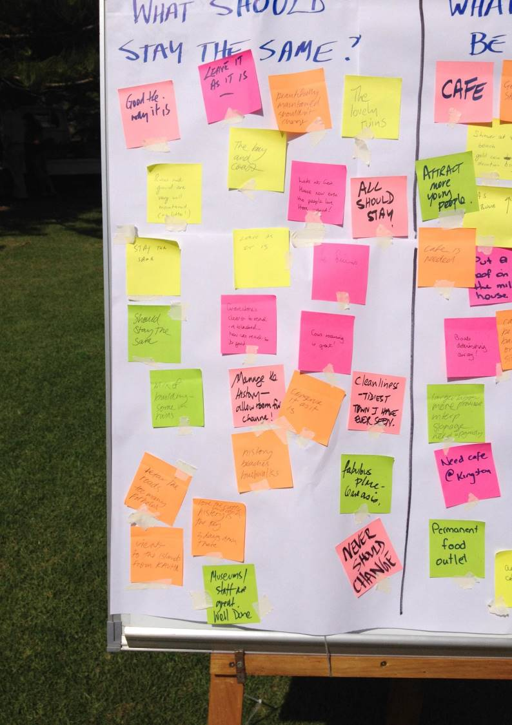

**Section 10:** Recommendations

**137**

* 1. **Introduction**

The Heritage Management Plan (HMP) is an overarching document which will guide the conservation and management of the KAVHA site over a five-year period. The following recommendations present an agenda for the Australian Government, the KAVHA Heritage Manager and all those involved in the care, control and management of the KAVHA site.

The recommendations had been arranged according to the conservation policies of the HMP. They set out a program of specific actions and projects that are recommended to implement the HMP policies. They are presented in a practical form which should facilitate use by KAVHA staff and other personnel involved in strategic planning, resource allocation and the development of annual programs. It is recognised that the program and priorities for these actions will change over time and that the specific recommendations do not include all the necessary tasks, as many such tasks are accounted for in the detailed policy statements. However, for the sake of completeness, and to facilitate effective planning, there is some repetition of the preceding Priority Programs section.

* 1. **Natural Environment**

|  |  |  |  |
| --- | --- | --- | --- |
| **Recommendation** | **Priority** | **Suggested Timing** | **Resources/Responsibilities** |
| 1. Regular monitoring and annual reporting on water quality should be undertaken and made publicly available. | Essential | 1 year | KAVHA Manager and/or external consultant |
| 2. An appropriate grazing and watering regime for cattle should be developed to protect water quality, public health and safety, and significant features. Management of cattle should be informed by *Stock and Waterways: A Managers Guide*, published by Land and Water, Australia. | Essential | 1 year | KAVHA Manager and/or external consultant |
| 3. A comprehensive survey of biodiversity should be undertaken. | High | 1 year | KAVHA Manager and/or external consultant |
| 4. Sand mining should cease within the KAVHA site. | High | 1 years | KAVHA Manager and KAVHA staff |
| 5. A program should be prepared to develop KAVHA staff skills and capacity in the management of natural values. | High | 2 years | External consultant or university department |
| 6. An environmental management strategy should be prepared for the KAVHA site to include slope and dune stabilisation, weed management, waste management, and opportunities for community engagement in land management. | Medium | 1–2 years | KAVHA Manager and KAVHA staff and/or external consultant |
| 7. Natural and cultural values at risk from climate change should be identified and data collected and maintained so change can be measured over time. | Medium | 3–5 years | KAVHA Manager and KAVHA staff |

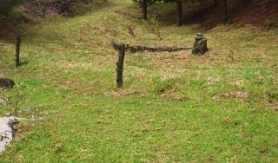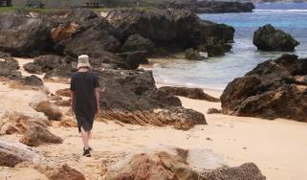

|  |  |  |  |
| --- | --- | --- | --- |
| **Recommendation** | **Priority** | **Suggested Timing** | **Resources/Responsibilities** |
| 8. The KAVHA site Landscape Management Plan should be reviewed and updated as a ‘cultural landscape plan’. Initiatives such as reducing mown areas, reinstating agricultural field boundaries and patterns, interpretive garden planting and design, and watering systems should be considered. | Essential | 2 years | KAVHA Manager and/or external consultant |
| 9. Review of the KAVHA site Landscape Management Plan should include analysis of archival and field evidence for the potential reintroduction of agriculture, and consider practical implications including risks, costs, labour and ongoing management. | High | 2 years | KAVHA Manager and/or external consultant |
| 10. A program should be established to monitor the success and health of cultural plantings and gardens. | Essential | 1 year | KAVHA Manager and/or external consultant |
| 11. A seed bank or plant cutting system should be established and maintained for plants historically appropriate and suitable for the site conditions. (Seeds and stock should be provided to landholders within the KAVHA site at no charge.) | High | 2 years | KAVHA and other Norfolk Island gardeners. |
| 12. The Government House and Quality Row Residences Gardens Conservation Management Plan should be reviewed and updated and should include plant lists for the gardens. | Medium | 1–2 years | Australian Government and KAVHA Manager, in consultation with KAVHA staff |
| 13. A register should be established of significant trees and vegetation of heritage significance within the KAVHA site. | Medium | 1–2 years | KAVHA Manager, in consultation with KAVHA staff, or contractor |
| 14. Potential subdivision and rezoning of freehold and leasehold lots along the boundary KAVHA site should be considered, having regard to potential heritage impacts, benefits for landholders and applicable planning controls. | Medium | 2–3 years | KAVHA Manager and/or external consultant, in consultation with landholders |
| 15. The formal leases for government owned residences within the KAVHA site should be reviewed to ensure occupants are required to maintain or allow maintenance of gardens in accordance with this HMP and associated plans. | Medium | 3–5 years | KAVHA staff in consultation with KAVHA Manager |
| 16. Other convict settlements on Norfolk Island, particularly Longridge and Cascades, should be assessed for potential National Heritage values as a first stage of any wider cultural landscape considerations, including conservation and interpretation. | Medium | 3–5 years | KAVHA staff in consultation with KAVHA Manager, Norfolk Island administration and relevant landowners |

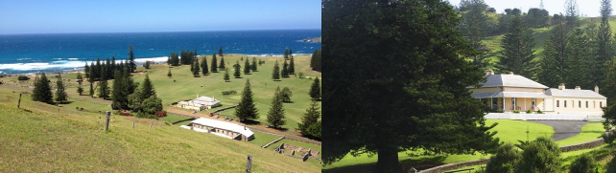

**10.4 Structures and Objects**

|  |  |  |  |
| --- | --- | --- | --- |
| **Recommendation** | **Priority** | **Suggested Timing** | **Resources/Responsibilities** |
| 17. A program should be established for preparing, reviewing and updating detailed conservation management plans and/or inventory records for individual buildings and features. | Essential | 1 year | KAVHA Manager |
| 18. A prioritised five-year forward plan should be prepared for fabric conservation works to identify urgent works, catch up works and cyclical works. Priority should be afforded to critical infrastructure, such as electricity and fire protection services. | Essential | 1 year | KAVHA Manager, KAVHA Works Team |
| 19. A skills training and trades program should be developed for conservation works to ensure the KAVHA Works Team develop and transfer skills and experience. | Essential | 1 year | KAVHA Manager, KAVHA works crew and/or external consultant |
| 20. A panel of specialist providers should be established for the supply of materials, goods and services to the KAVHA site to complement existing Australian Government Heritage and Environment panels. Where possible, preference should be given to local suppliers and providers. | High | 1 year | KAVHA Manager |
| 21. A technical advice or support service should be established to provide KAVHA staff and landholders with best practice guidance regarding conservation management and fabric conservation. | High | 2 years | KAVHA Manager and/or external consultant |
| 22. Further non-invasive ground penetration radar survey work should be undertaken to identify the extent and location of burials in the cemetery. | High | 2 years | KAVHA staff, in conjunction with university department |
| 23. An ongoing program should be developed for the identification, documentation, storage, interpretation, and display of movable heritage objects. This program should, where necessary, include determination of ownership. | Medium | 3–5 years | KAVHA Manager, Norfolk Island Museum |
| 24. A research strategy should be prepared to support and encourage historical research and scholarship at the KAVHA site. The strategy should identify priorities for non- invasive research into structures, objects, conservation techniques, family and other historical research. | Medium | 3–5 years | KAVHA Manager, Norfolk Island Museum, Research Centre, in conjunction with relevant teaching institutions and historical societies |

|  |  |  |  |
| --- | --- | --- | --- |
| **Recommendation** | **Priority** | **Suggested Timing** | **Resources/Responsibilities** |
| 25. A ‘Code of Practice’ should be developed for all archaeological investigations at the KAVHA site, including both research investigations and conservation and development programs. | Essential | 1 year | KAVHA Manager and/or external consultant |
| 26. Written guidelines for ground disturbance should be prepared for the design and management of works in a way which avoids or minimises impact on archaeological resources. | Essential | 1 year | KAVHA Manager and/or external consultant |
| 27. An integrated GIS-based ‘Archaeological Zoning Plan’ should be prepared for the KAVHA site, incorporating the existing CAD plan and other data, to document all known sites and predicted areas of archaeological sensitivity. This plan should be updated as new information becomes available. | High | 2 years | External consultant or university department |
| 28. A research prospectus should be prepared which identifies priorities for archaeological investigation within the KAVHA site. | Medium | 1–2 years | KAVHA Manager and KAVHA staff |
| 29. Information gathered through archaeological investigation— including reports, artefact catalogues and raw data—should be collated within a single database and made accessible online. | Medium | 3–5 years | KAVHA Manager and KAVHA staff |

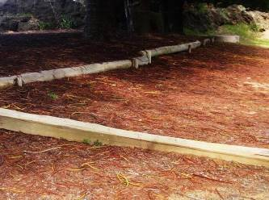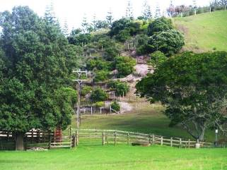

|  |  |  |  |
| --- | --- | --- | --- |
| **Recommendation** | **Priority** | **Suggested Timing** | **Resources/Responsibilities** |
| 30. Free access should continue to be available to the KAVHA site for the Norfolk Island community to encourage and support traditional cultural practices. | High | Immediate | Australian Government, KAVHA Manager |
| 31. All traditional activities and uses that exist at the KAVHA site should be documented, and the opportunities for their transmission to future generations assessed. Some of these may include work practices and skills. | High | 2 years | KAVHA Manager, Norfolk Island Museum, external consultant  Norfolk Island Cultural Strategic Plan: 2014–2018 |
| 32. A program designed to pass on traditions and the associated cultural knowledge should be developed and implemented. |  |  | KAVHA Manager, Norfolk Island Museum, external consultant  Norfolk Island Cultural Strategic Plan: 2014–2018 |
| 33. Cultural traditions and traditional uses and activities that were once present on the KAVHA site or that could assist in interpreting aspects of the history and local culture should be identified along with opportunities to progressively accommodate them on the site. This should be linked to the Norfolk Island Cultural Strategic Plan: 2015–2018 and to tourism recommendations in this HMP. | High | 3–5 years | External consultant, KAVHA Manager, Museum  Norfolk Island Cultural Strategic Plan: 2014–2018 |
| 34. A program should be developed to introduce and convey Norfolk Island cultural traditions to visitors, using the KAVHA site as a focus. | Medium | 3–5 years | Norfolk Island Tourism Bureau |

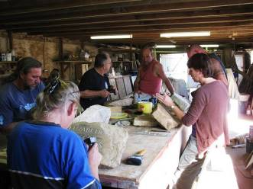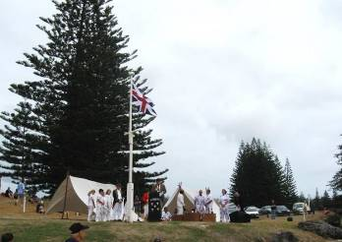

|  |  |  |  |
| --- | --- | --- | --- |
| **Recommendation** | **Priority** | **Suggested Timing** | **Resources/Responsibilities** |
| 35. A simple pro forma process should be developed to allow assessment of heritage impact, compliance with the conservation policies of the HMP, and permissibility under the Norfolk Island Plan for proposed activities, including the annual KAVHA works program. | Essential | 1 year | KAVHA Manager, KAVHA works crew |
| 36. An independent monitoring program should be established for unstable structures, ruins, structural timber and rainwater disposal systems. | Essential | 1 year | KAVHA Manager, external consultant |
| 37. An annual independent monitoring program should assess the state of the heritage values and condition of the fabric of the KAVHA site. The results should be presented in an annual ‘State of Heritage’ report. This report should inform the Australian Government's compulsory periodic reporting to the World Heritage Committee. | High | 1 year | KAVHA Manager, external consultant |
| 38. Lease and tenancy agreements should be reviewed and revised as necessary to include requirements to protect heritage values. | High | 1 year | KAVHA Manager and Australian Government as property owner |
| 39. A detailed schedule of traditional, compatible and incompatible uses should be compiled for each area and structure within the KAVHA site. | High | 1 year | KAVHA Manager, external consultant, Norfolk Island administration planners |
| 40. The licensing policy should be reviewed to ensure that it provides guidance on allowable uses, fees and other arrangements for both commercial and community activities. | High | 1 year | KAVHA Manager, KAVHA staff, Norfolk Island administration |
| 41. A written and graphic Development Control Plan (DCP) should be prepared for the KAVHA site which identifies compatible uses and potential locations, and provides design guidelines for new developments within the KAVHA site. The DCP should be published in hardcopy form and online. | High | 2 years | KAVHA Manager, external consultant, Norfolk Island administration planners |
| 42. Incentive clauses that promote desired heritage outcomes (such as those in the standard NSW Local Environmental Plan) should be included within the heritage provisions of the Norfolk Island Plan when it is next reviewed. | Medium | 2 years | Norfolk Island administration |
| 43. Guidelines should be developed which define townscape character and significant views that should be retained. These guidelines should become part of the proposed DCP. | Medium | 3–5 years | KAVHA Manager and/or external consultant |
| 44. Guidelines should be established for new commercial activities within the KAVHA site, including an open and transparent ‘Expression of Interest’ process. | Medium | 3 years | KAVHA Manager, Norfolk Island administration and/or external consultant |
| 45. An information package should be assembled for development proponents on the development approvals process, including information on heritage values and heritage impact assessment. | Medium | 3 years | KAVHA Manager, Norfolk Island administration planners |
| 46. Information about heritage significance and archaeological potential should be incorporated within the Norfolk Island administration land information system. | Medium | 3–5 years | KAVHA Manager, external consultant, Norfolk Island administration planning/registry section |

|  |  |  |  |
| --- | --- | --- | --- |
| **Recommendation** | **Priority** | **Suggested Timing** | **Resources/Responsibilities** |
| 47. The Australian Government and KAVHA Manager should participate in and contribute to the strategic development of the tourism industry on Norfolk Island and the implementation of the Norfolk Island Strategic Plan, as part of their roles in the conservation and management of the KAVHA site. | High | Immediate | Australian Government, KAVHA Manager |
| 48. A tourism consultative group should be convened comprising representatives from the KAVHA site and the tourism industry. This group should meet at least every six months. | High | 1 year | KAVHA Manager, plus KAVHA Tourism and Museum staff, Norfolk Island Tourism Board  *Norfolk Island Tourism Strategic Plan* |
| 49. A financial contribution should be introduced for commercial tourism activities within the KAVHA site, in consultation with the tourism industry. | High | 1 year | Tourism Consultative Group, KAVHA Manager and Norfolk Island administration |
| 50. A new food and beverage outlet should be provided within the KAVHA site. | High | 1 year | KAVHA Manager to manage EOI process with external consultant |
| 51. A Code of Conduct should be prepared for tourism industry operators and visitors to the KAVHA site which specifies appropriate visitor behaviour and industry practices. | High | 2 years | KAVHA Manager or external consultant |
| 52. Relevant information including the Code of Conduct should be collated and made available for visitors, online and through tourism operators, prior to their visit. | High | 2 years | KAVHA Manager, KAVHA Tourism staff and Norfolk Island Tourism Board |
| 53. A program should be developed for the training of tourism industry personnel in the history, heritage value and management of the KAVHA site so as to facilitate the delivery of consistent, accurate messages. | High | 2 years | KAVHA Manager, KAVHA Tourism staff and Norfolk Island Tourism Board |
| 54. Community events (such as weddings) should be encouraged within the KAVHA site and financial contributions should only be sought on a cost recovery basis. | Medium | 2 years | KAVHA Tourism and Norfolk Island Museum staff |
| 55. As additional resources are available, the opening hours and availability of tourist attractions within the KAVHA site should be extended. | Medium | 2 years | KAVHA Manager, KAVHA Tourism and Norfolk Island Museum staff |
| 56. A prospectus should be prepared which identifies new types of tourism products that are desirable within the KAVHA site, particularly including appropriate cultural traditions and activities. | Medium | 3 years | KAVHA Manager, Tourism Consultative Group, plus KAVHA Tourism and Museum staff, Norfolk Island Tourism Board  *Norfolk Island Tourism Strategic Plan* |
| 57. Provision should be made for including the KAVHA site as part of the proposed Great Norfolk Walk. | Medium | 2–4 years | KAVHA Manager, Tourism Consultative Group, Norfolk Island administration and Great Norfolk Walk proponents |
| 58. Visitor satisfaction should be monitored through an ongoing survey program. | Medium | 3 years | KAVHA staff, in conjunction with Norfolk Island Tourism Board |

|  |  |  |  |
| --- | --- | --- | --- |
| **Recommendation** | **Priority** | **Suggested Timing** | **Resources/Responsibilities** |
| 59. The KAVHA site Heritage Interpretation Strategy should be reviewed and updated to become a full Interpretation Plan. | Essential | 1 year | KAVHA Manager and/or external consultant |
| 60. The KAVHA site should be branded and presented as one of the 11 sites which comprise the Australian Convict Sites World Heritage property. | Essential | 1 year | KAVHA Manager and/or external consultant |
| 61. An updated suite of visitor maps, site plans and brochures should be prepared for the KAVHA site. | Essential | 1 year | KAVHA Manager and/or external consultant |
| 62. The KAVHA Museum and the Research Centre should be integrated to provide a single and coordinated collections management, and interpretive and research program. Consideration should be given to the appropriate venue or venues for the integrated Museum and Research Centre. | High | 1–2 years | KAVHA Manager, KAVHA staff and Norfolk Island Museum |
| 63. The three Norfolk Island Museum collections should be brought within a single set of management arrangements (subject to consultation with stakeholders, including the Norfolk Island Museum Trust and specific arrangements with donors). | Medium | 2–3 years | KAVHA Manager, KAVHA staff and Norfolk Island Museum |
| 64. A digital interpretive experience should be developed as part of a KAVHA site website. | High | 1–2 years | KAVHA Manager and KAVHA staff |
| 65. A coordinated strategic plan should be prepared for collections, research, exhibitions and interpretive activities. | High | 2 years | KAVHA Manager, KAVHA staff and Norfolk Island Museum |
| 66. Access should continue to be provided to publicly owned significant buildings. The Government House open days should be continued, and extended if and where possible. | High | Immediate | KAVHA Manager, KAVHA staff and Norfolk Island Museum Administrator |
| 67. A public events program should be developed to communicate the heritage values of the KAVHA site. | Medium | 2 years | KAVHA Manager, KAVHA staff and Norfolk Island Museum |
| 68. An educational program with accompanying kits should be developed for local and Australian schools to support increased educational use of the KAVHA site. | Medium | 2 years | KAVHA staff, external consultant |

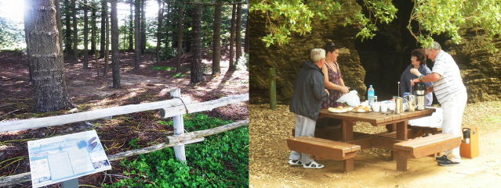

|  |  |  |  |
| --- | --- | --- | --- |
| **Recommendation** | **Priority** | **Suggested Timing** | **Resources/Responsibilities** |
| 69. The HMP should be approved by the interim KAVHA Steering Group based on input provided by the KAVHA Advisory Committee, and advice provided by the Minister for the Environment that it is consistent with World Heritage Principles under the *Environment Protection and Biodiversity Conservation Act 1999*. | Essential | Immediate | KAVHA Steering Group, KAVHA Advisory Committee, Department of the Environment, Minister for the Environment |
| 70. Governance and site management arrangements should address the need for collaboration between governments and the community, sharing information and improving accountability and transparency. | Essential | Immediate | Australian Government and Norfolk Island administration |
| 71. The Australian Government should develop proposals for the long-term governance and funding of KAVHA. | Essential | Immediate | Australian Government and Norfolk Island administration |
| 72. DIRD should prepare a Position Description for the KAVHA Manager. | Essential | Immediate | DIRD |
| 73. All operating units and KAVHA staff should report to the KAVHA Manager and reporting lines should be adjusted in accordance with the new organisational structure and operating management units. | Essential | Immediate | KAVHA Manager, Norfolk Island administration and Australian Government |
| 74. The roles and responsibilities of the Australian Government and Norfolk Island administration, the KAVHA Manager, all KAVHA staff and others (as relevant) should be clearly presented in a readily available document and reflected in position descriptions and delegations. | Essential | 1 year | Australian Government |
| 75. Following endorsement of this HMP, implementation workshops should be conducted for KAVHA staff and other relevant stakeholders. | High | Immediate | KAVHA staff, Norfolk Island administration staff and external consultant |
| 76. The KAVHA Advisory Committee should be appointed by the interim KAVHA Steering Group. It should include a minimum of five members with no less than two Norfolk Island community members (including landholder representation), no less than two expert members (with skills in place management, heritage, cultural tourism and /or collections), and a senior Australian Government official as Chair. | Essential | Immediate | Australian Government |
| 77. A mechanism should be established to provide the Australian Government with expert and stakeholder advice on matters relating to KAVHA, including governance. Opportunities should be provided for the community and landholders to have their opinions considered, including through consultative forums. | Essential |  | Australian Government, KAVHA Advisory Committee and KAVHA Manager |

|  |  |  |  |
| --- | --- | --- | --- |
| **Recommendation** | **Priority** | **Suggested Timing** | **Resources/Responsibilities** |
| 78. An HMP implementation plan should be prepared and regular reports provided to the Australian Government and the community on the progress of actions identified in the HMP. | Essential | Immediate | KAVHA Manager |
| 79. An audit should be undertaken of existing and required site facilities, and plant and equipment. | Essential | 2 years | KAVHA Manager |
| 80. An audit should be undertaken of existing and required heritage trades and professional skills within the KAVHA staff. | High | 2 years | KAVHA Manager or external consultant |
| 81. Opportunities should be identified to facilitate the intergenerational transfer of traditional heritage skills. | High | 2–3 years | KAVHA Manager and KAVHA staff, in consultation with the Australian Government |
| 82. Where necessary, statutory/regulatory reform should occur to enable the new KAVHA site organisational structure and operating management units. | High | 2 years | Australian Government and Norfolk Island administration |
| 1. The funding base for the KAVHA site should be broadened through consideration of:    * eligibility for either government or non- government grant funding;    * opportunities for financial returns from commercial and tourism uses and developments, and a per capita visitor fee; and    * philanthropy and corporate sponsorship. | High | 3 years | Australian Government, Norfolk Island administration and KAVHA Manager |
| 84. Records related to the KAVHA site should all be retained, catalogued, conserved and progressively transferred to electronic media and made available online for legitimate management and research purposes. | Medium | 3 years | KAVHA staff and/or external consultant |
| 85. The existing KAVHA site Heritage Inventory should be reviewed and updated now and on an annual basis, and should include records of management decisions and works undertaken. KAVHA staff and others should be trained in its use. | Medium | 2 years | KAVHA staff and/or external consultant |
| 86. The *Planning Act 2002* (NI), associated regulations and the Norfolk Island Plan should be reviewed, revised and updated to reflect the new governance arrangements for KAVHA and this HMP. | Medium | 2 years | Norfolk Island administration |

|  |  |  |  |
| --- | --- | --- | --- |
| **Recommendation** | **Priority** | **Suggested Timing** | **Resources/Responsibilities** |
| 1. Operational documents should be reviewed, revised and updated to reflect the new governance arrangements for KAVHA and this HMP. These documents include but are not limited to:    * *Plans of Management for the ‘Public Reserves’ within the KAVHA site;*    * *Government House Norfolk Island: Conservation and Management Plan;*    * *Landscape Management and Conservation Plan;*    * *Kingston Cemetery Study and Management Plan;*    * *Recreation Management Plan;*    * *Conservation Management Plan: Government House and Quality Row Gardens;* and    * *Water Quality Management Plan.* | Medium | 4 years | KAVHA staff and/or external consultant |
| 88. Existing KAVHA site management documentation should be reviewed and amalgamated into an overall ‘Site Operations Manual’. | High | 2 years | KAVHA Manager and KAVHA staff |
| 89. KAVHA should continue to participate in the Australian Convict Sites Steering Committee and operate in accordance with the Australian Convict Sites Strategic Management Framework. | High | Immediate | KAVHA Manager |
| 90. A review of the HMP should occur in 2020. As changes to the site’s governance arrangements will be ongoing during this time, they should be reported annually. | Essential | 4 years | Australian Government, KAVHA Advisory Committee and KAVHA Manager |

* 1. **Communication and Engagement**

|  |  |  |  |
| --- | --- | --- | --- |
| **Recommendation** | **Priority** | **Suggested Timing** | **Resources/Responsibilities** |
| 91. A succinct plain-English brochure should be prepared summarising the key principles, policies, programs and recommendations of this Heritage Management Plan. This brochure should be readily available in hardcopy form on Norfolk Island and online. | High | Immediate | KAVHA Manager and HMP consultant team |
| 92. A database of all KAVHA site stakeholders should be established, kept up-to-date and used as a basis for communications and engagement. | Essential | Immediate | KAVHA staff |
| 93. A new KAVHA site website should be developed that offers information about visiting the site, its history, conservation and community connections, the Museum and Research Centre, tours, events and activities, and opportunities to get involved. It should offer links to the other properties which comprise the Australian Convict Sites. | Essential | 1 year | Australian Government, external consultant, with input from KAVHA Manager |
| 94. The KAVHA site website should be developed collaboratively and in consultation with Norfolk Island Tourism. | Essential | 1–2 years | KAVHA Manager |
| 1. A program of regular discussion forums should be established with the following stakeholders:    * landholders within the KAVHA site;    * occupiers of buildings within the KAVHA site;    * tourism operators delivering tourism services on Norfolk Island;    * the Council of Elders; and    * Norfolk Island National Park. | Essential | 1 year | KAVHA Manager and participants |
| 96. An electronic and hardcopy resources library should be established to provide an easily accessible and comprehensive source for all heritage and conservation activities at the KAVHA site. It should include all studies, research, maps and plans, works programs, monitoring reports, management plans and KAVHA Advisory Committee reports and minutes. It should be publicly available and include a searchable index. | High | 2–3 years | KAVHA Project Officer and Research Centre and external consultant |

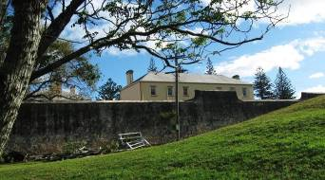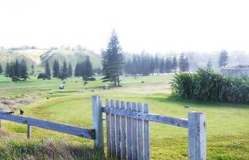

|  |  |  |  |
| --- | --- | --- | --- |
| **Recommendation** | **Priority** | **Suggested Timing** | **Resources/Responsibilities** |
| 97. A Communications and Engagement Policy and Plan should be developed to guide external communications and community engagement. It should have regard to best practice principles and guidance, and the draft should be subject to community and stakeholder review. It should include consideration of regular discussion forums. | High | 1–2 years | KAVHA Manager and KAVHA staff |
| 98. Skills in communication and conflict resolution should be developed across the KAVHA team, especially at a management level. This would involve external training opportunities, combined with policies and internal training for all staff. | High | 1–5 years, ongoing | KAVHA Manager, KAVHA staff and external training provider |
| 99. A program designed to expand skills in, and the use of the Norf’k language across the site should be developed and implemented. The program should include language development across the KAVHA team (if needed) and visitor exposure to more opportunities to hear and read Norf’k language. | Medium | 1–3 years | KAVHA Manager, external advisor/consultant |