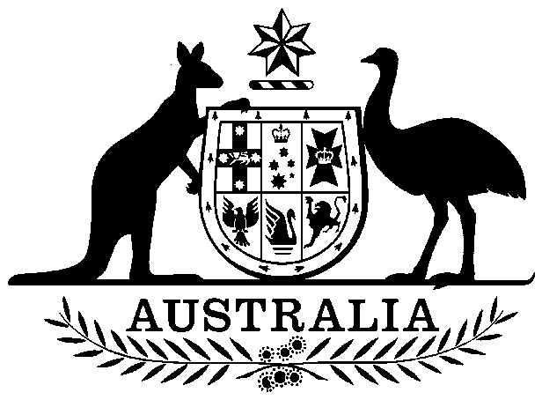

**COMMONWEALTH OF AUSTRALIA**

##### Environment Protection and Biodiversity Conservation Act 1999

**Amendment of List of Exempt Native Specimens**

I, Nathan Hanna, Acting Assistant Secretary, Wildlife Trade and Biosecurity Branch, as Delegate of the Minister for the Environment and Energy, pursuant to subsection303DC(1) of the *Environment Protection and Biodiversity Conservation Act 1999* (EPBC Act), hereby amend the list of exempt native specimens established under section 303DB of the EPBC Act by **deleting** from the list specimens and any associated restrictions or conditions as set out in **Schedule 1**, and by **including** in the list specimens and associated restrictions or conditions as set out in **Schedule 2**.

# Dated this 11th day of January 2017

Nathan Hanna

Delegate of the Minister for the Environment and Energy

**SCHEDULE 1**

Under the heading Freshwater and Marine Invertebrates delete from the list the following items and any associated notations:

|  |  |  |
| --- | --- | --- |
| Phylum: Mollusca | | |
| Miscellaneous (not species specific) | | |
| Marine shells of any taxa within the Phylum Mollusca except species of Tridacnidae. | molluscs | Marine shells of specimen shell quality, obtained from Western Australian, South Australian, Queensland or Victorian waters as personal baggage. Limit 5 specimens per person. |
| Marine shells of any taxa within the Phylum Mollusca except species of Tridacnidae. | molluscs | Beach cast marine shells as personal baggage. |

**SCHEDULE 2**

Under the heading Freshwater and Marine Invertebrates include in the list the following items and associated notations:

|  |  |  |
| --- | --- | --- |
| Phylum: Mollusca | | |
| Miscellaneous (not species specific) | | |
| Marine shells of any taxa within the Phylum Mollusca except species of Tridacnidae and Nautilidae. | molluscs | Marine shells of specimen shell quality, obtained from Western Australian, South Australian, Queensland or Victorian waters as personal baggage. Limit 5 specimens per person. |
| Marine shells of any taxa within the Phylum Mollusca except species of Tridacnidae and Nautilidae. | molluscs | Beach cast marine shells as personal baggage. |