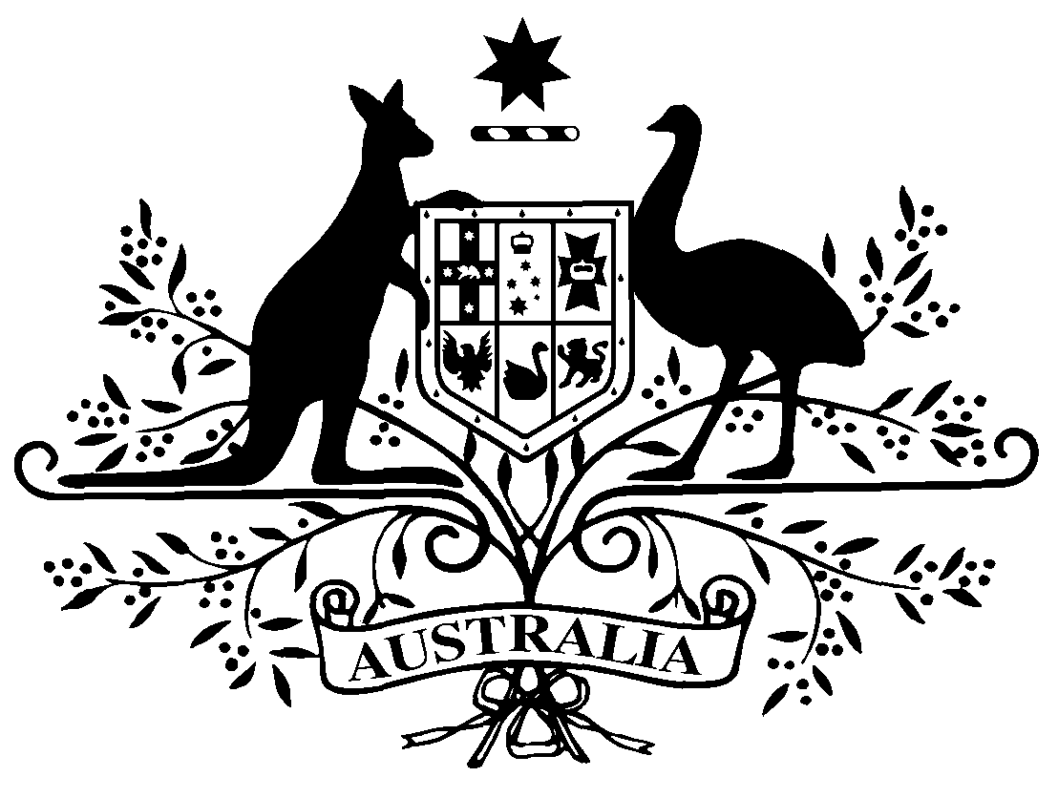

PB 12 of 2017
National Health (Weighted average disclosed price – April 2017 reduction day) Amendment Determination 2017 (No.1)
National Health Act 1953
I, LOUISE CLARKE, Acting First Assistant Secretary, Pharmaceutical Benefits Division, Department of Health, delegate of the Minister for Health, make this determination under subsection 99ADB(4) of the National Health Act 1953.
Dated: 17 January 2017

LOUISE CLARKE

Acting First Assistant Secretary
Pharmaceutical Benefits Division
Department of Health

1 Name of Determination
(1) This Determination is the National Health (Weighted average disclosed price – April 2017 reduction day) Amendment Determination 2017 (No.1).
(2) This Determination may also be cited as PB 12 of 2017.
2 Commencement
This Determination commences on the day after it is registered.

- Amendments to PB 109 of 2016
Schedule 1 amends the National Health (Weighted average disclosed price – April 2017 reduction day) Determination 2016 (PB 109 of 2016).
Schedule 1 Amendments

[1] Schedule 1
omit:
470 | Iron polymaltose complex | Injection 100 mg (iron) in 2 mL | Injection | Ferrosig | 7.53
471 | Iron polymaltose complex | Injection 100 mg (iron) in 2 mL | Injection | Ferrum H | 7.53

[2] Schedule 1
omit:
1034 | Sorbitol with sodium citrate and sodium lauryl sulfoacetate | Enemas 3.125 g-450 mg-45 mg in 5 mL, 12 | Rectal | Micolette | 7.28

[3] Schedule 1
omit:
1135 | Ursodeoxycholic acid | Capsule 250 mg | Oral | Ursodox GH | 116.74
1136 | Ursodeoxycholic acid | Capsule 250 mg | Oral | Ursofalk | 116.74
1137 | Ursodeoxycholic acid | Capsule 250 mg | Oral | Ursosan | 116.74

[4] Schedule 1
omit:
1153 | Zoledronic acid | Injection concentrate for I.V. infusion 4 mg (as monohydrate) in 5 mL | Injection | APO-Zoledronic Acid | 244.25
1154 | Zoledronic acid | Injection concentrate for I.V. infusion 4 mg (as monohydrate) in 5 mL | Injection | DBL Zoledronic Acid | 244.25
1155 | Zoledronic acid | Injection concentrate for I.V. infusion 4 mg (as monohydrate) in 5 mL | Injection | Zometa | 244.25
1156 | Zoledronic acid | Solution for I.V. infusion 4 mg (as monohydrate) in 100 mL | Injection | DBL Zoledronic Acid | 244.25
1157 | Zoledronic acid | Solution for I.V. infusion 4 mg (as monohydrate) in 100 mL | Injection | Zometa | 244.25
1158 | Zoledronic acid | Solution for I.V. infusion 5 mg (as monohydrate) in 100 mL | Injection | Aclasta | 327.01
1159 | Zoledronic acid | Solution for I.V. infusion 5 mg (as monohydrate) in 100 mL | Injection | Osteovan | 327.01
1160 | Zoledronic acid | Solution for I.V. infusion 5 mg (as monohydrate) in 100 mL | Injection | Ostira | 327.01
1161 | Zoledronic acid | Solution for I.V. infusion 5 mg (as monohydrate) in 100 mL | Injection | Zoledasta | 327.01
substitute:
1153 | Zoledronic acid | Injection concentrate for I.V. infusion 4 mg (as monohydrate) in 5 mL | Injection | APO-Zoledronic Acid | 245.33
1154 | Zoledronic acid | Injection concentrate for I.V. infusion 4 mg (as monohydrate) in 5 mL | Injection | DBL Zoledronic Acid | 245.33
1155 | Zoledronic acid | Injection concentrate for I.V. infusion 4 mg (as monohydrate) in 5 mL | Injection | Zometa | 245.33
1156 | Zoledronic acid | Solution for I.V. infusion 4 mg (as monohydrate) in 100 mL | Injection | DBL Zoledronic Acid | 245.33
1157 | Zoledronic acid | Solution for I.V. infusion 4 mg (as monohydrate) in 100 mL | Injection | Zometa | 245.33
1158 | Zoledronic acid | Solution for I.V. infusion 5 mg (as monohydrate) in 100 mL | Injection | Aclasta | 328.46
1159 | Zoledronic acid | Solution for I.V. infusion 5 mg (as monohydrate) in 100 mL | Injection | Osteovan | 328.46
1160 | Zoledronic acid | Solution for I.V. infusion 5 mg (as monohydrate) in 100 mL | Injection | Ostira | 328.46
1161 | Zoledronic acid | Solution for I.V. infusion 5 mg (as monohydrate) in 100 mL | Injection | Zoledasta | 328.46

[4] Schedule 2
after:
1032 | Irbesartan with hydrochlorothiazide | Tablet 300 mg-25 mg | Oral | Terry White Chemists Irbesartan HCTZ | 4.54
insert:
1032A | Iron polymaltose complex | Injection 100 mg (iron) in 2 mL | Injection | Ferrosig | 11.63
1032B | Iron polymaltose complex | Injection 100 mg (iron) in 2 mL | Injection | Ferrum H | 11.63

[5] Schedule 2
after:
2116 | Somatropin | Solution for injection 6 mg (18 i.u.) in 1.03 mL cartridge (with preservative) | Injection | Saizen | 249.48
insert:
2116A | Sorbitol with sodium citrate and sodium lauryl sulfoacetate | Enemas 3.125 g-450 mg-45 mg in 5 mL, 12 | Rectal | Micolette | 8.05

[6] Schedule 2
after:
2302 | Tropisetron | I.V. injection 5 mg (as hydrochloride) in 5 mL | Injection | Tropisetron-AFT | 4.74
insert:
2302A | Ursodeoxycholic acid | Capsule 250 mg | Oral | Ursodox GH | 132.03
2302B | Ursodeoxycholic acid | Capsule 250 mg | Oral | Ursofalk | 132.03
2302C | Ursodeoxycholic acid | Capsule 250 mg | Oral | Ursosan | 132.03

