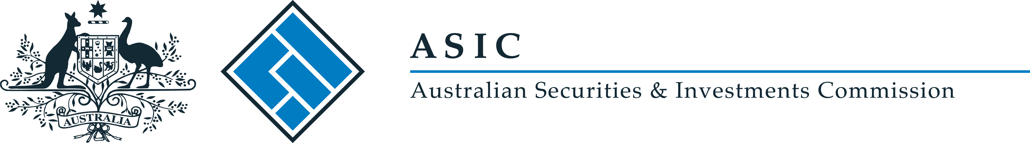
ASIC Corporations (Securities and Managed Investment Scheme Hawking Relief) Instrument 2017/184
I, Stephen Yen PSM, delegate of the Australian Securities and Investments Commission, make the following legislative instrument.
Date: 1 March 2017

Stephen Yen

Contents
Part 1—Preliminary 3
1 Name of legislative instrument 3
2 Commencement 3
3 Authority 3
4 Definitions 3
Part 2—Exemptions 4
5 Hawking relief for certain financial products 4

Part 1—Preliminary

1 Name of legislative instrument
This instrument is the ASIC Corporations (Securities and Managed Investment Scheme Hawking Relief) Instrument 2017/184.

2 Commencement
This instrument commences on the day after it is registered on the Federal Register of Legislation.
Note: The register may be accessed at www.legislation.gov.au.

3 Authority
This instrument is made under subsection 992B(1) of the Corporations Act 2001.

4 Definitions
In this instrument:
Act means the Corporations Act 2001.

Part 2—Exemptions

5 Hawking relief for certain financial products

Relief for unregistered managed investment schemes
(1) A person making an offer of interests in a managed investment scheme that are not managed investment products does not have to comply with subsection 992A(1) of the Act.

Relief for securities and interests in managed investment schemes
(2) A person making an offer of securities or interests in a managed investment scheme does not have to comply with subsection 992A(3) of the Act.

