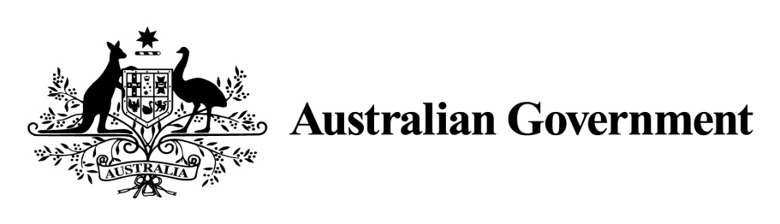

Norfolk Island Employment(Show Day) Declaration 2017

I, **GARY HARDGRAVE**, a delegate of the Commonwealth Minister, make this declaration under subsection 9(2) of the *Employment Act 1988* (NI).

Dated 24 February 2017

signed

**GARY HARDGRAVE**  
Administrator of Norfolk Island

1 Name of Instrument

This instrument is the *Norfolk Island Employment (Show Day) Declaration 2017*.

**2 Commencement**

This instrument commences the day after it is registered.

**3 Authority**

This instrument is made under subsection 9(2) of the *Employment Act 1988* (NI).

**4 Declaration of a Public Holiday on Norfolk Island**

I declare that, from the commencement of this instrument:

1. the second Monday in October is Show Day.

Note: Under paragraph 9(1)(q) of the *Employment Act 1988* (NI) the day declared by the Commonwealth Minister to be Show Day will be observed as a public holiday.