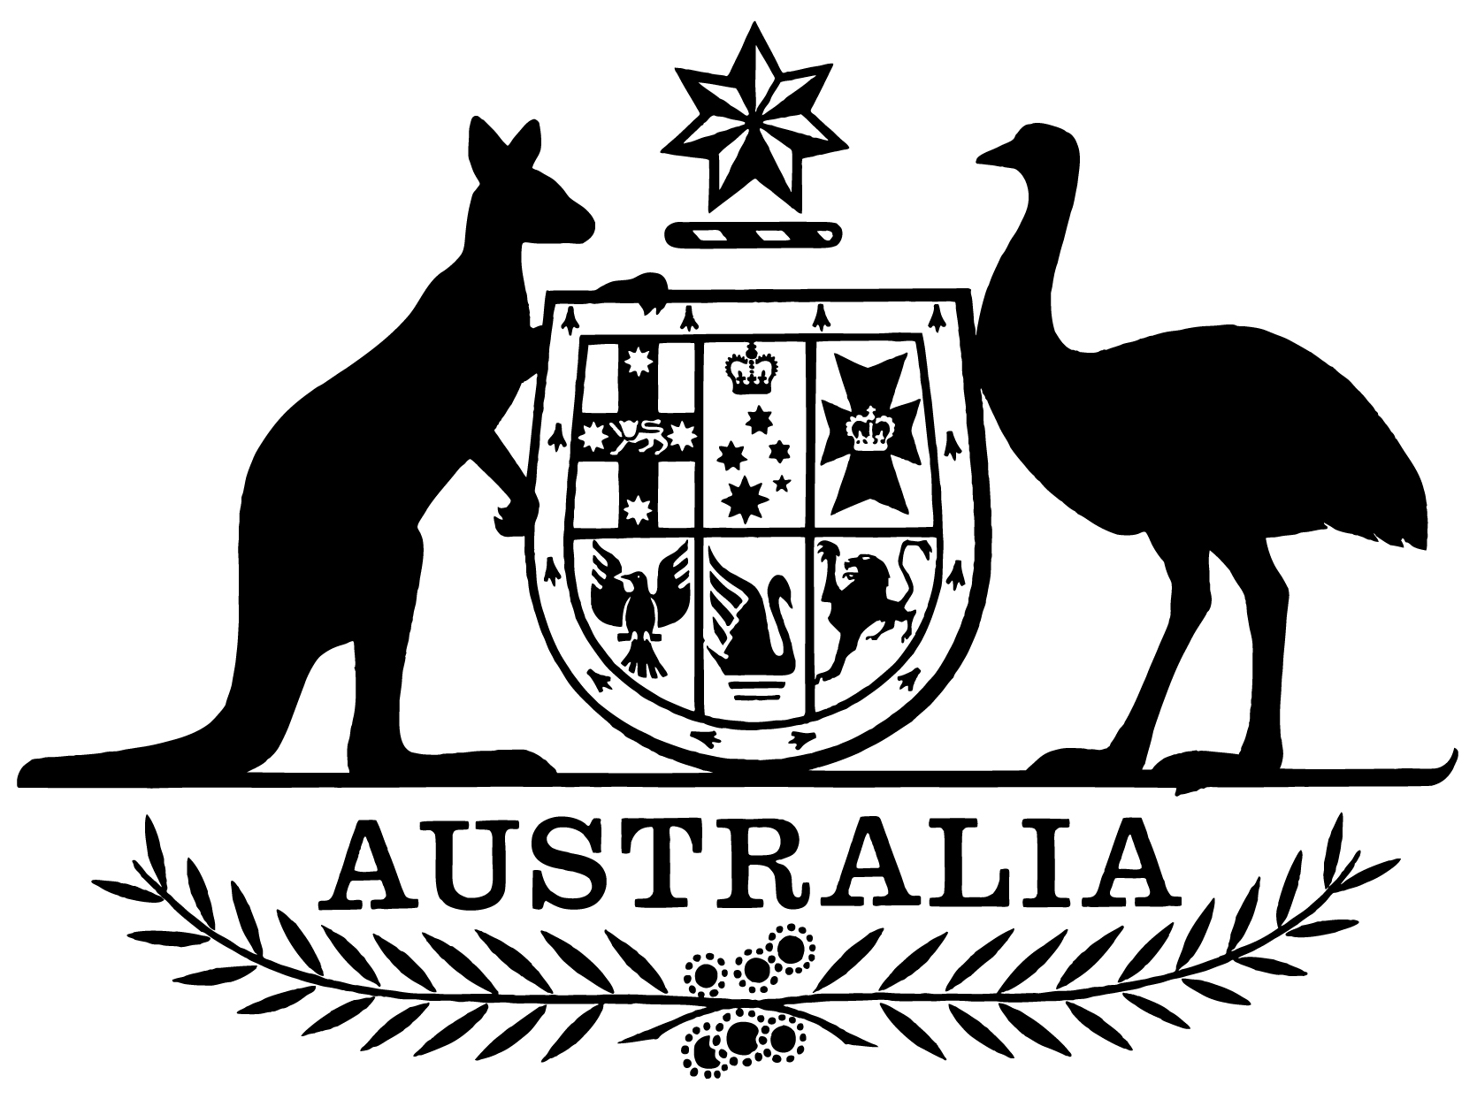

***Statement of Expectations for the Board of the Civil Aviation Safety Authority for the Period 27 March 2017 to 30 June 2019***

I,Darren Chester, Minister for Infrastructure and Transport, make the following instrument.

Dated 21 March 2017

Darren Chester

Minister for Infrastructure

and Transport

1. **Overview**

This instrument is known as the *Statement of Expectations for the Board of the Civil Aviation Safety Authority for the Period 27 March 2017 to 30 June 2019*.

This instrument commences on 27 March 2017 and expires at the end of 30 June 2019 as if it had been repealed by another instrument.

This instrument repeals the previous *Statement of Expectations for the Board of the Civil Aviation Safety Authority for the period 1 July 2013 to 30 June 2015* and the *Statement of Expectations for the Board of the Civil Aviation Safety Authority for the period 16 April 2015 to 30 June 2017*.

This instrument puts in place a new Statement of Expectations (SOE) which serves as a notice to the Board of the Civil Aviation Safety Authority (CASA) under Section 12A of the *Civil Aviation Act 1988* (the Act).

This new SOE outlines in a formal and public way, the Government’s expectations concerning the operations and performance of CASA.

CASA should perform its functions in accordance with the Act, the *Airspace Act 2007* and the *Public Governance, Performance and Accountability Act 2013* (PGPA Act) as well as other relevant legislation.

CASA should maintain high standards of professionalism, service, probity, reporting, accountability and transparency, consistent with the provisions of the PGPA Act and have a code of conduct and values consistent with those used by the Australian Public Service. I expect CASA to operate as a world leading aviation safety regulator, backed by a workforce with the requisite skills and capabilities.

1. **Governance**

I expect that the Board and the Director of Aviation Safety (DAS) will work together to enable the effective operation of CASA as the national aviation safety regulator.

The Board is responsible for the matters set out in the Act, including in particular CASA’s strategic direction, risk management and corporate planning.

In addition, I expect the Board to ensure that CASA makes progress on strategic priorities, in particular the categorisation of operations, emerging risks in aviation such as remotely piloted aircraft systems, and amendments to regulations and other statutory instruments.

I also expect the Board to facilitate effective interaction between CASA and the industry.

Subject to the Act, I expect the DAS, as the Chief Executive Officer of CASA, to be responsible for managing the operations of CASA, its organisational capacity (including recruitment and training) and the exercise of its statutory functions, such as the development and implementation of regulation, executive-decision making, and all day-to-day operational, financial, personnel and administrative activities.

1. **Regulatory Approach**

In terms of its regulatory approach, my expectation is that CASA will:

(a) continue to focus on aviation safety as the highest priority;

(b) consider the economic and cost impact on individuals, businesses and the community in the development and finalisation of new or amended regulatory changes;

(c) take a pragmatic, practical and proportionate approach to regulation as it applies to different industry sectors having regard to risk; and

(d) implement its regulatory philosophy, with the philosophy being reflected in relevant policies, procedures, manuals, and when CASA personnel are carrying out their day-to-day operations.

1. **Key Aviation Initiatives**

I expect CASA, in conducting its responsibilities as the aviation safety regulator, to have regard to the following key aviation initiatives:

(a) changes taking place in relation to air traffic services, including Airservices Australia’s (Airservices) new operating model and the transition to a new air traffic management system under the OneSKY Project;

(b) workforce planning, including ensuring CASA’s training and recruitment strategies provide the organisation with the skills and expertise to meet the current and emerging challenges in aviation safety regulation;

(c) the appropriate sharing and use of safety information by CASA consistent with the Safety Information Policy Statement agreed with the Australian Transport Safety Bureau (ATSB) and informed by ‘just culture’ principles;

(d) completing implementation of the remaining parts of the Government’s response to the Aviation Safety Regulation Review, including actively progressing regulatory reform in consultation with industry and supported by appropriate safety cases;

(e) implementation of the recommendations of the review of the operations and functions of the Office of Airspace Regulation;

(f) working with Airservices and the Department of Infrastructure and Regional Development (the Department) on enhancing the level of controlled airspace in Australian airspace including at major regional airports; and

(g) strengthening international and Asia-Pacific regional aviation safety engagement through:

* establishment of appropriate mutual recognition arrangements;
* support of the Government’s aviation safety initiatives in the Asia-Pacific region; and
* commitment to the Memorandum of Understanding between CASA, the Department and Airservices, regarding the management of Australia’s International Civil Aviation Organization (ICAO) responsibilities.

1. **Stakeholder Engagement**

I expect that in performing its functions CASA will:

(a) undertake effective and ongoing engagement with the aviation industry to create a collaborative relationship between CASA and industry based on a foundation of mutual understanding and respect;

(b) consider recommendations by the Industry Complaints Commissioner (ICC) about systemic issues arising from the ICC’s investigations;

(c) communicate regularly with relevant Government agencies, industry and other key stakeholders regarding CASA’s activities and functions;

(d) keep the Secretary of the Department and me fully informed of CASA’s actions in relation to the requirements stated in this SOE, and promptly advise about any events or issues that may impact on the operations of CASA, including through the provision of timely quarterly progress reports from the Board against the Corporate Plan; and

(e) work closely with the Department and other Government agencies, including the ATSB, Airservices and the Department of Defence, to deliver integrated and comprehensive safety advice to the Government, the aviation industry and the community.