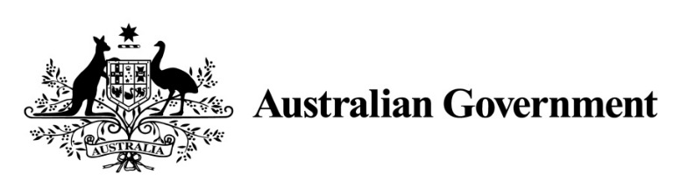

National Land Transport Act 2014

VARIATION OF THE ROADS TO RECOVERY LIST 2014

Instrument No. 2017/1
I, SARAH LEEMING, General Manager, South East Investment Projects, Department of Infrastructure and Regional Development, under section 88(2A) of the National Land Transport Act 2014, vary the Roads to Recovery List 2014 which was made by the Minister on 12 September 2014, and amended by Instrument No. 2015/1 made on 24 March 2015, Instrument No. 2015/2 made on 2 April 2015, Instrument No. 2015/3 made on 12 August 2015, Instrument No. 2016/1 made on 12 July 2016, Instrument No. 2016/2 made on 31 August 2016 and Instrument No. 2016/3 made on 14 October 2016, as follows:

- Name of variation
This variation instrument is the Roads to Recovery List 2014 Variation Instrument No. 2017/1.

- Variation
(a) In Schedule 1 of the List, in the part relating to Western Australia:
omit the amount specified in Column 2 of Schedule 1 for each applicable person or body named in Column 1 of the schedule to this instrument and replace the omitted amount with the amount specified for that person or body in Column 2 of the schedule to this instrument.
(b) Schedule 2 of the List, in the part relating to Western Australia:
Omit the amount specified in Column 2 of Schedule 2, and replace the omitted amount with the word ‘Nil’.

- Commencement
This instrument commences on 30 April 2017.

Dated: 20th March 2017

SARAH LEEMING
General Manager
South East Investment Projects
Infrastructure Investment Division
Department of Infrastructure and Regional Development

Schedule to Instrument 2017/1

Column 1 | Column 2
Shire of Beverley | $5,854,121
Shire of Boyup Brook | $3,979,238
Shire of Bridgetown Greenbushes | $3,856,184
Shire of Broome | $4,068,138
Shire of Bruce Rock | $3,444,153
Shire of Capel | $2,644,569
Shire of Denmark | $2,517,026
Shire of Derby West Kimberley | $4,192,594
Shire of East Pilbara | $10,456,138
Shire of Halls Creek | $4,267,498
City of Kalgoorlie-Boulder | $7,177,600
City of Karratha | $3,934,394
Shire of Laverton | $4,175,382
Shire of Menzies | $3,564,675
Shire of Ngaanyatjarraku | $5,137,669
Town of Port Hedland | $3,049,202
City of Swan | $11,713,770
Shire of Upper Gascoyne | $3,971,025
Shire of Victoria Plains | $2,694,405
Shire of Wyndham East Kimberley | $9,541,777

