AIRWORTHINESS DIRECTIVE

On the commencement date specified below, and for the reasons set out in the background section, the CASA delegate whose signature appears below repeals Airworthiness Directive (**AD**) AD/A320/77 and issues the following AD under subregulation 39.001 (1) of CASR 1998 and subsection 33 (3) of the *Acts Interpretation Act 1901*. The AD requires that the action set out in the requirement section (being action that the delegate considers necessary to correct an unsafe condition) be taken in relation to the aircraft or aeronautical product mentioned in the applicability section: (a) in the circumstances mentioned in the requirement section; and (b) in accordance with the instructions set out in the requirement section; and (c) at the time mentioned in the compliance section.

# Airbus A319, A320 and A321 Series Aeroplanes

|  |  |  |
| --- | --- | --- |
| AD/A320/77 Amdt 1 | Loral DFDR F800 Damping Rack Installation | 11/2017 |

|  |  |
| --- | --- |
| Applicability: | All Airbus A320 series aeroplanes, models -111, -211, -212, -231 and -232, equipped with a Loral Data Systems Digital Flight Data Recorder (DFDR) F800, without Airbus modification 24959 or Airbus Service Bulletin (SB) A320-31-1088 as in force from time to time incorporated. |
| Requirement: | Install a DFDR rack incorporating improved damping and reroute the cable harness in accordance with Airbus SB A320-31-1088 as in force from time to time.  *Note 1: This AD is based on DGAC AD 96-272-098(B)R1.*  *Note 2: The words “as in force from time to time” require compliance with the most recent version of the referenced document.* |
| Compliance: | Prior to 31 July 1998.  *Note 3: Previous compliance with any requirement in AD/A320/77 constitutes compliance with the same requirement in this AD.* |
|  | This AD commences on 26 May 2017. |
| Background: | Airbus advised that under certain flight conditions the DFDR may not record all necessary data correctly. Actions specified by this Directive are designed to rectify this discrepancy.  Amendment 1 is issued to clarify the AD applicability and update the DGAC AD reference to the latest revision. |

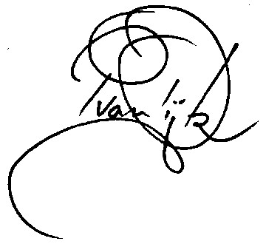

Pieter van Dijk  
Delegate of the Civil Aviation Safety Authority

18 May 2017