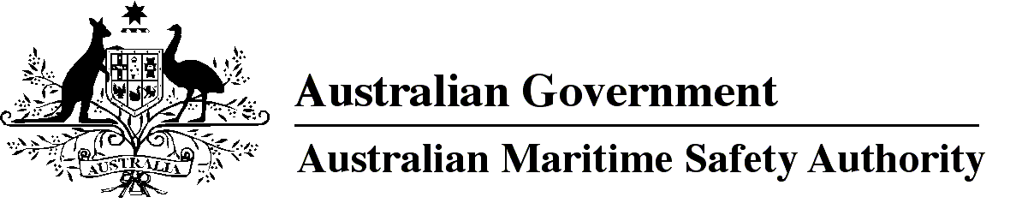

AMSA MO 2017/1

Marine Order 505 (Certificates of competency — national law) Amendment 2017 (No. 1)

I, Michael Kinley, Chief Executive Officer of the Australian Maritime Safety Authority, (the National Marine Safety Regulator under section 9 of the *Marine Safety (Domestic Commercial Vessel) National Law*), make this Order under subsection 163(1) of the *Marine Safety (Domestic Commercial Vessel) National Law*.

12 May 2017

Michael Kinley  
Chief Executive Officer

1 Name of Order

This Order is *Marine Order 505 (Certificates of competency — national law) Amendment 2017 (No. 1)*.

2 Commencement

This Order commences on 1 July 2017.

3 Repeal of *Marine Order 506 (Approval of training organisations — national law) 2013*

*Marine Order 506 (Approval of training organisations — national law) 2013* is repealed.

4 Amendment of *Marine Order 505 (Certificates of competency —national law) 2013*

Schedule 1 amends *Marine Order 505 (Certificates of competency — national law) 2013*.

Schedule 1 Amendment

[1] Subsection 5(1), after definition of *existing certificate*

insert

***registered training organisation*** means a training organisation registered by any of the following:

(a) the Australian Skills Quality Authority;

(b) the Victorian Registration and Qualifications Authority;

(c) the Training Accreditation Council Western Australia.

*Note* See the website at http://www.asqa.gov.au for information about the Australian Skills Quality Authority, the website at http://www.vrqa.vic.gov.au for information about the Victorian Registration and Qualifications Authority and the website at http://www.tac.wa.gov.au for information about the Training Accreditation Council Western Australia.

[2] Subsection 5(1), note 2

omit

* approved training organisation

[3] Subsection 10(1), note

omit

[4] Paragraph 30(e)

omit

an approved training organisation

insert

a registered training organisation

**Note**

1. All legislative instruments and compilations are registered on the Federal Register of Legislation under the *Legislation Act 2003.* See https://www.legislation.gov.au.