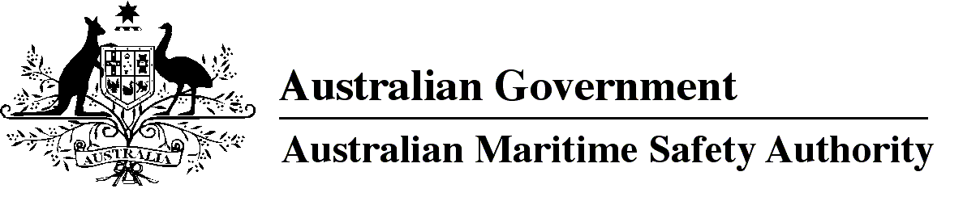

AMSA MO 2017/2

Marine Order 59 (Offshore support vessel operations) Repeal Order 2017

I, Michael Kinley, Chief Executive Officer of the Australian Maritime Safety Authority, make this Order under subsection 342(1) of the *Navigation Act 2012*.

9 June 2017

Michael Kinley  
Chief Executive Officer

1 Name of Order

This Order is *Marine Order 59 (Offshore support vessel operations) Repeal Order 2017*.

2 Commencement

This Order commences on the day after it is registered.

3 Repeal of *Marine Order 59 (Offshore support vessel operations) 2011*

*Marine Order 59 (Offshore support vessel operations) 2011* is repealed.

**Note**

1. All legislative instruments and compilations of legislative instruments are registered on the Federal Register of Legislation under the *Legislation Act 2003.* See https://www.legislation.gov.au.