***Australian Film, Television and Radio School Act 1973***

# **DETERMINATION OF DEGREES, DIPLOMAS AND CERTIFICATES No. 2017/2**

I, **Darren Dale**, Deputy Chair of the Council of the Australian Film, Television and Radio School, on behalf of the Australian Film, Television and Radio School, make a determination under section 6A of the *Australian Film, Television and Radio School Act 1973* (AFTRS Act) specifying the following degrees, diplomas and certificates for the purposes of paragraph 5(1)(g) of the Act.

That Council approve the creation of the following courses by legislative instrument:

**Diploma in Colour Grading**

**Diploma in Editing: AVID**

**Diploma in Screen Business Management**

**Diploma in Social Media: Content Creation and Distribution**

**Diploma in Digital Content: Radio**

**Advanced Diploma in Production Management**

**Advanced Diploma in Editing: Reality Television**

**Advanced Diploma in 3D Animation and Visual Effects**

**Advanced Diploma in Screenwriting: Feature Film**

**Advanced Diploma in Screenwriting: Series Television**

**Graduate Diploma Screen: Business and Leadership**

**Graduate Certificate Screen: Business and Leadership**

This Determination comes into effect on the day after it is registered on the Federal Register of Legislative Instruments.

Dated: 29th May 2017

Signed:

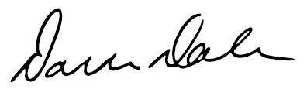

Darren Dale  
Deputy Chair of Council

Australian Film, Television and Radio School