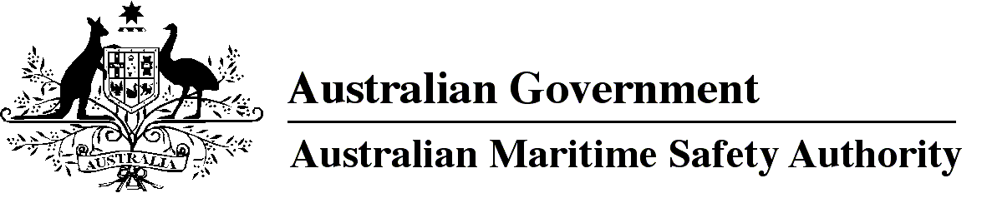

AMSA MO 2017/4

Marine Order 97 (Marine pollution prevention — air pollution) Amendment Order 2017

I, Gary Prosser, Acting Chief Executive Officer of the Australian Maritime Safety Authority, make this Order under subsection 342(1) of the *Navigation Act 2012* and subsection 34(1) of the *Protection of the Sea (Prevention of Pollution from Ships) Act 1983*.

25 July 2017

Gary Prosser  
Acting Chief Executive Officer

1 Name of Order

This Order is *Marine Order 97 (Marine pollution prevention — air pollution) Amendment Order 2017*.

2 Commencement

This Order commences on 1 September 2017.

3 Amendment of *Marine Order (Marine pollution prevention — air pollution) 2013*

Schedule 1 amends *Marine Order 97 (Marine pollution prevention — air pollution) 2013*.

Schedule 1 Amendment

[1] After section 21

insert

21A Engine status in emission control areas

(1) The master of a regulated Australian vessel operating in an emission control area must ensure that any record required to be made for the vessel under paragraph 5.3 of regulation 13 of Annex VI is entered in the official logbook.

*Note*Paragraph 5.3 of regulation 13 of Annex VI provides that the following must be recorded for a vessel constructed on or after 1 January 2016 with marine diesel engines that are certified to Tier II or Tier III standard: details of the engine tier, engine on/off status when entering and exiting an emission control area, any changes to that status within the area, and the date, time and position of the vessel.

(2) For subsection (1), an emission control area is an emission control area mentioned in paragraph 6 of regulation 13 of Annex VI.

**Note**

1. All legislative instruments and compilations of legislative instruments are registered on the Federal Register of Legislation under the *Legislation Act 2003.* See https://www.legislation.gov.au.