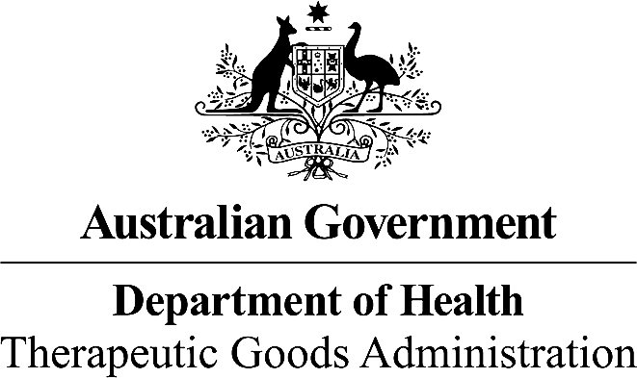

Therapeutic Goods Order No. 91A - Therapeutic Goods Order No. 91 (Standard for labels of prescription and related medicines) Amendment Order 2017

I, JANE COOK, a delegate of the Minister for Health, make this order under section 10 of the *Therapeutic Goods Act 1989*.

Dated Seventh August 2017

(Signed by)

JANE COOK

Delegate of the Minister for Health

Contents

1 Name 3

2 Commencement 3

3 Schedules 3

Schedule 1—Amendments 4

Therapeutic Goods Order No. 91 - Standard for labels of prescription and related medicines 4

1 Name

This instrument is the *Therapeutic Goods Order No. 91A - Therapeutic Goods Order No. 91 (Standard for labels of prescription and related medicines) Amendment Order 2017*.

2 Commencement

This instrument commences on the day after it is registered.

3 Schedules

Each instrument that is specified in a Schedule to this instrument is amended or repealed as set out in the applicable items in the Schedule concerned, and any other item in a Schedule to this instrument has effect according to its terms.

Schedule 1—Amendments

Therapeutic Goods Order No. 91 - Standard for labels of prescription and related medicines

Section 4 Transition arrangements

1 Subsection 4(1)

Omit subsection 4(1), substitute:

1. On and from 31 August 2016 and before 1 September 2020, each medicine to which this Order applies must comply with either:
2. the requirements specified in this Order; or
3. the requirements specified in:
   1. *Therapeutic Goods Order No. 69 General requirements for labels for medicines* (TGO 69), up until 30 June 2017 (inclusive); or
   2. *Therapeutic Goods Order No. 69 - General Requirements for Labels for Medicines 2017* (TGO 69 (2017)), on or after 1 July 2017.

2 Subsection 4(3)

Omit subsection 4(3), substitute:

(3) Notwithstanding subsections (1) and (2), medicines imported into or manufactured in Australia before 1 September 2020 but supplied by a person other than the sponsor after that date must comply with TGO 69 (2017) if at the time of their release for supply they complied with TGO 69 (2017).

Section 5 Exemptions - Medicines to which this Order does not apply

3 Subsection 5(1)

Insert in subsection 5(1), after paragraph (c):

(ca) intended for use in the treatment of humans in accordance with rules specified for the purposes of subsection 19(7A) of the Act; or

Schedule 1 - Substances or Groups of substances present in medicines that are required to be declared on the label of medicines

4 Schedule 1 (introductory text box)

Insert, after the final sentence under the paragraph starting ‘**Column 4**’:

Where more than one name (as set out under Column 4) is required to be declared, they may be combined to form simple sentences where appropriate.

5 Schedule 1 (table, Substance name or Group of substances name ‘potassium salts, including: potassium bicarbonate potassium chloride’, Column 2, Circumstances (if any) and additional requirements (if any))

Omit ‘**Circumstance:** Where the total potassium content of the maximum recommended daily dose is greater than 39 mg (1mmol) elemental potassium per dose

**Requirement:** To declare on the label (in mg) the quantity of elemental potassium per dose unit.’,

substitute:

‘**Circumstance:** Where the total potassium content of the maximum recommended daily dose is greater than 39 mg (1mmol) elemental potassium.

**Requirement:** To declare on the label (in mg) the quantity of elemental potassium per dosage unit or in a stated weight or volume of the medicine.’

6 Schedule 1 (table, Substance name or Group of substances name ‘sodium salts, including: sodium bicarbonate sodium chloride’, Column 2, Circumstances (if any) and additional requirements (if any))

Omit ‘**Circumstance:**Where the total sodium content of the maximum recommended daily dose of the formulation is greater than 120 mg of elemental sodium per dose.

**Requirement:** To declare on the label (in mg) the quantity of elemental sodium per dose unit.’,

substitute:

‘**Circumstance:**Where the total sodium content of the maximum recommended daily dose is greater than 120 mg of elemental sodium.

**Requirement:** To declare on the label (in mg) the quantity of elemental sodium per dosage unit or in a stated weight or volume of the medicine.’

7 Schedule 1 (table, Column 1, Substance name or Group of substances name ‘sorbates, including: potassium sorbate sorbic acid’)

Omit ‘**sorbates**, including: potassium sorbate sorbic acid’, substitute: ‘**sorbic acid and sorbic acid salts**, including: potassium sorbate’.

8 Schedule 1 (table, Column 1, Substance name or Group of substances name ‘sugar alcohols’)

Insert, after ‘**sugar alcohols’**, ‘(see Note 5A)’.

**9 Schedule 1 (Notes)**

Insert, after Note 5, ‘**Note 5A: Sugar alcohols** – It is generally accepted that while glycerol is a sugar alcohol, it does not have a laxative effect. Therefore, glycerol is not required to be declared in relation to sugar alcohols and their associated laxative effect.’