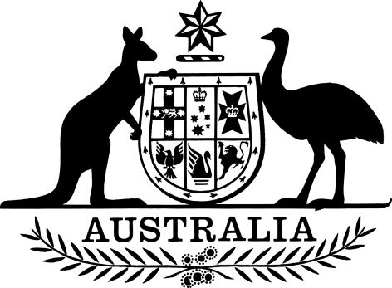

Australian Citizenship (IMMI 17/073: Declared Terrorist Organisation—Jabhat Al-Nusra) Declaration 2017
I, Peter Dutton, Minister for Immigration and Border Protection, make the following declaration.
Dated 27 July 2017
Peter Dutton
Peter Dutton
Minister for Immigration and Border Protection

Contents
1 Name 1
2 Commencement 1
3 Authority 1
4 Declared terrorist organisation—Jabhat al-Nusra 1

1 Name
(1) This instrument is the Australian Citizenship (IMMI 17/073: Declared Terrorist Organisation—Jabhat Al-Nusra) Declaration 2017.
(2) This instrument may be cited as IMMI 17/073.

2 Commencement
(1) Each provision of this instrument specified in column 1 of the table commences, or is taken to have commenced, in accordance with column 2 of the table. Any other statement in column 2 has effect according to its terms.

Commencement information
Column 1 | Column 2 | Column 3
Provisions | Commencement | Date/Details
1. The whole of this instrument | The day after this instrument is registered. | 15 August 2017
Note: This table relates only to the provisions of this instrument as originally made. It will not be amended to deal with any later amendments of this instrument.
(2) Any information in column 3 of the table is not part of this instrument. Information may be inserted in this column, or information in it may be edited, in any published version of this instrument.

3 Authority
This instrument is made under section 35AA of the Australian Citizenship Act 2007.

4 Declared terrorist organisation—Jabhat al-Nusra
The organisation that was known as Jabhat al-Nusra (among other names) at the time this instrument commenced is declared as a declared terrorist organisation for the purposes of section 35AA of the Australian Citizenship Act 2007.
Note 1: Subsection 35AA(1) of the Australian Citizenship Act 2007 requires an organisation declared under that subsection to be a terrorist organisation within the meaning of paragraph (b) of the definition of terrorist organisation in subsection 102.1(1) of the Criminal Code, which covers organisations specified by regulations.
Note 2: When this instrument commenced, the organisation known as Jabhat al-Nusra was such a terrorist organisation because it was specified by section 5 of the Criminal Code (Terrorist Organisation—Jabhat al-Nusra) Regulation 2016. Jabhat al-Nusra was at that time also known by a variety of other names listed in that section. After that commencement, if the name (or names) by which the organisation is known changes, that regulation may be amended to ensure that the organisation is still so specified (see section 102.1AA of the Criminal Code).
Note 3: However, if no regulation is in effect that specifies the organisation for the purposes of the Criminal Code, this instrument also has no effect. The Criminal Code (Terrorist Organisation—Jabhat al-Nusra) Regulation 2016 ceases to have effect on 28 June 2019 at the latest, but may cease to have effect earlier if repealed, or if a notice is published under subsection 102.1(4) of the Criminal Code in relation to the organisation (see subsection 102.1(3) of the Criminal Code).

