

**Food Standards (Application A1126 – Pectins & Carrageenan as Processing Aids in Wine (Fining Agent)) Variation**

The Board of Food Standards Australia New Zealand gives notice of the making of this variation under section 92 of the *Food Standards Australia New Zealand Act 1991*. The variation commences on the date specified in clause 3 of this variation.

5 September 2017

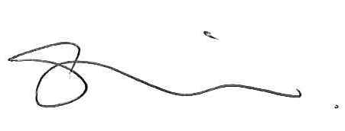

Standards Management Officer

Delegate of the Board of Food Standards Australia New Zealand

**Note:**

This variation will be published in the Commonwealth of Australia Gazette No. FSC 114 on 7 September 2017. This means that this date is the gazettal date for the purposes of clause 3 of the variation.

**1 Name**

This instrument is the *Food Standards (Application A1126 – Pectins & Carrageenan as Processing Aids in Wine (Fining Agent)) Variation*.

**2 Variation to a standard in the *Australia New Zealand Food Standards Code***

The Schedule varies a Standard in the *Australia New Zealand Food Standards Code*.

**3 Commencement**

The variation commences on the date of gazettal.

**Schedule**

**[1] Standard 4.5.1** is varied by inserting each of the following into the Table to clause 4 in alphabetical order

|  |
| --- |
| Carrageenan |
| Pectins |