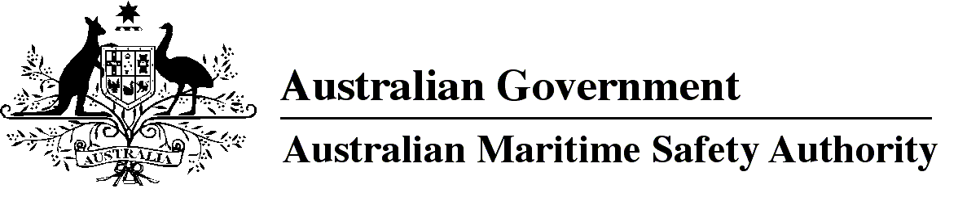

AMSA MO 2017/5

Marine Orders (Navigation Act) Administrative Amendment Order 2017

I, Michael Kinley, Chief Executive Officer of the Australian Maritime Safety Authority, make this Order under subsection 342(1) of the *Navigation Act 2012*.

5 October 2017

Michael Kinley  
Chief Executive Officer

1 Name of Order

This Order is *Marine Orders (Navigation Act) Administrative Amendment Order 2017*.

2 Commencement

This Order commences on the day after it is registered.

3 Amendment of Marine Orders

Each Order mentioned in the title of a Schedule to this Order is amended in accordance with the Schedule.

Schedule 1 Marine Order 12 (Construction — subdivision and stability, machinery and electrical installations) 2016

[1] Subparagraph 10(1)(a)(i)

omit

3 and 6

insert

3, 5 and 6

[2] Section 23

substitute

23 Access to vessels in port — responsibility of persons boarding or disembarking

(1) A person boarding or leaving a vessel must use the means of access provided or identified by the master.

Penalty: 50 penalty units.

(2) An offence against subsection (1) is a strict liability offence.

(3) A person is liable to a civil penalty if the person contravenes subsection (1).

Civil penalty: 50 penalty units.

Schedule 2 Marine Order 25 (Equipment — lifesaving) 2014

[1] Subsection 4(1), after definition of *GT*

insert

***launching appliance*** means a means of transferring a survival craft or rescue boat from its stowed position safely to the water.

[2] Section 30

substitute

30 Cargo vessels certified Class 2C — survival craft and rescue boats

(1) The vessel must comply with sections 33, 34 and 35 as if it were certified as Class 2A or 2B.

(2) If the vessel is less than 25 m long it must:

(a) comply with section 36 as if it were certified as Class 2A or 2B; and

(b) have at least 1 liferaft that complies with Table 3 of subsection 7A of Part C of the NSCV.

[3] Section 33

substitute

33 Survival craft and rescue boats — vessels at least 85 m long

(1) If the vessel is at least 85 m long, it must comply with the requirements mentioned in subsection (2) or (3).

(2) For subsection (1), the requirements are that the vessel carries:

(a) on each side of the vessel — at least 1 lifeboat with a total capacity of at least the number of persons that the vessel is certified to carry; and

(b) either:

(i) on each side of the vessel — at least 1 liferaft with a total capacity of at least half the number of persons that the vessel is certified to carry; or

(ii) at least 1 liferaft that has a total capacity of at least half the number of persons that the vessel is certified to carry and that is stowed to allow easy side-to-side transfer at a single open deck level.

(3) For subsection (1), the requirements are that the vessel carries:

(a) at least 1 free-fall lifeboat that:

(i) complies with section 4.7 of the LSA Code; and

(ii) has a total capacity of at least the number of persons that the vessel is certified to carry; and

(b) on each side of the vessel — at least 1 inflatable or rigid liferaft that:

(i) complies with section 4.2 or 4.3 of the LSA Code; and

(ii) has a total capacity of at least the number of persons that the vessel is certified to carry; and

(iii) is served by a launching appliance.

[4] Schedule 1, subsubparagraph 10(1)(b)(iii)(A)

substitute

(A) AS/NZS 4280.1:2017 *406 MHz satellite distress beacons — Marine emergency position-indicating radio beacons (EPIRB)*, as amended from time to time; or

[5] Schedule 1, subclause 10(1), note 1

omit

4280.1:2003

insert

4280.1:2017, as amended from time to time,

[6] Schedule 1, clause 13

omit

in force

insert

amended

Schedule 3 Marine Order 27 (Safety of navigation and radio equipment) 2016

[1] Paragraph 26(8)(e), note

omit

[2] Subsection 26(8), note

substitute

*Note for paragraph (e)*The handbook for GMDSS ship station operators is available from the AMSA website at http://www.amsa.gov.au.

*Note*AMSA will consider exempting a vessel to which Chapter IV of SOLAS does not apply from paragraphs (8)(g) to (j).

Schedule 4 Marine Order 28 (Operations standards and procedures) 2015

[1] Subsection 2(1), note

after

http://www.imo.org/publications.

insert

The STCW Convention (ATS series number [1984] ATS 7) and STCW Code (ATS series number [1997] ATS 33) including any amendments in force are in the Australian Treaties Series accessible from the Australian Treaties Library on the AustLII website at http://www.austlii.edu.au.

Schedule 5 Marine Order 32 (Cargo handling equipment) 2016

[1] Section 4, note 1

after

http://www.amsa.gov.au.

insert

Copies of incorporated documents will be made available for viewing free of charge at the nearest AMSA office, on request.

[2] Schedule 3, subclause 13(3), definition of *safety factor*

after

2017

insert

or in Appendix E of the ILO Code

[3] Schedule 3, subclause 13(4)

substitute

(4)Material, design, manufacture, marking, testing and certification of flat synthetic-webbing slings must comply with:

(a) AS 1353.2-1997 *Flat Synthetic Webbing Slings* *Part 2: Care and use*,as in force on 1 January 2017; or

(b) Appendix E of the ILO Code.

*Note*   Standards mentioned in this clause will be made available for viewing free of charge at AMSA offices on request — see note 1 under section 4.

Schedule 6 Marine Order 34 (Sold bulk cargoes) 2016

[1] Section 21, note

omit

*31 (Vessel surveys and certification) 2015*

insert

*1 (Administration) 2013*

Schedule 7 Marine Order 63 (Vessel reporting systems) 2015

[1] Schedule 3, clause 2, note

omit

*Guidelines for the onboard operational use of shipborne automatic identification systems (AIS)* adopted by IMO Resolution A.917(22)

insert

*Revised guidelines for the onboard operational use of shipborne automatic identification systems (AIS)*,adopted by IMO Resolution A.1106(29),

Schedule 8 Marine Order 91 (Marine pollution prevention — oil) 2014

[1] Paragraph 37(1)(a)

omit

IMO Resolution MEPC.107(49)

insert

the *Revised guidelines and specifications for pollution prevention equipment for machinery space bilges of ships*, adopted by IMO Resolution MEPC.107(49), as amended from time to time

**Note**

1. All legislative instruments and compilations of legislative instruments are registered on the Federal Register of Legislation under the *Legislation Act 2003.* See https://www.legislation.gov.au.