Airports Legislation Amendment (Essendon Fields Airport) Regulations 2017
I, General the Honourable Sir Peter Cosgrove AK MC (Ret’d), Governor-General of the Commonwealth of Australia, acting with the advice of the Federal Executive Council, make the following regulations.
Dated 09 October 2017
Peter Cosgrove
Governor-General
By His Excellency’s Command
Darren Chester
Minister for Infrastructure and Transport

Contents
1 Name 1
2 Commencement 1
3 Authority 1
4 Schedules 1
Schedule 1—Amendments 2
Air Navigation (Essendon Airport) Regulations 2001 2
Airports (Building Control) Regulations 1996 2
Airports (Control of On-Airport Activities) Regulations 1997 2
Airports (Environment Protection) Regulations 1997 2
Airports (Ownership—Interests in Shares) Regulations 1996 2
Airports Regulations 1997 3
Civil Aviation (Buildings Control) Regulations 1988 3

1 Name
This instrument is the Airports Legislation Amendment (Essendon Fields Airport) Regulations 2017.

2 Commencement
(1) Each provision of this instrument specified in column 1 of the table commences, or is taken to have commenced, in accordance with column 2 of the table. Any other statement in column 2 has effect according to its terms.

Commencement information
Column 1 | Column 2 | Column 3
Provisions | Commencement | Date/Details
1. The whole of this instrument. | The day after this instrument is registered. | 12 October 2017
Note: This table relates only to the provisions of this instrument as originally made. It will not be amended to deal with any later amendments of this instrument.
(2) Any information in column 3 of the table is not part of this instrument. Information may be inserted in this column, or information in it may be edited, in any published version of this instrument.

3 Authority
This instrument is made under the following:
(a) the Air Navigation Act 1920;
(b) the Airports Act 1996;
(c) the Civil Aviation Act 1988.

4 Schedules
Each instrument that is specified in a Schedule to this instrument is amended or repealed as set out in the applicable items in the Schedule concerned, and any other item in a Schedule to this instrument has effect according to its terms.

Schedule 1—Amendments

Air Navigation (Essendon Airport) Regulations 2001
1 Regulation 1
Omit “Essendon Airport”, substitute “Essendon Fields Airport”.
2 Amendments of listed provisions—Essendon Fields Airport
Omit “Essendon Airport” (wherever occurring) and substitute “Essendon Fields Airport” in the following provisions:
(a) sections 3 and 4;
(b) paragraph 6(a);
(c) section 7 (note);
(d) paragraphs 8(a), 9(1)(a) and 10(1)(a) and (2)(a);
(e) subsections 10(3) and 12(1);
(f) section 13;
(g) subsection 14(1);
(h) paragraph 14(1)(b);
(i) subsection 15(2);
(j) Schedule 1 (note to Schedule heading).

Airports (Building Control) Regulations 1996
3 Part 8 of Schedule 1 (heading)
Repeal the heading, substitute:

Part 8—Melbourne (Tullamarine), Essendon Fields and Moorabbin Airports

Airports (Control of On-Airport Activities) Regulations 1997
4 Paragraph 4(d)
Omit “Essendon Airport”, substitute “Essendon Fields Airport”.

Airports (Environment Protection) Regulations 1997
5 Paragraph 1.03A(b)
Omit “Essendon Airport”, substitute “Essendon Fields Airport”.

Airports (Ownership—Interests in Shares) Regulations 1996
6 Subregulation 4.04(1)
Omit “Essendon”, substitute “Essendon Fields”.

Airports Regulations 1997
7 Paragraphs 1.03(1)(i), 2.01A(b), 5.01A(b) and 12.01(b)
Omit “Essendon Airport”, substitute “Essendon Fields Airport”.
8 Part 1.9 of Schedule 1 (heading)
Repeal the heading, substitute:

Part 1.9—Essendon Fields Airport
9 Clause 9 of Schedule 1 (heading)
Repeal the heading, substitute:

9 Essendon Fields Airport
10 Clause 9 of Schedule 1
Omit “Essendon Airport”, substitute “Essendon Fields Airport”.

Civil Aviation (Buildings Control) Regulations 1988
11 Schedule 1 (table items 15 to 17, column headed “Area”)
Omit “Essendon Airport”, substitute “Essendon Fields Airport”.
12 Schedule 2 (table items 22 to 25, column headed “Area”)
Omit “Essendon Airport”, substitute “Essendon Fields Airport”.
13 Schedule 3 (table item 11, column headed “Area”)
Omit “Essendon Airport”, substitute “Essendon Fields Airport”.
14 Schedule 4 (table items 11 and 12, column headed “Area”)
Omit “Essendon Airport”, substitute “Essendon Fields Airport”.
15 Schedule 6 (Plans No. 3, No. 4, No. 5 and No. 6)
Repeal the Plans, substitute:
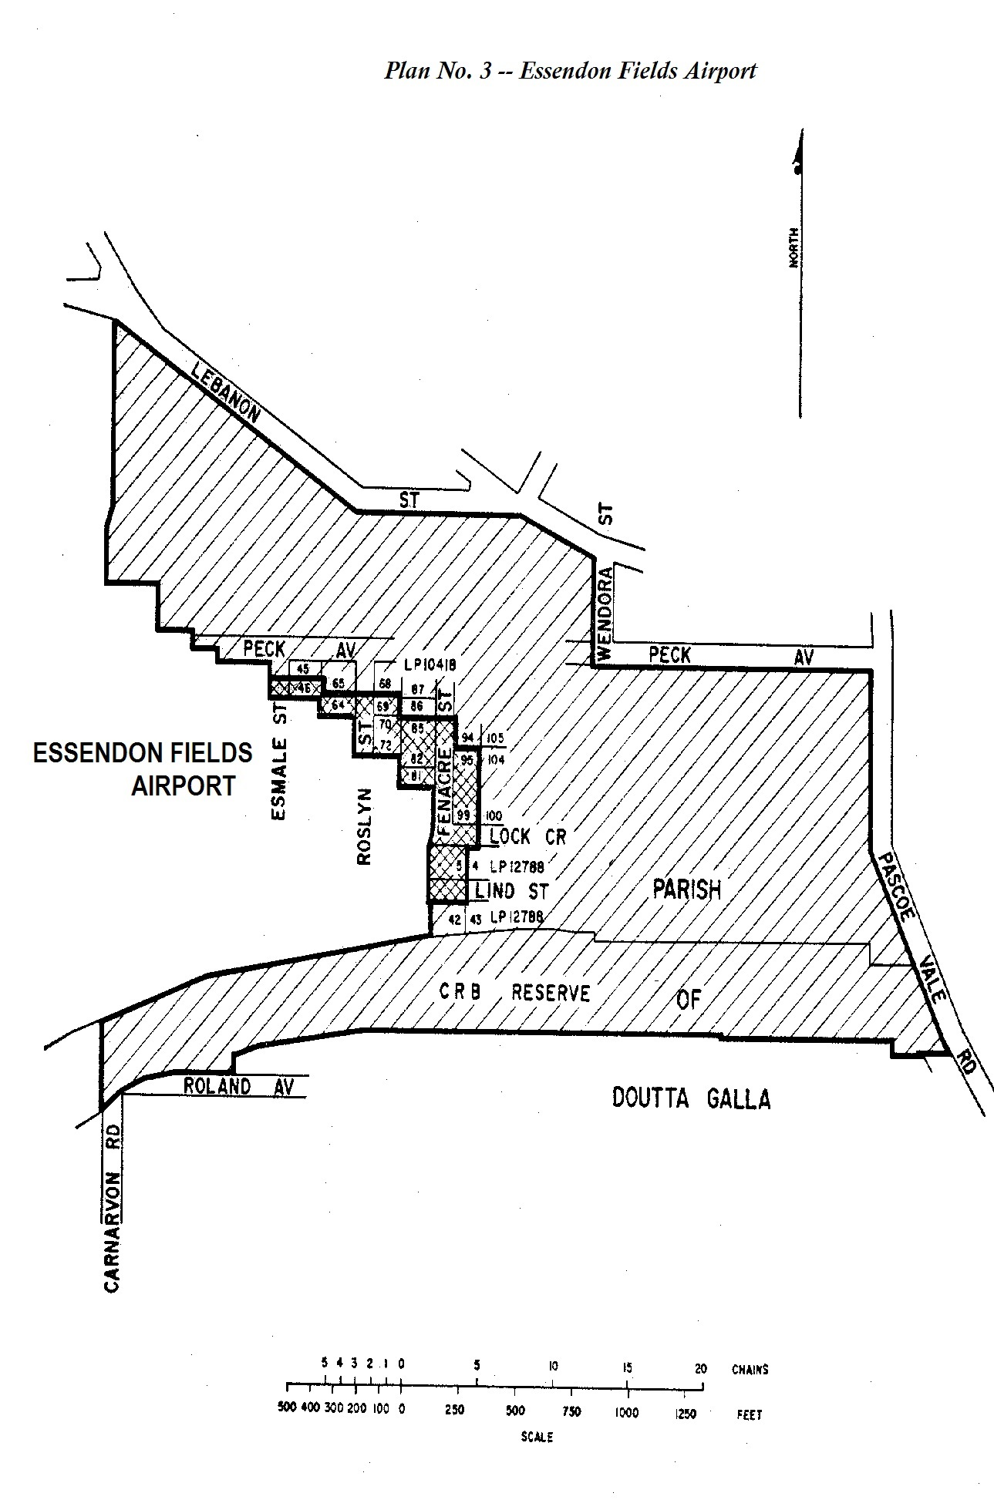
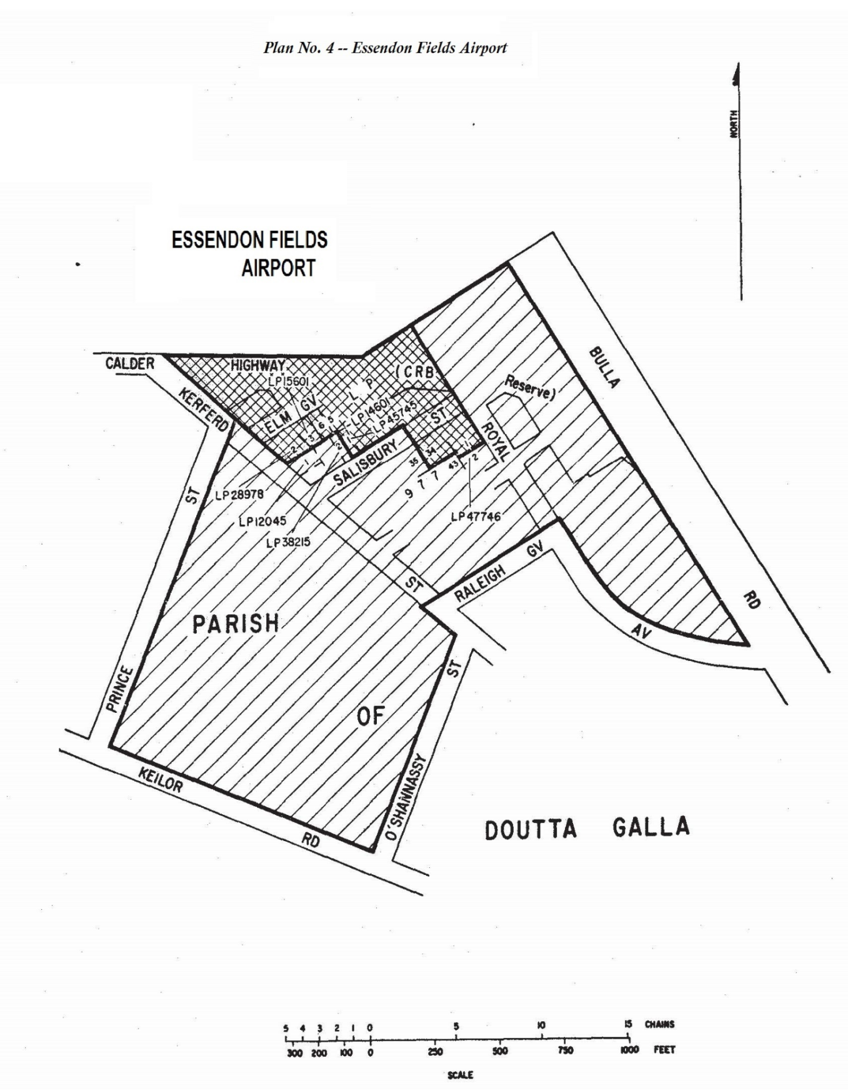
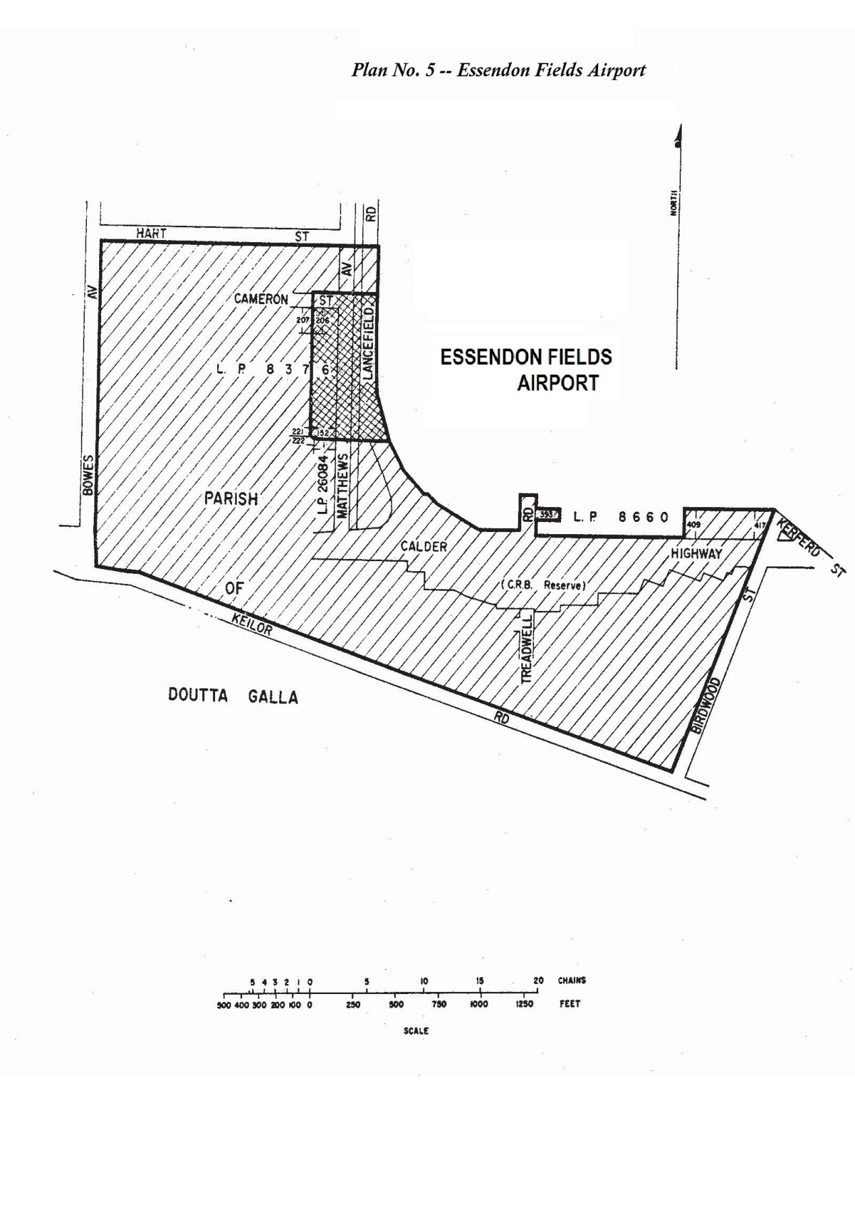
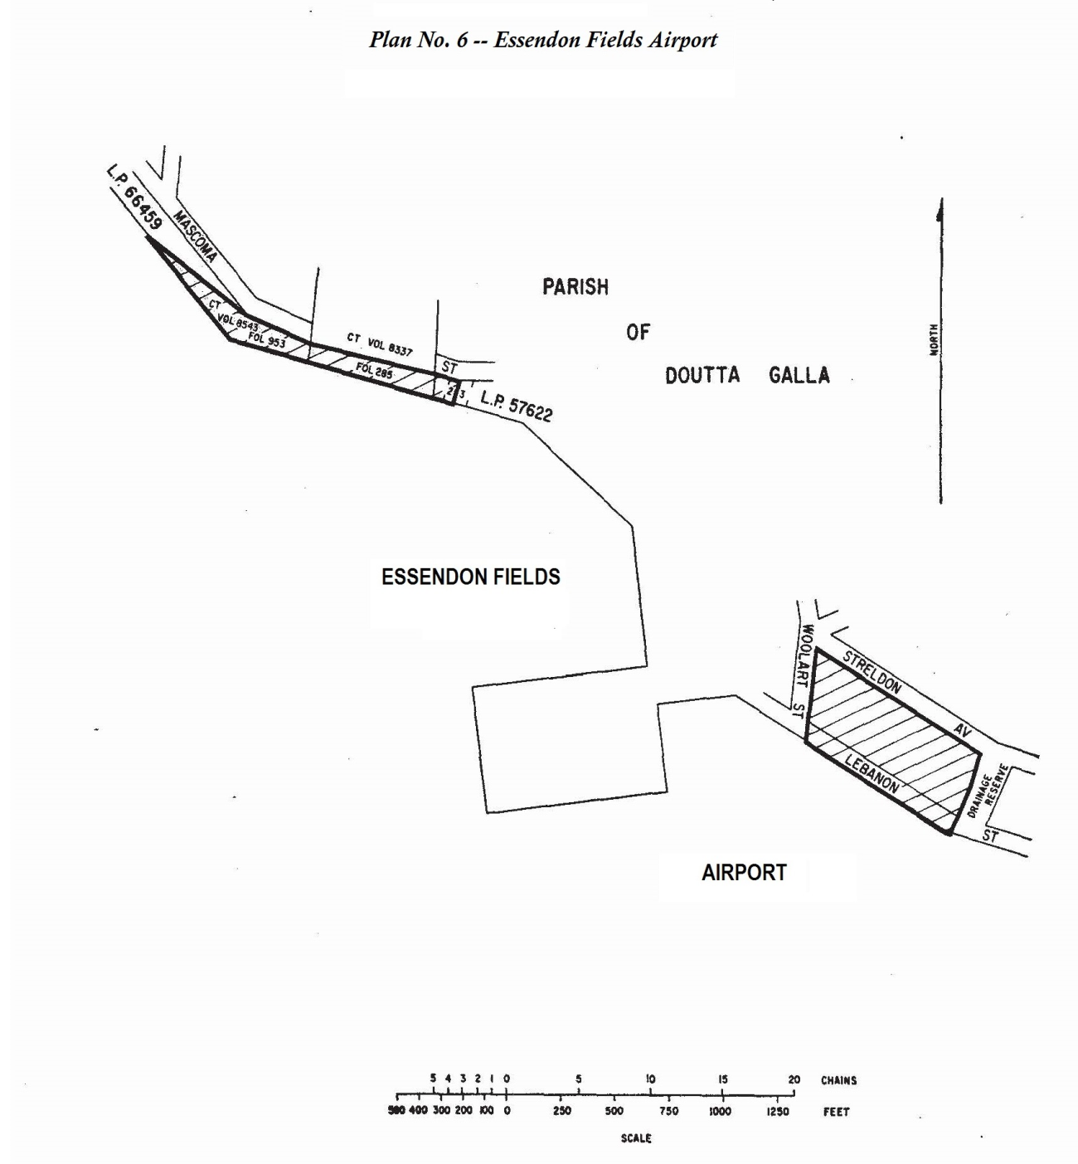
16 Schedule 6 (Plans No. 14 and No. 15)
Repeal the Plans, substitute:
