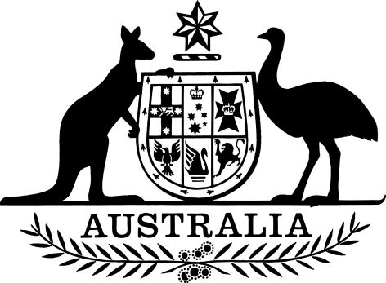

Dental Benefits (Relevant Professional Bodies under subsection 32B(4)) Declaration 2017
Dental Benefits Act 2008
I, Natasha Cole, delegate of the Minister for Health, make this Declaration under subsection 32B(4) of the Dental Benefits Act 2008.
Dated 19 July 2017

NATASHA COLE

First Assistant Secretary
Health Services Division
Department of Health

Table of contents
1 Name 3
2 Commencement 3
3 Authority 3
4 Relevant professional bodies 3

1 Name
This Declaration is the Dental Benefits (Relevant Professional Bodies under subsection 32B(4)) Declaration 2017.

2 Commencement
This instrument commences on the day after it is registered.

3 Authority
This instrument is made under subsection 32B(4) of the Dental Benefits Act 2008.

4 Relevant professional bodies
A body mentioned in an item of the table is declared to be a relevant professional body for the purposes of section 32B of the Dental Benefits Act 2008.
Table List of relevant professional bodies

Item | Body
1 | Australian Dental Association Inc (ABN 95 174 118 424)

