Food Standards (Application A1127 – Processing Aids in Wine) Variation

The Board of Food Standards Australia New Zealand gives notice of the making of this variation under section 92 of the Food Standards Australia New Zealand Act 1991. The variation commences on the date specified in clause 3 of this variation.

Dated 23 October 2017

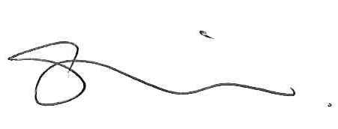
A/g Standards Management Officer
Delegate of the Board of Food Standards Australia New Zealand

Note:

This variation will be published in the Commonwealth of Australia Gazette No. FSC 115 on 26 October 2017. This means that this date is the gazettal date for the purposes of clause 3 of the variation.

1 Name
This instrument is the Food Standards (Application A1127 – Processing Aids in Wine) Variation.
2 Variation to standards in the Australia New Zealand Food Standards Code
The Schedule varies Standards in the Australia New Zealand Food Standards Code.
3 Commencement
The variation commences on the date of gazettal.
Schedule
[[1] Standard 4.5.1 is varied by inserting each of the following into the Table to clause 4, in alphabetical order
Ammonium bisulphite
Chitin-glucan
Polyvinylimidazole-polyvinylpyrrolidone co-polymers
[2] Schedule 18 is varied by inserting each of the following into the table to subsection 18—9(3), in alphabetical order
Ammonium bisulphite | For use in the manufacture of wine, sparkling wine and fortified wine as a microbial nutrient and microbial nutrient adjunct. | GMP
Chitin-glucan | For use in the manufacture of wine, sparkling wine and fortified wine as a decolourant, clarifying, filtration and absorbent agent. | GMP
Polyvinylimidazole-polyvinylpyrrolidone co-polymers | For use in the manufacture of wine, sparkling wine and fortified wine as a decolourant, clarifying, filtration and absorbent agent. | GMP
Silver chloride | For use in the manufacture of wine, sparkling wine and fortified wine to remove fermentation and storage-related odours. | GMP

