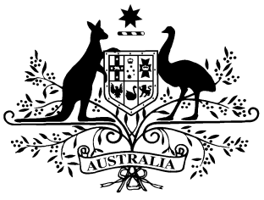

**PB 90 of 2017**

**National Health (Pharmaceutical Benefits Scheme- Exempt items - Section 84AH) Amendment Determination 2017 (No. 1)**

*National Health Act* *1953*

I, LISA LA RANCE, Assistant Secretary, Pricing and Policy Branch, Technology Assessment and Access Division, Department of Health, delegate of the Minister for Health, make this Determination under section 84AH of the *National Health Act 1953*.

Dated 26 October 2017

**LISA LA RANCE**

Assistant Secretary

Pricing and Policy Branch

Technology Assessment and Access Division

Department of Health

**1 Name of Instrument**

1. This instrument is the *National Health (Pharmaceutical Benefits Scheme-Exempt items - Section 84AH) Amendment Determination 2017 (No. 1).*
2. This instrument may also be cited as PB 90 of 2017.

**2 Commencement**

This instrument commences on 1 November 2017.

**3 Amendments to PB 81 of 2017**

Schedule 1 amends the legislative instrument titled *National Health (Pharmaceutical Benefits Scheme – Exempt items – Section 84AH) Determination 2017 (PB 81 of 2017)* (as amended)

Schedule 1 Amendments

1. Schedule 1, after entry for Clozapine, Oral liquid 50 mg per mL, 100 mL:

*Omit:*

|  |  |  |
| --- | --- | --- |
| Cefuroxime | Powder for oral suspension 125 mg (as axetil) per 5 mL, 70 mL | Oral |