AIRWORTHINESS DIRECTIVE

On the commencement date specified below, and for the reasons set out in the background section, the CASA delegate whose signature appears below repeals Airworthiness Directive (**AD**) AD/DHC-8/138 and issues the following AD under subregulation 39.001 (1) of CASR 1998 and subsection 33 (3) of the *Acts Interpretation Act 1901*. The AD requires that the action set out in the requirement section (being action that the delegate considers necessary to correct an unsafe condition) be taken in relation to the aircraft or aeronautical product mentioned in the applicability section: (a) in the circumstances mentioned in the requirement section; and (b) in accordance with the instructions set out in the requirement section; and (c) at the time mentioned in the compliance section.

# Bombardier DHC-8 Series Aeroplanes

|  |  |  |
| --- | --- | --- |
| AD/DHC-8/138 Amdt 1 | Fuel System Safety | 22/2017 |

|  |  |
| --- | --- |
| Applicability: | Bombardier DHC-8-400, DHC-8-401 and DHC-8-402 model aeroplanes. |
| Requirement: | To ensure management and control of Critical Design Configuration Control Limitations (CDCCL) items, each registered operator of the aeroplane must:  a. Amend their copies of the DHC-8-400 Maintenance Requirements Manual, PSM 1‑84‑7 Part 2 “Airworthiness Limitations Items”, as in force at the time of issue of AD/DHC-8/138, to incorporate the CDCCL items introduced in Temporary Revisions (TR) ALI-55 and ALI-56, as in force at the time of issue of AD/DHC‑8/138. This may be accomplished by inserting copies of the TR in the manual.  b. Amend any of their DHC-8-400 Series aircraft related procedures and documentation to highlight the existence of CDCCL items noted above and to highlight the necessary requirements to maintain the design features of those CDCCL items.  *Note 1: Maintenance Requirements Manual TRs introduced by this Directive may be removed from the manual when the TR is cancelled or superseded by either a further TR or later normal revision to the manual.*  *Note 2: Transport Canada AD CF-2008-06 refers.* |
| Compliance: | Within 30 days after the commencement date of this Directive, unless previously accomplished.  *Note 3: Previous compliance with the requirements in AD/DHC-8/138 constitutes compliance with the equivalent requirements in this AD.* |
|  | This AD commences on 3 November 2017. |
| Background: | Bombardier Aerospace has completed a system safety review of the aircraft fuel system against fuel tank safety standards introduced in Chapter 525 of the Airworthiness Manual through Notice of Proposed Amendment (NPA) 2002-043. The identified non-compliances were then assessed using Transport Canada Policy Letter No. 525-001, to determine if mandatory corrective action is required. |

|  |  |
| --- | --- |
|  | Amendment 1 of the AD is issued to correct a temporary revision number referenced in the Requirement section of this AD. |

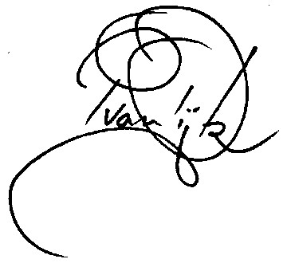

Pieter van Dijk  
Delegate of the Civil Aviation Safety Authority

31 October 2017