

Vehicle Standard (Australian Design Rule 74/00 – Side Marker Lamps) 2006 Amendment 1

I, PAUL FLETCHER, Minister for Urban Infrastructure, determine this vehicle standard under section 7 of the *Motor Vehicle Standards Act 1989*.

Dated 8/11/ 2017

[SIGNED]

PAUL FLETCHER

Minister for Urban Infrastructure

**CONTENTS**

1. legislative provisions 3

2. amendment of vehicle standard 3

Schedule 1 4

Schedule 2 6

1. legislative provisions
   1. Name of Legislative Instrument
      1. This instrument is the Vehicle Standard (Australian Design Rule 74/00 – Side Marker Lamps) 2006 Amendment 1.
   2. Commencement
      1. This instrument commences on the day after it is registered.
2. amendment of vehicle standard
   1. The changes specified in Schedule 1 and Schedule 2 amend Vehicle Standard (Australian Design Rule 74/00 – Side Marker Lamps) 2006.

Schedule 1

1. Renumber clauses 0 – 8., to clauses 1 – 9.
2. Delete clause 2. and replace with:

“2. FUNCTION

The function of Australian Design Rule (ADR) 74/00 is to prescribe the photometric requirements of side marker lamps which are used to increase the visibility of the sides of road vehicles.”

1. Amend clause 3.1. to read:

“3.1. The circumstances under which side marker lamps are mandatory, optional, or prohibited are set out in either ADRs 13/…, 19/… or 67/…”

1. Amend clause 4.1. to read:

“4.1. For vehicle categories, definitions and meanings used in this standard, refer to:”

1. Insert clauses 4.1.1. and 4.1.2. to read:

“4.1.1. Definitions in Appendix A of this standard; and where there is no conflict.

4.1.2. Vehicle Standard (Australian Design Rule – Definitions and Vehicle Categories) 2005.”

1. Amend clause 5.1. to read:

“5.1. Devices complying with either clause 5.1.1. or 5.1.2. below shall be accepted as complying with this rule:”

1. Insert clauses 5.1.1 and 5.1.2. and subclauses to read:

“5.1.1. the technical requirements of Appendix A as varied by clause 6 Exemptions and Alternative Procedures and clause 7 Supplementary General Requirements; or

5.1.2. ‘Side Marker Lamp’ alternative requirements

5.1.2.1. Colour of light emitted Amber/red - see Figure 1.

5.1.2.2. Intensity of light emitted

5.1.2.2.1. Minimum: 0.3 cd within the angles of light distribution of clause 5.1.2.3.

5.1.2.2.2. Maximum: 12 cd in any direction. However, for ‘Side Marker Lamps’ combined with front position (side) lamps, luminous intensity of 60 cd shall be permitted within a forward angle from 45° inboard to 80° outboard.

5.1.2.3. Angles of light distribution

5.1.2.3.1. Vertical: from 10° above to 10° below the horizontal.

5.1.2.3.2. Horizontal: See Figure 1.

5.1.2.4. Other requirements: None.

5.1.2.5. Test procedures

5.1.2.5.1. All measurements shall be made with a standard filament globe of the category prescribed for the device, or LED light source as specified by the manufacturer, the supply voltage being so regulated as to produce the normal luminous flux prescribed. In the case that the LED light source is fitted to the unit and not removable, the unit shall be tested as supplied at the voltage specified by the manufacturer.

5.1.2.5.2. Photometric measurements

5.1.2.5.2.1. Measurement methods

5.1.2.5.2.1.1. During photometric measurements, stray reflections shall be avoided by appropriate masking.

5.1.2.5.2.1.2. Measurements shall be carried out in such a way as to meet the following requirements:

5.1.2.5.2.1.2.1. The distance of measurement shall be such that the law of the inverse of the square of the distance is applicable;

5.1.2.5.2.1.2.2. The measuring equipment shall be such that the angular aperture of the receiver viewed from the reference centre of the light is comprised between 10’ and one degree;

5.1.2.5.2.1.2.3. The intensity requirement for a particular direction of observation shall be deemed to be satisfied if that requirement is met in a direction deviating by not more than one-quarter of a degree from the direction of observation.”

1. Insert clause 5.1.2.6.:

“5.1.2.6. Right-hand requirements are described above and shown in Figure 1 below. Left-hand requirements are the same but opposite hand.”

1. Insert Figure 1 below clause 5:

“

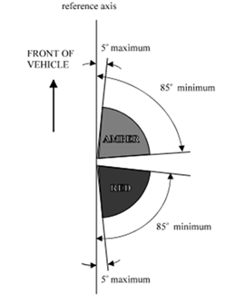

Figure 1: Angles of horizontal light distribution”

1. Delete clause 6 and replace with:

“6. EXEMPTIONS AND ALTERNATIVE PROCEDURES

6.1. The following provisions of Appendix A do not apply.

Section 3 Application for approval

Section 4 Markings

Section 5 Approval

Section 10 Modification of side-marker Lamp Type and extension of approval

Section 11 Conformity of production

Section 12 Penalties for non conformity of production

Section 13 Production definitely discontinued

Section 14 Names and addresses of Technical services responsible for conducting approval tests, and of administrative departments

Section 15 Transitional Provisions

Annexes

Annex 2 Communication concerning the approval (or refusal or withdrawal of approval or production definitely discontinued) of a type of side marker lamp SM1/SM2

Annex 3 Arrangements of approval marks”

1. Delete clause 7 and replace with:

“7. SUPPLEMENTARY GENERAL REQUIREMENTS

7.1. The following general requirements are supplementary to the requirements of Appendix A:

7.1.1. The requirements and procedures set out in Annexes 5 and 6 of Appendix A are acceptable for the purposes of demonstrating compliance with the technical requirements of this rule.”

1. Amend clause 8.1. to read:

“8.1. The technical requirements of United Nations Regulation No. 91 - UNIFORM PROVISIONS CONCERNING THE APPROVAL OF SIDE MARKER LAMPS FOR MOTOR VEHICLES AND THEIR TRAILERS, from the 00 series of amendments and including up to the 03 series of amendments, shall be deemed equivalent to the technical requirements of this standard.”

Schedule 2

1. Delete Appendix A and replace with:

“**APPENDIX A**

**Agreement**

**Concerning the Adoption of Uniform Technical Prescriptions for Wheeled Vehicles, Equipment and Parts which can be Fitted and/or be Used on Wheeled Vehicles and the Conditions for Reciprocal Recognition of Approvals Granted on the Basis of these Prescriptions[1]**

(Revision 2, including the amendments which entered into force on 16 October 1995)

**Addendum 90: Regulation No. 91**

**Revision 3**

Incorporating all valid text up to:

Supplement 11 to the original version of the Regulation - Date of entry into force: 15 October 2008

Supplement 12 to the original version of the Regulation - Date of entry into force:

9 December 2010

Supplement 13 to the original version of the Regulation - Date of entry into force: 23 June 2011

Supplement 14 to the original version of the Regulation - Date of entry into force: 15 July 2013

Supplement 15 to the original version of the Regulation - Date of entry into force:

3 November 2013

**Incorporating valid text up to, by the Department of Infrastructure and Regional Development:**

Corrigendum 1 to Revision 3 of the Regulation (Erratum by the secretariat) – Date of entry into force: 13 March 2015

**Uniform provisions concerning the approval of side-marker lamps for motor vehicles and their trailers**



**UNITED NATIONS**

**Regulation No. 91**

**Uniform provisions concerning the approval of side-marker lamps for motor vehicles and their trailers**

Contents

Regulation

1. Scope

2. Definitions

3. Application for approval

4. Markings

5. Approval

6. General specifications

7. Intensity of light emitted

8. Colour of light emitted

9. Test procedure

10. Modification of side-marker lamp type and extension of approval

11. Conformity of production

12. Penalties for non-conformity of production

13. Production definitively discontinued

14. Names and addresses of Technical Services responsible for conducting approval tests,

and of Type Approval Authorities

15. Transitional provisions

Annexes

1 Minimum angles required for light distribution in space

2 Communication concerning the approval or refusal or extension or withdrawal of approval or production definitively discontinued of a type of side-marker lamp marked SM1/SM2

3 Examples of arrangements of the approval marks

4 Photometric measurements

5 Minimum requirements for conformity of production control procedures

6 Minimum requirements for sampling by an inspector

1. Scope

This Regulation applies to side-marker lamps for vehicles of categories M, N, O and T.[2]

1. Definitions
   1. The definitions given in Regulation No. 48 and the series of amendments in force at the time of application for the type of approval shall apply to this Regulation.
   2. "Side-marker lamp" means a lamp used to indicate the presence of the vehicle when viewed from the side;
   3. "Side-marker lamps of different types" means lamps which differ in such essential respects as:

(a) The trade name or mark;

(b) The characteristics of the optical system (levels of intensity, light distribution angles, category of light source, light source module, etc.);

A change of the colour of the light source or the colour of any filter does not constitute a change of type.

* 1. References made in this Regulation to standard (étalon) filament lamp(s) and to Regulation No. 37 shall refer to Regulation No. 37 and its series of amendments in force at the time of application for type approval.

References made in this Regulation to standard (étalon) LED light source(s) and to Regulation No. 128 shall refer to Regulation No. 128 and its series of amendments in force at the time of application for type approval.

1. Application for approval
   1. The application for approval shall be submitted by the holder of the trade name or mark or by his duty accredited representative.

At the choice of the applicant, it will specify that the device may be installed on the vehicle with different inclinations of the reference axis in respect to the vehicle reference planes and to the ground or rotate around its reference axis; these different conditions of installation shall be indicated in the communication form. It shall specify:

* + 1. Whether the side-marker lamp is intended to emit amber or red light.
  1. For each type of side-marker lamp the application shall be accompanied by:
     1. Drawings in triplicate, sufficiently detailed to permit identification of the type of lamp and showing geometrically in what position(s) it may be mounted on the vehicle; the axis of observation to be taken as the axis of reference in the tests (horizontal angle H = 0°, vertical angle V = 0°); the point to be taken as the centre of reference in the said tests; the vertical and horizontal tangents to the illuminating surface and their distances from the centre of reference of the lamp. The drawings shall show the position intended for the approval number and the additional symbols in relation to the circle of the approval mark.
     2. A brief technical description stating, in particular, with the exception of lamps with non-replaceable light sources:

(a) The category or categories of filament lamp(s) prescribed; this filament lamp category shall be one of those contained in Regulation No. 37 and its series of amendments in force at the time of application for type approval; and/or

(b) The category or categories of LED light source(s) prescribed; this LED light source category shall be one of those contained in Regulation No. 128 and its series of amendments in force at the time of application for type approval; and/or

(c) The light source module specific identification code.

* + 1. Two samples; if the application is made for side-marker lamps which are not identical but are symmetrical and suitable for mounting one on the left and one on the right side of the vehicle and/or, alternatively, one towards the front and one towards the rear, the two samples submitted may be identical and be suitable for mounting only on the right or only on the left side of the vehicle and/or, alternatively, only towards the front or only towards the rear.

1. Markings
   1. Side-marker lamps submitted for approval:
   2. Must bear the trade name or mark of the applicant; this marking must be clearly legible and indelible.
   3. With the exception of lamps with non-replaceable light sources must bear a clearly legible and indelible marking indicating:
2. The category or categories of light source(s) prescribed; and/or
3. The light source module specific identification code.
   1. Must comprise a space of sufficient size for the approval marking and the additional symbols prescribed in paragraph 5.4. below; this space shall be shown in the drawings mentioned in paragraph 3.2.1. above.
   2. In the case of lamps with non-replaceable light sources or light source module(s), shall bear the marking of rated voltage or the range of voltages, and the rated wattage.
   3. In the case of lamps with light source module(s), the light source module(s) shall bear:
      1. The trade name or mark of the applicant; this marking must be clearly legible and indelible;
      2. The specific identification code of the module; this marking must be clearly legible and indelible. This specific identification code shall comprise the starting letters "MD" for "MODULE" followed by the approval marking without the circle as prescribed in paragraph 5.4.1.1. below and, in the case of several non-identical light source modules are used, followed by additional symbols or characters; this specific identification code shall be shown in the drawings mentioned in paragraph 3.2.1. above.

The approval marking does not have to be the same as the one on the lamp in which the module is used, but both markings shall be from the same applicant.

* + 1. The marking of the rated voltage (and rated wattage).

1. Approval
   1. If the two side-marker lamps submitted for approval pursuant to paragraph 3.2.3. above satisfy the provisions of this Regulation, approval shall be granted.
   2. An approval number shall be assigned to each type approved. Its first two digits shall indicate the series of amendments incorporating the most recent major technical amendments made to the Regulation at the time of issue of the approval. The same Contracting Party shall not assign this number to another type of side-marker lamp covered by this Regulation except in the case of the extension of the approval to a side-marker lamp differing only in the colour of the light emitted.
   3. Notice of approval or of extension or of refusal of approval of a type of side-marker lamp shall be communicated to the Parties to the Agreement which apply this Regulation, by means of a form conforming to the model in Annex 2 to this Regulation.
   4. Every side-marker lamp conforming to a type approved under this Regulation shall bear, in the space referred to in paragraph 4.4. above, and in addition to the markings prescribed in paragraphs 4.2. and 4.3. or 4.4. respectively:
      1. An international approval mark consisting of:
         1. A circle surrounding the letter "E" followed by distinguishing number of the country which has granted the approval,[3] and
         2. The approval number prescribed in paragraph 5.2. above.
      2. The additional symbol "SM1" or "SM2."
      3. The two digits of the approval number which indicate the series of amendments in force on the date of issue of the approval may be marked close to the above additional symbol.
      4. On devices with reduced light distribution in conformity to paragraph 2.5. of Annex 4 to this Regulation a vertical arrow starting from a horizontal segment and directed downwards.
   5. The marks and symbols mentioned in paragraphs 5.4.1. to 5.4.3. above shall be indelible and clearly legible even when the device is mounted on the vehicle.
   6. Where grouped, combined or reciprocally incorporated lamps have been found to comply with the requirements of several Regulations, a single international approval mark may be applied provided that such lamps are not grouped, combined or reciprocally incorporated with a lamp or lamps not satisfying any one of those Regulations.
      1. The approval mark shall consist of a circle surrounding the letter "E" followed by the distinguishing number of the country which has granted the approval; an approval mark may be located anywhere on the grouped, combined or reciprocally incorporated lamps provided that:
         1. It is visible after their installation;
         2. No part of the grouped, combined or reciprocally incorporated lamps that transmits light can be removed without at the same time removing the approval mark.
   7. The identification symbol for each lamp appropriate to each Regulation under which approval has been granted, together with the corresponding series of amendments incorporating the most recent major technical amendments to the Regulation at the time of issue of approval shall be marked:
      1. Either on the appropriate light-emitting surface, or
      2. In a group, in such a way that each lamp may be clearly identified (see three possible models in example 2 shown in Annex 3).
   8. The size of the components of a single approval mark shall not be less than the minimum size required for the smallest of the individual marks under which the approval was granted.
   9. An approval number shall be assigned to each type approved. The same Contracting Party shall not assign the same number to another type of assembly covered by this Regulation.
   10. Annex 3 to this Regulation gives examples of arrangements of approval marks for a single lamp (example 1) and for an assembly (example 2).
   11. Lamps grouped with a type of headlamp of which the lens is also used for another type of headlamp. The provisions laid down in paragraphs 5.6. to 5.9. above are applicable.
       1. However, if different types of headlamps or units of lamps including a headlamp comprise the same lens, the latter may bear the different approval marks relating to these types of headlamp or units of lamps, provided that the main body of the headlamp, even if it cannot be separated from the lens, bears the approval marks of the actual functions. If different types of headlamps comprise the same main body, the latter may bear the different approval marks.
       2. Annex 3 to this Regulation gives examples of approval marks relating to lamps which are grouped with a headlamp (example 3).
   12. The approval marking shall be clearly legible and indelible. It may be placed on an inner or outer part (transparent or not) of the device which cannot be separated from the transparent part of the device emitting the light. In any case the marking shall be visible when the device is fitted on the vehicle or when a movable part such as the hood or boot lid or a door is opened.
2. General specifications
   1. Each side-marker lamp submitted for approval shall conform to the specifications set out in paragraphs 7. and 8. of this Regulation.
   2. Side-marker lamps shall be so designed and made that, in normal use, despite the vibrations to which they may then be subjected, their satisfactory operation continues to be ensured and they retain the characteristics prescribed by this Regulation.
   3. In the case of light source modules, it shall be checked that:
      1. The design of the light source module(s) shall be such as:

(a) That each light source module can only be fitted in no other position than the designated and correct one and can only be removed with the use of tool(s);

(b) If there are more than one light source module used in the housing for a device, light source modules having different characteristics can not be interchanged within the same lamp housing.

* + 1. The light source module(s) shall be tamperproof.
    2. A light source module shall be so designed that regardless of the use of tool(s), it shall not be mechanically interchangeable with any replaceable approved light source.
  1. In the case of replaceable light source(s):
     1. Any category or categories of light source(s) approved according to Regulation No. 37 and/or Regulation No. 128 may be used, provided that no restriction on the use is made in Regulation No. 37 and its series of amendments in force at the time of application for type approval or in Regulation No. 128 and its series of amendments in force at the time of application for type approval.
     2. The design of the device shall be such that the light source can be fixed in no other position but the correct one.
     3. The light source holder shall conform to the characteristics given in IEC Publication 60061. The holder data sheet relevant to the category of light source used, applies.

1. Intensity of light emitted
   1. The intensity of the light emitted by each of the two samples submitted shall be:

|  | *Side-marker lamp category* | | *SM1* | *SM2* |
| --- | --- | --- | --- | --- |
| 7.1.1. | Minimum intensity | In the axis of reference | 4.0 cd | 0.6 cd |
|  | Within the specified angular field, other than above | 0.6 cd | 0.6 cd |
| 7.1.2. | Maximum intensity | Within the specified angular field1 | 25.0 cd | 25.0 cd |
| 7.1.3. | Angular field | Horizontal | ±45 deg. | ±30 deg. |
|  | Vertical | ±10 deg. | ±10 deg. |
| 1 In addition, for red side-marker lamp, in the angular field from 60° to 90° in horizontal direction and ±20° in vertical direction towards the front of the vehicle, the maximum intensity is limited to 0.25 cd. | | | | |

7.1.4. In the case of a lamp containing more than one light source:

The lamp shall comply with the minimum intensity required when any one light source has failed;

When all light sources are illuminated the maximum intensity specified may not be exceeded.

All light sources which are connected in series are considered to be one light source.

* 1. Outside the reference axis and within the angular fields defined in the diagrams in Annex 1 to this Regulation, the intensity of the light emitted by each of the two side-marker lamps supplied must:
     1. In each direction corresponding to the points in the light distribution table reproduced in Annex 4 to this Regulation, be not less than the product of the minimum specified in paragraph 7.1. above by the percentage specified in the said table for the direction in question;
     2. In no direction within the space from which the side-marker lamp is visible, exceed the maximum specified in paragraph 7.1. above;
     3. The provisions of paragraph 2.2. of Annex 4 to this Regulation on local variations of intensity must be observed.
  2. Annex 4, to which reference is made in paragraph 7.2.1. above, gives particulars of the measurement methods to be used.

1. Colour of light emitted

The colour of the light emitted inside the field of the light distribution grid defined at paragraph 2. of Annex 4 shall be amber. However it can be red, if the rearmost side-marker lamp is grouped or combined or reciprocally incorporated with the rear position lamp, the rear end-outline marker lamp, the rear fog lamp, the stop lamp, or is grouped with or has part of the light emitting surface in common with the rear retro-reflector. To check these colorimetric characteristics, the test procedure described in paragraph 9. of this Regulation shall be applied. Outside this field no sharp variation of colour shall be observed.

However, for lamps equipped with non-replaceable light sources (filament lamps and other), the colorimetric characteristics should be verified with the light sources present in the lamp, in accordance with relevant subparagraphs of paragraph 9.1. of this Regulation.

1. Test procedure
   1. All measurements, photometric and colorimetric shall be carried out with an uncoloured or coloured standard light source of the category prescribed for the device, supplied with the voltage:

(a) In the case of filament lamps, that is necessary to produce the reference luminous flux required for that category of filament lamp;

(b) In the case of LED light sources of 6.75 V or 13.5 V; the luminous flux value produced shall be corrected. The correction factor is the ratio between the objective luminous flux and the mean value of the luminous flux found at the voltage applied;

(c) In the case of lamps with non-replaceable light sources: 6.75 V and 13.5 V respectively;

(d) In the case of a system that uses an electronic light source control gear being part of the lamp[4] applying at the input terminals of the lamp the voltage declared by the manufacturer or, if not indicated, 6.75 V, 13.5 V or 28.0 V, respectively;

(e) In the case of a system that uses an electronic light source control gear not being part of the lamp, the voltage declared by the manufacturer shall be applied to the input terminals of the lamp.

* 1. The test laboratory shall require from the manufacturer the light source control gear needed to supply the light source and the applicable functions.
  2. The voltage to be applied to the lamp shall be noted in the communication form in Annex 2 of this Regulation.
  3. The limits of the apparent surface in the direction of the reference axis of a light-signalling device shall be determined.

1. Modification of side-marker lamp type and extension of approval
   1. Any modification of a side-marker lamp type shall be notified to the Type Approval Authority which approved the lamp. The Type Approval Authority may then either:
      1. Consider that the modifications are unlikely to have an appreciable adverse effect and that, in any case, the side-maker lamp still meets the requirements; or
      2. Require a further test report from the Technical Service responsible for conducting the tests.
   2. Confirmation or refusal of approval, specifying the alterations, shall be communicated by the procedure specified in paragraph 5.3. of this Regulation to the Parties to the Agreement which apply this Regulation.
   3. The Type Approval Authority issuing the extension of approval shall assign a series number to each communication form drawn up for such an extension and inform thereof the other Contracting Parties to the Agreement applying this Regulation by means of a communication form conforming to the model in Annex 2 to this Regulation.
2. Conformity of production

The conformity of production procedures shall comply with those set out in the Agreement, Appendix 2 (E/ECE/324-E/ECE/TRANS/505/Rev.2), with the following requirements:

* 1. Any side-marker lamp approved according to this Regulation shall be so manufactured as to conform to the type approved by meeting the requirements set forth in paragraphs 7. and 8. above.
  2. The minimum requirements for conformity of production control procedures set forth in Annex 5 to this Regulation shall be complied with.
  3. The minimum requirements for sampling by an inspector set forth in Annex 6 to this Regulation shall be complied with.
  4. The Type Approval Authority which has granted type approval may at any time verify the conformity control methods applied in each production facility. The normal frequency of these verifications shall be once every two years.

1. Penalties for non-conformity of production
   1. The approval granted in respect of a side-marker lamp may be withdrawn if the foregoing conditions are not satisfied.
   2. If a Contracting Party to the Agreement applying this Regulation withdraws an approval it has previously granted, it shall forthwith so notify the other Contracting Parties applying this Regulation, by means of a communication form conforming to the model in Annex 2 to this Regulation.
2. Production definitively discontinued

If the holder of an approval completely ceases to manufacture a side-marker lamp approved in accordance with this Regulation, he shall so inform Type Approval Authority which granted the approval. Upon receiving the relevant communication, that Authority shall inform the other Parties to the Agreement applying this Regulation, by means of a communication form conforming to the model in Annex 2 to this Regulation.

1. Names and addresses of Technical Services responsible for conducting approval tests, and of Type Approval Authorities

The Contracting Parties to the Agreement applying this Regulation shall communicate to the United Nations secretariat the names and addresses of the Technical Services responsible for conducting approval tests and of the Type Approval Authorities which grant approval and to which communication forms certifying approval or extension or refusal or withdrawal of approval, issued in other countries, are to be sent.

1. Transitional provisions
   1. As from the official date of entry into force of Supplement 3 to the original version of the Regulation, no Contracting Party applying this Regulation shall refuse to grant type approval under this Regulation as amended by Supplement 3 of the original version of the Regulation.
   2. As from 24 months after the date of entry into force of Supplement 3 to the original version of the Regulation, Contracting Parties applying this Regulation shall grant type approvals only if the type of side-marker lamp to be approved meets the requirements of this Regulation as amended by Supplement 3 of the original version of the Regulation.
   3. Contracting Parties applying this Regulation shall not refuse to grant extensions of approval to this Regulation in its original form and the subsequent supplements.
   4. Contracting Parties applying this Regulation shall continue to grant approvals to those types of side-marker lamps which comply with the requirements of this Regulation in its original form and the subsequent supplements during the 12 months period which follows the date of entry into force of Supplement 3 to the original version of this Regulation.
   5. Type approvals granted under this Regulation earlier than 12 months after the date of entry into force and all extensions of approvals, including those to this Regulation in its original form and the subsequent supplements granted subsequently, shall remain valid indefinitely. When the type of side-marker lamp approved to this Regulation in its original form and the subsequent supplements meets the requirements of this Regulation as amended by Supplement 3 of the original version of the Regulation, the Contracting Party which granted the approval shall notify the other Contracting Parties applying this Regulation thereof.
   6. No Contracting Party applying this Regulation shall refuse a type of side-marker lamp approved to Supplement 3 of the original version of the Regulation.
   7. Until 36 months after the date of entry into force of Supplement 3 of the original version of the Regulation, no Contracting Party applying this Regulation shall refuse a type of side-marker lamp approved to the this Regulation in its original form and the subsequent supplements.
   8. Starting 36 months after the date of entry into force of Supplement 3 of the original version of the Regulation, Contracting Parties applying this Regulation may refuse the sale of a type of side-marker lamp which does not meet the requirements of Supplement 3 of the original version of the Regulation unless the side-marker lamp is intended as a replacement for fitting on vehicles in use.
   9. Contracting Parties applying this Regulation shall continue to issue approvals for side-marker lamps on the basis of any previous supplement to the Regulation, provided that these side-marker lamps are intended as replacements for fitting to vehicles in use.
   10. As from the official date of entry into force of Supplement 3 of the original version of the Regulation, no Contracting Party applying this Regulation shall prohibit the fitting on a vehicle of a side-marker lamp approved under this Regulation as amended by Supplement 3 of the original version of the Regulation.
   11. Contracting Parties applying this Regulation shall continue to allow the fitting on a vehicle of a side-marker lamp approved to this Regulation in its original form and the subsequent supplements during the 48 months period which follows the date of entry into force of Supplement 3 of the original version of the Regulation.
   12. Upon the expiration of a period of 48 months after the date of entry into force of Supplement 3 of the original version of the Regulation, Contracting Parties applying this Regulation may prohibit the fitting of a side-marker lamp which does not meet the requirements of this Regulation as amended by Supplement 3 of the original version of the Regulation on a new vehicle for which national type or individual approval was granted more than 24 months after the date of entry into force of Supplement 3 of the original version of the Regulation.
   13. Upon the expiration of a period of 60 months after the date of entry into force, Contracting Parties applying this Regulation may prohibit the fitting of a side-marker lamp which does not meet the requirements of this Regulation as amended by Supplement 3 of the original version of the Regulation on a new vehicle first registered more than 60 months after the date of entry into force of Supplement 3 of the original version of the Regulation.

**Annex 1**

**Minimum angles required for light distribution in space**

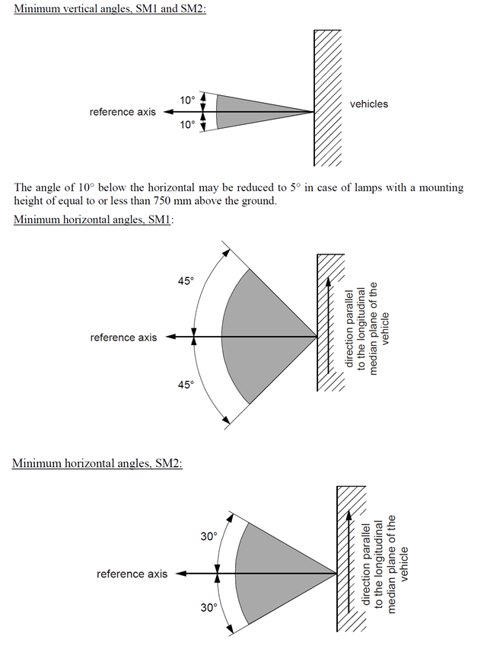**Annex 2**

**Communication concerning the approval or refusal or extension or withdrawal of approval or production definitively discontinued of a type of side-marker lamp marked SM1/SM2**

(Maximum format: A4 (210 x 297 mm))

issued by: Name of administration:

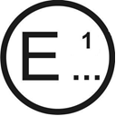[5]

concerning:[6] Approval granted

Approval extended

Approval refused

Approval withdrawn

Production definitively discontinued

of a type of side-marker lamp marked SM1/SM2 pursuant to Regulation No. 91

Approval No. Extension No:

1. Trade name or mark of the side-marker lamp:

2. Manufacturer’s name for the type of side-marker lamp:

3. Manufacturer’s name and address:

4. If applicable, name and address of the manufacturer’s representative:

5. Submitted for approval on:

6. Technical Service responsible for conducting approval tests:

7. Date of test report:

8. Number of test report:

9. Concise description:[7]

Colour of light emitted: amber / red2

Number and category(ies) of light source(s):

Light source module: yes/no2

Light source module specific identification code:

Only for limited mounting height equal to or less than 750 mm above the ground: yes/no2

Geometrical conditions of installation and relating variations, if any:

Application of an electronic light source control gear/variable intensity control:

(a) Being part of the lamp: yes/no/not applicable2

(b) Being not part of the lamp: yes/no/not applicable2

Input voltage(s) supplied by an electronic light source control gear/variable intensity control:

Electronic light source control gear/variable intensity control manufacturer and identification number (when the light source control gear is part of the lamp but is not included into the lamp body):

10. Position of the approval mark:

11. Reason(s) for extension (if applicable):

12. Approval granted/refused/extended/withdrawn: 2

13. Place:

14. Date:

15. Signature:

16. The list of documents deposited with the Type Approval Authority which has granted approval is annexed to this communication and may be obtained on request.

Annex 3

**Examples of arrangements of the approval marks**

**Example 1 (a)**



The device bearing the approval mark shown above is a side-marker lamp, approved in the United Kingdom (E 11) pursuant to Regulation No. 91 under the number 216. The vertical arrow starting from a horizontal segment and directed downwards indicates a permissible mounting height of equal to or less than 750 mm from the ground for this device.

Note: The number mentioned close to the symbol "SM1" indicates that the approval was granted in accordance with the requirements of this Regulation in its original form.

**Example 1 (b)**

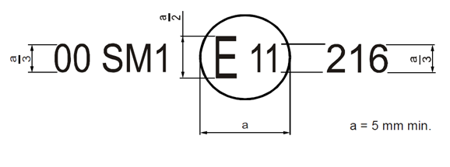

**Example 2**

Simplified marking for an assembly of several lamps that are part of the same unit

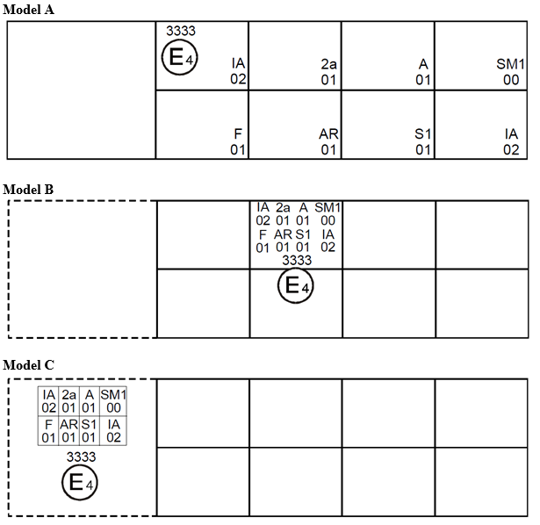

Notes: The three examples of approval mark, models A, B, and C represent three possible variants of marking of a light-signalling device when two or more lamps are part of the same unit of grouped, combined or reciprocally incorporated lamps.

The approval mark shows that the device was approved in the Netherlands (E 4) under 3333 and comprises:

*A rear and a side retro-reflector* of a class IA approved in accordance with Regulation No. 3, 02 series of amendments;

*A rear direction indicator lamp* of category 2a approved in accordance with Regulation No. 6, 01 series of amendments;

*A rear position lamp* (R) approved in accordance with Regulation No. 7, 01 series of amendments;

*A rear fog lamp* (F) approved in accordance with Regulation No. 38, 01 series of amendments;

*A reversing lamp* (AR) approved in accordance with Regulation No. 23, 01 series of amendments;

*A stop lamp* (S1) approved in accordance with Regulation No. 7, 01 series of amendments;

*A side-marker lamp* (SM1) approved in conformity with the present Regulation in its original form.

Lamp reciprocally incorporated as grouped with a headlamp

**Example 3**

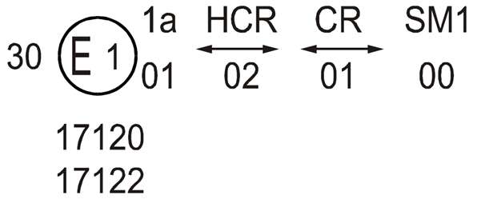

The above example corresponds to the marking of a lens intended to be used in different types of headlamps, namely:

Either: A headlamp with a passing-beam designed for right-hand and left-hand traffic and a driving-beam with a maximum intensity comprised between 86,250 and 101,250 candelas, approved in Germany (E 1) in accordance with the requirements of Regulation No. 8 as amended by the 02 series of amendments; which is reciprocally incorporated with a front direction indicator approved in accordance with the 01 series of amendments to Regulation No. 6 and grouped with a side-marker lamp in accordance with this Regulation in the original form.

or: A headlamp with a passing-beam designed for right-hand and left-hand traffic and a driving-beam approved in Germany (E 1) in accordance with the requirements of Regulation No. 1 as amended by the 01 series of amendments, which is reciprocally incorporated with the same front direction indicator and the same side-marker lamp as above.

or even: Either of the above-mentioned headlamps approved as a single lamp.

The main body of the headlamp shall bear the only valid approval number, for instance:

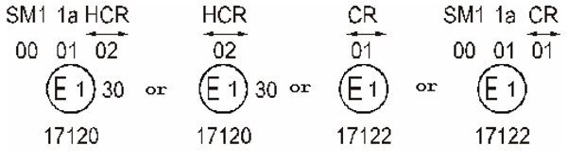

**Example 4**

Light source modules

MD E3 17325

The light source module bearing the identification code shown above has been approved together with a lamp approved in Italy (E 3) under approval number 17325.

Annex 4

**Photometric measurements**

1. Measurement methods
   1. During photometric measurement stray reflections shall be avoided by appropriate marking.
   2. In case the results of measurements should be challenged, measurements shall be carried out in such a way as to meet the following requirements:
      1. The distance of measurement shall be such that the law of the inverse of the square of the distance is applicable;
      2. The measuring equipment shall be such that the angular aperture of the receiver viewed from the reference centre of the lamp is comprised between 10 minutes and 1 degree;
      3. The intensity requirement for a particular direction of observation shall be deemed to be satisfied if that requirement is met in a direction deviating by not more than one-quarter of a degree from the direction of observation.
   3. In the case where the device may be installed on the vehicle in more than one or in a field of different positions the photometric measurements shall be repeated for each position or for the extreme positions of the field of the reference axis specified by the manufacturer.
   4. The direction H = 0° and V = 0° corresponds to the reference axis. (On the vehicle it is horizontal, perpendicular to the median longitudinal plane of the vehicle and oriented in the required direction of visibility.) It passes through the centre of reference.
2. Tables of light distribution
   1. SM1 category of side-marker lamps

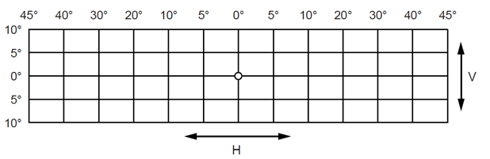

* + 1. Minimum values:

0.6 cd at any point other than the reference axis, at which it shall be 4.0 cd.

* + 1. Maximum values:

25.0 cd at any point

* 1. SM2 category of side-marker lamps

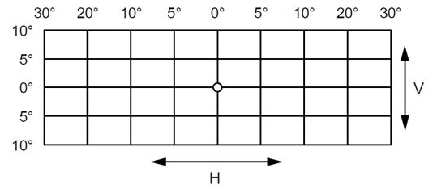

* + 1. Minimum values:

0.6 cd, at any point

* + 1. Maximum values:

25.0 cd, at any point

* 1. For SM1 and SM2 category of side-marker lamps it may be sufficient to check only five points selected by the Type Approval Authority.
  2. Within the field of light distribution shown above as a grid the light pattern should be substantially uniform, i.e. the light intensity in every direction within a part of the field formed by the grid lines shall meet at least the lowest minimum value applicable to the respective grid lines.
  3. However in the case where a device is intended to be installed with its H plane at a mounting height less than 750 mm above the ground, the photometric intensity is verified only up to an angle of 5° downwards.

1. Photometric measurement of lamps

The photometric performance shall be checked:

* 1. For non-replaceable light sources (filament lamps and other): with the light sources present in the lamp, in accordance with the relevant subparagraph of paragraph 9.1. of this Regulation.
  2. For replaceable light sources:

When equipped with light sources at 6.75 V, 13.5 V or 28.0 V, the luminous intensity values produced shall be corrected. For filament lamps the correction factor is the ratio between the reference luminous flux and the mean value of the luminous flux found at the voltage applied (6.75 V, 13.5 V or 28.0 V).

For LED light sources the correction factor is the ratio between the objective luminous flux and the mean value of the luminous flux found at the voltage applied (6.75 V, 13.5 V or 28.0 V).

The actual luminous fluxes of each light source used shall not deviate more than ±5 per cent from the mean value. Alternatively and in case of filament lamps only, a standard filament lamp may be used in turn, in each of the individual positions, operated at its reference flux, the individual measurements in each position being added together.

* 1. For any signalling lamp except those equipped with filament lamp(s), the luminous intensities, measured after one minute and after 30 minutes of operation, shall comply with the minimum and maximum requirements. The luminous intensity distribution after one minute of operation can be calculated from the luminous intensity distribution after 30 minutes of operation by applying at each test point the ratio of luminous intensities measured at HV after one minute and after 30 minutes of operation.

Annex 5

**Minimum requirements for conformity of production control procedures**

1. General
   1. The conformity requirements shall be considered satisfied from a mechanical and geometric standpoint, if the differences do not exceed inevitable manufacturing deviations within the requirements of this Regulation.
   2. With respect to photometric performances, the conformity of mass-produced side-marker lamps shall not be contested if, when testing photometric performances of any side-marker lamp chosen at random and equipped with a standard light source, or when the side-marker lamps are equipped with non-replaceable light sources (filament lamps or other), and when all measurements are made at 6.75 V, 13.5 V or 28.0 V respectively:
      1. No measured value deviates unfavourably by more than 20 per cent from the values prescribed in this Regulation.
      2. If, in the case of a side-marker lamp equipped with a replaceable light source and if results of the test described above do not meet the requirements, tests on side-marker lamps shall be repeated using another standard light source.
   3. The chromaticity coordinates shall be complied with when the side-marker lamp is equipped with a standard light source, or for lamps equipped with non-replaceable light sources (filament lamps or other), when the colorimetric characteristics are verified with the light source present in the side-marker lamp.
2. Minimum requirements for verification of conformity by the manufacturer

For each type of side-marker lamp the holder of the approval mark shall carry out at least the following tests, at appropriate intervals. The tests shall be carried out in accordance with the provisions of this Regulation.

If any sampling shows non-conformity with regard to the type of test concerned, further samples shall be taken and tested. The manufacturer shall take steps to ensure the conformity of the production concerned.

* 1. Nature of tests

Tests of conformity in this Regulation shall cover the photometric and colorimetric characteristics.

* 1. Methods used in tests
     1. Tests shall generally be carried out in accordance with the methods set out in this Regulation.
     2. In any test of conformity carried out by the manufacturer, equivalent methods may be used with the consent of the Type Approval Authority responsible for approval tests. The manufacturer is responsible for proving that the applied methods are equivalent to those laid down in this Regulation.
     3. The application of paragraphs 2.2.1. and 2.2.2. above requires regular calibration of test apparatus and its correlation with measurements made by a Type Approval Authority.
     4. In all cases the reference methods shall be those of this Regulation, particularly for the purpose of administrative verification and sampling.
  2. Nature of sampling

Samples of side-marker lamps shall be selected at random from the production of a uniform batch. A uniform batch means a set of side-marker lamps of the same type, defined according to the production methods of the manufacturer.

The assessment shall in general cover series production from individual factories. However, a manufacturer may group together records concerning the same type from several factories, provided these operate under the same quality system and quality management.

* 1. Measured and recorded photometric characteristics

The sampled lamp shall be subjected to photometric measurements for the minimum values at the points listed in Annex 4 and the required chromaticity coordinates.

* 1. Criteria governing acceptability

The manufacturer is responsible for carrying out a statistical study of the test results and for defining, in agreement with the Type Approval Authority, criteria governing the acceptability of his products in order to meet the specifications laid down for verification of conformity of products in paragraph 11.1. of this Regulation.

The criteria governing the acceptability shall be such that, with a confidence level of 95 per cent, the minimum probability of passing a spot check in accordance with Annex 6 (first sampling) would be 0.95.

Annex 6

**Minimum requirements for sampling by an inspector**

1. General
   1. The conformity requirements shall be considered satisfied from a mechanical and a geometric standpoint, in accordance with the requirements of this Regulation, if any, if the differences do not exceed inevitable manufacturing deviations.
   2. With respect to photometric performance, the conformity of mass-produced side-marker lamps shall not be contested if, when testing photometric performances of any side-marker lamp chosen at random and equipped with a standard light source, or when the side-marker lamps are equipped with non-replaceable light sources (filament lamps or other), and when all measurements are made at 6.75 V, 13.5 V or 28.0 V respectively:
      1. No measured value deviates unfavourably by more than 20 per cent from the values prescribed in this Regulation.
      2. If, in the case of a side-marker lamp equipped with a replaceable light source and if results of the test described above do not meet the requirements, tests on side-marker lamps shall be repeated using another standard light source.
      3. Side-marker lamps with apparent defects are disregarded.
   3. The chromaticity coordinates shall be complied with when the side-marker lamp is equipped with a standard light source, or for side-marker lamps equipped with non-replaceable light sources (filament lamps or other), when the colorimetric characteristics are verified with the light source present in the side-marker lamp.
2. First sampling

In the first sampling four side-marker lamps are selected at random. The first sample of two is marked A, the second sample of two is marked B.

* 1. The conformity is not contested
     1. Following the sampling procedure shown in Figure 1 of this annex the conformity of mass-produced side-marker lamps shall not be contested if the deviation of the measured values of the side-marker lamps in the unfavourable directions are:
        1. Sample A

|  |  |  |
| --- | --- | --- |
| A1: | one side-marker lamp | 0 per cent |
|  | one side-marker lamp not more than | 20 per cent |
|  |  |  |
| A2: | both side-marker lamps more than | 0 per cent |
|  | but not more than | 20 per cent |
|  | go to sample B |  |

* + - 1. Sample B

|  |  |  |
| --- | --- | --- |
| B1: | both side-marker lamps | 0 per cent |

* + 1. Or, if the conditions of paragraph 1.2.2. above for sample A are fulfilled.
  1. The conformity is contested
     1. Following the sampling procedure shown in Figure 1 of this annex the conformity of mass-produced side-marker lamps shall be contested and the manufacturer requested to make his production meet the requirements (alignment) if the deviations of the measured values of the side-marker lamps are:

2.2.1.1. Sample A

|  |  |  |
| --- | --- | --- |
| A3: | one side-marker lamp not more than | 20 per cent |
|  | one side-marker lamp more than | 20 per cent |
|  | but not more than | 30 per cent |

2.2.1.2. Sample B

|  |  |  |
| --- | --- | --- |
| B2: | in the case of A2 |  |
|  | one side-marker lamp more than | 0 per cent |
|  | but not more than | 20 per cent |
|  | one side-marker lamp not more than | 20 per cent |
|  |  |  |
| B3: | in the case of A2 |  |
|  | one side-marker lamp | 0 per cent |
|  | one side-marker lamp more than | 20 per cent |
|  | but not more than | 30 per cent |

* + 1. Or, if the conditions of paragraph 1.2.2. above for sample A are not fulfilled.
  1. Approval withdrawn

Conformity shall be contested and paragraph 12. of this Regulation applied if, following the sampling procedure in Figure 1 of this annex, the deviations of the measured values of the side-marker lamps are:

* + 1. Sample A

|  |  |  |
| --- | --- | --- |
| A4: | one side-marker lamp not more than | 20 per cent |
|  | one side-marker lamp more than | 30 per cent |
| A5: | both side-marker lamps more than | * 1. per cent |

* + 1. Sample B

|  |  |  |
| --- | --- | --- |
| B4: | in the case of A2 |  |
|  | one side-marker lamp more than | 0 per cent |
|  | but not more than | 20 per cent |
|  | one side-marker lamp more than | 20 per cent |
|  |  |  |
| B5: | in the case of A2 |  |
|  | both side-marker lamps more than | 20 per cent |
|  |  |  |
| B6: | in the case of A2 |  |
|  | one side-marker lamp | 0 per cent |
|  | one side-marker lamp more than | 30 per cent |

* + 1. Or, if the conditions of paragraph 1.2.2. above for samples A and B are not fulfilled.

1. Repeated sampling

In the cases of A3, B2, B3 a repeated sampling, third sample C of two side-marker lamps and fourth sample D of two side-marker lamps, selected from stock manufactured after alignment, is necessary within two months' time after the notification.

* 1. conformity is not contested
     1. Following the sampling procedure shown in Figure 1 of this annex the conformity of mass-produced side-marker lamps shall not be contested if the deviations of the measured values of the side-marker lamps are:
        1. Sample C

|  |  |  |
| --- | --- | --- |
| C1: | one side-marker lamp | 0 per cent |
|  | one side-marker lamp not more than | 20 per cent |
|  |  |  |
| C2: | both side-marker lamps more than | 0 per cent |
|  | but not more than | 20 per cent |
|  | go to sample D |  |

* + - 1. Sample D

|  |  |  |
| --- | --- | --- |
| D1: | in the case of C2 |  |
|  | both side-marker lamps | 0 per cent |

* + 1. Or, if the conditions of paragraph 1.2.2. above for sample C are fulfilled.
  1. The conformity is contested
     1. Following the sampling procedure shown in Figure 1 of this annex the conformity of mass-produced side-marker lamps shall be contested and the manufacturer requested to make his production meet the requirements (alignment) if the deviations of the measured values of the side-marker lamps are:
        1. Sample D

|  |  |  |
| --- | --- | --- |
| D2: | in the case of C2 |  |
|  | one side-marker lamp more than | 0 per cent |
|  | but not more than | 20 per cent |
|  | one side-marker lamp not more than | 20 per cent |

* + - 1. Or, if the conditions of paragraph 1.2.2. above for sample C are not fulfilled.
  1. Approval withdrawn

Conformity shall be contested and paragraph 12. of this Regulation applied if, following the sampling procedure in Figure 1 of this annex, the deviations of the measured values of the side-marker lamps are:

* + 1. Sample C

|  |  |  |
| --- | --- | --- |
| C3: | one side-marker lamp not more than | 20 per cent |
|  | one side-marker lamp more than | 20 per cent |
| C4: | both side-marker lamps more than | 20 per cent |

* + 1. Sample D

|  |  |  |
| --- | --- | --- |
| D3: | in the case of C2 |  |
|  | one side-marker lamp 0 or more than | 0 per cent |
|  | one side-marker lamp more than | 20 per cent |

* + 1. Or, if the conditions of paragraph 1.2.2. above for samples C and D are not fulfilled.

Figure 1



“

1. Former title of the Agreement: Agreement Concerning the Adoption of Uniform Conditions of Approval and Reciprocal Recognition of Approval for Motor Vehicle Equipment and Parts, done at Geneva on 20 March 1958.
2. As defined in the Consolidated Resolution on the Construction of Vehicles (R.E.3.), document ECE/TRANS/WP.29/78/Rev.2, para. 2. - www.unece.org/trans/main/wp29/wp29wgs/wp29gen/wp29resolutions.html
3. The distinguishing numbers of the Contracting Parties to the 1958 Agreement are reproduced in Annex 3 to the Consolidated Resolution on the Construction of Vehicles (R.E.3), document ECE/TRANS/WP.29/78/Rev.2/Amend.3 - www.unece.org/trans/main/wp29/wp29wgs/wp29gen/wp29resolutions.html
4. For the purpose of this Regulation "being part of the lamp" means to be physically included in the lamp body or to be external, separated or not, but supplied by the lamp manufacturer as part of the lamp system. The functioning and installation conditions of these additional systems will be defined by special provisions.
5. Distinguishing number of the country which has granted/extended/refused/withdrawn approval (see approval provisions in the Regulation).
6. Strike out what does not apply.
7. For lamps with non-replaceable light sources indicate the number and the total wattage of the light sources.