

Family Law Amendment (2018 Measures No. 1) Rules 2018

We, Judges of the Family Court of Australia, make the following Rules of Court.

Dated 9 February 2018

W Alstergren A/g CJ

A Ainslie-Wallace J

J Ryan J

P Murphy J

M Aldridge J

M Kent J

J Stevenson J

M Le Poer Trench J

G Watts J

R Benjamin J

V Bennett J

P Cronin J

S Austin J

S Moncrieff J

M Cleary J

W Johnston J

I Loughnan J

C Forrest J

K Macmillan J

J Rees J

S Duncanson J

J Walters J

P Tree J

J Hogan J

D Berman J

S Johns J

G Foster J

C Thornton J

H Hannam J

R McClelland

C Carew J

R O’Brien J

S Gill J

M Baumann J

Judges of the Family Court  
of Australia

Contents

1 Name 1

2 Commencement 1

3 Authority 1

4 Schedules 1

Schedule 1—Consent orders 2

Family Law Rules 2004 2

Schedule 2—Submitting notices and notices of contention 17

Family Law Rules 2004 17

Schedule 3—Other amendments 19

Family Law Rules 2004 19

Schedule 4—Application and transitional provisions 25

Family Law Rules 2004 25

1 Name

These Rules are the *Family Law Amendment (2018 Measures No. 1) Rules 2018*.

2 Commencement

(1) Each provision of these Rules specified in column 1 of the table commences, or is taken to have commenced, in accordance with column 2 of the table. Any other statement in column 2 has effect according to its terms.

| Commencement information | | |
| --- | --- | --- |
| Column 1 | Column 2 | Column 3 |
| Provisions | Commencement | Date/Details |
| 1. The whole of these Rules | 1 March 2018. | 1 March 2018 |

Note: This table relates only to the provisions of these Rules as originally made. It will not be amended to deal with any later amendments of these Rules.

(2) Any information in column 3 of the table is not part of these Rules. Information may be inserted in this column, or information in it may be edited, in any published version of these Rules.

3 Authority

These Rules are made under the *Family Law Act 1975.*

4 Schedules

Each instrument that is specified in a Schedule to these Rules is amended or repealed as set out in the applicable items in the Schedule concerned, and any other item in a Schedule to these Rules has effect according to its terms.

Schedule 1—Consent orders

Family Law Rules 2004

1 Subrule 2.02(1) (table 2.2, item 9, column headed “Documents to be filed with application”, paragraphs (b) and (c))

Repeal the paragraphs, substitute:

(b) if the orders sought relate to a superannuation interest—proof of the value of the interest (see subsection 90MT(2) of the Act)

2 Subrule 2.04D(1)

Repeal the subrule, substitute:

(1) The prescribed form for a notice mentioned in subsection 67Z(2) or 67ZBA(2) of the Act is:

(a) if the notice relates to an application in a current case—the Notice of Child Abuse, Family Violence or Risk of Family Violence (Current Case); or

(b) if the notice relates to an Application for Consent Orders—the Notice of Child Abuse, Family Violence or Risk of Family Violence (Application for Consent Orders).

Note: The Notice of Child Abuse, Family Violence or Risk of Family Violence (Current Case) and the Notice of Child Abuse, Family Violence or Risk of Family Violence (Application for Consent Orders) are set out in Schedule 2.

3 Subrule 2.04D(2)

Omit “subrule (1)”, substitute “paragraph (1)(a)”.

4 Rule 2.04E

Repeal the rule.

5 After subrule 2.05(2)

Insert:

(2A) Subrule (2) does not apply to a party starting a case by filing an Application for Consent Orders.

6 Paragraph 10.15(2)(d)

Before “be accompanied by additional copies of the order”, insert “unless the order relates to an Application for Consent Orders filed by electronic communication,”.

7 Subrule 10.15A(1)

Omit “in a current case “.

8 Before subrule 10.15A(2)

Insert:

Application made orally in a current case

9 Subrule 10.15A(2)

Omit “If an application”, substitute “If the application”.

10 At the end of subrule 10.15A(2)

Add:

Note: If the party alleges that the child concerned has been abused or is at risk of being abused, or there has been, or there is a risk of, family violence by one of the parties to the proceedings, the party making the allegation, or if represented by a lawyer, that party’s lawyer, must also file and serve a Notice of Child Abuse, Family Violence or Risk of Family Violence (Current Case) in the form set out in Schedule 2 (see subsections 67Z(2) and 67ZBA(2) of the Act and subrule 2.04D(1)).

11 Before subrule 10.15A(3)

Insert:

Other applications made in a current case

12 Subrule 10.15A(3)

Omit “For any other application”, substitute “If the application is made in a current case by lodging or tendering a draft consent order,”.

13 At the end of subrule 10.15A(3)

Add:

Note: If the party alleges that the child concerned has been abused or is at risk of being abused, or there has been, or there is a risk of, family violence by one of the parties to the proceedings, the party making the allegation, or if represented by a lawyer, that party’s lawyer, must also file and serve a Notice of Child Abuse, Family Violence or Risk of Family Violence (Current Case) in the form set out in Schedule 2 (see subsections 67Z(2) and 67ZBA(2) of the Act and subrule 2.04D(1)).

14 At the end of rule 10.15A

Add:

Application when there is no current case

(4) If the application is made when there is no current case, each party, or if represented by a lawyer, the party’s lawyer:

(a) must certify, in the Application for Consent Orders, whether the party considers that the child concerned has been, or is at risk of being, subjected to or exposed to abuse, neglect or family violence;

(b) must certify, in the Application for Consent Orders, whether the party considers that he or she, or another party to the proceedings, has been or is at risk of being subjected to family violence; and

(c) if allegations of abuse or family violence have been made—must explain, in the Application for Consent Orders, how the order attempts to deal with the allegations.

Note: If the party alleges that the child concerned has been abused or is at risk of being abused, or there has been, or there is a risk of, family violence by one of the parties to the proceedings, the party making the allegation, or if represented by a lawyer, that party’s lawyer, must also file and serve a Notice of Child Abuse, Family Violence or Risk of Family Violence (Application for Consent Orders) in the form set out in Schedule 2 (see subsections 67Z(2) and 67ZBA(2) of the Act and subrule 2.04D(1)).

15 Paragraph 19.41(2)(b)

Repeal the paragraph, substitute:

(b) a form in Schedule 2; or

16 Paragraph 24.01(1)(g)

Omit “that is not included in Schedule 2”, substitute “other than a form in Schedule 2”.

17 Subrule 24.04(2)

Repeal the subrule, substitute:

(2) A reference in these Rules to:

(a) a Notice of Child Abuse, Family Violence or Risk of Family Violence (Current Case); or

(b) a Notice of Child Abuse, Family Violence or Risk of Family Violence (Application for Consent Orders);

is a reference to the form of that name in Schedule 2.

18 Subrule 24.04(3)

Omit “the form in Schedule 2”, substitute “a form in Schedule 2”.

19 Subclause 3(3) of Part 2 of Schedule 1

Omit “(Form 11)”.

20 Schedule 2

Repeal the Schedule, substitute:

Schedule 2—Forms

Note: See subrule 24.04(2) and Division 2.3.1.

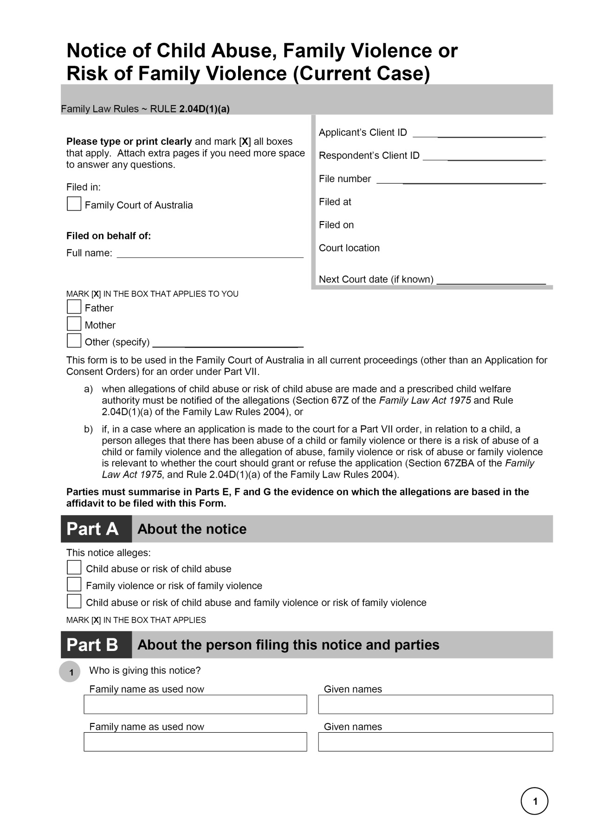

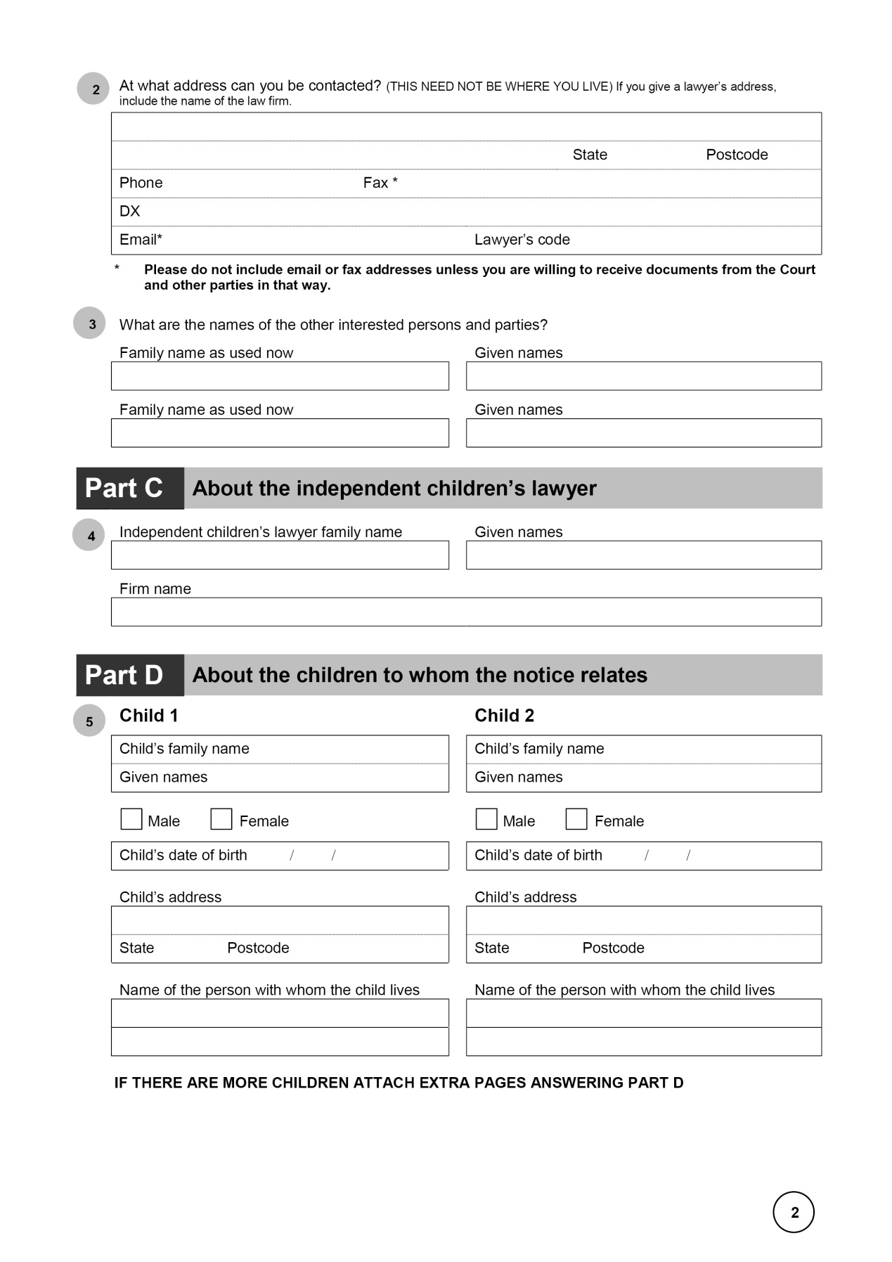

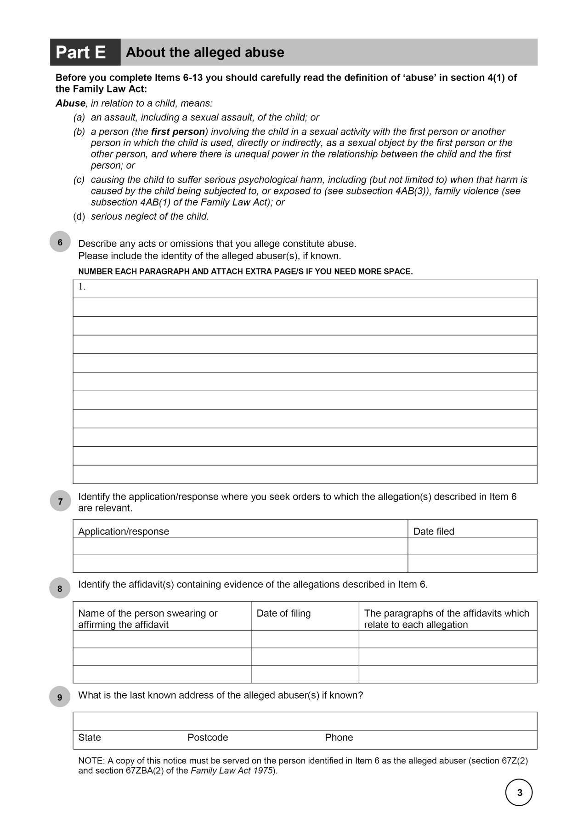

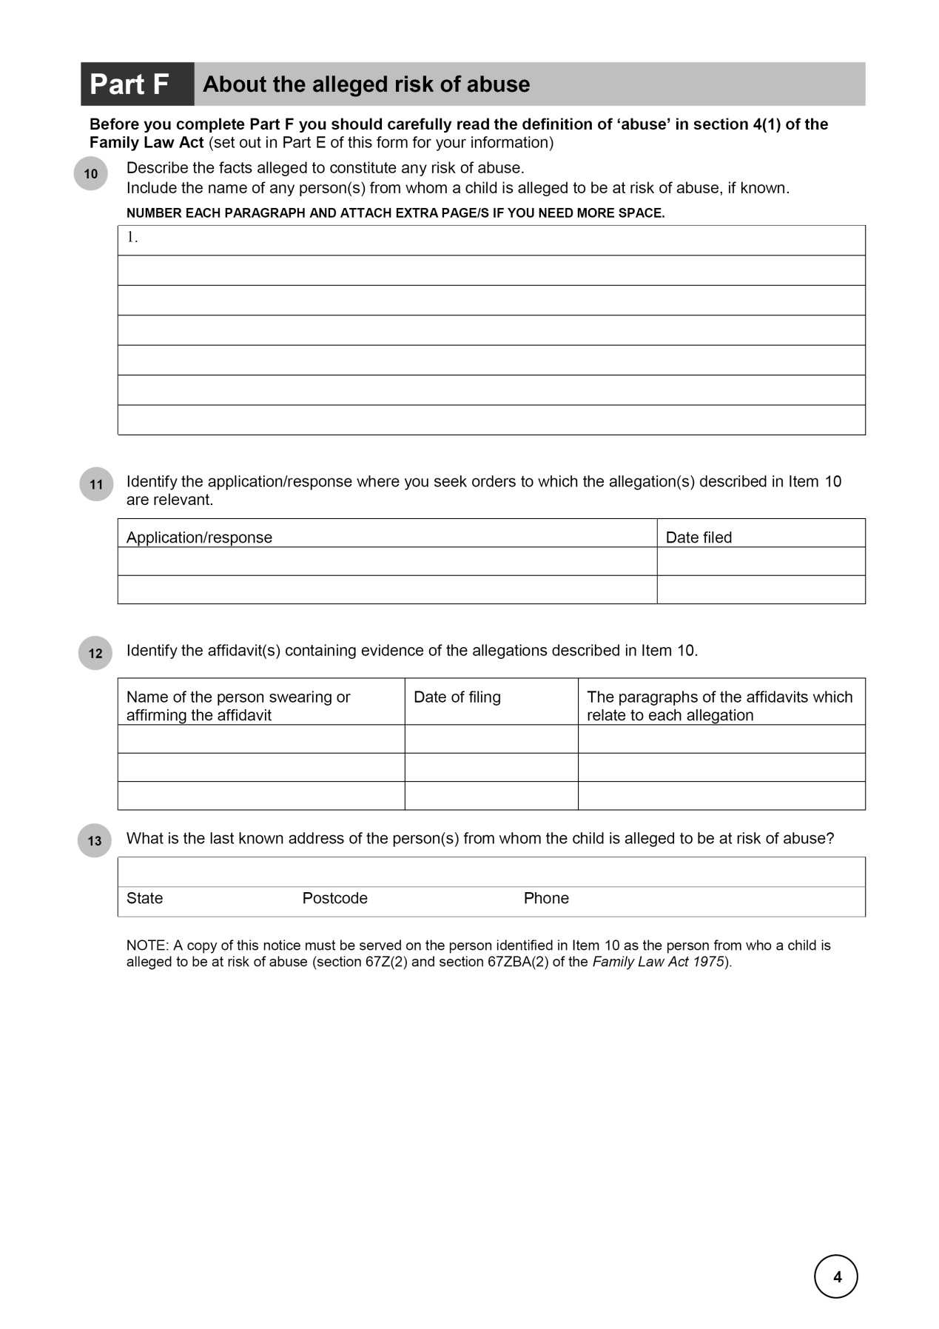

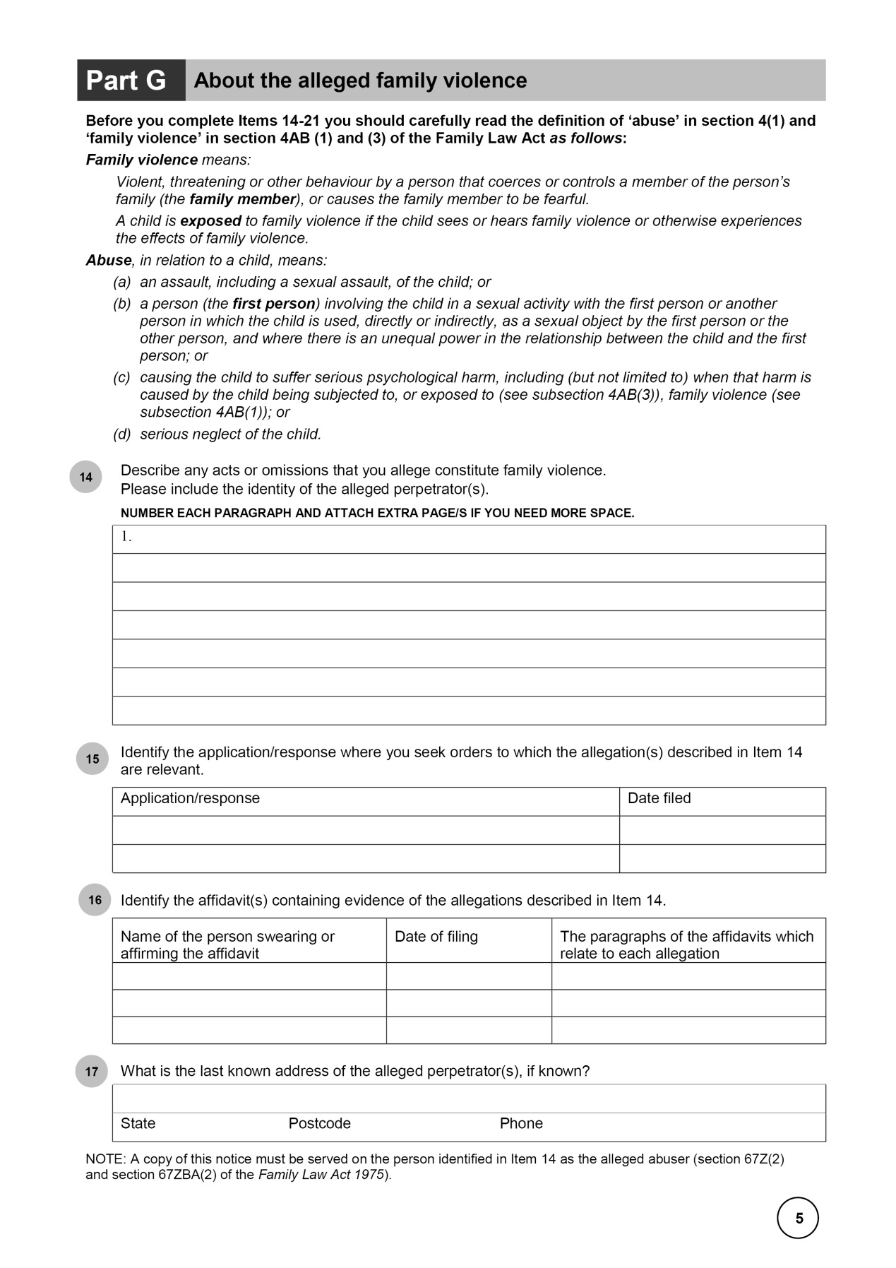

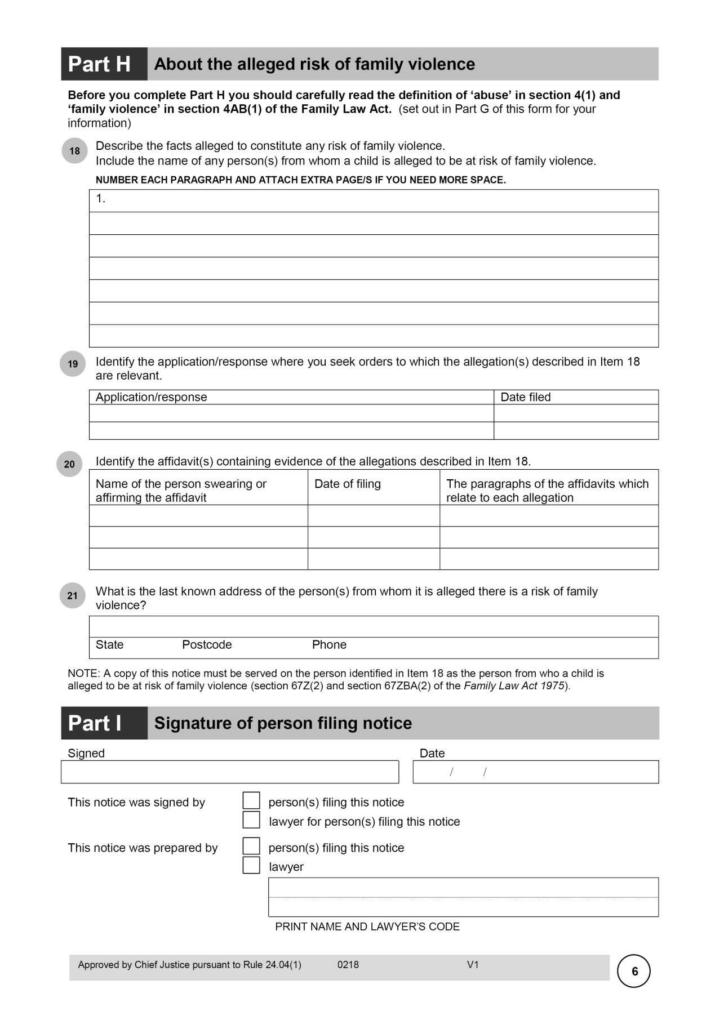

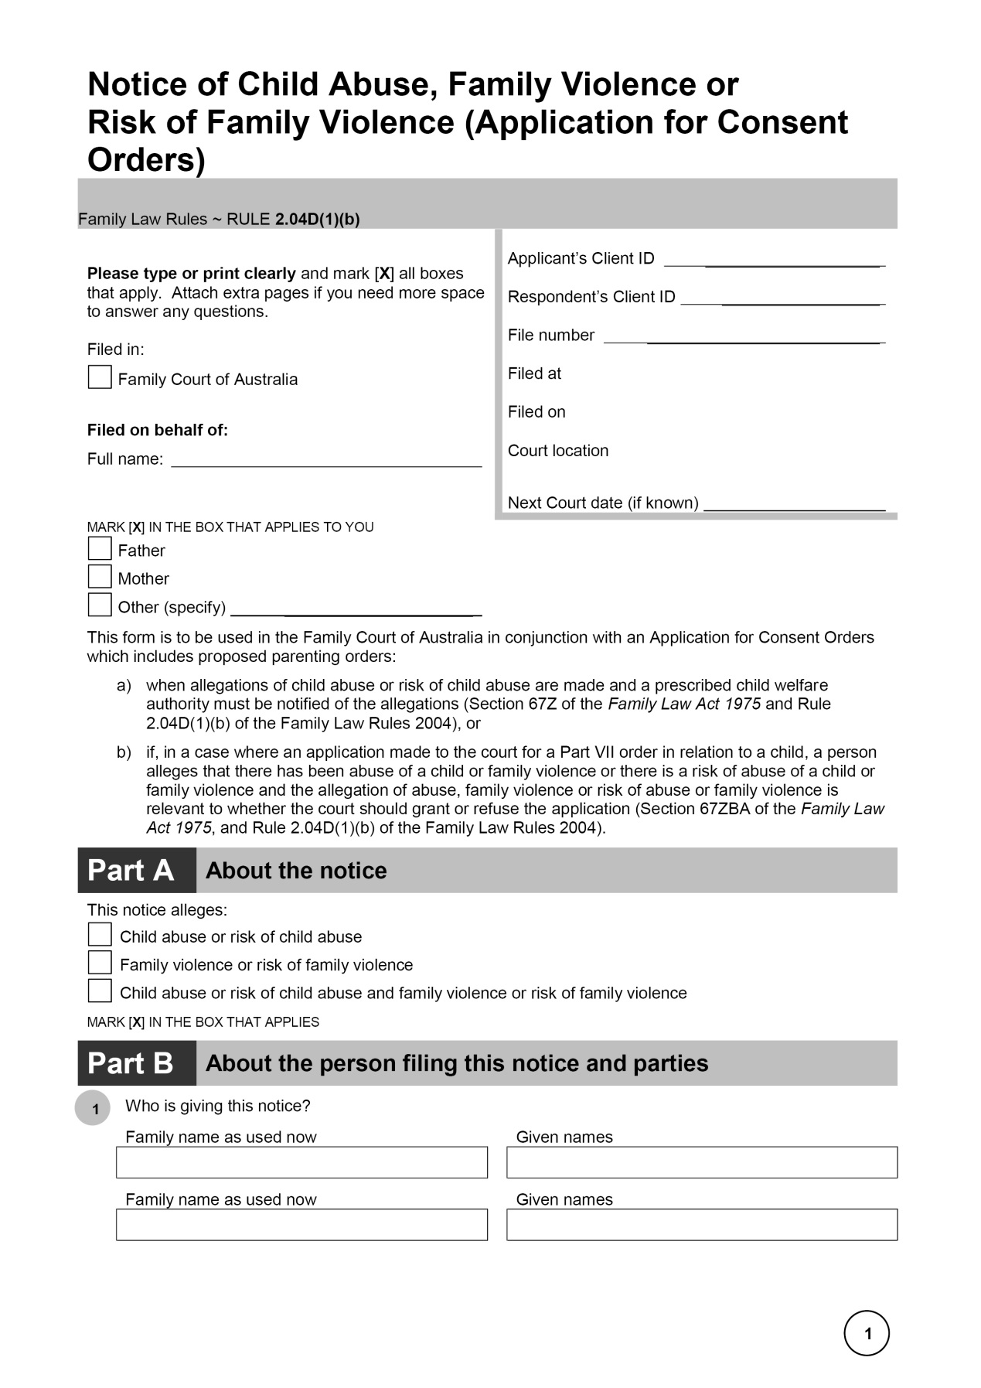

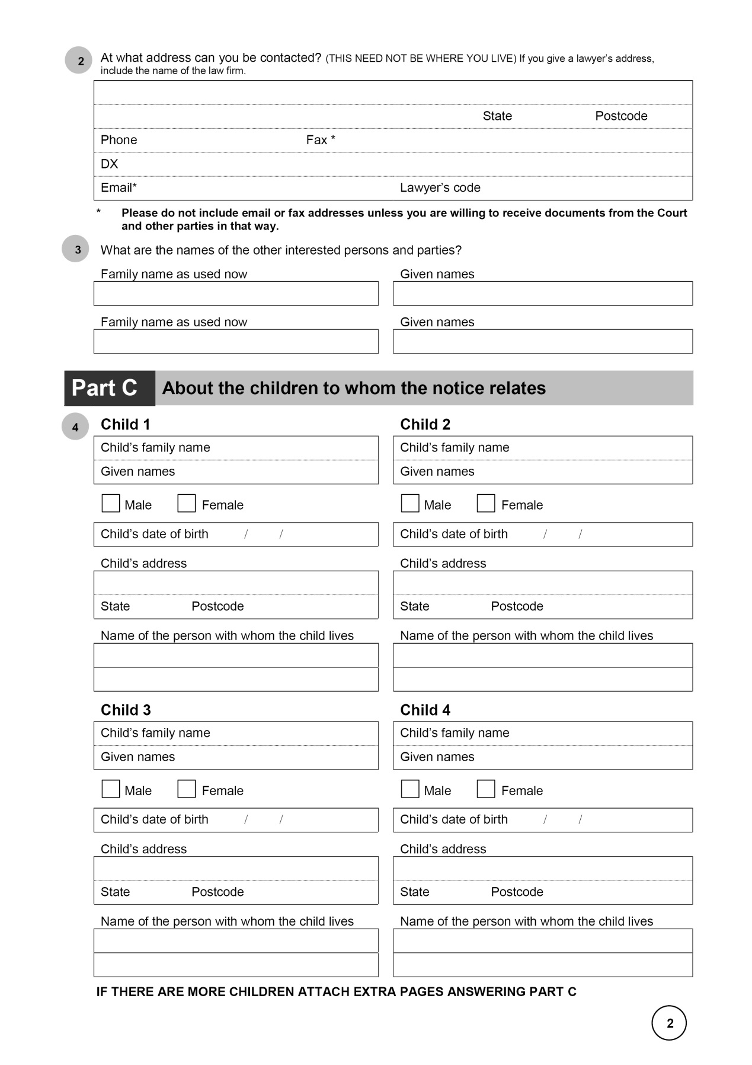

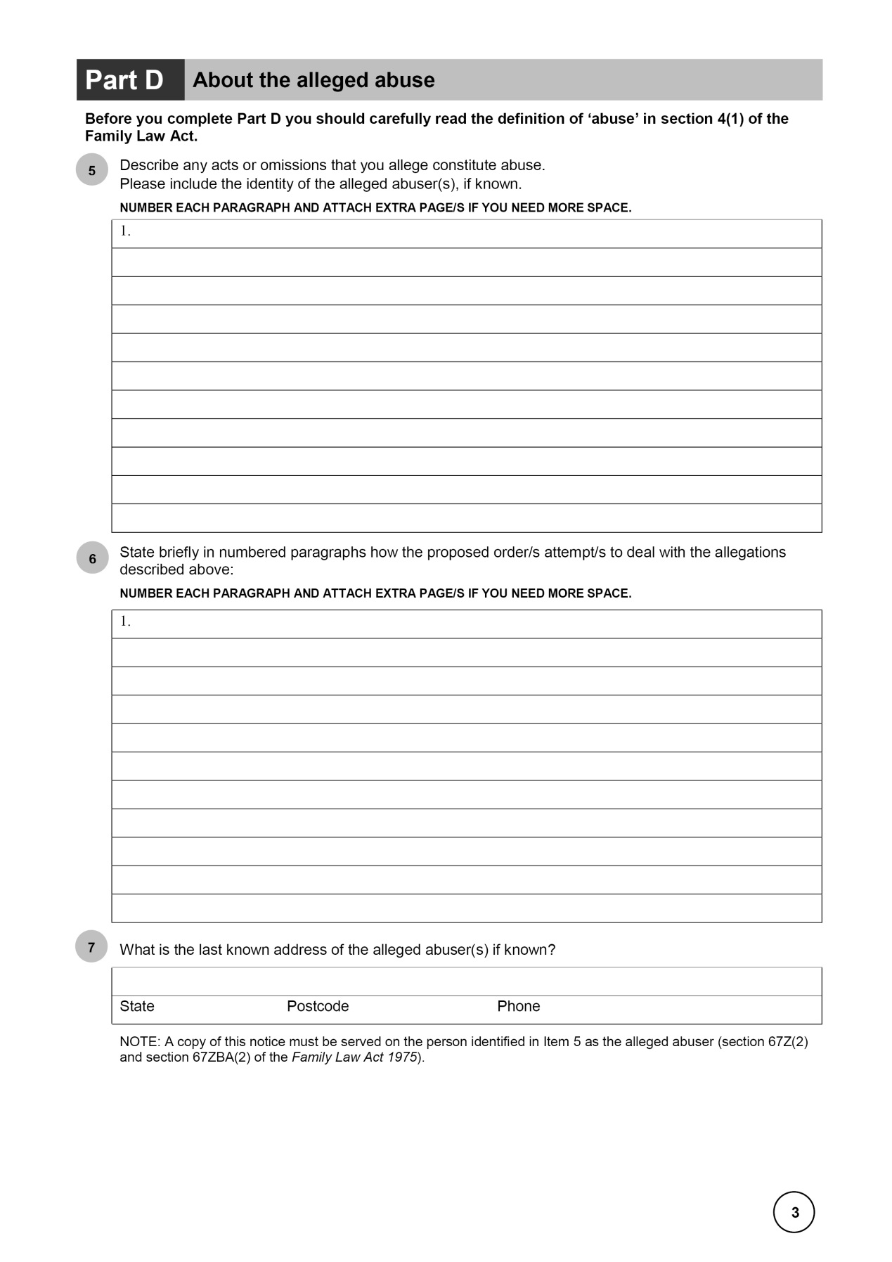

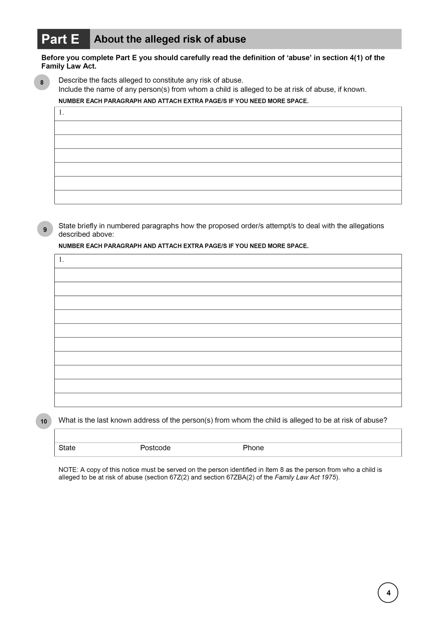

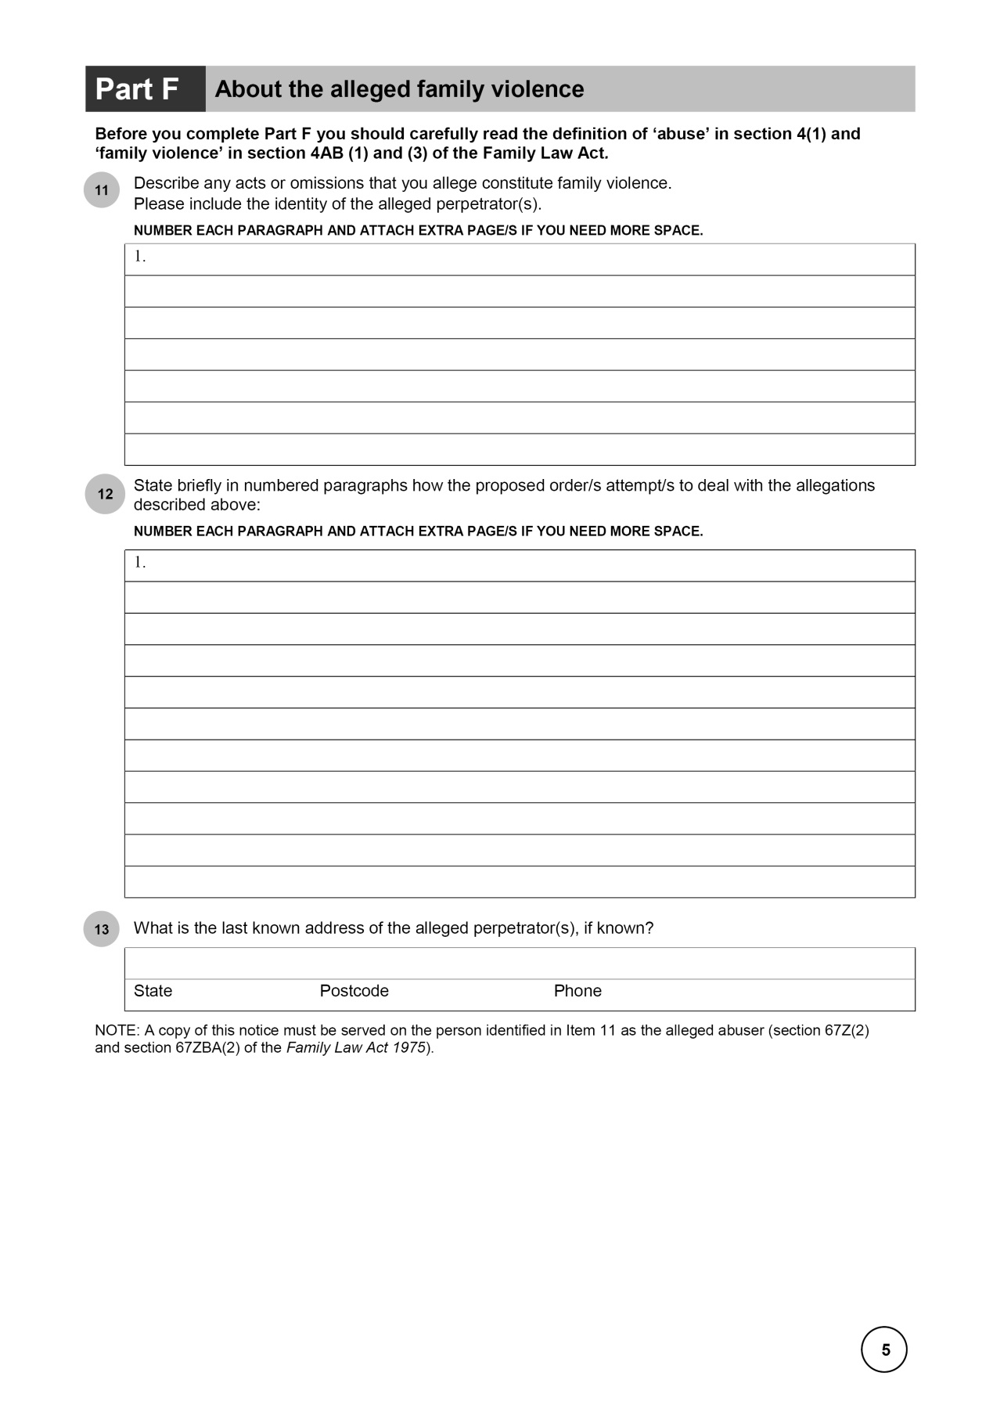

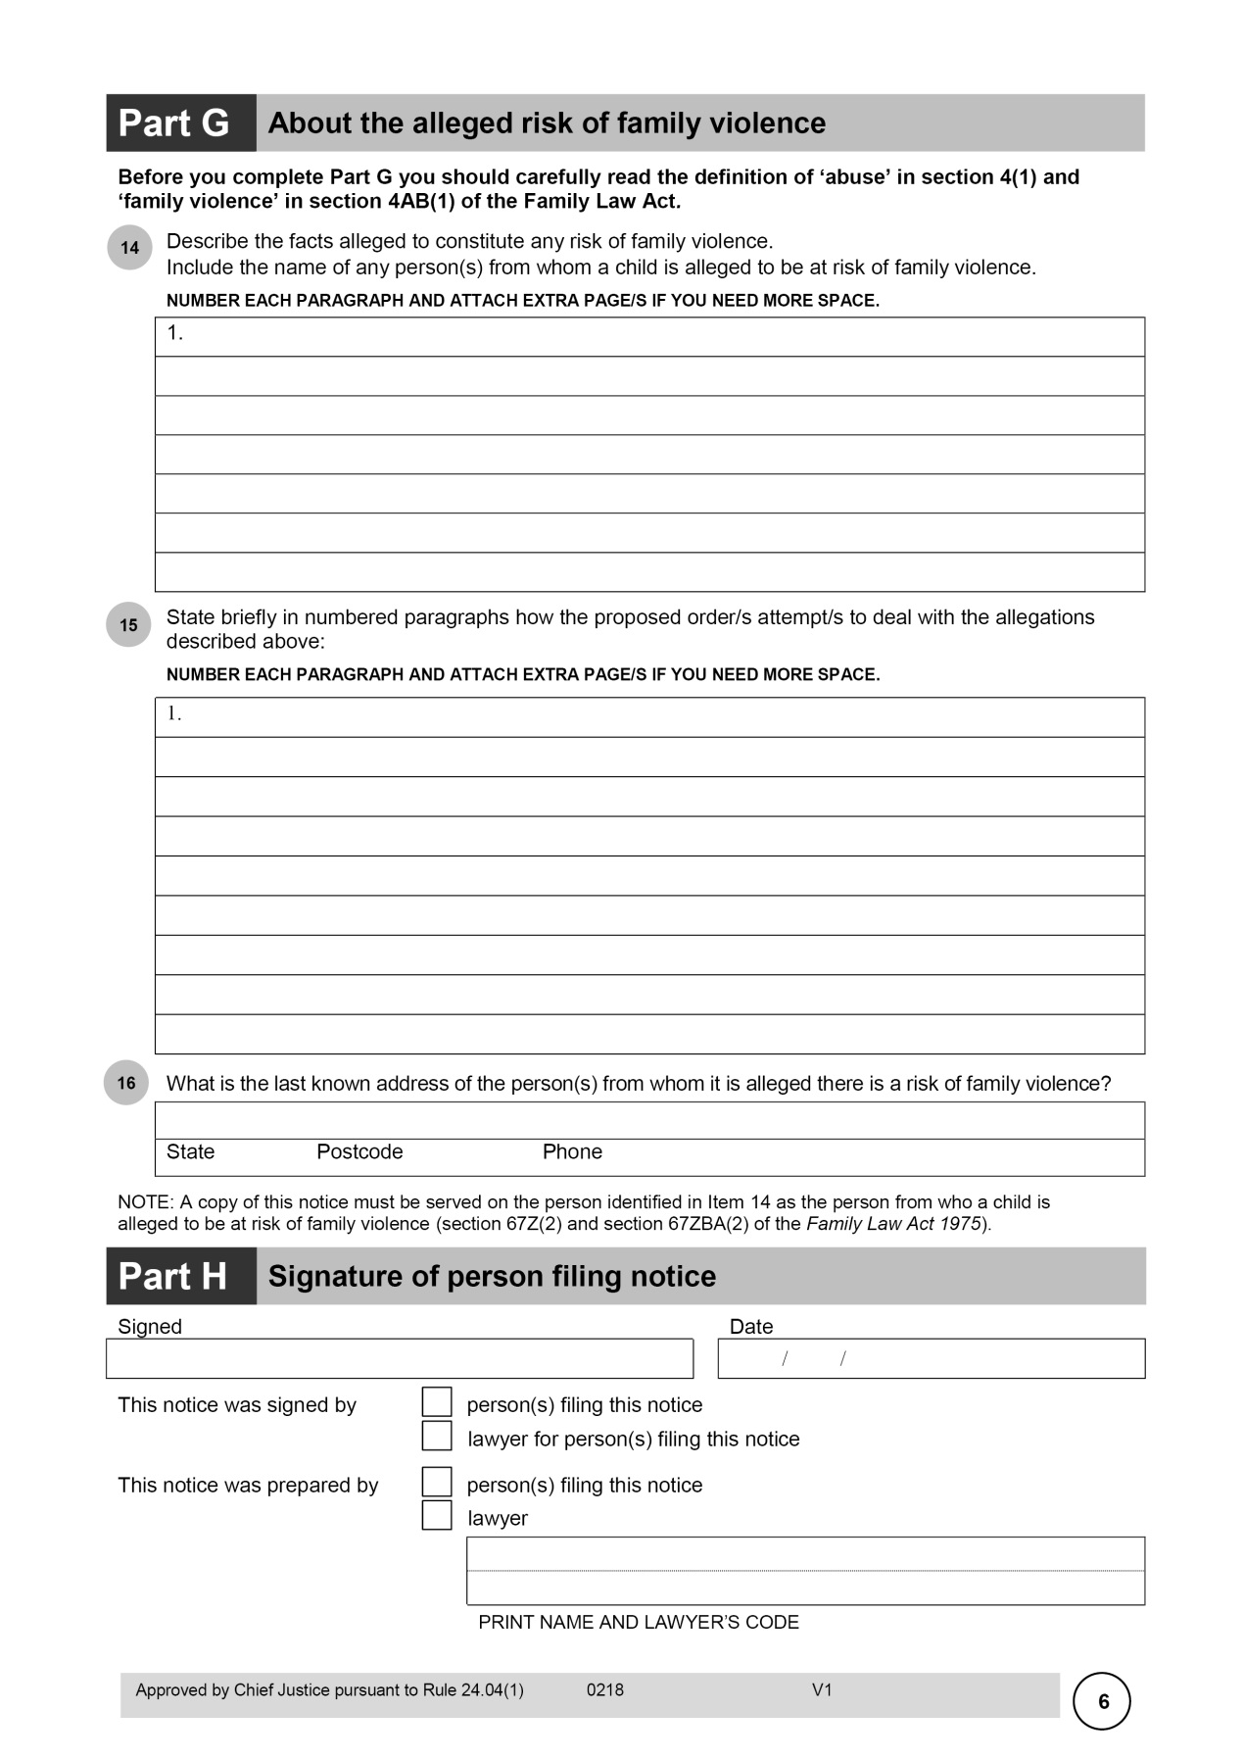

Schedule 2—Submitting notices and notices of contention

Family Law Rules 2004

1 Chapter 8 (heading)

Repeal the heading, substitute:

Chapter 8—Right to be heard, address for service and submitting notices

2 Chapter 8 (summary)

Omit:

• the people who may be heard by the court and the requirements for their address for service;

substitute:

• the people who may be heard by the court and the requirements for their address for service; and

• submitting notices; and

3 At the end of Chapter 8

Add:

Part 8.3—Submitting notices

8.07 Submitting notices

(1) A party who has been served with an application referred to in subrule (2), andwho does not want to contest the relief sought in the application, may file a submitting notice in the approved form.

Note: A document that is filed must be served on each person to be served (see rule 7.04).

(2) The applications are the following:

(a) an Initiating Application (Family Law) seeking final orders;

(b) a Response to an Initiating Application (Family Law);

(c) a Reply to a Response to an Initiating Application (Family Law);

(d) a Notice of Appeal.

(3) The submitting notice must:

(a) state that the party submits to any order that the court may make; and

(b) state whether the party wants to be heard on the question of costs; and

(c) include an address for service.

(4) A submitting notice for a party served with an application referred to in paragraph (2)(a), (b) or (c) must be filed:

(a) before the first court date fixed under rule 4.03; or

(b) if the party was added to the case after that date—before the date for the procedural hearing set under subrule 11.10(3).

(5) A submitting notice for a party served with a Notice of Appeal must be filed within 14 days after the party was served with the Notice of Appeal.

(6) A party who has filed a submitting notice may apply to the court for leave to withdraw the notice.

(7) An application under subrule (6) must be accompanied by an affidavit stating:

(a) why the party wants to withdraw the submitting notice; and

(b) the party’s intentions in relation to the further conduct of the proceeding.

4 At the end of rule 22.07

Add:

Note: A party who does not want to contest the relief sought in the Notice of Appeal may file a submitting notice under rule 8.07.

5 After rule 22.08

Insert:

22.08A Notice of contention

If a respondent to an appeal does not want to cross‑appeal from any part of an order, but contends that the order should be affirmed on grounds other than those relied on by the court appealed from, the respondent must, within 14 days after the Notice of Appeal was served on the respondent, file a notice of contention in the approved form.

Note: A document that is filed must be served on each person to be served (see rule 7.04).

6 After paragraph 22.20(3)(f)

Insert:

(fa) any notice of contention;

(fb) any submitting notice;

7 Dictionary

Insert:

***notice of contention*** means a notice of contention referred to in rule 22.08A.

***submitting notice*** means a submitting notice referred to in rule 8.07.

Schedule 3—Other amendments

Family Law Rules 2004

1 Division 4.2.5 (overview)

Omit “subsection 95(6), section 98 or 136”, substitute “subsection 95(6) or section 136”.

2 Division 4.2.5 (overview)

Omit:

Section 110B of the *Child Support (Registration and Collection) Act 1988* allows appeals from the Social Security Appeals Tribunal on questions of law.

3 Paragraph 4.16(b)

Repeal the paragraph.

4 Subrule 4.17(1)

Omit “(1)”.

5 Subrule 4.17(2)

Repeal the subrule.

6 Subrule 4.18(1) (table 4.1, item 2, column headed “Application”)

Omit “98,”.

7 Rules 4.21 and 4.22

Repeal the rules.

8 Rule 4.23 (heading)

Repeal the heading, substitute:

4.23 Service of application

9 Subrule 4.23(1)

Omit “or notice of appeal”.

10 Paragraph 4.23(1)(b)

Omit “or appeal”.

11 Paragraph 4.23(1)(c)

Omit “Registrar; and”, substitute “Registrar.”.

12 Paragraph 4.23(1)(d)

Repeal the paragraph.

13 Subrule 4.23(2)

Omit “or notice of appeal”.

14 Subrule 4.23(3)

Repeal the subrule.

15 Subrule 4.23(4)

Omit “or appellant”.

16 Rule 4.24

Omit “or Registration Act”.

17 Subrules 4.25(1) and (2)

Omit “or appeal”.

18 Subrule 4.26(1)

Omit “98,”.

19 Subrule 11.05(2) (note 1)

Omit “Note 1”, substitute “Note”.

20 Subrule 11.05(2) (note 2)

Repeal the note.

21 At the end of paragraph 11.18(1)(g)

Add “, and any safety concerns”.

22 Rule 15.08 (heading)

Repeal the heading, substitute:

15.08 Requirements for affidavits

23 Rule 15.08

Before “An affidavit”, insert “(1)”.

24 At the end of rule 15.08

Add:

(2) A document that is to be used in conjunction with an affidavit and tendered in evidence in a proceeding:

(a) must be identified in the affidavit; and

(b) must not be attached or annexed to the affidavit, or filed as an exhibit to the affidavit.

(3) If a document that is to be used in conjunction with an affidavit and tendered in evidence in a proceeding is in the possession of the party on whose behalf the affidavit is filed, a hard copy of the document must be served on each person to be served at the same time as the affidavit is served on that person.

25 Rule 15.12

Repeal the rule.

26 Subrule 15.29(4) (paragraphs (b) and (c) of the definition of *copy*)

Repeal the paragraphs, substitute:

(b) a copy in an electronic format that is approved by the Registry Manager, and is capable of being printed in the form in which it was created without any loss of content.

27 Chapter 17 (heading)

Repeal the heading, substitute:

Chapter 17—Orders and undertakings

28 Chapter 17 (summary)

After “certain monetary orders.”, insert “Chapter 17 also deals with undertakings.”.

29 Before rule 17.01

Insert:

Part 17.1—Orders

30 At the end of Chapter 17

Add:

Part 17.2—Undertakings

17.06 Undertakings

(1) An undertaking that is required or permitted to be given by a person under these Rules may be given orally or in writing.

(2) An undertaking given by a person in writing must be:

(a) signed by the person or the person’s legal representative; and

(b) filed in the filing registry.

Note: A document that is filed must be served (see rule 7.04).

(3) If an undertaking is given by a person orally:

(a) a written record of the undertaking must be made; and

(b) the record must be:

(i) signed by the person or the person’s legal representative; and

(ii) filed in the filing registry within 14 days of the undertaking being given; and

(iii) served within 14 days of the undertaking being given.

(4) An undertaking as to damages is an undertaking:

(a) to submit to such order (if any) as the court may consider to be just for the payment of compensation (to be assessed by the court or as the court may direct) to any person (whether or not that person is a party) affected by the operation of the order or undertaking or any continuation (with or without variation) of the order or undertaking; and

(b) to pay compensation referred to in paragraph (a) to the person affected by the order or undertaking.

(5) This rule is subject to any requirements specified in these Rules for the giving of particular undertakings.

31 Subrule 18.06(1) (table 18.4, after item 10)

Insert:

|  |  |
| --- | --- |
| 10A | paragraph 44(3A)(d) (but only if all parties consent to leave being granted) |
| 10B | paragraph 44(3B)(d) (but only if all parties consent to leave being granted) |
| 10C | subsection 44(6) (but only if all parties consent to leave being granted) |

32 Subrule 18.06(1) (table 18.4, after item 18A)

Insert:

|  |  |
| --- | --- |
| 18AA | subsection 67M(2) |
| 18AB | subsection 67N(2) |

33 Subrule 18.06(1) (table 18.4, after item 27)

Insert:

|  |  |
| --- | --- |
| 28 | section 106A |

34 Subrule 18.06(1) (table 18.4, after item 33)

Insert:

|  |  |
| --- | --- |
| 33AA | subregulation 23(6) |

35 Subrule 18.06(2) (table 18.5, after item 4)

Insert:

|  |  |
| --- | --- |
| 4A | subrule 5.11(2) |

36 Subrule 18.06(2) (table 18.5, after item 6A)

Insert:

|  |  |
| --- | --- |
| 6B | Part 6.3 |

37 Subrule 18.06(2) (table 18.5, item 13)

Before “paragraph 11.02(2)(d)”, insert “paragraph 11.02(2)(a),”.

38 Subrule 18.06(2) (table 18.5, after item 14)

Insert:

|  |  |
| --- | --- |
| 14A | subrules 11.06(1) and (2) |

39 Rule 19.31

Before “If”, insert “(1)”.

40 At the end of rule 19.31

Add:

(2) A cost assessment order under this rule has the force and effect of an order of the court.

41 At the end of rule 19.32

Add:

(5) A cost assessment order under this rule has the force and effect of an order of the court.

42 At the end of rule 19.37

Add:

(4) A cost assessment order under this rule has the force and effect of an order of the court.

43 Subrule 19.38(1)

Omit “rule 19.31 or subrule”, substitute “subrule 19.31(1) or”.

44 Subrule 22.01(2)

Repeal the subrule, substitute:

(2) This Chapter does not apply to an application to a Judge of a Family Court for a review of an order of a Judicial Registrar or Registrar (see Chapter 18).

45 Subrule 26B.23(1)

After “required documents”, insert “, or copies of the required documents,”.

46 Subrule 26B.23(3) (paragraphs (b) and (c) of the definition of *copy*)

Repeal the paragraphs, substitute:

(b) a copy in an electronic format that is approved by the Registry Manager, and is capable of being printed in the form in which it was created without any loss of content.

47 Schedule 7

Repeal the Schedule.

48 Dictionary (definition of *costs assessment order*)

Omit “and 19.32”, substitute “, 19.32 and 19.37”.

49 Dictionary (paragraph (d) of the definition of *financial case*)

Omit “98,”.

50 Dictionary (paragraph (b) of the definition of *financial orders*)

Omit “98,”.

51 Dictionary

Insert:

***undertaking as to damages***—see subrule 17.06(4).

52 Explanatory Guide (definition of *undertaking as to damages*)

Repeal the definition.

Schedule 4—Application and transitional provisions

Family Law Rules 2004

1 In the appropriate position in Chapter 27

Insert:

Part 27.3—Transitional provisions relating to the Family Law Amendment (2018 Measures No. 1) Rules 2018

27.04 Application—submitting notices

Rule 8.07, as inserted by Schedule 2 to the *Family Law Amendment (2018 Measures No. 1) Rules 2018*, applies in relation to an application that is served on or after 1 March 2018.

27.05 Application—notices of contention

Rule 22.08A, as inserted by Schedule 2 to the *Family Law Amendment (2018 Measures No. 1) Rules 2018*, applies in relation to a Notice of Appeal that is served on or after 1 March 2018.

27.06 Application—documents to be used in conjunction with an affidavit

Rule 15.08, as amended by Schedule 3 to the *Family Law Amendment (2018 Measures No. 1) Rules 2018*, applies in relation to an affidavit that is to be filed on or after 1 March 2018.

27.07 Application—compliance with subpoena

Rules 15.29 and 26B.23, as amended by Schedule 3 to the *Family Law Amendment (2018 Measures No. 1) Rules 2018*, apply in relation to a subpoena for production that is issued on or after 1 March 2018.

27.08 Application—undertakings

Rule 17.06, as inserted by Schedule 3 to the *Family Law Amendment (2018 Measures No. 1) Rules 2018*, applies in relation to an undertaking that is given on or after 1 March 2018.