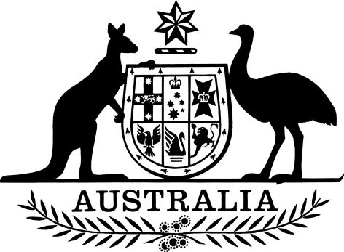

Public Governance, Performance and Accountability Amendment (Procurement by Regional Investment Corporation) Rules 2018
I, Mathias Cormann, Minister for Finance, make the following rules.
Dated 1 March 2018
Mathias Cormann
Minister for Finance

Contents
1 Name 1
2 Commencement 1
3 Authority 1
4 Schedules 1
Schedule 1—Amendments 2
Public Governance, Performance and Accountability Rule 2014 2

1 Name
This instrument is the Public Governance, Performance and Accountability Amendment (Procurement by Regional Investment Corporation) Rules 2018.

2 Commencement
(1) Each provision of this instrument specified in column 1 of the table commences, or is taken to have commenced, in accordance with column 2 of the table. Any other statement in column 2 has effect according to its terms.

Commencement information
Column 1 | Column 2 | Column 3
Provisions | Commencement | Date/Details
1. The whole of this instrument | The later of:  - the day after this instrument is registered; and  - the day sections 3 to 54 of the Regional Investment Corporation Act 2018 commence.
Note: This table relates only to the provisions of these Rules as originally made. It will not be amended to deal with any later amendments of these Rules.
(2) Any information in column 3 of the table is not part of this instrument. Information may be inserted in this column, or information in it may be edited, in any published version of this instrument.

3 Authority
This instrument is made under the Public Governance, Performance and Accountability Act 2013.

4 Schedules
Each instrument that is specified in a Schedule to this instrument is amended or repealed as set out in the applicable items in the Schedule concerned, and any other item in a Schedule to this instrument has effect according to its terms.

Schedule 1—Amendments

Public Governance, Performance and Accountability Rule 2014
1 Section 30 (after table item 17A)
Insert:

17B | Regional Investment Corporation

