The Temperate East Marine Parks Network

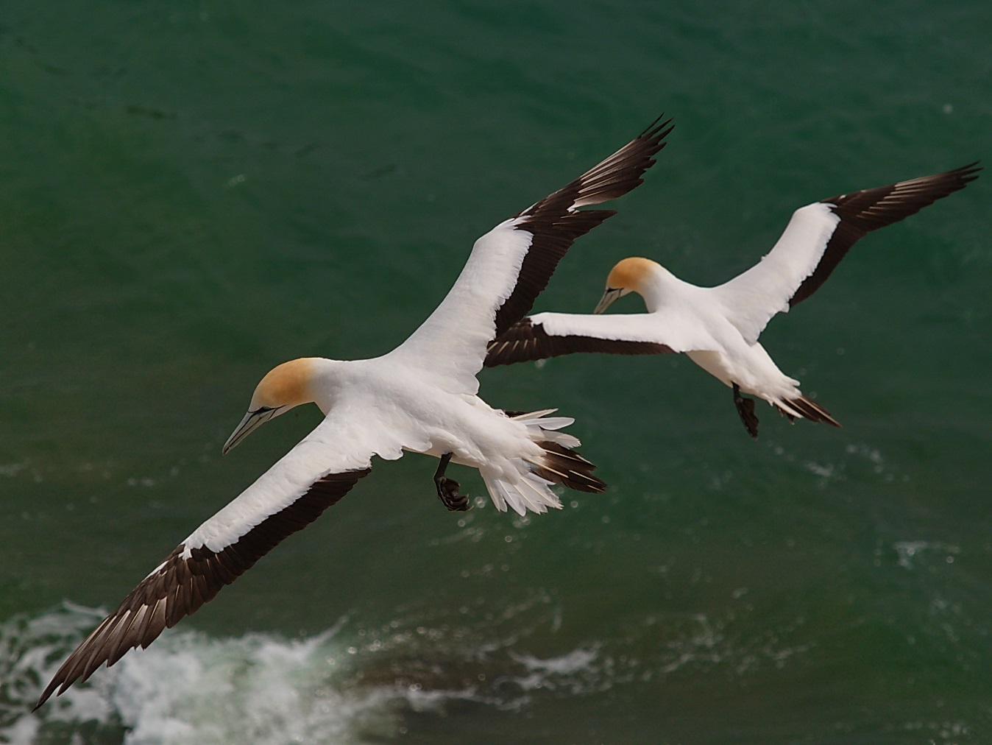
Australasian gannets (Alan Danks)

The Temperate East Marine Region
The Temperate East Marine Region (region) extends from the southern boundary of the Great Barrier Reef Marine Park to Bermagui in southern New South Wales, as well as the waters surrounding Lord Howe and Norfolk islands. The region covers approximately 1.47 million km² of temperate and subtropical waters and abuts the coastal waters of southern Queensland and New South Wales (Figure 2.1).
Traditional owners have managed and used sea country within the region for tens of thousands of years. They use and actively manage the coastal and marine environments of the region as a resource and to maintain cultural identity, health and wellbeing. Fishing, hunting and the maintenance of culture and heritage through ritual, stories and traditional knowledge continue as important uses of near shore and adjacent areas.
The region is popular for activities such as fishing, snorkelling, diving and boating. Tourism operators offer unique experiences for visitors to enjoy the offshore reefs, islands, cays and deep-water environments. Although many of the marine parks are remote and far offshore, opportunities exist for recreational use, particularly around Solitary Islands, Norfolk and Lord Howe Marine Parks.
There are significant industries in the region, including commercial fishing and shipping that contribute to economic growth, employment and social wellbeing in adjacent towns and communities. Activities and businesses that support these industries such as marine industry suppliers and repair yards are also important sources of employment for coastal communities.
The marine environment of the region is characterised by continental shelf, slope, and abyssal plain/deep ocean floor, with significant variation in seafloor features including tropical and cold-water reef systems, seamounts and canyons. Linking these habitats are strong ocean currents that greatly influence and structure the region’s productivity and biological diversity. The East Australian Current is the dominant oceanographic influence, bringing warm waters from the Coral Sea down the outer edge of the continental shelf, extending the range of tropical species into subtropical and temperate waters. For this reason, the region supports high levels of species richness and diversity, particularly among corals, crustaceans, echinoderms, molluscs, sea sponges and fish. This is particularly true in places like Lord Howe Island and Elizabeth and Middleton Reefs, where both warm and cold-water species flourish alongside each other.
The region has high species diversity, globally significant populations of internationally threatened species and a small number of species found nowhere else. It supports biologically important areas for species, including sharks, whales and seabirds. For example the east coast population of grey nurse shark (Carcharias taurus) and migratory white shark (Carcharodon carcharias) aggregate off the coast of New South Wales, while migratory humpback whale (Megaptera novaeangliae) migrate through the region to and from breeding grounds in Queensland. The region also includes important offshore reef habitat at Elizabeth and Middleton Reefs, Lord Howe Island and Norfolk Island. These sites support the vulnerable black cod, are the southernmost extent of many reef-building coral species, and are important breeding, foraging and feeding areas for several species of seabird. Other species known to occur in the region include species of marine turtle and bony fish.
Further information about the region can be found in the Marine bioregional plan for the Temperate East Marine Region (2012), and the East marine bioregional plan: bioregional profile (2009) (available on the Department’s website), and the marine park values in Section 2.3 and Schedule 2 of this plan.
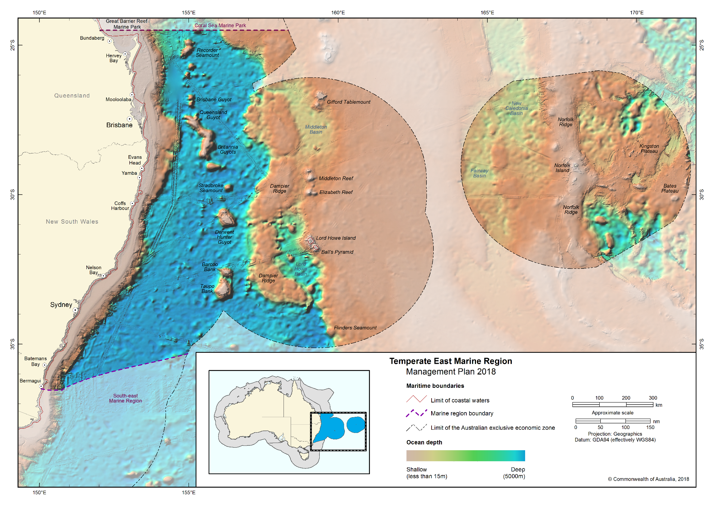Figure 2.1 Temperate East Marine Region

The Temperate East Marine Parks Network
The Temperate East Network (Figure 2.2) covers 383,339 km² and includes eight marine parks. An overview of the marine parks and their values is provided in Schedule 2.
The Temperate East Network comprises the following marine parks:
- Gifford Marine Park
- Norfolk Marine Park
- Lord Howe Marine Park
- Central Eastern Marine Park
- Solitary Islands Marine Park
- Cod Grounds Marine Park
- Hunter Marine Park
- Jervis Marine Park
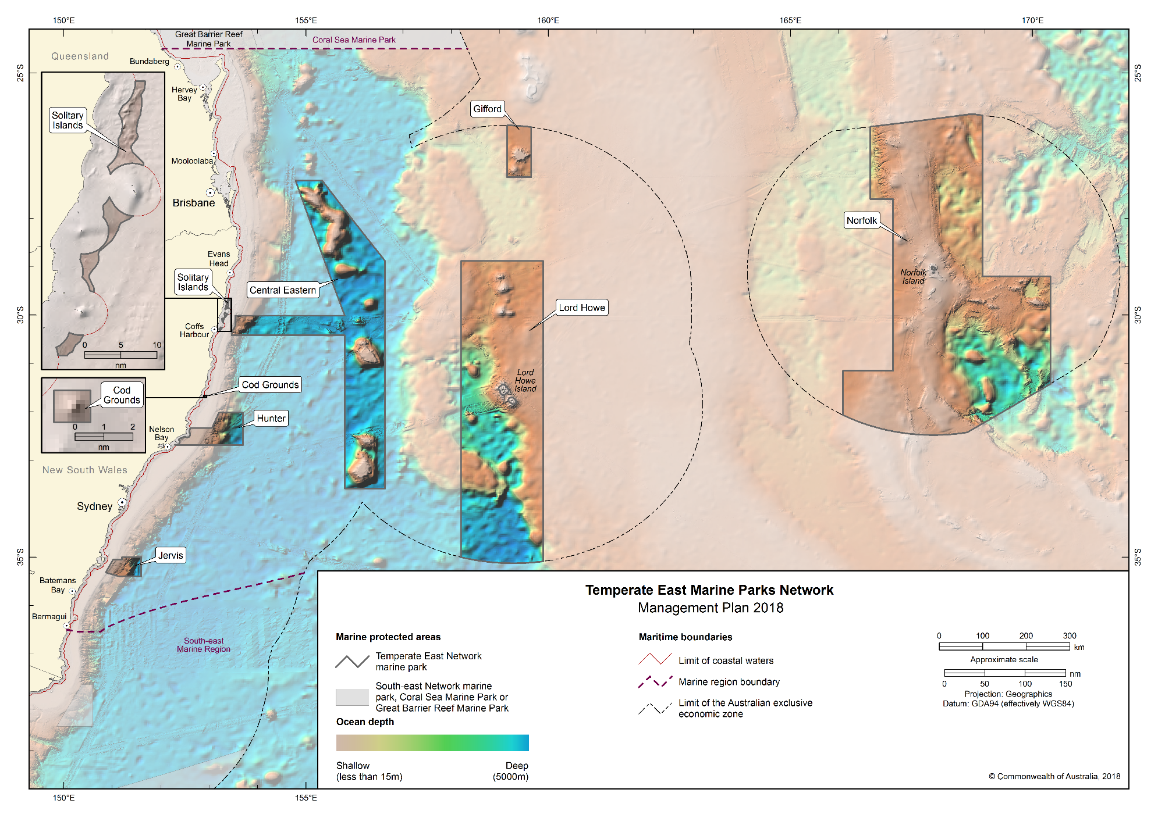Figure 2.2 Temperate East Marine Parks Network

Values of the Temperate East Network
Values are broadly defined as:
- Natural values—habitats, species and ecological communities within marine parks, and the processes that support their connectivity, productivity and function.
- Cultural values—living and cultural heritage recognising Indigenous beliefs, practices and obligations for country, places of cultural significance and cultural heritage sites.
- Heritage values—non-Indigenous heritage that has aesthetic, historic, scientific or social significance.
- Socio-economic values—the benefit of marine parks for people, businesses and the economy.
A summary of the values of the Temperate East Network is provided in Table 2.1. The values of individual marine parks are set out in Schedule 2. As outlined in Part 1, in managing marine parks, the Director will need to make decisions about what activities can occur in the marine parks and what actions to take to manage them. This will involve the Director making decisions that carefully balance the need to protect natural, cultural, heritage and socio-economic values of marine parks with enabling use and managing pressures.
In making these decisions, the Director will carefully consider the impacts and risks to natural, cultural, heritage or socio-economic values for the relevant marine park/s. The Director will also consider any positive impacts associated with allowing an activity, such as socio-economic or cultural benefits, and ensure that activities are undertaken in a manner that minimises negative impacts.
For some marine parks, such as the Lord Howe Marine Park, there is a relatively strong understanding of park values. Where there is less information, environmental features are used as indicators for the types of species and habitats likely to occur. These include bioregions, water depth, seafloor features and key ecological features (Schedule 3).
As understanding of marine park values improves over the life of this plan, the Director will make new information about values available on the Parks Australia website. Other important sources of information on values (also on the Department’s website) include:
- Species profile and threats database for protected species;
- Directory of important wetlands in Australia;
- Australian heritage database for natural, historic and Indigenous heritage places;
- Australian national shipwreck database for known shipwrecks;
- National Conservation Values Atlas;
- Marine bioregional plan for the Temperate East Marine Region (2012); and
- East marine bioregional plan: bioregional profile (2009).

Table 2.1 Summary of values in the Temperate East Network
Statement of significance
The Temperate East Network was designed to protect representative examples of the region’s ecosystems and biodiversity in accordance with the Goals and principles for the establishment of the National Representative System of Marine Protected Areas in Commonwealth waters (ANZECC, 1998).
Natural values
Bioregions—the Temperate East Marine Region is divided into areas of ocean with broadly similar characteristics based on the distribution of marine species and seafloor features. The Network represents examples of the region’s marine environments including ecosystems, species and habitats. There are seven bioregions represented in the Temperate East Network (Schedule 2).
Key ecological features—elements of the marine environment considered to be of importance for biodiversity or ecosystem function and integrity, represented in the Network are:
- Lord Howe seamount chain;
- Tasmantid seamount chain;
- Norfolk Ridge;
- Shelf rocky reefs;
- Tasman Front and eddy field; and
- Canyons on the eastern continental slope.
Species and habitats—all species and habitats are important components of the ecosystems represented in the Temperate East Network. Many species are protected under the EPBC Act and international agreements such as the Convention on the Conservation of Migratory Species (CMS or Bonn Convention), the Japan– Australia Migratory Bird Agreement (JAMBA), the China–Australia Migratory Bird Agreement (CAMBA), and the Republic Of Korea–Australia Migratory Bird Agreement (ROKAMBA). Further information on these agreements is in Schedule 1.
The Temperate East Network supports important habitats, including biologically important areas, for a range of protected species. Biologically important areas are where aggregations of individuals of a protected species breed, forage or rest during migration. More information on protected species and biologically important areas can be found in the Marine bioregional plan for the Temperate East Marine Region (2012) and the conservation values atlas on the Department’s website.
The coral reefs of Emily Bay and Slaughter Bay in the Norfolk Marine Park are the eastern-most coral reefs in Australian waters, and contain a unique reef fish assemblage of endemic, sub-tropical and temperate species.
Elizabeth and Middleton Reefs Ramsar site
The Elizabeth and Middleton Reefs Ramsar site is located within the Lord Howe Marine Park. The site was listed under the Ramsar Convention in 2002 and is a wetland of international importance under the EPBC Act. The reefs form the southernmost open-ocean reef platform in the world and support internationally significant populations of seabirds and shorebirds.
Cultural values
Aboriginal people of eastern Australia have been sustainably using and managing their sea country for thousands of years, in some cases since before rising sea levels created these marine environments. Sea country refers to the areas of the sea that Aboriginal people are particularly affiliated with through their traditional lore and customs. Sea country is valued for Indigenous cultural identity, health and wellbeing.
Aboriginal people continue to assert inherited rights and responsibilities over sea country within the Temperate East Network. It is recognised that spiritual corridors extend from terrestrial areas into nearshore and offshore waters, that a number of marine animals are totems for Indigenous people, and that songlines pass through marine parks.
Heritage values
Protected places (world, national and Commonwealth heritage, historic shipwrecks)
The EPBC Act protects matters of national environmental significance that are classified as protected places, including world heritage properties and national heritage places. Places on the Commonwealth Heritage List or shipwrecks listed under the Historic Shipwrecks Act 1976 are also protected places.
Historic shipwrecks are a unique historic value and the region is an area of considerable importance in Australia’s maritime history. The Temperate East Network includes many historic shipwrecks that can be found in the Australian national shipwrecks database, such as the HMS Sirius, a flagship of the First Fleet, which was wrecked on the coral reef off Slaughter Bay, Norfolk Island in 1790.
The Temperate East Network includes the following internationally listed place:
Lord Howe Island Group World Heritage Property
The Lord Howe Island Group World Heritage Property is in and adjacent to the Lord Howe Marine Park. The property was inscribed on the World Heritage List by the World Heritage Committee in 1982 on the basis of its outstanding universal value. It supports a number of endemic species or subspecies of plants and animals.
Social and economic values
The Temperate East Network supports a range of important social and economic uses that underpin the prosperity and wellbeing of regional communities (Figure 2.3).
Commercial fishing, shipping and port-related activities, and tourism are industries of national economic significance.
Marine tourism activities, including charter fishing, snorkelling, diving and wildlife watching are also important commercial activities that offer unique visitor experiences to reefs, islands and lagoons particularly around Lord Howe and Norfolk Marine Parks. The Network also supports a range of recreational activities including fishing.
The island communities of Norfolk Island and Lord Howe Island have a particularly strong affinity and historic connection to the ocean surrounding them as a source of food and for a range of social and economic benefits. The Norfolk Marine Park includes waters up to the high water mark, which incorporate a wide range of near-shore values and uses by the Norfolk community and visitors

Pressures in the Temperate East Network
Pressures are human-driven processes, events and activities that, if left unchecked, may impact on marine park values. Contemporary drivers of environmental change in the marine environment include population growth and economic activity, and related pressures such as increased vessel activity, marine debris, climate extremes and ocean warming. Figure 2.3 shows the types of uses occurring across the Temperate East Network. These present key challenges for biodiversity conservation and sustainable management of our marine resources, including in Australian Marine Parks.
Australia’s 2016 State of the environment report reviewed pressures on Australia’s marine environment and determined that they were low by global standards. However, given that more than 85 per cent of Australians live within 50 km of the sea, and with Australia’s population of approximately 24.4 million projected to grow to 39.7 million by 2055, pressures on the marine environment are likely to increase.
Although pressures on marine ecosystems and biodiversity in the Temperate East Network may change over time, examples of pressures in the Network are outlined in Table 2.2. Research in the Great Barrier Reef Marine Park and elsewhere in the world has demonstrated that effective management of marine parks, helps to maintain the resilience of marine ecosystems and their ability to withstand and recover from such pressures.
In determining the management actions to be taken in the Temperate East Network and in making decisions about the activities that will be allowed to occur within marine parks, the Director will carefully consider how the values outlined in Section 2.3 and in Schedule 2 will be impacted by these pressures now and in the future.
Pressures such the extraction of living resources by fishing, and habitat modification through installation of infrastructure and anchoring will be managed in part through the zones and rules set out in Parts 3 and 4 of this plan.
Table 2.2 Summary of pressures in the Temperate East Network
Climate change
The impacts of climate change on the marine environment are complex and may include changes in sea temperature, sea level, ocean acidification, sea currents, increased storm frequency and intensity, species range extensions or local extinctions, all of which have the potential to impact on marine park values. The International Panel on Climate Change recognises climate change as a major contributor to Australian marine ecosystem changes since 2007. Habitats vulnerable to the effects of climate change include Elizabeth and Middleton Reefs and other reef and fish communities.
Changes in hydrology
Rivers, estuaries and other waterways have the potential to discharge increased sediment loads and pollutants into the marine environment from activities such as coastal development and agriculture. This can result in increased turbidity and siltation, impacting on species that inhabit or spawn in coastal, estuary and offshore waters. Examples of habitat vulnerable to changes in hydrology include reefs and fish communities surrounding islands in the Temperate East Network.
Extraction of living resources
Australia’s world class fisheries management, led by Commonwealth, state and territory governments is important for ensuring sustainable fishing practices. Fishing, including illegal, unregulated and unreported fishing (including illegal foreign fishing), can modify natural populations of target species. Bycatch of non-target species and/or physical disturbance to habitats can result from certain fishing methods, and may therefore impact on marine park values. Examples of habitats, key ecological features and species vulnerable to such impacts include reef and shoal habitats, the Tasmantid and Lord Howe seamount chains, and species of shark, dolphin and fish.
Habitat modification
Commonwealth, state and territory governments play an important role in managing activities in the marine environment. For example, the National Offshore Petroleum Safety and Environmental Management Authority (NOPSEMA) works with the mining industry to ensure their environment plans address environmental management issues. Impacts on habitat in marine parks can occur directly through physical disturbance, or indirectly through the presence of infrastructure. For example, benthic communities are vulnerable to the discharge of sediments which can result in localised smothering of benthic biota and or reduction in the quality and quantity of light received at the seabed. In addition, modification of natural light through the installation of lighting associated with infrastructure can cause changes in animal behaviour. Examples of habitats and species vulnerable to habitat modification pressures include reef, shoal and pinnacle habitats, and species of seabirds, fish, dolphin and shark.
Human presence
Activities such as wildlife watching are a drawcard for people visiting marine parks. While enjoying the wildlife experience, it is important to be aware of the potential impacts of human presence on the natural behaviour of wildlife. Activities such as boating, camping, diving and snorkelling have the potential to impact marine park values directly through contact from collision or indirectly through changes in behaviour from disturbance. These activities may result in changes to wildlife behaviour such as nesting, breeding, feeding or resting, or may damage fragile marine environments e.g. reefs. Examples of habitats and species vulnerable to human disturbance include reef habitats, and species of dolphin and seabird.
Invasive species
Invasive species have the potential to impact on marine park values directly and indirectly. Potential sources of invasive species include vessel ballast and bilge water discharge, vessel biofouling, accidental or deliberate transport of species and land-based activities. Islands, reefs and other shallow-water ecosystems and native species are vulnerable to invasive species, from direct impacts such as predation or damage to important habitat e.g. nesting habitat, or indirect impacts such as competition with native species for habitat and food. Examples of habitats and species vulnerable to the impacts of invasive species include reef and island habitats and nesting seabirds.
Marine pollution
Marine and land-based activities have potential to result in marine pollution which may impact on marine park values. Pollution includes the emission of noise or light, marine debris (for example, plastics and lost fishing gear), and discharge of oil, chemicals or waste. Pollution can be detrimental to marine life, causing contamination of ecosystems, entanglement, or can be ingested by marine species. Examples of habitat, key ecological features and species vulnerable to marine pollution include island, reef, and other shallow-water habitats, Elizabeth and Middleton Reefs, and species of dolphin, whale and seabird.
Further information on pressures in the region is provided in the Marine bioregional plan for the Temperate East Marine Region (2012).
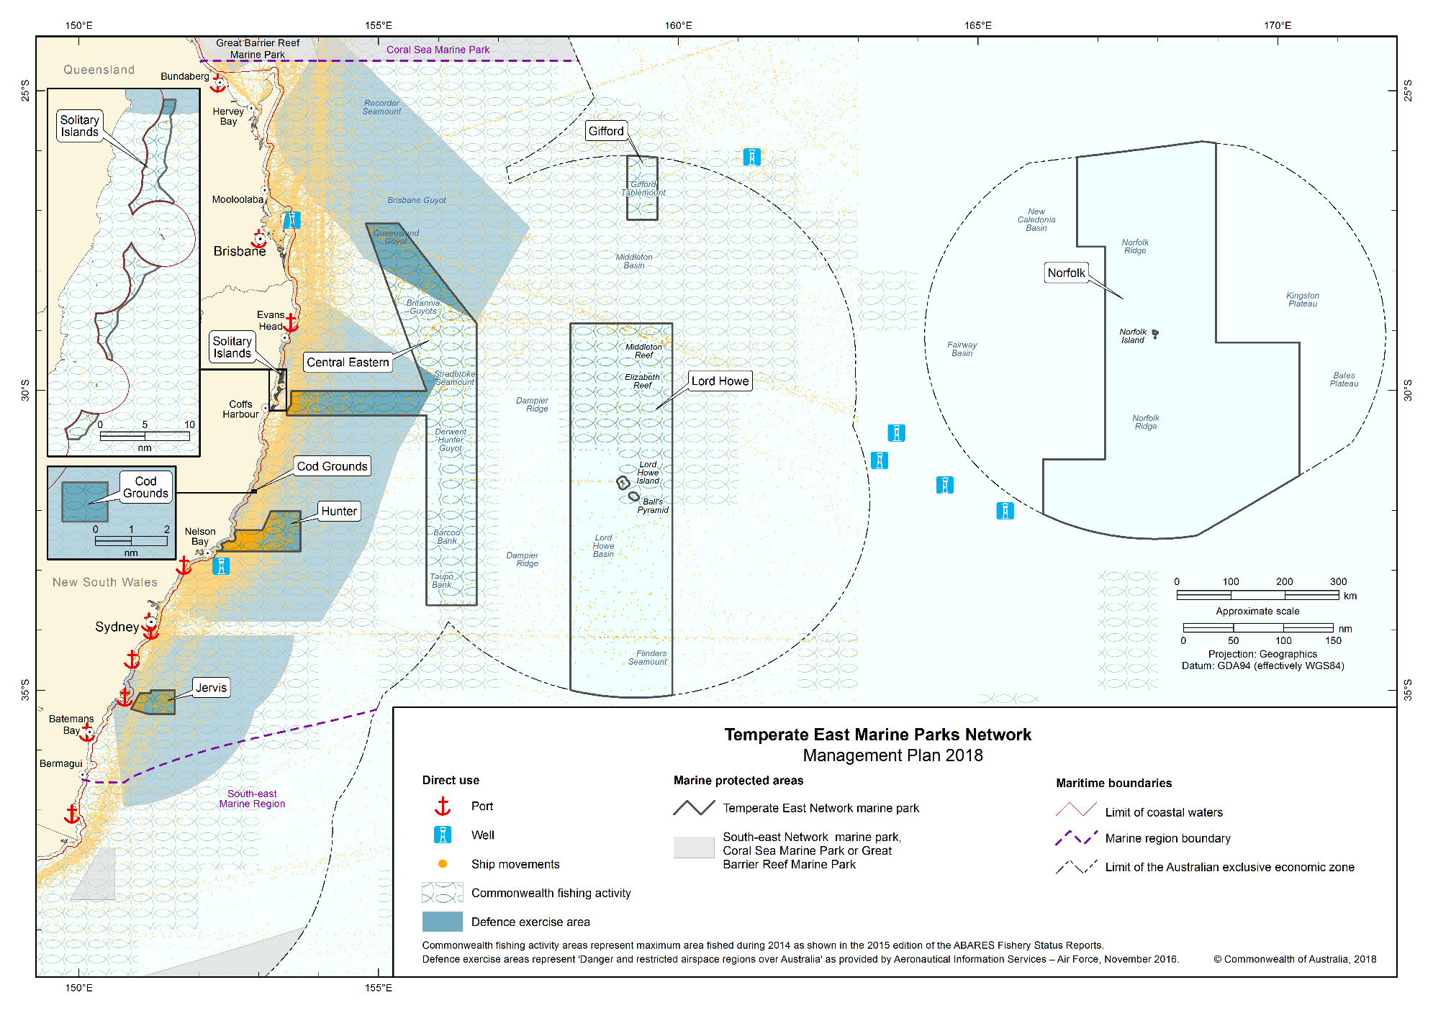Figure 2.3 Direct use in the Temperate East Network

Management programs and actions in the Temperate East Network
As outlined in Part 1, the Director will proactively implement management programs and actions to protect marine parks from threats and pressures, to minimise damage, and to rehabilitate and improve the resilience of marine parks.
These management programs and actions will be implemented on a national scale across all Australian Marine Parks. In addition, specific actions will be undertaken in the Temperate East Network. Table 2.3 outlines the management programs and actions likely to be undertaken in the Temperate East Network. These programs and actions may change during the life of this plan as new information and approaches become available. Additional actions will be developed in partnership with stakeholders through a network advisory committee and in implementation plans.
Table 2.3 Management programs, outcomes and actions in the Temperate East Network
Communication, education and awareness program
Actions to improve awareness, understanding and support for marine parks and park management.
Outcome
- Increased awareness, understanding and support for marine parks.
Actions—the Director will
under a national program:
- develop a marketing and communication strategy for Australian Marine Parks to raise awareness and understanding of marine park values and the contribution marine parks make to enhancing Australia’s wellbeing,
- develop online information resources to facilitate awareness of marine park values, management arrangements and visitor opportunities,
- maximise the use of new technologies and partnerships (including with schools, universities, museums and non-government organisations) to inspire people of all ages to become involved in marine park management and protection,
- establish network advisory committees to ensure users and interested stakeholders have on-going input to the management of Australian Marine Parks, and
- develop a customer focussed approach to tracking the aspirations and concerns of stakeholders in relation to marine parks.
in the Temperate East Network:
- develop information for visitors on marine parks in the Network to encourage increased awareness and understanding of their values and management arrangements,
- provide infrastructure in and adjacent to the Network, such as signs and marker buoys, to increase understanding of marine park values and rules, particularly at sites that are regularly visited,
- establish a Temperate East Network advisory committee/s or other engagement mechanisms to support and collaborate with the Director in management, and
- engage closely with Norfolk Marine Park and Lord Howe Marine Park users and communities about marine parks and opportunities.

Tourism and visitor experience program
Actions to provide for and promote a range of environmentally appropriate, high-quality recreation and tourism experiences and contribute to Australia’s visitor economy.
Outcomes
- High-quality visitor experiences that are appealing, engaging and raise awareness of the natural and cultural values of marine parks.
- Increased visitation to marine parks.
- Social and economic benefits from the contribution of marine parks to Australia's visitor economy.
Actions—the Director will
under a national program:
- develop a sustainable tourism and visitor experience strategy for Australian Marine Parks,
- work with national, state and local tourism authorities and operators to maximise the value of a sustainable ecotourism opportunities associated with marine parks,
- develop a commercial tourism authorisation system to encourage best-practice and eco-accredited businesses operating in Australian Marine Parks,
- work with Tourism Australia and state and regional tourism authorities and the fishing industry to market and promote Australian Marine Parks, including opportunities to promote locally caught and sustainably caught seafood,
- monitor visitor trends and levels of satisfaction with marine park experiences and products,
- promote culturally sensitive tourism by encouraging tourism operators to liaise with traditional owners, and
- work with tourism operators and Indigenous people to recognise and promote cultural values and cultural tourism opportunities.
in the Temperate East Network:
- promote visitor experiences that foster curiosity and appreciation of natural and heritage values in the Network, for example nature watching, diving or snorkelling at the Norfolk, Solitary Islands, Cod Grounds and Lord Howe Marine Parks, and
- work with other Commonwealth and state government agencies, the Norfolk Island Regional Council, Lord Howe Island Board, and the tourism industry to support tourism initiatives, events and attractions that promote visitor experiences in marine parks.
Indigenous engagement program
Actions to recognise and respect the ongoing cultural responsibilities of Indigenous people to care for sea country and support multiple benefits for traditional owners.
Outcomes
- Social, cultural and economic benefits for traditional owners.
- Partnerships with traditional owners and Indigenous groups to manage sea country in marine parks.
Actions—the Director will
under a national program:
- develop an Australian Marine Parks Indigenous engagement and cultural heritage strategy, to improve understanding of cultural heritage, link management with sea country plans and maximise employment and enterprise opportunities for traditional owners,
- develop agreements to support Indigenous ranger programs to deliver management in marine parks, and
- provide information to Indigenous people about marine park management.
in the Temperate East Network:
- collaborate with traditional owners and relevant partners such as the New South Wales Aboriginal Land Council on implementing the Indigenous engagement program, including supporting Indigenous groups to participate in marine park management,
- implement cultural awareness training for Parks Australia staff in association with traditional owners,
- establish protocols for researchers working with Parks Australia to guide engagement with traditional owners,
- identify opportunities and mechanisms to engage traditional owners including through coastal Local Aboriginal Land Councils, established under the Aboriginal Land Rights Act 1983 in the management of marine parks, and
- increase understanding of traditional knowledge and cultural values.

Marine science program
Actions to provide necessary scientific knowledge and understanding of marine park values, pressures, and adequacy of responses for effective management.
Outcomes
- Increase understanding of marine park values, pressures and adequacy of responses.
- Improve understanding of the effectiveness of marine park management in protecting park values.
- Informed decision-making and improved evidence-based decisions.
Actions—the Director will
under a national program:
- establish ecological, social and economic baselines to support evidence-based decision-making and adaptive management,
- develop an Australian Marine Parks science strategy to prioritise and encourage research and monitoring of park values, pressures and management effectiveness, and foster science communication and knowledge uptake,
- encourage and facilitate knowledge brokering to support collaboration and partnerships with the science community, private enterprise, citizen science organisations and other Commonwealth, state and territory agencies,
- establish an authorisation system for scientific research and monitoring by third parties, and encourage data to be made publicly available through the appropriate information portals such as the Australian Ocean Data Network,
- collaborate with the science community (including through the National Marine Science Committee and the National Environmental Science Program) and other marine park users to assist in improving the understanding of marine park values, pressures and management effectiveness, and
- collaborate with the science community and other government agencies to increase the use of innovative and effective technology and systems including sensor technology.
in the Temperate East Network:
- monitor the social and economic uses and their benefits and impacts on marine parks in the Network,
- monitor the condition of important habitats and their vulnerability to climate change,
- monitor the impact of invasive species on marine park values and the effectiveness of management,
- collaborate with other Commonwealth and state government agencies, the Norfolk Island Regional Council, Lord Howe Island Board, marine park users, and the science sector to support long-term monitoring. For example, monitoring of coral reefs, protected species and effects of fishing on marine parks, and
- investigate opportunities to extend citizen science programs.
Assessments and authorisations program
Actions to provide for efficient, effective, transparent and accountable assessment, authorisation and monitoring processes to enable sustainable use and protection of marine park values.
Outcome
- Assessments and authorisations ensure ongoing protection of marine park values through the management of activities in marine parks.
Actions—the Director will
under a national program:
- develop and apply best-practice approaches to regulation and decision-making in the authorisation of activities within marine parks. This includes developing policy to ensure assessment and authorisation requirements are clearly articulated and that decision making is robust, consistently applied, and transparent to all marine park users,
- collaborate with industry to investigate innovative technologies and systems (including vessel monitoring systems) that can assist businesses and individuals to comply with regulatory requirements,
- develop an effective and efficient process to assess new technologies and gear types to allow for the use of new equipment during the life of this plan if appropriate,
- develop a guarantee of service for the regulated community that includes a commitment to work with key marine park users and interest groups whose interests are likely to be affected by regulatory decisions, and
- develop a customer focused online authorisation system for marine park users that includes publishing authorisations issued by Parks Australia on its website.
in the Temperate East Network:
- issue authorisations—permit, class approval, activity licence or lease—for activities in marine parks assessed as acceptable either by the Director or another government or industry policy, plan or program accepted by the Director, and
- work with other Commonwealth and state government agencies, the Norfolk Island Regional Council, and the Lord Howe Island Board, to improve experiences and consistency of approaches for people seeking authorisations.

Park protection and management program
Timely and appropriate preventative and restorative actions to protect natural, cultural and heritage values from impacts.
Outcome
- Impact of pressures on marine park values are minimised as far as reasonably practicable.
Actions—the Director will
under a national program:
- apply a risk-based assessment process to prioritise park protection and management actions,
- develop an Australian Marine Parks critical incident strategy in collaboration with the Australian Maritime Safety Authority and other responsible agencies, to respond to critical incidents,
- develop a mooring and anchoring strategy to protect marine park values and improve visitor experience,
- support the removal of marine debris and ghost nets from marine parks through partnerships with Commonwealth, state and territory government agencies and other organisations involved in the management of marine debris, and
- contribute to actions, where appropriate, that support Australia’s obligations under international agreements and national environmental law. This includes the World Heritage Convention, Ramsar Convention, recovery plans, wildlife conservation plans and threat abatement plans.
in the Temperate East Network:
- enable infrastructure such as moorings to protect habitats and enhance visitor safety,
- collaborate with and support other agencies that undertake invasive and protected species management and marine debris removal. For example, this may include working in partnership with relevant agencies to foster high standards of biosecurity, particularly in sensitive marine ecosystems and World Heritage-listed areas of the Lord Howe Marine Park
- work with other Commonwealth and state government agencies, the Norfolk Island Regional Council, and Lord Howe Island Board, to respond to environmental incidents and accidents, and
- collaborate with traditional owners and Indigenous ranger groups to undertake management actions.

Compliance program
Actions to support appropriate and high level compliance by marine park users with the rules set out in this plan.
Outcomes
- Improved user awareness of marine park rules.
- Increased levels of voluntary compliance and self-regulation by marine park users.
- High overall levels of compliance with the rules by marine park users.
- A decrease in the number of non-compliances.
Actions—the Director will
under a national program:
- apply a risk-based approach to compliance planning, targeted enforcement and compliance auditing,
- collaborate with Australian, state and territory government agencies by sharing assets and information,
- investigate the use of new technologies and warning systems to assist in the detection of potential illegal activities, and
- work with marine park users to promote understanding of the rules for activities and how to comply.
in the Temperate East Network:
- work with other Commonwealth and state government agencies, the Norfolk Island Regional Council, and Lord Howe Island Board, particularly where marine parks adjoin state marine parks, in compliance planning, including implementing actions to deter illegal activities and encourage voluntary compliance, and
- collaborate with Commonwealth and state government agencies, the Norfolk Island Regional Council, and Lord Howe Island Board, in surveillance, including water and aerial patrols.

