Glossary
action | Has the meaning given by Subdivision A of Division 1 of Part 23 of the EPBC Act.
artificial reef | Has the meaning given by the Environment Protection (Sea Dumping) Act 1981, namely, a structure or formation placed on the seabed:  (a) for the purpose of increasing or concentrating populations of marine plants and animals; or  (b) for the purpose of being used in human recreational activities.
Australian Government or the Government | The Government of the Commonwealth of Australia.
Australian Marine Parks or Marine Park | Commonwealth reserves, named as Marine Parks, comprising the South-west, North-west, North and Temperate East Networks of Marine Parks and the Coral Sea Marine Park declared by the Environment Protection and Biodiversity Conservation (Commonwealth Marine Reserves) Proclamation 2013, and the reserves comprising the South-east Commonwealth Network of Marine Parks declared by the Proclamations made under the EPBC Act on 28 June 2007.
authorisation | As described in Section 4.4 (Authorisation of activities) of this plan.
biodiversity or biological diversity | Has the meaning given by s.528 of the EPBC Act.
biologically important areas | Areas where a protected species displays a biologically important behaviour such as breeding, foraging, resting or migration. These areas serve to highlight the parts of a marine region that are particularly important for the conservation of protected species.
bioregion | A large area that has similar types of plants, animals and ocean conditions compared with other similarly sized areas, and, in this document, those bioregions as defined in the Integrated Marine and Coastal Regionalisation of Australia Version 4.0.
bioregional plan | Has the meaning given by s.528 of the EPBC Act.
CAR | Comprehensiveness—includes the full range of ecosystems recognised at an appropriate scale within and across each bioregion;  Adequacy—the maintenance of the ecological viability and integrity of populations, species and communities; and  Representativeness—those marine areas that are selected for inclusion in reserves should reasonably reflect the biotic diversity of the marine ecosystems from which they derive.
class approval | As described in Section 4.4.2 (Class approvals) of this plan.
commercial aquaculture | Farming and culturing of aquatic organisms, such as fish, crustaceans and molluscs.
commercial fishing | Has the meaning given by s.390SC (1A) of the EPBC Act: a fishing activity that is engaged in for a commercial purpose, and, to avoid doubt, does not include an activity that constitutes recreational fishing.
Commonwealth marine area | Has the meaning given by s.24 of the EPBC Act.
Commonwealth marine environment | The environment in the Commonwealth marine area.
Commonwealth reserve | A reserve established and managed under Division 4 of Part 15 of the EPBC Act, including Australian Marine Parks.
Danish seine | A net connected to two long, weighted ropes on either side used to surround fish. An anchor buoy is deployed first to hold the line in place while the net and remaining line is paid out in a circular pattern around the target area. The boat then either steams slowly away or remains stationary while the net is hauled on board.
Department | The Department responsible for administering the EPBC Act.
Director | The Director of National Parks established under s.514A of the EPBC Act, including any person to whom the Director has delegated powers and functions under the EPBC Act in relation to the Temperate East Marine Parks Network.
dropline | A line that is vertically set or suspended in the water column between a weight (normally in contact with the seabed) and a vessel or a buoy on the water surface. Baited hooks are attached to the main line via smaller lines (branch-lines or snoods).
ecologically sustainable use | Has the meaning given by s.528 of the EPBC Act.
ecosystem | Has the meaning given by s.528 of the EPBC Act.
endemic/endemism | Native to or confined to a certain region.
environment | Has the meaning given by s.528 of the EPBC Act.
EPBC Act | Environment Protection and Biodiversity Conservation Act 1999, including any Act amending, repealing or replacing the Act.
EPBC Regulations | Environment Protection and Biodiversity Conservation Regulations 2000, including any Regulations amending, repealing or replacing the Regulations.
fish aggregating device | Has the meaning given by the Sea Installation Act 1987, namely:  (a) a man-made structure that, when in, or brought into, physical contact with the seabed or when floating, is used solely for the purpose of attracting populations of fish so as to facilitate the taking of those fish; or  (b) any electronic or other equipment designed or intended to be ancillary to, or associated with, such a structure while it is being used, or in order to facilitate the use of the structure, for that purpose;  and do not include a net, trap or other equipment for taking, catching or capturing fish.
hand collection | Removing species from rocks, crevices, the seafloor or other benthic substrate by hand using dive hookah, self-contained underwater breathing apparatus (scuba) or snorkel.
hand net (hand, barrier, skimmer, cast, scoop, drag, lift) | A small mesh net that is operated by hand to trap fish including a hand net, barrier net, skimmer net, cast net, scoop net, drag net, lift net.
Indigenous Protected Area (IPA) | An Indigenous Protected Area (IPA) is an area voluntarily dedicated for protection by Indigenous groups on Indigenous owned or managed land or sea country. IPAs are recognised by the Australian Government as part of the National Reserve System, protecting the nation’s biodiversity for the benefit of all Australians. Most IPAs are dedicated to promote a balance between conservation and other sustainable uses to deliver social, cultural and economic benefits for local Indigenous communities. IPAs combine traditional and contemporary knowledge into a framework to leverage partnerships with conservation and commercial organisations and provide employment, education and training opportunities for Indigenous people.
Integrated Marine and Coastal Regionalisation of Australia (IMCRA) | A spatial framework for classifying Australia’s marine environment into bioregions that forms the basis for the development of a National Representative System of Marine Protected Areas.
IUCN | International Union for the Conservation of Nature.
key ecological feature | Elements of the Commonwealth marine environment that, based on best available scientific understanding, are considered to be of regional importance for either the region's biodiversity or ecosystem function and integrity.
longline (demersal, auto-longline) | A line that is horizontally set along the seafloor between weights to maintain contact with the seafloor. The main line has a vertical line attached at each end which is connected to buoys on the water surface. Baited hooks are attached to the main line via smaller lines (branch-lines or snoods). An auto-longline is a longline where the hooks are baited by a machine rather than manually.
longline (pelagic) | A line that is horizontally set near the surface of the water and avoids contact with the seafloor. The main line has a vertical line attached at each end which is connected to buoys on the surface of the water. Baited hooks are attached to the main line via smaller lines (branch-lines or snoods). Buoys are generally used intermittently along the main line to help maintain buoyancy in the water column. The line may be left to drift in the water or be anchored by vertical lines to the seafloor.
management category | An IUCN category prescribed by Schedule 8 of the EPBC Regulations.
management plan or the plan or this plan | This management plan unless otherwise stated.
management principles | Australian IUCN reserve management principles prescribed by r.10.04 and Schedule 8 of the EPBC Regulations.
MARPOL | The International Convention for the Prevention of Pollution from Ships (MARPOL) is the International Maritime Organisation (IMO) convention covering prevention of pollution of the marine environment by ships from operational or accidental causes. This is the main international convention for the prevention of ship-sourced pollution in the marine environment. MARPOL addresses pollution that might result from accidents such as collisions or groundings, as well as all types of waste generated during the normal operation of a ship. Ships are permitted to discharge small quantities of certain wastes, subject to very strict controls.
mining operations | Has the meaning given by s.355(2) of the EPBC Act.
Minister | The Minister responsible for administering the EPBC Act.
minor line (handline, rod & reel, trolling, squid jig, poling) | Any line fishing with a small number of hooks, often just one (i.e. handline, rod and reel, squid jigging and pole fishing). Trolling is dragging a lure or baited hook behind a moving vessel and reeling it in (either by hand, reel or winches). Poling is dragging a lure or baited hook on a fixed length of line behind a vessel and flicking or gaffing the fish into the boat. Squid jigging involves vertical lines with several barbless lures being mechanically jigged up and down to attract squid.
National Representative System of Marine Protected Areas (NRSMPA) | Australia’s comprehensive, adequate and representative system of marine protected areas that contributes to the long-term ecological viability of marine and estuarine systems, maintains ecological processes and systems, and protects Australia's biological diversity at all levels.
native title | Has the meaning given by s.223 of the Native Title Act 1993.
net (demersal) | A rectangular mesh net anchored to the seafloor with weights. The net may have small floats along the upper line to maintain its shape in the water. Each end has a vertical line that is connected to buoys on the surface of the water.
net (pelagic) | A rectangular mesh net set near the surface of the water that is not in contact with the seafloor. The net generally has floats along the upper line to maintain buoyancy. Each end is connected to a buoy on the surface of the water. The net can be left to drift or connected to a boat.
news of the day | The reporting by newspaper, television, radio or other electronic media, of unanticipated events that happen from time to time, such as rescue events. It does not include general items about a marine park or planned activities in the park.
Parks Australia | The Division of the Department that supports the Director of National Parks.
pelagic fishing gear | Fishing gear that does not come in contact with the seabed during use.
permit | As described in Section 4.4.1 (Permits) of this plan.
prescription | Mandatory rules for managing marine parks.
protected species | Species listed under the EPBC Act as threatened, migratory or marine species and/or cetaceans (whales, dolphins and porpoises).
purse seine | A semi-rectangular mesh net with floats along the top and a weighted line along the bottom. A vessel or buoy is used to anchor one end of the net while it is set around a fish aggregation in a circular pattern. The bottom of the net has a cable threaded through it which, when pulled, brings the bottom of the net together like a purse trapping the fish inside. The net is then pulled toward the vessel and the fish are either lifted or pumped on board the vessel.
recreational fishing | Taking marine species, including shells, not for commercial purposes and that is not commercial fishing.
sea country | Sea country refers to the areas of the sea that Aboriginal and Torres Strait Islander groups are particularly affiliated with through their traditional lore and customs.
stowed and secured | All fishing apparatus, including nets and lines, are rendered inoperative in zones where fishing is not permitted, including that the apparatus is inboard the vessel and otherwise completely out of the water or as determined by the Director.
Temperate East Marine Parks Network, or Temperate East Network, or the Network | The eight areas described in Schedule 2 to the Environment Protection and Biodiversity Conservation (Commonwealth Marine Reserves) Proclamation 2013, and declared to be Commonwealth reserves by Section 6 of the proclamation.
traditional owners | A local descent group of Indigenous persons who have common spiritual affiliations to an area of sea country and are entitled by Indigenous traditions to fish and hunt in an area of sea country.
transit | Continuous and expeditious passage through an area. However, passage includes stopping and anchoring, but only in so far as rendered necessary by force majeure or distress or for the purpose of rendering assistance to persons, ships or aircraft in danger or distress.
trap, pot | Traps and pots are made in a variety of shapes and sizes from various materials. They are generally baited to attract fish or crustaceans through one or more entrances or openings. Traps and pots are set on the seafloor and connected to a vertical line with a buoy on the surface of the water.
trawl (demersal) | A cone-shaped mesh net towed through the water column on or near the seabed that may come into contact with the seabed during use. The net is held open horizontally by otter boards or trawl doors while towing. The bottom of the net opening generally has chains, rubber or steel bobbins and spacers threaded along its length to help reduce snagging by slightly lifting the net off the seafloor. The last section of the net is a cod end where the catch is retained. Long metal cables connect the net and boards to a vessel. The cable length and mesh size varies depending on the species being targeted (fish or prawns). These nets can be towed by one vessel in various configurations such as one or four nets.
trawl (midwater) | A cone-shaped mesh net towed through the water column that does not come into contact with the seabed at any stage during use. The net is held open horizontally by otter boards or trawl doors while towing. The bottom of the net opening is weighted. The last section of the net is a codend where the catch is retained. Long metal cables connect the net and boards to a vessel. The cable length and mesh size varies depending on the species being targeted (fish or prawns). These nets can be towed by one vessel in various configurations, such as one or four nets.
trotline | A trotline is very similar to a demersal longline. It is a line that is horizontally set along the seafloor. The main line has a vertical line attached at each end which is connected to buoys on the surface of the water. Baited hooks are attached to the main line via smaller lines (branch-lines or snoods). Buoys are used intermittently along the main line to lift baited hooks away from the seafloor.
UNCLOS | United Nations Convention on the Law of the Sea, concluded at Montego Bay on 10 December 1982.
values | As defined in Part 2 of this plan.
vessel identification and monitoring system | A system whereby vessels are fitted with an electronic device that can transmit or provide information to a central management agency about the vessels’ course or position, or other such information.

Schedule 1 Summary of legislative and policy contexts

S1.1 The EPBC Act and EPBC Regulations
The objects of the EPBC Act (s.3) are:
- to provide for the protection of the environment, especially those aspects of the environment that are matters of national environmental significance;
- to promote ecologically sustainable development through the conservation and ecologically sustainable use of natural resources;
- to promote the conservation of biodiversity;
ca) to provide for the protection and conservation of heritage;
- to promote a co-operative approach to the protection and management of the environment involving governments, the community, landholders and Indigenous peoples;
- to assist in the co-operative implementation of Australia’s international environmental responsibilities;
- to recognise the role of Indigenous people in the conservation and ecologically sustainable use of Australia’s biodiversity; and
- to promote the use of Indigenous people’s knowledge of biodiversity with the involvement of, and in cooperation with, the owners of the knowledge.
Director of National Parks
The Director of National Parks is a corporation under the EPBC Act (s.514A) and a Commonwealth corporate entity for the purposes of the Public Governance Performance and Accountability Act 2013. The corporation is controlled by the person appointed by the Governor-General to the office that is called the Director of National Parks (s.514F of the EPBC Act).
The functions of the Director (s.514B) include the administration, management and control of Commonwealth reserves, including Australian Marine Parks, established under the EPBC Act. The Director generally has power to do all things necessary or convenient for performing the Director’s functions (s.514C). The Director has a number of specified powers under the EPBC Act and EPBC Regulations, including to prohibit or control some activities, and to issue permits for activities that are otherwise prohibited. The Director performs functions and exercises powers in accordance with this plan.
Establishment of Commonwealth reserves
Commonwealth reserves, including Australian Marine Parks, are declared by proclamation by the Governor-General under the EPBC Act. The EPBC Act and the EPBC Regulations provide the legal basis and framework for management of Commonwealth reserves.
Commonwealth reserves can be declared over areas specified in s.344 of the EPBC Act, including the Commonwealth marine area as defined in s.24 of the Act (which extends generally from the three nautical mile limit of the coastal waters of the states and territories to the outer limit of Australia’s exclusive economic zone). The Commonwealth marine area is also a matter of national environmental significance protected from significant impacts to the environment by Part 3 of the EPBC Act.

IUCN categories and management principles
The International Union for the Conservation of Nature (IUCN) sets out guidelines for categorising protected areas, which Australia and many other countries have adopted as a national standard. The EPBC Act requires Commonwealth reserves, and any zones into which a reserve is divided, to be assigned to one of the seven categories prescribed by the EPBC Regulations (r. 10.03H), which correspond to the categories identified by the IUCN:
- strict nature reserve (category Ia);
- wilderness area (category Ib);
- national park (category II);
- natural monument (category III);
- habitat/species management area (category IV);
- protected landscape/seascape (category V); or
- managed resource protected area (category VI).
Reserve management must be consistent with the relevant Australian IUCN reserve management principles prescribed for each category by Schedule 8 to the EPBC Regulations and set out below:
General administrative principles
Part 1 of Schedule 8 of the EPBC Regulations sets out general administrative principles applicable to all Commonwealth reserves. These principles underpin management approaches with regard to:
- community participation—management arrangements should, to the extent practicable, provide for broad and meaningful participation by the community, public organisations and private interests in designing and carrying out the functions of a reserve or zone;
- effective and adaptive management—management arrangements should be effective and appropriate to the biodiversity objectives and the socio-economic context of the reserve or zone. They should be adaptive in character to ensure a capacity to respond to uncertainty and change;
- the precautionary principle—a lack of full scientific certainty should not be used as a reason for postponing measures to prevent degradation of the natural and cultural heritage of a reserve or zone where there is a threat of serious or irreversible damage;
- minimising impacts—the integrity of a reserve or zone is best conserved by protecting it from disturbance and threatening processes. Potential adverse impacts on the natural, cultural and social environment and surrounding communities should be minimised as far as practicable;
- ecologically sustainable use—if resource use is consistent with the management principles that apply to a reserve or zone, it should be based on the principle (the principle of ecologically sustainable use) that:
- natural resources should only be used within their capacity to sustain natural processes while maintaining the life-support systems of nature, and
- the benefit of the use to the present generation should not diminish the potential of the reserve or zone to meet the needs and aspirations of future generations;
- transparency of decision-making—the framework and processes for decision-making for management of the reserve or zone should be transparent. The reason for making decisions should be publicly available, except to the extent that information, including information that is culturally sensitive or commercial-in-confidence, needs to be treated as confidential; and
- joint management—if the reserve or zone is wholly or partly owned by Aboriginal people, continuing traditional use of the reserve or zone by resident Indigenous people, including the protection and maintenance of cultural heritage, should be recognised.
Principles for each IUCN category represented in the Temperate East Marine Parks Network
Part 2 of Schedule 8 of the EPBC Regulations sets out the management principles applicable to each category in the Temperate East Network. The principles provide guidance on the purposes for which an area should be used and the general types of activities that may be conducted. They underpin decisions and prescriptions for each IUCN category.
- Strict nature reserve (IUCN category Ia)
- The reserve or zone should be managed primarily for scientific research or environmental monitoring based on the following principles.
- Habitats, ecosystems and native species should be conserved in as undisturbed a state as possible.
- Genetic resources should be maintained in a dynamic and evolutionary state.
- Established ecological processes should be maintained.
- Structural landscape features or rock exposures should be safeguarded.
- Examples of the natural environment should be secured for scientific studies, environmental monitoring and education, including baseline areas from which all avoidable access is excluded.
- Disturbance should be minimised by careful planning and execution of research and other approved activities.
- Public access should be limited to the extent it is consistent with these principles.
- National park (IUCN category II)
  - The reserve or zone should be protected and managed to preserve its natural condition according to the following principles.
- Natural and scenic areas of national and international significance should be protected for spiritual, scientific, educational, and recreational or tourist purposes.
- Representative examples of physiographic regions, biotic communities, genetic resources and native species should be perpetuated in as natural a state as possible to provide ecological stability and diversity.
- Visitor use should be managed for inspirational, educational, cultural and recreational purposes at a level that will maintain the reserve or zone in a natural or near-natural state.
- Management should seek to ensure that exploitation or occupation inconsistent with these principles does not occur.
- Respect should be maintained for the ecological, geomorphologic, sacred and aesthetic attributes for which the reserve or zone was assigned to this category.
- The needs of Indigenous people should be taken into account, including subsistence resource use, to the extent that they do not conflict with these principles.
- The aspirations of traditional owners of land within the reserve or zone, their continuing land management practices, the protection and maintenance of cultural heritage and the benefit the traditional owners derive from enterprises, established in the reserve or zone, consistent with these principles should be recognised and taken into account.
- Habitat/species management area (IUCN category IV)
  - The reserve or zone should be managed primarily, including (if necessary) through active intervention, to ensure the maintenance of habitats or to meet the requirements of collections or specific species based on the following principles.
  - Habitat conditions necessary to protect significant species, groups or collections of species, biotic communities or physical features of the environment should be secured and maintained, if necessary through specific human manipulation.
  - Scientific research and environmental monitoring that contribute to reserve management should be facilitated as primary activities associated with sustainable resource management.
  - The reserve or zone may be developed for public education and appreciation of the characteristics of habitats, species or collections, and of the work of wildlife management.
  - Management should seek to ensure that exploitation or occupation inconsistent with these principles does not occur. People with rights or interests in the reserve or zone should be entitled to benefits derived from activities in the reserve or zone that are consistent with these principles.
  - If the reserve or zone is proclaimed for the purpose of a botanic garden, it should also be managed for the increase of knowledge, appreciation and enjoyment of Australia’s plant heritage by establishing, as an integrated resource, a collection of living and herbarium specimens of Australian and related plants for study, interpretation, conservation and display.
- Managed resource protected area (IUCN category VI)
  - The reserve or zone should be managed mainly for the sustainable use of natural ecosystems based on the following principles.
  - The biological diversity and other natural values of the reserve or zone should be protected and maintained in the long term.
  - Management practices should be applied to ensure ecologically sustainable use of the reserve or zone.
  - Management of the reserve or zone should contribute to regional and national development to the extent that this is consistent with these principles.
Management plans
The EPBC Act requires the Director to prepare a management plan for a Commonwealth reserve. When prepared, a plan is given to the Minister administering the EPBC Act for approval. A management plan is a ‘legislative instrument’ for the purposes of the Legislative Instruments Act 2003 and must be registered under that Act. Following registration, the plan is tabled in each House of the Commonwealth Parliament and may be disallowed by either House on a motion moved within 15 sitting days of the House after tabling.
A management plan for a Commonwealth reserve has effect for ten years, subject to being revoked or amended earlier by another management plan for the reserve. The Director must give effect to a management plan in operation for a Commonwealth reserve. The Commonwealth and Commonwealth agencies must also not perform functions or exercise powers in relation to the reserve inconsistently with the plan (s.362).
Under the EPBC Act (s.367) a management plan for a Commonwealth reserve must provide for the protection and conservation of the reserve.
A management plan for a Commonwealth reserve may divide the reserve into zones and assign each zone to an IUCN category (whether or not a proclamation has assigned the reserve or each zone of the reserve to that IUCN category). The category to which a zone is assigned may differ from the category to which the reserve is assigned.
The provisions of a management plan for a Commonwealth reserve that relate to the reserve or a particular zone of the reserve must not be inconsistent with the Australian IUCN reserve management principles for the IUCN category to which the reserve or zone is assigned by the plan.
If the management plan for a Commonwealth reserve assigns the reserve to one IUCN category and assigns a zone of the reserve to a different IUCN category, disregard the IUCN category to which the reserve is assigned for the purposes of the application of subsection (3) in relation to the zone.
A single management plan may be the management plan for more than one Commonwealth reserve.
A management plan for a Commonwealth reserve may include provisions relating to an area that is proposed to be included in the reserve, but they do not have effect until the area is included in the reserve.
Under the EPBC Act (s.368), in preparing a management plan for a Commonwealth reserve, the Director must take account of:
(a) any report considered by the Minister under Section 351 before a proclamation declaring the reserve was made; and
(b) the regulation of the use of the reserve for the purpose for which it was declared; and
(c) the interests of:
(i) any owner of any land or seabed in the reserve; and
(ii) the traditional owners of any Indigenous people’s land in the reserve; and
(iii) any other Indigenous persons interested in the reserve; and
(iv) any person who has a usage right relating to land, sea or seabed in the reserve that existed (or is derived from a usage right that existed) immediately before the reserve was declared; and
(d) the protection of the special features of the reserve, including objects and sites of biological, historical, palaeontological, archaeological, geological and geographical interest; and
(e) the protection, conservation and management of biodiversity and heritage within the reserve; and
(f) the protection of the reserve against damage; and
(g) Australia’s obligations under agreements between Australia and one or more other countries relevant to the protection and conservation of biodiversity and heritage.
Control of actions in Commonwealth reserves
The EPBC Act (ss.354 and 354A) prohibits certain actions being taken in Commonwealth reserves except in accordance with a management plan in operation for the reserve:
- kill, injure, take trade, keep or move a member of a native species; or
- damage heritage; or
- carry out an excavation; or
- erect a building or other structure; or
- carry out works; or
- take an action for commercial purposes.
Mining operations are also prohibited (ss.355 and 355A of the EPBC Act) except in accordance with a management plan. Section 355(2) defines mining operations as follows:
a) operations or activities connected with, or incidental to, the mining or recovery of minerals or the production of material from minerals, including:
(i) prospecting and exploration for minerals; and
(ii) milling, refining, treatment and processing of minerals; and
(iii) storage and disposal of minerals and materials produced from minerals;
b) the construction and use of towns, camps, dams, pipelines power lines or other structures for the purposes of operations or activities described in paragraph (a); and
c) the performance of any other work for the purposes of operations or activities described in paragraph (a).
Section 358 of the EPBC Act allows the Director to grant a lease or a licence relating to land or seabed in a Commonwealth reserve in accordance with a management plan.
The EPBC Regulations control, or allow the Director to control, a range of activities in Commonwealth reserves. The Director applies the Regulations subject to and in accordance with the EPBC Act and management plan. The Regulations do not apply to the Director or to wardens or rangers appointed under the EPBC Act. Activities that are prohibited or restricted by the EPBC Act may be carried on if they are authorised by a permit issued by the Director and/or they are carried on in accordance with a management plan or if another exception prescribed by r.12.06(1) of the Regulations applies.
Access to biological resources in Commonwealth areas is regulated under Part 8A of the EPBC Regulations. Access to biological resources is also covered by ss.354 and 354A of the EPBC Act if the resources are members of a native species and/or if access is for commercial purposes.
Environmental assessment and approval
Actions that are likely to have a significant impact on matters of national environmental significance are subject to the referral, assessment and approval provisions of Chapters 2 to 4 of the EPBC Act (irrespective of where the action is taken).
At commencement of this plan, the matters of national environmental significance identified in the EPBC Act are:
- world heritage properties;
- national heritage places;
- wetlands of international importance (Ramsar wetlands);
- listed threatened species and communities;
- listed migratory species;
- protection of the environment from nuclear actions (including uranium mining);
- marine environment (Commonwealth marine areas);
- the Great Barrier Reef Marine Park; and
- protection of water resources from coal seam gas development and large coal mining development.
The referral, assessment and approval provisions also apply to actions on Commonwealth land that are likely to have a significant impact on the environment and to actions taken outside Commonwealth land that are likely to have a significant impact on the environment on Commonwealth land.
Responsibility for compliance with the assessment and approvals provisions of the EPBC Act lies with persons taking relevant ‘controlled’ actions. A person proposing to take an action that the person thinks may be or is a controlled action should refer the proposal to the Minister. The Minister will decide whether or not the action is a controlled action. The Director of National Parks may also refer proposed actions to the Minister.
Wildlife protection
Part 13 of the EPBC Act contains provisions that prohibit and regulate actions in relation to listed threatened species and ecological communities, listed migratory species, listed marine species and cetaceans (whale, dolphin and porpoise).
Actions taken in accordance with a Commonwealth reserve in accordance with a management plan in relation to any native species listed under Part 13 of the EPBC Act are exempt from prohibitions in Part 13 of the Act.

Heritage protection
The EPBC Act world heritage protection provisions (s.12–15A, ss.320–324) provide:
- that the primary purpose of management of natural heritage and cultural heritage of a declared world heritage property must be, in accordance with Australia’s obligations under the World Heritage Convention, to identify, protect, conserve, present, transmit to future generations and, if appropriate, rehabilitate the world heritage values of the property;
- that at least one management plan should be prepared for each declared world heritage property;
- that the Commonwealth and each Commonwealth agency must take all reasonable steps to ensure it exercises its powers and performs its functions in relation to the property in a way that is not inconsistent with the World Heritage Convention, the Australian world heritage management principles; and if the property is on the World Heritage List and a plan for managing the property has been prepared as described in s.321—that plan;
- that an action should not be approved if it would be inconsistent with the protection, conservation, presentation or transmission to future generations of the world heritage values of the property.
The EPBC Act national and Commonwealth heritage protection provisions (ss.324A to 324ZC and ss.341A to 341ZH) provide:
- for the establishment and maintenance of a National Heritage List and a Commonwealth Heritage List, criteria and values for inclusion of places in either list and heritage management principles for places that are included in the two lists;
- that Commonwealth agencies must not take an action that is likely to have an adverse impact on the heritage values of a place included in either list unless there is no feasible and prudent alternative to taking the action and all measures that can reasonably be taken to mitigate the impact of the action on those values are taken and that Commonwealth agencies that own or control places must—
- prepare a written heritage strategy for managing those places to protect and conserve their Commonwealth heritage values. The strategy must address any matters required by the EPBC Regulations, and not be inconsistent with the Commonwealth heritage management principles, and
- identify Commonwealth heritage values for each place, and produce a register that sets out the Commonwealth heritage values (if any) for each place (and do so within the timeframe set out in the place’s heritage strategy).
The prescriptions in this plan are consistent with the Commonwealth heritage and national heritage management principles and other relevant obligations under the EPBC Act for protecting and conserving the heritage values for which the reserve has been listed on the National Heritage List.
Wetlands of international importance
The EPBC Act management of wetlands of international importance provisions (ss.325 to 336) provide:
- that the Commonwealth may designate a wetland for inclusion in the List of Wetlands of International Importance kept under the Ramsar Convention only after seeking the agreement of relevant states, self-governing territories and land holders;
- that the Minister must make plans for managing wetlands listed under the Ramsar Convention that are entirely in Commonwealth areas other than Commonwealth reserves. The Commonwealth and Commonwealth agencies must not contravene such plans;
- that the Commonwealth must try to prepare and implement management plans for other wetlands listed under the Ramsar Convention, in cooperation with the relevant states and self-governing territories;
- that the Commonwealth and Commonwealth agencies have duties relating to declared Ramsar wetlands in states and territories; and
- that the Commonwealth can provide assistance for the protection or conservation of declared Ramsar wetlands.
The prescriptions in this plan are consistent with the Australian Ramsar management principles prescribed in Schedule 6 of the EPBC Regulations and other relevant obligations under the EPBC Act for the management of wetlands included in the List of Wetlands of International Importance kept under the Ramsar Convention.
EPBC Act and Indigenous traditional rights and native title rights
Native title rights may exist in offshore waters within Australia’s jurisdiction. Native title determinations need not have been made in order for native title rights to exist.
The EPBC Act does not affect the operation of the Native Title Act 1993 and s.211 in particular, which in certain circumstances allows native title holders to hunt (and undertake other activities) in the exercise of native title rights without a permit or licence (s.8 EPBC Act). Prohibitions and other provisions of the EPBC Act and EPBC Regulations dealing with activities in Commonwealth reserves do not prevent Indigenous people from continuing their traditional use of an area in a reserve for hunting or gathering (except for purposes of sale), or for ceremonial and religious purposes, in accordance with the EPBC Act s.359A.
Access to biological resources
Access to biological resources in Commonwealth areas is regulated under the EPBC Regulations Part 8A and a permit from the Minister is required. Access to biological resources is defined in the EPBC Regulations and broadly means the taking of biological resources of native species for research and development on any genetic resources, or biochemical compounds, comprising or contained in the biological resources. Biological resources are defined by the EPBC Act as genetic resources, organisms, parts of organisms, populations and any other biotic component of an ecosystem with actual or potential use or value for humanity. Genetic resources are defined by the EPBC Act as any material of plant, animal, microbial or other origin that contains functional units of heredity, and that has actual or potential value for humanity.
Penalties
Civil and criminal penalties may be imposed for breaches of the EPBC Act and criminal penalties may be imposed for breaches of the EPBC Regulations.

S1.2 Other relevant legislation
The Environment Protection (Sea Dumping) Act 1981 (Sea Dumping Act) regulates the loading for the purpose of dumping and dumping of controlled material at sea (including certain wastes and other matter), and the placement of artificial reefs. The Act gives effect to Australia’s obligations under the 1996 Protocol to the Convention on the Prevention of Marine Pollution by Dumping of Wastes and Other Matter, 1972 (London Protocol). Under the Sea Dumping Act, dumping at sea is prohibited, except for possibly acceptable wastes or other matter that may be considered under a permit.
The NSW Fisheries Management Act 1994is the regulatory framework for the management of New South Wales fisheries resources. The Fisheries Act 1994 and Fisheries Regulation 2008 are the regulatory framework for the management of Queensland fisheries resources. The Fisheries Act 1988 and Fisheries Regulations 1993 are the regulatory framework for the management of Northern Territory fisheries resources.
The Fisheries Management Act 1991 regulates fishing activities in the Australian Fishing Zone, from the Australian coastline to 200 nm, including waters surrounding external territories.
The Historic Shipwrecks Act 1976 provides for the protection of historic shipwrecks and associated relics and the establishment of protected zones around historic shipwrecks from the lowest astronomical tide mark to the exclusive economic zone. All shipwrecks and associated relics more than 75 years old whether located or not are protected under the Act by Ministerial declaration. A wreck less than 75 years old may also be protected by a declaration of the Minister.
The Historic Shipwrecks Act 1976 prohibits conduct in relation to historic shipwrecks and relics without a permit, which includes conduct that destroys or causes damage to a historic shipwreck or relic, causes interference with a historic shipwreck or relic; causes the disposal of a historic shipwreck or relic, or causes a historic shipwreck or relic to be removed from Australia.
The most current information about the status of discovered shipwrecks, protected shipwrecks or shipwrecks that have a declared protected zone is in the Australian national shipwrecks database (www.environment.gov.au).
The Offshore Minerals Act 1994 establishes the regulatory framework for offshore exploration and recovery of minerals beyond the three nautical mile limit of the coastal waters of states and territories. Management of these activities within coastal waters is the responsibility of the relevant state or territory governments.
The Offshore Petroleum and Greenhouse Gas Storage Act 2006 is the regulatory framework for offshore exploration and production of petroleum, and greenhouse gas storage activities, beyond the three nautical mile limit of the coastal waters of states and territories. Management of these activities within coastal waters is the responsibility of the relevant state or territory governments.
The Protection of the Sea (Prevention of Pollution from Ships) Act 1983 and the Navigation Act 2012 address the protection of the marine environment from ship-sourced pollution. The Prevention of Pollution from Ships Act implements the International Convention for the Prevention of Pollution from Ships (MARPOL), and regulates normal or routine operational discharges from ships. MARPOL annexes regulate the discharge of oil (Annex I), noxious liquid substances (Annex II), the disposal of sewage from ships (Annex IV) and garbage (Annex V), harmful substances carried by sea in packaged forms (Annex III) and air pollution from ships (Annex VI). The Australian Maritime Safety Authority (AMSA) is responsible for the application and enforcement of MARPOL in areas of Commonwealth jurisdiction, that is, to the limit of the 200 nautical mile exclusive economic zone. State and territory governments give effect to MARPOL Annexes in coastal waters out to three nautical miles (approximately 5.5 km) from land.

S1.3 International agreements
This plan takes into account Australia’s obligations under international agreements that are relevant to the Temperate East Network. These include:
Agreement between the Government of Australia and the Government of Japan for the Protection of Migratory Birds and Birds in Danger of Extinction and their Environment (JAMBA)
JAMBA provides for Australian and Japanese cooperation on the protection of migratory birds and birds in danger of extinction (listed in the annex to the agreement) and the management and protection of their environments. It requires both countries to take appropriate measures to preserve and enhance the environment of birds protected under the provisions of the agreement.
Agreement between the Government of Australia and the Government of the People’s Republic of China for the Protection of Migratory Birds and their Environment (CAMBA)
CAMBA provides for Australian and Chinese cooperation on the protection of migratory birds (listed in the annex to the agreement) and their environment. It requires both countries to take appropriate measures to preserve and enhance the environment of migratory birds.
Agreement between the Government of Australia and the Government of the Republic of Korea for the Protection of Migratory Birds 2007 (ROKAMBA)
ROKAMBA provides for Australian and Korean cooperation on the protection of migratory birds (listed in the annex to the agreement) and their habitat and the prevention of the extinction of certain birds. It requires both countries to take appropriate measures to conserve and improve the environment of birds protected under the provisions of the agreement.
Agreement on the Conservation of Albatrosses and Petrels (ACAP)
This agreement provides for parties to conserve highly migratory and threatened seabirds over their normal range by protecting critical habitat, controlling non-native species detrimental to albatrosses and petrels, introducing measures to reduce the incidental catch of seabirds in fisheries, and supporting research into the effective conservation of albatrosses and petrels.
Convention Concerning the Protection of World Cultural and Natural Heritage (World Heritage Convention)
The World Heritage Convention was adopted to ensure the proper identification, protection, conservation and presentation of cultural and natural heritage with outstanding universal value. Australian world heritage management principles are prescribed in Schedule 5 of the EPBC Regulations.
Convention on Biological Diversity (CBD)
Australia is a signatory to the CBD, which requires parties to pursue the conservation of biological diversity, the sustainable use of its components, and the fair and equitable sharing of the benefits arising out of the use of genetic resources. Article 8 of the convention identifies that parties should ‘establish a system of protected areas or areas where special measures need to be taken to conserve biodiversity’. The establishment and management of the Temperate East Network assists Australia in meeting its obligations under the CBD.
In 2010, the Conference of Parties to the CBD adopted a Strategic plan for biodiversity. It includes Target 11 relevant to protected areas:
By 2020, at least 17 per cent of terrestrial and inland water, and 10 per cent of coastal and marine areas, especially areas of particular importance for biodiversity and ecosystem services, are conserved through effectively and equitably managed, ecologically representative and well connected systems of protected areas and other effective area-based conservation measures, and integrated into the wider landscapes and seascapes.
The strategic plan complements, but does not replace, the commitment to establish representative networks of marine protected areas by 2012, made at the 2002 World Summit on Sustainable Development. Australia has met and exceeded this target.
Convention on International Trade in Endangered Species of Wild Fauna and Flora (CITES)
CITES aims to ensure that the international trade of wild fauna and flora specimens does not threaten the survival of the species from which they are derived. It places controls on the international trade of specimens of certain species. At the time of preparing this plan, several marine mammal species found in the Temperate East Network were listed under CITES Annex II.
Convention on the Conservation of Migratory Species of Wild Animals (Bonn Convention)
The Convention on the Conservation of Migratory Species of Wild Animals (Bonn Convention) aims to conserve terrestrial, marine and avian migratory species throughout their range. Parties to this convention work together to conserve migratory species and their habitats. Species that are listed under the above migratory agreements and conventions are listed species under Part 13 of the EPBC Act.
Convention on Wetlands of International Importance especially as Waterfowl Habitat 1971 (Ramsar Convention)
This international agreement is more commonly known as the Ramsar Convention on Wetlands, and originally aimed to conserve and wisely use wetlands primarily as habitat for waterbirds. Over the years, the Ramsar Convention’s scope has broadened to cover all aspects of wetland conservation and wise use, recognising that wetland ecosystems are important for both biodiversity conservation and the wellbeing of human communities.
To achieve its aims, the Ramsar Convention requires international cooperation, policy-making, capacity-building and technology transfer from its members. Under the Ramsar Convention, a wide variety of natural and human-made habitat types can be classified as wetlands, including features in the marine environment.
All wetlands listed under the Ramsar Convention are recognised as matters of national environmental significance under the EPBC Act. As such, approval is required for actions that will have, or are likely to have a significant impact on the ecological character of a Ramsar-listed wetland.
International Convention for the Prevention of Pollution from Ships (MARPOL)
MARPOL deals with preventing and minimising the discharge of ship-generated pollution into the sea. This is the main international convention for the prevention of ship-sourced pollution in the marine environment. The International Maritime Organization (IMO), a specialised agency of the United Nations, administers this convention and related conventions. MARPOL is given effect in Australia by the Commonwealth Protection of the Sea (Prevention of Pollution from Ships) Act 1983 and the Navigation Act 2012. It is the basis for Australian, state and territory government regulation of pollution from all ships, including fishing vessels, in Australian waters. The Australian Maritime Safety Authority (AMSA) and state and territory governments are responsible for the application and enforcement of MARPOL in Australian waters.
International Convention for the Regulation of Whaling
Australia is a member of the International Whaling Commission, which supports the conservation of whales and the management of whaling under the International Convention for the Regulation of Whaling. Through its membership of the Commission, Australia promotes international collaboration and research that helps to protect whales in Commonwealth waters and internationally. This includes initiatives to support the growing whale watching industry, better understand where and why collisions occur between whales and ships, and coordinate actions to protect the most at-risk populations of whales and dolphins. All Commonwealth waters are assigned as the Australian Whale Sanctuary.
United Nations Convention on the Law of the Sea (UNCLOS)
UNCLOS defines the rights and responsibilities of nations in their use of the world’s oceans. It establishes guidelines for businesses, the environment and the management of marine natural resources. It provides foreign vessels with a right of innocent passage through territorial seas.
UN Declaration on the Rights of Indigenous Peoples
On 3 April 2009 the Australian Government announced its support for the UN Declaration on the Rights of Indigenous Peoples. Although the Declaration is non-binding and does not affect existing Australian law, it does set important international principles for nations to aspire to and many of its provisions are grounded in the core human rights treaties to which Australia is a party.
1996 Protocol to the Convention on the Prevention of Marine Pollution by Dumping of Wastes and Other Matter, 1972 (the London Protocol)
Australia is a party to the London Protocol, the objective of which is to protect and preserve the marine environment from all sources of pollution and prevent pollution caused by dumping or incineration at sea of wastes or other matter. The London Protocol limits the type of materials that can be considered for ocean disposal, and bans the incineration of wastes at sea. In Australia, the London Protocol is administered by the Australian Government under the Sea Dumping Act.
2030 Agenda for Sustainable Development and the Sustainable Development Goals (2030 Agenda)
The 2030 Agenda for Sustainable Development (2030 Agenda) aims to integrate the social, environmental and economic dimensions of sustainable development. The 2030 Agenda was agreed by 193 Member States at the United Nations Sustainable Development Summit in New York in September 2015. It includes 17 Sustainable Development Goals (SDGs) – a roadmap for sustainable development efforts to 2030 and beyond. Australian Marine Parks contribute to five SDGs: SDG 8 – Decent Work and Economic Growth; SDG 12 – Responsible Production and Consumption; SDG 13 – Climate Action; SDG 14 – Life below Water; and SDG 15 – Life on Land.

Schedule 2 Temperate East Network overview and values

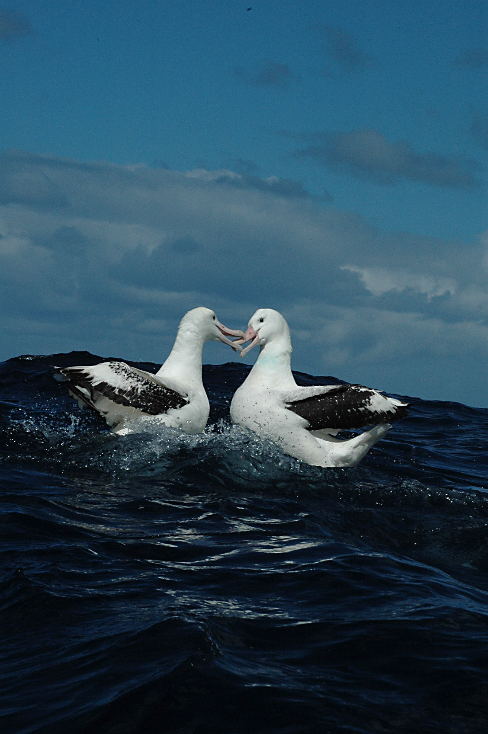
Wandering albatross (Michael Double)

S2.1 Temperate East Network overview
The marine parks of the Temperate East Network were proclaimed under the EPBC Act on 14 December 2013 (Federal Register of Legislation No. F2013L02108) and renamed on 9 October 2017 (Federal Register of Legislation No. F2017L01337).
Table S2.1. Overview of the Temperate East Network
Marine park name | Zones, IUCN categories and zone area | Marine park IUCN category | Total marine park area
Gifford | Habitat Protection Zone (IV) 5828 km² | IV | 5828 km²
Norfolk | National Park Zone (II) 41,661 km²  Habitat Protection Zone (IV) 138,796 km²  Special Purpose Zone (Norfolk) (VI) 7986 km² | IV | 188,444 km²
Lord Howe | National Park Zone (II) 9273 km²  Habitat Protection Zone (IV) 54,884 km²  Habitat Protection Zone (Lord Howe) (IV) 5136 km²  Recreational Use Zone (IV) 1170 km²  Multiple Use Zone (VI) 39,662 km² | IV | 110,126 km²
Central Eastern | National Park Zone (II) 8110 km²  Habitat Protection Zone (IV) 61,336 km²  Multiple Use Zone (VI) 608 km² | IV | 70,054 km²
Solitary Islands | National Park Zone (II) 2 km²  Multiple Use Zone (VI) 37 km²  Special Purpose Zone (Trawl) (VI) 114 km² | VI | 152 km²
Cod Grounds | National Park Zone (II) 4 km² | II | 4 km²
Hunter | Habitat Protection Zone (IV) 4519 km²  Special Purpose Zone (Trawl) (VI) 1739 km² | IV | 6257 km²
Jervis | Habitat Protection Zone (IV) 1965 km²  Special Purpose Zone (Trawl) (VI) 508 km² | IV | 2473 km²
Note: Each marine park extends from 1000 m below the seabed to 3000 m above sea level.
Note: Zone and total marine park areas are rounded to the nearest km²; therefore, the sum of areas may not equate to the total marine park or network areas in some instances.

S2.2 Temperate East Network values
This Schedule describes the values represented in each marine park of the Temperate East Network.
Values are broadly defined as:
- Natural values—habitats, species and ecological communities within marine parks, and the processes that support their connectivity, productivity and function.
- Cultural values—living and cultural heritage recognising Indigenous beliefs, practices and obligations for country, places of cultural significance and cultural heritage sites.
- Heritage values—non-Indigenous heritage that has aesthetic, historic, scientific or social significance.
- Socio-economic values—the benefit of marine parks for people, businesses and the economy.
Values will be used to inform the Director’s decisions when authorising activities in marine parks. Activities will be assessed in relation to their impacts and risk to values, to ensure activities are undertaken in a manner that minimises impacts to as low as reasonably practicable (Section 4.3 Making decisions about activities).
As understanding of park values improves over time, updated information will be available on the Parks Australia website.
Other sources of information on marine park values can be found on the Department’s website, in particular, for protected species (species profile and threats database), wetlands (Australian wetlands directory), heritage places (Australian heritage database), and shipwrecks (Australian national shipwrecks database), and in the Marine bioregional plan for the Temperate East Marine Region (2012) and the East marine bioregional plan: bioregional profile (2009).

Gifford Marine Park
The Gifford Marine Park (Figure S2.1) is located approximately 480 km north of Lord Howe Island and borders on the limit of Australia’s exclusive economic zone. The Marine Park covers an area of 5828 km² and a depth range between 220 m and 4000 m.
The Marine Park was proclaimed under the EPBC Act on 14 December 2013 and renamed Gifford Marine Park on 9 October 2017. The Marine Park is assigned IUCN category IV and includes one zone assigned under this plan: Habitat Protection Zone (IV).
Coordinates for the Gifford Marine Park and zone are provided in Figure S2.1 and Schedule 4.
Statement of significance
The Gifford Marine Park is significant because it contains habitats, species and ecological communities associated with the Lord Howe Province. It includes one key ecological feature: the Lord Howe Seamount Chain, valued for high productivity, aggregations of marine life, biodiversity and endemism.
Natural values
The Marine Park includes examples of ecosystems representative of the Lord Howe Province. Ecosystems of this region are influenced by tropical and temperate currents due to its location in the path of the Tasman Front that brings a mix of warm tropical waters and colder, nutrient-rich waters from the south.
A key ecological feature of the Marine Park is the Lord Howe Seamount Chain—running approximately 1000 km north–south from the Coral Sea to Lord Howe Island. The Lord Howe Seamount Chain contains a series of submerged mountains that includes Lord Howe Island and Gifford Tablemount, the prominent seafloor feature of the Marine Park.
The Marine Park supports a range of species, including species listed as threatened, migratory, marine or cetacean under the EPBC Act. Biologically important areas within the Marine Park include foraging habitat for seabirds and a migratory pathway for humpback whales.
Cultural values
Sea country is valued for Indigenous cultural identity, health and wellbeing. Across Australia, Indigenous people have been sustainably managing their sea country for tens of thousands of years. At the commencement of this plan, there is limited information about the cultural significance of this Marine Park.
The Native Title Services Corporation is the Native Title Service Provider for the New South Wales region.
Heritage values
No international, Commonwealth or national heritage listings apply to the Marine Park at commencement of this plan.
Social and economic values
Commercial fishing is an important activity in the Marine Park that contributes to the wellbeing of regional communities and the prosperity of the nation.
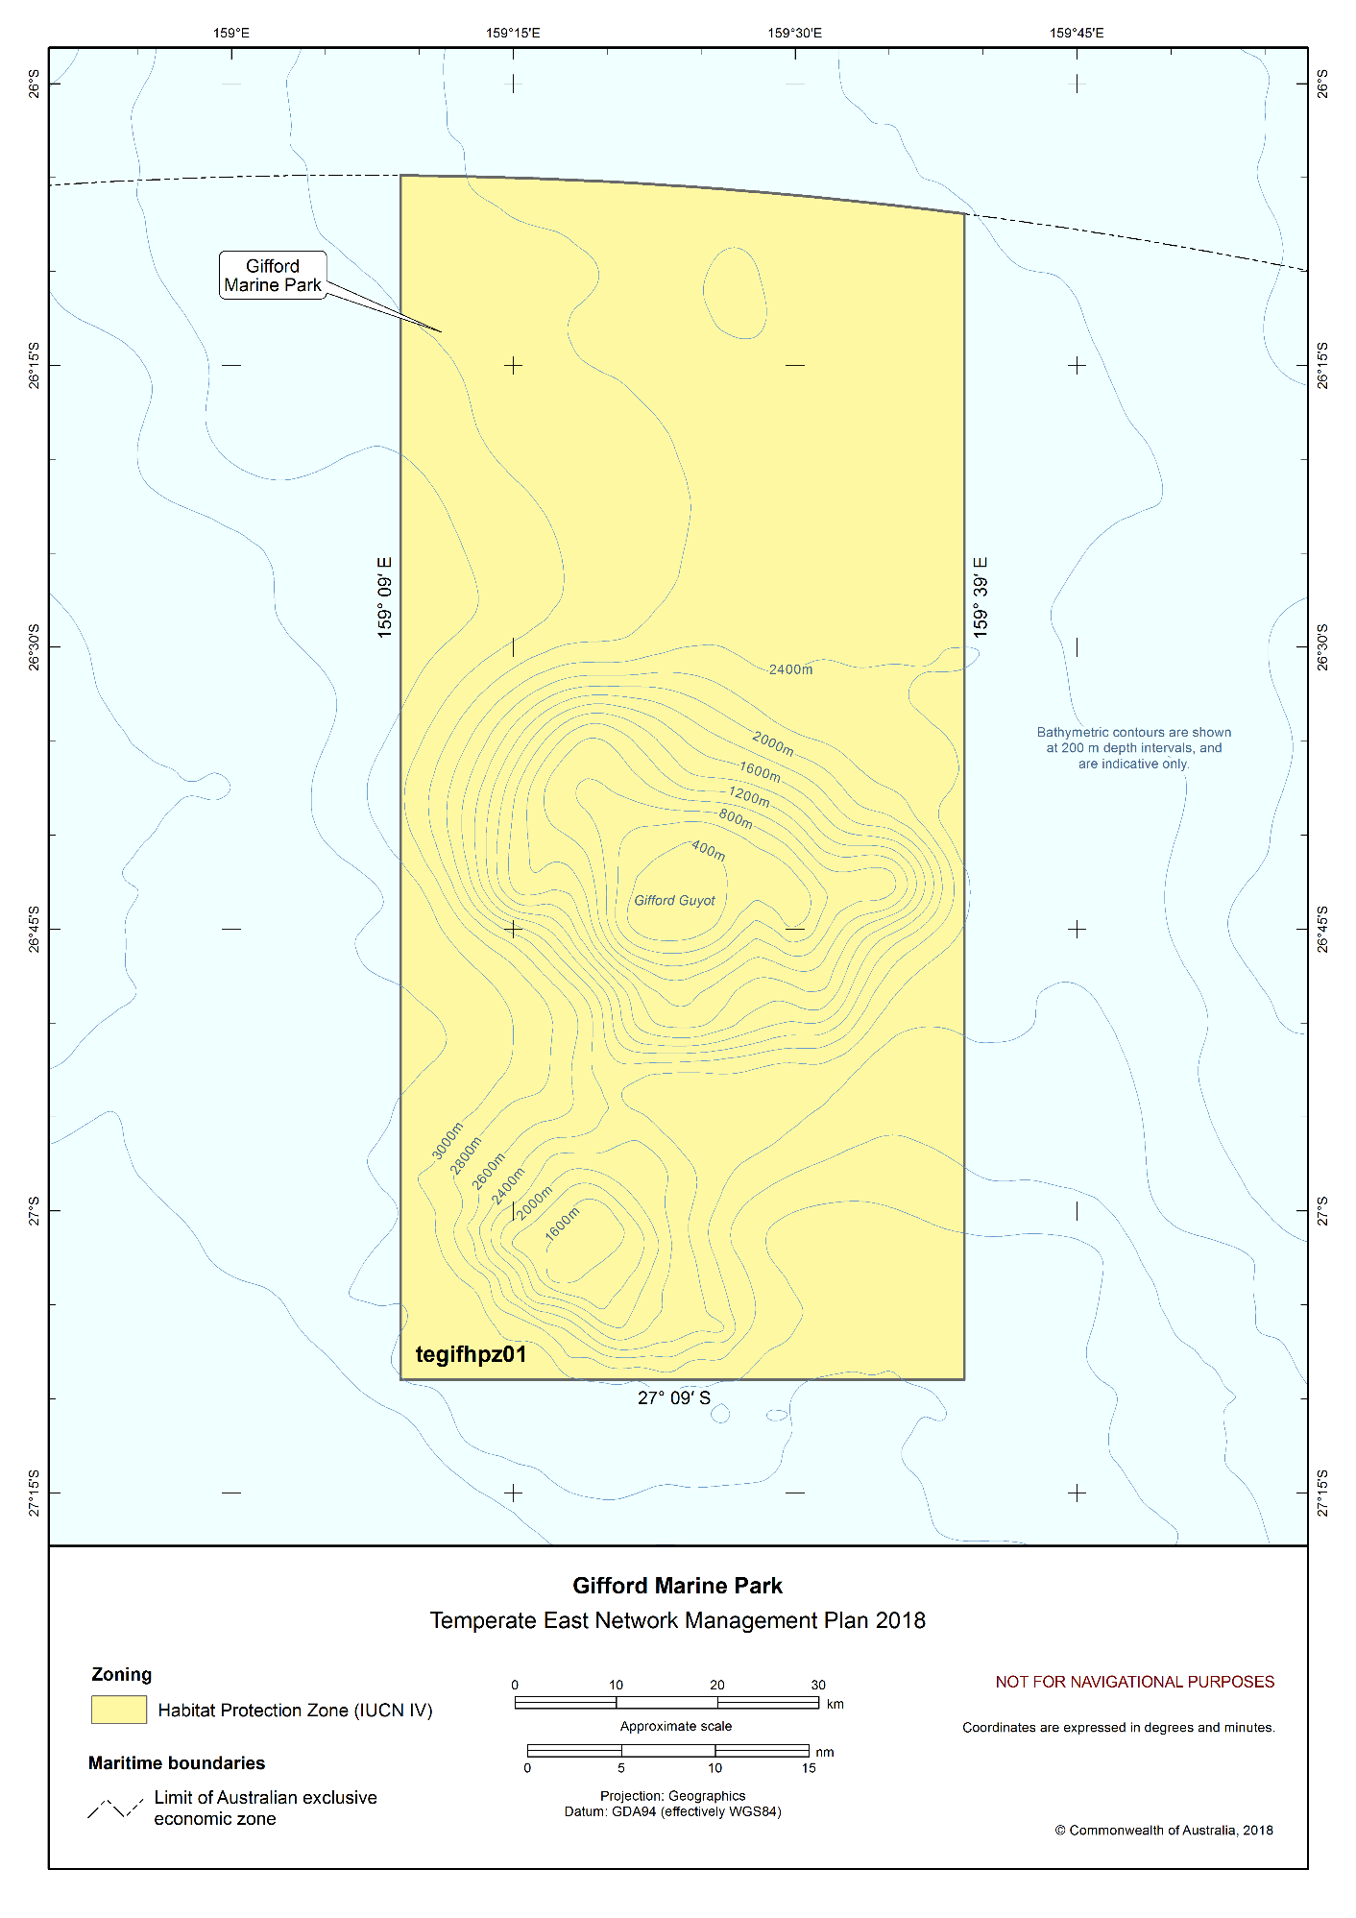Figure S2.1 Gifford Marine Park

Norfolk Marine Park
The Norfolk Marine Park (Figure S2.2) is around Norfolk Island, including Nepean Island Reserve and Phillip Island, approximately 1400 km offshore from Evans Head in New South Wales. The Marine Park spans 700 km in a north–south direction, covering an area of 188,444 km² and a depth range of 5000 m up to the high water mark.
The Marine Park was proclaimed under the EPBC Act on 14 December 2013 and renamed Norfolk Marine Park on 9 October 2017. The Marine Park is assigned IUCN category IV and includes three zones assigned under this plan: National Park Zone (II), Habitat Protection Zone (IV) and Special Purpose Zone (Norfolk) (VI).
Coordinates for the Norfolk Marine Park and zones are provided in Figure S2.2 and Schedule 4.
Statement of significance
The Norfolk Marine Park is significant because it contains habitats, species and ecological communities associated with the Norfolk Island Province. It includes two key ecological features: Norfolk Ridge, and the Tasman Front and eddy field, both valued for high productivity, aggregations of marine life, biodiversity and endemism.
Natural values
The Marine Park includes examples of ecosystems representative of the Norfolk Island Province. The mixing of warm-water and cold-water currents and eddies, and their interactions with seamounts influence biological productivity, with east-moving eddies associated with the Tasman Front transporting Coral Sea biota including corals, crustaceans and molluscs to the area. The shallow-water habitats of Norfolk Island support diverse tropical and temperate species of fish, corals and other marine organisms similar to those found in the reefs surrounding Lord Howe Island, but with a unique reef fish assemblage of endemic, sub-tropical and temperate species. Coral reefs in Emily Bay and Slaughter Bay are the eastern-most coral reefs in Australian waters.
Key ecological features of the Marine Park are:
- Tasman Front and eddy field—a region that separates the warm, nutrient-poor waters of the Coral Sea from the cold, nutrient-rich waters of the Tasman Sea, providing increased nutrients and plankton aggregations, and enhanced productivity that attracts mobile species such as turtles, cetaceans, tuna and billfish.
- Norfolk Ridge—a steep-sided, narrow and elongated feature approximately 1000 km long and 70 km wide. The pinnacles and seamounts of the Norfolk Ridge support relatively productive and diverse benthic habitats, and are thought to act as stepping stones for faunal dispersal, connecting deep-water fauna from New Caledonia to New Zealand.
The Marine Park supports a range of species, including species listed as threatened, migratory, marine or cetacean under the EPBC Act. Biologically important areas within the Marine Park include breeding and foraging habitat for seabirds, and a migratory pathway for humpback whales.
Cultural values
The marine environment around Norfolk Island has long held significance among Norfolk Islanders. A unique community and culture has developed by those who have visited and settled the island over time.
Polynesian
The first people to inhabit Norfolk Island were of Polynesian descent. Stone tools have been found at both Emily and Slaughter bays within the Kingston and Arthur’s Vale Historic Area (see Heritage values). Archaeological investigations have revealed evidence of landscape modifications in the Emily Bay area including artefact assemblages and structural remains that have been interpreted as a rudimentary marae, a religious structure characteristic of East Polynesian culture. Radiocarbon dating indicates Polynesian settlement of the area occurred between AD 1200 and AD 1600.
Pitcairn Islanders
In 1853, an Order in Council repealed all previous orders making Norfolk Island a penal settlement. Occupation was granted to incoming settlers from Pitcairn Island, who constituted the third settlement phase of the island's history. The whole Pitcairn community landed on Norfolk Island in 1856. Their descendants, who comprise the majority of Norfolk Island's population, still speak the Pitcairn language.
Indigenous Australians
Across Australia, Indigenous people have been sustainably managing their sea country for tens of thousands of years. At the commencement of this plan, there is limited information about the cultural significance of this Marine Park to Indigenous people due to its remote location.
Heritage values
National heritage
Kingston and Arthur’s Vale Historic Area (on Norfolk Island, adjacent to the Norfolk Marine Park), is one of 11 sites that make up the Australian Convict Sites world heritage property.
Commonwealth heritage
There are no Commonwealth heritage sites within the Norfolk Marine Park. However, there are Commonwealth heritage places on Norfolk Island that provide important habitat for seabirds that forage in the Marine Park.
Adjacent to Norfolk Island, Nepean Island Reserve and Phillip Island are on the Commonwealth Heritage List, providing important breeding habitat for at least eight species of seabird that also forage in the Marine Park.
Historic shipwrecks
The Marine Park contains over 20 known shipwrecks listed under the Historic Shipwrecks Act 1976 (including six shipwrecks that are less than 75 years old that will become eligible for listing as historic shipwrecks during the life of this plan). One of these is the HMS Sirius, a flagship of the First Fleet, which was wrecked on the coral reef off Slaughter Bay, Norfolk Island in 1790.
European heritage
Discovered by Captain James Cook in 1774, Norfolk Island was inhabited by convicts and free settlers from 1788. This first settlement's population peaked at 1156 in 1792. By 1804, the free settlers on the island significantly outnumbered convicts. The first settlement was abandoned in 1814, and later re-occupied in 1825 as a penal settlement.
Social and economic values
Fishing in the Norfolk Island Inshore Fishery area is managed by the Norfolk Island Regional Council in collaboration with the Norfolk Island Fishing Association, and in accordance with the Norfolk Island Inshore Fishery Policy 2009. The associated Memorandum of Understanding (MoU) with the Australian Fisheries Management Authority (AFMA) for the inshore fishery area known locally as the “MoU Box” has enabled AFMA to provide management expertise and guidance to the Norfolk Island Regional Council and the Norfolk Island Fishing Association as required. The “MoU Box” area existing at the time of commencement of this plan has been zoned Special Purpose Zone (Norfolk) and the community has a strong affinity and interest in its management (Figure S2.2).
Within the coastal waters surrounding Norfolk Island, boating and shipping, tourism and recreation are important activities in the Marine Park. This includes the sheltered coral lagoon of Emily Bay which is a valuable community asset used for swimming, snorkeling and tourism. These activities contribute to the economy and wellbeing of the island community.

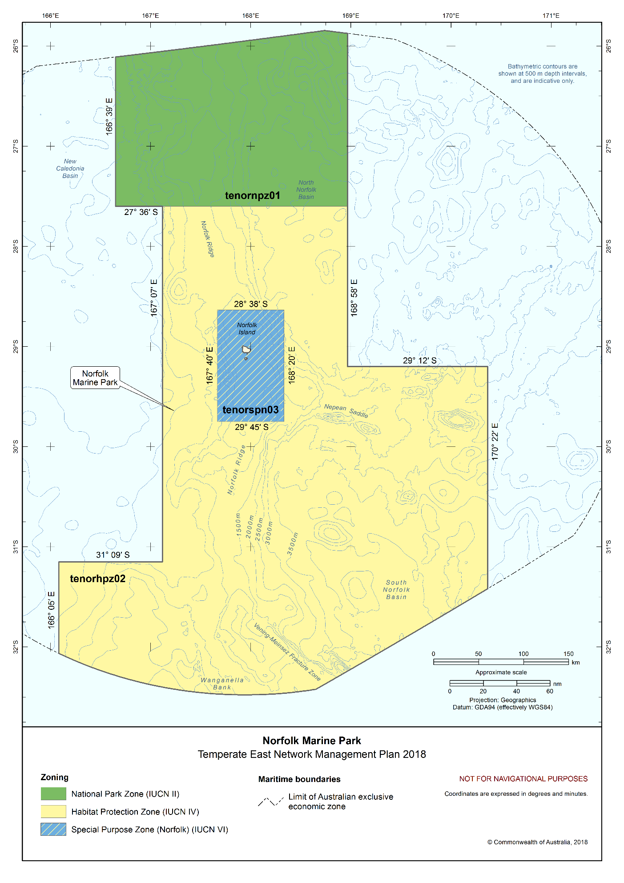
Figure S2.2 Norfolk Marine Park

Lord Howe Marine Park
The Lord Howe Marine Park (Figure S2.3) is located approximately 550 km offshore of New South Wales, adjacent to the New South Wales Lord Howe Island Marine Park and World Heritage Area. The Marine Park covers an area of 110,126 km² and a depth range from less than 15 m to 6000 m.
The Lord Howe Marine Park was proclaimed under the EPBC Act on 14 December 2013 and renamed Lord Howe Marine Park on 9 October 2017. It includes the areas of the Lord Howe Island Marine Park (Commonwealth Waters) originally proclaimed under the National Parks and Wildlife Conservation Act 1975 on 7 June 2000, and the Elizabeth and Middleton Reefs Marine National Nature Reserve originally proclaimed under the National Parks and Wildlife Conservation Act 1975 on 11 December 1987. The Marine Park is assigned IUCN category IV and includes five zones assigned under this plan: National Park Zone (II), Habitat Protection Zone (IV), Habitat Protection Zone (Lord Howe) (IV), Recreational Use Zone (IV) and Multiple Use Zone (VI).
Coordinates for the Lord Howe Marine Park and zones are provided in Figure S2.3 and Schedule 4.
Statement of significance
The Lord Howe Marine Park is significant because it includes habitats, species and ecological communities associated with the Lord Howe Province and the Tasman Basin Province. It includes three key ecological features: the Lord Howe Seamount Chain; Elizabeth and Middleton Reefs (the southernmost coral reefs in the world); and the Tasman Front and eddy field, all valued for high productivity, aggregations of marine life, biodiversity and endemism.
The Elizabeth and Middleton Reefs Ramsar site is located within the Marine Park. The site was listed under the Ramsar Convention in 2002 and is a wetland of international importance under the EPBC Act, due to its unique nature as the southernmost open-ocean coral-reef platform in the world. An Ecological Character Description that sets out the Ramsar listing criteria met by the site, the key threats and knowledge gaps, is available on the Department’s website.
The Marine Park includes habitats connecting to and complementing the adjacent New South Wales Lord Howe Island Marine Park.
Natural values
The Marine Park includes examples of ecosystems representative of:
- Lord Howe Province—due to the convergence of warm, tropical and cooler temperate waters in the area, the Marine Park supports a unique mix of tropical, subtropical and temperate species, many found at the northern or southern extent of their range.
- Tasman Basin Province—interactions between currents, eddies and seamounts and the movements of the deep sub-Antarctic water mass influence biological productivity in this area.
Key ecological features of the Marine Park are:
- Lord Howe Seamount Chain—a chain of submerged volcanoes running 1000 km north–south, the seamount chain includes Lord Howe Island and Elizabeth and Middleton Reefs. These isolated, oceanic reefs support a diverse range of tropical and temperate marine life, including both warm-water and cold-water corals and an abundance of fish species. This diversity is a result of the effect of the East Australian Current on the reefs as it exposes the area to its warm waters, in contrast to the surrounding cooler ocean.
- Elizabeth and Middleton Reefs—small, isolated, oceanic platforms reefs that occur on top of the volcanic seamounts of the Lord Howe seamount chain. The lagoons of both reefs are important areas for populations of black cod and the Galapagos shark.
- Tasman Front and eddy field—a region that separates the warm, nutrient-poor waters of the Coral Sea from the cold, nutrient-rich waters of the Tasman Sea, providing increased nutrients and plankton aggregations, and enhanced productivity that attracts mobile species such as turtles, cetaceans, tuna and billfish.
The Marine Park supports a range of species, including species listed as threatened, migratory, marine or cetacean under the EPBC Act. Biologically important areas within the Marine Park include breeding and foraging habitat for seabirds, and a migratory pathway for humpback whale.
Elizabeth and Middleton Reefs Ramsar site
The reefs of the Elizabeth and Middleton Reefs Ramsar site form the southernmost open-ocean reef platform in the world and support internationally significant populations of seabirds and shorebirds.
Cultural values
The marine environment around Lord Howe Island has long held significance among Lord Howe Islanders. A unique community and culture has developed by those who have visited and settled the island over time.
Across Australia, Indigenous people have been sustainably managing their sea country for tens of thousands of years. At the commencement of this plan, there is limited information about the cultural significance of this Marine Park to Indigenous people due to its remote location.
Heritage values
World heritage
Parts of the Marine Park are within the world heritage-listed Lord Howe Island Group, which was listed as an area of outstanding universal value under the World Heritage Convention in 1982. The Lord Howe Island Group comprises Lord Howe Island, Admiralty Islands, Mutton Bird Islands, Ball's Pyramid, and associated coral reefs and marine environments. It includes spectacular landscapes, volcanic mountains, and diverse low-lying rainforests, palm forests and grasslands. There are a large number of species of native plants, of which many are endemic to Lord Howe Island, and colonies of endangered seabirds.
National heritage
The Lord Howe Island Group was included in the National Heritage List in 2007.
Historic shipwrecks
The Marine Park contains over 25 known shipwrecks listed under the Historic Shipwrecks Act 1976.
Social and economic values
Tourism, commercial fishing, recreation, including fishing, and scientific research, are important activities in the Marine Park. These activities contribute to the wellbeing of regional communities and the prosperity of the nation.

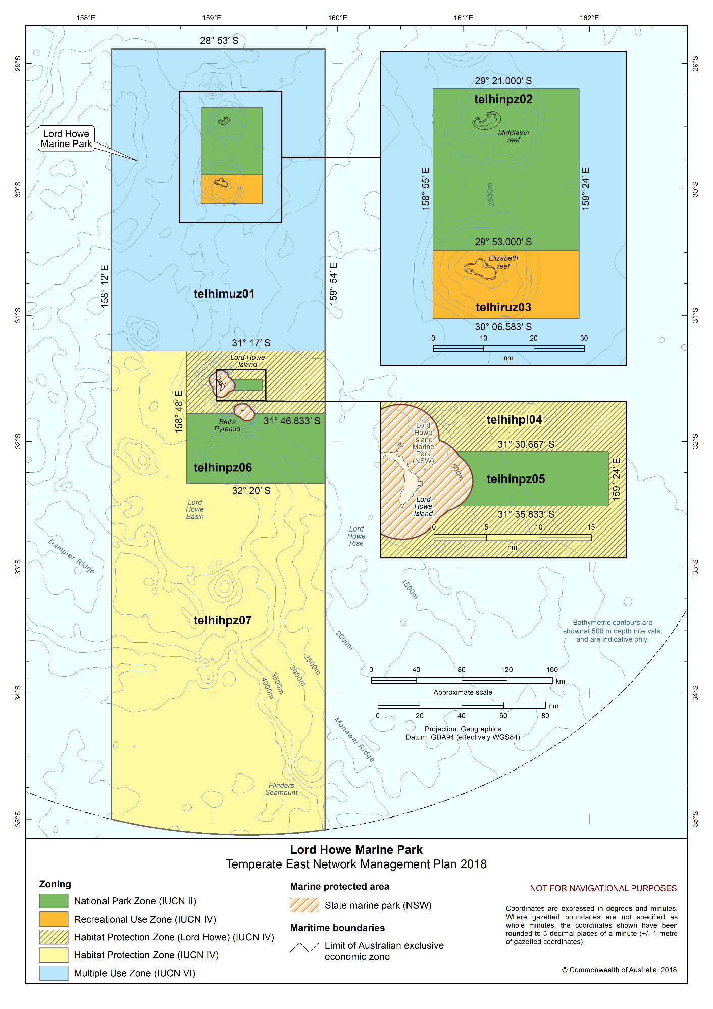Figure S2.3 Lord Howe Marine Park

Central Eastern Marine Park
The Central Eastern Marine Park (Figure S2.4) is located approximately 30 km east of Coffs Harbour at the edge of the continental shelf. It extends to deep ocean waters approximately 200 km offshore of New South Wales. The Marine Park covers an area of 70,054 km² and water depths ranging from 120 m to 6000 m.
The Marine Park was proclaimed under the EPBC Act on 14 December 2013 and renamed Central Eastern Marine Park on 9 October 2017. The Marine Park is assigned IUCN category IV and includes three zones assigned under this plan: National Park Zone (II), Habitat Protection Zone (IV) and Multiple Use Zone (VI).
Coordinates for the Central Eastern Marine Park and zones are provided in Figure S2.4 and Schedule 4.
Statement of significance
The Central Eastern Marine Park is significant because it includes habitats, species and ecological communities associated with the Central Eastern Province, the Central Eastern Shelf Transition and the Tasman Basin Province. It includes three key ecological features: canyons on the eastern continental slope (valued as a unique seafloor feature with ecological properties of regional significance); the Tasmantid Seamount Chain; and the Tasman Front and eddy field (both valued for high productivity, aggregations of marine life, biodiversity and endemism).
Natural values
The Marine Park includes examples of ecosystems representative of:
- Central Eastern Province—includes canyons along the continental shelf that interact with currents and ocean gyres resulting in upwellings that influence biological productivity. Plankton blooms associated with the upwellings attract aggregations of tuna, whales and albatrosses and support over 50 fish species endemic to the area.
- Central Eastern Shelf Transition—upwellings caused by the East Australian Current crossing the continental shelf, and river sediment influence biological productivity in this area.
- Tasman Basin Province—interactions between currents, eddies and seamounts and the movements of the deep sub-Antarctic water mass influence biological productivity in this area. The deep-reef coral communities on seamounts are dominated by filter feeders and provide stepping stones for large oceanic species moving between breeding, nesting, calving and foraging sites.
Key ecological features of the Marine Park are:
- Tasmantid Seamount Chain—a series of underwater volcanic mountains comprised of guyots, seamounts, tablemounts, banks, plateaux and terraces that runs in a north–south direction, and extends into the Tasman Basin. The feature rises from approximately 4800 m deep to 125 m from the surface at Taupo Seamount in the south, approximately 280 m from the surface at Derwent–Hunter Seamount in the centre of the Marine Park, and to approximately 350 m from the surface at Queensland Guyot in the north of the Marine Park. The seamounts support a diverse range of habitats in temperate and subtropical waters.
- Canyons on the eastern continental slope—canyons enhance diversity and abundance of species, driven by the combined effects of steep and rugged topography, ocean currents, seafloor types and nutrient availability. Canyons also create localised changes in productivity in the water column above them, providing feeding opportunities for a range of species.
- Tasman Front and eddy field—a region that separates the warm, nutrient-poor waters of the Coral Sea from the cold, nutrient-rich waters of the Tasman Sea, providing increased nutrients and plankton aggregations, and enhanced productivity that attracts mobile species such as turtles, cetaceans, tuna and billfish.The Marine Park supports a range of species, including species listed as threatened, migratory, marine or cetacean under the EPBC Act. Biologically important areas within the Marine Park include foraging and breeding habitat for seabirds, and a migratory pathway for the humpback whale.
Cultural values
Sea country is valued for Indigenous cultural identity, health and wellbeing. Across Australia, Indigenous people have been sustainably managing their sea country for tens of thousands of years. At the commencement of this plan, there is limited information about the cultural significance of this Marine Park.
The Native Title Services Corporation is the Native Title Service Provider for the New South Wales region.
Heritage values
No international, Commonwealth or national heritage listings apply to the Marine Park at commencement of this plan.
Historic shipwrecks
The Marine Park contains two known shipwrecks listed under the Historic Shipwrecks Act 1976—Amelia (wrecked in 1816) and Illagong (wrecked in 1872).
Social and economic values
Tourism, commercial fishing, and recreation, including fishing, are important activities in the Marine Park. These activities contribute to the wellbeing of regional communities and the prosperity of the nation.

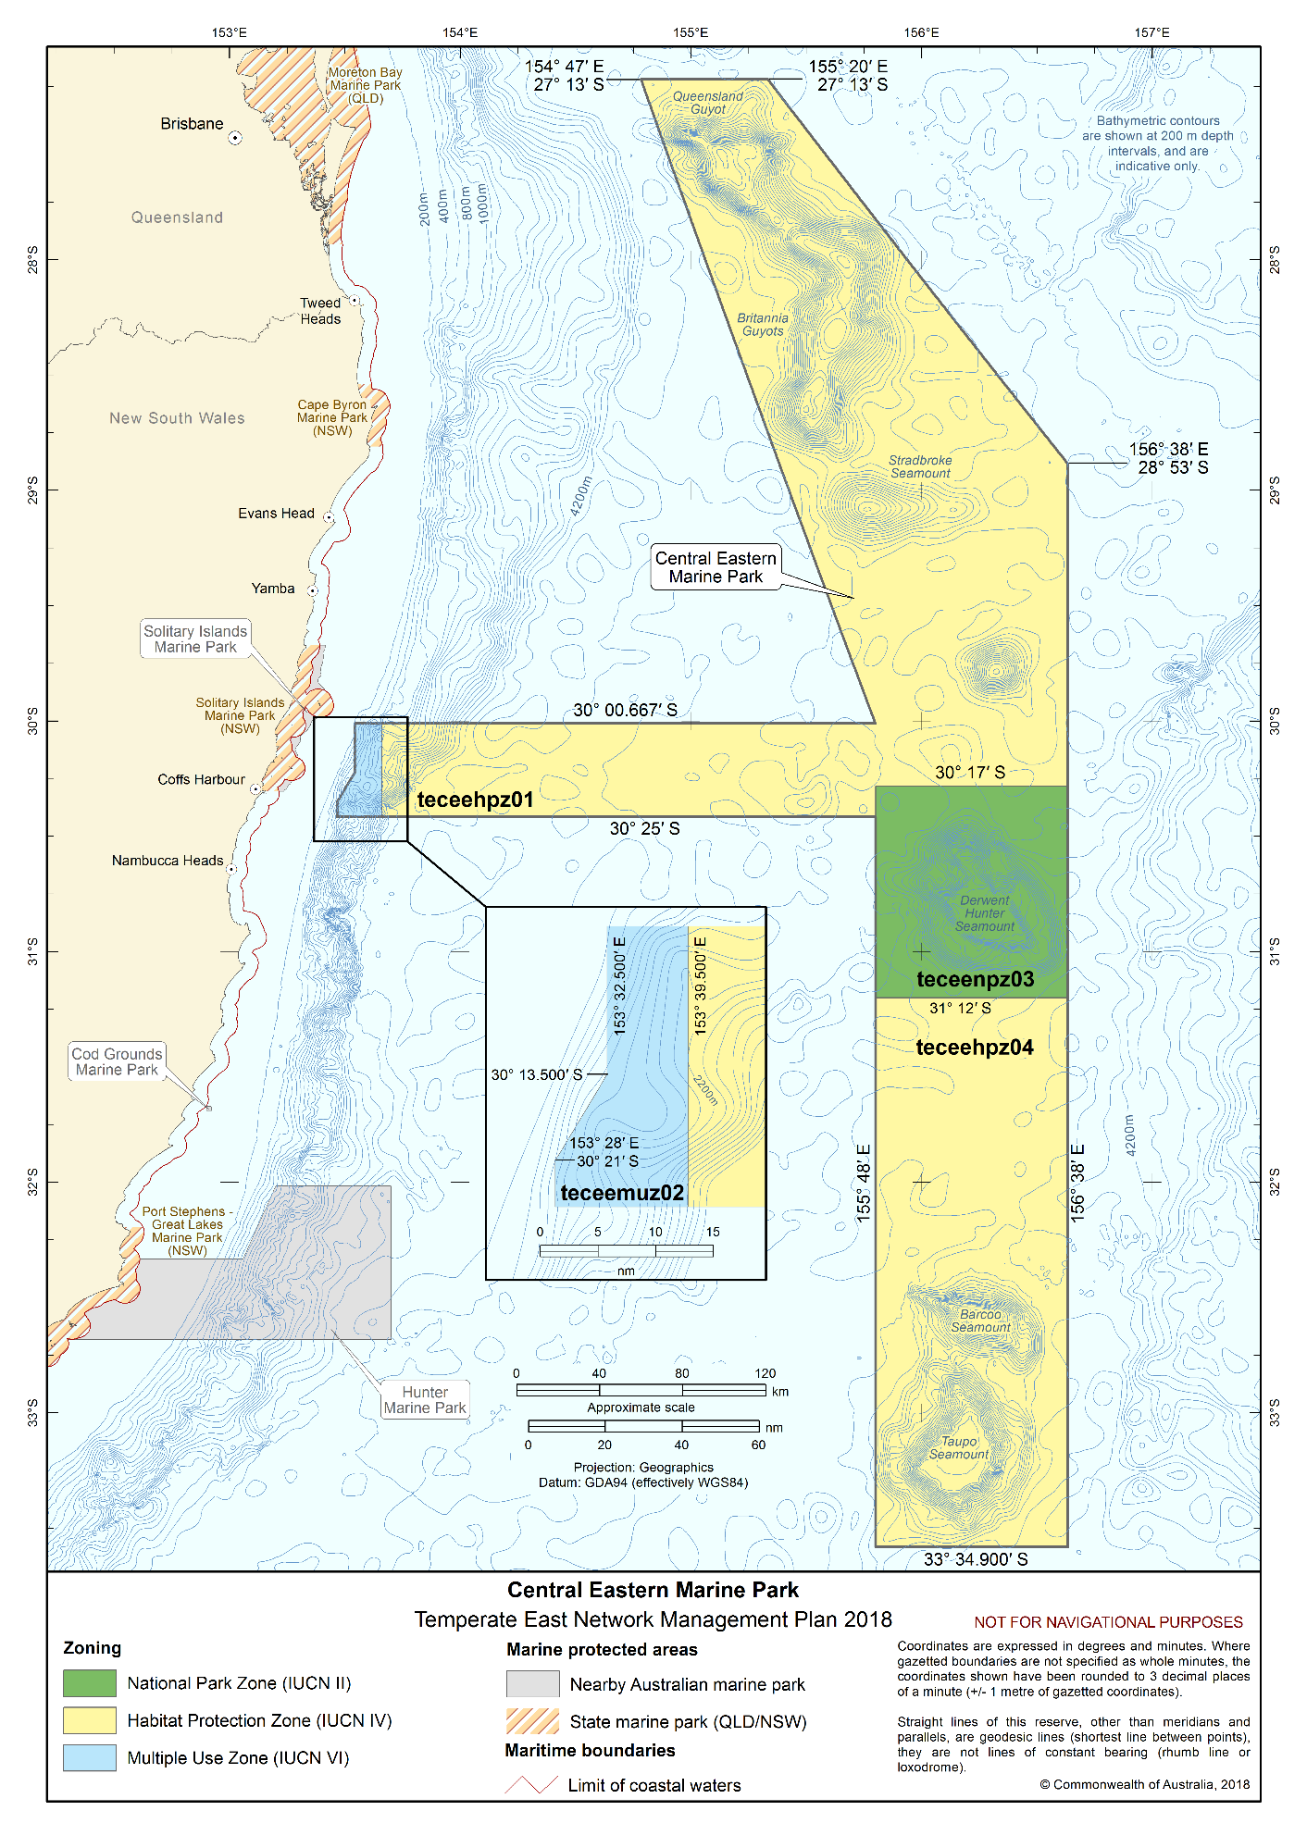Figure S2.4 Central Eastern Marine Park

Solitary Islands Marine Park
The Solitary Islands Marine Park (Figure S2.5) is located approximately 5.5 km offshore of New South Wales, adjacent to the New South Wales Solitary Islands Marine Park. The Marine Park covers an area of 152 km² and a depth range of 15 m to 70 m.
The Marine Park was originally proclaimed under the National Parks and Wildlife Conservation Act 1975 on 17 February 1993 as the Solitary Islands Marine Reserve (Commonwealth Waters), and proclaimed under the EPBC Act on 14 December 2013 and renamed Solitary Islands Marine Park on 9 October 2017. The Marine Park is assigned IUCN category VI and includes three zones assigned under this plan: National Park Zone (II), Multiple Use Zone (VI) and Special Purpose Zone (Trawl) (VI).
Coordinates for the Solitary Islands Marine Park and zones are provided in Figure S2.5 and Schedule 4.
Statement of significance
The Solitary Islands Marine Park is significant because it contains habitats, species and ecological communities associated with the Central Eastern Shelf Transition. The Marine Park contains habitat for species of special conservation interest such as grey nurse sharks, and biologically important areas for humpback whale, white shark and a number of migratory seabirds.
The Marine Park includes habitats connecting to and complementing the adjacent New South Wales Solitary Islands Marine Park.
Natural values
The Marine Park includes examples of ecosystems representative of the Central Eastern Shelf Transition. Ecosystems of this area are influenced by tropical waters of the East Australian Current meeting temperate, southern waters, creating a combination of tropical and temperate environments. Many species found within the Marine Park are at, or close to, either their southern or northern geographical limits. Tropical, subtropical and temperate marine communities co-exist within the same area.
Waters of the Marine Park are a relatively undisturbed, distinct and species-rich ecosystem associated an open-ocean, subtidal reef and soft substrate habitats. Pimpernel Rock is a significant feature of the Marine Park. It is a submerged pinnacle that rises from the seabed to within a few metres of the surface. It provides habitat for benthic communities, pelagic fish, and other marine life.
The Marine Park supports a range of species, including species listed as threatened, migratory, marine or cetacean under the EPBC Act. Biologically important areas within the Marine Park include foraging habitat for seabirds, migratory and foraging habitat for sharks, a migratory pathway for humpback whales, and breeding habitat for Indo-Pacific/spotted bottlenose dolphin.
Cultural values
Sea country is valued for Indigenous cultural identity, health and wellbeing. Across Australia, Indigenous people have been sustainably using and managing their sea country for tens of thousands of years.
The Yaegl People’s sea country extends into the southern portion of the Marine Park. The Yaegl Traditional Owners Aboriginal Corporation Prescribed Body Corporate represents the Yaegl native title holders. The Yaegl Traditional Owners Aboriginal Corporation is the point of contact for their sea country.
The Native Title Services Corporation is the Native Title Service Provider for the New South Wales region.
Heritage values
No international, Commonwealth or national heritage listings apply to the Marine Park at commencement of this plan.
Social and economic values
Tourism, commercial fishing, and recreation, including fishing, are important activities in the Marine Park. These activities contribute to the wellbeing of regional communities and the prosperity of the nation.

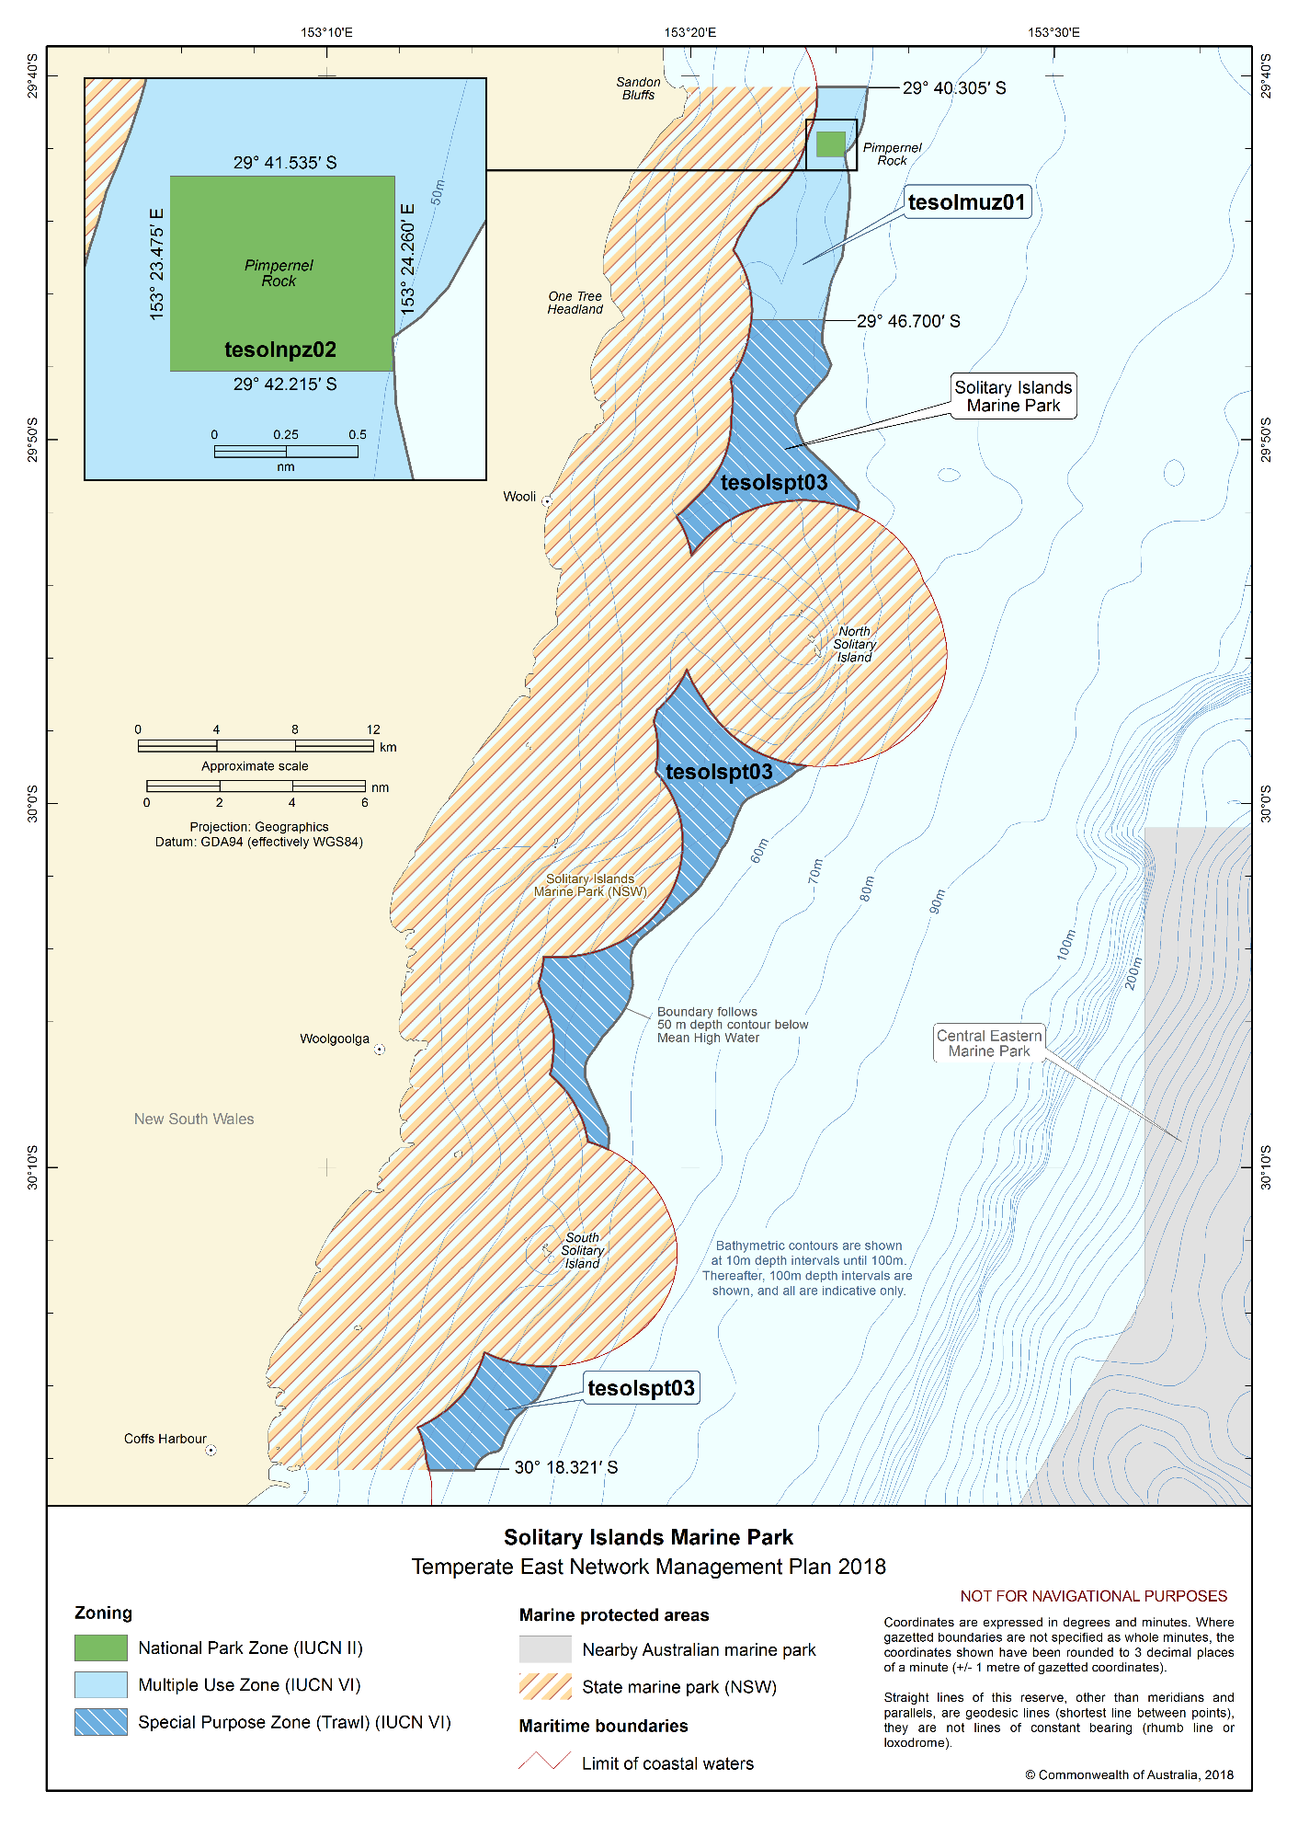Figure S2.5 Solitary Islands Marine Park

Cod Grounds Marine Park
The Cod Grounds Marine Park (Figure S2.6) is located approximately 5.5 km offshore of New South Wales. The Marine Park covers an area of 4 km² and a water depth range of 21 m to 46 m.
The Marine Park was proclaimed under the EPBC Act on 14 December 2013 and renamed Cod Grounds Marine Park on 9 October 2017. It includes the area of the Cod Grounds Commonwealth Marine Reserve originally proclaimed under the EPBC Act on 10 May 2007. The Marine Park is assigned IUCN category II and includes one zone assigned under this plan: National Park Zone (II).
Coordinates for the Cod Grounds Marine Park and zone are provided in Figure S2.6 and Schedule 4.
Statement of significance
The Cod Grounds Marine Park is significant because it contains habitats, species and ecological communities representative of the Central Eastern Shelf Transition. It provides habitat for grey nurse sharks.
Natural values
The Marine Park includes examples of ecosystems representative of the Central Eastern Shelf Transition. Ecosystems in this area are influenced by tropical waters of the East Australian Current meeting temperate waters, creating a combination of tropical and temperate environments. Many species found within the Marine Park are at, or close to, either their southern or northern geographical limits. Tropical, subtropical and temperate marine communities co-exist within the same area.
The Marine Park is predominantly rocky reef surrounded by boulder and cobble slopes that support diverse and abundant marine communities. The reefs are interlaced with sand and cobble gutters. The Cod Grounds reef is the northern-most of a series of reefs extending south and south-west. The Cod Grounds is the shallowest reef in the series and has steeper slopes. The rocky outcrops form several pinnacles which are surrounded by gutters, ledges and caves. The underwater pinnacles of the Marine Park provide habitat for grey nurse sharks and their prey species.
The Marine Park supports a range of species, including species listed as threatened, migratory, marine or cetacean under the EPBC Act. Biologically important areas within the Marine Park include foraging habitat for seabirds, a migratory pathway and aggregation area for grey nurse sharks, and migratory and foraging habitat for humpback whales.
Cultural values
Sea country is valued for Indigenous cultural identity, health and wellbeing. Across Australia, Indigenous people have been sustainably managing their sea country for tens of thousands of years. At the commencement of this plan, there is limited information about the cultural significance of this Marine Park.
The Native Title Services Corporation is the Native Title Service Provider for the New South Wales region.
Heritage values
No international, Commonwealth or national heritage listings apply to the Marine Park at commencement of this plan.
Social and economic values
Tourism, scientific research and recreation activities are important in the Marine Park. These activities contribute to the wellbeing of regional communities and the prosperity of the nation.
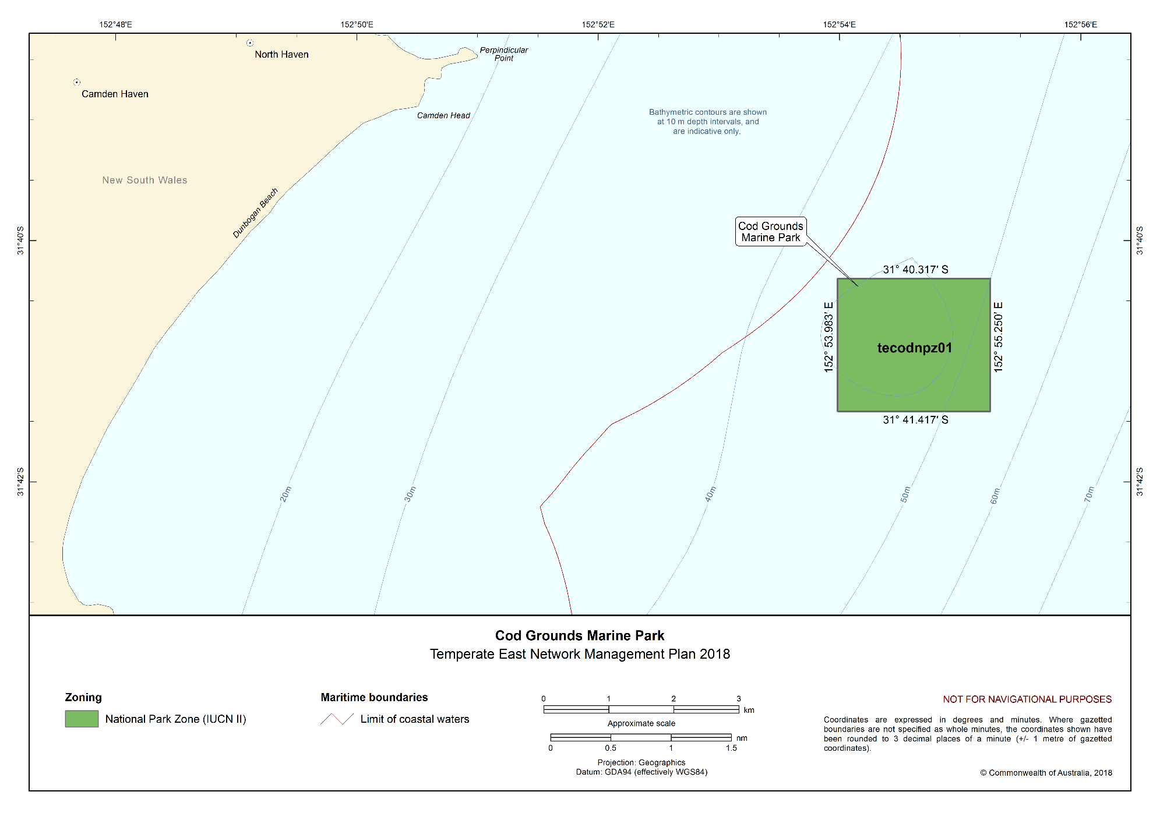Figure S2.6 Cod Grounds Marine Park

Hunter Marine Park
The Hunter Marine Park (Figure S2.7) extends from the New South Wales state water boundary to approximately 100 km offshore, and adjacent to the New South Wales Port Stephens–Great Lakes Marine Park. The Marine Park covers an area of 6257 km² and a depth range between 15 m and 6000 m.
The Marine Park was proclaimed under the EPBC Act on 14 December 2013 and renamed Hunter Marine Park on 9 October 2017. The Marine Park is assigned IUCN category IV and includes two zones assigned under this plan: Habitat Protection Zone (IV) and Special Purpose Zone (Trawl) (VI).
Coordinates for the Hunter Marine Park and zones are provided in Figure S2.7 and Schedule 4.
Statement of significance
The Hunter Marine Park is significant because it contains habitats, species and ecological communities representative of the Central Eastern Province and the Central Eastern Shelf Province. It includes three key ecological features: canyons on the eastern continental slope (valued for a unique seafloor feature with ecological properties of regional significance); shelf rocky reefs (valued for a unique seafloor feature with ecological properties of regional significance); and the Tasman Front and eddy field (valued for high productivity, aggregations of marine life, biodiversity and endemism).
The Marine Park includes habitats connecting to and complementing the adjacent New South Wales Port Stephens–Great Lakes Marine Park.
Natural values
The Marine Park includes examples of ecosystems representative of:
- Central Eastern Province—includes canyons along the shelf that interact with currents and ocean gyres resulting in upwellings that influence biological productivity. Plankton blooms associated with the upwellings attract aggregations of tuna, whale and albatross and support over 50 fish species endemic to the area.
- Central Eastern Shelf Province—upwellings caused by the East Australian Current crossing the continental shelf, and river sediment influence biological productivity in this provincial bioregion that extends south over the continental shelf from the boundary of the Great Barrier Reef Marine Park to offshore Coffs Harbour.
Key ecological features of the Marine Park are:
- Canyons on the eastern continental slope—canyons enhance diversity and abundance of species, driven by the combined effects of steep and rugged topography, ocean currents, seafloor types and nutrient availability. Canyons also create localised changes in productivity in the water column above them, providing feeding opportunities for a range of species.
- Shelf rocky reefs—have a diverse range of complex benthic habitats that support diverse benthic communities.
- Tasman Front and eddy field—a region that separates the warm, nutrient-poor waters of the Coral Sea from the cold, nutrient-rich waters of the Tasman Sea, providing increased nutrients and plankton aggregations, and enhanced productivity that attracts mobile species such as turtles, cetaceans, tuna and billfish.
The Marine Park supports a range of species, including species listed as threatened, migratory, marine or cetacean under the EPBC Act. Biologically important areas within the Marine Park include foraging habitat for seabirds, a migratory pathway and foraging habitat for humpback whales; and aggregation areas for grey nurse sharks.
Cultural values
Sea country is valued for Indigenous cultural identity, health and wellbeing. Across Australia, Indigenous people have been sustainably managing their sea country for tens of thousands of years. At the commencement of this plan, there is limited information about the cultural significance of this Marine Park.
The Native Title Services Corporation is the Native Title Service Provider for the New South Wales region.
Heritage values
No international, Commonwealth or national heritage listings apply to the Marine Park at commencement of this plan.
Historic shipwrecks
The Marine Park contains one known shipwreck listed under the Historic Shipwrecks Act 1976—India (wrecked in 1884).
Social and economic values
Commercial fishing, tourism and recreation, including fishing, are important activities in the Marine Park. These activities contribute to the wellbeing of regional communities and the prosperity of the nation.
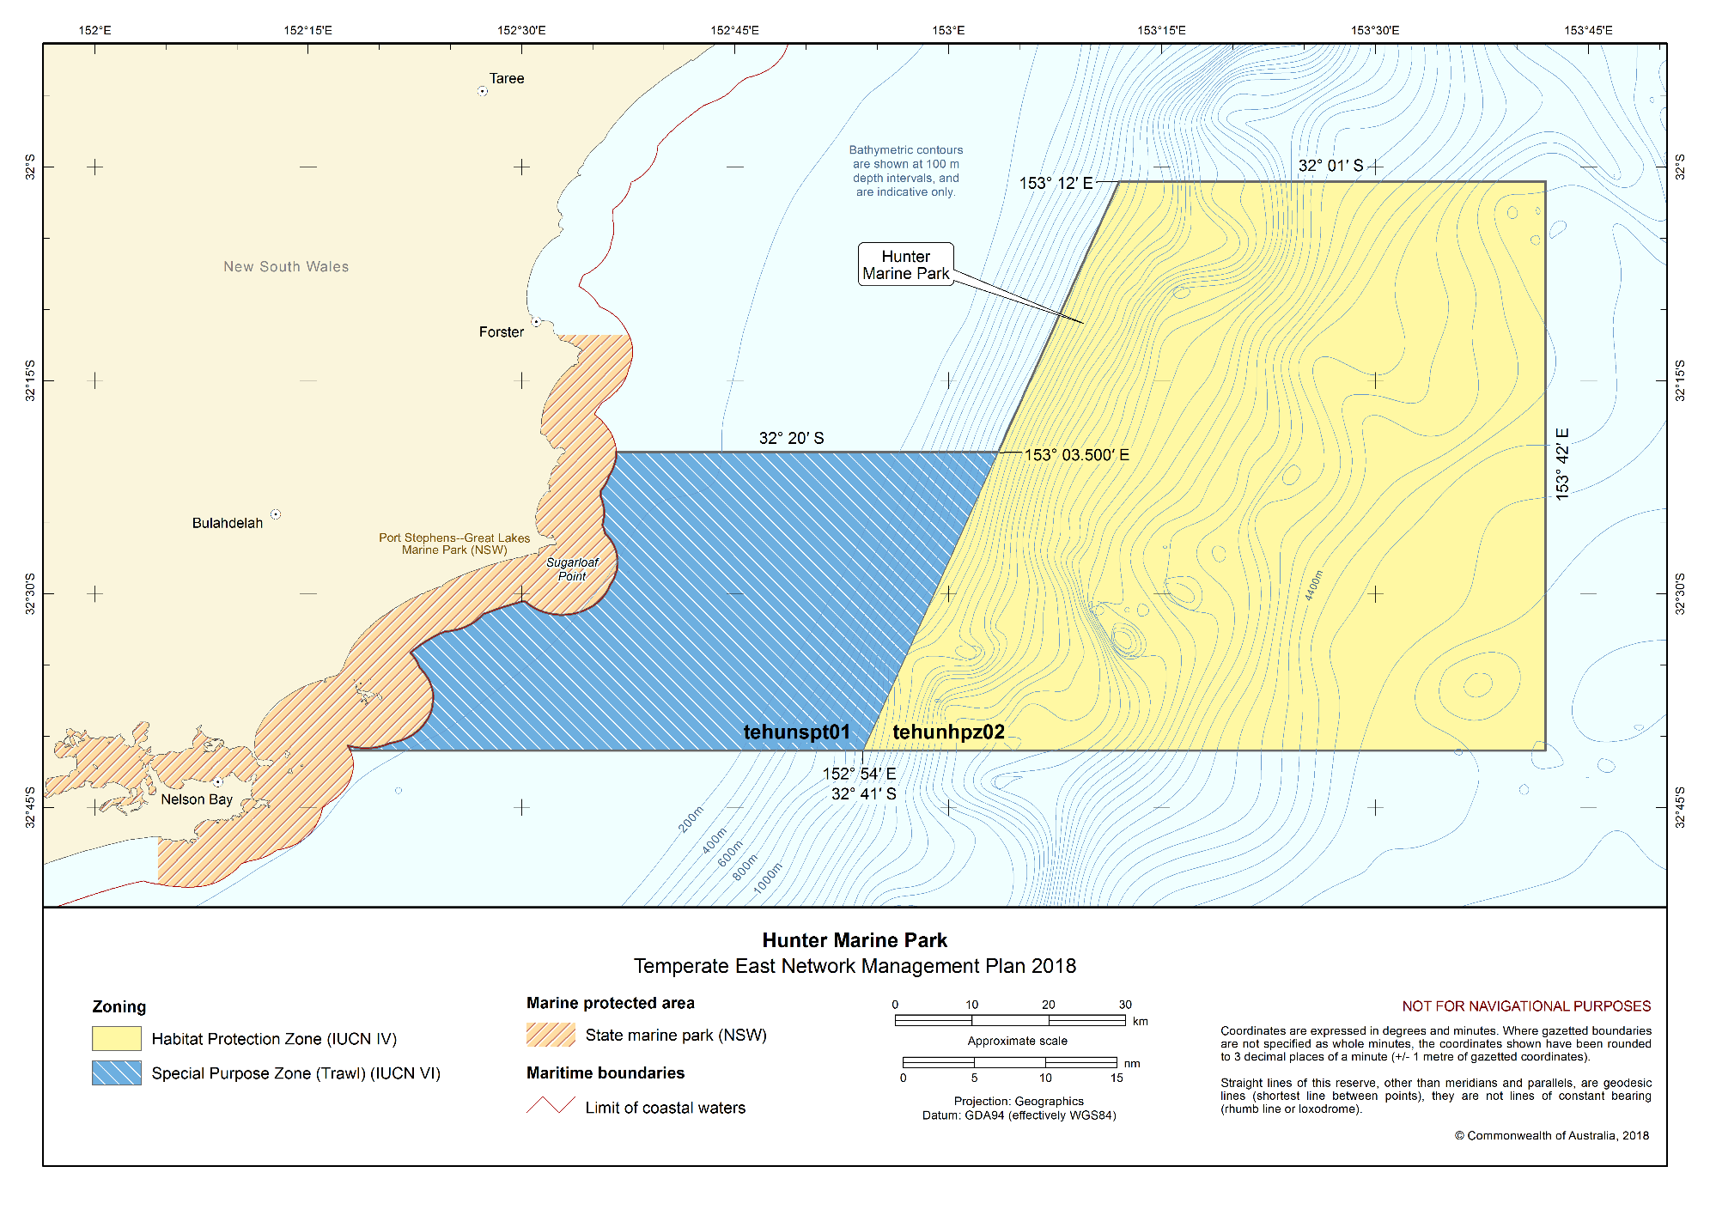Figure S2.7 Hunter Marine Park

Jervis Marine Park
The Jervis Marine Park (Figure S2.8) is located approximately 20 km offshore, adjacent to the New South Wales Jervis Bay Marine Park and Commonwealth Booderee National Park. The Marine Park covers an area of 2473 km² and a depth range between 120 m and 5000 m.
The Marine Park was proclaimed under the EPBC Act on 14 December 2013 and renamed Jervis Marine Park on 9 October 2017. The Marine Park is assigned IUCN category IV and includes two zones assigned under this plan: Habitat Protection Zone (IV) and Special Purpose Zone (Trawl) (VI).
Coordinates for the Jervis Marine Park and zones are provided in Figure S2.8 and Schedule 4.
Statement of significance
The Jervis Marine Park is significant because it contains habitats, species and ecological communities associated with the Central Eastern Province and the Southeast Shelf Transition. It includes two key ecological features: canyons on the eastern continental slope; and shelf rocky reefs (both valued as unique seafloor features with ecological properties of regional significance).
Natural values
The Marine Park includes examples of ecosystems representative of:
- Central Eastern Province—includes canyons along the edge of the continental shelf that interact with ocean currents and gyres resulting in plankton blooms associated with upwellings.
- Southeast Shelf Transition—includes upwellings caused by the East Australian Current crossing the continental shelf and river sediments that influence biological productivity in this region.
Key ecological features of the Marine Park are:
- Canyons on the eastern continental slope—canyons enhance diversity and abundance of species, driven by the combined effects of steep and rugged topography, ocean currents, seafloor types and nutrient availability. Canyons also create localised changes in productivity in the water column above them, providing feeding opportunities for a range of species.
- Shelf rocky reefs—which have a complex range of benthic habitat that supports diverse benthic communities.
The Marine Park supports a range of species, including species listed as threatened, migratory, marine or cetacean under the EPBC Act. Biologically important areas within the Marine Park include foraging habitat for seabirds, foraging habitat for grey nurse sharks, and a foraging habitat for humpback whales.
Cultural values
Sea country is valued for Indigenous cultural identity, health and wellbeing. Across Australia, Indigenous people have been sustainably managing their sea country for tens of thousands of years. At the commencement of this plan, there is limited information about the cultural significance of this Marine Park.
The Native Title Services Corporation is the Native Title Service Provider for the New South Wales region.
Heritage values
No international, Commonwealth or national heritage listings apply to the Marine Park at commencement of this plan.
Historic shipwrecks
The Marine Park contains one known shipwreck listed under the Historic Shipwrecks Act 1976— HMAS Tattoo (wrecked in 1939).
Social and economic values
Tourism, commercial fishing, and recreation are important activities in the Marine Park. These activities contribute to the wellbeing of regional communities and the prosperity of the nation.

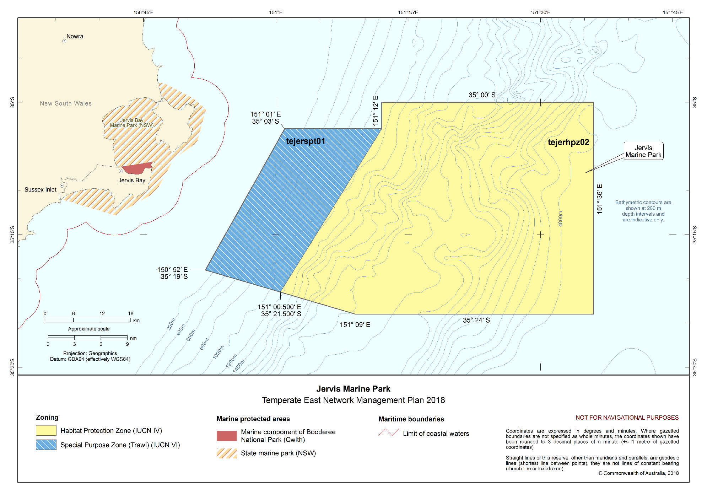Figure S2.8 Jervis Marine Park

Schedule 3 Environmental features used in the design of the Temperate East Network
Four types of environmental features were used in the design of the marine parks of the Temperate East Network to help identify areas for protection. These features were identified based on the scientifically known relationships between biodiversity and the physical environment and include bioregions, water depth, seafloor features and key ecological features. They are identified below.
More information on these features can be found in the Marine bioregional plan for the Temperate East Marine Region (2012), the East marine bioregional plan: bioregional profile (2008), and the conservation values atlas on the Department’s website.
Bioregions
Bioregions are identified in the Integrated Marine and Coastal Regionalisation of Australia (IMCRA) as large areas of ocean with broadly similar characteristics that have been classified by scientists based on the distribution of fish and other marine species, seafloor types and ocean conditions. The Temperate East Network represents seven of the ten bioregions found in the region: Central Eastern Transition, Central Eastern Shelf Transition, Central Eastern Shelf Province, Central Eastern Province, Tasman Basin Province, Lord Howe Province, Norfolk Island Province and the South-east Shelf Transition (Figure S3.1).
Depth ranges
The Temperate East Network represents the full range of depths found in the region, from shallow waters of less than 15 m to approximately 6000 m depth. Marine biological communities change with depth, and similar depth ranges in different bioregions support different groups of species. The range of ocean depths in each bioregion, represented as bathomes in Figure S3.2, have been included in the Network to ensure that examples of marine biodiversity are represented.
Seafloor features
The landscape-scale physical structure of the seafloor is important in determining where habitats or species occur. There is strong scientific evidence that different types of seafloor features provide different habitats and associated marine species and communities. The Network represents 15 of the 17 seafloor features found in the region: abyssal plain/deep ocean floor, bank/shoal, basin, canyon, deep/hole/ valley, knoll/abyssal hills/hills/mountain/peak, pinnacle, plateau, ridge, saddle, seamount/guyot, shelf, slope, terrace, and trench/trough (Figure S3.3).
Key ecological features
Key ecological features were identified through the marine bioregional planning program as areas or features that support distinct or important ecological communities at a regional scale. The Temperate East Network represents six of eight key ecological features found in the region: shelf rocky reefs, canyons on the eastern continental slope, Tasman Front and eddy field, Tasmantid Seamount Chain, Lord Howe Seamount Chain, Norfolk Ridge, and Elizabeth and Middleton Reefs. (Figure S3.4).
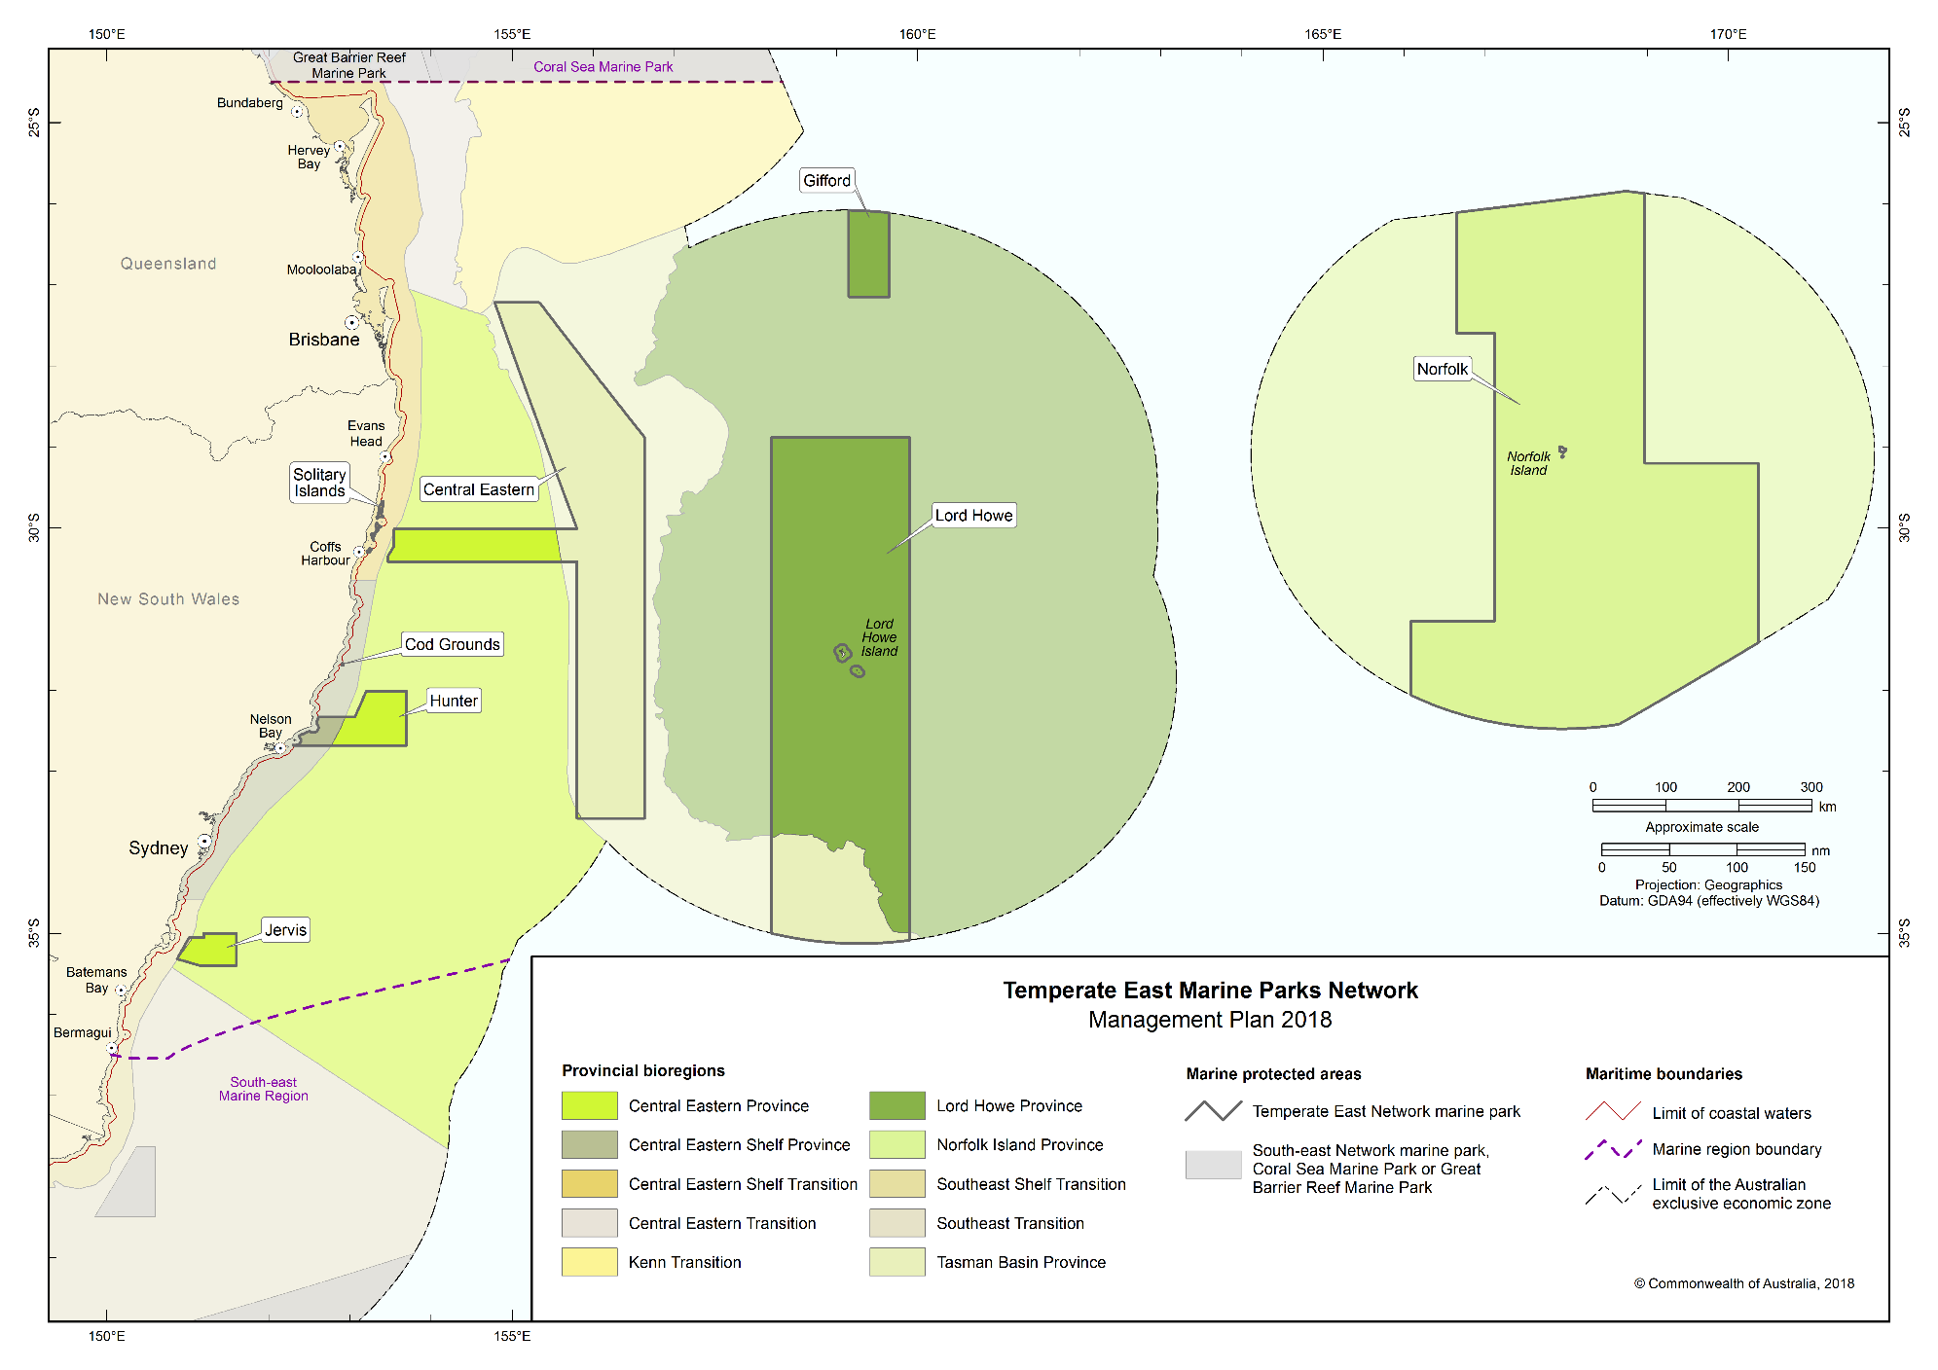Figure S3.1 Provincial bioregions represented in the Temperate East Network

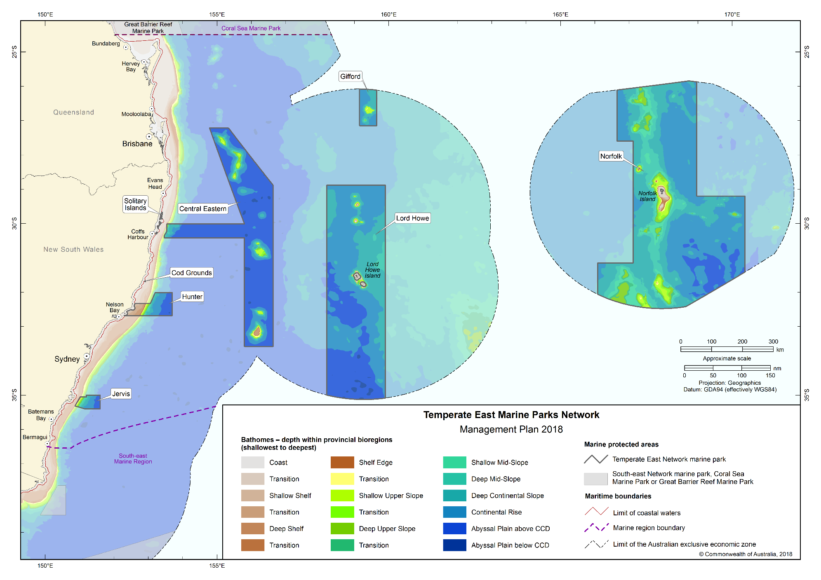Figure S3.2 Bathomes indicating depth ranges represented in the Temperate East Network

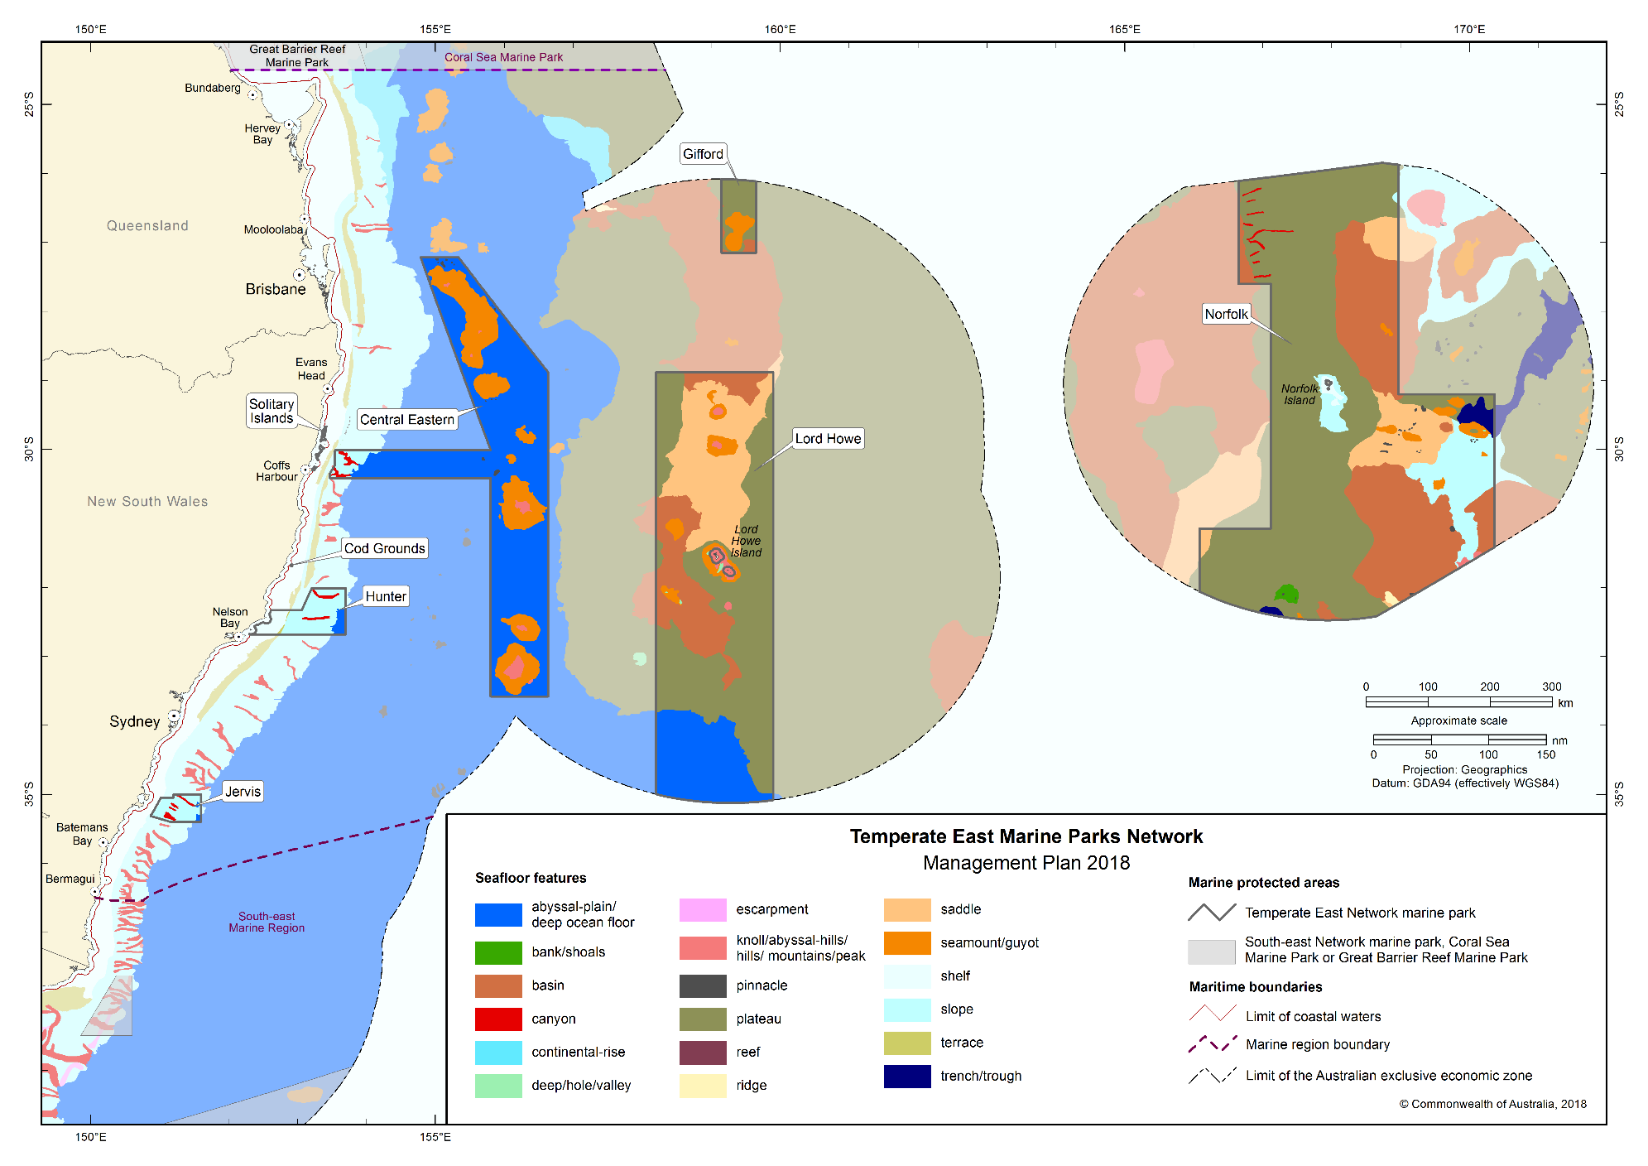Figure S3.3 Seafloor features represented in the Temperate East Network

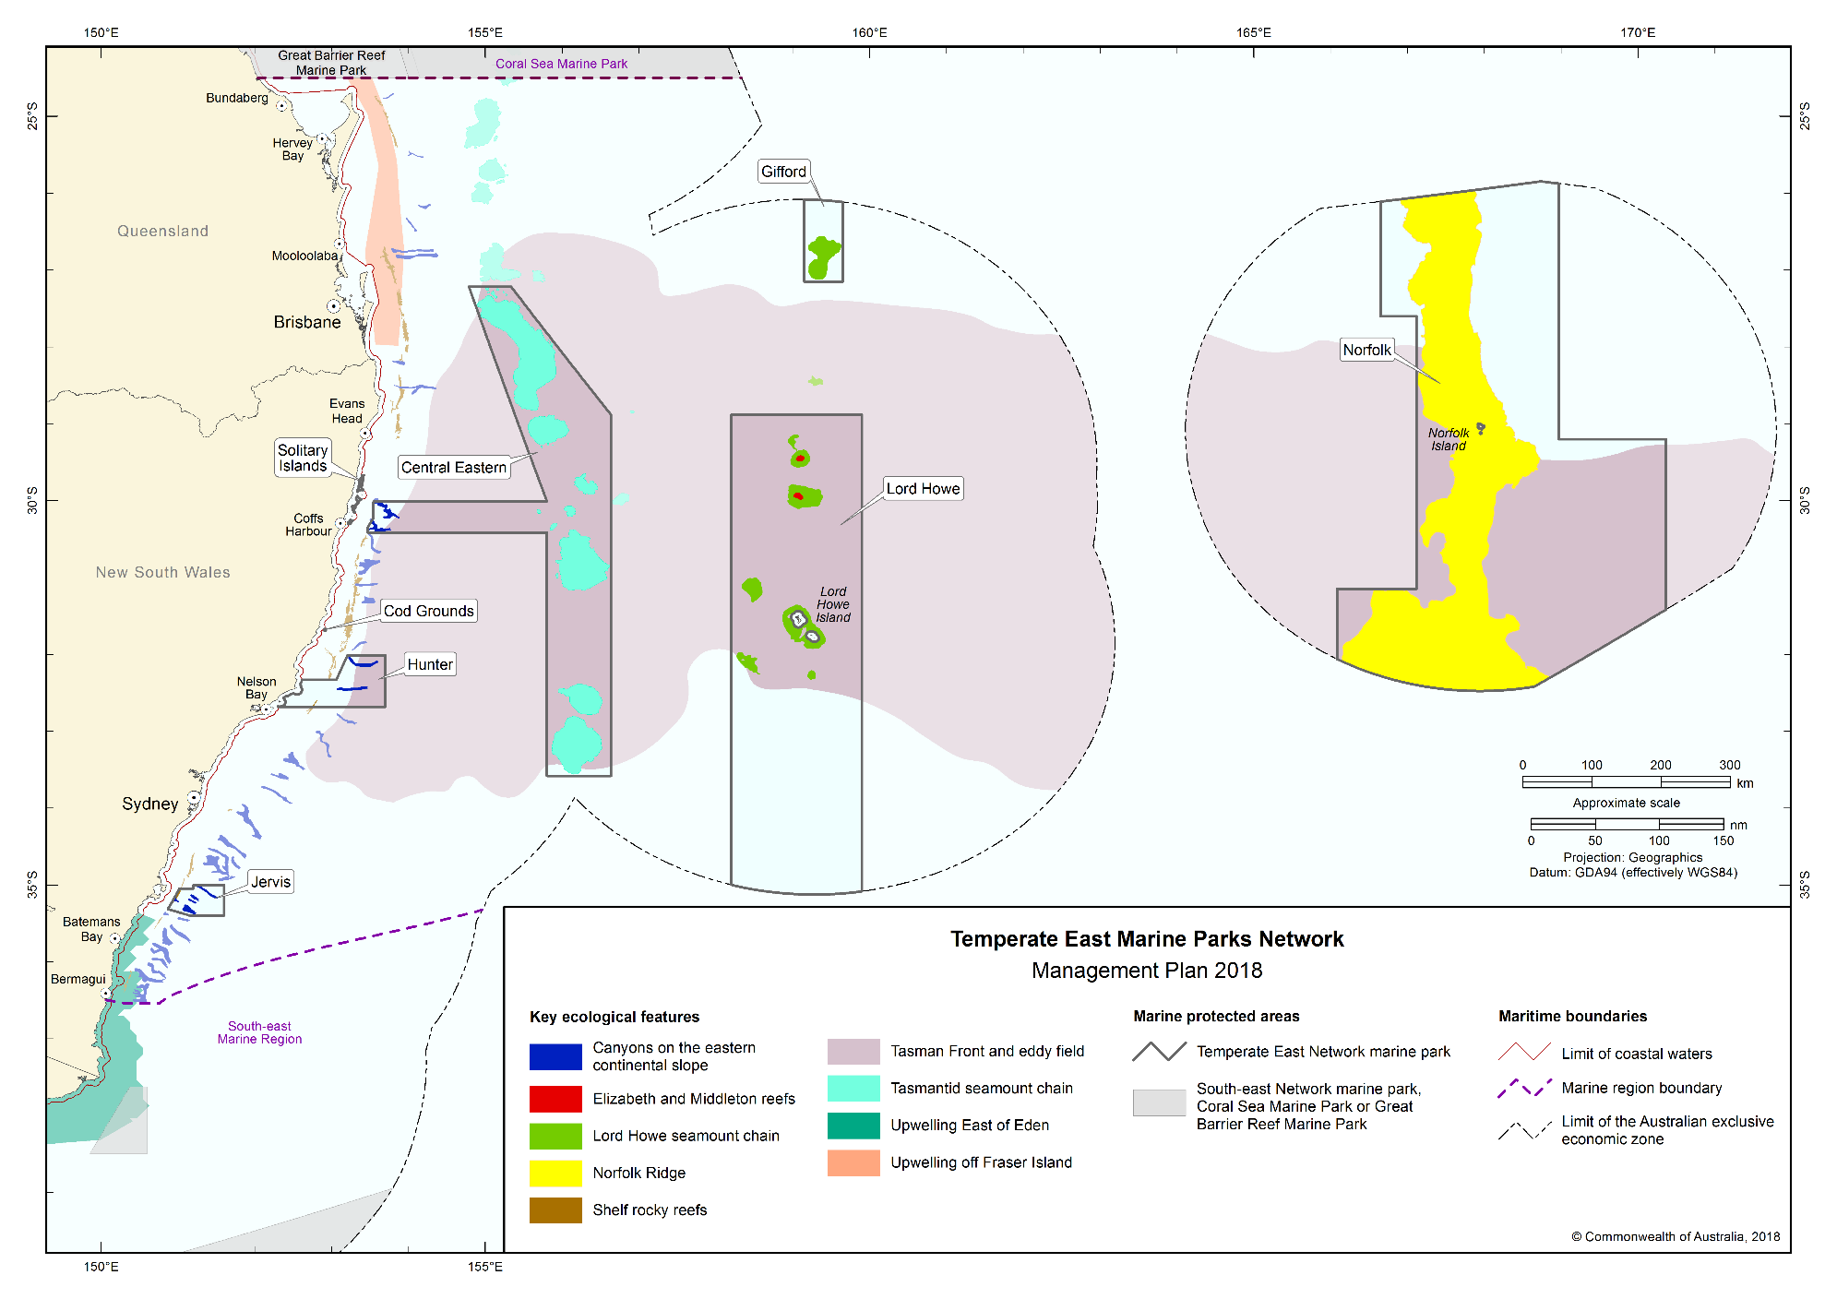Figure S3.4 Key ecological features represented in the Temperate East Network

Schedule 4 Temperate East Network marine parks and zone boundary descriptions

In this Schedule:
Maritime boundary (French Republic) Agreement means the Agreement on Maritime Delimitation between the Government of Australia and the Government of the French Republic, done at Melbourne on 4 January 1982. The Agreement is in Australian Treaty Series 1983 No. 3 ([1983] ATS 3) and could in 2013 be viewed in the Australian Treaties Library on the AustLII website (http://www.austlii.edu.au).

Maritime boundary (New Zealand) Treaty means the Treaty between the Government of Australia and the Government of New Zealand Establishing Certain Exclusive Economic Zone Boundaries and Continental Shelf Boundaries, done at Adelaide on 25 July 2004. The Treaty is in Australian Treaty Series 2006 No. 4 ([2006] ATS 4) and could in 2013 be viewed in the Australian Treaties Library on the AustLII website (http://www.austlii.edu.au).
Norfolk Island has the same meaning as Territory in subsection 4(1) of the Norfolk Island Act 1979.
State waters has the same meaning as coastal waters of the State in subsection 3(1) of the Coastal Waters (State Powers) Act 1980.
Note: Geographic coordinates in this Proclamation are expressed in terms of the Geocentric Datum of Australia 1994.
Note: The Geocentric Datum of Australia 1994 (also known as GDA94) was published in Gazette No. GN 35 of 6 September 1995.

Part 1 — Gifford Marine Park

1.1 Area of marine park
The Gifford Marine Park consists of an area in the South Pacific Ocean bounded by the line commencing at the point described in item 1 of the following table and running progressively as described in the table.
Area of marine park
Item | Description
1 | The point of latitude 27° 09′ 00″ S, longitude 159° 09′ 00″ E
2 | North along the meridian of longitude 159° 09′ 00″ E to its intersection by the outer limit of the exclusive economic zone
3 | Generally easterly along that outer limit to its intersection by the meridian of longitude 159° 39 ′ 00″ E
4 | South along that meridian to its intersection by the parallel of latitude 27° 09′ 00″ S
5 | West along that parallel to the point of commencement

1.2 Zone (tegifhpz01) for marine park
(1) The Gifford Marine Park has the following zone:
(a) the Habitat Protection Zone (IV) described in Section 1.1 of this Part.

Part 2 — Norfolk Marine Park

2.1 Area of marine park
Zone 1 of the marine park consists of an area bounded by the line commencing at the point described in item 1 of the following table and running progressively as described in the table.
Area of marine park
Item | Description
1 | The point of latitude 27° 36′ 00″ S, longitude 166° 39′ 00″ E
2 | North along the meridian of longitude 166° 39′ 00″ E to its intersection by the line described by article 1 of the Maritime boundary (French Republic) Agreement
3 | Generally easterly along that line to its intersection by the meridian of longitude 168° 58′ 00″ E
4 | South along that meridian to its intersection by the parallel of latitude 29° 12′ 00″ S
5 | East along that parallel to its intersection by the meridian of longitude 170° 22′ 00″ E
6 | South along that meridian to its intersection by the line described by article 2 of the Maritime boundary (New Zealand) Treaty
7 | Generally south-westerly and westerly along that line to its intersection by the meridian of longitude 166 ° 05 ′ 00″ E
8 | North along that meridian to its intersection by the parallel of latitude 31° 09′ 00″ S
9 | East along that parallel to its intersection by the meridian of longitude 167° 07′ 00″ E
10 | North along that meridian to its intersection by the parallel of latitude 27° 36′ 00″ S
11 | West along that parallel to the point of commencement

2.2 Zones for marine park
(1) The Norfolk Marine Park is divided into the following zones:
(a) the National Park Zone (II) described in Section 2.3 of this Part;
(b) the Habitat Protection Zone (IV) described in Section 2.4 of this Part;
(c) the Special Purpose Zone (Norfolk) (VI) described in Section 2.5 of this Part.

2.3 Zone 1 (tenornpz01) of marine park—National Park Zone (II)
Zone 1 (tenornpz01) of the marine park consists of an area bounded by the line commencing at the point described in item 1 of the following table and running progressively as described in the table.
Zone 1 (tenornpz01) of marine park—National Park Zone (II)
Item | Description
1 | The point of latitude 27° 36′ 00″ S, longitude 166° 39′ 00″ E
2 | North along the meridian of longitude 166° 39′ 00″ E to its intersection by the line described by article 1 of the Maritime boundary (French Republic) Agreement
3 | Generally easterly along that line to its intersection by the meridian of longitude 168° 58′ 00″ E
4 | South along that meridian to its intersection by the parallel of latitude 27° 36′ 00″ S
5 | West along that parallel to the point of commencement

2.4 Zone 2 (tenorhpz02) of marine park—Habitat Protection Zone (IV)
Zone 2 (tenorhpz02) of the marine park consists of an area bounded by the line commencing at the point described in item 1 of the following table and running progressively as described in the table.
Zone 2 (tenorhpz02) of marine park—Habitat Protection Zone (IV)
Item | Description
1 | The point of latitude 29° 12′ 00″ S, longitude 168° 58′ 00″ E
2 | East along the parallel of latitude 29° 12′ 00″ S to its intersection by the meridian of longitude 170° 22′ 00″ E
3 | South along that meridian to its intersection by the line described by article 2 of the Maritime boundary (New Zealand) Treaty
4 | Generally south-westerly and westerly along that line to its intersection by the meridian of longitude 166° 05′ 00″ E
5 | North along the meridian of longitude 166° 05′ 00″ E to its intersection by the parallel of latitude 31° 09′ 00″ S
6 | East along that parallel to its intersection by the meridian of longitude 167° 07′ 00″ E
7 | North along that meridian to its intersection by the parallel of latitude 27° 36′ 00″ S
8 | East along that parallel to its intersection by the meridian of longitude 168° 58′ 00″ E
9 | South along that meridian to the point of commencement

2.5 Zone 3 (tenorspn03) of marine park—Special Purpose Zone (Norfolk) (VI)
Zone 3 (tenorspn03) of the marine park consists of an area bounded by the line commencing at the point described in item 1 of the following table and running progressively as described in the table.
Zone 3 (tenorspn03) of marine park—Special Purpose Zone (Norfolk) (VI)
Item | Description
1 | The point of latitude 28° 38′ 00″ S, longitude 167° 40′ 00″ E
2 | East along the parallel of latitude 28° 38′ 00″ S to its intersection by the meridian of longitude 168° 20′ 00″ E
3 | South along that meridian to its intersection by the parallel of latitude 29° 45′ 00″ S
4 | West along that parallel to its intersection by the meridian of longitude 167° 40′ 00″ E
5 | North along that meridian to the point of commencement

Part 3 — Lord Howe Marine Park

3.1 Area of marine park
The Lord Howe Marine Park consists of an area in the South Pacific Ocean, excluding any State waters of New South Wales, bounded by the line commencing at the point described in item 1 of the following table and running progressively as described in the table.
Area of marine park
Item | Description
1 | The point of latitude 28° 53′ 00″ S, longitude 158° 12′ 00″ E
2 | East along the parallel of latitude 28° 53′ 00″ S to its intersection by the meridian of longitude 159 ° 54′ 00″ E
3 | South along that meridian to its intersection by the outer limit of the exclusive economic zone
4 | Generally westerly along that outer limit to its intersection by the meridian of longitude 158° 12′ 00″E
5 | North along that meridian to the point of commencement

3.2 Zones for marine park
(1) The Lord Howe Marine Park is divided into the following zones:
(a) the Multiple Use Zone (VI) described in Section 3.3 of this Part;
(b) the National Park Zones (II) described in Sections 3.4, 3.7 and 3.8 of this Part;
(c) the Recreational Use Zone (IV) described in Section 3.5 of this Part
(d) the Habitat Protection Zone (Lord Howe) (IV) described in Section 3.6 of this Part;
(e) the Habitat Protection Zone (IV) described in Section 3.9 of this Part.

3.3 Zone 1 (telhimuz01) of marine park—Multiple Use Zone (VI)
Zone 1 (telhimuz01) of the marine park consists of an area, excluding the zones described in Sections 3.5 and 3.6, bounded by the line commencing at the point described in item 1 of the following table and running progressively as described in the table.
Zone 1 (telhimuz01) of marine park—Multiple Use Zone (VI)
Item | Description
1 | The point of latitude 28° 53′ 00″ S, longitude 158° 12′ 00″ E
2 | East along the parallel of latitude 28° 53′ 00″ S to its intersection by the meridian of longitude 159° 54′ 00″ E
3 | South along that meridian to its intersection by the parallel of latitude 31° 17′ 00″ S
4 | West along that parallel to its intersection by the meridian of longitude 158° 12′ 00″ E
5 | North along that meridian to the point of commencement

3.4 Zone 2 (telhinpz02) of marine park—National Park Zone (II)
Zone 2 (telhinpz02) of the marine park consists of an area bounded by the line commencing at the point described in item 1 of the following table and running progressively as described in the table.
Zone 2 (telhinpz02) of marine park—National Park Zone (II)
Item | Description
1 | The point of latitude 29° 21′ 00″ S, longitude 158° 55′ 00″ E
2 | East along the parallel of latitude 29° 21′ 00″ S to its intersection by the meridian of longitude 159° 24′ 00″ E
3 | South along that meridian to its intersection by the parallel of latitude 29° 53′ 00″ S
4 | West along that parallel to its intersection by the meridian of longitude 158° 55′ 00″ E
5 | North along that meridian to the point of commencement

3.5 Zone 3 (telhiruz03) of marine park—Recreational Use Zone (IV)
Zone 3 (telhiruz03) of the marine park consists of an area bounded by the line commencing at the point described in item 1 of the following table and running progressively as described in the table.
Zone 3 (telhiruz03) of marine park—Recreational Use Zone (IV)
Item | Description
1 | The point of latitude 29° 53′ 00″ S, longitude 158° 55′ 00″ E
2 | East along the parallel of latitude 29° 53′ 00″ S to its intersection by the meridian of longitude 159° 24′ 00″ E
3 | South along that meridian to its intersection by the parallel of latitude 30° 06′ 35″ S
4 | West along that parallel to its intersection by the meridian of longitude 158° 55′ 00″ E
5 | North along that meridian to the point of commencement

3.6 Zone 4 (telhihpl04) of marine park—Habitat Protection Zone (Lord Howe) (IV)
Zone 4 (telhihpl04) of the marine park consists of an area, excluding any State waters of New South Wales and the zone described in Section 3.6, bounded by the line commencing at the point described in item 1 of the following table and running progressively as described in the table.
Zone 4 (telhihpl04) of marine park—Habitat Protection Zone (Lord Howe) (IV)
Item | Description
1 | The point of latitude 31° 46′ 50″ S, longitude 158° 48′ 00″ E
2 | East along the parallel of latitude 31° 46′ 50″ S to its westernmost intersection by the outer limit of the State waters of New South Wales, adjacent to Ball’s Pyramid
3 | Generally northerly, easterly and south-easterly along that outer limit to its easternmost intersection by the parallel of latitude 31° 46′ 50″ S
4 | East along that parallel to its intersection by the meridian of longitude 159° 54′ 00″ E
5 | North along that meridian to its intersection by the parallel of latitude 31° 17′ 00″ S
6 | West along that parallel to its intersection by the meridian of longitude 158° 48′ 00″ E
7 | South along that meridian to the point of commencement

3.7 Zone 5 (telhinpz05) of marine park—National Park Zone (II)
Zone 5 (telhinpz05) of the marine park consists of an area bounded by the line commencing at the point described in item 1 of the following table and running progressively as described in the table.
Zone 5 (telhinpz05) of marine park—National Park Zone (II)
Item | Description
1 | The point of latitude 31° 30′ 40″ S, longitude 159° 24′ 00″ E
2 | South along the meridian of longitude 159° 24′ 00″ E to its intersection by the parallel of latitude 31° 35′ 50″ S
3 | West along that parallel to its intersection by the outer limit of the State waters of New South Wales, adjacent to Lord Howe Island
4 | Generally north-easterly and north-westerly along that outer limit to its intersection by the parallel of latitude 31° 30′ 40″ S
5 | East along that parallel to the point of commencement

3.8 Zone 6 (telhinpz06) of marine park—National Park Zone (II)
Zone 6 (telhinpz06) of the marine park consists of an area bounded by the line commencing at the point described in item 1 of the following table and running progressively as described in the table.
Zone 6 (telhinpz06) of marine park—National Park Zone (II)
Item | Description
1 | The point of latitude 31° 46′ 50″ S, longitude 158° 48′ 00″ E
2 | East along the parallel of latitude 31° 46′ 50″ S to its westernmost intersection by the outer limit of the State waters of New South Wales, adjacent to Ball’s Pyramid
3 | Generally south-easterly and north-easterly along that outer limit to its easternmost intersection by the parallel of latitude 31° 46′ 50″ S
4 | East along that parallel to its intersection by the meridian of longitude 159° 54′ 00″ E
5 | South along that meridian to its intersection by the parallel of latitude 32° 20′ 00″ S
6 | West along that parallel to its intersection by the meridian of longitude 158° 48′ 00″ E
7 | North along that meridian to the point of commencement

3.9 Zone 7 (telhihpz07) of marine park—Habitat Protection Zone (IV)
Zone 7 (telhihpz07) of the marine park consists of an area bounded by the line commencing at the point described in item 1 of the following table and running progressively as described in the table.
Zone 7 (telhihpz07) of marine park—Habitat Protection Zone (IV)
Item | Description
1 | The point of latitude 31° 17′ 00″ S, longitude 158° 12′ 00″ E
2 | East along the parallel of latitude 31° 17′ 00″ S to its intersection by the meridian of longitude 158° 48′ 00″ E
3 | South along that meridian to its intersection by the parallel of latitude 32° 20′ 00″ S
4 | East along that parallel to its intersection by the meridian of longitude 159° 54′ 00″ E
5 | South along that meridian to its intersection by the outer limit of the exclusive economic zone
6 | Generally westerly along that outer limit to its intersection by the meridian of longitude 158° 12′ 00″ E
7 | North along that meridian to the point of commencement

Part 4 — Central Eastern Marine Park

4.1 Area of marine park
The Central Eastern Marine Park consists of an area in the South Pacific Ocean bounded by the line commencing at the point described in item 1 of the following table and running progressively as described in the table.
Area of marine park
Item | Description
1 | The point of latitude 27° 13′ 00″ S, longitude 154° 47′ 00″ E
2 | East along the parallel of latitude 27° 13′ 00″ S to its intersection by the meridian of longitude 155° 20′ 00″ E
3 | South-easterly along the geodesic to the point of latitude 28° 53′ 00″ S, longitude 156° 38′ 00″ E
4 | South along the meridian of longitude 156° 38′ 00″ E to its intersection by the parallel of latitude 33° 34′ 54″ S
5 | West along that parallel to its intersection by the meridian of longitude 155° 48′ 00″ E
6 | North along that meridian to its intersection by the parallel of latitude 30° 25′ 00″ S
7 | West along that parallel to its intersection by the meridian of longitude 153° 28′ 00″ E
8 | North along that meridian to its intersection by the parallel of latitude 30° 21′ 00″ S
9 | North-easterly along the geodesic to the point of latitude 30° 13′ 30″ S, longitude 153° 32′ 30″ E
10 | North along the meridian of longitude 153° 32′ 30″ E to its intersection by the parallel of latitude 30° 00′ 40″S
11 | East along that parallel to its intersection by the meridian of longitude 155° 48′ 00″ E
12 | North-westerly along the geodesic to the point of commencement

4.2 Zones for marine park
(1) The Central Eastern Marine Park is divided into the following zones:
(a) the Habitat Protection Zones (IV) described in clauses 4.3 and 4.6 of this Part;
(b) the Multiple Use Zone (VI) described in clause 4.4 of this Part;
(c) the National Park Zone (II) described in clause 4.5 of this Part.
4.3 Zone 1 (teceehpz01) of marine park—Habitat Protection Zone (IV)
Zone 1 (teceehpz01) of the marine park consists of an area bounded by the line commencing at the point described in item 1 of the following table and running progressively as described in the table.
Zone 1 (teceehpz01) of marine park—Habitat Protection Zone (IV)
Item | Description
1 | The point of latitude 27° 13′ 00″ S, longitude 154° 47′ 00″ E
2 | East along the parallel of latitude 27° 13′ 00″ S to its intersection by the meridian of longitude 155° 20′ 00″ E
3 | South-easterly along the geodesic to the point of latitude 28° 53′ 00″ S, longitude 156° 38′ 00″ E
4 | South along the meridian of longitude 156° 38′ 00″ E to its intersection by the parallel of latitude 30° 17′ 00″ S
5 | West along that parallel to its intersection by the meridian of longitude 155° 48′ 00″ E
6 | South along that meridian to its intersection by the parallel of latitude 30° 25′ 00″ S
7 | West along that parallel to its intersection by the meridian of longitude 153° 39′ 30″ E
8 | North along that meridian to its intersection by the parallel of latitude 30° 00′ 40″ S
9 | East along that parallel to its intersection by the meridian of longitude 155° 48′ 00″ E
10 | North-westerly along the geodesic to the point of commencement

4.4 Zone 2 (teceemuz02) of marine park—Multiple Use Zone (VI)
Zone 2 (teceemuz02) of the marine park consists of an area bounded by the line commencing at the point described in item 1 of the following table and running progressively as described in the table.
Zone 2 (teceemuz02) of marine park—Multiple Use Zone (VI)
Item | Description
1 | The point of latitude 30° 00′ 40″ S, longitude 153° 32′ 30″ E
2 | East along the parallel of latitude 30° 00′ 40″ S to its intersection by the meridian of longitude 153° 39′ 30″ E
3 | South along that meridian to its intersection by the parallel of latitude 30° 25′ 00″ S
4 | West along that parallel to its intersection by the meridian of longitude 153° 28′ 00″ E
5 | North along that meridian to its intersection by the parallel of latitude 30° 21′ 00″ S
6 | North-easterly along the geodesic to the point of latitude 30° 13′ 30″ S, longitude 153° 32′ 30″ E
7 | North along the meridian of longitude 153° 32′ 30″ E to the point of commencement

4.5 Zone 3 (teceenpz03) of marine park—National Park Zone (II)
Zone 3 (teceenpz03) of the marine park consists of an area bounded by the line commencing at the point described in item 1 of the following table and running progressively as described in the table.
Zone 3 (teceenpz03) of marine park—National Park Zone (II)
Item | Description
1 | The point of latitude 30° 17′ 00″ S, longitude 155° 48′ 00″ E
2 | East along the parallel of latitude 30° 17′ 00″ S to its intersection by the meridian of longitude 156° 38′ 00″ E
3 | South along that meridian to its intersection by the parallel of latitude 31° 12′ 00″ S
4 | West along that parallel to its intersection by the meridian of longitude 155° 48′ 00″ E
5 | North along that meridian to the point of commencement

4.6 Zone 4 (teceehpz04) of marine park—Habitat Protection Zone (IV)
Zone 4 (teceehpz04) of the marine park consists of an area bounded by the line commencing at the point described in item 1 of the following table and running progressively as described in the table.
Zone 4 (teceehpz04) of marine park—Habitat Protection Zone (IV)
Item | Description
1 | The point of latitude 31° 12′ 00″ S, longitude 155° 48′ 00″ E
2 | East along the parallel of latitude 31° 12′ 00″ S to its intersection by the meridian of longitude 156° 38′ 00″ E
3 | South along that meridian to its intersection by the parallel of latitude 33° 34′ 54″ S
4 | West along that parallel to its intersection by the meridian of longitude 155° 48′ 00″ E
5 | North along that meridian to the point of commencement

Part 5 — Solitary Islands Marine Park

5.1 Area of marine park
The Solitary Islands Marine Park consists of an area in the South Pacific Ocean, excluding any State waters of New South Wales, bounded by the line commencing at the intersection described in item 1 of the following table and running progressively as described in the table.

Area of marine park
Item | Description
1 | The intersection of the parallel of latitude 29° 40′ 18.28″ S by the coastline of New South Wales at mean low water
2 | East along that parallel to its intersection by the line corresponding with the 50 metre isobath below mean high water on the coast of New South Wales
3 | Generally southerly along that isobath to its intersection by the parallel of latitude 30° 18′ 19.27″ S
4 | West along that parallel to its intersection by the coastline of New South Wales at mean low water
5 | Generally northerly along that low water mark to the point of commencement

5.2 Zones for marine park
(1) The Solitary Islands Marine Park is divided into the following zones:
(a) the Multiple Use Zone (VI) described in clause 5.3 of this Part;
(b) the National Park Zone (II) described in clause 5.4 of this Part;
(c) the Special Purpose Zone (Trawl) (VI) described in Section 5.5 of this Part.

5.3 Zone 1 (tesolmuz01) of marine park—Multiple Use Zone (VI)
Zone 1 (tesolmuz01) of the marine park consists of an area, excluding the zone described in Section 5.5 and any State waters of New South Wales, bounded by the line commencing at the intersection described in item 1 of the following table and running progressively as described in the table.
Zone 1 (tesolmuz01) of marine park—Multiple Use Zone (VI)
Item | Description
1 | The intersection of the parallel of latitude 29° 40′ 18.28″ S by the coastline of New South Wales at mean low water
2 | East along that parallel to its intersection by the line corresponding with the 50 metre isobath below mean high water on the coast of New South Wales
3 | Generally southerly along that isobath to its intersection by the parallel of latitude 29° 46′ 42″ S
4 | West along that parallel to its intersection by the coastline of New South Wales at mean low water
5 | Generally northerly along that low water mark to the point of commencement

5.4 Zone 2 (tesolnpz02) of marine park—National Park Zone (II)
Zone 2 (tesolnpz02) of the marine park consists of an area bounded by the line commencing at the point described in item 1 of the following table and running progressively as described in the table.
Zone 2 (tesolnpz02) of marine park—National Park Zone (II)
Item | Description
1 | The point of latitude 29° 41′ 32.1″ S, longitude 153° 23′ 28.5″ E
2 | East along the parallel of latitude 29° 41′ 32.1″ S, to its intersection by the meridian of longitude 153° 24′ 15.6″ E
3 | South along that meridian to its intersection by the line corresponding with the 50 metre isobath below mean high water on the coast of New South Wales
4 | Generally southerly along that isobath to its intersection by the parallel of latitude 29° 42′ 12.9″ S
4 | West along that parallel to its intersection by the meridian of longitude 153° 23′ 28.5″ E
5 | North along that meridian to the point of commencement

5.5 Zone 3 (tesolspt03) of marine park—Special Purpose Zone (Trawl) (VI)
Zone 3 (tesolspt03) of the marine park consists of an area, excluding any State waters of New South Wales, bounded by the line commencing at the intersection described in item 1 of the following table and running progressively as described in the table.
Zone 3 (tesolspt03) of marine park—Special Purpose Zone (Trawl) (VI)
Item | Description
1 | The intersection of the parallel of latitude 29° 46′ 42″ S by the coastline of New South Wales at mean low water
2 | East along that parallel to its intersection by the line corresponding with the 50 metre isobath below mean high water on the coast of New South Wales
3 | Generally southerly along that isobath to its intersection by the parallel of latitude 30° 18′ 19.27″ S
4 | West along that parallel to its intersection by the coastline of New South Wales at mean low water
5 | Generally northerly along that low water mark to the point of commencement

Part 6 — Cod Grounds Marine Park

6.1 Area of marine park
The Cod Grounds Marine Park consists of an area in the Tasman Sea bounded by the line commencing at the point described in item 1 of the following table and running progressively as described in the table.
Area of marine park
Item | Description
1 | The point of latitude 31° 40′ 19″ S, longitude 152° 53′ 59″ E
2 | East along the parallel of latitude 31° 40′ 19″ S, to its intersection by the meridian of longitude 152° 55′ 15″E
3 | South along that meridian to its intersection by the parallel of latitude 31° 41′ 25″ S
4 | West along that parallel to its intersection by the meridian of longitude 152° 53′ 59″ E
5 | North along that meridian to the point of commencement

6.2 Zone (tecodnpz01) for marine park
(1) The Cod Grounds Marine Park has the following zone:
(a) the National Park Zone (II) described in Section 6.1 of this Part.

Part 7 — Hunter Marine Park

7.1 Area of marine park
The Hunter Marine Park consists of an area in the Tasman Sea bounded by the line commencing at the point described in item 1 of the following table and running progressively as described in the table.
Area of marine park
Item | Description
1 | The point of latitude 32° 01′ 00″ S, longitude 153° 12′ 00″ E
2 | East along the parallel of latitude 32° 01′ 00″ S to its intersection by the meridian of longitude 153° 42′ 00″ E
3 | South along that meridian to its intersection by the parallel of latitude 32° 41′ 00″ S
4 | West along that parallel to its intersection by the outer limit of the State waters of New South Wales
5 | Generally north-easterly and northerly along that outer limit to its intersection by the parallel of latitude 32° 20′ 00″ S
6 | East along that parallel to its intersection by the meridian of longitude 153° 03′ 30″ E
7 | North-easterly along the geodesic to the point of commencement

7.2 Zones for marine park
(1) The Hunter Marine Park is divided into the following zones:
(a) the Special Purpose Zone (Trawl) (VI) described in Section 7.3 of this Part;
(b) the Habitat Protection Zone (IV) described in Section 7.4 of this Part.

7.3 Zone 1 (tehunspt01) of marine park—Special Purpose Zone (Trawl) (VI)
Zone 1 (tehunspt01) of the marine park consists of an area bounded by the line commencing at the point described in item 1 of the following table and running progressively as described in the table.
Zone 1 (tehunspt01) of marine park—Special Purpose Zone (Trawl) (VI)
Item | Description
1 | The point of latitude 32° 20′ 00″ S, longitude 153° 03′ 30″ E
2 | South-westerly along the geodesic to the point of latitude 32° 41′ 00″ S, longitude 152° 54′ 00″ E
3 | West along the parallel of latitude 32° 41′ 00″ S to its intersection by the outer limit of the State waters of New South Wales
4 | Generally north-easterly and northerly along that outer limit to its intersection by the parallel of latitude 32° 20′ 00″ S
5 | East along that parallel to the point of commencement

7.4 Zone 2 (tehunhpz02) of marine park—Habitat Protection Zone (IV)
Zone 2 (tehunhpz02) of the marine park consists of an area bounded by the line commencing at the point described in item 1 of the following table and running progressively as described in the table.
Zone 2 (tehunhpz02) of marine park—Habitat Protection Zone (IV)
Item | Description
1 | The point of latitude 32° 01′ 00″ S, longitude 153° 12′ 00″ E
2 | East along the parallel of latitude 32° 01′ 00″ S to its intersection by the meridian of longitude 153° 42′ 00″ E
3 | South along that meridian to its intersection by the parallel of latitude 32° 41′ 00″ S
4 | West along that parallel to its intersection by the meridian of longitude 152° 54′ 00″ E
5 | North-easterly along the geodesic to the point of latitude 32° 20′ 00″ S, longitude 153° 03′ 30″ E
6 | North-easterly along the geodesic to the point of commencement

Part 8 — Jervis Marine Park

8.1 Area of marine park
The Jervis Marine Park consists of an area in the Tasman Sea bounded by the line commencing at the point described in item 1 of the following table and running progressively as described in the table.
Area of marine park
Item | Description
1 | The point of latitude 35° 00′ 00″ S, longitude 151° 12′ 00″ E
2 | East along the parallel of latitude 35° 00′ 00″ S to its intersection by the meridian of longitude 151° 36′ 00″ E
3 | South along that meridian to its intersection by the parallel of latitude 35° 24′ 00″ S
4 | West along that parallel to its intersection by the meridian of longitude 151° 09′ 00″ E
5 | North-westerly along the geodesic to the point of latitude 35° 21′ 30″ S, longitude 151° 00′ 30″ E
6 | North-westerly along the geodesic to the point of latitude 35° 19′ 00″ S, longitude 150° 52′ 00″ E
7 | North-easterly along the geodesic to the point of latitude 35° 03′ 00″ S, longitude 151° 01′ 00″ E
8 | East along the parallel of latitude 35° 03′ 00″ S to its intersection by the meridian of longitude 151° 12′ 00″E
9 | North along that meridian to the point of commencement

8.2 Zones for marine park
(1) The Jervis Marine Park is divided into the following zones:
(a) the Special Purpose Zone (Trawl) (VI) described in Section 8.3 of this Part;
(b) the Habitat Protection Zone (IV) described in Section 8.4 of this Part.

8.3 Zone 1 (tejerspt01) of marine park—Special Purpose Zone (Trawl) (VI)
Zone 1 (tejerspt01) of the marine park consists of an area bounded by the line commencing at the point described in item 1 of the following table and running progressively as described in the table.
Zone 1 (tejerspt01) of marine park—Special Purpose Zone (Trawl) (VI)
Item | Description
1 | The point of latitude 35° 03′ 00″ S, longitude 151° 01′ 00″ E
2 | East along the parallel of latitude 35° 03′ 00″ S to its intersection by the meridian of longitude 151° 12′ 00″ E
3 | South-westerly along the geodesic to the point of latitude 35° 21′ 30″ S, longitude 151° 00′ 30″ E
4 | North-westerly along the geodesic to the point of latitude 35° 19′ 00″ S, longitude 150° 52′ 00″ E
5 | North-easterly along the geodesic to the point of commencement

8.4 Zone 2 (tejerhpz02) of marine park—Habitat Protection Zone (IV)
Zone 2 (tejerhpz02) of the marine park consists of an area bounded by the line commencing at the point described in item 1 of the following table and running progressively as described in the table.
Zone 2 (tejerhpz02) of marine park—Habitat Protection Zone (IV)
Item | Description
1 | The point of latitude 35° 00′ 00″ S, longitude 151° 12′ 00″ E
2 | East along the parallel of latitude 35° 00′ 00″ S to its intersection by the meridian of longitude 151° 36′ 00″ E
3 | South along that meridian to its intersection by the parallel of latitude 35° 24′ 00″ S
4 | West along that parallel to the meridian of longitude 151° 09′ 00″ E
5 | North-westerly along the geodesic to the point of latitude 35° 21′ 30″ S, longitude 151° 00′ 30″ E
6 | North-easterly along the geodesic to the point of latitude 35° 03′ 00″ S, longitude 151° 12′ 00″ E
7 | North along the meridian of longitude 151° 12′ 00″ E to the point of commencement

Schedule 5 Supporting information
ANZECC (Australian and New Zealand Environment and Conservation Council) (1998) Guidelines for establishing the National Representative System of Marine Protected Areas. ANZECC Task Force on Marine Protected Areas, Canberra.
ANZECC (Australian and New Zealand Environment and Conservation Council) (1999) Strategic plan of action for the National Representative System of Marine Protected Areas: a guide for action for Australian Governments. ANZECC Task Force on Marine Protected Areas, Canberra.
Beeton RJS, Buxton CD, Cochrane P, Dittmann S, Pepperell JG (2015) Commonwealth marine reserves review: report of the expert scientific panel. Department of the Environment, Canberra.
Buxton CD, Cochrane P (2015) Commonwealth marine reserves review: report of the bioregional advisory panel. Department of the Environment, Canberra, 341 pp.
Commonwealth of Australia (1976) Historic Shipwrecks Act 1976.
Commonwealth of Australia (1999) Environment Protection and Biodiversity Conservation Act 1999. Environment Australia, Canberra.
Commonwealth of Australia (2000) Environment Protection and Biodiversity Conservation Regulations 2000. Environment Australia, Canberra.
Commonwealth of Australia (2006) A guide to the Integrated Marine and Coastal Regionalisation of Australia Version 4.0. Department of the Environment and Heritage, Canberra.
Commonwealth of Australia (2006) Threat abatement plan to reduce the impacts of tramp ants on biodiversity in Australia and its territories. Department of the Environment, Water, Heritage and the Arts, Canberra.
Commonwealth of Australia (2009) East marine bioregional plan: bioregional profile. Department of Sustainability, Environment, Water, Population and Communities, Canberra.
Commonwealth of Australia (2009) Threat abatement plan for the impacts of marine debris on vertebrate marine life. Department of the Environment, Water, Heritage and the Arts, Canberra.
Commonwealth of Australia (2012) Marine bioregional plan for the Temperate East Marine Region. Department of Sustainability, Environment, Water, Population and Communities, Canberra.
Day J, Dudley N, Hockings M, Holmes G, Laffoley D, Stolton S, Wells S (2012) Guidelines for applying the IUCN protected area management categories to marine protected areas. International Union for the Conservation of Nature, Gland, Switzerland, 36pp.
Jackson WJ, Argent RM, Bax NJ, Clark GF, Coleman S, Cresswell ID, Emmerson KM, Evans K, Hibberd MF, Johnston EL, Keywood MD, Klekociuk A, Mackay R, Metcalfe D, Murphy H, Rankin A, Smith DC, Wienecke B (2017) Australia state of the environment 2016: overview. Independent report to the Australian Government Minister for the Environment and Energy, Australian Government Department of the Environment and Energy, Canberra.

Map data sources
Aeronautical Information Services – Airforce (2016): Danger and restricted airspace regions over Australia.
Australian Fisheries Management Authority (2014): Commonwealth Fishing Activity (Status Report).
Australian Maritime Safety Authority (2015): Automatic Identification System (Shipping).
Department of the Environment and Energy (2018): Australia's Network of Marine Parks.
Department of the Environment and Energy (2015): Key Ecological Features.
Department of the Environment and Energy (2016): Collaborative Australian Protected Areas Database.
Department of the Environment and Energy (2012): Commonwealth Marine Regions.
Department of the Environment and Energy (2011): Bathomes within Australian waters.
Department of the Environment and Energy (2006): Integrated Marine and Coastal Regionalisation of Australia v.4.0 Provincial Bioregions.
Department of Prime Minister and Cabinet (Environment branch-Indigenous Employment and Recognition Division) (2017): Indigenous Protected Areas – dedicated.
ESRI Australia Pty Ltd (1992): ARCWORLD World Dataset 1:3 million.
Geoscience Australia (2014): Australian Maritime Boundaries (AMB) v3.
Geoscience Australia (2006): GEODATA TOPO 250K.
Geoscience Australia (2006): GEODATA TOPO 2.5 M.
Geoscience Australia (2005): Australian Bathymetry and Topography.
Geoscience Australia (2004): Geomorphic Features of the EEZ.
Geoscience Australia (2004): GEODATA TOPO 100k – Coastline.
Great Barrier Reef Marine Park Authority (2004): Great Barrier Reef Marine Park Zoning Boundaries.
National Geospatial – Intelligence Agency (2012): World Port Index.
PBEncom Petroleum Information (2017): GPInfo petroleum exploration database.

