Glossary
action | Has the meaning given by Subdivision A of Division 1 of Part 23 of the EPBC Act.
artificial reef | Has the meaning given by the Environment Protection (Sea Dumping) Act 1981, namely, a structure or formation placed on the seabed:  (a) for the purpose of increasing or concentrating populations of marine plants and animals; or  (b) for the purpose of being used in human recreational activities.
Australian Government or the Government | The Government of the Commonwealth of Australia.
Australia–Indonesia MoU | Australia–Indonesia Memorandum of Understanding regarding the Operations of Indonesian Traditional Fishermen in Areas of the Australian Fishing Zone and Continental Shelf – 1974 and the 1989 Guidelines.
Australian Marine Parks or Marine Park | Commonwealth reserves, named as Marine Parks, comprising the South-west, North-west, North and Temperate East Networks of Marine Parks and the Coral Sea Marine Park declared by the Environment Protection and Biodiversity Conservation (Commonwealth Marine Reserves) Proclamation 2013, and the reserves comprising the South-east Commonwealth Network of Marine Parks declared by the Proclamations made under the EPBC Act on 28 June 2007.
authorisation | As described in Section 4.4 (Authorisation of activities) of this plan.
biodiversity or biological diversity | Has the meaning given by s.528 of the EPBC Act.
biologically important areas | Areas where a protected species displays a biologically important behaviour such as breeding, foraging, resting and migration. These areas serve to highlight the parts of a marine region that are particularly important for the conservation of protected species.
bioregion | A large area that has similar types of plants, animals and ocean conditions compared with other similarly sized areas, and, in this document, those bioregions as defined in the Integrated Marine and Coastal Regionalisation of Australia Version 4.0.
Bioregional plan | Has the meaning given by s.528 of the EPBC Act.
CAR | Comprehensiveness—includes the full range of ecosystems recognised at an appropriate scale within and across each bioregion.  Adequacy—has the required level of protection to maintain the ecological viability and integrity of populations, species and communities.  Representativeness—those marine areas that are selected for inclusion in reserves should reasonably reflect the biotic diversity of the marine ecosystems from which they derive.
class approval | As described in Section 4.4.2 (Class approvals) of this plan.
commercial aquaculture | Farming and culturing of aquatic organisms, such as fish, crustaceans and molluscs.
commercial fishing | Has the meaning given by s.390SC(1A) of the EPBC Act: a fishing activity that is engaged in for a commercial purpose, and, to avoid doubt, does not include an activity that constitutes recreational fishing.
commercial pearling | Collecting, farming and culturing of pearl oyster.
Commonwealth marine area | Has the meaning given by s.24 of the EPBC Act.
Commonwealth marine environment | The environment in the Commonwealth marine area.
Commonwealth reserve | A reserve established and managed under Division 4 of Part 15 of the EPBC Act, including Australian Marine Parks
Department | The Department responsible for administering the EPBC Act.
Director | The Director of National Parks established under s.514A of the EPBC Act, including any person to whom the Director has delegated powers and functions under the EPBC Act in relation to the North-west Marine Parks Network.
dropline | A line that is vertically set or suspended in the water column between a weight (normally in contact with the seabed) and a vessel or a buoy on the water surface. Baited hooks are attached to the mainline via smaller lines (branch-lines or snoods).
ecologically sustainable use | Has the meaning given by s.528 of the EPBC Act.
ecosystem | Has the meaning given by s.528 of the EPBC Act.
endemic/endemism | Native to or confined to a certain region.
environment | Has the meaning given by s.528 of the EPBC Act.
EPBC Act | Environment Protection and Biodiversity Conservation Act 1999, including any Act amending, repealing or replacing the Act.
EPBC Regulations | Environment Protection and Biodiversity Conservation Regulations 2000, including any Regulations amending, repealing or replacing the Regulations.
fish aggregating device | Has the meaning given by the Sea Installation Act 1987, namely:  (a) a man-made structure that, when in, or brought into, physical contact with the seabed or when floating, is used solely for the purpose of attracting populations of fish so as to facilitate the taking of those fish; or  (b) any electronic or other equipment designed or intended to be ancillary to, or associated with, such a structure while it is being used, or in order to facilitate the use of the structure, for that purpose;  and do not include a net, trap or other equipment for taking, catching or capturing fish.
hand collection | Removing species from rocks, crevices, the seafloor or other benthic substrate by hand using dive hookah, self-contained underwater breathing apparatus (scuba) or snorkel.
hand net (hand, barrier, skimmer, cast, scoop, drag, lift) | A small mesh net that is operated by hand to trap fish including a hand net, barrier net, skimmer net, cast net, scoop net, drag net, lift net.
Indigenous Protected Area (IPA) | An Indigenous Protected Area (IPA) is an area voluntarily dedicated for protection by Indigenous groups on Indigenous owned or managed land or sea country. IPAs are recognised by the Australian Government as part of the National Reserve System, protecting the nation’s biodiversity for the benefit of all Australians. Most IPAs are dedicated to promote a balance between conservation and other sustainable uses to deliver social, cultural and economic benefits for local Indigenous communities. IPAs combine traditional and contemporary knowledge into a framework to leverage partnerships with conservation and commercial organisations and provide employment, education and training opportunities for Indigenous people.
Integrated Marine and Coastal Regionalisation of Australia (IMCRA) | A spatial framework for classifying Australia’s marine environment into bioregions that forms the basis for the development of a National Representative System of Marine Protected Areas.
IUCN | International Union for the Conservation of Nature.
Key ecological feature | Elements of the Commonwealth marine environment that, based on best available scientific understanding, are considered to be of regional importance for either the region's biodiversity or ecosystem function and integrity.
longline (demersal, auto-longline) | A line that is horizontally set along the seafloor between weights to maintain contact with the seafloor. The main line has a vertical line attached at each end which is connected to buoys on the water surface. Baited hooks are attached to the main line via smaller lines (branch-lines or snoods). An auto-longline is a longline where the hooks are baited by a machine rather than manually.
longline (pelagic) | A line that is horizontally set near the surface of the water and avoids contact with the seafloor. The main line has a vertical line attached at each end which is connected to buoys on the surface of the water. Baited hooks are attached to the main line via smaller lines (branch-lines or snoods). Buoys are generally used intermittently along the main line to help maintain buoyancy in the water column. The line may be left to drift in the water or anchored by vertical lines to the seafloor.
management category | An IUCN category prescribed by Schedule 8 of the EPBC Regulations.
management plan, or the plan, or this plan | This management plan unless otherwise stated.
management principles | Australian IUCN reserve management principles prescribed by r.10.04 and Schedule 8 of the EPBC Regulations.
MARPOL | The International Convention for the Prevention of Pollution from Ships (MARPOL) is the International Maritime Organisation (IMO) convention covering prevention of pollution of the marine environment by ships from operational or accidental causes. This is the main international convention for the prevention of ship-sourced pollution in the marine environment. MARPOL addresses pollution that might result from accidents such as collisions or groundings, as well as all types of waste generated during the normal operation of a ship. Ships are permitted to discharge small quantities of certain wastes, subject to very strict controls
mining operations | Has the meaning given by s.355(2) of the EPBC Act.
Minister | The Minister responsible for administering the EPBC Act.
minor line (handline, rod & reel, trolling, squid jig, poling) | Any line fishing with a small number of hooks, often just one (i.e. handline, rod and reel, squid jigging and pole fishing). Trolling is dragging a lure or baited hook behind a moving vessel and reeling it in (either by hand, reel or winches). Poling is dragging a lure or baited hook on a fixed length of line behind a vessel and flicking or gaffing the fish into the boat. Squid jigging involves vertical lines with several barbless lures being mechanically jigged up and down to attract squid.
National Representative System of Marine Protected Areas (NRSMPA) | Australia’s comprehensive, adequate and representative system of marine protected areas that contributes to the long-term ecological viability of marine and estuarine systems, maintains ecological processes and systems, and protects Australia's biological diversity at all levels.
native title | Has the meaning given by s.223 of the Native Title Act 1993.
net (demersal) | A rectangular mesh net anchored to the seafloor with weights. The net may have small floats along the upper line to maintain its shape in the water. Each end has a vertical line that is connected to buoys on the surface of the water.
net (pelagic) | A rectangular mesh net set near the surface of the water that is not in contact with the seafloor. The net generally has floats along the upper line to maintain buoyancy. Each end is connected to a buoy on the surface of the water. The net can be left to drift or connected to a boat.
news of the day | The reporting by newspaper, television, radio or other electronic media, of unanticipated events that happen from time to time, such as rescue events. It does not include general items about a marine park or planned activities in the park.
North-west Marine Parks Network, or North-west Network, or the Network | The 13 areas described in Schedule 2 to the Environment Protection and Biodiversity Conservation (Commonwealth Marine Reserves) Proclamation 2013, and declared to be Commonwealth reserves by Section 6 of the proclamation.
Parks Australia | The Division of the Department that supports the Director of National Parks.
pelagic fishing gear | Fishing gear that does not come in contact with the seabed during use.
permit | As described in Section 4.4.1 (Permits) of this plan.
prescription | Mandatory rules for managing marine parks.
protected species | Species protected under the EPBC Act as listed threatened, migratory or marine species and/or cetaceans (whales, dolphins and porpoises).
purse seine | A semi-rectangular mesh net with floats along the top and a weighted line along the bottom. A vessel or buoy is used to anchor one end of the net while it is set around a fish aggregation in a circular pattern. The bottom of the net has a cable threaded through it which, when pulled, brings the bottom of the net together like a purse trapping the fish inside. The net is then pulled toward the vessel and the fish are either lifted or pumped on board the vessel.
recreational fishing | Taking marine species, including shells, not for commercial purposes and that is not commercial fishing.
Sea country | Sea country refers to the areas of the sea that Aboriginal and Torres Strait Islander groups are particularly affiliated with through their traditional lore and customs.
stowed and secured | All fishing apparatus, including nets and lines, are rendered inoperative in zones where fishing is not permitted, including that the apparatus is inboard the vessel and otherwise completely out of the water or as determined by the Director.
traditional owners | A local descent group of Indigenous persons who have common spiritual affiliations to an area of sea country and are entitled by Indigenous traditions to fish and hunt in an area of sea country.
transit | Continuous and expeditious passage through an area. However, passage includes stopping and anchoring, but only in so far as rendered necessary by force majeure or distress or for the purpose of rendering assistance to persons, ships or aircraft in danger or distress.
trap, pot | Traps and pots are made in a variety of shapes and sizes from various materials. They are generally baited to attract fish or crustaceans through one or more entrances or openings. Traps and pots are set on the seafloor and connected to a vertical line with a buoy on the surface of the water.
trawl (demersal) | A cone-shaped mesh net towed through the water column on or near the seabed that may come into contact with the seabed during use. The net is held open horizontally by otter boards or trawl doors while towing. The bottom of the net opening generally has chains, rubber or steel bobbins and spacers threaded along its length to help reduce snagging by slightly lifting the net off the seafloor. The last section of the net is a cod end where the catch is retained. Long metal cables connect the net and boards to a vessel. The cable length and mesh size varies depending on the species being targeted (fish or prawns). These nets can be towed by one vessel in various configurations such as one or four nets.
trawl (midwater) | A cone-shaped mesh net towed through the water column that does not come into contact with the seabed at any stage during use. The net is held open horizontally by otter boards or trawl doors while towing. The bottom of the net opening is weighted. The last section of the net is a cod end where the catch is retained. Long metal cables connect the net and boards to a vessel. The cable length and mesh size varies depending on the species being targeted (fish or prawns). These nets can be towed by one vessel in various configurations, such as one or four nets.
trotline | A trotline is very similar to a demersal longline. It is a line that is horizontally set along the seafloor. The main line has a vertical line attached at each end which is connected to buoys on the surface of the water. Baited hooks are attached to the main line via smaller lines (branch-lines or snoods). Buoys are used intermittently along the mainline to lift baited hooks away from the seafloor.
UNCLOS | United Nations Convention on the Law of the Sea, concluded at Montego Bay on 10 December 1982
values | Defined in Part 2 of this plan.
vessel identification and monitoring system | A system whereby vessels are fitted with an electronic device that can transmit or provide information to a central management agency about the vessel’s course or position, or other such information.

Schedule 1. Summary of legislative and policy contexts

S1.1 The EPBC Act and EPBC Regulations
The objects of the EPBC Act (s.3) are:
- to provide for the protection of the environment, especially those aspects of the environment that are matters of national environmental significance;
- to promote ecologically sustainable development through the conservation and ecologically sustainable use of natural resources;
- to promote the conservation of biodiversity;
ca) to provide for the protection and conservation of heritage;
- to promote a co-operative approach to the protection and management of the environment involving governments, the community, landholders and Indigenous peoples;
- to assist in the co-operative implementation of Australia’s international environmental responsibilities;
- to recognise the role of Indigenous people in the conservation and ecologically sustainable use of Australia’s biodiversity; and
- to promote the use of Indigenous people’s knowledge of biodiversity with the involvement of, and in cooperation with, the owners of the knowledge.
Director of National Parks
The Director of National Parks is a corporation under the EPBC Act (s.514A) and a Commonwealth corporate entity for the purposes of the Public Governance Performance and Accountability Act 2013. The corporation is controlled by the person appointed by the Governor-General to the office that is called the Director of National Parks (s.514F of the EPBC Act).
The functions of the Director (s.514B) include the administration, management and control of Commonwealth reserves established under the EPBC Act. The Director generally has power to do all things necessary or convenient for performing the Director’s functions (s.514C). The Director has a number of specified powers under the EPBC Act and EPBC Regulations, including to prohibit or control some activities, and to issue permits for activities that are otherwise prohibited. The Director performs functions and exercises powers in accordance with this plan.
Establishment of Commonwealth reserves
Commonwealth reserves, including Australian Marine Parks, are declared by proclamation by the Governor-General under the EPBC Act. The EPBC Act and the EPBC Regulations provide the legal basis and framework for management of Commonwealth reserves.
Commonwealth reserves can be declared over areas specified in s.344 of the EPBC Act, including the Commonwealth marine area as defined in s.24 of the Act (which extends generally from the three nautical mile limit of the coastal waters of the states and territories to the outer limit of Australia’s exclusive economic zone). The Commonwealth marine area is also a matter of national environmental significance protected from significant impacts to the environment by Part 3 of the EPBC Act.
IUCN categories and management principles
The International Union for the Conservation of Nature (IUCN) sets out guidelines for categorising protected areas, which Australia and many other countries have adopted as a national standard. The EPBC Act requires Commonwealth reserves, and any zones into which a reserve is divided, to be assigned to one of the seven categories prescribed by the EPBC Regulations (r. 10.03H), which correspond to the categories identified by the IUCN:
- strict nature reserve (category Ia);
- wilderness area (category Ib);
- national park (category II);
- natural monument (category III);
- habitat/species management area (category IV);
- protected landscape/seascape (category V); or
- managed resource protected area (category VI).
Reserve management must be consistent with the relevant Australian IUCN reserve management principles prescribed for each category by Schedule 8 to the EPBC Regulations and set out below:
General administrative principles
Part 1 of Schedule 8 of the EPBC Regulations sets out general administrative principles applicable to all Commonwealth reserves. These principles underpin management approaches with regard to:
- community participation—management arrangements should, to the extent practicable, provide for broad and meaningful participation by the community, public organisations and private interests in designing and carrying out the functions of a reserve or zone;
- effective and adaptive management—management arrangements should be effective and appropriate to the biodiversity objectives and the socio-economic context of the reserve or zone. They should be adaptive in character to ensure a capacity to respond to uncertainty and change;
- the precautionary principle—a lack of full scientific certainty should not be used as a reason for postponing measures to prevent degradation of the natural and cultural heritage of a reserve or zone where there is a threat of serious or irreversible damage;
- minimising impacts—the integrity of a reserve or zone is best conserved by protecting it from disturbance and threatening processes. Potential adverse impacts on the natural, cultural and social environment and surrounding communities should be minimised as far as practicable;
- ecologically sustainable use—if resource use is consistent with the management principles that apply to a reserve or zone, it should be based on the principle (the principle of ecologically sustainable use) that:
- natural resources should only be used within their capacity to sustain natural processes while maintaining the life-support systems of nature and
- the benefit of the use to the present generation should not diminish the potential of the reserve or zone to meet the needs and aspirations of future generations;
- transparency of decision-making—the framework and processes for decision-making for management of the reserve or zone should be transparent. The reason for making decisions should be publicly available, except to the extent that information, including information that is culturally sensitive or commercial-in-confidence, needs to be treated as confidential; and
- joint management—if the reserve or zone is wholly or partly owned by Aboriginal people, continuing traditional use of the reserve or zone by resident Indigenous people, including the protection and maintenance of cultural heritage, should be recognised.
Principles for each IUCN category represented in the North-west Network
Part 2 of Schedule 8 of the EPBC Regulations sets out the management principles applicable to each category in the North-west Network. The principles provide guidance on the purposes for which an area should be used and the general types of activities that may be conducted. They underpin decisions and prescriptions for each IUCN category.
- Strict nature reserve (IUCN category Ia)
  - The reserve or zone should be managed primarily for scientific research or environmental monitoring based on the following principles.
  - Habitats, ecosystems and native species should be conserved in as undisturbed a state as possible.
  - Genetic resources should be maintained in a dynamic and evolutionary state.
  - Established ecological processes should be maintained.
  - Structural landscape features or rock exposures should be safeguarded.
  - Examples of the natural environment should be secured for scientific studies, environmental monitoring and education, including baseline areas from which all avoidable access is excluded.
  - Disturbance should be minimised by careful planning and execution of research and other approved activities.
  - Public access should be limited to the extent it is consistent with these principles.
- National park (IUCN category II)
  - The reserve or zone should be protected and managed to preserve its natural condition according to the following principles.
  - Natural and scenic areas of national and international significance should be protected for spiritual, scientific, educational, and recreational or tourist purposes.
  - Representative examples of physiographic regions, biotic communities, genetic resources and native species should be perpetuated in as natural a state as possible to provide ecological stability and diversity.
  - Visitor use should be managed for inspirational, educational, cultural and recreational purposes at a level that will maintain the reserve or zone in a natural or near-natural state.
  - Management should seek to ensure that exploitation or occupation inconsistent with these principles does not occur.
  - Respect should be maintained for the ecological, geomorphologic, sacred and aesthetic attributes for which the reserve or zone was assigned to this category.
  - The needs of Indigenous people should be taken into account, including subsistence resource use, to the extent that they do not conflict with these principles.
  - The aspirations of traditional owners of land within the reserve or zone, their continuing land management practices, the protection and maintenance of cultural heritage and the benefit the traditional owners derive from enterprises, established in the reserve or zone, consistent with these principles should be recognised and taken into account.
- Habitat/species management area (IUCN category IV)
  - The reserve or zone should be managed primarily, including (if necessary) through active intervention, to ensure the maintenance of habitats or to meet the requirements of collections or specific species based on the following principles.
  - Habitat conditions necessary to protect significant species, groups or collections of species, biotic communities or physical features of the environment should be secured and maintained, if necessary through specific human manipulation.
  - Scientific research and environmental monitoring that contribute to reserve management should be facilitated as primary activities associated with sustainable resource management.
  - The reserve or zone may be developed for public education and appreciation of the characteristics of habitats, species or collections, and of the work of wildlife management.
  - Management should seek to ensure that exploitation or occupation inconsistent with these principles does not occur. People with rights or interests in the reserve or zone should be entitled to benefits derived from activities in the reserve or zone that are consistent with these principles.
  - If the reserve or zone is proclaimed for the purpose of a botanic garden, it should also be managed for the increase of knowledge, appreciation and enjoyment of Australia’s plant heritage by establishing, as an integrated resource, a collection of living and herbarium specimens of Australian and related plants for study, interpretation, conservation and display.
- Managed resource protected area (IUCN category VI)
  - The reserve or zone should be managed mainly for the sustainable use of natural ecosystems based on the following principles.
  - The biological diversity and other natural values of the reserve or zone should be protected and maintained in the long term.
  - Management practices should be applied to ensure ecologically sustainable use of the reserve or zone.
  - Management of the reserve or zone should contribute to regional and national development to the extent that this is consistent with these principles.
Management plans
The EPBC Act requires the Director to prepare a management plan for a Commonwealth reserve. When prepared, a plan is given to the Minister administering the EPBC Act for approval. A management plan is a ‘legislative instrument’ for the purposes of the Legislative Instruments Act 2003 and must be registered under that Act. Following registration, the plan is tabled in each House of the Commonwealth Parliament and may be disallowed by either House on a motion moved within 15 sitting days of the House after tabling.
A management plan for a Commonwealth reserve has effect for ten years, subject to being revoked or amended earlier by another management plan for the reserve. The Director must give effect to a management plan in operation for a Commonwealth reserve. The Commonwealth and Commonwealth agencies must also not perform functions or exercise powers in relation to the reserve inconsistently with the plan (s.362).
Under the EPBC Act (s.367) a management plan for a Commonwealth reserve must provide for the protection and conservation of the reserve.
A management plan for a Commonwealth reserve may divide the reserve into zones and assign each zone to an IUCN category (whether or not a proclamation has assigned the reserve or each zone of the reserve to that IUCN category). The category to which a zone is assigned may differ from the category to which the reserve is assigned.
The provisions of a management plan for a Commonwealth reserve that relate to the reserve or a particular zone of the reserve must not be inconsistent with the Australian IUCN reserve management principles for the IUCN category to which the reserve or zone is assigned by the plan.
If the management plan for a Commonwealth reserve assigns the reserve to one IUCN category and assigns a zone of the reserve to a different IUCN category, disregard the IUCN category to which the reserve is assigned for the purposes of the application of subsection (3) in relation to the zone.
A single management plan may be the management plan for more than one Commonwealth reserve.
A management plan for a Commonwealth reserve may include provisions relating to an area that is proposed to be included in the reserve, but they do not have effect until the area is included in the reserve.
Under the EPBC Act (s.368), in preparing a management plan for a Commonwealth reserve, the Director must take account of:
(a) any report considered by the Minister under Section 351 before a proclamation declaring the reserve was made; and
(b) the regulation of the use of the reserve for the purpose for which it was declared; and
(c) the interests of:
(i) any owner of any land or seabed in the reserve; and
(ii) the traditional owners of any Indigenous people’s land in the reserve; and
(iii) any other Indigenous persons interested in the reserve; and
(iv) any person who has a usage right relating to land, sea or seabed in the reserve that existed (or is derived from a usage right that existed) immediately before the reserve was declared; and
(d) the protection of the special features of the reserve, including objects and sites of biological, historical, palaeontological, archaeological, geological and geographical interest; and
(e) the protection, conservation and management of biodiversity and heritage within the reserve; and
(f) the protection of the reserve against damage; and
(g) Australia’s obligations under agreements between Australia and one or more other countries relevant to the protection and conservation of biodiversity and heritage.
Control of actions in Commonwealth reserves
The EPBC Act (ss.354 and 354A) prohibits certain actions being taken in Commonwealth reserves except in accordance with a management plan in operation for the reserve:
- kill, injure, take trade, keep or move a member of a native species; or
- damage heritage; or
- carry out an excavation; or
- erect a building or other structure; or
- carry out works; or
- take an action for commercial purposes.
Mining operations are also prohibited (ss.355 and 355A of the EPBC Act) except in accordance with a management plan. Section 355(2) defines mining operations as follows:
a) operations or activities connected with, or incidental to, the mining or recovery of minerals or the production of material from minerals, including:
(i) prospecting and exploration for minerals; and
(ii) milling, refining, treatment and processing of minerals; and
(iii) storage and disposal of minerals and materials produced from minerals;
b) the construction and use of towns, camps, dams, pipelines power lines or other structures for the purposes of operations or activities described in paragraph (a); and
c) the performance of any other work for the purposes of operations or activities described in paragraph (a).
Section 358 of the EPBC Act allows the Director to grant a lease or a licence relating to land or seabed in a Commonwealth reserve in accordance with a management plan.
The EPBC Regulations control, or allow the Director to control, a range of activities in Commonwealth reserves. The Director applies the Regulations subject to and in accordance with the EPBC Act and management plan. The Regulations do not apply to the Director or to wardens or rangers appointed under the EPBC Act. Activities that are prohibited or restricted by the EPBC Act may be carried on if they are authorised by a permit issued by the Director and/or they are carried on in accordance with a management plan or if another exception prescribed by r.12.06(1) of the Regulations applies.
Access to biological resources in Commonwealth areas is regulated under Part 8A of the EPBC Regulations. Access to biological resources is also covered by ss.354 and 354A of the EPBC Act if the resources are members of a native species and/or if access is for commercial purposes.
Environmental assessment and approval
Actions that are likely to have a significant impact on matters of national environmental significance are subject to the referral, assessment and approval provisions of Chapters 2 to 4 of the EPBC Act (irrespective of where the action is taken).
At commencement of this plan, the matters of national environmental significance identified in the EPBC Act are:
- world heritage properties;
- national heritage places;
- wetlands of international importance (Ramsar wetlands);
- listed threatened species and communities;
- listed migratory species;
- protection of the environment from nuclear actions (including uranium mining);
- marine environment (Commonwealth marine areas);
- the Great Barrier Reef Marine Park; and
- protection of water resources from coal seam gas development and large coal mining development.
The referral, assessment and approval provisions also apply to actions on Commonwealth land that are likely to have a significant impact on the environment and to actions taken outside Commonwealth land that are likely to have a significant impact on the environment on Commonwealth land.
Responsibility for compliance with the assessment and approvals provisions of the EPBC Act lies with persons taking relevant ‘controlled’ actions. A person proposing to take an action that the person thinks may be or is a controlled action should refer the proposal to the Minister. The Minister will decide whether or not the action is a controlled action. The Director of National Parks may also refer proposed actions to the Minister.
Wildlife protection
Part 13 of the EPBC Act contains provisions that prohibit and regulate actions in relation to listed threatened species and ecological communities, listed migratory species, listed marine species and cetaceans (whale, dolphin and porpoise).
Actions taken in accordance with a Commonwealth reserve in accordance with a management plan in relation to any native species listed under Part 13 of the EPBC Act are exempt from prohibitions in Part 13 of the Act.

Heritage protection
The EPBC Act world heritage protection provisions (s.12–15A, ss.320–324) provide:
- that the primary purpose of management of natural heritage and cultural heritage of a declared world heritage property must be, in accordance with Australia’s obligations under the World Heritage Convention, to identify, protect, conserve, present, transmit to future generations and, if appropriate, rehabilitate the world heritage values of the property;
- that at least one management plan should be prepared for each declared world heritage property;
- that the Commonwealth and each Commonwealth agency must take all reasonable steps to ensure it exercises its powers and performs its functions in relation to the property in a way that is not inconsistent with the World Heritage Convention, the Australian world heritage management principles; and if the property is on the World Heritage List and a plan for managing the property has been prepared as described in s.321—that plan;
- that an action should not be approved if it would be inconsistent with the protection, conservation, presentation or transmission to future generations of the world heritage values of the property.
The EPBC Act National and Commonwealth heritage protection provisions (ss.324A to 324ZC and ss.341A to 341ZH) provide:
- for the establishment and maintenance of a National Heritage List and a Commonwealth Heritage List, criteria and values for inclusion of places in either list and heritage management principles for places that are included in the two lists;
- that Commonwealth agencies must not take an action that is likely to have an adverse impact on the heritage values of a place included in either list unless there is no feasible and prudent alternative to taking the action and all measures that can reasonably be taken to mitigate the impact of the action on those values are taken and that Commonwealth agencies that own or control places must—
- prepare a written heritage strategy for managing those places to protect and conserve their Commonwealth heritage values. The strategy must address any matters required by the EPBC Regulations, and not be inconsistent with the Commonwealth heritage management principles, and
- identify Commonwealth heritage values for each place, and produce a register that sets out the Commonwealth heritage values (if any) for each place (and do so within the timeframe set out in the place’s heritage strategy).
The prescriptions in this plan are consistent with the Commonwealth heritage and national heritage management principles and other relevant obligations under the EPBC Act for protecting and conserving the heritage values for which the reserve has been listed on the National Heritage List.
Wetlands of international importance
The EPBC Act management of wetlands of international importance provisions (ss.325 to 336) provide:
- that the Commonwealth may designate a wetland for inclusion in the List of Wetlands of International Importance kept under the Ramsar Convention only after seeking the agreement of relevant states, self-governing territories and land holders;
- that the Minister must make plans for managing wetlands listed under the Ramsar Convention that are entirely in Commonwealth areas other than Commonwealth reserves. The Commonwealth and Commonwealth agencies must not contravene such plans;
- that the Commonwealth must try to prepare and implement management plans for other wetlands listed under the Ramsar Convention, in cooperation with the relevant states and self-governing territories;
- that the Commonwealth and Commonwealth agencies have duties relating to declared Ramsar wetlands in states and territories; and
- that the Commonwealth can provide assistance for the protection or conservation of declared Ramsar wetlands.
The prescriptions in this plan are consistent with the Australian Ramsar management principles prescribed in Schedule 6 of the EPBC Regulations and other relevant obligations under the EPBC Act for the management of wetlands included in the List of Wetlands of International Importance kept under the Ramsar Convention.
EPBC Act and Indigenous traditional rights and native title rights
Native title rights may exist in offshore waters within Australia’s jurisdiction. Native title determinations need not have been made in order for native title rights to exist.
The EPBC Act does not affect the operation of the Native Title Act 1993 and s.211 in particular, which in certain circumstances allows native title holders to hunt (and undertake other activities) in the exercise of native title rights without a permit or licence (s.8 EPBC Act). Prohibitions and other provisions of the EPBC Act and EPBC Regulations dealing with activities in Commonwealth reserves do not prevent Indigenous people from continuing their traditional use of an area in a reserve for hunting or gathering (except for purposes of sale), or for ceremonial and religious purposes, in accordance with the EPBC Act s.359A.
Access to biological resources
Access to biological resources in Commonwealth areas is regulated under the EPBC Regulations Part 8A and a permit from the Minister is required. Access to biological resources is defined in the EPBC Regulations and broadly means the taking of biological resources of native species for research and development on any genetic resources, or biochemical compounds, comprising or contained in the biological resources. Biological resources are defined by the EPBC Act as genetic resources, organisms, parts of organisms, populations and any other biotic component of an ecosystem with actual or potential use or value for humanity. Genetic resources are defined by the EPBC Act as any material of plant, animal, microbial or other origin that contains functional units of heredity, and that has actual or potential value for humanity.
Penalties
Civil and criminal penalties may be imposed for breaches of the EPBC Act and criminal penalties may be imposed for breaches of the EPBC Regulations.

S1.2 Other relevant legislation
The Environment Protection (Sea Dumping) Act 1981 (Sea Dumping Act) regulates the loading for the purpose of dumping and dumping of controlled material at sea (including certain wastes and other matter), and the placement of artificial reefs. The Act gives effect to Australia’s obligations under the 1996 Protocol to the Convention on the Prevention of Marine Pollution by Dumping of Wastes and Other Matter, 1972 (London Protocol). Under the Sea Dumping Act, dumping at sea is prohibited, except for possibly acceptable wastes or other matter that may be considered under a permit.
The Fish Resources Management Act 1994 and the Pearling Act 1990 are the regulatory framework for the management of Western Australia’s fisheries and aquatic biological resources. The Fisheries Act 1988 and Fisheries Regulations 1993 are the regulatory framework for the management of Northern Territory fisheries resources.
The Fisheries Management Act 1991 regulates fishing activities in the Australian Fishing Zone, from the Australian coastline to 200 nm, including waters surrounding external territories.
The Historic Shipwrecks Act 1976 provides for the protection of historic shipwrecks and associated relics and the establishment of protected zones around historic shipwrecks from the lowest astronomical tide mark to the exclusive economic zone. All shipwrecks and associated relics more than 75 years old whether located or not are protected under the Act by Ministerial declaration. A wreck less than 75 years old may also be protected by a declaration of the Minister.
The Historic Shipwrecks Act 1976 prohibits conduct in relation to historic shipwrecks and relics without a permit, which includes conduct that destroys or causes damage to a historic shipwreck or relic, causes interference with a historic shipwreck or relic, causes the disposal of a historic shipwreck or relic, or causes a historic shipwreck or relic to be removed from Australia.
The most current information about the status of discovered shipwrecks, protected shipwrecks or shipwrecks that have a declared protected zone is in the Australian national shipwrecks database (www.environment.gov.au).
The Offshore Minerals Act 1994 establishes the regulatory framework for offshore exploration and recovery of minerals beyond the three nautical mile limit of the coastal waters of states and territories. Management of these activities within coastal waters is the responsibility of the relevant state or territory governments.
The Offshore Petroleum and Greenhouse Gas Storage Act 2006 is the regulatory framework for offshore exploration and production of petroleum, and greenhouse gas storage activities, beyond the three nautical mile limit of the coastal waters of states and territories. Management of these activities within coastal waters is the responsibility of the relevant state or territory governments.
The Protection of the Sea (Prevention of Pollution from Ships) Act 1983 and the Navigation Act 2012 address the protection of the marine environment from ship-sourced pollution. The Prevention of Pollution from Ships Act implements the International Convention for the Prevention of Pollution from Ships (MARPOL), and regulates normal or routine operational discharges from ships. MARPOL annexes regulate the discharge of oil (Annex I), noxious liquid substances (Annex II), the disposal of sewage from ships (Annex IV) and garbage (Annex V), harmful substances carried by sea in packaged forms (Annex III) and air pollution from ships (Annex VI). The Australian Maritime Safety Authority (AMSA) is responsible for the application and enforcement of MARPOL in areas of Commonwealth jurisdiction, that is, to the limit of the 200 nautical mile exclusive economic zone. State and territory governments give effect to MARPOL Annexes in coastal waters out to three nautical miles (approximately 5.5 km) from land.

S1.3 International agreements
This plan takes into account Australia’s obligations under international agreements that are relevant to the North-west Network. These include:
Agreement between the Government of Australia and the Government of Japan for the Protection of Migratory Birds and Birds in Danger of Extinction and their Environment (JAMBA)
JAMBA provides for Australian and Japanese cooperation on the protection of migratory birds and birds in danger of extinction (listed in the annex to the agreement) and the management and protection of their environments. It requires both countries to take appropriate measures to preserve and enhance the environment of birds protected under the provisions of the agreement.
Agreement between the Government of Australia and the Government of the People’s Republic of China for the Protection of Migratory Birds and their Environment (CAMBA)
CAMBA provides for Australian and Chinese cooperation on the protection of migratory birds (listed in the annex to the agreement) and their environment. It requires both countries to take appropriate measures to preserve and enhance the environment of migratory birds.
Agreement between the Government of Australia and the Government of the Republic of Korea for the Protection of Migratory Birds 2007 (ROKAMBA)
ROKAMBA provides for Australian and Korean cooperation on the protection of migratory birds (listed in the annex to the agreement) and their habitat and the prevention of the extinction of certain birds. It requires both countries to take appropriate measures to conserve and improve the environment of birds protected under the provisions of the agreement.
Agreement on the Conservation of Albatrosses and Petrels (ACAP)
This agreement provides for parties to conserve highly migratory and threatened seabirds over their normal range by protecting critical habitat, controlling non-native species detrimental to albatrosses and petrels, introducing measures to reduce the incidental catch of seabirds in fisheries, and supporting research into the effective conservation of albatrosses and petrels.
Australia–Indonesia Memorandum of Understanding regarding the Operations of Indonesian Traditional Fishermen in Areas of the Australian Fishing Zone and Continental Shelf – 1974
This agreement between the Government of Australia and the Government of the Republic of Indonesia Relating to Cooperation in Fisheries (1992 Fisheries Cooperation Agreement) provides the framework for fisheries and marine cooperation between Australia and Indonesia. It includes the MoU Box, an area of Australian water in the Timor Sea where Indonesian traditional fishers are permitted to operate using traditional fishing methods only.
As part of negotiations to delineate seabed boundaries, Australia and Indonesia entered into the MoU which recognises the rights of access for traditional Indonesian fishers in shared waters to the north of Australia. This access was granted in recognition of the long history of traditional Indonesian fishing in the area. The MoU provides Australia with a tool to manage access to its waters while for Indonesia, it enables Indonesian traditional fishers to continue their customary practices and target species such as trepang, trochus, abalone and sponges. Guidelines were agreed in 1989 to clarify access boundaries for traditional fishers and take into account the declaration of the 200 nm fishing zones. Because of its approximate shape the MoU area became known as the MoU Box.
Convention Concerning the Protection of World Cultural and Natural Heritage (World Heritage Convention)
The World Heritage Convention was adopted to ensure the proper identification, protection, conservation and presentation of cultural and natural heritage with outstanding universal value. Australian world heritage management principles are prescribed in Schedule 5 of the EPBC Regulations.
Convention on Biological Diversity (CBD)
Australia is a signatory to the CBD, which requires parties to pursue the conservation of biological diversity, the sustainable use of its components, and the fair and equitable sharing of the benefits arising out of the use of genetic resources. Article 8 of the convention identifies that parties should ‘establish a system of protected areas or areas where special measures need to be taken to conserve biodiversity’. The establishment and management of the North-west Network assists Australia in meeting its obligations under the CBD.
In 2010, the Conference of Parties to the CBD adopted a ‘Strategic Plan for Biodiversity’. It includes ‘Target 11’ relevant to protected areas:
By 2020, at least 17 per cent of terrestrial and inland water, and 10 per cent of coastal and marine areas, especially areas of particular importance for biodiversity and ecosystem services, are conserved through effectively and equitably managed, ecologically representative and well connected systems of protected areas and other effective area-based conservation measures, and integrated into the wider landscapes and seascapes.
The Strategic Plan complements, but does not replace, the commitment to establish representative networks of marine protected areas by 2012, made at the 2002 World Summit on Sustainable Development. Australia has met and exceeded this target.
Convention on International Trade in Endangered Species of Wild Fauna and Flora (CITES)
CITES aims to ensure that the international trade of wild fauna and flora specimens does not threaten the survival of the species from which they are derived. It places controls on the international trade of specimens of certain species. At the time of preparing this plan, several marine mammal species found in the North-west Network were listed under CITES Annex II.
Convention on the Conservation of Migratory Species of Wild Animals (Bonn Convention)
The Convention on the Conservation of Migratory Species of Wild Animals (Bonn Convention) aims to conserve terrestrial, marine and avian migratory species throughout their range. Parties to this convention work together to conserve migratory species and their habitats. Species that are listed under the above migratory agreements and conventions are listed species under Part 13 of the EPBC Act.
Convention on Wetlands of International Importance especially as Waterfowl Habitat 1971 (Ramsar Convention)
This international agreement is more commonly known as the Ramsar Convention on Wetlands, and originally aimed to conserve and wisely use wetlands primarily as habitat for waterbirds. Over the years, the Ramsar Convention’s scope has broadened to cover all aspects of wetland conservation and wise use, recognising that wetland ecosystems are important for both biodiversity conservation and the wellbeing of human communities.
To achieve its aims, the Ramsar Convention requires international cooperation, policy-making, capacity-building and technology transfer from its members. Under the Ramsar Convention, a wide variety of natural and human-made habitat types can be classified as wetlands, including features in the marine environment.
All wetlands listed under the Ramsar Convention are recognised as matters of national environmental significance under the EPBC Act. As such, approval is required for actions that will have, or are likely to have a significant impact on the ecological character of a Ramsar-listed wetland.
International Convention for the Prevention of Pollution from Ships (MARPOL)
MARPOL deals with preventing and minimising the discharge of ship-generated pollution into the sea. This is the main international convention for the prevention of ship-sourced pollution in the marine environment. The International Maritime Organization (IMO), a specialised agency of the United Nations, administers this convention and related conventions. MARPOL is given effect in Australia by the Commonwealth Protection of the Sea (Prevention of Pollution from Ships) Act 1983 and the Navigation Act 2012. It is the basis for Australian, state and territory government regulation of pollution from all ships, including fishing vessels, in Australian waters. The Australian Maritime Safety Authority (AMSA) and state and territory governments are responsible for the application and enforcement of MARPOL in Australian waters.
International Convention for the Regulation of Whaling
Australia is a member of the International Whaling Commission, which supports the conservation of whales and the management of whaling under the International Convention for the Regulation of Whaling. Through its membership of the Commission, Australia promotes international collaboration and research that helps to protect whales in Commonwealth waters and internationally. This includes initiatives to support the growing whale watching industry, better understand where and why collisions occur between whales and ships, and coordinate actions to protect the most at-risk populations of whales and dolphins. All Commonwealth waters are assigned as the Australian Whale Sanctuary.

United Nations Convention on the Law of the Sea (UNCLOS)
UNCLOS defines the rights and responsibilities of nations in their use of the world’s oceans. It establishes guidelines for businesses, the environment and the management of marine natural resources. It provides foreign vessels with a right of innocent passage through territorial seas.
In December 2012, the IMO endorsed an Australian submission to establish an Area to be Avoided (ATBA, an IMO ship routing measure), off the Ningaloo Coast in Western Australia. The ATBA, which came into effect on 1 June 2013 and applies to all ships over 150 gross tonnage and all ships engaged in towing operations, aims to
- mitigate the risk created by increasing coastal traffic and shipping activity, by maintaining a safer distance between ships and the reefs;
- prevent incursions by off-loading and offshore support ships servicing production facilities further north;
- reduce the risk of shipping accidents; and
- protect a world heritage-listed region from any ship-sourced pollution.
UN Declaration on the Rights of Indigenous Peoples
On 3 April 2009 the Australian Government announced its support for the UN Declaration on the Rights of Indigenous Peoples. Although the Declaration is non-binding and does not affect existing Australian law, it does set important international principles for nations to aspire to and many of its provisions are grounded in the core human rights treaties to which Australia is a party.
1996 Protocol to the Convention on the Prevention of Marine Pollution by Dumping of Wastes and Other Matter, 1972 (the London Protocol)
Australia is a party to the London Protocol, the objective of which is to protect and preserve the marine environment from all sources of pollution and prevent pollution caused by dumping or incineration at sea of wastes or other matter. The London Protocol limits the types of materials that can be considered for ocean disposal, and bans the incineration of wastes at sea. In Australia, the London Protocol is administered by the Australian Government under the Sea Dumping Act.
2030 Agenda for Sustainable Development and the Sustainable Development Goals (2030 Agenda)
The 2030 Agenda for Sustainable Development (2030 Agenda) aims to integrate the social, environmental and economic dimensions of sustainable development. The 2030 Agenda was agreed by 193 Member States at the United Nations Sustainable Development Summit in New York in September 2015. It includes 17 Sustainable Development Goals (SDGs) – a roadmap for sustainable development efforts to 2030 and beyond. Australian Marine Parks contribute to five SDGs: SDG 8 – Decent Work and Economic Growth; SDG 12 – Responsible Production and Consumption; SDG 13 – Climate Action; SDG 14 – Life below Water; and Goal 15 – Life on Land.

Schedule 2. North-west Network overview and values

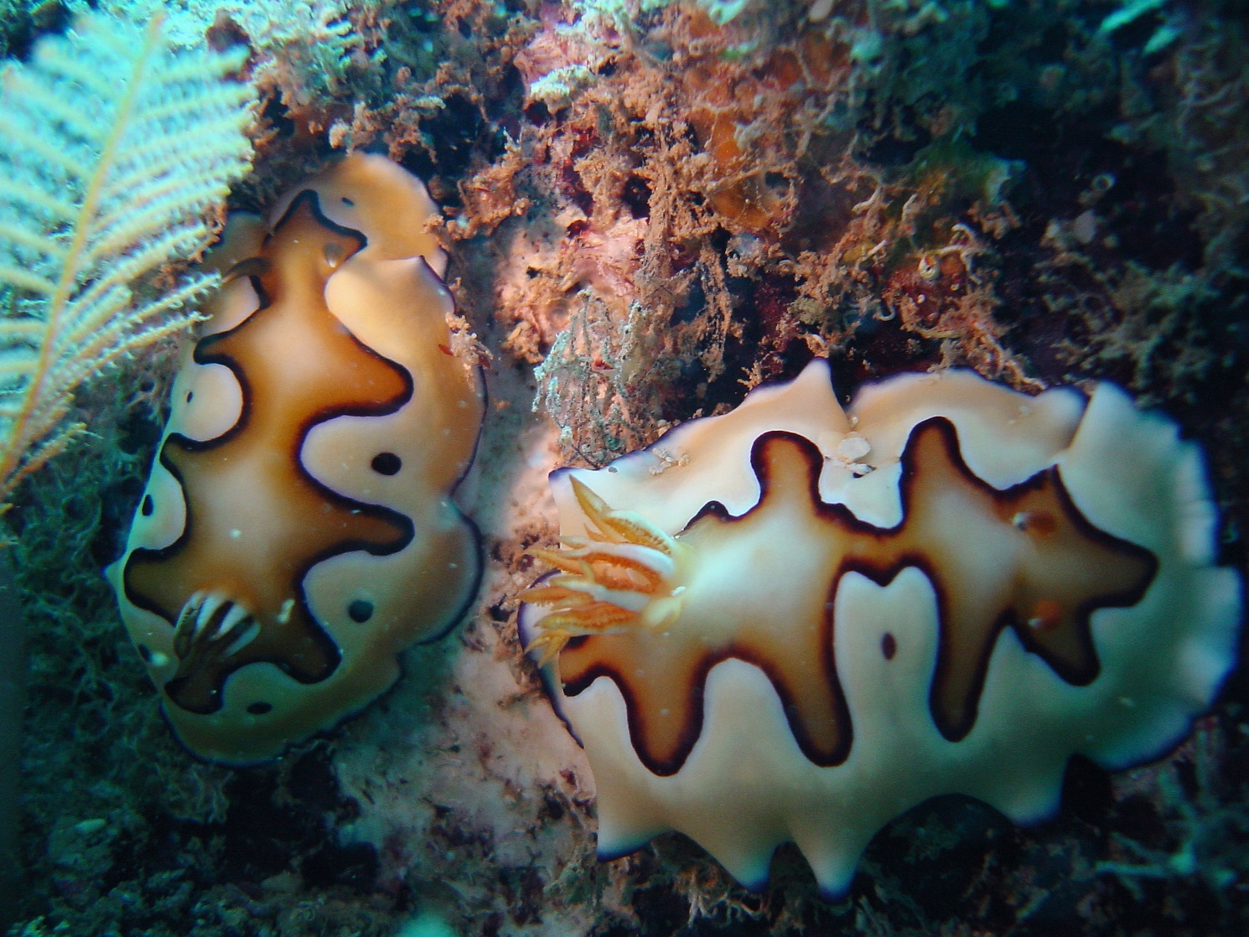
Nudibranch (Parks Australia)

S2.1 North-west Network overview
The marine parks of the North-west Network were proclaimed under the EPBC Act on 14 December 2013 (Federal Register of Legislation No. F2013L02108) and renamed on 9 October 2017 (Federal Register of Legislation No. F2017L01337).
Table S2.1. Overview of the North-west Network
Marine park name | Zones, IUCN categories and zone area | Marine park IUCN category | Total marine park area
Shark Bay | Multiple Use Zone (VI) 7443 km² | VI | 7443 km²
Carnarvon Canyon | Habitat Protection Zone (IV) 6177 km² | IV | 6177 km²
Ningaloo | National Park Zone (II) 116 km²  Recreational Use Zone (IV) 2319 km² | IV | 2435 km²
Gascoyne | National Park Zone (II) 9132 km²  Habitat Protection Zone (IV) 38,982 km²  Multiple Use Zone (VI) 33,652 km² | IV | 81,766 km²
Montebello | Multiple Use Zone (VI) 3413 km² | VI | 3413 km²
Dampier | National Park Zone (II) 73 km²  Habitat Protection Zone (IV) 104 km²  Multiple Use Zone (VI) 1074 km² | VI | 1252 km²
Eighty Mile Beach | Multiple Use Zone (VI) 10,785 km² | VI | 10,785 km²
Roebuck | Multiple Use Zone (VI) 304 km² | VI | 304 km²
Mermaid Reef | National Park Zone (II) 540 km² | II | 540 km²
Argo–Rowley Terrace | National Park Zone (II) 36,050 km²  Multiple Use Zone (VI) 108,812 km²  Special Purpose Zone (Trawl) (VI) 1141 km² | VI | 146,003 km²
Kimberley | National Park Zone (II) 6392 km²  Habitat Protection Zone (IV) 5665 km²  Multiple Use Zone (VI) 62,411 km² | VI | 74,469 km²
Ashmore Reef | Sanctuary Zone (Ia) 550 km²  Recreational Use Zone (IV) 34 km² | Ia | 583 km²
Cartier Island | Sanctuary Zone (Ia) 172 km² | Ia | 172 km²
Note: Each marine park extends from 1000 m below the seabed (except for Ashmore Reef which extends from 200 m) to 3000 m above sea level.
Note: Zone and total marine park areas are rounded to the nearest km²; therefore, the sum of areas may not equate to the total marine park or network areas in some instances.

S2.2 North-west Network values
This Schedule describes the values represented in each marine park of the North-west Network.
Values are broadly defined as:
- Natural values—habitats, species and ecological communities within marine parks, and the processes that support their connectivity, productivity and function.
- Cultural values—living and cultural heritage recognising Indigenous beliefs, practices and obligations for country, places of cultural significance and cultural heritage sites.
- Heritage values—non-Indigenous heritage that has aesthetic, historic, scientific or social significance.
- Socio-economic values—the benefit of marine parks for people, businesses and the economy.
Values will be used to inform the Director’s decisions when authorising activities in marine parks. Activities will be assessed in relation to their impacts on and risk to values to ensure activities are undertaken in a manner that minimises impacts to as low as reasonably practicable (Section 4.2 Making decisions about activities).
As understanding of park values improves over time, updated information will be available on the Parks Australia website.
Other sources of information on marine park values can be found on the Department’s website, in particular, for protected species (species profile and threats database), wetlands (Australian wetlands directory), heritage places (Australian heritage database), and shipwrecks (Australian national shipwrecks database); and in the Marine bioregional plan for the North-west Marine Region (2012) and the North-west marine bioregional plan: bioregional profile (2008).

Shark Bay Marine Park
The Shark Bay Marine Park (Figure S2.1) is located approximately 60 km offshore of Carnarvon, adjacent to the Shark Bay world heritage property and national heritage place. The Marine Park covers an area of 7443 km², extending from the Western Australian state water boundary, and a water depth range between 15 m and 220 m.
The Marine Park was proclaimed under the EPBC Act on 14 December 2013 and renamed Shark Bay Marine Park on 9 October 2017. The Marine Park is assigned IUCN category VI and includes one zone assigned under this plan: Multiple Use Zone (VI).
Coordinates for the Shark Bay Marine Park and zone are provided in Figure S2.1 and Schedule 4.
Statement of significance
The Shark Bay Marine Park is significant because it contains habitats, species and ecological communities associated with the Central Western Shelf Province and Central Western Transition. The Marine Park provides connectivity between deeper Commonwealth waters and the inshore waters of the Shark Bay world heritage property.
Natural values
The Marine Park includes examples of ecosystems representative of:
- Central Western Shelf—a predominantly flat, sandy and low-nutrient area, in water depths 50–100 m. The bioregion is a transitional zone between tropical and temperate species; and
- Central Western Transition—characterised by large areas of continental slope, a range of topographic features such as terraces, rises and canyons, seasonal and sporadic upwelling, and benthic slope communities comprising tropical and temperate species .
Ecosystems represented in the Marine Park are influenced by the Leeuwin, Ningaloo and Capes currents.
The Marine Park supports a range of species including species listed as threatened, migratory, marine or cetacean under the EPBC Act. Biologically important areas within the Marine Park include breeding habitat for seabirds, internesting habitat for marine turtles, and a migratory pathway for humpback whales. The Marine Park and adjacent coastal areas are also important for shallow-water snapper.
Cultural values
Sea country is valued for Indigenous cultural identity, health and wellbeing. Across Australia, Indigenous people have been sustainably using and managing their sea country for tens of thousands of years. The Gnulli and Malgana people have responsibilities for sea country in the Marine Park.
The Yamatji Marlpa Aboriginal Corporation is the Native Title Representative Body for the Yamatji region.
Heritage values
No international, Commonwealth or national heritage listings apply to the Marine Park at commencement of this plan, but the Marine Park is adjacent to the Shark Bay, Western Australia World Heritage Property and Shark Bay, Western Australia National Heritage Place.
Historic shipwrecks
The Marine Park contains approximately 20 known shipwrecks listed under the Historic Shipwrecks Act 1976.
Social and economic values
Tourism, commercial fishing, mining and recreation, including fishing, are important activities in the Marine Park. These activities contribute to the wellbeing of regional communities and the prosperity of the nation.
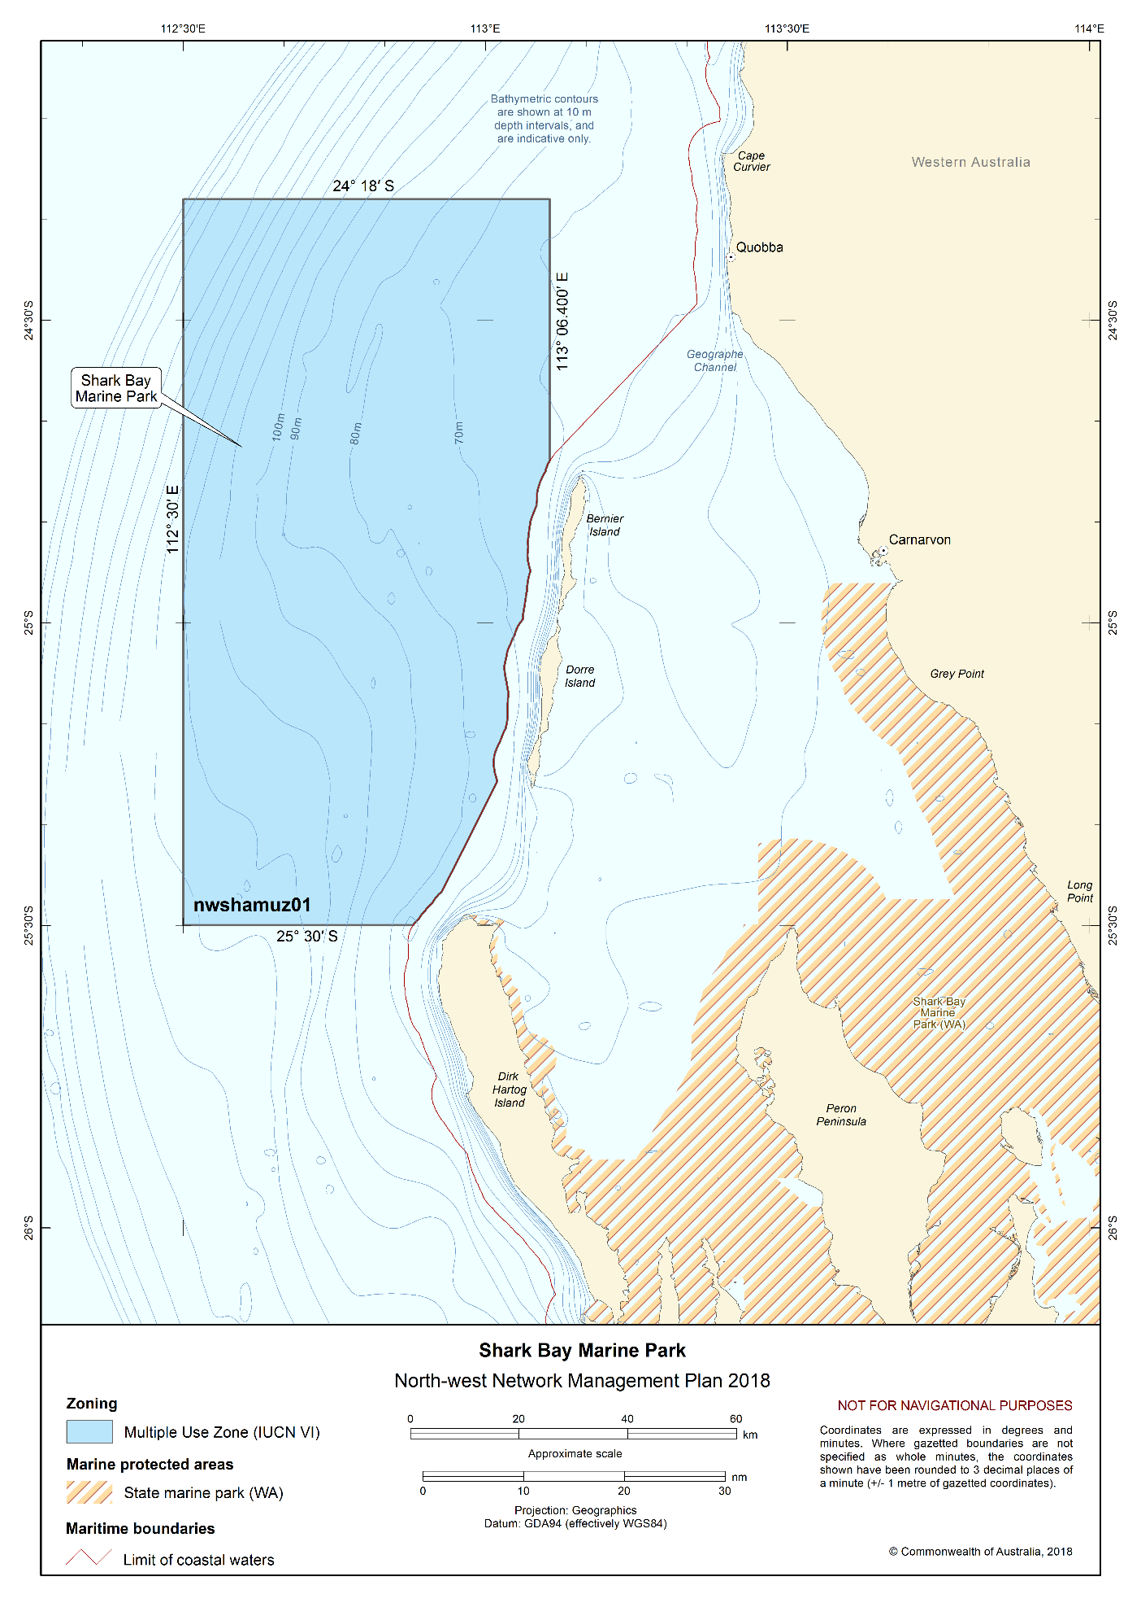
Figure S2.1 Shark Bay Marine Park

Carnarvon Canyon Marine Park
The Carnarvon Canyon Marine Park (Figure S2.2) is located approximately 300 km north-west of Carnarvon. It covers an area of 6177 km² and a water depth range of 1500–6000 m.
The Marine Park was proclaimed under the EPBC Act on 14 December 2013 and renamed Carnarvon Canyon Marine Park on 9 October 2017. The Marine Park is assigned IUCN category IV and includes one zone assigned under this plan: Habitat Protection Zone (IV).
Coordinates for the Carnarvon Canyon Marine Park and zone are provided in Figure S2.2 and Schedule 4.
Statement of significance
The Carnarvon Canyon Marine Park is significant because it contains habitats, species and ecological communities associated with the Central Western Transition. This includes deep-water ecosystems associated with the Carnarvon Canyon. The Marine Park lies within a transition zone between tropical and temperate species and is an area of high biotic productivity.
Natural values
The Marine Park includes examples of ecosystems representative of the Central Western Transition—a bioregion characterised by large areas of continental slope, a range of topographic features such as terraces, rises and canyons, seasonal and sporadic upwelling, and benthic slope communities comprising tropical and temperate species. It includes the Carnarvon Canyon, a single-channel canyon covering the entire depth range of the Marine Park.
Ecosystems of the Marine Park are influenced by tropical and temperate currents, deep-water environments and proximity to the continental slope and shelf. The soft-bottom environment at the base of the Carnarvon Canyon is likely to support species that are typical of the deep seafloor (e.g. holothurians, polychaetes and sea-pens).
The Marine Park supports a range of species, including species listed as threatened, migratory, marine or cetacean under the EPBC Act. There is limited information about species’ use of this Marine Park.
Cultural values
Sea country is valued for Indigenous cultural identity, health and wellbeing. Across Australia, Indigenous people have been sustainably using and managing their sea country for tens of thousands of years.
Heritage values
No international, Commonwealth or national heritage listings apply to the Marine Park at commencement of this plan.
Social and economic values
Commercial fishing is an important activity in the Marine Park. These activities contribute to the wellbeing of regional communities and the prosperity of the nation.
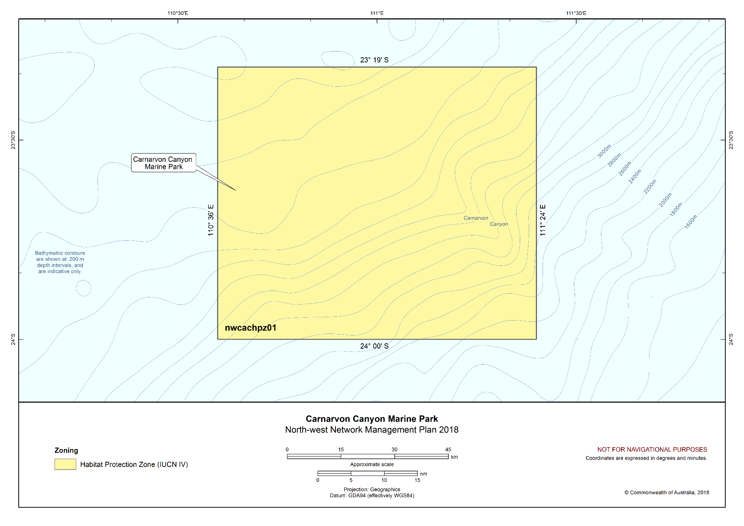
Figure S2.2 Carnarvon Canyon Marine Park

Ningaloo Marine Park
The Ningaloo Marine Park (Figure S2.3) stretches approximately 300 km along the west coast of the Cape Range Peninsula, and is adjacent to the Western Australian Ningaloo Marine Park and Gascoyne Marine Park. The Marine Park covers an area of 2435 km² and a water depth range of 30 m to more than 500 m.
The Marine Park was originally proclaimed under the National Parks and Wildlife Conservation Act 1975 on 20 May 1987 as the Ningaloo Marine Park (Commonwealth Waters), and proclaimed under the EPBC Act on 14 December 2013 and renamed Ningaloo Marine Park on 9 October 2017. The Marine Park is assigned IUCN category IV and includes two zones assigned under this plan: National Park Zone (II) and Recreational Use Zone (IV).
Coordinates for the Ningaloo Marine Park and zone are provided in Figure S2.3 and Schedule 4.
Statement of significance
The Ningaloo Marine Park is significant because it contains habitats, species and ecological communities associated with the Central Western Shelf Transition, Central Western Transition, Northwest Province, and Northwest Shelf Province. It includes three key ecological features: canyons linking the Cuvier Abyssal Plain and the Cape Range Peninsula (valued for unique seafloor features with ecological properties of regional significance); Commonwealth waters adjacent to Ningaloo Reef (valued for high productivity and aggregations of marine life); and continental slope demersal fish communities (valued for high levels of endemism and diversity).
The Marine Park provides connectivity between deeper offshore waters of the shelf break and coastal waters of the adjacent Western Australian Ningaloo Marine Park. It includes some of the most diverse continental slope habitats in Australia, in particular the continental slope area between North West Cape and the Montebello Trough. Canyons in the Marine Park are important for their role in sustaining the nutrient conditions that support the high diversity of Ningaloo Reef.
The Marine Park is located in a transition zone between tropical and temperate waters and sustains tropical and temperate plants and animals, with many species at the limits of their distributions.
Natural values
The Marine Park includes examples of ecosystems representative of:
- Central Western Shelf Transition—continental shelf of water depths up to 100 m, and a significant transition zone between tropical and temperate species;
- Central Western Transition—characterised by large areas of continental slope, a range of topographic features such as terraces, rises and canyons, seasonal and sporadic upwelling, and benthic slope communities comprising tropical and temperate species;
- Northwest Province—an area of continental slope comprising diverse and endemic fish communities; and
- Northwest Shelf Province—a dynamic environment, influenced by strong tides, cyclonic storms, long-period swells and internal tides. The bioregion includes diverse benthic and pelagic fish communities, and ancient coastline thought to be an important seafloor feature and migratory pathway for humpback whales.
Key ecological features of the Marine Park are:
- Canyons linking the Cuvier Abyssal Plain and the Cape Range Peninsula—an area resulting in upwelling of nutrient rich water and aggregations of marine life;
- Commonwealth waters adjacent to Ningaloo Reef—an area where the Leeuwin and Ningaloo currents interact, resulting in enhanced productivity and aggregations of marine life; and
- Continental slope demersal fish communities—an area of high diversity among demersal fish assemblages on the continental slope.
Ecosystems represented in the Marine Park are influenced by interaction of the Leeuwin Current, Leeuwin Undercurrent and the Ningaloo Current.
The Marine Park supports a range of species including species listed as threatened, migratory, marine or cetacean under the EPBC Act. Biologically important areas within the Marine Park include breeding and or foraging habitat for seabirds, internesting habitat for marine turtles, a migratory pathway for humpback whales, foraging habitat and migratory pathway for pygmy blue whales, breeding, calving, foraging and nursing habitat for dugong and foraging habitat for whale sharks.
Cultural values
Sea country is valued for Indigenous cultural identity, health and wellbeing. Across Australia, Indigenous people have been sustainably using and managing their sea country for tens of thousands of years. The Gnulli people have responsibilities for sea country in the Marine Park.
The Yamatji Marlpa Aboriginal Corporation is the Native Title Representative Body for the Yamatji region.
Heritage values
World heritage
The Marine Park is within the Ningaloo Coast World Heritage Property, recognised for its outstanding universal heritage values, meeting world heritage listing criteria vii and x. In addition to the Marine Park, the world heritage area includes the Western Australian Ningaloo Marine Park, the Murion Islands, the Western Australian Cape Range National Park and other terrestrial areas. The area is valued for high terrestrial species endemism, marine species diversity and abundance, and the interconnectedness of large-scale marine, coastal and terrestrial environments. The area connects the limestone karst system and fossil reefs of the ancient Cape Range to the nearshore reef system of Ningaloo Reef, to the continental slope and shelf in Commonwealth waters.
National heritage
The Ningaloo Coast overlaps the Marine Park and was established on the National Heritage List in 2010, meeting the national heritage listing criteria A, B, C, D, and F.
Commonwealth heritage
The Ningaloo Marine Area (Commonwealth waters) was established on the Commonwealth Heritage List in 2004, meeting Commonwealth heritage listing criteria A, B and C. The Ningaloo Marine Area overlaps the Marine Park.
Historic shipwrecks
The Marine Park contains more than 15 known shipwrecks listed under the Historic Shipwrecks Act 1976.
Social and economic values
Tourism and recreation, including fishing, are important activities in the Marine Park. These activities contribute to the wellbeing of regional communities and the prosperity of the nation.
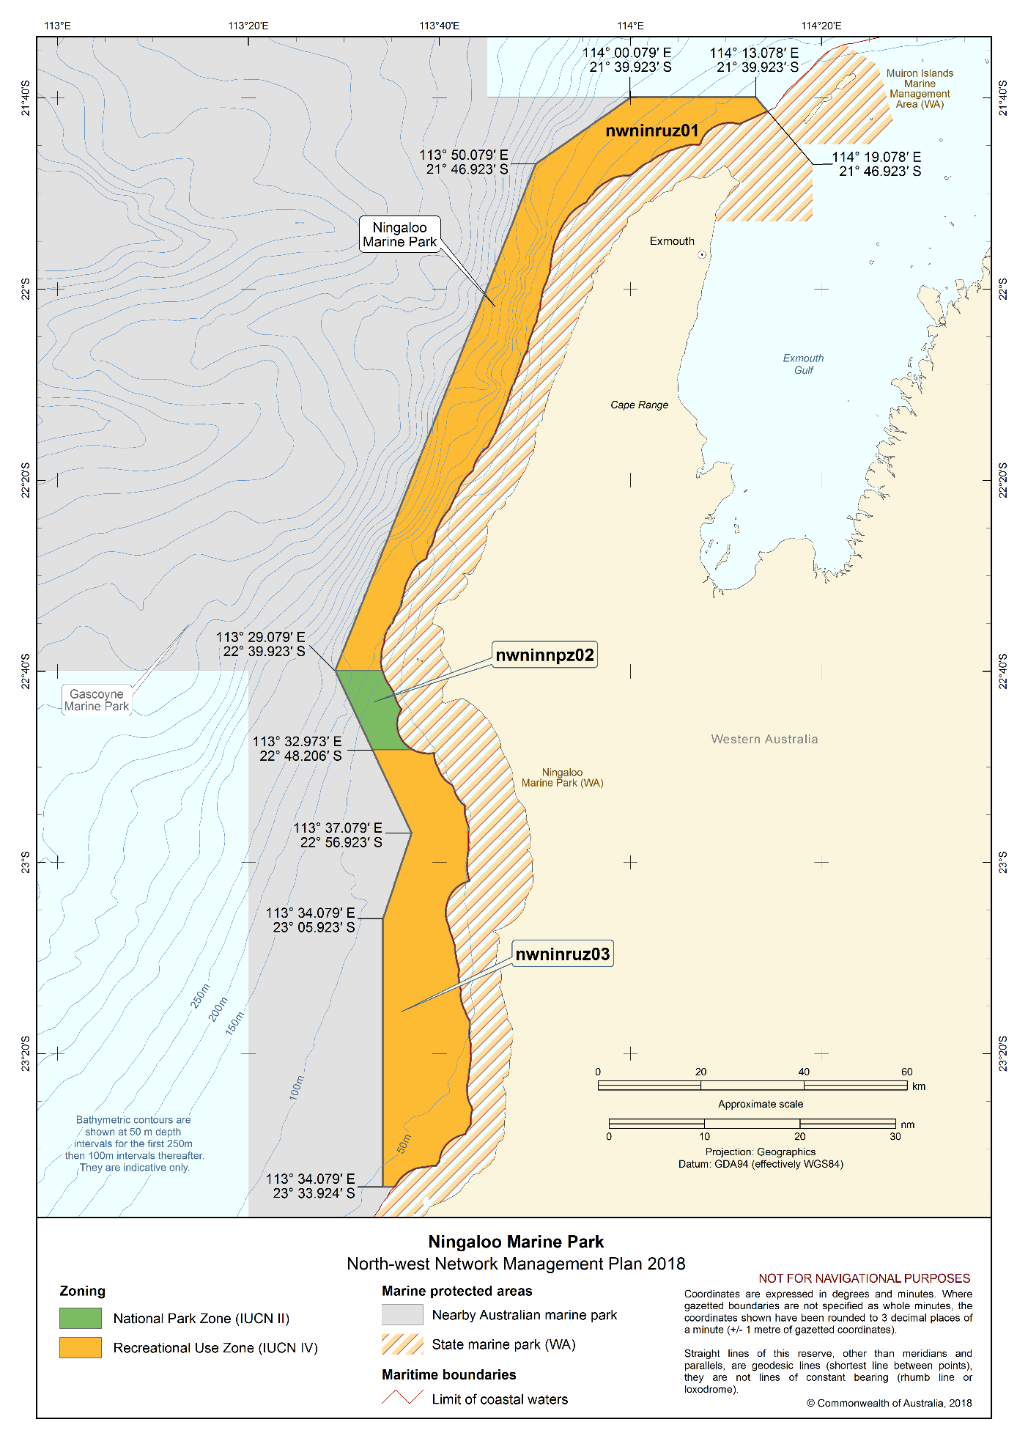
Figure S2.3 Ningaloo Marine Park

Gascoyne Marine Park
The Gascoyne Marine Park (Figure S2.4) is located approximately 20 km off the west coast of the Cape Range Peninsula, adjacent to the Ningaloo Reef Marine Park and the Western Australian Ningaloo Marine Park, and extends to the limit of Australia’s exclusive economic zone. The Marine Park covers an area of 81,766 km² and water depths between 15 m and 6000 m.
The Marine Park was proclaimed under the EPBC Act on 14 December 2013 and renamed Gascoyne Marine Park on 9 October 2017. The Marine Park is assigned IUCN category IV and includes three zones assigned under this plan: National Park Zone (II), Habitat Protection Zone (IV) and Multiple Use Zone (VI).
Coordinates for the Gascoyne Marine Park and zones are provided in Figure S2.4 and Schedule 4.
Statement of significance
The Gascoyne Marine Park is significant because it contains habitats, species and ecological communities associated with the Central Western Shelf Transition, Central Western Transition, and Northwest Province. It includes four key ecological features: Canyons linking the Cuvier Abyssal Plain and the Cape Range Peninsula (valued for unique seafloor features with ecological properties of regional significance); Commonwealth waters adjacent to Ningaloo Reef (valued for high productivity and aggregations of marine life); continental slope demersal fish communities (valued for high levels of endemism and diversity); and the Exmouth Plateau (valued as a unique seafloor feature with ecological properties of regional significance).
The Marine Park includes some of the most diverse continental slope habitats in Australia, in particular the continental slope area between North West Cape and the Montebello Trough. Canyons in the Marine Park link the Cuvier Abyssal Plain to the Cape Range Peninsula and are important for their role in sustaining the nutrient conditions that support the high diversity of Ningaloo Reef.
Natural values
The Marine Park includes examples of ecosystems representative of:
- Central Western Shelf Transition—continental shelf with water depths up to 100 m, and a significant transition zone between tropical and temperate species;
- Central Western Transition—characterised by large areas of continental slope, a range of topographic features such as terraces, rises and canyons, seasonal and sporadic upwelling, and benthic slope communities comprising tropical and temperate species; and
- Northwest Province—an area of continental slope comprising diverse and endemic fish communities.
Key ecological features of the Marine Park are:
- Canyons linking the Cuvier Abyssal Plain and the Cape Range Peninsula—an area resulting in upwelling of nutrient rich water and aggregations of marine life;
- Commonwealth waters adjacent to Ningaloo Reef—an area where the Leeuwin and Ningaloo currents interact resulting in enhanced productivity and aggregations of marine life;
- Continental slope demersal fish communities—an area of high diversity of demersal fish assemblages on the continental slope; and
- Exmouth Plateau—a regionally and nationally unique deep-sea plateau in tropical waters.
Ecosystems represented in the Marine Park are influenced by the interaction of the Leeuwin Current, Leeuwin Undercurrent and the Ningaloo Current.

The Marine Park supports a range of species including species listed as threatened, migratory, marine or cetacean under the EPBC Act. Biologically important areas within the Marine Park include breeding habitat for seabirds, internesting habitat for marine turtles, a migratory pathway for humpback whales, and foraging habitat and migratory pathway for pygmy blue whales.
Cultural values
Sea country is valued for Indigenous cultural identity, health and wellbeing. Across Australia, Indigenous people have been sustainably using and managing their sea country for tens of thousands of years. The Gnulli people have responsibilities for sea country in the Marine Park.
The Yamatji Marlpa Aboriginal Corporation is the Native Title Representative Body for the Yamatji region.
Heritage values
World heritage
The Ningaloo Coast was listed as an area of outstanding universal value under the World Heritage Convention in 2011, meeting world heritage listing criteria vii and x. The Ningaloo Coast World Heritage Property is adjacent to the Marine Park.
Commonwealth heritage
The Ningaloo Marine Area (Commonwealth waters) was established on the Commonwealth Heritage List in 2004, meeting the Commonwealth heritage listing criteria A, B and C. The Ningaloo Marine Area is adjacent to the Marine Park.
National heritage
The Ningaloo Coast was established on the National Heritage List in 2010, meeting the national heritage listing criteria A, B, C, D, and F and is adjacent to the Marine Park.
Historic shipwrecks
The Marine Park contains more than five known shipwrecks listed under the Historic Shipwrecks Act 1976.
Social and economic values
Commercial fishing, mining and recreation are important activities in the Marine Park. These activities contribute to the wellbeing of regional communities and the prosperity of the nation.
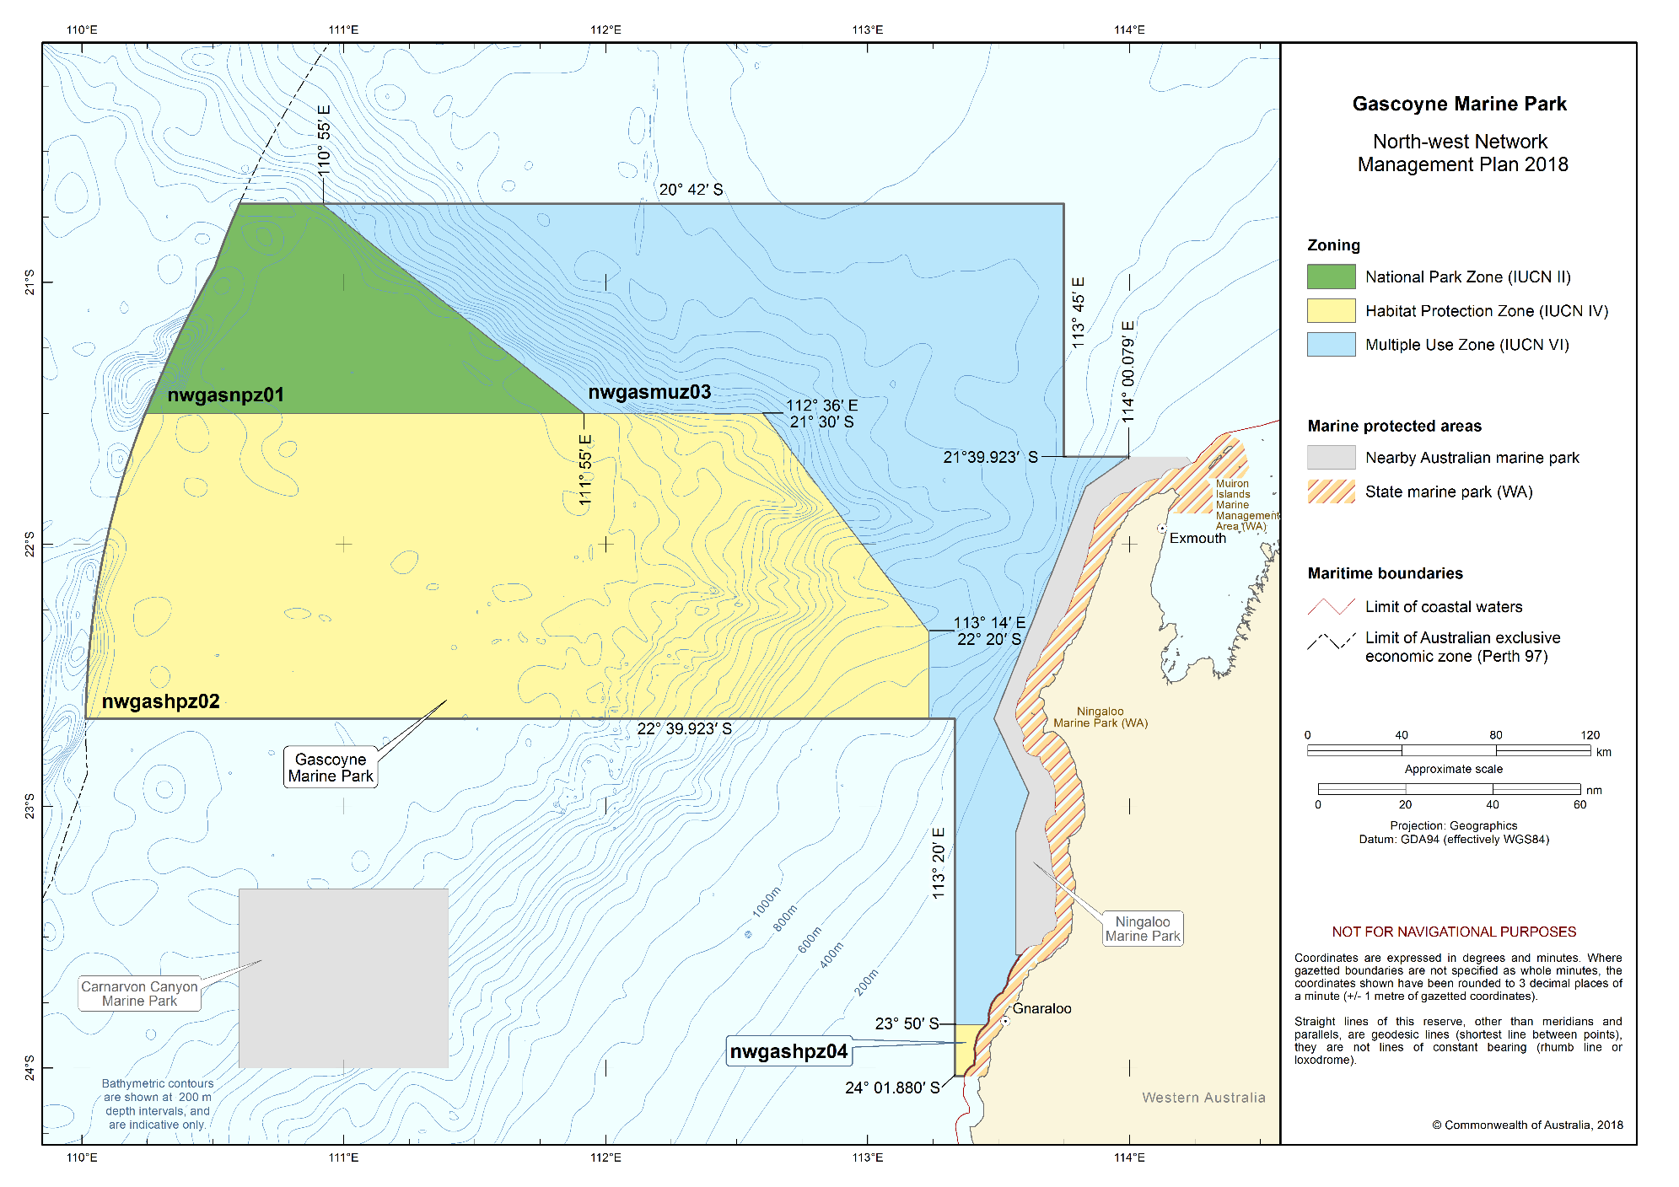
Figure S2.4 Gascoyne Marine Park

Montebello Marine Park
The Montebello Marine Park (Figure S2.5) is located offshore of Barrow Island and 80 km west of Dampier extending from the Western Australian state water boundary, and is adjacent to the Western Australian Barrow Island and Montebello Islands Marine Parks. The Marine Park covers an area of 3413 km² and water depths from less than 15 m to 150 m.
The Marine Park was proclaimed under the EPBC Act on 14 December 2013 and renamed Montebello Marine Park on 9 October 2017. The Marine Park is assigned IUCN category VI and includes one zone assigned under this plan: Multiple Use Zone (VI). Coordinates for the Montebello Marine Park and zone are provided in Figure S2.5 and Schedule 4.
Statement of significance
The Montebello Marine Park is significant because it contains habitats, species and ecological communities associated with the Northwest Shelf Province. It includes one key ecological feature: the ancient coastline at the 125-m depth contour (valued as a unique seafloor feature with ecological properties of regional significance).
The Marine Park provides connectivity between deeper waters of the shelf and slope, and the adjacent Barrow Island and Montebello Islands Marine Parks. A prominent seafloor feature in the Marine Park is Trial Rocks consisting of two close coral reefs. The reefs are emergent at low tide.
Natural values
The Marine Park includes examples of ecosystems representative of the Northwest Shelf Province—a dynamic environment influenced by strong tides, cyclonic storms, long-period swells and internal tides. The bioregion includes diverse benthic and pelagic fish communities, and ancient coastline thought to be an important seafloor feature and migratory pathway for humpback whales. A key ecological feature of the Marine Park is the ancient coastline at the 125-m depth contour where rocky escarpments are thought to provide biologically important habitat in areas otherwise dominated by soft sediments.
The Marine Park supports a range of species including species listed as threatened, migratory, marine or cetacean under the EPBC Act. Biologically important areas within the Marine Park include breeding habitat for seabirds, internesting, foraging, mating, and nesting habitat for marine turtles, a migratory pathway for humpback whales and foraging habitat for whale sharks.
Cultural values
Sea country is valued for Indigenous cultural identity, health and wellbeing. Across Australia, Indigenous people have been sustainably using and managing their sea country for tens of thousands of years. At the commencement of this plan, there is limited information about the cultural significance of this Marine Park. The Yamatji Marlpa Aboriginal Corporation is the Native Title Representative Body for the Pilbara region.
Heritage values
No international, Commonwealth or national listings apply to the Marine Park at commencement of this plan, however the Marine Park is adjacent to the Western Australia Barrow Island and the Montebello–Barrow Island Marine Conservation Reserves which have been nominated for national heritage listing.
Historic shipwrecks
The Marine Park contains two known shipwrecks listed under the Historic Shipwrecks Act 1976: Trial (wrecked in 1622), the earliest known shipwreck in Australian waters and Tanami (unknown date).
Social and economic values
Tourism, commercial fishing, mining and recreation are important activities in the Marine Park. These activities contribute to the wellbeing of regional communities and the prosperity of the nation.
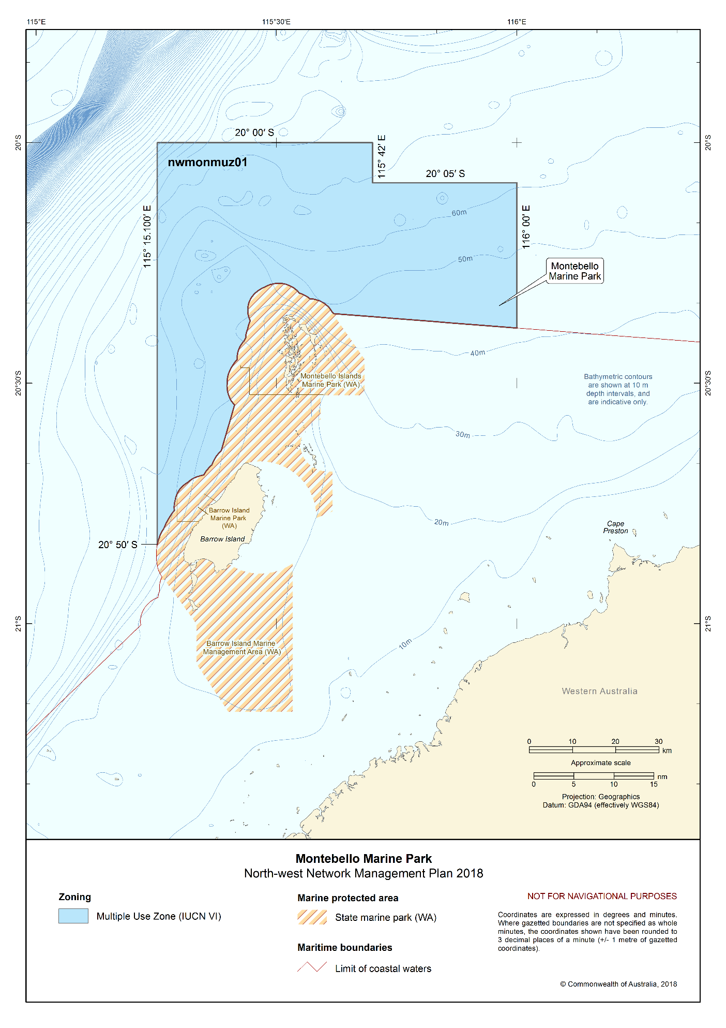
Figure S2.5 Montebello Marine Park

Dampier Marine Park
The Dampier Marine Park (Figure S2.6) is located approximately 10 km north-east of Cape Lambert and 40 km from Dampier extending from the Western Australian state water boundary. The Marine Park covers an area of 1252 km² and a water depth range between less than 15 m and 70 m.
The Marine Park was proclaimed under the EPBC Act on 14 December 2013 and renamed Dampier Marine Park on 9 October 2017. The Marine Park is assigned IUCN category VI and includes three zones assigned under this plan: National Park Zone (II), Habitat Protection Zone (IV) and Multiple Use Zone (VI).
Coordinates for the Dampier Marine Park and zones are provided in Figure S2.6 and Schedule 4.
Statement of significance
The Dampier Marine Park is significant because it contains habitats, species and ecological communities associated with the Northwest Shelf Province. The Marine Park provides protection for offshore shelf habitats adjacent to the Dampier Archipelago, and the area between Dampier and Port Hedland, and is a hotspot for sponge biodiversity.
The Marine Park includes several submerged coral reefs and shoals including Delambre Reef and Tessa Shoals.
Natural values
The Marine Park includes examples of ecosystems representative of the Northwest Shelf Province—a dynamic environment influenced by strong tides, cyclonic storms, long-period swells and internal tides. The bioregion includes diverse benthic and pelagic fish communities, and ancient coastline thought to be an important seafloor feature and migratory pathway for humpback whales.
The Marine Park supports a range of species including those listed as threatened, migratory, marine or cetacean under the EPBC Act. Biologically important areas within the Marine Park include breeding and foraging habitat for seabirds, internesting habitat for marine turtles and a migratory pathway for humpback whales.
Cultural values
Sea country is valued for Indigenous cultural identity, health and wellbeing. Across Australia, Indigenous people have been sustainably using and managing their sea country for tens of thousands of years.
The Ngarluma, Yindjibarndi, Yaburara, and Mardudhunera people have responsibilities for sea country in the Marine Park. The native title holders for these people are represented by the Ngarluma Aboriginal Corporation and Yindjibarndi Aboriginal Corporation. These Prescribed Body Corporates represent traditional owners with native title over coastal area adjacent to the Marine Park are the points of contact for their respective areas of responsibility for sea country in the Marine Park.
The Yamatji Marlpa Aboriginal Corporation is the Native Title Representative Body for the Pilbara and Yamatji regions.
Heritage values
No international, Commonwealth or national listings apply to the Marine Park at commencement of this plan, however the Marine Park is approximately 10 km north of the Dampier Archipelago (including Burrup Peninsula) national heritage listing, which has significant Indigenous heritage values including rock art sites.
Social and economic values
Port activities, commercial fishing and recreation, including fishing, are important activities in the Marine Park. These activities contribute to the wellbeing of regional communities and the prosperity of the nation.
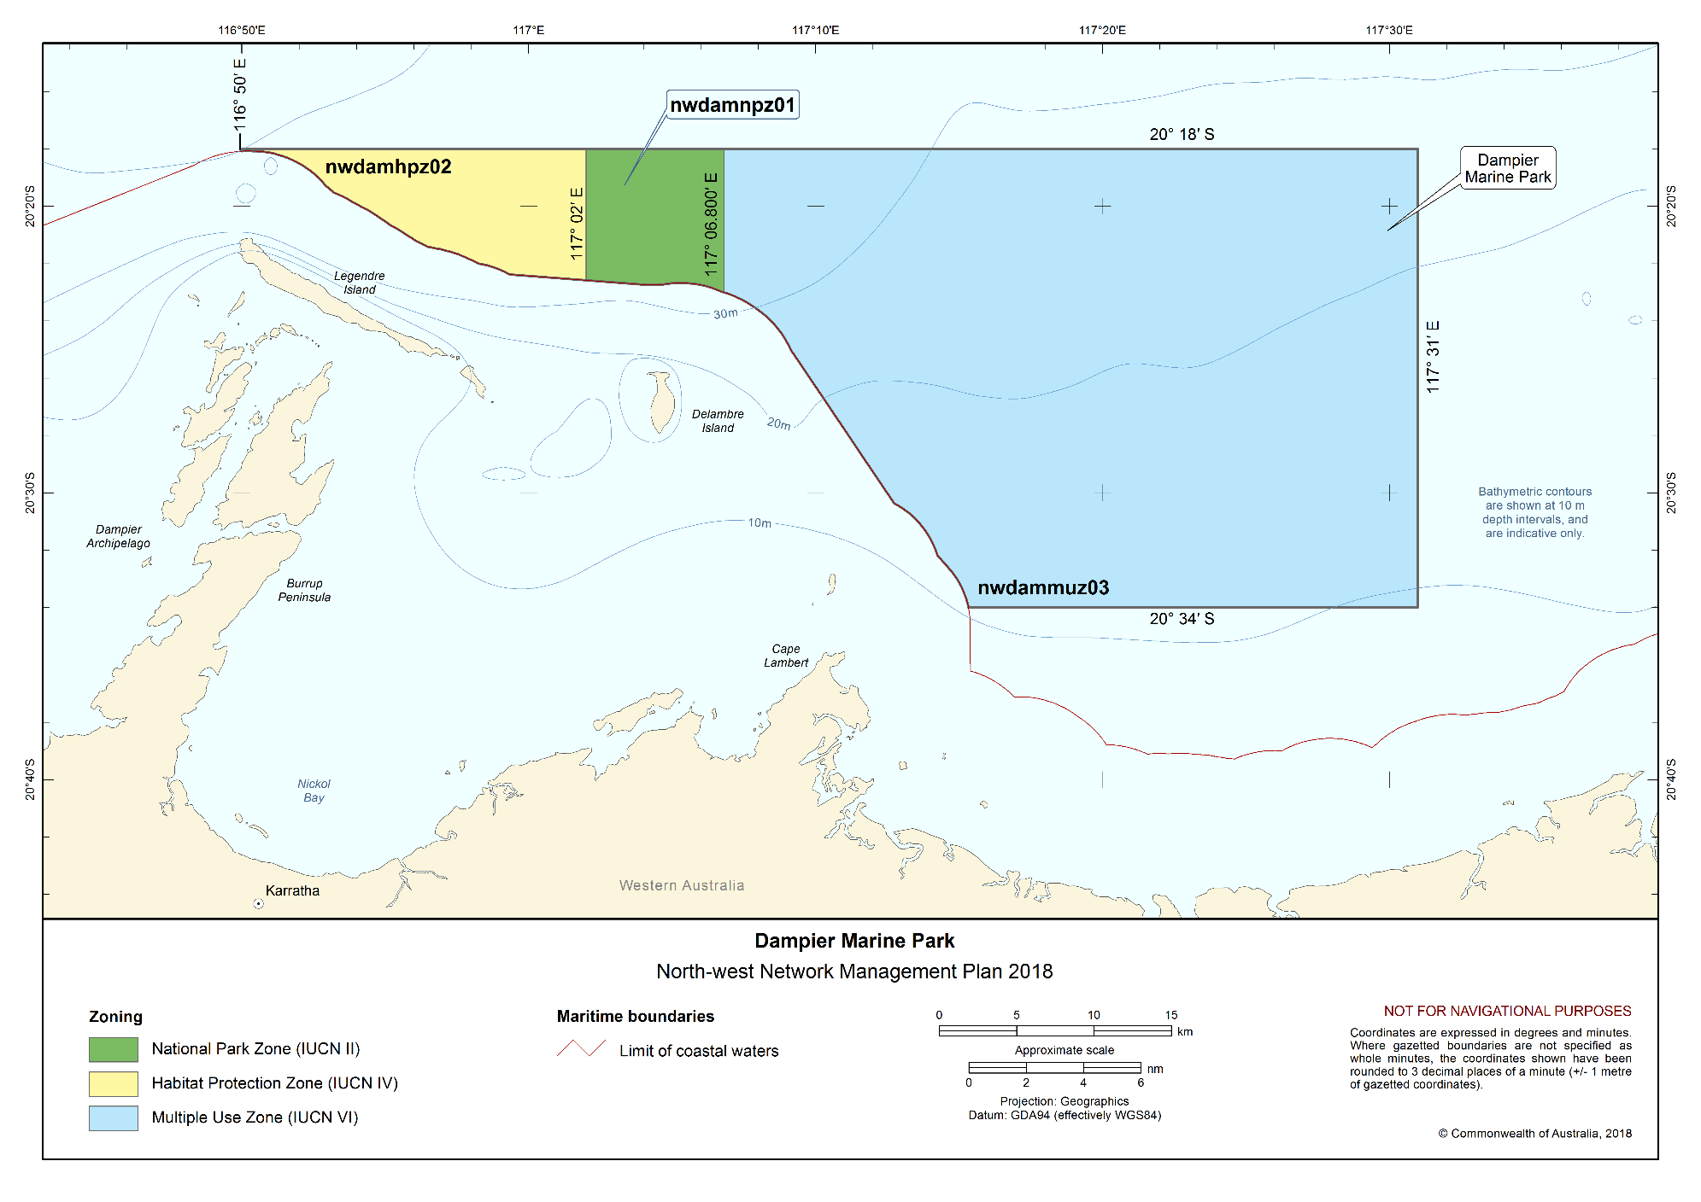
Figure S2.6 Dampier Marine Park

Eighty Mile Beach Marine Park
The Eighty Mile Beach Marine Park (Figure S2.7) is located approximately 74 km north-east of Port Hedland, adjacent to the Western Australian Eighty Mile Beach Marine Park. The Marine Park covers an area of 10,785 km² and a water depth ranges between less than 15 m and 70 m.
The Marine Park was proclaimed under the EPBC Act on 14 December 2013 and renamed Eighty Mile Beach Marine Park on 9 October 2017. The Marine Park is assigned IUCN category VI and includes one zone assigned under this plan: Multiple Use Zone (VI).
Coordinates for the Eighty Mile Beach Marine Park and zone are provided in Figure S2.7 and Schedule 4.
Statement of significance
The Eighty Mile Beach Marine Park is significant because it contains habitats, species and ecological communities associated with the Northwest Shelf Province and consists of shallow shelf habitats, including terrace, banks and shoals.
The Marine Park is adjacent to the Eighty Mile Beach Ramsar site, recognised as one of the most important areas for migratory shorebirds in Australia; and the Western Australian Eighty Mile Beach Marine Park, providing connectivity between offshore and inshore coastal waters of Eighty Mile Beach.
Natural values
The Marine Park includes examples of ecosystems representative of the Northwest Shelf Province—a dynamic environment influenced by strong tides, cyclonic storms, long-period swells and internal tides. The bioregion includes diverse benthic and pelagic fish communities, and ancient coastline thought to be an important seafloor feature and migratory pathway for humpback whales.
The Marine Park supports a range of species including species listed as threatened, migratory, marine or cetacean under the EPBC Act. Biologically important areas within the Marine Park include breeding, foraging and resting habitat for seabirds, internesting and nesting habitat for marine turtles, foraging, nursing and pupping habitat for sawfish and a migratory pathway for humpback whales.
Cultural values
Sea country is valued for Indigenous cultural identity, health and wellbeing. Across Australia, Indigenous people have been sustainably using and managing their sea country for tens of thousands of years.
The sea country of the Nyangumarta, Karajarri and Ngarla people extends into Eighty Mile Beach Marine Park. Sea country is culturally significant and important to their identity. They have an unbroken, deep spiritual connection to their sea country, with traditional practices continuing today. Staple foods of living cultural value for the Nyangumarta, Karajarri and Ngarla people include saltwater fish, turtles, dugong, crabs and oysters. Access to sea country by families is important for cultural traditions, livelihoods and future socio-economic development opportunities.
The native title holders for the Nyangumarta, Karajarri and Ngarla people are represented by the Karajarri Aboriginal Corporation, Nyangumarta Karajarri Aboriginal Corporation, Nyangumarta Warrarn Aboriginal Corporation, and Wanparta Aboriginal Corporation. These Prescribed Body Corporates represent traditional owners with native title over coastal area adjacent to the Marine Park and are the points of contact for their respective areas of responsibility for sea country in the Marine Park.
The Kimberley Land Council and the Yamatji Marlpa Aboriginal Corporation are the Native Title Representative Bodies for Kimberley and Pilbara regions.
Heritage values
No international, Commonwealth or national listings apply to the Marine Park at commencement of this plan.
Historic shipwrecks
The Marine Park contains three known shipwrecks listed under the Historic Shipwrecks Act 1976: Lorna Doone (wrecked in 1923), Nellie (wrecked in 1908), and Tifera (wrecked in 1923).
Social and economic values
Tourism, commercial fishing, pearling and recreation are important activities in the Marine Park. These activities contribute to the wellbeing of regional communities and the prosperity of the nation.
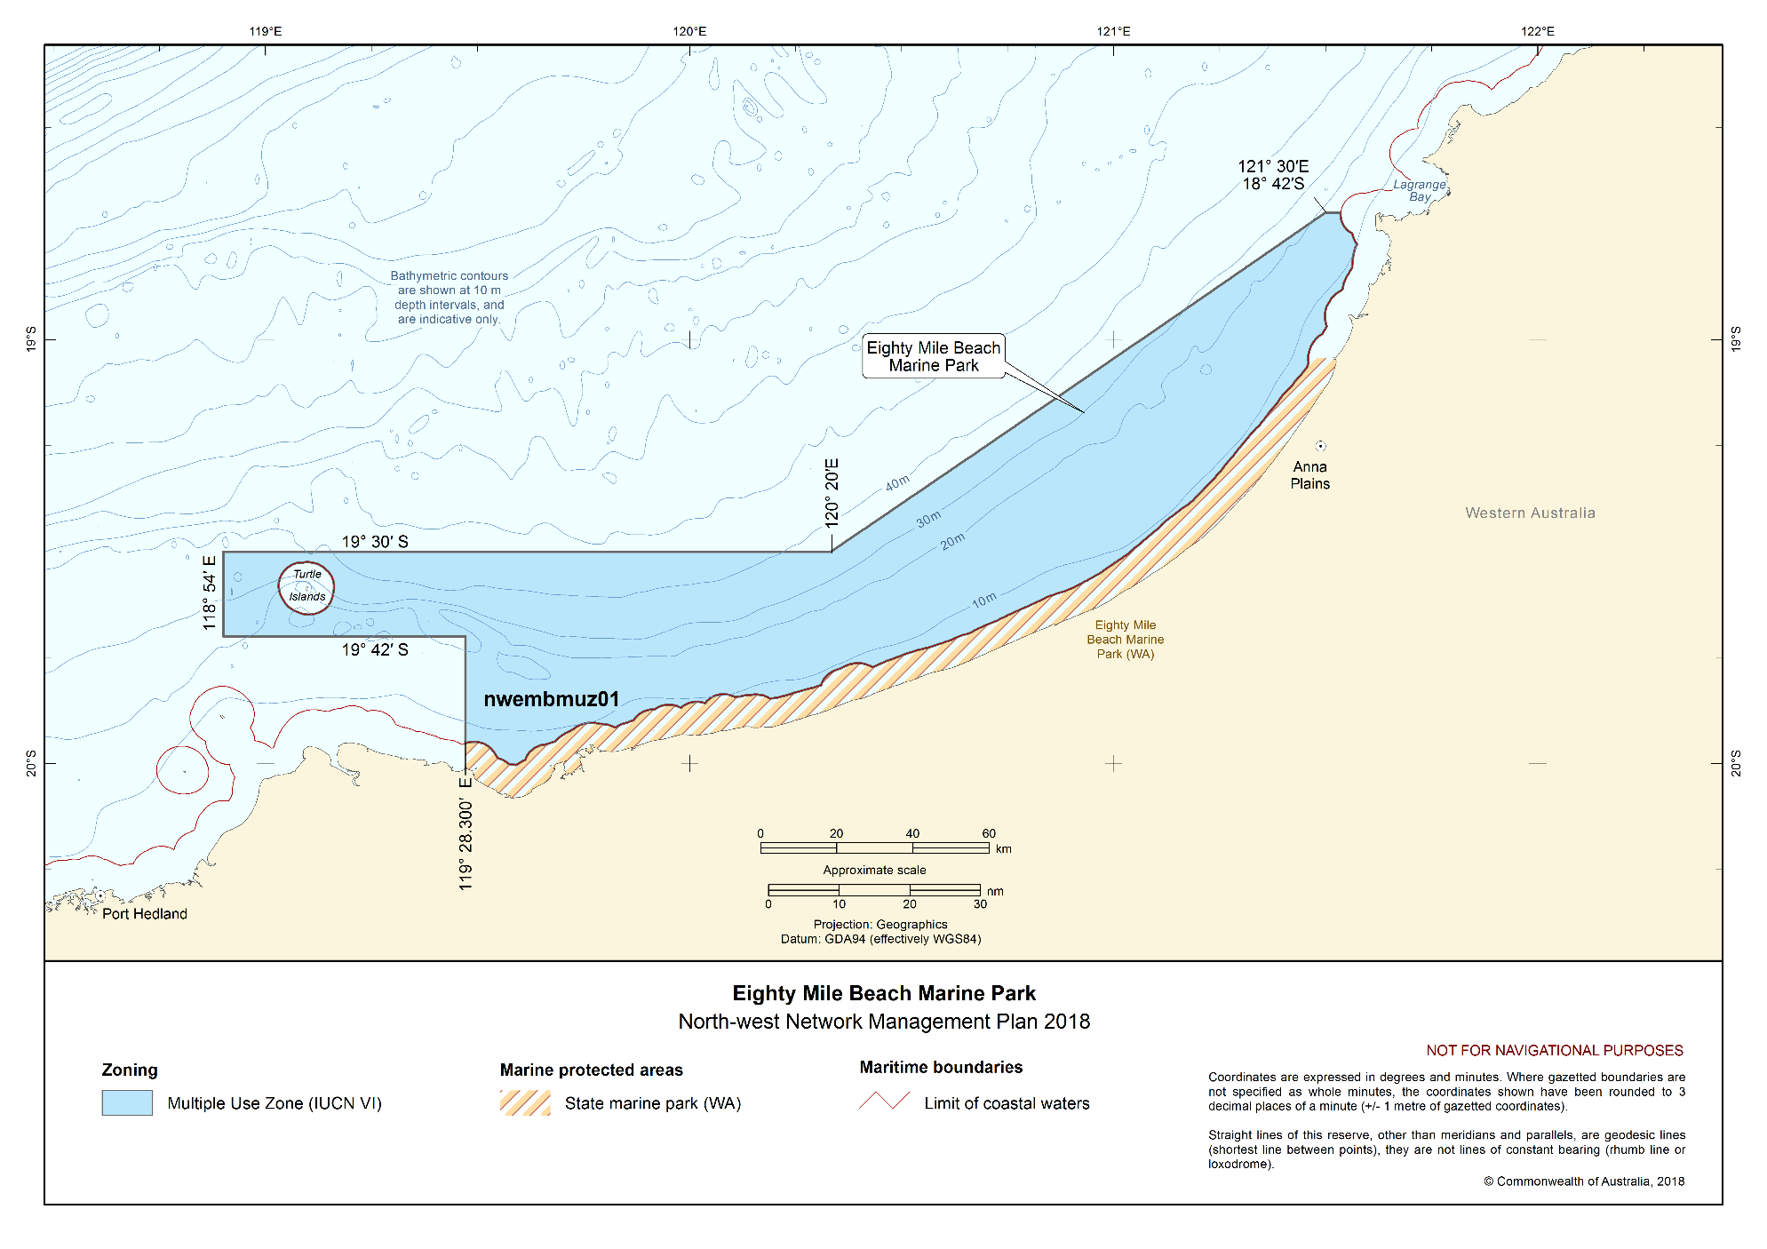
Figure S2.7 Eighty Mile Beach Marine Park

Roebuck Marine Park
The Roebuck Marine Park (Figure S2.8) is located approximately 12 km offshore of Broome, and is adjacent to the Western Australian Yawuru Nagulagun/Roebuck Bay Marine Park. The Marine Park covers an area of 304 km² and a water depth range of less than 15 m to 70 m.
The Marine Park was proclaimed under the EPBC Act on 14 December 2013 and renamed Roebuck Marine Park on 9 October 2017. The Marine Park is assigned IUCN category VI and includes one zone assigned under this plan: Multiple Use Zone (VI). Coordinates for the Roebuck Marine Park and zone are provided in Figure S2.8 and Schedule 4.
Statement of significance
The Roebuck Marine Park is significant because it contains habitats, species and ecological communities associated with the Northwest Shelf Province, and consists entirely of shallow continental shelf habitat. The Marine Park is adjacent to the Roebuck Bay Ramsar site, recognised as one of the most important areas for migratory shorebirds in Australia; and the Western Australian Yawuru Nagulagun/Roebuck Bay Marine Park, providing connectivity between offshore and inshore coastal waters of Roebuck Bay.
Natural values
The Marine Park includes examples of ecosystems representative of the Northwest Shelf Province—a dynamic environment influenced by strong tides, cyclonic storms, long-period swells and internal tides. The bioregion includes diverse benthic and pelagic fish communities, and ancient coastline thought to be an important seafloor feature and migratory pathway for humpback whales.
The Marine Park supports a range of species including species listed as threatened, migratory, marine or cetacean under the EPBC Act. Biologically important areas within the Marine Park include breeding and resting habitat for seabirds, foraging and internesting habitat for marine turtles, a migratory pathway for humpback whales and foraging habitat for dugong.
Cultural values
Sea country is valued for Indigenous cultural identity, health and wellbeing. Across Australia, Indigenous people have been sustainably using and managing their sea country for tens of thousands of years.
Yawuru people have always recognised the waters of Roebuck Bay as nagula (Yawuru sea country), and have customary responsibilities to care for it. They have a deep spiritual connection to offshore landscapes from Bugarrigarra (creator beings), and believe that snake-like metaphysical beings inhabit the sea. Cultural sites in sea country are also a source of law. The Yawuru people harvest marine resources according to the six Yawuru seasons. They have harvested pearl shell for food and cultural purposes. Fish are a staple food source, and fishing a form of cultural expression, connecting people to their country, modelled on tradition and based in traditional law. Access to sea country by families is important to cultural traditions, livelihoods and future socio-economic development opportunities. The Yawuru Native Title Holders Aboriginal Corporation is the Prescribed Body Corporate representing traditional owners with native title over coastal areas adjacent to the Marine Park, and is the point of contact for sea country in the Marine Park. The Kimberley Land Council is the Native Title Representative Body for the Kimberley region.
Heritage values
No international, Commonwealth or national listings apply to the Marine Park at commencement of this plan, however the Marine Park is adjacent to the West Kimberley National Heritage Place.
Social and economic values
Tourism, commercial fishing, pearling and recreation, including fishing, are important activities that occur in the Marine Park. These activities contribute to the wellbeing of regional communities and the prosperity of the nation.
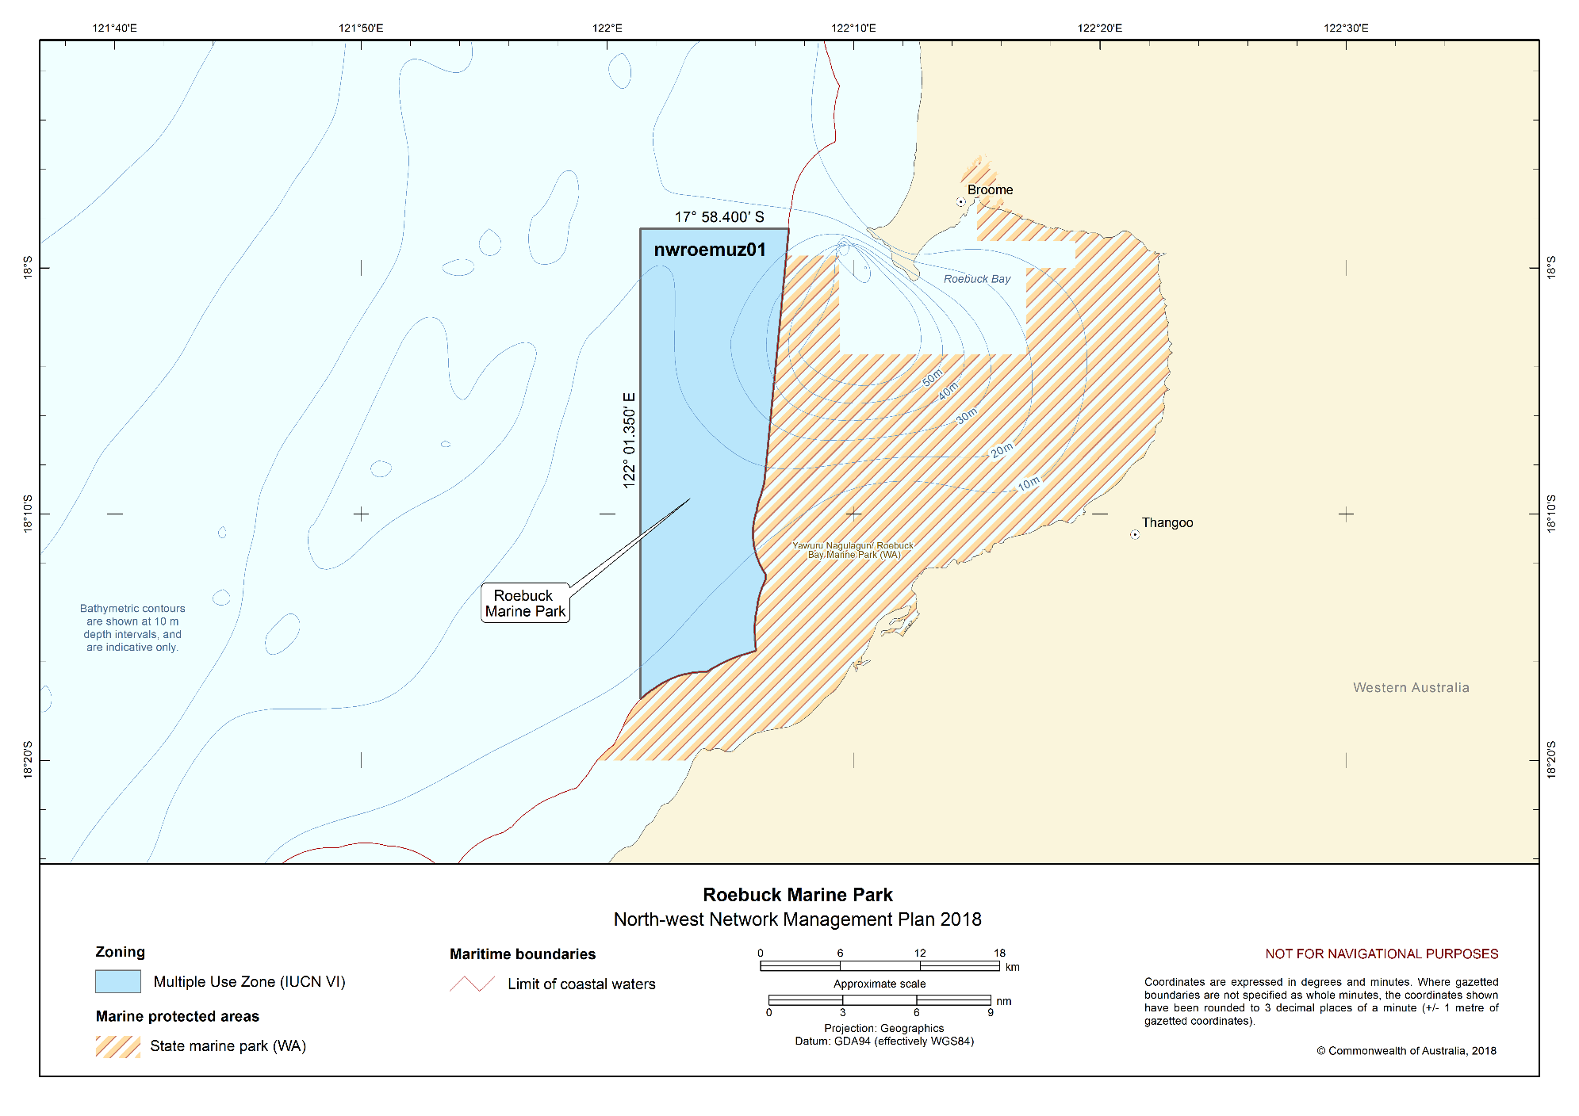
Figure S2.8 Roebuck Marine Park

Mermaid Reef Marine Park
The Mermaid Reef Marine Park (Figure S2.9) is located approximately 280 km north-west of Broome, adjacent to the Argo–Rowley Terrace Marine Park and approximately 13 km from the Western Australian Rowley Shoals Marine Park. The Marine Park covers an area of 540 km² and water depths from less than 15 m to 500 m.
The Marine Park was originally proclaimed under the National Parks and Wildlife Conservation Act 1975 on 10 April 1991 as the Mermaid Reef Marine National Nature Reserve, and proclaimed under the EPBC Act on 14 December 2013 and renamed Mermaid Reef Marine Park on 9 October 2017. The Marine Park is assigned IUCN category II and includes one zone assigned under this plan: National Park Zone (II).
Coordinates for the Mermaid Reef Marine Park and zone are provided in Figure S2.9 and Schedule 4.
Statement of significance
The Mermaid Reef Marine Park is significant because it contains habitats, species and ecological communities associated with the Northwest Transition. It includes one key ecological feature: Mermaid Reef and Commonwealth waters surrounding Rowley Shoals (valued for its high productivity, aggregations of marine life and high species richness).
Mermaid Reef is one of three reefs forming the Rowley Shoals. The other two are Clerke Reef and Imperieuse Reef, to the south-west of the Marine Park, which are included in the Western Australian Rowley Shoals Marine Park. The Rowley Shoals have been described as the best geological examples of shelf atolls in Australian waters.
The reefs of the Rowley Shoals are ecologically significant in that they are considered ecological stepping stones for reef species originating in Indonesian/Western Pacific waters, are one of a few offshore reef systems on the north-west shelf, and may also provide an upstream source for recruitment to reefs further south.
Natural values
The Marine Park includes examples of ecosystems representative of the Northwest Transition—an area of shelf break, continental slope, and the majority of the Argo Abyssal Plain. Together with Clerke Reef and Imperieuse Reef, Mermaid Reef is a biodiversity hotspot and key topographic feature of the Argo Abyssal Plain.
A key ecological feature of the Marine Park is the Mermaid Reef and Commonwealth waters surrounding Rowley Shoals—an area of enhanced productivity and high species richness thought to be facilitated by internal wave action generated by internal tides in the lagoon.
Ecosystems of the Marine Park are associated with emergent reef flat, deep reef flat, lagoon, and submerged sand habitats.
The Marine Park supports a range of species, including species listed as threatened, migratory, marine or cetacean under the EPBC Act. Biologically important areas within the Marine Park include breeding habitat for seabirds and a migratory pathway for the pygmy blue whale.
Cultural values
Sea country is valued for Indigenous cultural identity, health and wellbeing. Across Australia, Indigenous people have been sustainably using and managing their sea country for tens of thousands of years. At the commencement of this plan, there is limited information about the cultural significance of this Marine Park.
Heritage values
No international or national listings apply to the Marine Park at commencement of this plan.
Commonwealth heritage
Mermaid Reef–Rowley Shoals was established on the Commonwealth Heritage List in 2004, meeting Commonwealth heritage listing criteria A, B, C and D.
Historic shipwrecks
The Marine Park contains one known shipwreck listed under the Historic Shipwrecks Act 1976: Lively (wrecked in 1810).
Social and economic values
Tourism, recreation, and scientific research are important activities in the Marine Park. These activities contribute to the wellbeing of regional communities and the prosperity of the nation.
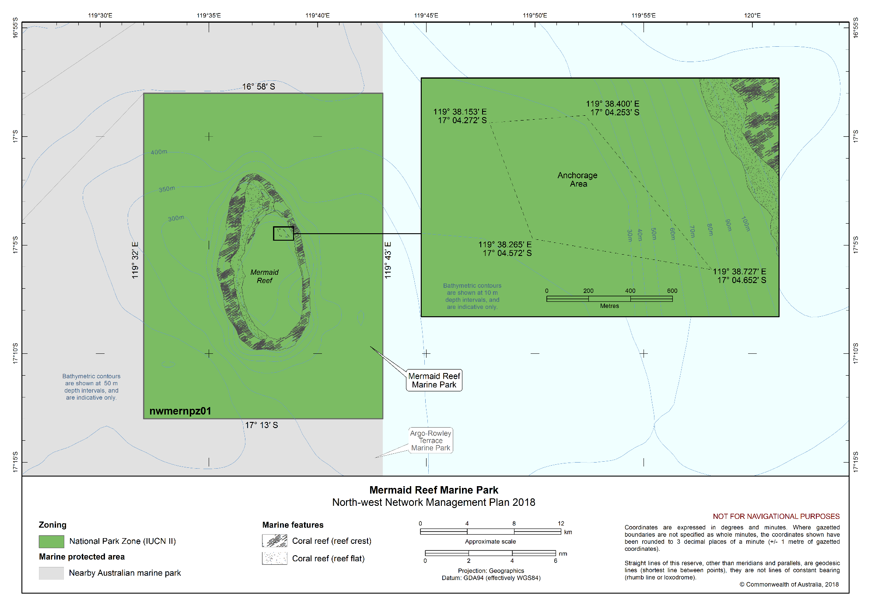
Figure S2.9 Mermaid Reef Marine Park

Argo–Rowley Terrace Marine Park
The Argo–Rowley Terrace Marine Park (Figure S2.10) is located approximately 270 km north-west of Broome, Western Australia, and extends to the limit of Australia’s exclusive economic zone. The Marine Park is adjacent to the Mermaid Reef Marine Park and the Western Australian Rowley Shoals Marine Park. The Marine Park covers an area of 146,003 km² and water depths between 220 m and 6000 m.
The Marine Park was proclaimed under the EPBC Act on 14 December 2013 and renamed Argo-Rowley Terrace Marine Park on 9 October 2017. The Marine Park is assigned IUCN category VI and includes three zones assigned under this plan: National Park Zone (II), Multiple Use Zone (VI) and Special Purpose Zone (Trawl) (VI).
Coordinates for the Argo–Rowley Terrace Marine Park and zones are provided in Figure S2.10 and Schedule 4.
Statement of significance
The Argo–Rowley Marine Park is significant because it contains habitats, species and ecological communities associated with the Northwest Transition and Timor Province. It includes two key ecological features: canyons linking the Argo Abyssal Plain with the Scott Plateau (valued for high productivity and aggregations of marine life); and Mermaid Reef and Commonwealth waters surrounding Rowley Shoals (valued for enhanced productivity, aggregations of marine life and high species richness).
The Marine Park is the largest in the North-west Network, surrounding the existing Mermaid Reef Marine Park and reefs of the Western Australian Rowley Shoals Marine Park. It includes the deeper waters of the region and a range of seafloor features such as canyons on the slope between the Argo Abyssal Plain, Rowley Terrace and Scott Plateau. These are believed to be up to 50 million years old and are associated with small, periodic upwellings that results in localised higher levels of biological productivity.
Natural values
The Marine Park includes examples of ecosystems representative of:
- Northwest Transition—an area of shelf break, continental slope, and the majority of the Argo Abyssal Plain. Key topographic features include Mermaid, Clerke and Imperieuse Reefs which collectively are a biodiversity hotspot; and
- Timor Province—an area dominated by warm, nutrient-poor waters. Canyons are an important feature in this area of the Marine Park and are generally associated with high productivity and aggregations of marine life.
Key ecological features of the Marine Park are:
- Canyons linking the Argo Abyssal Plain with the Scott Plateau—an area likely to result in upwelling of nutrient rich water and aggregations of marine life; and
- Mermaid Reef and Commonwealth waters surrounding Rowley Shoals—an area of enhanced productivity and high species richness, thought to be facilitated by internal wave action generated by internal tides.
The Marine Park supports a range of species including species listed as threatened, migratory, marine or cetacean under the EPBC Act. Biologically important areas within the Marine Park include resting and breeding habitat for seabirds and a migratory pathway for the pygmy blue whale.
Cultural values
Sea country is valued for Indigenous cultural identity, health and wellbeing. Across Australia, Indigenous people have been sustainably using and managing their sea country for tens of thousands of years. At the commencement of this plan there is limited information about the cultural significance of this Marine Park.
Heritage values
No international, Commonwealth or national listings apply to the Marine Park at commencement of this plan.
Historic shipwrecks
The Marine Park contains two known shipwrecks listed under the Historic Shipwrecks Act 1976: Alfred (wrecked in 1908) and Pelsart (wrecked in 1908).
Social and economic values
Commercial fishing and mining are important activities in the Marine Park. These activities contribute to the wellbeing of regional communities and the prosperity of the nation.
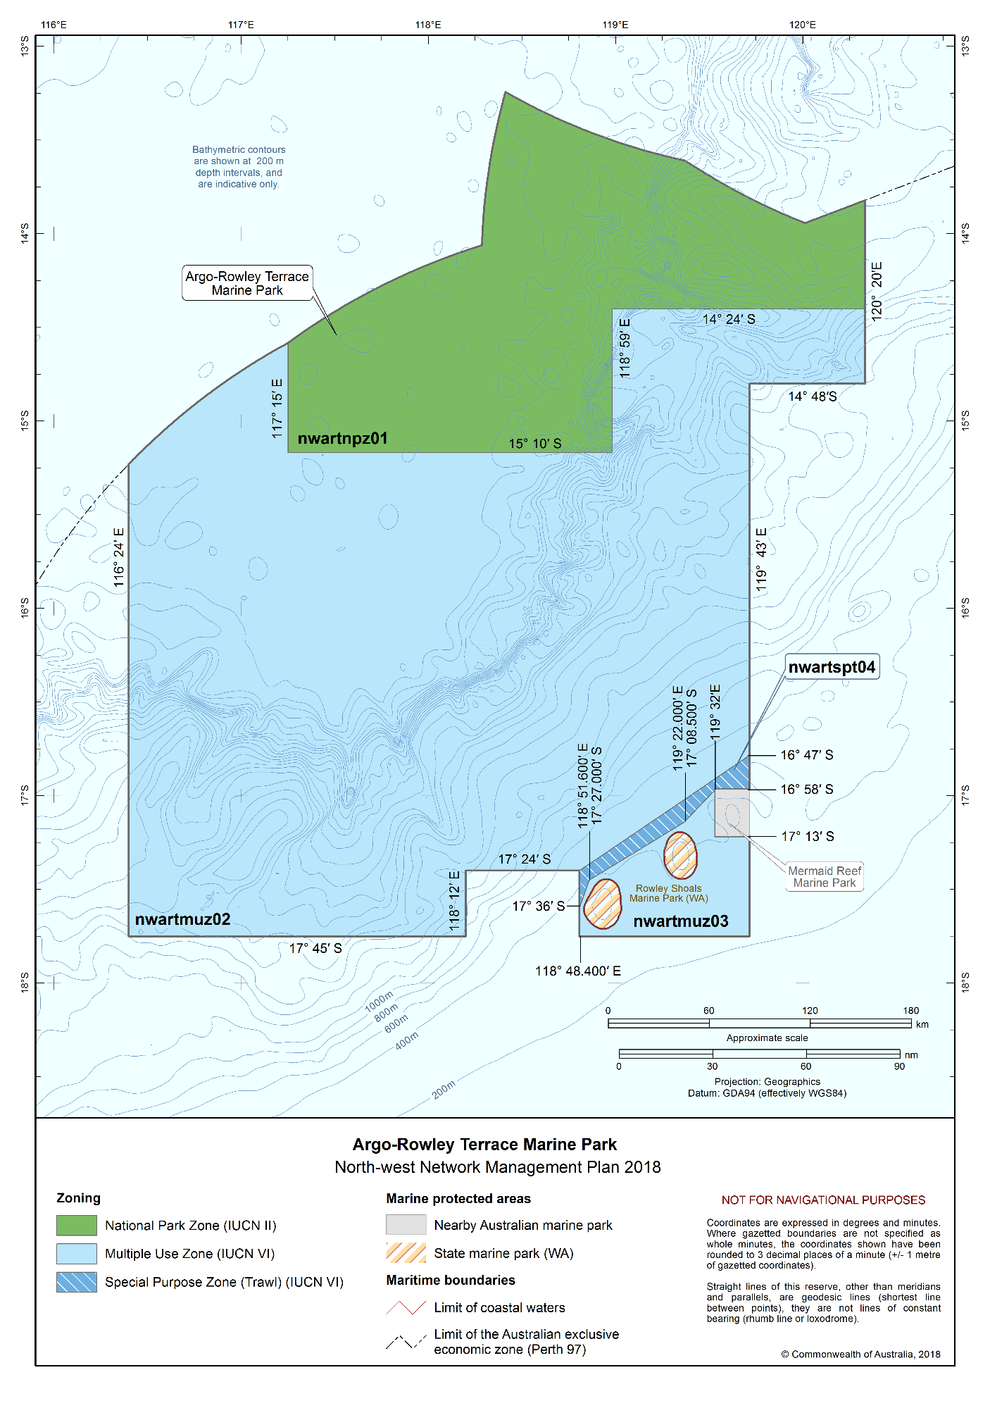
Figure S2.10 Argo–Rowley Terrace Marine Park

Kimberley Marine Park
The Kimberley Marine Park (Figure S2.11) is located approximately 100 km north of Broome, extending from the Western Australian state water boundary north from the Lacepede Islands to the Holothuria Banks offshore from Cape Bougainville. The Marine Park is adjacent to the Western Australian Lalang-garram/Camden Sound Marine Park and the North Kimberley Marine Park. The Marine Park covers an area of 74,469 km² and water depths from less than 15 m to 800 m.
The Marine Park was proclaimed under the EPBC Act on 14 December 2013 and renamed Kimberley Marine Park on 9 October 2017. The Marine Park is assigned IUCN category VI and includes three zones assigned under this plan: National Park Zone (II), Habitat Protection Zone (IV) and Multiple Use Zone (VI).
Coordinates for the Kimberley Marine Park and zones are provided in Figure S2.11 and Schedule 4.
Statement of significance
The Kimberley Marine Park is significant because it includes habitats, species and ecological communities associated with the Northwest Shelf Province, Northwest Shelf Transition and Timor Province. It includes two key ecological features: the ancient coastline at the 125-m depth contour (an area of enhanced productivity and migratory pathway for cetaceans and pelagic marine species); and continental slope demersal fish communities (valued for high levels of endemism and diversity and the second richest area for demersal fish species in Australia).
The Marine Park provides connectivity between deeper offshore waters, and the inshore waters of the adjacent Western Australia North Kimberley Marine Park and Lalang-garram/Camden Sound Marine Park.
Natural values
The Marine Park includes examples of ecosystems representative of:
- Northwest Shelf Province—a dynamic environment influenced by strong tides, cyclonic storms, long-period swells and internal tides. The bioregion includes diverse benthic and pelagic fish communities, and an ancient coastline thought to be an important seafloor feature and migratory pathway for humpback whales.
- Northwest Shelf Transition—straddles the North-west and North Marine Regions and in the North-west includes shelf break, continental slope, and the majority of the Argo Abyssal Plain and is subject to a high incidence of cyclones. Benthic biological communities in the deeper parts of the bioregion have not been extensively studied, although high levels of species diversity and endemism occur among demersal fish communities on the continental slope.
- Timor Province—water depths (of the bioregion) ranging from about 200 m near the shelf break to 5920 m over the Argo Abyssal Plain. The reefs and islands of the bioregion are regarded as biodiversity hotspots. Endemism in demersal fish communities of the continental slope is high; two distinct communities have been identified on the upper and mid slopes.
Key ecological features of the Marine Park are:
- the ancient coastline at the 125-m depth contour—where rocky escarpments are thought to provide biologically important habitats in areas otherwise dominated by soft sediments; and
- the continental slope demersal fish communities—characterised by high diversity of demersal fish assemblages.
The Marine Park supports a range of species, including protected species listed as threatened, migratory, marine or cetacean under the EPBC Act. Biologically important areas within the Marine Park include breeding and foraging habitat for seabirds, internesting and nesting habitat for marine turtles, breeding, calving and foraging habitat for inshore dolphins, calving, migratory pathway and nursing habitat for humpback whales, migratory pathway for pygmy blue whales, foraging habitat for dugong and foraging habitat for whale sharks.
Cultural values
Sea country is valued for Indigenous cultural identity, health and wellbeing. Across Australia, Indigenous people have been sustainably using and managing their sea country for tens of thousands of years.
The Wunambal Gaambera, Dambimangari, Bardi Jawi and the Nyul Nyul people’s sea country extends into the Kimberley Marine Park. The Wunambal Gaambera people’s country includes daagu (deep waters), with about 3400 km² of their sea country located in the Marine Park. The Wunambal Gaambera, Dambimangari, Bardi Jawi and the Nyul Nyul people have an unbroken connection to their sea country, having deep spiritual connection through Wunggurr (creator snakes) that still live in the sea. Staple foods of living cultural value include saltwater fish, turtles, dugong, crabs and oysters. Access to sea country by families is important for cultural traditions, livelihoods and future socio-economic development opportunities.
The national heritage listing for the West Kimberley recognises the following key cultural heritage values:
- Wanjina Wunggurr Cultural Tradition which incorporates many sea country cultural sites;
- log-raft maritime tradition, which involved using tides and currents to access warrurru (reefs) far offshore to fish;
- interactions with Makassan traders around sea foods over hundreds of years; and
- important pearl resources that were used in traditional trade through the wunan and in contemporary commercial agreements.
The Wunambal Gaambera, Dambimangari and Bardi Jawi people consider that these values extend into the Kimberley Marine Park. The Wanjina Wunggurr is law of the Wunambal Gaambera and Dambimangari people and it is recognised that all of the sea country, land, plants and animals were put there by Wanjina Wunggurr. Under Wanjina Wunggurr law, the Wunambal Gaambera and Dambimangari people have a responsibility to manage country, to maintain the health of the country and all living things. The Wunambal Gaambera, Dambimangari and the Bardi and Jawi people have had native title determined over parts of their sea country included in this Park. The native title holders for these people are represented by the Wunambal Gaambera Aboriginal Corporation, Dambimangari Aboriginal Corporation and Bardi Jai Niimidiman Aboriginal Corporation. These Prescribed Body Corporates are the points of contact for their respective areas of sea country for the Marine Park.
The Kimberley Land Council is the Native Title Representative Body for Kimberley region.
Heritage values
No international, Commonwealth or national heritage listings apply to the Marine Park at commencement of this plan, however the Marine Park is adjacent to the national heritage place of The West Kimberley.
Historic shipwrecks
The Marine Park contains more than 40 known shipwrecks listed under the Historic Shipwrecks Act 1976.
Social and economic values
Tourism, commercial fishing, mining, recreation, including fishing, and traditional use are important activities in the Marine Park. These activities contribute to the wellbeing of regional communities and the prosperity of the nation.
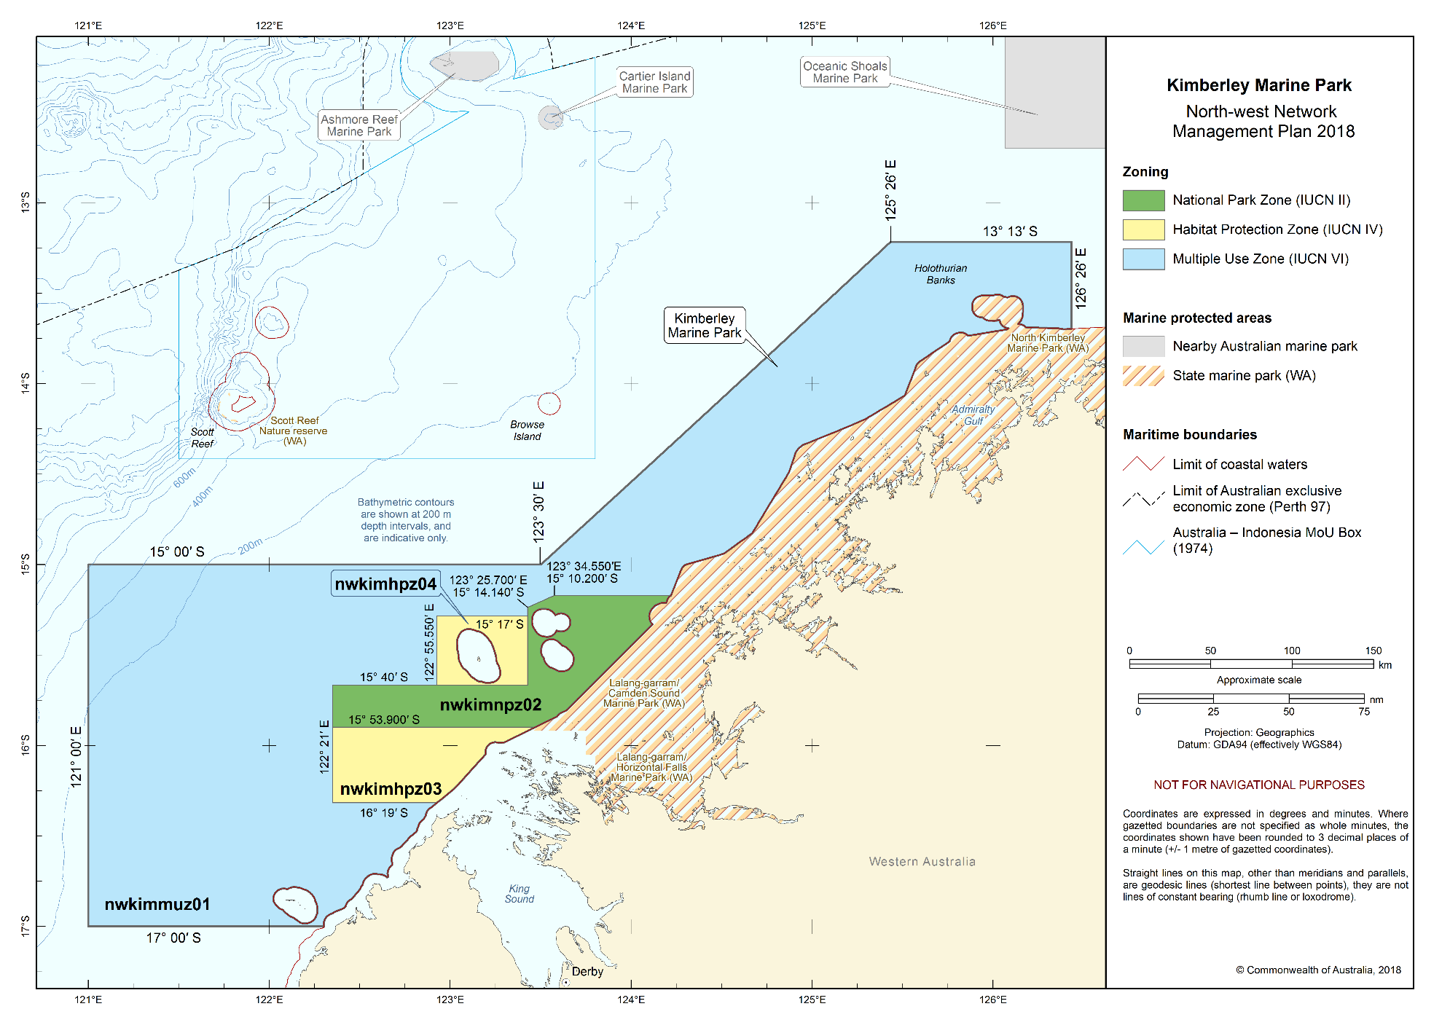
Figure S2.11 Kimberley Marine Park

Ashmore Reef Marine Park
The Ashmore Reef Marine Park (Figure S2.12) is located approximately 630 km north of Broome and 110 km south of the Indonesian island of Roti. The Marine Park is located in Australia’s External Territory of Ashmore and Cartier Islands and is within an area subject to a Memorandum of Understanding (MoU) between Indonesia and Australia, known as the MoU Box. The Marine Park covers an area of 583 km² and water depths from less than 15 m to 500 m. The Marine Park contains three vegetated sand cays that are permanently above water: West, Middle and East islands.
The Marine Park was originally proclaimed under the National Parks and Wildlife Conservation Act 1975 on 16 August 1983 as the Ashmore Reef National Nature Reserve, and proclaimed under the EPBC Act on 14 December 2013 and renamed Ashmore Reef Marine Park on 9 October 2017. The Marine Park is assigned IUCN category Ia and includes two zones assigned under this plan: Sanctuary Zone (Ia) and Recreational Use Zone (IV).
Coordinates for the Ashmore Reef Marine Park and zones are provided in Figure S2.12 and Schedule 4.
Statement of significance
The Ashmore Reef Marine Park is significant because it includes habitats, species and ecological communities associated with the Timor Province. It includes two key ecological features: Ashmore Reef and Cartier Island and surrounding Commonwealth waters (valued for high productivity and breeding aggregations of birds and other marine life); and continental slope demersal fish communities (valued for high levels of endemism).
Ashmore Reef is the largest of three emergent oceanic reefs in the region and the only one with vegetated islands. The Marine Park is an area of enhanced biological productivity and a biodiversity hotspot, supporting a range of pelagic and benthic marine species and an important biological stepping stone facilitating the transport of biological material to the reef systems along the Western Australian coast via the south-flowing Leeuwin Current which originates in the region.
The Ashmore Reef Ramsar site is located within the boundary of the Marine Park. The site was listed under the Ramsar Convention in 2002 and is a wetland of international importance under the EPBC Act. An Ecological Character Description that sets out the Ramsar listing criteria met by the site, the key threats and knowledge gaps, is available on the Department’s website.
Natural values
The Marine Park includes examples of ecosystems representative of the Timor Province—a bioregion with a depth range from about 200 m near the shelf break to 5920 m over the Argo Abyssal Plain. The reefs and islands of the bioregion are regarded as biodiversity hotspots. Ashmore Reef is an important feature of the bioregion. Endemism in demersal fish communities of the continental slope is high with two distinct communities identified: one on the upper slope, the other mid slope.
Key ecological features of the Marine Park are:
- Ashmore Reef and Cartier Island and surrounding Commonwealth waters—areas of enhanced productivity in an otherwise low-nutrient environment, of regional importance for feeding and breeding aggregations of birds and marine life; and
- continental slope demersal fish communities—an area of high-diversity demersal fish assemblages.
The marine environment of the Marine Park includes habitats associated with two extensive lagoons, sand flats, shifting sand cays, extensive reef flat and large areas of seagrass. The reef ecosystems are comprised of hard and soft corals, gorgonians, sponges and a range of encrusting organisms, with the highest number of coral species of any reef off the Western Australian coast.
The Marine Park supports a range of species, including species listed as threatened, migratory, marine or cetacean under the EPBC Act. Biologically important areas within the Marine Park include breeding, foraging and resting habitat for seabirds, resting and foraging habitat for migratory shorebirds, foraging, mating, nesting and internesting habitat for marine turtles, foraging habitat for dugong, and a migratory pathway for pygmy blue whales.
Ashmore Reef Ramsar site
The Ashmore Reef Ramsar site includes the largest of the atolls in the region. West Island, Middle Island and East Island represent the only vegetated islands in the region. Ashmore Reef Ramsar site supports internationally significant populations of seabirds and shorebirds, is important for turtles (green, hawksbill and loggerhead) and dugong, and has the highest diversity of hermatypic (reef-building) corals on the West Australian coast. It is known for its abundance and diversity of sea snakes. However, since 1998 populations of sea snakes at Ashmore Reef have been in decline.
Cultural values
Indigenous Australians
Sea country is valued for Indigenous cultural identity, health and wellbeing. Across Australia, Indigenous people have been sustainably using and managing their sea country for tens of thousands of years. At the commencement of this plan there is limited information about the cultural significance of this Marine Park.
Indonesian
The Marine Park contains Indonesian artefacts and grave sites and Ashmore lagoon is still accessed as a rest or staging area for traditional Indonesian fishers travelling to and from fishing grounds within the MoU Box.
Heritage values
No international or national heritage listings apply to the Marine Park at commencement of this plan.
Commonwealth heritage
Ashmore Reef was listed on the Commonwealth Heritage List in 2004, meeting Commonwealth heritage listing criteria A, B and C.
Social and economic values
Tourism, recreation and scientific research are important activities in the Marine Park. These activities contribute to the wellbeing of regional communities and the prosperity of the nation.
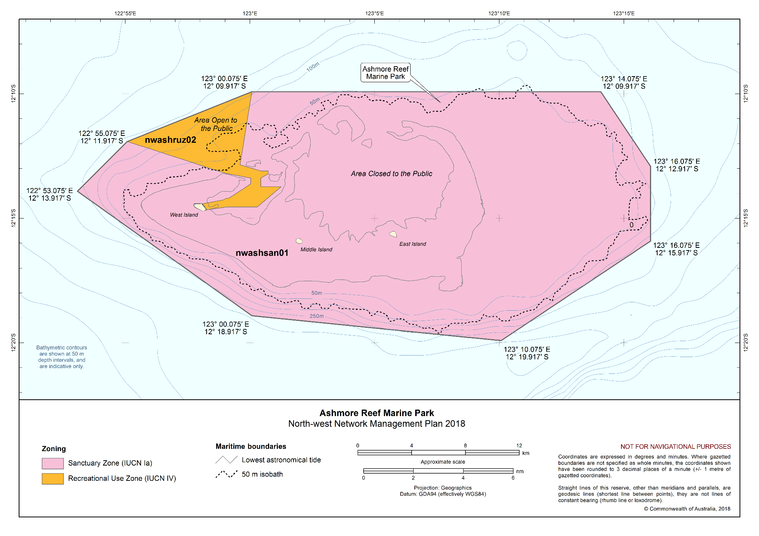
Figure S2.12 Ashmore Reef Marine Park

Cartier Island Marine Park
The Cartier Island Marine Park (figure S2.13) is located approximately 45 km south-east of Ashmore Reef Marine Park and 610 km north of Broome, Western Australia. Both Marine Parks are located in Australia’s External Territory of Ashmore and Cartier Islands and are also within an area subject to a Memorandum of Understanding (MoU) between Indonesia and Australia, known as the MoU Box. The Marine Park covers an area of 172 km² and water depths from less than 15 m to 500 m.
The Marine Park was originally proclaimed under the National Parks and Wildlife Conservation Act 1975 on 21 June 2000 as the Cartier Island Marine Reserve, and proclaimed under the EPBC Act on 14 December 2013 and renamed Cartier Island Marine Park on 9 October 2017. The Marine Park is assigned IUCN category Ia and includes one zone assigned under this plan: Sanctuary Zone (Ia).
Coordinates for the Cartier Island Marine Park and zone are provided in Figure S2.13 and Schedule 4.
Statement of significance
The Cartier Island Marine Park is significant because it includes habitats, species and ecological communities associated with the Timor Province. It includes two key ecological features: Ashmore Reef and Cartier Island and surrounding Commonwealth waters (valued for high productivity and breeding aggregations of birds and other marine life); and continental slope demersal fish communities (valued for high levels of endemism).
Like the islands of Ashmore Reef, Cartier Island is a biodiversity hotspot and an important biological stepping stone, facilitating the transport of biological material to the reef systems along the Western Australian coast via the south-flowing Leeuwin Current which originates in the region.
Natural values
The Marine Park includes examples of ecosystems representative of the Timor Province—a bioregion with a depth range from about 200 m near the shelf break to 5920 m over the Argo Abyssal Plain. The reefs and islands of the bioregion are regarded as biodiversity hotspots. Endemism of demersal fish communities of the continental slope is high with two distinct communities identified, one on the upper slope, the other mid slope.
Key ecological features represented in the Marine Park are:
- Ashmore Reef and Cartier Island and surrounding Commonwealth waters—areas of enhanced productivity in an otherwise low-nutrient environment, of regional importance for feeding and breeding aggregations of birds and marine life; and
- Continental slope demersal fish communities—an area of high diversity in demersal fish assemblages.
The Marine Park includes an unvegetated sand island (Cartier Island), mature reef flat, a small, submerged pinnacle (Wave Governor Bank), and two shallow pools to the north-east of the island. It is also an area of high diversity and abundance of hard and soft corals, gorgonians (sea fans), sponges and a range of encrusting organisms. The reef crests are generally algal dominated, while the reef flats feature ridges of coral rubble and large areas of seagrass.
The Marine Park supports a range of species, including species listed as threatened, migratory, marine or cetacean under the EPBC Act. Biologically important areas within the Marine Park include breeding and foraging habitat for seabirds, internesting, nesting and foraging habitat for marine turtles and foraging habitat for whale sharks.
The Marine Park is important for a range of other species and internationally significant for its abundance and diversity of sea snakes, some of which are listed species under the EPBC Act.
Cultural values
Sea country is valued for Indigenous cultural identity, health and wellbeing. Across Australia, Indigenous people have been sustainably using and managing their sea country for tens of thousands of years. At the commencement of this plan, there is limited information about the cultural significance of this Marine Park.
Heritage values
No international, Commonwealth or national listings apply to the Marine Park at commencement of this plan.
Historic shipwrecks
The Marine Park contains one known shipwreck listed under the Historic Shipwrecks Act 1976: the Ann Millicent (wrecked in 1888).
Social and economic values
Scientific research is an important activity in the Marine Park.
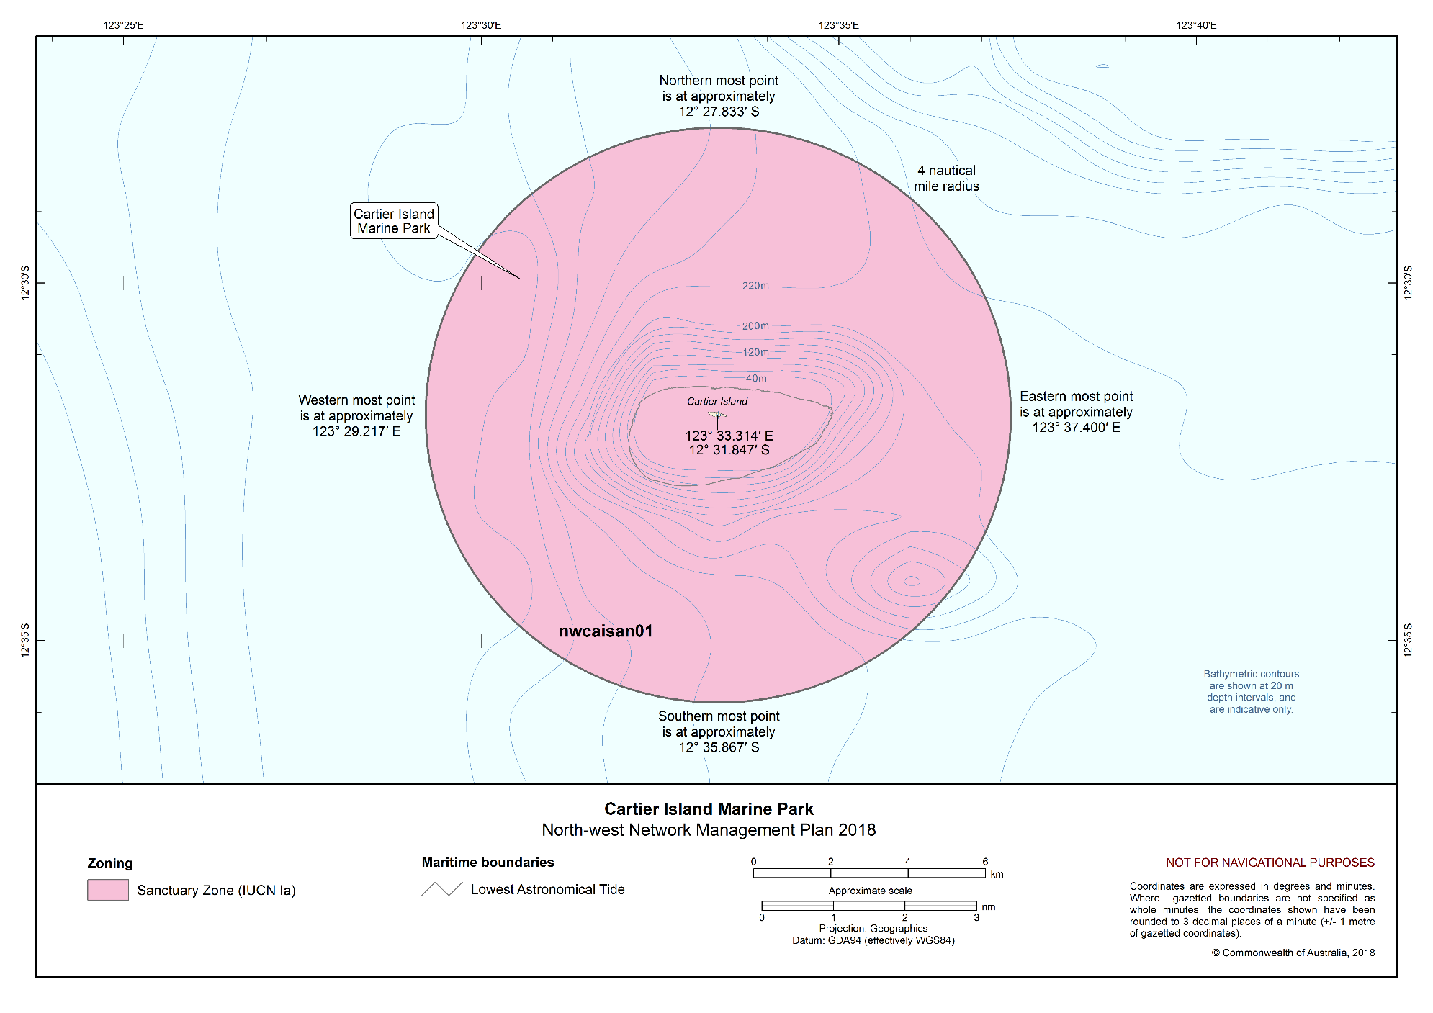
Figure S2.13 Cartier Island Marine Park

Schedule 3. Environmental features used in the design of the North-west Network
Four types of environmental features were used in the design of the Marine Parks of the North-west Network to help identify areas for protection. These features were identified based on the scientifically known relationships between biodiversity and the physical environment and include bioregions, water depth, seafloor features, and key ecological features. They are identified below.
More information on these features can be found in the Marine bioregional plan for the North-west Marine Region (2012), the North-west marine bioregional plan: bioregional profile (2008), and the conservation values atlas on the Department’s website.
Bioregions
Bioregions are identified in the Integrated Marine and Coastal Regionalisation of Australia (IMCRA) as large areas of ocean with broadly similar characteristics that have been classified by scientists based on the distribution of fish and other marine species, seafloor types and ocean conditions. The North-west Network represents all eight of the bioregions found in the region: Northwest Shelf Transition, Timor Province, Northwest Shelf Province, Northwest Transition, Northwest Province, Central Western Shelf Transition, Central Western Transition and Central Western Shelf Province (Figure S3.1).
Depth ranges
The North-west Network represents the full range of depths found in the region, from shallow waters of less than 15 m to approximately 6000 m depth. Marine biological communities change with depth, and similar depth ranges in different bioregions support different groups of species. The range of ocean depths in each bioregion, represented as bathomes in Figure S3.2, have been included in the Network to ensure that examples of marine biodiversity are represented.
Seafloor features
The landscape-scale physical structure of the seafloor is important in determining where habitats or species occur. There is strong scientific evidence that different types of seafloor features provide different habitats and associated marine species and communities. The Network represents 15 of the 19 seafloor features found in the region: abyssal plain/deep ocean floor, apron/fan, bank/shoal, canyon, continental rise, deep/hole/valley, knoll/abyssal hills/hills/mountain/peak, pinnacle, plateau, reef, ridge, shelf, slope, terrace, and trench/trough (Figure S3.3).
Key ecological features
Key ecological features were identified through the marine bioregional planning program as areas or features that support distinct or important ecological communities at a regional scale. The North-west Network represents eight of the 13 key ecological features found in the region: Ashmore Reef and Cartier Island and surrounding Commonwealth waters; continental slope demersal fish communities; canyons linking the Argo Abyssal Plain with the Scott Plateau; ancient coastline at the 125-m depth contour; Mermaid Reef and the Commonwealth waters surrounding the Rowley Shoals; Exmouth Plateau; canyons linking the Cuvier Abyssal Plain with the Cape Range Peninsula; and Commonwealth waters adjacent to Ningaloo Reef (Figure S3.4).
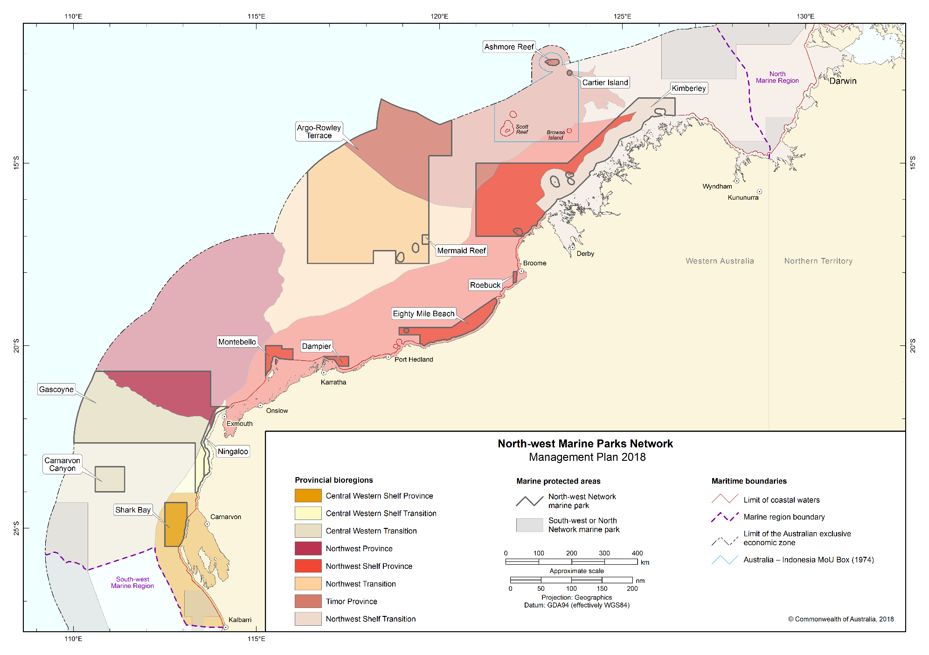
Figure S3.1 Bioregions represented in the North-west Network

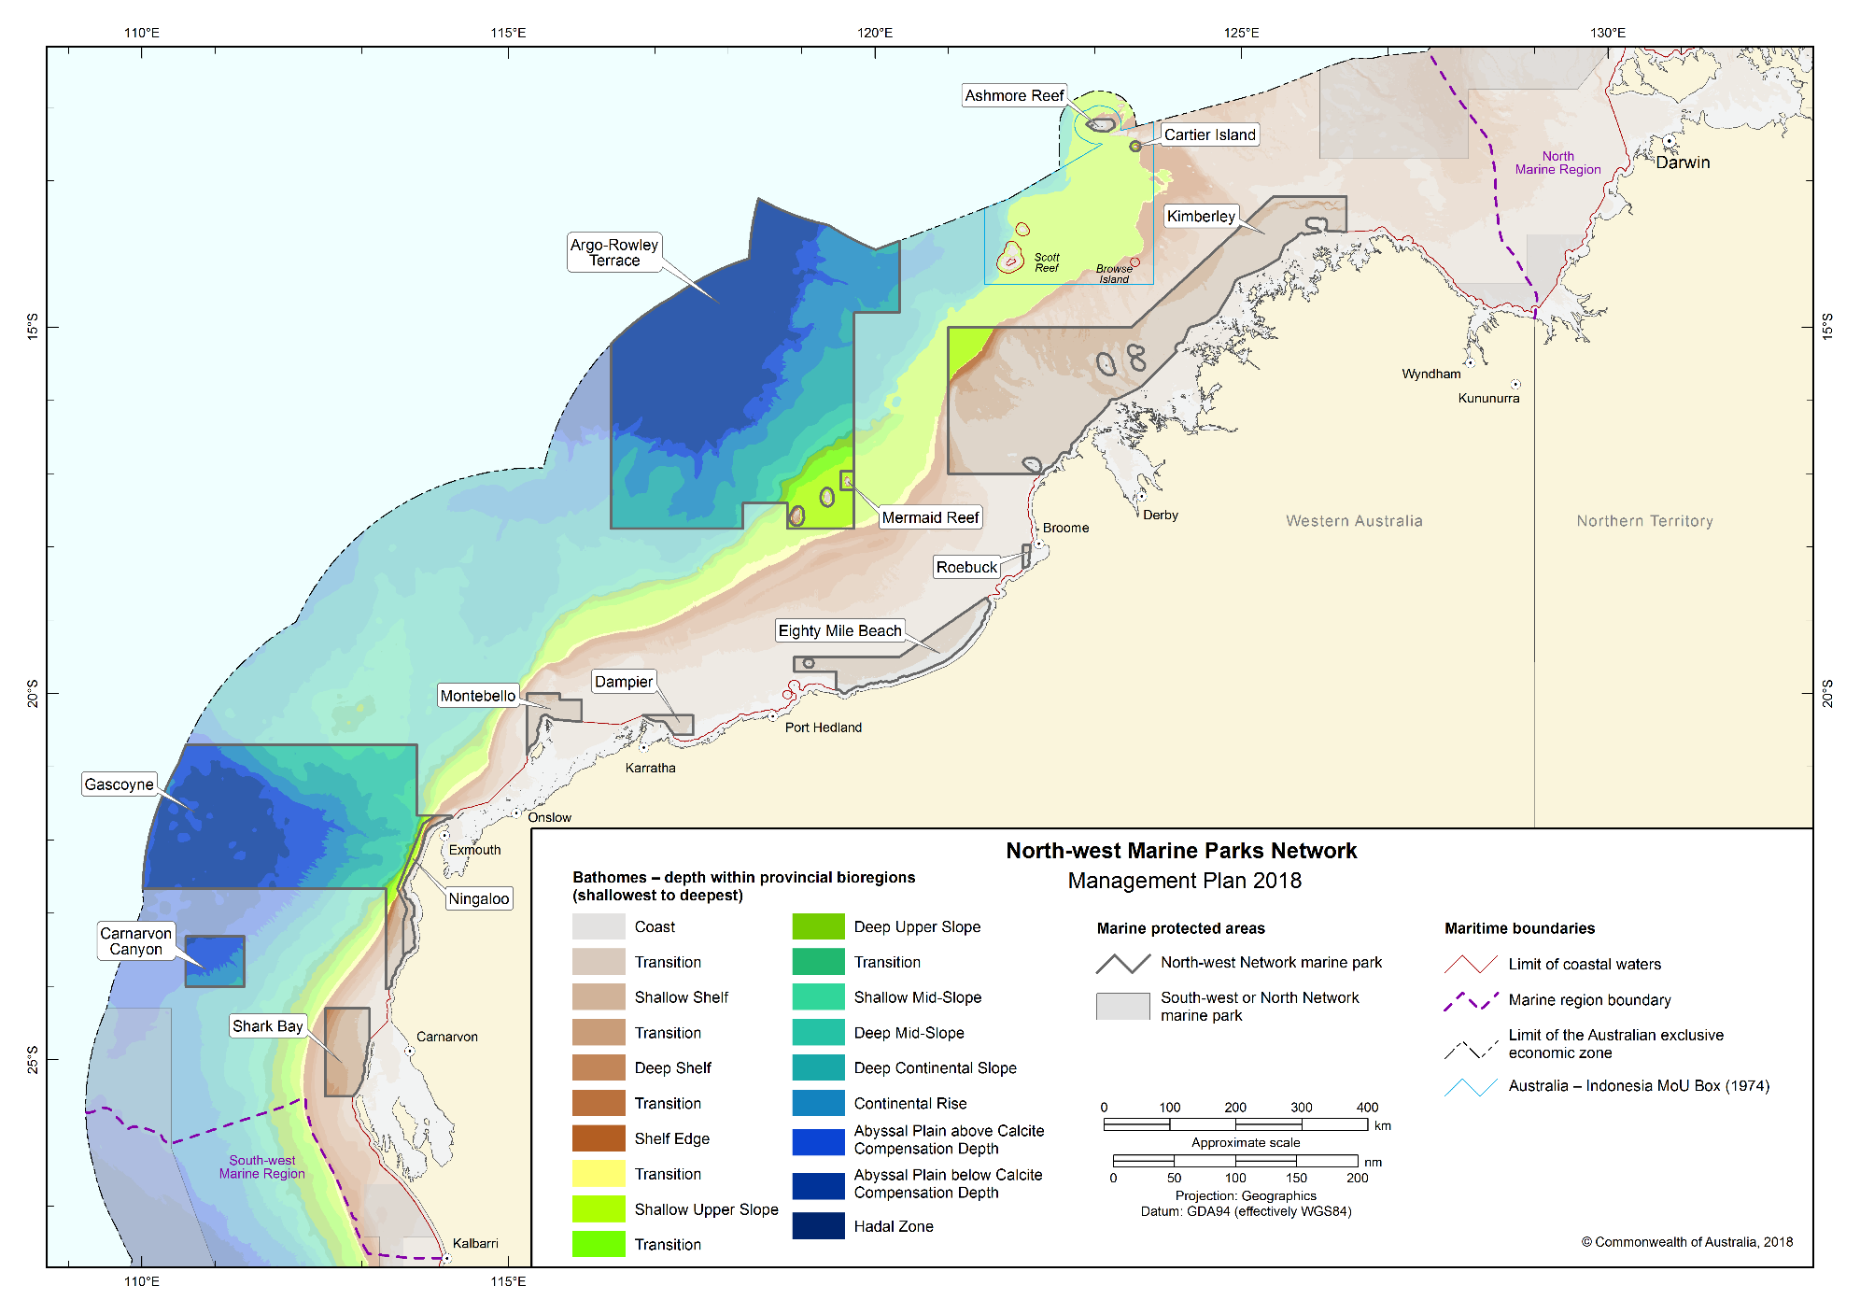
Figure S3.2 Bathomes indicating depth ranges represented in the North-west Network

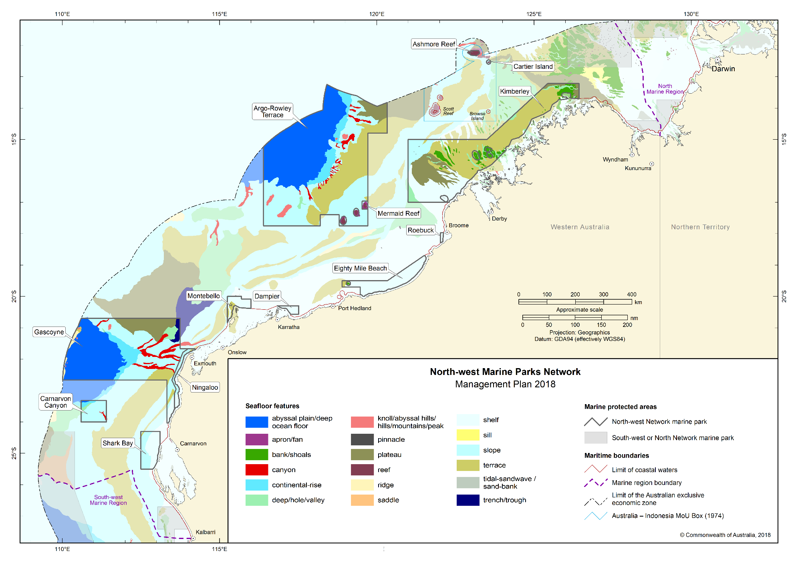
Figure S3.3 Seafloor features represented in the North-west Network
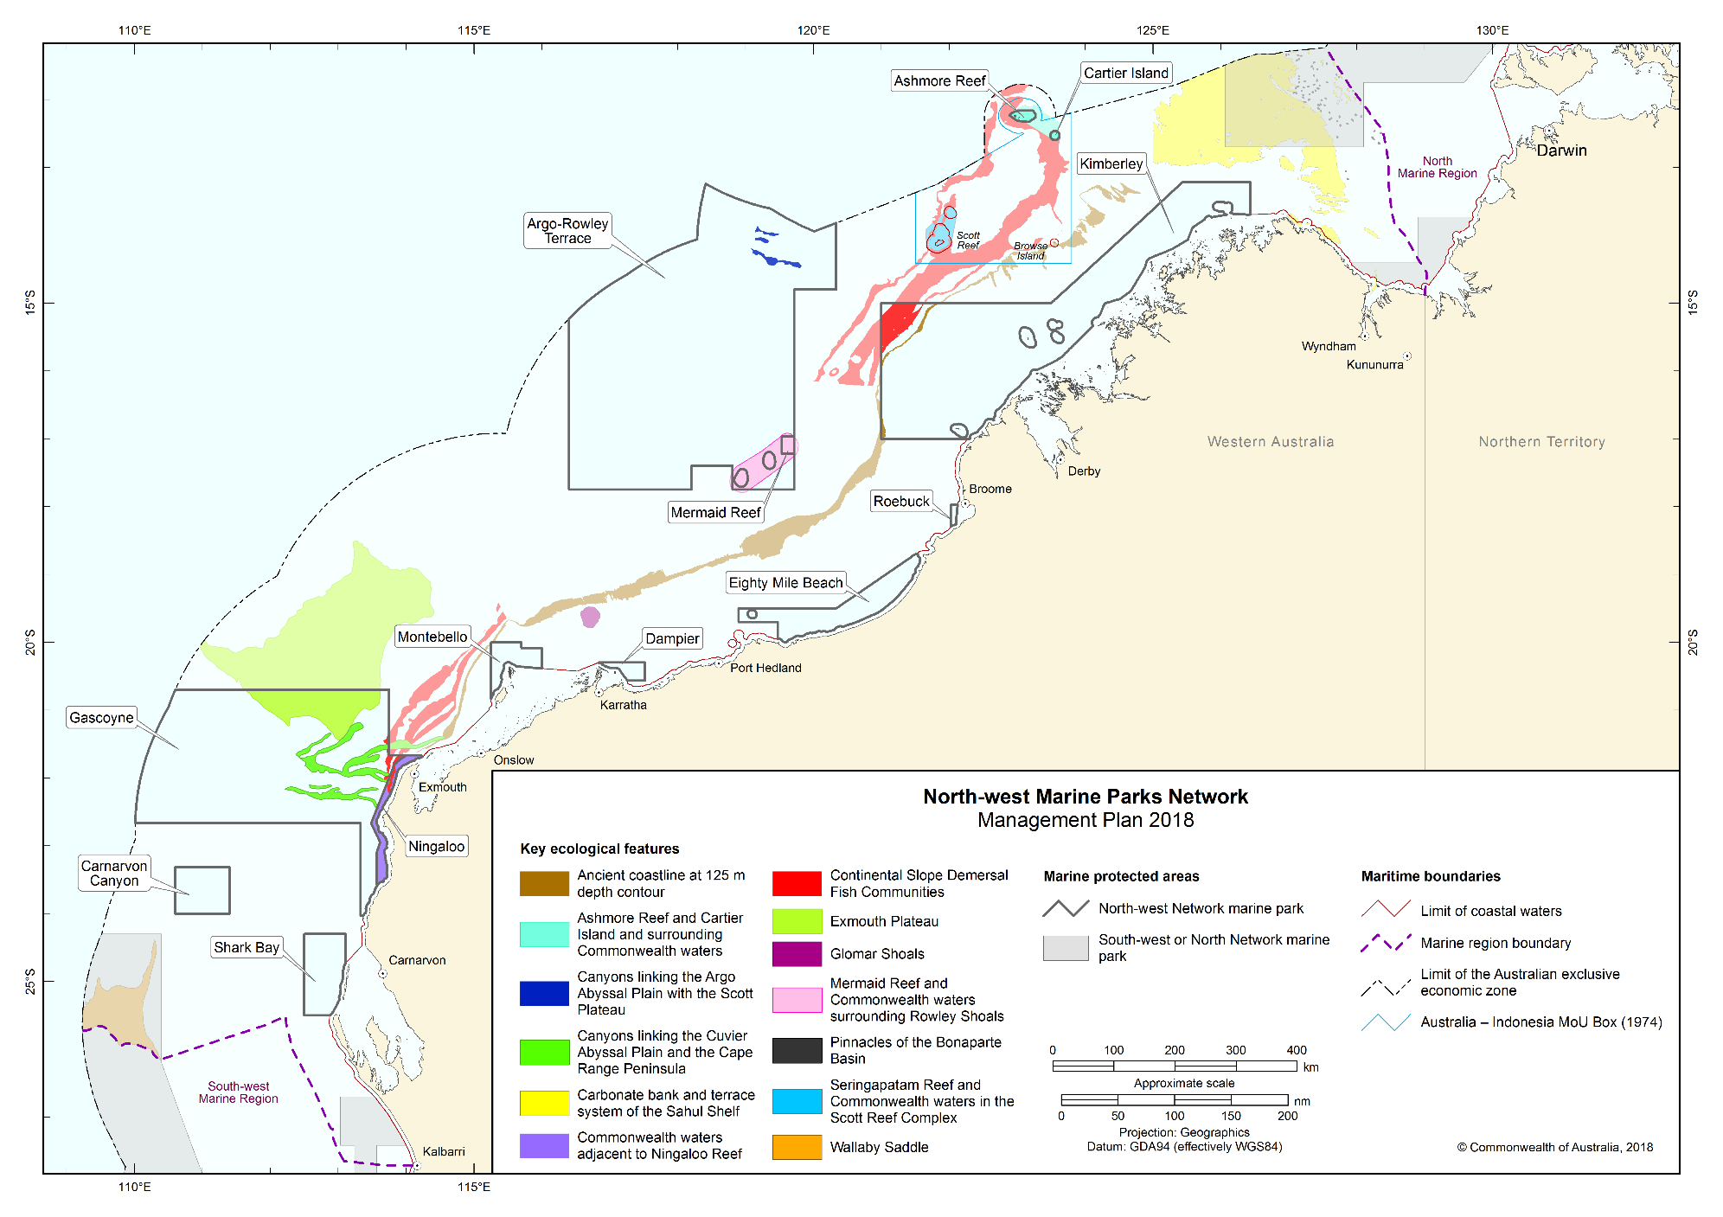
Figure S3.4 Key ecological features represented in the North-west Network

Schedule 4. North-west Network marine parks and zone boundary descriptions
In this Schedule:
State waters has the same meaning as coastal waters of the State in subsection 3 (1) of the Coastal Waters (State Powers) Act 1980.
Note: Geographic coordinates are expressed in terms of the Geocentric Datum of Australia 1994.
Note: The Geocentric Datum of Australia 1994 (also known as GDA94) was published in Gazette No. GN 35 of 6 September 1995.

Part 1 — Shark Bay Marine Park

1.1 Area of marine park
The Shark Bay Marine Park consists of an area in the Indian Ocean bounded by the line commencing at the point described in item 1 of the following table and running progressively as described in the table.
Area of marine park
Item | Description
1 | The point of latitude 24° 18′ 00″ S, longitude 112° 30′ 00″ E
2 | East along the parallel of latitude 24° 18′ 00″ S to its intersection by the meridian of longitude 113° 06′ 24″ E
3 | South along that meridian to its intersection by the outer limit of the State waters of Western Australia
4 | Generally south-westerly along that outer limit to its intersection by the parallel of latitude 25° 30′ 00″ S
5 | West along that parallel to its intersection by the meridian of longitude 112° 30′ 00″ E
6 | North along that meridian to the point of commencement

1.2 Zone (nwshamuz01) for marine park
(1) The Shark Bay Marine Park has the following zone:
(a) the Multiple Use Zone (VI) described in Section 1.1 of this Part.

Part 2 — Carnarvon Canyon Marine Park

2.1 Area of marine park
The Carnarvon Canyon Marine Park consists of an area in the Indian Ocean bounded by the line commencing at the point described in item 1 of the following table and running progressively as described in the table.
Area of marine park
Item | Description
1 | The point of latitude 23° 19′ 00″ S, longitude 110° 36′ 00″ E
2 | East along the parallel of latitude 23° 19′ 00″ S to its intersection by the meridian of longitude 111° 24′ 00″ E
3 | South along that meridian to its intersection by the parallel of latitude 24° 00′ 00″ S
4 | West along that parallel to its intersection by the meridian of longitude 110° 36′ 00″ E
5 | North along that meridian to the point of commencement

2.2 Zone (nwcachpz01) for marine park
(1) The Carnarvon Canyon Marine Park has the following zone:
(a) the Habitat Protection Zone (IV) described in Section 2.1 of this Part.

Part 3 — Ningaloo Marine Park

3.1 Area of marine park
The Ningaloo Marine Park consists of an area in the Indian Ocean, excluding any State waters of Western Australia, bounded by the line commencing at the point described in item 1 of the following table and running progressively as described in the table.
Area of marine park
Item | Description
1 | The point of latitude 21° 39′ 55.36″ S, longitude 114° 00′ 04.72″ E
2 | South-westerly along the geodesic to the point of latitude 21° 46′ 55.37″ S, longitude 113°50′ 04.73″ E
3 | South-westerly along the geodesic to the point of latitude 22° 39′ 55.39″ S, longitude 113° 29′ 04.76″ E
4 | South-easterly along the geodesic to the point of latitude 22° 56′ 55.39″ S, longitude 113° 37′ 04.75″ E
5 | South-westerly along the geodesic to the point of latitude 23° 05′ 55.40″ S, longitude 113° 34′ 04.76″ E
6 | South along the meridian of longitude 113° 34′ 04.76″ E to its intersection by the parallel of latitude 23° 33′ 55.42″ S
7 | East along that parallel to its intersection by the outer limit of the State waters of Western Australia
8 | Generally north-easterly, northerly and north-easterly along that outer limit to its intersection by the geodesic line between the point of latitude 21° 46′ 55.36″ S, longitude 114° 19′ 04.69″ E, and the point of latitude 21° 39′ 55.36″ S, longitude 114° 13′ 04.70″ E
9 | North-westerly along that geodesic to the point of latitude 21° 39′ 55.36″ S, longitude 114° 13′ 04.70″ E
10 | West along the parallel of latitude 21° 39′ 55.36″ S to the point of commencement

3.2 Zones for marine park
(1) The Ningaloo Marine Park is divided into the following zones:
(a) the Recreational Use Zones (IV) described in Section 3.3 and 3.5 of this Part;
(b) the National Park Zone (II) described in Section 3.4 of this Part.

3.3 Zone 1 (nwninruz01) for marine park—Recreational Use Zone (IV)
Zone 1 (nwninruz01) of the marine park consists of an area bounded by the line commencing at the point described in item 1 of the following table and running progressively as described in the table.
Zone 1 (nwninruz01) of marine park—Recreational Use Zone (IV)
Item | Description
1 | The point of latitude 21° 39′ 55.36″ S, longitude 114° 00′ 04.72″ E
2 | South-westerly along the geodesic to the point of latitude 21° 46′ 55.37″ S, longitude 113°50′ 04.73″ E
3 | South-westerly along the geodesic to the point of latitude 22° 39′ 55.39″ S, longitude 113° 29′ 04.76″ E
4 | East along the parallel of latitude 22° 39′ 55.39″ S to its intersection by the outer limit of the State waters of Western Australia
5 | Generally northerly and north-easterly along that outer limit to its intersection by the geodesic line between the point of latitude 21° 46′ 55.36″ S, longitude 114° 19′ 04.69″ E, and the point of latitude 21° 39′ 55.36″ S, longitude 114° 13′ 04.70″ E
6 | North-westerly along that geodesic to the point of latitude 21° 39′ 55.36″ S, longitude 114° 13′ 04.70″ E
7 | West along the parallel of latitude 21° 39′ 55.36″ S to the point of commencement

3.4 Zone 2 (nwninnpz02) of marine park—National Park Zone (II)
Zone 2 (nwninruz02) of the marine park consists of an area bounded by the line commencing at the point described in item 1 of the following table and running progressively as described in the table.
Zone 2 (nwninnpz02) of marine park—National Park Zone (II)
Item | Description
1 | The point of latitude 22° 39′ 55.39″ S, longitude 113° 29′ 04.76″ E
2 | South-easterly along the geodesic to the point of latitude 22° 48′ 12.37″ S, longitude 113° 32′ 58.35″ E
3 | East along the parallel of latitude 22° 48′ 12.37″ S to its intersection by the outer limit of the State waters of Western Australia
4 | Generally north-westerly along that outer limit to its intersection by the parallel of latitude 22° 39′ 55.39″ S
5 | West along that parallel to the point of commencement

3.5 Zone 3 (nwninruz03) of marine park—Recreational Use Zone
Zone 3 (nwninruz03) of the marine park consists of an area bounded by the line commencing at the point described in item 1 of the following table and running progressively as described in the table.
Zone 3 (nwninruz03) of marine park—Recreational Use Zone (IV)
Item | Description
1 | The point of latitude 22° 48′ 12.37″ S, longitude 113° 32′ 58.35″ E
2 | South-easterly along the geodesic to the point of latitude 22° 56′ 55.39″ S, longitude 113° 37′ 04.75″ E
3 | South-westerly along the geodesic to the point of latitude 23° 05′ 55.40″ S, longitude 113° 34′ 04.76″ E
4 | South along the meridian of longitude 113° 34′ 04.76″ E to its intersection by the parallel of latitude 23° 33′ 55.42″ S
5 | East along that parallel to its intersection by the outer limit of the State waters of Western Australia
6 | Generally north-easterly and northerly along that outer limit to its intersection by the parallel of latitude 22° 48′ 12.37″ S
7 | West along the parallel of latitude 22° 48′ 12.37″ S to the point of commencement

Part 4 — Gascoyne Marine Park

4.1 Area of marine park
The Gascoyne Marine Park consists of an area in the Indian Ocean bounded by the line commencing at the point described in item 1 of the following table and running progressively as described in the table.
Area of marine park
Item | Description
1 | The point of latitude 20° 42′ 00″ S, longitude 113° 45′ 00″ E
2 | South along the meridian of longitude 113° 45′ 00″ E to its intersection by the parallel of latitude 21° 39′ 55.36″ S
3 | East along that parallel to its intersection by the meridian of longitude 114° 00′ 04.72″ E
4 | South-westerly along the geodesic to the point of latitude 21° 46′ 55.37″ S, longitude 113° 50′ 04.73″ E
5 | South-westerly along the geodesic to the point of latitude 22° 39′ 55.39″ S, longitude 113° 29′ 04.76″ E
6 | South-easterly along the geodesic to the point of latitude 22° 56′ 55.39″ S, longitude 113° 37′ 04.75″ E
7 | South-westerly along the geodesic to the point of latitude 23° 05′ 55.40″ S, longitude 113° 34′ 04.76″ E
8 | South along the meridian of longitude 113° 34′ 04.76″ E to its intersection by the parallel of latitude 23° 33′ 55.42″ S
9 | East along that parallel to its intersection by the outer limit of the State waters of Western Australia
10 | Generally south-westerly along that outer limit to its intersection by the parallel of latitude 24° 01′ 52.816″ S
11 | West along that parallel to its intersection by the meridian of longitude 113° 20′ 00″ E
12 | North along that meridian to its intersection by the parallel of latitude 22° 39′ 55.39″ S
13 | West along that parallel to its intersection by the outer limit of the exclusive economic zone
14 | Generally northerly and north-westerly along that outer limit to its intersection by the parallel of latitude 20° 42′ 00″ S
15 | East along that parallel to the point of commencement

4.2 Zones for marine park
(1) The Gascoyne Marine Park is divided into the following zones:
(a) the National Park Zone (II) described in Section 4.3 of this Part;
(b) the Habitat Protection Zones (IV) described in Section 4.4 and 4.6 of this Part;
(c) the Multiple Use Zone (VI) described in Section 4.5 of this Part.

4.3 Zone 1 (nwgasnpz01) for marine park—National Park Zone (II)
Zone 1 (nwgasnpz01) of the marine park consists of an area bounded by the line commencing at the point described in item 1 of the following table and running progressively as described in the table.
Zone 1 (nwgasnpz01) of marine park—National Park Zone (II)
Item | Description
1 | The point of latitude 21° 30′ 00″ S, longitude 111° 55′ 00″ E
2 | North-westerly along the geodesic to the point of longitude 110° 55′ 00″ E, latitude 20° 42′ 00″ S
3 | West along the parallel of latitude 20° 42′ 00″ S to its intersection by the outer limit of the exclusive economic zone
4 | Generally southerly along that outer limit to its intersection by the parallel of latitude 21° 30′ 00″ S
5 | East along that parallel to the point of commencement

4.4 Zone 2 (nwgashpz02) of marine park—Habitat Protection Zone (IV)
Zone 2 (nwgashpz02) of the marine park consists of an area bounded by the line commencing at the point described in item 1 of the following table and running progressively as described in the table.
Zone 2 (nwgashpz02) of marine park—Habitat Protection Zone (IV)
Item | Description
1 | The point of latitude 22° 39′ 55.39″ S, longitude 113° 14′ 00″ E
2 | North along the meridian of longitude 113° 14′ 00″ E to its intersection by the parallel of latitude 22° 20′ 00″ S
3 | North westerly along the geodesic to the point of latitude 21° 30′ 00″ S, longitude 112° 36′ 00″ E
4 | West along the parallel of latitude 21° 30′ 00″ S to its intersection by the outer limit of the exclusive economic zone
5 | Generally southerly along that outer limit to its intersection by the parallel of latitude 22° 39′ 55.39″ S
6 | East along that parallel to the point of commencement

4.5 Zone 3 (nwgasmuz03) of marine park—Multiple Use Zone (VI)
Zone 3 (nwgasmuz03) of the marine park consists of an area bounded by the line commencing at the point described in item 1 of the following table and running progressively as described in the table.
Zone 3 (nwgasmuz03) of marine park—Multiple Use Zone (VI)
Item | Description
1 | The point of latitude 20° 42′ 00″ S, longitude 113° 45′ 00″ E
2 | South along the meridian of longitude 113° 45′ 00″ E to its intersection by the parallel of latitude 21° 39′ 55.36″ S
3 | East along that parallel to its intersection by the meridian of longitude 114° 00′ 04.72″ E
4 | South-westerly along the geodesic to the point of latitude 21° 46′ 55.37″ S, longitude 113° 50′ 04.73″ E
5 | South-westerly along the geodesic to the point of latitude 22° 39′ 55.39″ S, longitude 113° 29′ 04.76″ E
6 | South-easterly along the geodesic to the point of latitude 22° 56′ 55.39″ S, longitude 113° 37′ 04.75″ E
7 | South-westerly along the geodesic to the point of latitude 23° 05′ 55.40″ S, longitude 113° 34′ 04.76″ E
8 | South along the meridian of longitude 113° 34′ 04.76″ E to its intersection by the parallel of latitude 23° 33′ 55.42″ S
9 | East along that parallel to its intersection by the outer limit of the State waters of Western Australia
10 | Generally south-westerly along that outer limit to its intersection by the parallel of latitude 23° 50′ 00″ S
11 | West along that parallel to its intersection by the meridian of longitude  113° 20′ 00″ E
12 | North along that meridian to its intersection by the parallel of latitude 22° 39′ 55.39″ S
13 | West along that parallel to its intersection by the meridian of longitude 113° 14′ 00″ E
14 | North along that meridian to its intersection by the parallel of latitude 22° 20′ 00″ S
15 | North-westerly along the geodesic to the point of latitude 21° 30′ 00″ S, longitude 112° 36′ 00″ E
16 | West along that parallel to its intersection by the meridian of longitude 111° 55′ 00″ E
17 | North-westerly along the geodesic to the point of latitude 20° 42′ 00″ S, longitude 110° 55′ 00″ E
18 | East along the parallel of latitude 20° 42′ 00″ S to the point of commencement

4.6 Zone 4 (nwgashpz04) of marine park—Habitat Protection Zone (IV)
Zone 4 (nwgashpz04) of the marine park consists of an area bounded by the line commencing at the point described in item 1 of the following table and running progressively as described in the table.
Zone 4 (nwgashpz04) of marine park—Habitat Protection Zone (IV)
Item | Description
1 | The point of latitude 23° 50′ 00″ S, longitude 113° 20′ 00″ E
2 | East along the parallel of latitude 23° 50′ 00″ S to its intersection by the outer limit of the State waters of Western Australia
3 | Generally south-westerly along that outer limit to its intersection by the parallel of latitude 24° 01′ 52.816″ S
4 | West along that parallel to its intersection by the meridian of longitude 113° 20′ 00″ E
5 | North along that meridian to the point of commencement

Part 5 — Montebello Marine Park

5.1 Area of marine park
The Montebello Marine Park consists of an area bounded by the line commencing at the point described in item 1 of the following table and running progressively as described in the table.
Area of marine park
Item | Description
1 | The point of latitude 20° 00′ 00″ S, longitude 115° 15′ 06″ E
2 | East along the parallel of latitude 20° 00′ 00″ S to its intersection by the meridian of longitude 115° 42′ 00″ E
3 | South along that meridian to its intersection by the parallel of latitude 20° 05′ 00″ S
4 | East along that parallel to its intersection by the meridian of longitude 116° 00′ 00″ E
5 | South along that meridian to its intersection by the outer limit of the State waters of Western Australia
6 | Generally westerly and south-westerly along that outer limit to its intersection by the parallel of latitude 20° 50′ 00″ S
7 | West along that parallel to its intersection by the meridian of longitude 115° 15′ 06″ E
8 | North along that meridian to the point of commencement

5.2 Zone (nwmonmuz01) for marine park
(1) The Montebello Marine Park has the following zone:
(a) the Multiple Use Zone (VI) described in Section 5.1 of this Part.

Part 6 — Dampier Marine Park

6.1 Area of marine park
The Dampier Marine Park consists of an area in the Indian Ocean bounded by the line commencing at the point described in item 1 of the following table and running progressively as described in the table.
Area of marine park
Item | Description
1 | The point of latitude 20° 18′ 00″ S, longitude 116° 50′ 00″ E
2 | East along the parallel of latitude 20° 18′ 00″ S to its intersection by the meridian of longitude 117° 31′ 00″ E
3 | South along that meridian to its intersection by the parallel of latitude 20° 34′ 00″ S
4 | West along that parallel to its intersection by the outer limit of the State waters of Western Australia
5 | Generally north-westerly and westerly along that outer limit to its intersection by the meridian of longitude 116° 50′ 00″ E
6 | North along that meridian to the point of commencement

6.2 Zones for marine park
(1) The Dampier Marine Park is divided into the following zones:
(a) the National Park Zone (II) described in Section 6.3 of this Part;
(b) the Habitat Protection Zone (IV) described in Section 6.4 of this Part;
(c) the Multiple Use Zone (VI) described in Section 6.5 of this Part.

6.3 Zone 1 (nwdamnpz01) of marine park—National Park Zone (II)
Zone 1 (nwdamnpz01) of the marine park consists of an area bounded by the line commencing at the point described in item 1 of the following table and running progressively as described in the table.
Zone 1 (nwdamnpz01) of marine park—National Park Zone (II)
Item | Description
1 | The point of latitude 20° 18′ 00″ S, longitude 117° 02′ 00″ E
2 | East along the parallel of latitude 20° 18′ 00″ S to its intersection by the meridian of longitude 117° 06′ 48″ E
3 | South along that meridian to its intersection by the outer limit of the State waters of Western Australia
4 | Generally westerly along that outer limit to its intersection by the meridian of longitude 117° 02′ 00″ E
5 | North along that meridian to the point of commencement

6.4 Zone 2 (nwdamhpz02) of marine park—Habitat Protection Zone (IV)
Zone 2 (nwdamhpz02) of the marine park consists of an area bounded by the line commencing at the point described in item 1 of the following table and running progressively as described in the table.
Zone 2 (nwdamhpz02) of marine park—Habitat Protection Zone (IV)
Item | Description
1 | The point of latitude 20° 18′ 00″ S, longitude 116° 50′ 00″ E
2 | East along the parallel of latitude 20° 18′ 00″ S to its intersection by the meridian of longitude 117° 02′ 00″ E
3 | South along that meridian to its intersection by the outer limit of the State waters of Western Australia
4 | Generally north-westerly along that outer limit to its intersection by the meridian of longitude 116° 50′ 00″ E
5 | North along that meridian to the point of commencement

6.5 Zone 3 (nwdammuz03) of marine park—Multiple Use Zone (VI)
Zone 3 (nwdammuz03) of the marine park consists of an area bounded by the line commencing at the point described in item 1 of the following table and running progressively as described in the table.
Zone 3 (nwdammuz03) of marine park—Multiple Use Zone (VI)
Item | Description
1 | The point of latitude 20° 18′ 00″ S, longitude 117° 06′ 48″ E
2 | East along the parallel of latitude 20° 18′ 00″ S to its intersection by the meridian of longitude 117° 31′ 00″ E
3 | South along that meridian to its intersection by the parallel of latitude 20° 34′ 00″ S
4 | West along that parallel to its intersection by the outer limit of the State waters of Western Australia
5 | Generally north-westerly along that outer limit to its intersection by the meridian of longitude 117° 06′ 48″ E
6 | North along that meridian to the point of commencement

Part 7 — Eighty Mile Beach Marine Park

7.1 Area of marine park
The Eighty Mile Beach Marine Park consists of an area in the Indian Ocean, excluding any State waters of Western Australia, bounded by the line commencing at the point described in item 1 of the following table and running progressively as described in the table.
Area of marine park
Item | Description
1 | The point of latitude 19° 30′ 00″ S, longitude 118° 54′ 00″ E
2 | East along the parallel of latitude 19° 30′ 00″ S to its intersection by the meridian of longitude 120° 20′ 00″ E
3 | North-easterly along the geodesic to the point of latitude 18° 42′ 00″ S, longitude 121° 30′ 00″ E
4 | East along the parallel of latitude 18° 42′ 00″ S to its intersection by the outer limit of the State waters of Western Australia
5 | Generally southerly, south-westerly and westerly along that outer limit to its intersection by the meridian of longitude 119° 28′ 18″ E
6 | North along that meridian to its intersection by the parallel of latitude 19° 42′ 00″ S
7 | West along that parallel to its intersection by the meridian of longitude 118° 54′ 00″ E
8 | North along that meridian to the point of commencement

7.2 Zone (nwembmuz01) for marine park
(1) The Eighty Mile Beach Marine Park has the following zone:
(a) the Multiple Use Zone (VI) described in Section 7.1 of this Part.

Part 8 — Roebuck Marine Park

8.1 Area of marine park
The Roebuck Marine Park consists of an area in the Indian Ocean bounded by the line commencing at the point described in item 1 of the following table and running progressively as described in the table.
Area of marine park
Item | Description
1 | The point of latitude 17° 58′ 24″ S, longitude 122° 01′ 21″ E
2 | East along the parallel of latitude 17° 58′ 24″ S to its intersection by the outer limit of the State waters of Western Australia
3 | Generally southerly and south-westerly along that outer limit to its intersection by the meridian of longitude 122° 01′ 21″ E
4 | North along that meridian to the point of commencement

8.2 Zone (nwroemuz01) for marine park
(1) The Roebuck Marine Park has the following zone:
(a) the Multiple Use Zone (VI) described in Section 8.1 of this Part.

Part 9 — Mermaid Reef Marine Park

9.1 Area of marine park
The Mermaid Reef Marine Park consists of an area in the Indian Ocean bounded by the line commencing at the point described in item 1 of the following table and running progressively as described in the table.
Area of marine park
Item | Description
1 | The point of latitude 16° 58′ 00″ S, longitude 119° 32′ 00″ E
2 | East along the parallel of latitude 16° 58′ 00″ S to its intersection by the meridian of longitude 119° 43′ 00″ E
3 | South along that meridian to its intersection by the parallel of latitude 17° 13′ 00″ S
4 | West along that parallel to its intersection by the meridian of longitude 119° 32′ 00″ E
5 | North along that meridian to the point of commencement

9.2 Zone (nwmernpz01) for marine park
(1) The Mermaid Reef Marine Park has the following zone:
(a) the National Park Zone (II) described in Section 9.1 of this Part.

Part 10 — Argo-Rowley Terrace Marine Park

10.1 Area of marine park
The Argo-Rowley Terrace Marine Park consists of an area in the Indian Ocean, excluding any State waters of Western Australia, bounded by the line commencing at the point described in item 1 of the following table and running progressively as described in the table.
Area of marine park
Item | Description
1 | The point of latitude 17° 45′ 00″ S, longitude 116° 24′ 00″ E
2 | North along the meridian of longitude 116° 24′ 00″ E to its intersection by the outer limit of the exclusive economic zone
3 | Generally north-easterly and northerly along that outer limit to its intersection by the parallel of latitude 13° 16′ 10″ S
4 | Northerly along the geodesic to the point of latitude 13° 14′ 33.6148″ S, longitude 118° 24′ 44.0819″ E
5 | South-easterly along the arc of a circle of radius 200 nautical miles, passing through the following points:  (a) 13° 18′ 43.8147″ S, 118° 32′ 28.2819″ E;  (b) 13° 22′ 34.0147″ S, 118° 40′ 23.3819″ E;  (c) 13° 26′ 03.7147″ S, 118° 48′ 28.3819″ E;  (d) 13° 29′ 12.5147″ S, 118° 56′ 42.3819″ E;  (e) 13° 32′ 00.1146″ S, 119° 05′ 04.3818″ E;  (f) 13° 34′ 26.1146″ S, 119° 13′ 33.4818″ E
6 | South-easterly along that arc to the point of latitude 13° 36′ 30.2146″ S, longitude 119° 22′ 08.6818″ E
7 | South-easterly along the geodesic to the point of latitude 13° 40′ 34.1146″ S, longitude 119° 28′ 46.0818″ E
8 | South-easterly along the arc of a circle of radius 200 nautical miles, passing through the following points:  (a) 13° 45′ 04.5145″ S, 119° 36′ 29.2818″ E;  (b) 13° 49′ 14.5145″ S, 119° 44′ 24.4817″ E;  (c) 13° 53′ 03.7145″ S, 119° 52′ 30.6817″ E
9 | South-easterly along that arc to the point of latitude 13° 56′ 31.7145″ S, longitude 120° 00′ 46.8817″ E
10 | North-easterly along the geodesic to the point of latitude 13° 49′ 13.7266″ S, longitude 120° 20′ 00″ E
11 | South along the meridian of longitude 120° 20′ 00″ E to its intersection by the parallel of latitude 14° 48′ 00″ S
12 | West along that parallel to its intersection by the meridian of longitude 119° 43′ 00″ E
13 | South along that meridian to its intersection by the parallel of latitude 16° 58′ 00″ S
14 | West along that parallel to its intersection by the meridian of longitude 119° 32′ 00″ E
15 | South along that meridian to its intersection by the parallel of latitude 17° 13′ 00″ S
16 | East along that parallel to its intersection by the meridian of longitude 119° 43′ 00″ E
17 | South along that meridian to its intersection by the parallel of latitude 17° 45′ 00″ S
18 | West along that parallel to its intersection by the meridian of longitude 118° 48′ 24″ E
19 | North along that meridian to its intersection by the parallel of latitude 17° 24′ 00″ S
20 | West along that parallel to its intersection by the meridian of longitude 118° 12′ 00″ E
21 | South along that meridian to its intersection by the parallel of latitude 17° 45′ 00″ S
22 | West along that parallel to the point of commencement

10.2 Zones for marine park
(1) The Argo-Rowley Terrace Marine Park is divided into the following zones:
(a) the National Park Zone (II) described in Section 10.3 of this Part;
(b) the Multiple Use Zones (VI) described in Section 10.4 and 10.5 of this Part;
(c) the Special Purpose Zone (Trawl) (VI) described in Section 10.6 of this Part.

10.3 Zone 1 (nwartnpz01) of marine park—National Park Zone (II)
Zone 1 (nwartnpz01) of the marine park consists of an area bounded by the line commencing at the point described in item 1 of the following table and running progressively as described in the table.
Zone 1 (nwartnpz01) of marine park—National Park Zone (II)
Item |  | Description
1 |  | The point of latitude 15° 10′ 00″ S, longitude 117° 15′ 00″ E
2 |  | North along the meridian of longitude 117° 15′ 00″ E to its intersection by the outer limit of the exclusive economic zone
3 | Generally north-easterly and northerly along that outer limit to its intersection by the parallel of latitude 13° 16′ 10″ S
4 | Northerly along the geodesic to the point of latitude 13° 14′ 33.6148″ S, longitude 118° 24′ 44.0819″ E
5 | South-easterly along the arc of a circle of radius 200 nautical miles, passing through the following points:  (a) 13° 18′ 43.8147″ S, 118° 32′ 28.2819″ E;  (b) 13° 22′ 34.0147″ S, 118° 40′ 23.3819″ E;  (c) 13° 26′ 03.7147″ S, 118° 48′ 28.3819″ E;  (d) 13° 29′ 12.5147″ S, 118° 56′ 42.3819″ E;  (e) 13° 32′ 00.1146″ S, 119° 05′ 04.3818″ E;  (f) 13° 34′ 26.1146″ S, 119° 13′ 33.4818″ E
6 | South-easterly along that arc to the point of latitude 13° 36′ 30.2146″ S, longitude 119° 22′ 08.6818″ E
7 | South-easterly along the geodesic to the point of latitude 13° 40′ 34.1146″ S, longitude 119° 28′ 46.0818″ E
8 | South-easterly along the arc of a circle of radius 200 nautical miles, passing through the following points:  (a) 13° 45′ 04.5145″ S, 119° 36′ 29.2818″ E;  (b) 13° 49′ 14.5145″ S, 119° 44′ 24.4817″ E;  (c) 13° 53′ 03.7145″ S, 119° 52′ 30.6817″ E
9 | South-easterly along that arc to the point of latitude 13° 56′ 31.7145″ S, longitude 120° 00′ 46.8817″ E
10 | North-easterly along the geodesic to the point of latitude 13° 49′ 13.7266″ S, longitude 120° 20′ 00″ E
11 |  | South along the meridian of longitude 120° 20′ 00″ E to its intersection by the parallel of latitude 14° 24′ 00″ S
12 |  | West along that parallel to its intersection by the meridian of longitude 118° 59′ 00″ E
13 |  | South along that meridian to its intersection by the parallel of latitude 15° 10′ 00″ S
14 |  | West along that parallel to the point of commencement

10.4 Zone 2 (nwartmuz02) of marine park—Multiple Use Zone (VI)
Zone 2 (nwartmuz02) of the marine park consists of an area, excluding any State waters of Western Australia, bounded by the line commencing at the point described in item 1 of the following table and running progressively as described in the table.
Zone 2 (nwartmuz02) of marine park—Multiple Use Zone (VI)
Item | Description
1 | The point of latitude 17° 45′ 00″ S, longitude 116° 24′ 00″ E
2 | North along the meridian of longitude 116° 24′ 00″ E to its intersection by the outer limit of the exclusive economic zone
3 | Generally north-easterly along that outer limit to its intersection by the meridian of longitude 117° 15′ 00″ E
4 | South along the meridian of longitude of 117° 15′ 00″ E to its intersection by the parallel of latitude 15° 10′ 00″ S
5 | East along that parallel to its intersection by the meridian of longitude 118° 59′ 00″ E
6 | North along that meridian to its intersection by the parallel of latitude 14° 24′ 00″ S
7 | East along that parallel to its intersection by the meridian of longitude 120° 20′ 00″ E
8 | South along that meridian to its intersection by the parallel of latitude 14° 48′ 00″ S
9 | West along that parallel to its intersection by the meridian of longitude 119° 43′ 00″ E
10 | South along that meridian to its intersection by the parallel of latitude 16° 47′ 00″ S
11 | South-westerly along the geodesic to the point of latitude 17° 24′ 00″ S, longitude 118° 48′ 24″ E
12 | West along the parallel of latitude 17° 24′ 00″ S to its intersection by the meridian of longitude 118° 12′ 00″ E
13 | South along that meridian to its intersection by the parallel of latitude 17° 45′ 00″ S
14 | West along that parallel to the point of commencement

10.5 Zone 3 (nwartmuz03) of marine park—Multiple Use Zone (VI)
Zone 3 (nwartmuz03) of the marine park consists of an area, excluding any State waters of Western Australia, bounded by the line commencing at the point described in item 1 of the following table and running progressively as described in the table.
Zone 3 (nwartmuz03) of marine park—Multiple Use Zone (VI)
Item | Description
1 | The point of latitude 17° 45′ 00″ S, longitude 118° 48′ 24″ E
2 | North along the meridian of longitude 118° 48′ 24″ E to its intersection by the parallel of latitude 17° 36′ 00″ S
3 | North-easterly along the geodesic to the point of latitude 17° 27′ 00″ S, longitude 118° 51′ 36″ E
4 | North-easterly along the geodesic to the point of latitude 17° 08′ 30″ S, longitude 119° 22′ 00″ E
5 | North-easterly along the geodesic to the point of latitude 16° 58′ 00″ S, longitude 119° 32′ 00″ E
6 | South along the meridian of longitude 119° 32′ 00″ E to its intersection by the parallel of latitude 17° 13′ 00″ E
7 | East along that parallel to its intersection by the meridian of longitude 119° 43′ 00″ E
8 | South along that meridian to its intersection by the parallel of latitude 17° 45′ 00″ S
9 | West along that parallel to the point of commencement

10.6 Zone 4 (nwartspt04) of marine park—Special Purpose Zone (Trawl) (VI)
Zone 4 (nwartspt04) of the marine park consists of an area, excluding any State waters of Western Australia, bounded by the line commencing at the point described in item 1 of the following table and running progressively as described in the table.
Zone 4 (nwartspt04) of marine park—Special Purpose Zone (Trawl) (VI)
Item | Description
1 | The point of latitude 17° 36′ 00″ S, longitude 118° 48′ 24″ E
2 | North-easterly along the geodesic to the point of latitude 17° 27′ 00″ S, longitude 118° 51′ 36″ E
3 | North-easterly along the geodesic to the point of latitude 17° 08′ 30″ S, longitude 119° 22′ 00″ E
4 | North-easterly along the geodesic to the point of latitude 16° 58′ 00″ S, longitude 119° 32′ 00″ E
5 | East along parallel of latitude 16° 58′ 00″ S to its intersection by the meridian of longitude 119° 43′ 00″ E
6 | North along the meridian of longitude 119° 43′ 00″ E to its intersection by the parallel of latitude 16° 47′ 00″ S
7 | South-westerly along the geodesic to the point of latitude 17° 24′ 00″ S, longitude 118° 48′ 24″ E
8 | South along the meridian of longitude 118° 48′ 24″ E to the point of commencement

Part 11 — Kimberley Marine Park

11.1 Area of marine park
The Kimberley Marine Park consists of an area in the Indian Ocean, excluding any State waters of Western Australia, bounded by the line commencing at the point described in item 1 of the following table and running progressively as described in the table.
Area of marine park
Item | Description
1 | The point of latitude 15° 00′ 00″ S, longitude 121° 00′ 00″ E
2 | East along the parallel of latitude 15° 00′ 00″ S to its intersection by the meridian of longitude 123° 30′ 00″ E
3 | North-easterly along the geodesic to the point of latitude 13° 13′ 00″ S, longitude 125° 26′ 00″ E
4 | East along the parallel of latitude 13° 13′ 00″ S to its intersection by the meridian of longitude 126° 26′ 00″ E
5 | South along that meridian to its intersection by the outer limit of the State waters of Western Australia
6 | Generally westerly and south-westerly along that outer limit to its intersection by the parallel of latitude 17° 00′ 00″ S
7 | West along that parallel to its intersection by the meridian of longitude 121° 00′ 00″ E
8 | North along that meridian to the point of commencement

11.2 Zones for marine park
(1) The Kimberley Marine Park is divided into the following zones:
(a) the Multiple Use Zone (VI) described in Section 11.3 of this Part;
(b) the National Park Zone (II) described in Section 11.4 of this Part;
(c) the Habitat Protection Zones (IV) described in Sections 11.5 and 11.6 of this Part.

11.3 Zone 1 (nwkimmuz01) of marine park—Multiple Use Zone (VI)
Zone 1 (nwkimmuz01) of the marine park consists of an area, excluding any State waters of Western Australia, bounded by the line commencing at the point described in item 1 of the following table and running progressively as described in the table.
Zone 1 (nwkimmuz01) of marine park—Multiple Use Zone (VI)
Item | Description
1 | The point of latitude 15° 00′ 00″ S, longitude 121° 00′ 00″ E
2 | East along the parallel of latitude 15° 00′ 00″ S to its intersection by the meridian of longitude 123° 30′ 00″ E
3 | North-easterly along the geodesic to the point of latitude 13° 13′ 00″ S, longitude 125° 26′ 00″ E
4 | East along the parallel of latitude 13° 13′ 00″ S to its intersection by the meridian of longitude 126° 26′ 00″ E
5 | South along that meridian to its intersection by the outer limit of the State waters of Western Australia
6 | Generally westerly and south-westerly along that outer limit to its intersection by the parallel of latitude 15° 10′ 12″ S
7 | West along that parallel to its intersection by the meridian of longitude 123° 34′ 33″ E
8 | South-westerly along the geodesic to the point of latitude 15° 14′ 08.40″ S, longitude 123° 25′ 42″ E
9 | South along the meridian of longitude 123° 25′ 42″ E to its intersection by the parallel of latitude 15° 17′ 00″ S
10 | West along that parallel to its intersection by the meridian of longitude 122° 55′ 33″ E
11 | South along that meridian to its intersection by the parallel of latitude 15° 40′ 00″ S
12 | West along that parallel to its intersection by the meridian of longitude 122° 21′ 00″ E
13 | South along that meridian to its intersection by the parallel of latitude 16° 19′ 00″ S
14 | East along that parallel to its intersection by the outer limit of the State waters of Western Australia
15 | Generally south-westerly along that outer limit to its intersection by the parallel of latitude 17° 00′ 00″ S
16 | West along that parallel to its intersection by the meridian of longitude 121° 00′ 00″ E
17 | North along that meridian to the point of commencement

11.4 Zone 2 (nwkimnpz02) of marine park—National Park Zone (II)
Zone 2 (nwkimnpz02) of the marine park consists of an area, excluding any State waters of Western Australia, bounded by the line commencing at the point described in item 1 of the following table and running progressively as described in the table.
Zone 2 (nwkimnpz02) of marine park—National Park Zone (II)
Item | Description
1 | The point of latitude 15° 40′ 00″ S, longitude 122° 21′ 00″ E
2 | East along the parallel of latitude 15° 40′ 00″ S to its intersection by the meridian of longitude 123° 25′ 42″ E
3 | North along that meridian to its intersection by the parallel of latitude 15° 14′ 08.40″ S
4 | North-easterly along the geodesic to the point of latitude 15° 10′ 12″ S, longitude 123° 34′ 33″ E
5 | East along the parallel of latitude 15° 10′ 12″ S to its intersection by the outer limit of the State waters of Western Australia
3 | Generally south-westerly along that outer limit to its intersection by the parallel of latitude 15° 53′ 54″ S
4 | West along that parallel to its intersection by the meridian of longitude 122° 21′ 00″ E
7 | North along that meridian to the point of commencement

11.5 Zone 3 (nwkimhpz03) of marine park—Habitat Protection Zone (IV)
Zone 3 (nwkimhpz03) of the marine park consists of an area bounded by the line commencing at the point described in item 1 of the following table and running progressively as described in the table.
Zone 3 (nwkimhpz03) of marine park—Habitat Protection Zone (IV)
Item | Description
1 | The point of latitude 15° 53′ 54″ S, longitude 122° 21′ 00″ E
2 | East along the parallel of latitude 15° 53′ 54″ S to its intersection by the outer limit of the State waters of Western Australia
3 | Generally south-westerly along that outer limit to its intersection by the parallel of latitude 16° 19′ 00″ S
4 | West along that parallel to its intersection by the meridian of longitude 122° 21′ 00″ E
5 | North along that meridian to the point of commencement

11.6 Zone 4 (nwkimhpz04) of marine park—Habitat Protection Zone (IV)
Zone 4 (nwkimhpz04) of the marine park consists of an area, excluding any State waters of Western Australia, bounded by the line commencing at the point described in item 1 of the following table and running progressively as described in the table.
Zone 4 (nwkimhpz04) of marine park—Habitat Protection Zone (IV)
Item | Description
1 | The point of latitude 15° 17′ 00″ S, longitude 122° 55′ 33″ E
2 | East along the parallel of latitude 15° 17′ 00″ S to its intersection by the meridian of longitude 123° 25′ 42″ E
3 | South along that meridian to its intersection by the parallel of latitude 15° 40′ 00″ S
4 | West along that parallel to its intersection by the meridian of longitude 122° 55′ 33″ E
5 | North along that meridian to the point of commencement

Part 12 — Ashmore Reef Marine Park

12.1 Area of marine park
The Ashmore Reef Marine Park consists of an area in the Indian Ocean bounded by the line commencing at the point described in item 1 of the following table and running progressively as described in the table.
Area of marine park
Item | Description
1 | The point of latitude 12° 09′ 55″ S, longitude 123° 00′ 04.50″ E
2 | East along the parallel of latitude 12° 09′ 55″ S to its intersection by the meridian of longitude 123° 14′ 04.50″ E
3 | South-easterly along the geodesic to the point of latitude 12° 12′ 55″ S, longitude 123° 16′ 04.50″ E
4 | South along the meridian of longitude 123° 16′ 04.50″ E to its intersection by the parallel of latitude 12° 15′ 55″ S
5 | South-westerly along the geodesic to the point of latitude 12° 19′ 55″ S, longitude 123° 10′ 04.50″ E
6 | Westerly along the geodesic to the point of latitude 12° 18′ 55″ S, longitude 123° 00′ 04.50″ E
7 | North-westerly along the geodesic to the point of latitude 12° 13′ 55″ S, longitude 122° 53′ 04.50″ E
8 | North-easterly along the geodesic to the point of latitude 12° 11′ 55″ S, longitude 122° 55′ 04.50″ E
9 | North-easterly along the geodesic to the point of commencement

12.2 Zones for marine park
(1) The Ashmore Reef Marine Park is divided into the following zones:
(a) the Sanctuary Zone (Ia) described in Section 12.3 of this Part;
(b) the Recreational Use Zone (IV) described in Section 12.4 of this Part.

12.3 Zone 1 (nwashsan01) of marine park—Sanctuary Zone (Ia)
Zone 1 (nwashsan01) of the marine park consists of an area bounded by the line commencing at the point described in item 1 of the following table and running progressively as described in the table.
 | Zone 1 (nwashsan01) of marine park—Sanctuary Zone (Ia)
 | Item |  | Description
1 |  | The point of latitude 12° 09′ 55″ S, longitude 123° 00′ 04.50″ E
2 |  | Southerly along the geodesic to the point of latitude 12° 12′ 51″ S, longitude 122° 59′ 36″ E
3 |  | South-easterly along the geodesic to the point of latitude 12° 13′ 06″ S, longitude 123° 00′ 26″ E
4 |  | East along the parallel of latitude 12° 13′ 06″ S to its intersection by the meridian of longitude 123° 00′ 44″ E
5 |  | South along that meridian to its intersection by the parallel of latitude 12° 13′ 13″ S
6 |  | South-westerly along the geodesic to the point of latitude 12° 13′ 23″ S, longitude 123° 00′ 26″ E
7 |  | South along the meridian of longitude 123° 00′ 26″ E to its intersection by the parallel of latitude 12° 13′ 44″ S
8 |  | East along that parallel to its intersection by the meridian of longitude 123° 01′ 15″ E
9 |  | South-westerly along the geodesic to the point of latitude 12° 14′ 33″ S, longitude 123° 00′ 17″ E
10 |  | West along the parallel of latitude 12° 14′ 33″ S to its intersection by the meridian of longitude 122° 59′ 05″ E
11 |  | Westerly along the geodesic to the south-eastern most point on the coastline of West Island at mean high water
12 |  | Generally north-westerly along that high water mark to the point closest to the point of latitude 12° 14′ 29.20″ S, longitude 122° 58′ 08.10″ E
13 |  | South-westerly along the geodesic to the point of latitude 12° 14′ 33.70″ S, longitude 122° 58′ 01.10″ E
14 |  | North-westerly along the geodesic to the point of latitude 12° 14′ 32.30″ S, longitude 122° 58′ 00.20″ E
15 |  | North-easterly along the geodesic to the point on the coastline of West Island at mean high water closest to the point of latitude 12° 14′ 27.80″ S, longitude 122° 58′ 07.10″ E
16 |  | Generally north-westerly along that high water mark to the north-eastern most point of the West Island
17 |  | Easterly along the geodesic to the point of latitude 12° 14′ 16″ S, longitude 122° 58′ 55″ E
18 |  | North-easterly along the geodesic to the point of latitude 12° 14′ 12″ S, longitude 122° 59′ 03″ E
19 |  | Easterly along the geodesic to the point of latitude 12° 14′ 11″ S, longitude 122° 59′ 10″ E
20 |  | North-easterly along the geodesic to the point of latitude 12° 13′ 37″ S, longitude 123° 00′ 02″ E
21 |  | North along the meridian of longitude 123° 00′ 02″ E to its intersection by the parallel of latitude 12° 13′ 23″ S
22 |  | Westerly along the geodesic to the point of latitude 12° 13′ 12″ S, longitude 122° 59′ 02″ E
23 |  | North-westerly along the geodesic to the point of latitude 12° 11′ 55″ S, longitude 122° 55′ 04.50″ E
24 |  | South-westerly along the geodesic to the point of latitude 12° 13′ 55″ S, longitude 122° 53′ 04.50″ E
25 |  | South-easterly along the geodesic to the point of latitude 12° 18′ 55″ S, longitude 123° 00′ 04.50″ E
26 |  | Easterly along the geodesic to the point of latitude 12° 19′ 55″ S, longitude 123° 10′ 04.50″ E
27 |  | North-easterly along the geodesic to the point of latitude 12° 15′ 55″ S, longitude 123° 16′ 04.50″ E
28 |  | North along the meridian of longitude 123° 16′ 04.50″ E to its intersection by the parallel of latitude 12° 12′ 55″ S
29 |  | North-westerly along the geodesic to the point of latitude 12° 09′ 55″ S, longitude 123° 14′ 04.50″ E
30 |  | West along the parallel of latitude 12° 09′ 55″ S to the point of commencement

12.4 Zone 2 (nwashruz02) of marine park—Recreational Use Zone (IV)
Zone 2 (nwashruz02) of the marine park consists of an area bounded by the line commencing at the point described in item 1 of the following table and running progressively as described in the table.
 | Zone 2 (nwashruz02) of marine park—Recreational Use Zone (IV)
 | Item |  | Description
1 |  | The point of latitude 12° 09′ 55″ S, longitude 123° 00′ 04.50″ E
2 |  | Southerly along the geodesic to the point of latitude 12° 12′ 51″ S, longitude 122° 59′ 36″ E
3 |  | South-easterly along the geodesic to the point of latitude 12° 13′ 06″ S, longitude 123° 00′ 26″ E
4 |  | East along the parallel of latitude 12° 13′ 06″ S to its intersection by the meridian of longitude 123° 00′ 44″ E
5 |  | South along that meridian to its intersection by the parallel of latitude 12° 13′ 13″ S
6 |  | South-westerly along the geodesic to the point of latitude 12° 13′ 23″ S, longitude 123° 00′ 26″ E
7 |  | South along the meridian of longitude 123° 00′ 26″ E to its intersection by the parallel of latitude 12° 13′ 44″ S
8 |  | East along that parallel to its intersection by the meridian of longitude 123° 01′ 15″ E
9 |  | South-westerly along the geodesic to the point of latitude 12° 14′ 33″ S, longitude 123° 00′ 17″ E
10 |  | West along the parallel of latitude 12° 14′ 33″ S to its intersection by the meridian of longitude 122° 59′ 05″ E
11 |  | Westerly along the geodesic to the south-eastern most point on the coastline of West Island at mean high water
12 |  | Generally north-westerly along that high water mark to the point closest to the point of latitude 12° 14′ 29.20″ S, longitude 122° 58′ 08.10″ E
13 |  | South-westerly along the geodesic to the point of latitude 12° 14′ 33.70″ S, longitude 122° 58′ 01.10″ E
14 |  | North-westerly along the geodesic to the point of latitude 12° 14′ 32.30″ S, longitude 122° 58′ 00.20″ E
15 |  | North-easterly along the geodesic to the point on the coastline of West Island at mean high water closest to the point of latitude 12° 14′ 27.80″ S, longitude 122° 58′ 07.10″ E
16 |  | Generally north-westerly along that high water mark to the north-eastern most point of the West Island
17 |  | Easterly along the geodesic to the point of latitude 12° 14′ 16″ S, longitude 122° 58′ 55″ E
18 |  | North-easterly along the geodesic to the point of latitude 12° 14′ 12″ S, longitude 122° 59′ 03″ E
19 |  | Easterly along the geodesic to the point of latitude 12° 14′ 11″ S, longitude 122° 59′ 10″ E
20 |  | North-easterly along the geodesic to the point of latitude 12° 13′ 37″ S, longitude 123° 00′ 02″ E
21 |  | North along the meridian of longitude 123° 00′ 02″ E to its intersection by the parallel of latitude 12° 13′ 23″ S
22 |  | Westerly along the geodesic to the point of latitude 12° 13′ 12″ S, longitude 122° 59′ 02″ E
23 |  | North-westerly along the geodesic to the point of latitude 12° 11′ 55″ S, longitude 122° 55′ 04.50″ E
24 |  | North-easterly along the geodesic to the point of commencement

Part 13 — Cartier Island Marine Park

13.1 Area of marine park
The Cartier Island Marine Park consists of an area in the Indian Ocean enclosed within the circumference of a circle of radius 4 nautical miles, the centre of which is at the point of latitude 12° 31′ 50.8″ S, longitude 123° 33′ 18.8″ E.

13.2 Zone (nwcaisan01) for marine park
(1) The Cartier Island Marine Park has the following zone:
(a) the Sanctuary Zone (Ia) described in Section 13.1 of this Part.

Schedule 5. Supporting information
ANZECC (Australian and New Zealand Environment and Conservation Council) (1998) Guidelines for establishing the National Representative System of Marine Protected Areas, ANZECC Task Force on Marine Protected Areas, Canberra.
ANZECC (Australian and New Zealand Environment and Conservation Council) (1999) Strategic plan of action for the National Representative System of Marine Protected Areas: a guide for action for Australian Governments, ANZECC Task Force on Marine Protected Areas, Canberra.
Beeton RJS, Buxton CD, Cochrane P, Dittmann S, Pepperell JG (2015) Commonwealth marine reserves review: report of the expert scientific panel. Department of the Environment, Canberra.
Buxton CD, Cochrane P (2015) Commonwealth marine reserves review: report of the bioregional advisory panel. Department of the Environment, Canberra. 341pp.
Commonwealth of Australia (1976) Historic Shipwrecks Act 1976.
Commonwealth of Australia (1999) Environment Protection and Biodiversity Conservation Act 1999, Environment Australia, Canberra.
Commonwealth of Australia (2000) Environment Protection and Biodiversity Conservation Regulations 2000, Environment Australia, Canberra.
Commonwealth of Australia (2006) A guide to the Integrated Marine and Coastal Regionalisation of Australia Version 4.0, Department of the Environment and Heritage, Canberra.
Commonwealth of Australia (2006) Threat abatement plan to reduce the impacts of tramp ants on biodiversity in Australia and its territories. Department of the Environment, Water, Heritage and the Arts, Canberra.
Commonwealth of Australia (2008) North-west marine bioregional plan: bioregional profile, Department of Sustainability, Environment, Water, Population and Communities, Canberra.
Commonwealth of Australia (2009) Threat abatement plan for the impacts of marine debris on vertebrate marine life. Department of the Environment, Water, Heritage and the Arts, Canberra.
Commonwealth of Australia (2012) Marine bioregional plan for the North-west Marine Region, Department of Sustainability, Environment, Water, Population and Communities, Canberra.
Day J, Dudley N, Hockings M, Holmes G, Laffoley D, Stolton S, Wells S (2012) Guidelines for applying the IUCN protected area management categories to marine protected areas. International Union for the Conservation of Nature, Gland, Switzerland.
Jackson WJ, Argent RM, Bax NJ, Clark GF, Coleman S, Cresswell ID, Emmerson KM, Evans K, Hibberd MF, Johnston EL, Keywood MD, Klekociuk A, Mackay R, Metcalfe D, Murphy H, Rankin A, Smith DC, Wienecke B (2017) Australia state of the environment 2016: overview. Independent report to the Australian Government Minister for the Environment and Energy, Australian Government Department of the Environment and Energy, Canberra.

Map data sources
Aeronautical Information Services – Airforce (2016): Danger and restricted airspace regions over Australia.
Australian Fisheries Management Authority (2014): Commonwealth Fishing Activity (Status Report).
Australian Maritime Safety Authority (2015): Automatic Identification System (Shipping).
Department of the Environment and Energy (2018): Australia's Network of Marine Parks.
Department of the Environment and Energy (2015): Key Ecological Features.
Department of the Environment and Energy (2016): Collaborative Australian Protected Areas Database.
Department of the Environment and Energy (2012): Commonwealth Marine Regions.
Department of the Environment and Energy (2011): Bathomes within Australian waters.
Department of the Environment and Energy (2006): Integrated Marine and Coastal Regionalisation of Australia v.4.0 Provincial Bioregions.
Department of Prime Minister and Cabinet (Environment branch-Indigenous Employment and Recognition Division) (2017): Indigenous Protected Areas – dedicated.
ESRI Australia Pty Ltd (1992): ARCWORLD World Dataset 1:3 million.
Geoscience Australia (2014): Australian Maritime Boundaries (AMB) v3.
Geoscience Australia (2006): GEODATA TOPO 250K.
Geoscience Australia (2006): GEODATA TOPO 2.5 M.
Geoscience Australia (2005): Australian Bathymetry and Topography.
Geoscience Australia (2004): Geomorphic Features of the EEZ.
Geoscience Australia (2004): GEODATA TOPO 100k – Coastline.
National Geospatial – Intelligence Agency (2012): World Port Index.
PBEncom Petroleum Information (2017): GPInfo petroleum exploration database.
WA Department of Conservation and Land Management (2003): Marine Benthic Habitats of Rowley Shoals Marine Park and Mermaid Reef National Nature Reserve.

