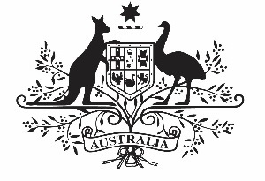

COMMONWEALTH OF AUSTRALIA

Environment Protection and Biodiversity Conservation Act 1999

APPROVAL OF THE NORTH MARINE PARKS NETWORK MANAGEMENT PLAN 2018

I, JOSH FRYDENBERG, Minister for the Environment and Energy, acting pursuant to section 370 of the Environment Protection and Biodiversity Conservation Act 1999, hereby approve the North Marine Parks Network Management Plan 2018.

Dated this ……......25............. day of ……………January…………., 2018

Josh Frydenberg
Minister for the Environment and Energy

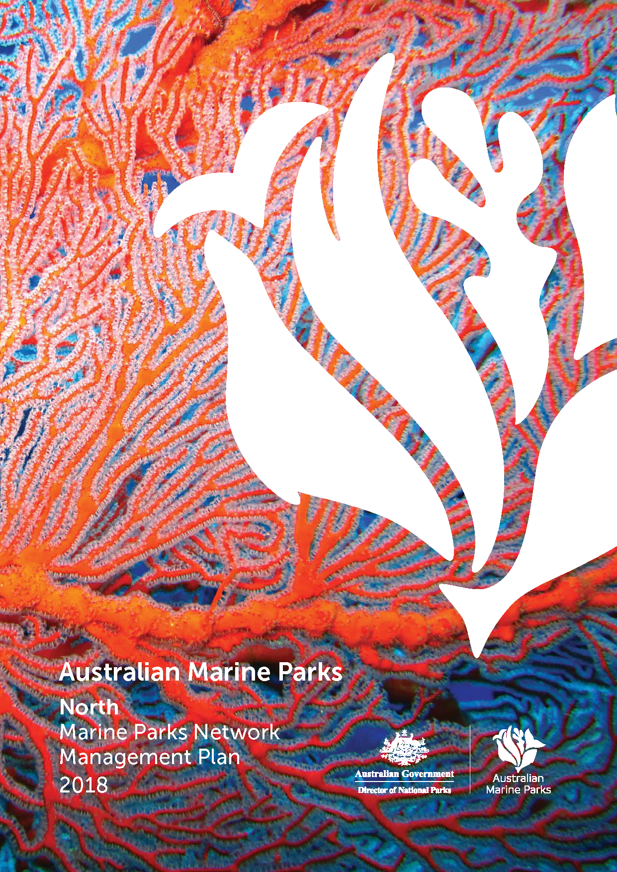
© Director of National Parks 2018
This document may be cited as:
Director of National Parks 2018, North Marine Parks Network Management Plan 2018, Director of National Parks, Canberra.
ISBN:
This management plan is copyright. Apart from any use permitted under the Copyright Act 1968, no part may be reproduced by any process without prior written permission from the Director of National Parks. Requests and enquires concerning reproduction and rights should be addressed to the:
Manager
North Marine Parks Network
203 Channel Highway
Hobart TAS 7050

Photography credits
Front cover
Gorgonian fan (Cathy Zwick)

Table of Contents
Chapter 1 Introduction 5
Part 1. Managing Australian Marine Parks 6
1.1 Introductory provisions 6
1.2 Australian Marine Parks 6
1.3 Australian Marine Parks vision and objectives 7
1.4 Management plan overview 7
1.5 Legislation and policy supporting marine park management 8
1.6 Approach to managing Australian Marine Parks 10
1.7 Ways of working 10
1.8 Partnerships 11
1.9 Management programs and actions 13
1.10 Zones 13
1.11 Implementation plans 14
1.12 Adaptive management 14
Part 2. The North Marine Parks Network 15
2.1 The North Marine Region 16
2.2 The North Marine Parks Network 18
2.3 Values of the North Network 20
2.4 Pressures in the North Network 24
2.5 Management programs and actions in the North Network 27
Chapter 2 Management and prescriptions 34
Part 3. Zoning 35
3.1 Zone categories, names and objectives 36
Part 4. Managing activities 39
4.1 Outline of Part 4 40
4.2 Rules for activities 40
4.2.1 General use, access, and waste management 42
4.2.2 Commercial shipping (other than commercial fishing and aquaculture vessels) 43
4.2.3 Commercial fishing 44
4.2.4 Commercial pearling 47
4.2.5 Commercial aquaculture 49
4.2.6 Commercial media 51
4.2.7 Commercial tourism (includes charter fishing tours, scuba diving, nature watching tours) 51
4.2.8 Recreational fishing 53
4.2.9 Mining operations (includes exploration) 54
4.2.10 Structures and works 57
4.2.11 Research and monitoring 59
4.2.12 National security and emergency response 61
4.2.13 New activities and authorisations 62
4.3 Making decisions about activities 62
4.3.1 Decision-making 62
4.3.2 Assessments under other processes 63
4.3.3 Review of decisions 63
4.4 Authorisation of allowable activities 64
4.4.1 Permits 64
4.4.2 Class approvals 65
4.4.3 Activity licences and leases 67
4.4.4 Publication of authorisations 67
Glossary 68
Schedule 1 Summary of legislative and policy contexts 74
S1.1 The EPBC Act and EPBC Regulations 74
S1.2 Other relevant legislation 81
S1.3 International agreements 82
Schedule 2 North Network overview and values 86
S2.1 North Network overview 87
S2.2 North Network values 88
Joseph Bonaparte Gulf Marine Park 89
Oceanic Shoals Marine Park 92
Arafura Marine Park 95
Arnhem Marine Park 98
Wessel Marine Park 100
Limmen Marine Park 103
Gulf of Carpentaria Marine Park 107
West Cape York Marine Park 110
Schedule 3 Environmental features used in the design of the North Network 113
Schedule 4 North Network marine parks and zone boundary descriptions 118
Part 1 — Joseph Bonaparte Gulf Marine Park 118
Part 2 — Oceanic Shoals Marine Park 120
Part 3 — Arafura Marine Park 126
Part 4 — Arnhem Marine Park 128
Part 5 — Wessel Marine Park 128
Part 6 — Limmen Marine Park 130
Part 7 — Gulf of Carpentaria Marine Park 130
Part 8 — West Cape York Marine Park 133
Schedule 5 Supporting information 137
Map data sources 138

Chapter 1
Introduction

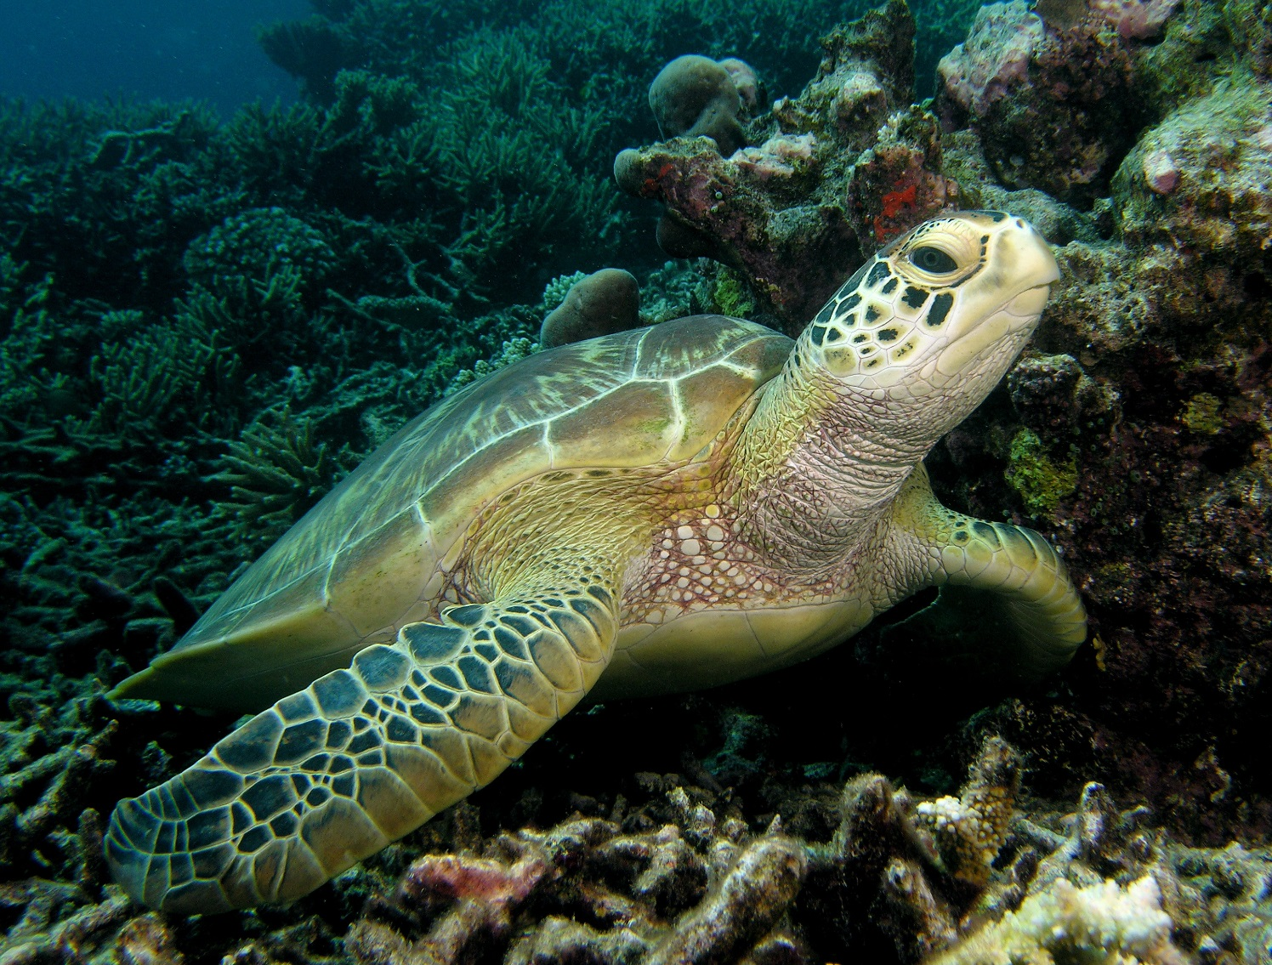
Green turtle on reef (David Harasti)

Managing Australian Marine Parks

Introductory provisions
Name
This management plan (plan) is the North Marine Parks Network Management Plan 2018.
Commencement
This plan commences on 1 July 2018.
Interpretation
The Glossary provides the meaning of certain words and expressions used, and includes references to certain words and expressions that are defined in the Environment Protection and Biodiversity Conservation Act 1999 (EPBC Act).
Authority
This plan is made under Section 370 of the EPBC Act. This plan replaces all previous approvals under s.359B of the EPBC Act that authorised a range of activities in the North Marine Parks Network in the period from proclamation of the Marine Parks to the commencement of this plan.

Australian Marine Parks
Australia is surrounded by ocean extending from the tropics to the sub-Antarctic, providing a home to a wealth of plants and animals, many of them found nowhere else in the world. Australia’s oceans help to support our way of life by providing beautiful places to enjoy, supporting businesses and jobs, and contributing to Australia’s food and energy needs.
Marine protected areas are recognised as one of the best ways to conserve and protect marine habitats and species in our oceans. In light of this, the Australian, state and territory governments agreed in 1998 to establish a National Representative System of Marine Protected Areas (NRSMPA). The NRSMPA was designed to create a comprehensive, adequate and representative (CAR) system of marine protected areas, to contribute to the long-term viability of the marine environment and protect biodiversity. To identify areas to protect in the NRSMPA, the Australian Government undertook scientific research and consolidated the best available information on the natural, social and economic characteristics of Australia’s marine environment.
On the basis of this work, in 2012, the Australian Government expanded the total coverage of Australia’s National Representative System of Marine Protected Areas to 3.3 million km². This included new marine parks in the North, North-west, South-west, and Temperate East marine regions, and in the Coral Sea. This is in addition to marine parks already established in the South-east Network, the Great Barrier Reef and at Heard and McDonald Islands.
Australian Marine Parks (Commonwealth reserves proclaimed under the EPBC Act in 2007 and 2013) are located in Commonwealth waters that start at the outer edge of state and territory waters, generally three nautical miles (approximately 5.5 km) from the shore, and extend to the outer boundary of Australia’s exclusive economic zone, 200 nautical miles (approximately 370 km) from the shore. Marine parks have also been established by state and territory governments in their respective waters under the NRSMPA. Many other countries have moved to establish marine protected areas in their waters and are implementing a range of legislative, policy and management tools to manage these important places.

Australian Marine Parks vision and objectives
Management of Australian Marine Parks requires a balance between protection of our marine environment and opportunities for sustainable use and enjoyment of these special places.
The vision of the Director of National Parks (the Director) is that marine parks are healthy, resilient and well-managed to enhance Australia’s wellbeing. This means ensuring that:
- their natural, cultural, socio-economic and heritage values are understood, appreciated and conserved;
- marine parks support jobs and businesses, providing multiple benefits to regional communities and the economy;
- people have opportunities to enjoy marine parks;
- visitors and tourists can enjoy world-class nature-based experiences in marine parks; and
- Indigenous people and marine park users are partners in managing marine parks.
The objectives of this plan are to provide for:
- the protection and conservation of biodiversity and other natural, cultural and heritage values of marine parks in the North Network; and
- ecologically sustainable use and enjoyment of the natural resources within marine parks in the North Network, where this is consistent with objective (a).

Management plan overview
This plan is structured into two chapters and five schedules (Table 1.1). Chapter 1 provides an introduction to how Australian Marine Parks are managed, and Chapter 2 provides for the management of the North Marine Parks Network (North Network).
Several inputs have contributed to the preparation of this plan, including:
- public consultation during the preparation of this plan;
- knowledge and expertise of marine park users and traditional owners;
- the independent Commonwealth marine reserves review (publicly released in 2016);
- the best available science and information on marine parks and approaches to marine park management, including insights from management of the South-east Network, the Great Barrier Reef Marine Park, and state and territory marine parks;
- the Integrated Marine and Coastal Regionalisation of Australia (IMCRA) framework;
- the Marine bioregional plan for the North Marine Region (2011);
- the North marine bioregional plan: bioregional profile (2008); and
- Government policies and commitment to competitive and sustainable fisheries.

Legislation and policy supporting marine park management
The EPBC Act is Australia’s primary environmental legislation. In recognition of the importance of the marine environment, it is listed as a matter of national environmental significance under the EPBC Act. Under the EPBC Act, the Director is responsible for managing marine parks (supported by Parks Australia), and is required to make management plans for marine parks. Other parts of the Australian Government must not perform functions or exercise powers in relation to these parks that are inconsistent with management plans (s.362 of the EPBC Act).
This plan complements a range of Commonwealth, state and territory laws, as well as international conventions and agreements that relate to protection of the marine environment (Schedule 1). Some of the ways in which the Australian Government protects the marine environment through national environmental law include management plans for Australian Marine Parks, marine bioregional plans for the Commonwealth marine environment, recovery plans for threatened species and threat abatement plans for key threats, such as invasive species and marine debris.
Other Australian, state and territory government agencies also have statutory roles in managing fisheries, tourism, oil and gas activities, shipping, maritime pollution and biosecurity threats.

Table 1.1 Structure of this plan
Chapter 1
Introduction
Part 1  Managing Australian Marine Parks | Outlines the context and approach to managing marine parks.
Part 2  The North Marine Parks Network | Provides a summary of the North Network including natural, cultural, heritage, social and economic values, the pressures facing the Network and the management actions to protect values and manage pressures.
Chapter 2
Management and prescriptions (the rules)
Part 3  Zoning | Explains the International Union for the Conservation of Nature (IUCN) categories assigned to each marine park and zone, and provides zone objectives.
Part 4  Managing activities | Provides the rules about what activities can and cannot occur within zones, and outlines the assessment and decision-making processes, and the types of authorisations (permits, class approvals, activity licences and leases).
Glossary | Lists terms and words used in this plan.
Schedules
Supporting information
Schedule 1  Summary of legislation and policy contexts | Includes the legislative and policy context for managing marine parks with respect to the EPBC Act and EPBC Regulations, and other relevant legislation and international agreements.
Schedule 2  North Network overview and values | Provides a summary of the marine parks as proclaimed, a description of values and a map for each park.
Schedule 3  Environmental features used in design of the North Network | Describes the environmental features used to identify areas for protection in the marine parks. These include provincial bioregions, depth ranges, seafloor features and key ecological features.
Schedule 4  North Network marine parks and zone boundary descriptions | Lists the coordinates of each marine park and zone.
Schedule 5  Supporting information | Lists references used in preparing this plan.

Approach to managing Australian Marine Parks
To achieve the best outcomes from Australian Marine Parks the different uses of parks must be balanced with protecting important habitats and features. This plan outlines the Director’s approach to managing Australian Marine Parks. This approach includes:
- A vision for Australian Marine Parks and management objectives.
- Partnerships with traditional owners, marine park users, stakeholders and governments to manage marine parks.
- Management programs and actions to protect the marine environment, improve scientific understanding, support tourism, improve awareness and appreciation of marine parks, work with Indigenous people to manage parks, assess and authorise activities, and ensure that people comply with the rules.
- Zones that set out what activities can be undertaken where and how.
- Outcome-based decision-making where each decision made balances enabling use with the need to protect natural, cultural and heritage values of marine parks.
- Implementation plans to support each management plan that set out the specific actions in the foundation phase (years 1–4), consolidation phase (years 5–8), and finalisation and review phase (years 9–10).
- Adaptive management including monitoring, evaluation and reporting to keep track of our progress and change our approach when necessary.

Ways of working
In managing Australian Marine Parks, the Director will seek to be:
- Respectful—of the traditional owners of the sea, marine park users, stakeholders and other government agencies.
- Collaborative—seeking to co-design management programs and systems wherever possible, and manage in consultation with marine park users.
- Balanced—focused on protecting natural, cultural and heritage values, while facilitating sustainable use and enjoyment of marine parks.
- Outcomes based—considering outcomes for natural, social-economic, cultural and heritage values of marine parks when making decisions about activities.
- Adaptive—encouraging innovation, accommodating new information about values, pressures and technologies, and allowing for continual improvement in management.
- Evidence and risk-based—using information to guide management and decision-making, including evidence gathered through monitoring, research, evaluation and reporting.
- Proactive—taking proactive action to protect marine parks from pressures, to minimise damage, and to improve resilience, wherever possible.
- Efficient and effective—minimising regulatory burden and costs on businesses and individuals, including by using assessment and approval mechanisms of other government agencies, while enforcing the rules established in this plan.

Partnerships
Effective management of Australian Marine Parks will be achieved by working with traditional owners, marine park users and stakeholders, and other government agencies through the following:
Partnerships with government agencies
The Director will build on existing partnerships with Commonwealth government agencies with critical roles in managing and understanding Australia’s marine environment, including the Australian Fisheries Management Authority, Australian Maritime Safety Authority, Defence, Geosciences Australia, Great Barrier Reef Marine Park Authority, Australian Border Force and the National Offshore Petroleum Safety and Environmental Management Authority. The Director will also build on partnerships with the Northern Territory and Western Australia fisheries and marine park agencies, and research institutions that provide support to the day-to-day management of the North Network marine parks, while ensuring a consistent approach to managing marine parks around Australia.
Network advisory committee
To support collaborative management and achieve the vision for marine parks, the Director intends to establish an advisory committee for the North Network. The Director will work closely with the advisory committee and stakeholders to develop and implement management programs and actions for the Network.
The role of the advisory committee will be to support and collaborate with the Director to manage marine parks by:
- helping to develop and deliver implementation plans, including assisting to prioritise management actions and develop performance measures;
- providing information about stakeholder and park user views, knowledge and needs; and
- contributing to the periodic evaluation and review of implementation plans.
Members will represent the broad range of marine park users, interests and knowledge about marine parks and may represent sectors such as commercial fishing, energy, Indigenous people, infrastructure, non-government organisations, recreational fishing, science, tourism, transport and the broader community. Membership and terms of reference for the committee will be developed in consultation with stakeholders as soon as practicable after the commencement of this plan.
Partnerships with traditional owners and Indigenous people
In implementing this plan, the Director acknowledges the national and international rights and cultural interests of Indigenous people and the deep understanding and experience that Indigenous people can contribute to the management of Australian Marine Parks. This includes international rights as detailed in the United Nations Declaration on the Rights of Indigenous People. The Director also acknowledges that Indigenous people have been sustainably using and managing their sea country, including areas now in marine parks, since time immemorial.
The Director is committed to working with Indigenous people to manage sea country within marine parks and will achieve this through the Indigenous engagement program (Section 2.5). This includes building partnerships with traditional owners and Indigenous people with responsibilities for sea country.
The Director also acknowledges that traditional owners are the primary source of information on the value of their heritage. For this reason, the Director will seek the active participation of Indigenous people in the identification and management of cultural values in marine parks.
To inform our approach to managing marine parks, the Director has worked with representatives from land councils, native title representative bodies and Indigenous ranger groups to develop a set of collaborative management principles (Table 1.2) to support Indigenous involvement in the management of Australian Marine Parks. These principles will inform the approach to implementing this plan, as well as the development and implementation of actions in each marine park (Part 2).
Table 1.2 Principles supporting Indigenous people to engage in management of Australian Marine Parks
Principle 1:
It is recognised that Indigenous people have been sustainably using and managing their sea country, including areas now included within Australian Marine Parks, for thousands of years—in some cases since before rising sea levels created these marine environments.
Principle 2:
Management of Australian Marine Parks should be undertaken on the basis that native title exists in sea country within Commonwealth waters.
Principle 3:
Indigenous people should be engaged in planning and managing Australian Marine Parks on the basis of their nationally and internationally recognised rights and cultural interests, not as a ‘stakeholder’ group.
Principle 4:
Maximise opportunities for Indigenous people to enjoy the management and use of their sea country.
Principle 5:
Maximise opportunities for the development of Indigenous livelihoods, consistent with national ‘closing the gap’ commitments.
Principle 6:
Governance and management activities within Australian Marine Parks should respect and complement local Indigenous governance arrangements, plans, capacities and activities.
Principle 7:
Indigenous engagement in managing Australian Marine Parks should be undertaken through good faith negotiations, seeking to build on the common ground that exists between Indigenous people and the Australian Government to protect and sustainably use Australia’s sea country environments and resources.
Principle 8:
Third party investment in management activities in Australian Marine Parks (e.g. through environmental offset investments) should include support for Indigenous people’s interests, capacity-building and development of livelihoods, consistent with all other principles outlined above; such third party investments must not impact on native title compensation negotiations or on the right to compensation.

Management programs and actions
The Director will implement management programs and actions to protect marine parks from threats and pressures, to minimise damage, and to rehabilitate and improve the resilience of marine parks. Management programs and actions may be adapted over the life of this plan, and include:
- Communication, education and awareness—actions that improve awareness, understanding and support for marine parks and park management.
- Tourism and visitor experience—actions that provide for and promote a range of environmentally appropriate, high-quality recreation and tourism experiences and contribute to Australia’s visitor economy.
- Indigenous engagement—actions that recognise and respect the ongoing cultural responsibilities of Indigenous people to care for sea country and support multiple benefits for traditional owners.
- Marine science—actions to provide necessary scientific knowledge and understanding of marine park values, pressures, and adequacy of responses for effective management.
- Assessments and authorisations—actions that provide for efficient, effective, transparent and accountable assessment, authorisation and monitoring processes to support sustainable use and protection of marine park values.
- Park protection and management—timely and appropriate preventative and restorative actions to protect natural, cultural and heritage values from impacts.
- Compliance—actions that ensure appropriate and high levels of compliance by marine parks users with the rules set out in this plan.
The specific actions that will be undertaken in each marine park will be determined in partnership with stakeholders and set out in implementation plans.

Zones
Zoning and related rules for managing activities are important tools for managing marine parks to ensure protection of marine habitats and species, while enabling use. Parts 3 and 4 of this plan set out the zones and rules for activities in the North Network.
In determining the zones and rules, the Director has considered the best available science, the advice of stakeholders, Indigenous people and the general public, the goals and principles of the NRSMPA and the Australian IUCN reserve management principles (Schedule 1). Zones established by this plan (Part 3) in marine parks in the North Network are summarised in Table 1.3.

Table 1.3 Summary of zones in the North Network
Special Purpose Zone (IUCN category VI)—managed to allow specific activities though special purpose management arrangements while conserving ecosystems, habitats and native species. The zone allows or prohibits specific activities.
Multiple Use Zone (IUCN category VI)—managed to allow ecologically sustainable use while conserving ecosystems, habitats and native species. The zone allows for a range of sustainable uses, including commercial fishing and mining where they are consistent with park values.
Habitat Protection Zone (IUCN category IV)—managed to allow activities that do not harm or cause destruction to seafloor habitats while conserving ecosystems, habitats and native species in as natural a state as possible.
National Park Zone (IUCN category II)—managed to protect and conserve ecosystems, habitats and native species in as natural a state as possible. The zone only allows non-extractive activities, unless authorised for research and monitoring.

Implementation plans
The Director will work closely with stakeholders and the advisory committee to develop detailed implementation plans. Three stages of implementation plans will be developed to set out the management actions that will occur in the North Network and identify performance indicators.
- Implementation plan 1—Foundation (years 1–4). To be developed in the first year and include foundational management actions and development of robust natural, social and economic baselines.
- Implementation plan 2—Consolidation (years 5–8). To be developed following a review of the first implementation plan, and considering lessons learnt. To continue any ongoing foundational management actions.
- Implementation plan 3—Finalisation and review (years 9–10). To set out arrangements to review the lessons learnt from implementing the management plan over the first eight years, and inform the development of the next management plan for the North Network.

Adaptive management
Regular monitoring, evaluation, reporting and review of the implementation of this plan will be essential to achieve the vision for Australian Marine Parks and the objectives for this plan. The Director will undertake periodic monitoring, evaluation, review and reporting on the implementation of this plan to:
- evaluate the effectiveness of this plan in achieving its objectives;
- track progress in meeting performance indicators identified in implementation plans;
- review the effectiveness of zoning and other management arrangements to protect and conserve marine park values;
- identify changes in management context and priorities;
- consider the adequacy of knowledge of marine park values, uses, pressures, social and economic benefits and impacts;
- consider the effectiveness of monitoring and evaluation, and the appropriateness of key indicators and performance measures;
- identify and prioritise future management actions;
- provide information to enable adaptive management; and
- inform the development of a new management plan for the North Network at the conclusion of this plan.

