The North Marine Parks Network

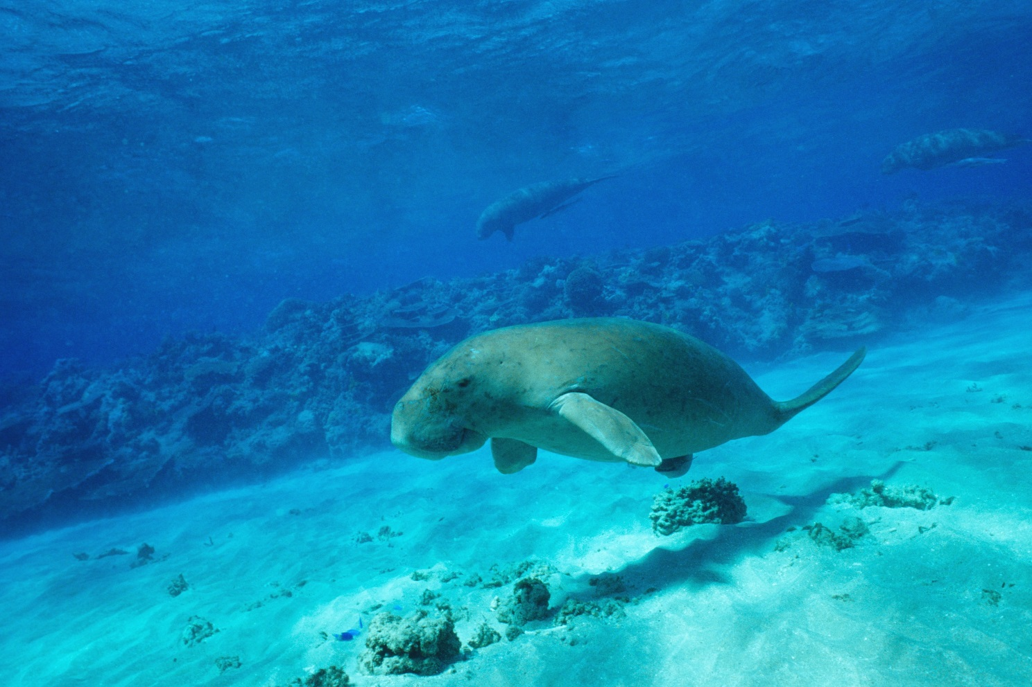
Dugong (Doug Perrine)

The North Marine Region
The North Marine Region (region) extends from the west Cape York Peninsula to the Northern Territory–Western Australia border. The region covers approximately 625,689 km² of tropical waters of the Gulf of Carpentaria and Arafura and Timor Seas (Figure 2.1).
Traditional owners have managed and used sea country within the region for tens of thousands of years. They use and actively manage the coastal and marine environments of the region as a resource and to maintain cultural identity, health and wellbeing. Fishing, hunting and the maintenance of culture and heritage through ritual, stories and traditional knowledge continue as important uses of nearshore and adjacent areas.
The region is popular for activities such as fishing, snorkelling, diving and boating. Tourism operators offer unique experiences for visitors to enjoy the offshore reefs, islands and deep water environments. Although many of the marine parks are remote and far offshore, opportunities exist for recreational use, particularly around offshore reefs.
There are significant industries in the region, including commercial fishing, mining and shipping that contribute to economic growth, employment and social wellbeing in adjacent towns and communities. Activities and businesses that support these industries such as marine industry suppliers and repair yards are also important sources of employment for coastal communities.
The marine environment of the region is characterised by shallow-water tropical marine ecosystems and a large area of continental shelf. Habitats include coral reefs, soft sediments, shelf, canyons and limestone pinnacles. The region is subject to extreme tidal regimes, monsoonal climatic patterns and a high incidence of cyclones. It is influenced by currents driven largely by strong winds and tides, with only minor influences from oceanographic currents.
The region has high species diversity and globally significant populations of internationally threatened species. Coral-reef systems of the region support some endemic species, but flora and fauna are generally typical of the Indo-West Pacific. Coral, invertebrates and phytoplankton are all highly diverse, and fish such as snapper, emperor and grouper are common higher-order predators of coral and rocky reef habitats. The region supports biologically important areas for a range of spectacular and unique species—seabirds, sharks, dolphins, and dugong (Dugong dugon). Six of the world’s seven species of marine turtle are known to occur in the region. Other species known to occur in the region include species of sawfish, sea snake, saltwater crocodile, seahorse and pipefish.
Further information about the region can be found in the Marine bioregional plan for the North Marine Region (2012) and the North marine bioregional plan: bioregional profile (2008) (available on the Department’s website), and the marine park values in Section 2.3 (Values of the North Network) and Schedule 2 of this plan.
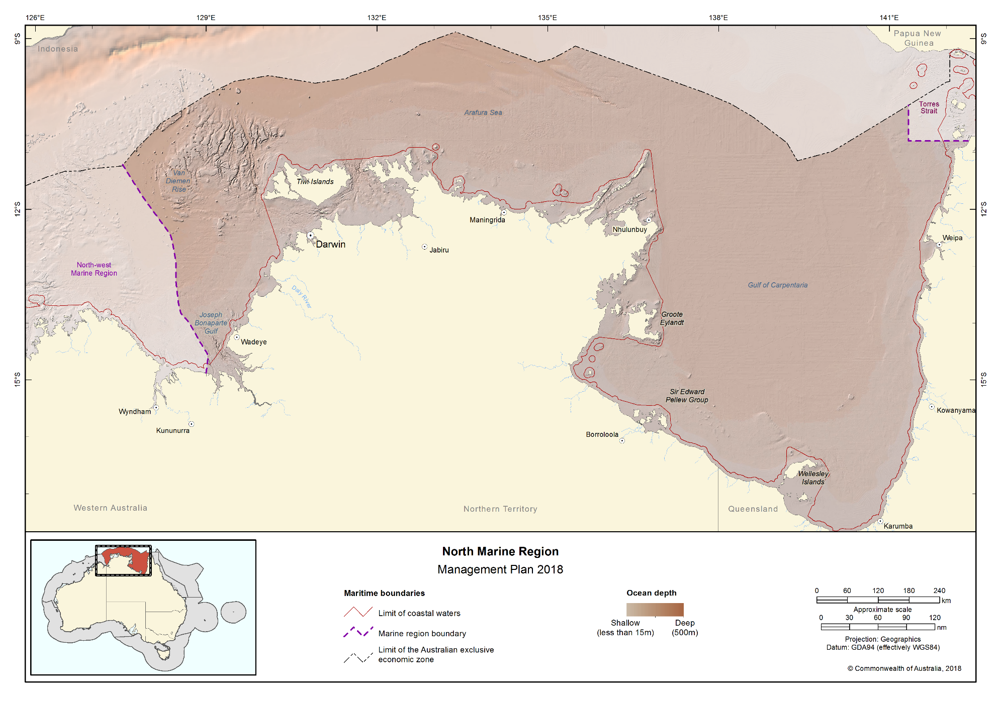Figure 2.1 North Marine Region

The North Marine Parks Network
The North Network (Figure 2.2) covers 157,480 km² and includes eight marine parks. An overview of the marine parks and their values is provided in Schedule 2.
The North Network comprises the following marine parks:
- Joseph Bonaparte Gulf Marine Park
- Oceanic Shoals Marine Park
- Arafura Marine Park
- Arnhem Marine Park
- Wessel Marine Park
- Limmen Marine Park
- Gulf of Carpentaria Marine Park
- West Cape York Marine Park
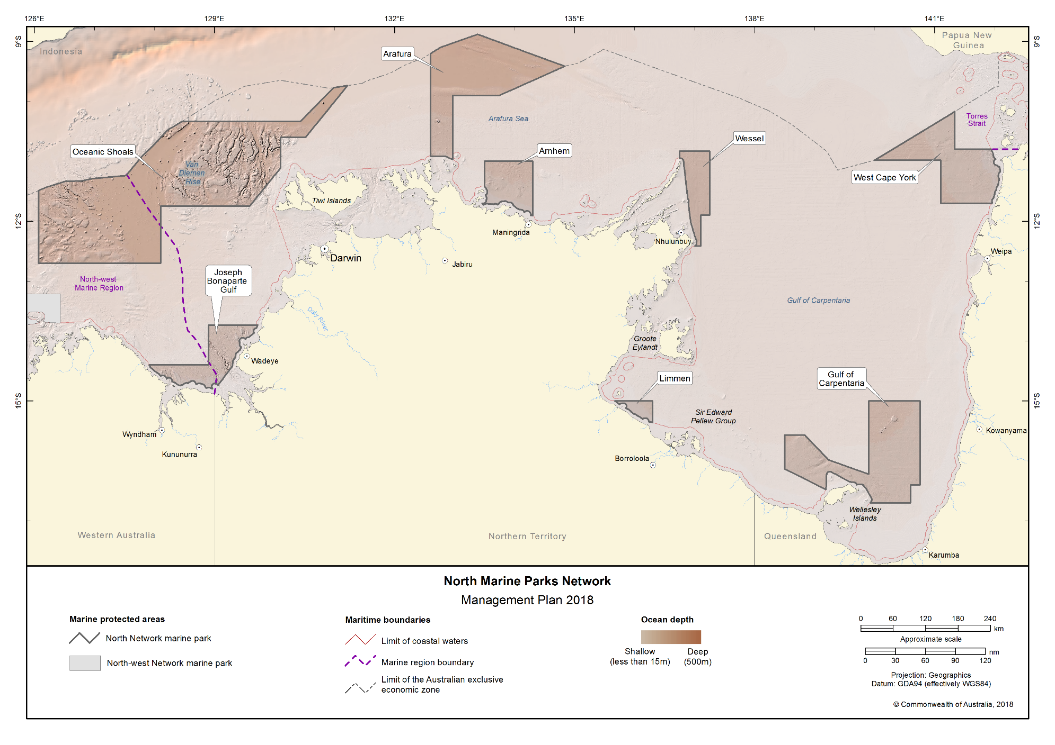Figure 2.2 North Marine Parks Network

Values of the North Network
Values are broadly defined as:
- Natural values—habitats, species and ecological communities within marine parks, and the processes that support their connectivity, productivity and function.
- Cultural values—living and cultural heritage recognising Indigenous beliefs, practices and obligations for country, places of cultural significance and cultural heritage sites.
- Heritage values—non-Indigenous heritage that has aesthetic, historic, scientific or social significance.
- Socio-economic values—the benefit of marine parks for people, businesses and the economy.
A summary of the values of the North Network is provided in Table 2.1. The values of individual marine parks are set out in Schedule 2. As outlined in Part 1, in managing marine parks, the Director will need to make decisions about what activities can occur in the marine parks and what actions to take to manage them. This will involve the Director making decisions that carefully balance the need to protect natural, cultural, heritage and socio-economic values of marine parks with enabling use and managing pressures.
In making these decisions, the Director will carefully consider the impacts and risks to natural, cultural, heritage or socio-economic values for the relevant marine park/s. The Director will also consider any positive impacts associated with allowing an activity, such as socio-economic or cultural benefits, and ensure that activities are undertaken in a manner that minimises negative impacts.
In marine parks where there is limited information, environmental features are used as indicators for the types of species and habitats likely to occur. These include bioregions, water depth, seafloor features and key ecological features (Schedule 3).
As understanding of marine park values improves over the life of this plan, the Director will make new information about values available on the Parks Australia website. Other important sources of information on values (also on the Department’s website) include:
- Species profile and threats database for protected species;
- Directory of important wetlands in Australia;
- Australian heritage database for natural, historic and Indigenous heritage places;
- Australian national shipwreck database for known shipwrecks;
- National Conservation Values Atlas;
- Marine bioregional plan for the North Marine Region (2012); and
- North marine bioregional plan: bioregional profile (2008).

Table 2.1 Summary of values in the North Network
Statement of significance
The North Network was designed to protect representative examples of the region’s ecosystems and biodiversity in accordance with the Goals and principles for the establishment of the National Representative System of Marine Protected Areas in Commonwealth waters (ANZECC, 1998).
Natural values
Bioregions—the North Marine Region is divided into areas of ocean with broadly similar characteristics based on the distribution of marine species and seafloor features. The Network represents examples of the region’s marine environments including ecosystems, species and habitats. There are four bioregions represented in the North Network (Schedule 2).
Key ecological features—elements of the marine environment considered to be of importance for biodiversity or ecosystem function and integrity, represented in the Network are:
- Carbonate banks and terrace system of the Sahul Shelf;
- Pinnacles of the Bonaparte Basin;
- Carbonate bank and terrace system of the Van Diemen Rise;
- Shelf break and slope of the Arafura Shelf;
- Tributary canyons of the Arafura;
- Gulf of Carpentaria basin;
- Plateaux and saddle north-west of the Wellesley Islands; and
- Submerged coral reefs of the Gulf of Carpentaria coastal zone.
Species and habitats—all species and habitats are important components of the ecosystems represented in the North Network. Many species are protected under the EPBC Act and international agreements such as the Convention on the Conservation of Migratory Species (CMS or Bonn Convention), the Japan–Australia Migratory Bird Agreement (JAMBA), the China–Australia Migratory Bird Agreement (CAMBA), and the Republic of Korea–Australia Migratory Bird Agreement (ROKAMBA). Further information on these agreements is in Schedule 1.
The North Network supports important habitats, including biologically important areas, for a range of protected species. Biologically important areas are where aggregations of individuals of a protected species breed, forage or rest during migration. More information on protected species and biologically important areas can be found in the Marine bioregional plan for the North Marine Region (2012) and the conservation values atlas on the Department’s website.
Cultural values
Aboriginal people and Torres Strait Islanders have been sustainably using and managing their sea country for tens of thousands of years, in some cases since before rising sea levels created these marine environments. Sea country refers to the areas of the sea that Aboriginal and Torres Strait people are particularly affiliated with through their traditional lore and customs. Sea country is valued for Indigenous cultural identity, health and wellbeing.
Aboriginal and Torres Strait Islander people continue to assert inherited rights and responsibilities over sea country within the North Network. It is recognised that sea country extends from terrestrial areas into nearshore and offshore waters; and that songlines traverse sea country. Sacred sites are also located in marine parks in the North Network and marine animals are recognised for their spiritual values, and their importance for the health and wellbeing of communities.
Within the North Network, Aboriginal and Torres Strait Islander people continue to actively manage sea country. Many groups have prepared sea country management plans and undertake work to protect and monitor the health of culturally significant and threatened species like marine turtles. Some groups have dedicated Indigenous Protected Areas (IPAs) over sea country, and more groups are in the process of establishing IPAs over their sea country. IPAs overlap the Wessel and Gulf of Carpentaria Marine Parks.
In the Torres Strait, in recognition of the cultural value of dugong, a dugong sanctuary has been voluntarily established under the Torres Strait Fisheries Act 1984. This sanctuary extends over much of the West Cape York Marine Park. This sanctuary bans harvest of dugong by Torres Strait Islanders in an area where they are known to be abundant.
Native title determinations have also been made over sea country within the North Network. Such declarations have recognised native title exists over waters within the Arafura and the Gulf of Carpentaria Marine Parks. These native title determinations recognise in law the continuing rights of these groups for sea country in these marine parks.
Figure 2.3 shows the Indigenous Protected Areas and Dugong Sanctuary established in or near the North Network.
Heritage values
Protected places (world, national and Commonwealth heritage, historic shipwrecks)
The EPBC Act protects matters of national environmental significance that are classified as protected places, including world heritage properties and national heritage places. Places on the Commonwealth Heritage List or shipwrecks listed under the Historic Shipwrecks Act 1976 are also protected places.
Historic shipwrecks are a unique historic value and the region is an area of considerable importance in Australia’s maritime history. There are approximately 500 known historic shipwrecks in and adjacent to the region; five are in the North Network: A.D.C (1886), Ada (1886), Douglas Mawson (1923), Mystery (1902) and Wild Duck (1876).
More information on located wrecks and shipwrecks historically reported as lost can be found in the Australian national shipwrecks database.
Social and economic values
The North Network supports a range of important social and economic uses that underpin the prosperity and wellbeing of regional communities (Figure 2.4).
Shipping, port-related activities, commercial fishing and aquaculture are industries of national economic significance. The Network also provides some opportunity for offshore mining operations.
Marine tourism such as charter fishing, snorkelling, diving and wildlife watching are also important commercial activities that offer unique visitor experiences on reefs, islands and in deep water environments. The Network also supports a range of recreational activities including fishing.
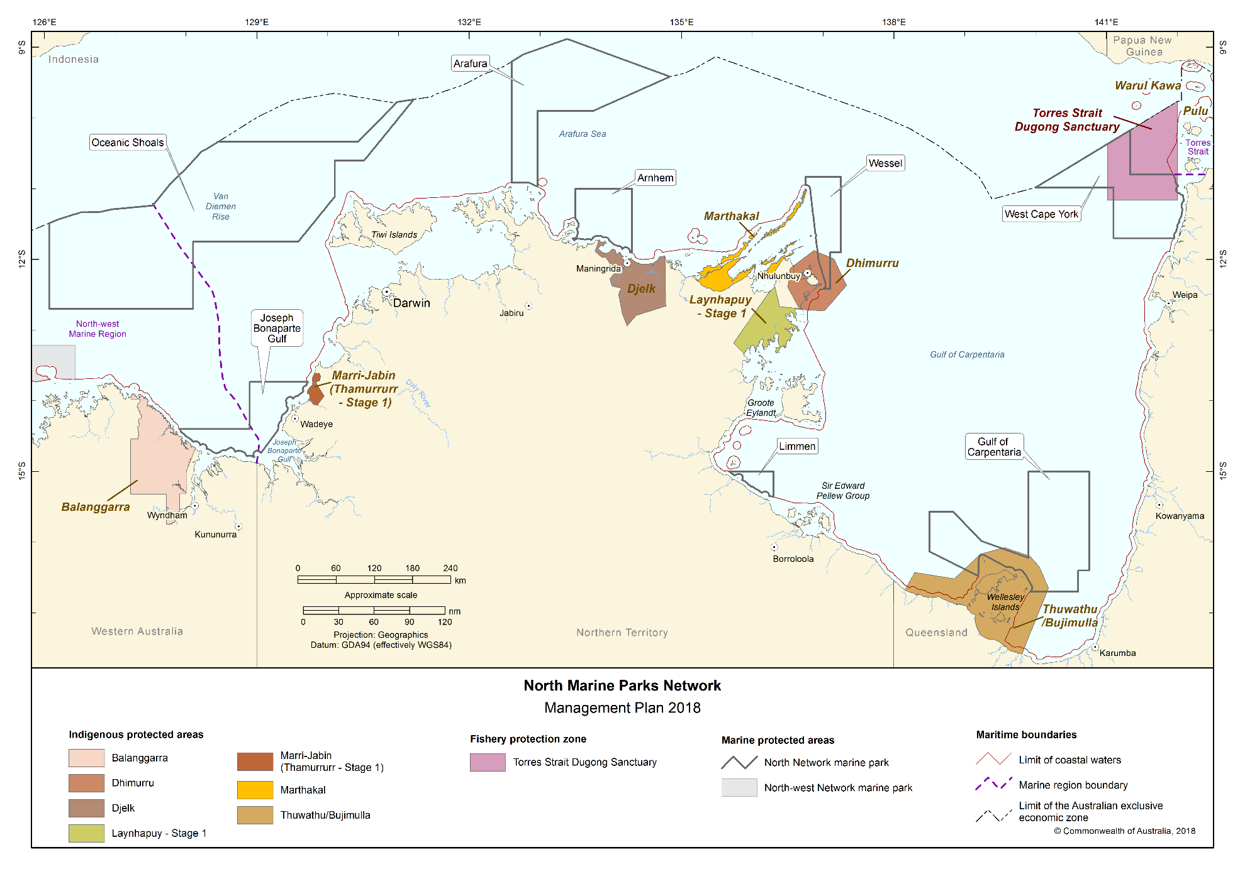
Figure 2.3 Indigenous Protected Areas and Dugong Sanctuary established in or near the North Network

Pressures in the North Network
Pressures are human-driven processes, events and activities that, if left unchecked, may impact on marine park values. Contemporary drivers of environmental change in the marine environment include population growth and economic activity, and related pressures such as increased vessel activity, marine debris, climate extremes, and ocean warming. Figure 2.4 shows the types of uses occurring across the North Network. These present key challenges for biodiversity conservation and sustainable management of our marine resources.
Australia’s 2016 State of the environment report reviewed pressures on Australia’s marine environment and determined that they were low by global standards. However, given that more than 85 per cent of Australians live within 50 km of the sea, and with Australia’s population of approximately 24.4 million projected to grow to 39.7 million by 2055, pressures on the marine environment are likely to increase.
Although pressures on marine ecosystems and biodiversity in the North Network may change over time, examples of pressures in the Network are outlined in Table 2.2. Research in the Great Barrier Reef Marine Park and elsewhere in the world has demonstrated that effective management of marine parks, helps to maintain the resilience of marine ecosystems and their ability to withstand and recover from such pressures.
In determining the management actions to be taken in the North Network and in making decisions about the activities that will be allowed to occur within marine parks, the Director will carefully consider how the values outlined in Section 2.3 and in Schedule 2 will be impacted by these pressures now and in the future.
Pressures such the extraction of living resources by fishing, and habitat modification through installation of infrastructure and anchoring will be managed in part through the zones and rules set out in Parts 3 and 4 of this plan.
Table 2.2 Summary of pressures in the North Network
Climate change
The impacts of climate change on the marine environment are complex and may include changes in sea temperature, sea level, ocean acidification, sea currents, increased storm frequency and intensity, species range extensions or local extinctions, all of which have the potential to impact on marine park values. The International Panel on Climate Change recognises climate change as a major contributor to Australian marine ecosystem changes since 2007. Examples of habitats, key ecological features, and species vulnerable to the effects of climate change include the submerged coral reefs of the Gulf of Carpentaria and pinnacles of the Bonaparte Basin, and species of sawfish, shark, dolphin, seabird, marine turtle and dugong.
Changes in hydrology
Rivers, estuaries and other waterways have the potential to discharge increased sediment loads and pollutants into the marine environment from activities such as coastal development and agriculture. This can result in increased turbidity and siltation, impacting on species that inhabit or spawn in coastal, estuary and offshore waters. Examples of habitats and species vulnerable to changes in hydrology include reef and seagrass habitats, the Gulf of Carpentaria coastal zone, and species of sawfish, shark and dugong.
Extraction of living resources
Australia’s world class fisheries management, led by Commonwealth, state and territory governments is important for ensuring sustainable fishing practices. Fishing, including illegal, unregulated and unreported fishing (including illegal foreign fishing), can modify natural populations of target species. Bycatch of non-target species and/or physical disturbance to habitats can result from certain fishing methods, and may therefore impact on marine park values. Examples of habitats, key ecological features and species vulnerable to such impacts include reef and shoal habitats, the pinnacles of the Bonaparte Basin, and species of shark, sawfish, dolphin, marine turtle, sea snake, fish and dugong.
Habitat modification
Commonwealth, state and territory governments play an important role in managing activities in the marine environment. For example, the National Offshore Petroleum Safety and Environmental Management Authority (NOPSEMA) works with the mining industry to ensure their environment plans address environmental management issues. Impacts on habitat in marine parks can occur directly through physical disturbance or indirectly through the presence of infrastructure. For example, benthic communities are vulnerable to the discharge of sediments which can result in localised smothering of benthic biota and or reduction in the quality and quantity of light received at the seabed. In addition, modification of natural light through the installation of lighting associated with infrastructure can cause changes in animal behaviour. Examples of habitats and species vulnerable to habitat modification pressures include reef, shoal and pinnacle habitats, the tributary canyons of the Arafura Depression and Gulf of Carpentaria coastal zone, and species of marine turtle, fish, sea snake, dolphin and dugong.
Human presence
Activities such as wildlife watching are a drawcard for people visiting marine parks. While enjoying the wildlife experience, it is important to be aware of the potential impacts of human presence on the natural behaviour of wildlife. Activities such as boating, camping, diving and snorkelling have the potential to impact marine park values directly through contact from collision or indirectly through changes in behaviour from disturbance. These activities may result in changes to wildlife behaviour such as nesting, breeding, feeding or resting, or may damage fragile marine environments e.g. reefs. Examples of habitats and species vulnerable to human disturbance include reef habitats, marine turtles and seabirds.
Invasive species
Invasive species have the potential to impact on park values directly and indirectly. Potential sources of invasive species include vessel ballast and bilge water discharge, vessel biofouling, accidental or deliberate transport of species, and land-based activities. Islands, reefs and other shallow-water ecosystems and native species are vulnerable to invasive species, with direct impacts from predation or damage to important habitat e.g. nesting habitat, and indirect impacts from competition with native species for habitat and food. Examples of habitats, key ecological features, and species vulnerable to the impacts of invasive species include reef habitats and species of nesting marine turtle, seabird and saltwater crocodile.
Marine pollution
Marine and land-based activities have potential to result in marine pollution which may impact on marine park values. Pollution includes the emission of noise or light, marine debris (for example, plastics and lost fishing gear), and discharge of oil, chemicals or waste. Pollution can be detrimental to marine life, causing contamination of ecosystems, entanglement, or can be ingested by marine species. Examples of habitats, key ecological features and species vulnerable to marine pollution include islands, reefs and other shallow-water habitats, the Gulf of Carpentaria basin, the plateaux and saddle north-west of the Wellesley Islands, and species of dolphin, whale, marine turtle, sawfish, shark, seabird and dugong.
Further information on pressures in the region is provided in the Marine bioregional pan for the North Marine Region (2012).
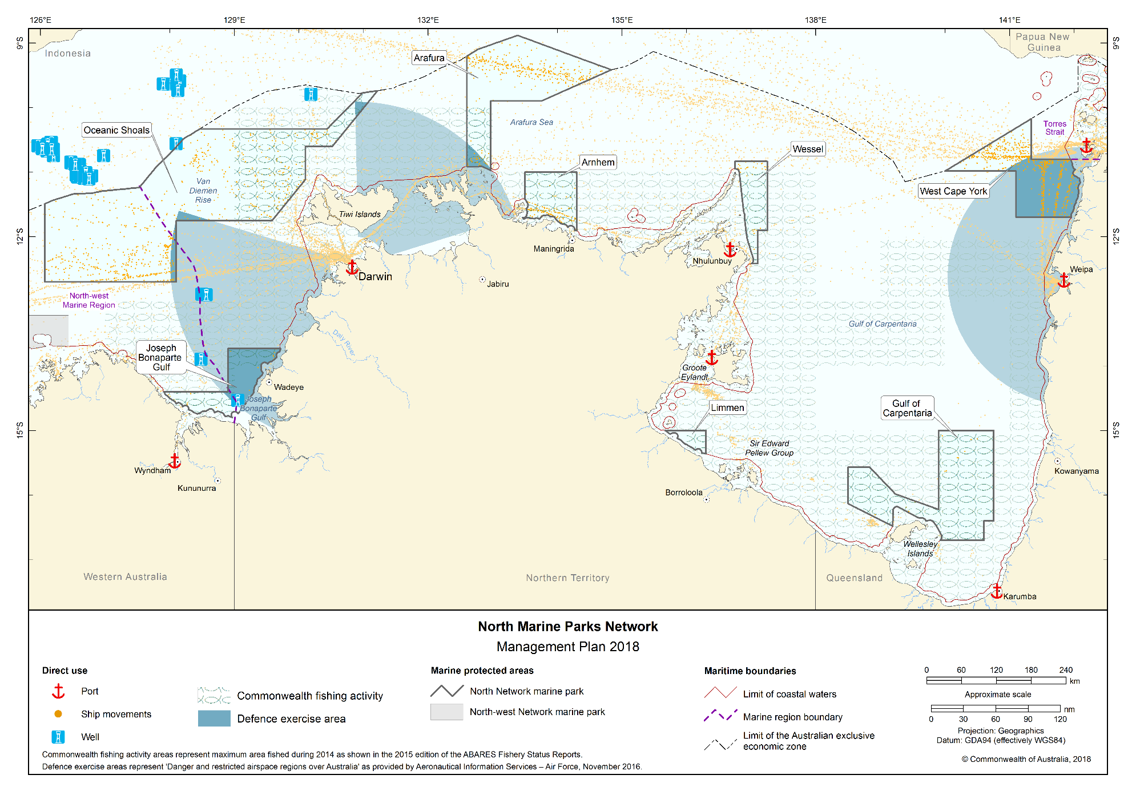Figure 2.4 Direct use in the North Network

Management programs and actions in the North Network
As outlined in Part 1, the Director will proactively implement management programs and actions to protect marine parks from threats and pressures, to minimise damage, and to rehabilitate and improve the resilience of marine parks.
These management programs and actions will be implemented on a national scale across all Australian Marine Parks. In addition, specific actions will be undertaken in the North Network. Table 2.3 outlines the management programs and actions likely to be undertaken in the North Network. These programs and actions may change during the life of this plan as new information and approaches become available. Additional actions will be developed in partnership with stakeholders through a network advisory committee and in implementation plans.
Table 2.3 Management programs, outcomes and actions in the North Network
Communication, education and awareness program
Actions to improve awareness, understanding and support for marine parks and park management.
Outcome
- Increased awareness, understanding and support for marine parks.
Actions—the Director will
under a national program:
- develop a marketing and communication strategy for Australian Marine Parks to raise awareness and understanding of marine park values and the contribution marine parks make to enhancing Australia’s wellbeing,
- develop online information resources to facilitate awareness of marine park values, management arrangements and visitor opportunities,
- maximise the use of new technologies and partnerships (including with schools, universities, museums and non-government organisations) to inspire people of all ages to become involved in marine park management and protection,
- establish network advisory committees to ensure users and interested stakeholders have on-going input to the management of Australian Marine Parks, and
- develop a customer focussed approach to tracking the aspirations and concerns of stakeholders in relation to marine parks.
in the North Network:
- develop information on marine parks in the Network to encourage increased awareness and understanding of their values and management arrangements,
- provide infrastructure in and adjacent to the Network, such as signs and marker buoys, to increase understanding of marine park values and rules, particularly at sites that are regularly visited, and
- establish a North Network advisory committee to support and collaborate with the Director in management.

Tourism and visitor experience program
Actions to provide for and promote a range of environmentally appropriate, high-quality recreation and tourism experiences and contribute to Australia’s visitor economy.
Outcomes
- High-quality visitor experiences that are appealing, engaging and raise awareness of the natural and cultural values of marine parks.
- Increased visitation to marine parks.
- Social and economic benefits from the contribution of marine parks to Australia's visitor economy.
Actions—the Director will
under a national program:
- develop a sustainable tourism and visitor experience strategy for Australian Marine Parks,
- work with national, state and local tourism authorities and operators to maximise the value of a sustainable ecotourism opportunities associated with marine parks,
- develop a commercial tourism authorisation system to encourage best-practice and eco-accredited businesses operating in Australian Marine Parks,
- work with Tourism Australia and state and regional tourism authorities and the fishing industry to market and promote Australian Marine Parks, including opportunities to promote locally caught and sustainably caught seafood,
- promote culturally sensitive tourism by encouraging tourism operators to liaise with traditional owners, and
- work with tourism operators and Indigenous people to recognise and promote cultural values and cultural tourism opportunities,
- monitor visitor trends and levels of satisfaction with marine park experiences and products.
in the North Network:
- promote visitor experiences that foster curiosity and appreciation of natural and heritage values in the Network,
- work with other Commonwealth, state and territory government agencies, and the tourism industry to support tourism initiatives, events and attractions that promote visitor experiences in marine parks, and
- facilitate partnerships between Indigenous people and tourism operators.

Indigenous engagement program
Actions to recognise and respect the ongoing cultural responsibilities of Indigenous people to care for sea country and support multiple benefits for traditional owners.
Outcomes
- Social, cultural and economic benefits for traditional owners.
- Partnerships with traditional owners and Indigenous groups to manage sea country in marine parks.
Actions—the Director will
under a national program:
- develop an Australian Marine Parks Indigenous engagement and cultural heritage strategy, to improve understanding of cultural heritage, link management with sea country plans and maximise employment and enterprise opportunities for traditional owners,
- develop agreements to support Indigenous ranger programs to deliver management in marine parks, and
- provide information to Indigenous people about marine park management.
in the North Network:
- collaborate with traditional owners and Indigenous ranger groups and relevant partners to undertake marine park management such as surveillance, monitoring and threat mitigation including marine debris removal, and implement actions identified in sea country plans where applicable,
- ,identify opportunities and mechanisms to engage traditional owners and Indigenous rangers in the management of marine parks,
- increase understanding of traditional knowledge, map cultural values and manage significant sites,
- implement cultural awareness training for Parks Australia staff in association with traditional owners, and
- establish protocols for researchers working with Parks Australia to guide engagement with traditional owners.

Marine science program
Actions to provide necessary scientific knowledge and understanding of marine park values, pressures and adequacy of responses for effective management.
Outcomes
- Increase understanding of marine park values, pressures and adequacy of responses.
- Improve understanding of the effectiveness of marine park management in protecting park values.
- Informed decision-making and improved evidence-based decisions.
Actions—the Director will
under a national program:
- establish ecological, social and economic baselines to support evidence-based decision-making and adaptive management,
- develop an Australian Marine Parks science strategy to prioritise and encourage research and monitoring of park values, pressures and management effectiveness, and foster science communication and knowledge uptake,
- encourage and facilitate knowledge brokering to support collaboration and partnerships with the science community, private enterprise, citizen science organisations and other Commonwealth, state and territory agencies,
- establish an authorisation system for scientific research and monitoring by third parties, and encourage data to be made publicly available through appropriate information portals such as the Australian Ocean Data Network,
- collaborate with the science community (including through the National Marine Science Committee and the National Environmental Science Program) and other marine park users to assist in improving the understanding of marine park values, pressures and management effectiveness, and
- collaborate with the science community and other government agencies to increase the use of innovative and effective technology and systems including sensor technology.
in the North Network:
- monitor social and economic uses and their benefits and impacts on marine parks.
- monitor the condition of important habitats such as reef systems and their vulnerability to climate change,
- monitor the impact of invasive species on marine park values and the effectiveness of management,
- collaborate with other Commonwealth, state and territory government agencies, marine park users and the science sector to support long-term monitoring. For example, monitoring of coral reefs, protected species and the effects of fishing on marine parks, and
- investigate opportunities to extend citizen science programs.
Assessments and authorisations program
Actions to provide for efficient, effective, transparent and accountable assessment, authorisation and monitoring processes to enable sustainable use and protection of marine park values.
Outcome
- Assessments and authorisations ensure ongoing protection of marine park values through the management of activities in marine parks.
Actions—the Director will
under a national program:
- develop and apply best-practice approaches to regulation and decision-making in the authorisation of activities within marine parks. This includes developing policy to ensure assessment and authorisation requirements are clearly articulated and that decision making is robust, consistently applied, and transparent to all marine park users,
- collaborate with industry to investigate innovative technologies and systems (including vessel monitoring systems) that can assist businesses and individuals to comply with regulatory requirements,
- develop an effective and efficient process to assess new technologies and gear types to allow for the use of new equipment during the life of this plan if appropriate,
- develop a guarantee of service for the regulated community that includes a commitment to work with key marine park users and interest groups whose interests are likely to be affected by regulatory decisions, and
- develop a customer focused online authorisation system for marine park users that includes publishing authorisations issued by Parks Australia on its website.
in the North Network:
- issue authorisations—a permit, class approval, activity licence or lease—for activities in marine parks assessed as acceptable either by the Director or another government or industry policy, plan or program accepted by the Director, and
- work with other Commonwealth, state and territory government agencies to improve experiences and consistency of approaches for people seeking authorisations.

Park protection and management program
Timely and appropriate preventative and restorative actions to protect natural, cultural and heritage values from impacts.
Outcome
- Impact of pressures on marine park values are minimised as far as reasonably practicable.
Actions—the Director will
under a national program:
- apply a risk-based assessment process to prioritise park protection and management actions,
- develop an Australian Marine Parks critical incident strategy in collaboration with the Australian Maritime Safety Authority and other responsible agencies to respond to critical incidents,
- develop a mooring and anchoring strategy to protect marine park values and improve visitor experience,
- support the removal of marine debris and ghost nets from marine parks through partnerships with Commonwealth, state and territory government agencies and other organisations involved in the management of marine debris, and
- contribute to actions, where appropriate, that support Australia's obligations under international agreements and national environmental law. This includes the World Heritage Convention, Ramsar Convention, recovery plans, wildlife conservation plans and threat abatement plans.
in the North Network:
- enable infrastructure such as moorings to protect habitats and enhance visitor safety,
- collaborate with and support other agencies that undertake invasive and protected species management and marine debris removal. For example, biosecurity assessments, research, or removal of ghost nets,
- work with other Commonwealth, state and territory government agencies to respond to environmental incidents and accidents, and
- collaborate with traditional owners and Indigenous ranger groups to undertake management actions.

Compliance program
Actions to support appropriate and high level compliance by marine park users with the rules set out in this plan.
Outcomes
- Improved user awareness of marine park rules.
- Increased levels of voluntary compliance and self-regulation by marine park users.
- High overall levels of compliance with the rules by marine park users.
- A decrease in the number of non-compliances.
Actions—the Director will
under a national program:
- apply a risk-based approach to compliance planning, targeted enforcement and compliance auditing,
- collaborate with Australian, state and territory government agencies by sharing assets and information,
- investigate the use of new technologies and warning systems to assist in the detection of potential illegal activities, and
- work with marine park users to promote understanding of the rules for activities and how to comply.
in the North Network:
- work with other Commonwealth, state and territory government agencies, particularly where parks adjoin state or territory marine parks, in compliance planning, including implementing actions to deter illegal activities and encourage voluntary compliance, and
- collaborate with Commonwealth, state and territory government agencies in surveillance, including water and aerial patrols.

