Glossary
action | Has the meaning given by Subdivision A of Division 1 of Part 23 of the EPBC Act.
artificial reef | Has the meaning given by the Environment Protection (Sea Dumping) Act 1981, namely, a structure or formation placed on the seabed:  (a) for the purpose of increasing or concentrating populations of marine plants and animals; or  (b) for the purpose of being used in human recreational activities.
Australian Government or the Government | The Government of the Commonwealth of Australia.
Australian Marine Parks or Marine Park | Commonwealth reserves, named as Marine Parks, comprising the South-west, North-west, North and Temperate East Networks of Marine Parks and the Coral Sea Marine Park declared by the Environment Protection and Biodiversity Conservation (Commonwealth Marine Reserves) Proclamation 2013, and the reserves comprising the South-east Commonwealth Network of Marine Parks declared by the Proclamations made under the EPBC Act on 28 June 2007.
authorisation | As described in Section 4.4 (Authorisation of activities) of this plan.
biodiversity or biological diversity | Has the meaning given by s.528 of the EPBC Act.
biologically important areas | Areas where a protected species displays a biologically important behaviour such as breeding, foraging, resting or migration. These areas serve to highlight the parts of a marine region that are particularly important for the conservation of protected species.
bioregion | A large area that has similar types of plants, animals and ocean conditions compared with other similarly sized areas, and, in this document, those bioregions as defined in the Integrated Marine and Coastal Regionalisation of Australia Version 4.0.
bioregional plan | Has the meaning given by s.528 of the EPBC Act.
CAR | Comprehensiveness—includes the full range of ecosystems recognised at an appropriate scale within and across each bioregion;  Adequacy—the maintenance of the ecological viability and integrity of populations, species and communities; and  Representativeness—those marine areas that are selected for inclusion in reserves should reasonably reflect the biotic diversity of the marine ecosystems from which they derive.
class approval | As described in Section 4.4.2 (Class approvals) of this plan.
commercial aquaculture | Farming and culturing of aquatic organisms, such as fish, crustaceans and molluscs.
commercial fishing | Has the meaning given by s.390SC(1A) of the EPBC Act: a fishing activity that is engaged in for a commercial purpose, and, to avoid doubt, does not include an activity that constitutes recreational fishing.
Commonwealth marine area | Has the meaning given by s.24 of the EPBC Act.
Commonwealth marine environment | The environment in the Commonwealth marine area.
Commonwealth reserve | A reserve established and managed under Division 4 of Part 15 of the EPBC Act, including Australian Marine Parks.
Department | The Department responsible for administering the EPBC Act.
Director | The Director of National Parks established under s.514A of the EPBC Act, including any person to whom the Director has delegated powers and functions under the EPBC Act in relation to the South-west Marine Parks Network.
dropline | A line that is vertically set or suspended in the water column between a weight (normally in contact with the seabed) and a vessel or a buoy on the water surface. Baited hooks are attached to the mainline via smaller lines (branch-lines or snoods).
ecologically sustainable use | Has the meaning given by s.528 of the EPBC Act.
ecosystem | Has the meaning given by s.528 of the EPBC Act.
endemic/endemism | Native to or confined to a certain region.
environment | Has the meaning given by s.528 of the EPBC Act.
EPBC Act | Environment Protection and Biodiversity Conservation Act 1999, including any Act amending, repealing or replacing the Act.
EPBC Regulations | Environment Protection and Biodiversity Conservation Regulations 2000, including any Regulations amending, repealing or replacing the Regulations.
fish aggregating device | Has the meaning given by the Sea Installation Act 1987, namely:  (a) a man-made structure that, when in, or brought into, physical contact with the seabed or when floating, is used solely for the purpose of attracting populations of fish so as to facilitate the taking of those fish; or  (b) any electronic or other equipment designed or intended to be ancillary to, or associated with, such a structure while it is being used, or in order to facilitate the use of the structure, for that purpose;  and do not include a net, trap or other equipment for taking, catching or capturing fish.
hand collection | Removing species from rocks, crevices, the seafloor or other benthic substrate by hand using dive hookah, self-contained underwater breathing apparatus (scuba) or snorkel.
Indigenous Protected Area (IPA) | An Indigenous Protected Area (IPA) is an area voluntarily dedicated for protection by Indigenous groups on Indigenous owned or managed land or sea country. IPAs are recognised by the Australian Government as part of the National Reserve System, protecting the nation’s biodiversity for the benefit of all Australians. Most IPAs are dedicated to promote a balance between conservation and other sustainable uses to deliver social, cultural and economic benefits for local Indigenous communities. IPAs combine traditional and contemporary knowledge into a framework to leverage partnerships with conservation and commercial organisations and provide employment, education and training opportunities for Indigenous people.
hand net (hand, barrier, skimmer, cast, scoop, drag, lift) | A small mesh net that is operated by hand to trap fish including a hand net, barrier net, skimmer net, cast net, scoop net, drag net, lift net.
Integrated Marine and Coastal Regionalisation of Australia (IMCRA) | A spatial framework for classifying Australia’s marine environment into bioregions that forms the basis for the development of a National Representative System of Marine Protected Areas.
IUCN | International Union for the Conservation of Nature.
key ecological feature | Elements of the Commonwealth marine environment that, based on best available scientific understanding, are considered to be of regional importance for either the region's biodiversity or ecosystem function and integrity.
longline (demersal, auto-longline) | A line that is horizontally set along the seafloor between weights to maintain contact with the seafloor. The main line has a vertical line attached at each end which is connected to buoys on the water surface. Baited hooks are attached to the main line via smaller lines (branch-lines or snoods). An auto-longline is a longline where the hooks are baited by a machine rather than manually.
longline (pelagic) | A line that is horizontally set near the surface of the water and avoids contact with the seafloor. The main line has a vertical line attached at each end which is connected to buoys on the surface of the water. Baited hooks are attached to the main line via smaller lines (branch-lines or snoods). Buoys are generally used intermittently along the main line to help maintain buoyancy in the water column. The line may be left to drift in the water or be anchored by vertical lines to the seafloor.
management category | An IUCN category prescribed by Schedule 8 of the EPBC Regulations.
management plan or the plan or this plan | This management plan unless otherwise stated.
management principles | Australian IUCN reserve management principles prescribed by r.10.04 and Schedule 8 of the EPBC Regulations.
MARPOL | The International Convention for the Prevention of Pollution from Ships (MARPOL) is the International Maritime Organisation (IMO) convention covering prevention of pollution of the marine environment by ships from operational or accidental causes. This is the main international convention for the prevention of ship-sourced pollution in the marine environment. MARPOL addresses pollution that might result from accidents such as collisions or groundings, as well as all types of waste generated during the normal operation of a ship. Ships are permitted to discharge small quantities of certain wastes, subject to very strict controls.
mining operations | Has the meaning given by s.355(2) of the EPBC Act.
Minister | The Minister responsible for administering the EPBC Act.
minor line (handline, rod & reel, trolling, squid jig, poling) | Any line fishing with a small number of hooks, often just one (i.e. handline, rod and reel, squid jigging and pole fishing). Trolling is dragging a lure or baited hook behind a moving vessel and reeling it in (either by hand, reel or winches). Poling is dragging a lure or baited hook on a fixed length of line behind a vessel and flicking or gaffing the fish into the boat. Squid jigging involves vertical lines with several barbless lures being mechanically jigged up and down to attract squid.
National Representative System of Marine Protected Areas (NRSMPA) | Australia’s comprehensive, adequate and representative system of marine protected areas that contributes to the long-term ecological viability of marine and estuarine systems, maintains ecological processes and systems, and protects Australia's biological diversity at all levels.
native title | Has the meaning given by s.223 of the Native Title Act 1993.
net (demersal) | A rectangular mesh net anchored to the seafloor with weights. The net may have small floats along the upper line to maintain its shape in the water. Each end has a vertical line that is connected to buoys on the surface of the water.
net (pelagic) | A rectangular mesh net set near the surface of the water that is not in contact with the seafloor. The net generally has floats along the upper line to maintain buoyancy. Each end is connected to a buoy on the surface of the water. The net can be left to drift or connected to a boat.
news of the day | The reporting by newspaper, television, radio or other electronic media, of unanticipated events that happen from time to time, such as rescue events. It does not include general items about a marine park or planned activities in the park.
South-west Marine Parks Network, or South-west Network, or the Network | The 14 areas described in Schedule 2 to the Environment Protection and Biodiversity Conservation (Commonwealth Marine Reserves) Proclamation 2013, and declared to be Commonwealth reserves by Section 6 of the proclamation.
Parks Australia | The Division of the Department that supports the Director of National Parks.
pelagic fishing gear | Fishing gear that does not come in contact with the seabed during use.
permit | As described in Section 4.4.1 (Permits) of this plan.
prescription | Mandatory rules for managing marine parks.
protected species | Species listed under the EPBC Act as threatened, migratory or marine species and/or cetaceans (whales, dolphins and porpoises).
purse seine | A semi-rectangular mesh net with floats along the top and a weighted line along the bottom. A vessel or buoy is used to anchor one end of the net while it is set around a fish aggregation in a circular pattern. The bottom of the net has a cable threaded through it which, when pulled, brings the bottom of the net together like a purse trapping the fish inside. The net is then pulled toward the vessel and the fish are either lifted or pumped on board the vessel.
recreational fishing | Taking marine species, including shells, not for commercial purposes and that is not commercial fishing.
sea country | Sea country refers to the areas of the sea that Aboriginal and Torres Strait Islander groups are particularly affiliated with through their traditional lore and customs.
stowed and secured | All fishing apparatus, including nets and lines, are rendered inoperative in zones where fishing is not permitted, including that the apparatus is inboard the vessel and otherwise completely out of the water or as determined by the Director.
traditional owners | A local descent group of Indigenous persons who have common spiritual affiliations to an area of sea country and are entitled by Indigenous traditions to fish and hunt in an area of sea country.
transit | Continuous and expeditious passage through an area. However, passage includes stopping and anchoring, but only in so far as rendered necessary by force majeure or distress or for the purpose of rendering assistance to persons, ships or aircraft in danger or distress.
trap, pot | Traps and pots are made in a variety of shapes and sizes from various materials. They are generally baited to attract fish or crustaceans through one or more entrances or openings. Traps and pots are set on the seafloor and connected to a vertical line with a buoy on the surface of the water.
trawl (demersal) | A cone-shaped mesh net towed through the water column on or near the seabed that may come into contact with the seabed during use. The net is held open horizontally by otter boards or trawl doors while towing. The bottom of the net opening generally has chains, rubber or steel bobbins and spacers threaded along its length to help reduce snagging by slightly lifting the net off the seafloor. The last section of the net is a cod end where the catch is retained. Long metal cables connect the net and boards to a vessel. The cable length and mesh size varies depending on the species being targeted (fish or prawns). These nets can be towed by one vessel in various configurations such as one or four nets.
trawl (midwater) | A cone-shaped mesh net towed through the water column that does not come into contact with the seabed at any stage during use. The net is held open horizontally by otter boards or trawl doors while towing. The bottom of the net opening is weighted. The last section of the net is a codend where the catch is retained. Long metal cables connect the net and boards to a vessel. The cable length and mesh size varies depending on the species being targeted (fish or prawns). These nets can be towed by one vessel in various configurations, such as one or four nets.
trotline | A trotline is very similar to a demersal longline. It is a line that is horizontally set along the seafloor. The main line has a vertical line attached at each end which is connected to buoys on the surface of the water. Baited hooks are attached to the main line via smaller lines (branch-lines or snoods). Buoys are used intermittently along the main line to lift baited hooks away from the seafloor.
UNCLOS | United Nations Convention on the Law of the Sea, concluded at Montego Bay on 10 December 1982
values | Defined in Part 2 of this plan.
vessel identification and monitoring system | A system whereby vessels are fitted with an electronic device that can transmit or provide information to a central management agency about the vessel’s course or position, or other such information.

Schedule 1 Summary of legislative and policy contexts

S1.1 The EPBC Act and EPBC Regulations
The objects of the EPBC Act (s.3) are:
- to provide for the protection of the environment, especially those aspects of the environment that are matters of national environmental significance;
- to promote ecologically sustainable development through the conservation and ecologically sustainable use of natural resources;
- to promote the conservation of biodiversity;
ca) to provide for the protection and conservation of heritage;
- to promote a co-operative approach to the protection and management of the environment involving governments, the community, landholders and Indigenous peoples;
- to assist in the co-operative implementation of Australia’s international environmental responsibilities;
- to recognise the role of Indigenous people in the conservation and ecologically sustainable use of Australia’s biodiversity; and
- to promote the use of Indigenous people’s knowledge of biodiversity with the involvement of, and in cooperation with, the owners of the knowledge.
Director of National Parks
The Director of National Parks is a corporation under the EPBC Act (s.514A) and a Commonwealth corporate entity for the purposes of the Public Governance Performance and Accountability Act 2013. The corporation is controlled by the person appointed by the Governor-General to the office that is called the Director of National Parks (s.514F of the EPBC Act).
The functions of the Director (s.514B) include the administration, management and control of Commonwealth reserves, including Australian Marine Parks, established under the EPBC Act. The Director generally has power to do all things necessary or convenient for performing the Director’s functions (s.514C). The Director has a number of specified powers under the EPBC Act and EPBC Regulations, including to prohibit or control some activities, and to issue permits for activities that are otherwise prohibited. The Director performs functions and exercises powers in accordance with this plan.
Establishment of Commonwealth reserves
Commonwealth reserves, including Australian Marine Parks, are declared by proclamation by the Governor-General under the EPBC Act. The EPBC Act and the EPBC Regulations provide the legal basis and framework for management of Commonwealth reserves.
Commonwealth reserves can be declared over areas specified in s.344 of the EPBC Act, including the Commonwealth marine area as defined in s.24 of the Act (which extends generally from the three nautical mile limit of the coastal waters of the states and territories to the outer limit of Australia’s exclusive economic zone). The Commonwealth marine area is also a matter of national environmental significance protected from significant impacts to the environment by Part 3 of the EPBC Act.

IUCN categories and management principles
The International Union for the Conservation of Nature (IUCN) sets out guidelines for categorising protected areas, which Australia and many other countries have adopted as a national standard. The EPBC Act requires Commonwealth reserves, and any zones into which a reserve is divided, to be assigned to one of the seven categories prescribed by the EPBC Regulations (r. 10.03H), which correspond to the categories identified by the IUCN:
- strict nature reserve (category Ia);
- wilderness area (category Ib);
- national park (category II);
- natural monument (category III);
- habitat/species management area (category IV);
- protected landscape/seascape (category V); or
- managed resource protected area (category VI).
Reserve management must be consistent with the relevant Australian IUCN reserve management principles prescribed for each category by Schedule 8 to the EPBC Regulations and set out below:
General administrative principles
Part 1 of Schedule 8 of the EPBC Regulations sets out general administrative principles applicable to all Commonwealth reserves. These principles underpin management approaches with regard to:
- community participation—management arrangements should, to the extent practicable, provide for broad and meaningful participation by the community, public organisations and private interests in designing and carrying out the functions of a reserve or zone;
- effective and adaptive management—management arrangements should be effective and appropriate to the biodiversity objectives and the socio-economic context of the reserve or zone. They should be adaptive in character to ensure a capacity to respond to uncertainty and change;
- the precautionary principle—a lack of full scientific certainty should not be used as a reason for postponing measures to prevent degradation of the natural and cultural heritage of a reserve or zone where there is a threat of serious or irreversible damage;
- minimising impacts—the integrity of a reserve or zone is best conserved by protecting it from disturbance and threatening processes. Potential adverse impacts on the natural, cultural and social environment and surrounding communities should be minimised as far as practicable;
- ecologically sustainable use—if resource use is consistent with the management principles that apply to a reserve or zone, it should be based on the principle (the principle of ecologically sustainable use) that:
- natural resources should only be used within their capacity to sustain natural processes while maintaining the life-support systems of nature, and
- the benefit of the use to the present generation should not diminish the potential of the reserve or zone to meet the needs and aspirations of future generations;
- transparency of decision-making—the framework and processes for decision-making for management of the reserve or zone should be transparent. The reason for making decisions should be publicly available, except to the extent that information, including information that is culturally sensitive or commercial-in-confidence, needs to be treated as confidential; and
- joint management—if the reserve or zone is wholly or partly owned by Aboriginal people, continuing traditional use of the reserve or zone by resident Indigenous people, including the protection and maintenance of cultural heritage, should be recognised.
Principles for each IUCN category represented in the South-west Network
Part 2 of Schedule 8 of the EPBC Regulations sets out the management principles applicable to each category in the South-west Network. The principles provide guidance on the purposes for which an area should be used and the general types of activities that may be conducted. They underpin decisions and prescriptions for each IUCN category.
- Strict nature reserve (IUCN category Ia)
- The reserve or zone should be managed primarily for scientific research or environmental monitoring based on the following principles.
- Habitats, ecosystems and native species should be conserved in as undisturbed a state as possible.
- Genetic resources should be maintained in a dynamic and evolutionary state.
- Established ecological processes should be maintained.
- Structural landscape features or rock exposures should be safeguarded.
- Examples of the natural environment should be secured for scientific studies, environmental monitoring and education, including baseline areas from which all avoidable access is excluded.
- Disturbance should be minimised by careful planning and execution of research and other approved activities.
- Public access should be limited to the extent it is consistent with these principles.
- National park (IUCN category II)
  - The reserve or zone should be protected and managed to preserve its natural condition according to the following principles.
- Natural and scenic areas of national and international significance should be protected for spiritual, scientific, educational, and recreational or tourist purposes.
- Representative examples of physiographic regions, biotic communities, genetic resources and native species should be perpetuated in as natural a state as possible to provide ecological stability and diversity.
- Visitor use should be managed for inspirational, educational, cultural and recreational purposes at a level that will maintain the reserve or zone in a natural or near-natural state.
- Management should seek to ensure that exploitation or occupation inconsistent with these principles does not occur.
- Respect should be maintained for the ecological, geomorphologic, sacred and aesthetic attributes for which the reserve or zone was assigned to this category.
- The needs of Indigenous people should be taken into account, including subsistence resource use, to the extent that they do not conflict with these principles.
- The aspirations of traditional owners of land within the reserve or zone, their continuing land management practices, the protection and maintenance of cultural heritage and the benefit the traditional owners derive from enterprises, established in the reserve or zone, consistent with these principles should be recognised and taken into account.
- Habitat/species management area (IUCN category IV)
  - The reserve or zone should be managed primarily, including (if necessary) through active intervention, to ensure the maintenance of habitats or to meet the requirements of collections or specific species based on the following principles.
  - Habitat conditions necessary to protect significant species, groups or collections of species, biotic communities or physical features of the environment should be secured and maintained, if necessary through specific human manipulation.
  - Scientific research and environmental monitoring that contribute to reserve management should be facilitated as primary activities associated with sustainable resource management.
  - The reserve or zone may be developed for public education and appreciation of the characteristics of habitats, species or collections, and of the work of wildlife management.
  - Management should seek to ensure that exploitation or occupation inconsistent with these principles does not occur. People with rights or interests in the reserve or zone should be entitled to benefits derived from activities in the reserve or zone that are consistent with these principles.
  - If the reserve or zone is proclaimed for the purpose of a botanic garden, it should also be managed for the increase of knowledge, appreciation and enjoyment of Australia’s plant heritage by establishing, as an integrated resource, a collection of living and herbarium specimens of Australian and related plants for study, interpretation, conservation and display.
- Managed resource protected area (IUCN category VI)
  - The reserve or zone should be managed mainly for the sustainable use of natural ecosystems based on the following principles.
  - The biological diversity and other natural values of the reserve or zone should be protected and maintained in the long term.
  - Management practices should be applied to ensure ecologically sustainable use of the reserve or zone.
  - Management of the reserve or zone should contribute to regional and national development to the extent that this is consistent with these principles.
Management plans
The EPBC Act requires the Director to prepare a management plan for a Commonwealth reserve. When prepared, a plan is given to the Minister administering the EPBC Act for approval. A management plan is a ‘legislative instrument’ for the purposes of the Legislative Instruments Act 2003 and must be registered under that Act. Following registration, the plan is tabled in each House of the Commonwealth Parliament and may be disallowed by either House on a motion moved within 15 sitting days of the House after tabling.
A management plan for a Commonwealth reserve has effect for ten years, subject to being revoked or amended earlier by another management plan for the reserve. The Director must give effect to a management plan in operation for a Commonwealth reserve. The Commonwealth and Commonwealth agencies must also not perform functions or exercise powers in relation to the reserve inconsistently with the plan (s.362).
Under the EPBC Act (s.367) a management plan for a Commonwealth reserve must provide for the protection and conservation of the reserve.
A management plan for a Commonwealth reserve may divide the reserve into zones and assign each zone to an IUCN category (whether or not a proclamation has assigned the reserve or each zone of the reserve to that IUCN category). The category to which a zone is assigned may differ from the category to which the reserve is assigned.
The provisions of a management plan for a Commonwealth reserve that relate to the reserve or a particular zone of the reserve must not be inconsistent with the Australian IUCN reserve management principles for the IUCN category to which the reserve or zone is assigned by the plan.
If the management plan for a Commonwealth reserve assigns the reserve to one IUCN category and assigns a zone of the reserve to a different IUCN category, disregard the IUCN category to which the reserve is assigned for the purposes of the application of subsection (3) in relation to the zone.
A single management plan may be the management plan for more than one Commonwealth reserve.
A management plan for a Commonwealth reserve may include provisions relating to an area that is proposed to be included in the reserve, but they do not have effect until the area is included in the reserve.
Under the EPBC Act (s.368), in preparing a management plan for a Commonwealth reserve, the Director must take account of:
- any report considered by the Minister under Section 351 before a proclamation declaring the reserve was made; and
- the regulation of the use of the reserve for the purpose for which it was declared; and
- the interests of:
(i) any owner of any land or seabed in the reserve; and
(ii) the traditional owners of any Indigenous people’s land in the reserve; and
(iii) any other Indigenous persons interested in the reserve; and
(iv) any person who has a usage right relating to land, sea or seabed in the reserve that existed (or is derived from a usage right that existed) immediately before the reserve was declared; and
- the protection of the special features of the reserve, including objects and sites of biological, historical, palaeontological, archaeological, geological and geographical interest; and
- the protection, conservation and management of biodiversity and heritage within the reserve; and
- the protection of the reserve against damage; and
- Australia’s obligations under agreements between Australia and one or more other countries relevant to the protection and conservation of biodiversity and heritage.
Control of actions in Commonwealth reserves
The EPBC Act (ss.354 and 354A) prohibits certain actions being taken in Commonwealth reserves except in accordance with a management plan in operation for the reserve:
- kill, injure, take trade, keep or move a member of a native species; or
- damage heritage; or
- carry out an excavation; or
- erect a building or other structure; or
- carry out works; or
- take an action for commercial purposes.
Mining operations are also prohibited (ss.355 and 355A of the EPBC Act) except in accordance with a management plan. Section 355(2) defines mining operations as follows:
a) operations or activities connected with, or incidental to, the mining or recovery of minerals or the production of material from minerals, including:
(i) prospecting and exploration for minerals; and
(ii) milling, refining, treatment and processing of minerals; and
(iii) storage and disposal of minerals and materials produced from minerals;
b) the construction and use of towns, camps, dams, pipelines power lines or other structures for the purposes of operations or activities described in paragraph (a); and
c) the performance of any other work for the purposes of operations or activities described in paragraph (a).
Section 358 of the EPBC Act allows the Director to grant a lease or a licence relating to land or seabed in a Commonwealth reserve in accordance with a management plan.
The EPBC Regulations control, or allow the Director to control, a range of activities in Commonwealth reserves. The Director applies the Regulations subject to and in accordance with the EPBC Act and management plan. The Regulations do not apply to the Director or to wardens or rangers appointed under the EPBC Act. Activities that are prohibited or restricted by the EPBC Act may be carried on if they are authorised by a permit issued by the Director and/or they are carried on in accordance with a management plan or if another exception prescribed by r.12.06(1) of the Regulations applies.
Access to biological resources in Commonwealth areas is regulated under Part 8A of the EPBC Regulations. Access to biological resources is also covered by ss.354 and 354A of the EPBC Act if the resources are members of a native species and/or if access is for commercial purposes.
Environmental assessment and approval
Actions that are likely to have a significant impact on matters of national environmental significance are subject to the referral, assessment and approval provisions of Chapters 2 to 4 of the EPBC Act (irrespective of where the action is taken).
At commencement of this plan, the matters of national environmental significance identified in the EPBC Act are:
- world heritage properties;
- national heritage places;
- wetlands of international importance (Ramsar wetlands);
- listed threatened species and communities;
- listed migratory species;
- protection of the environment from nuclear actions (including uranium mining);
- marine environment (Commonwealth marine areas);
- the Great Barrier Reef Marine Park; and
- protection of water resources from coal seam gas development and large coal mining development.
The referral, assessment and approval provisions also apply to actions on Commonwealth land that are likely to have a significant impact on the environment and to actions taken outside Commonwealth land that are likely to have a significant impact on the environment on Commonwealth land.
Responsibility for compliance with the assessment and approvals provisions of the EPBC Act lies with persons taking relevant ‘controlled’ actions. A person proposing to take an action that the person thinks may be or is a controlled action should refer the proposal to the Minister. The Minister will decide whether or not the action is a controlled action. The Director of National Parks may also refer proposed actions to the Minister.
Wildlife protection
Part 13 of the EPBC Act contains provisions that prohibit and regulate actions in relation to listed threatened species and ecological communities, listed migratory species, listed marine species and cetaceans (whale, dolphin and porpoise).
Actions taken in accordance with a Commonwealth reserve in accordance with a management plan in relation to any native species listed under Part 13 of the EPBC Act are exempt from prohibitions in Part 13 of the Act.

Heritage protection
The EPBC Act world heritage protection provisions (s.12–15A, ss.320–324) provide:
- that the primary purpose of management of natural heritage and cultural heritage of a declared world heritage property must be, in accordance with Australia’s obligations under the World Heritage Convention, to identify, protect, conserve, present, transmit to future generations and, if appropriate, rehabilitate the world heritage values of the property;
- that at least one management plan should be prepared for each declared world heritage property;
- that the Commonwealth and each Commonwealth agency must take all reasonable steps to ensure it exercises its powers and performs its functions in relation to the property in a way that is not inconsistent with the World Heritage Convention, the Australian world heritage management principles; and if the property is on the World Heritage List and a plan for managing the property has been prepared as described in s.321—that plan;
- that an action should not be approved if it would be inconsistent with the protection, conservation, presentation or transmission to future generations of the world heritage values of the property.
The EPBC Act national and Commonwealth heritage protection provisions (ss.324A to 324ZC and ss.341A to 341ZH) provide:
- for the establishment and maintenance of a National Heritage List and a Commonwealth Heritage List, criteria and values for inclusion of places in either list and heritage management principles for places that are included in the two lists;
- that Commonwealth agencies must not take an action that is likely to have an adverse impact on the heritage values of a place included in either list unless there is no feasible and prudent alternative to taking the action and all measures that can reasonably be taken to mitigate the impact of the action on those values are taken and that Commonwealth agencies that own or control places must—
- prepare a written heritage strategy for managing those places to protect and conserve their Commonwealth heritage values. The strategy must address any matters required by the EPBC Regulations, and not be inconsistent with the Commonwealth heritage management principles, and
- identify Commonwealth heritage values for each place, and produce a register that sets out the Commonwealth heritage values (if any) for each place (and do so within the timeframe set out in the place’s heritage strategy).
The prescriptions in this plan are consistent with the Commonwealth heritage and national heritage management principles and other relevant obligations under the EPBC Act for protecting and conserving the heritage values for which the reserve has been listed on the National Heritage List.
Wetlands of international importance
The EPBC Act management of wetlands of international importance provisions (ss.325 to 336) provide:
- that the Commonwealth may designate a wetland for inclusion in the List of Wetlands of International Importance kept under the Ramsar Convention only after seeking the agreement of relevant states, self-governing territories and land holders;
- that the Minister must make plans for managing wetlands listed under the Ramsar Convention that are entirely in Commonwealth areas other than Commonwealth reserves. The Commonwealth and Commonwealth agencies must not contravene such plans;
- that the Commonwealth must try to prepare and implement management plans for other wetlands listed under the Ramsar Convention, in cooperation with the relevant states and self-governing territories;
- that the Commonwealth and Commonwealth agencies have duties relating to declared Ramsar wetlands in states and territories; and
- that the Commonwealth can provide assistance for the protection or conservation of declared Ramsar wetlands.
The prescriptions in this plan are consistent with the Australian Ramsar management principles prescribed in Schedule 6 of the EPBC Regulations and other relevant obligations under the EPBC Act for the management of wetlands included in the List of Wetlands of International Importance kept under the Ramsar Convention.
EPBC Act and Indigenous traditional rights and native title rights
Native title rights may exist in offshore waters within Australia’s jurisdiction. Native title determinations need not have been made in order for native title rights to exist.
The EPBC Act does not affect the operation of the Native Title Act 1993 and s.211 in particular, which in certain circumstances allows native title holders to hunt (and undertake other activities) in the exercise of native title rights without a permit or licence (s.8 EPBC Act). Prohibitions and other provisions of the EPBC Act and EPBC Regulations dealing with activities in Commonwealth reserves do not prevent Indigenous people from continuing their traditional use of an area in a reserve for hunting or gathering (except for purposes of sale), or for ceremonial and religious purposes, in accordance with the EPBC Act s.359A.
Access to biological resources
Access to biological resources in Commonwealth areas is regulated under the EPBC Regulations Part 8A and a permit from the Minister is required. Access to biological resources is defined in the EPBC Regulations and broadly means the taking of biological resources of native species for research and development on any genetic resources, or biochemical compounds, comprising or contained in the biological resources. Biological resources are defined by the EPBC Act as genetic resources, organisms, parts of organisms, populations and any other biotic component of an ecosystem with actual or potential use or value for humanity. Genetic resources are defined by the EPBC Act as any material of plant, animal, microbial or other origin that contains functional units of heredity, and that has actual or potential value for humanity.
Penalties
Civil and criminal penalties may be imposed for breaches of the EPBC Act and criminal penalties may be imposed for breaches of the EPBC Regulations.

S1.2 Other relevant legislation
The Environment Protection (Sea Dumping) Act 1981 (Sea Dumping Act) regulates the loading for the purpose of dumping and dumping of controlled material at sea (including certain wastes and other matter), and the placement of artificial reefs. The Act gives effect to Australia’s obligations under the 1996 Protocol to the Convention on the Prevention of Marine Pollution by Dumping of Wastes and Other Matter, 1972 (London Protocol). Under the Sea Dumping Act, dumping at sea is prohibited, except for possibly acceptable wastes or other matter that may be considered under a permit.
The Fish Resources Management Act 1994 and the Pearling Act 1990 are the regulatory framework for the management of Western Australia’s fisheries and aquatic biological resources. The Fisheries Management Act 2007 is the regulatory framework for the management of South Australian fisheries resources.
The Fisheries Management Act 1991 regulates fishing activities in the Australian Fishing Zone, from the Australian coastline to 200 nm, including waters surrounding external territories.
The Historic Shipwrecks Act 1976 provides for the protection of historic shipwrecks and associated relics and the establishment of protected zones around historic shipwrecks from the lowest astronomical tide mark to the exclusive economic zone. All shipwrecks and associated relics more than 75 years old whether located or not are protected under the Act by Ministerial declaration. A wreck less than 75 years old may also be protected by a declaration of the Minister.
The Historic Shipwrecks Act 1976 prohibits conduct in relation to historic shipwrecks and relics without a permit, which includes conduct that destroys or causes damage to a historic shipwreck or relic, causes interference with a historic shipwreck or relic, causes the disposal of a historic shipwreck or relic, or causes a historic shipwreck or relic to be removed from Australia.
The most current information about the status of discovered shipwrecks, protected shipwrecks or shipwrecks that have a declared protected zone is in the Australian national shipwrecks database (www.environment.gov.au).
The Offshore Minerals Act 1994 establishes the regulatory framework for offshore exploration and recovery of minerals beyond the three nautical mile limit of the coastal waters of states and territories. Management of these activities within coastal waters is the responsibility of the relevant state or territory governments.
The Offshore Petroleum and Greenhouse Gas Storage Act 2006 is the regulatory framework for offshore exploration and production of petroleum, and greenhouse gas storage activities, beyond the three nautical mile limit of the coastal waters of states and territories. Management of these activities within coastal waters is the responsibility of the relevant state or territory governments.
The Protection of the Sea (Prevention of Pollution from Ships) Act 1983 and the Navigation Act 2012 address the protection of the marine environment from ship-sourced pollution. The Prevention of Pollution from Ships Act implements the International Convention for the Prevention of Pollution from Ships (MARPOL), and regulates normal or routine operational discharges from ships. MARPOL annexes regulate the discharge of oil (Annex I), noxious liquid substances (Annex II), the disposal of sewage from ships (Annex IV) and garbage (Annex V), harmful substances carried by sea in packaged forms (Annex III) and air pollution from ships (Annex VI). The Australian Maritime Safety Authority (AMSA) is responsible for the application and enforcement of MARPOL in areas of Commonwealth jurisdiction, that is, to the limit of the 200 nautical mile exclusive economic zone. State and territory governments give effect to MARPOL Annexes in coastal waters out to three nautical miles (approximately 5.5 km) from land.

S1.3 International agreements
This plan takes into account Australia’s obligations under international agreements that are relevant to the South-west Network. These include:
Agreement between the Government of Australia and the Government of Japan for the Protection of Migratory Birds and Birds in Danger of Extinction and their Environment (JAMBA)
JAMBA provides for Australian and Japanese cooperation on the protection of migratory birds and birds in danger of extinction (listed in the annex to the agreement) and the management and protection of their environments. It requires both countries to take appropriate measures to preserve and enhance the environment of birds protected under the provisions of the agreement.
Agreement between the Government of Australia and the Government of the People’s Republic of China for the Protection of Migratory Birds and their Environment (CAMBA)
CAMBA provides for Australian and Chinese cooperation on the protection of migratory birds (listed in the annex to the agreement) and their environment. It requires both countries to take appropriate measures to preserve and enhance the environment of migratory birds.
Agreement between the Government of Australia and the Government of the Republic of Korea for the Protection of Migratory Birds 2007 (ROKAMBA)
ROKAMBA provides for Australian and Korean cooperation on the protection of migratory birds (listed in the annex to the agreement) and their habitat and the prevention of the extinction of certain birds. It requires both countries to take appropriate measures to conserve and improve the environment of birds protected under the provisions of the agreement.
Agreement on the Conservation of Albatrosses and Petrels (ACAP)
This agreement provides for parties to conserve highly migratory and threatened seabirds over their normal range by protecting critical habitat, controlling non-native species detrimental to albatrosses and petrels, introducing measures to reduce the incidental catch of seabirds in fisheries, and supporting research into the effective conservation of albatrosses and petrels.
Convention Concerning the Protection of World Cultural and Natural Heritage (World Heritage Convention)
The World Heritage Convention was adopted to ensure the proper identification, protection, conservation and presentation of cultural and natural heritage with outstanding universal value. Australian world heritage management principles are prescribed in Schedule 5 of the EPBC Regulations.
Convention on Biological Diversity (CBD)
Australia is a signatory to the CBD, which requires parties to pursue the conservation of biological diversity, the sustainable use of its components, and the fair and equitable sharing of the benefits arising out of the use of genetic resources. Article 8 of the convention identifies that parties should ‘establish a system of protected areas or areas where special measures need to be taken to conserve biodiversity’. The establishment and management of the South-west Network assists Australia in meeting its obligations under the CBD.
In 2010, the Conference of Parties to the CBD adopted a Strategic plan for biodiversity. It includes Target 11 relevant to protected areas:
By 2020, at least 17 per cent of terrestrial and inland water, and 10 per cent of coastal and marine areas, especially areas of particular importance for biodiversity and ecosystem services, are conserved through effectively and equitably managed, ecologically representative and well connected systems of protected areas and other effective area-based conservation measures, and integrated into the wider landscapes and seascapes.
The strategic plan complements, but does not replace, the commitment to establish representative networks of marine protected areas by 2012, made at the 2002 World Summit on Sustainable Development. Australia has met and exceeded this target.
Convention on International Trade in Endangered Species of Wild Fauna and Flora (CITES)
CITES aims to ensure that the international trade of wild fauna and flora specimens does not threaten the survival of the species from which they are derived. It places controls on the international trade of specimens of certain species. At the time of preparing this plan, several marine mammal species found in the South-west Network were listed under CITES Annex II.
Convention on the Conservation of Migratory Species of Wild Animals (Bonn Convention)
The Convention on the Conservation of Migratory Species of Wild Animals (Bonn Convention) aims to conserve terrestrial, marine and avian migratory species throughout their range. Parties to this convention work together to conserve migratory species and their habitats. Species that are listed under the above migratory agreements and conventions are listed species under Part 13 of the EPBC Act.
Convention on Wetlands of International Importance especially as Waterfowl Habitat 1971 (Ramsar Convention)
This international agreement is more commonly known as the Ramsar Convention on Wetlands, and originally aimed to conserve and wisely use wetlands primarily as habitat for waterbirds. Over the years, the Ramsar Convention’s scope has broadened to cover all aspects of wetland conservation and wise use, recognising that wetland ecosystems are important for both biodiversity conservation and the wellbeing of human communities.
To achieve its aims, the Ramsar Convention requires international cooperation, policy-making, capacity-building and technology transfer from its members. Under the Ramsar Convention, a wide variety of natural and human-made habitat types can be classified as wetlands, including features in the marine environment.
All wetlands listed under the Ramsar Convention are recognised as matters of national environmental significance under the EPBC Act. As such, approval is required for actions that will have, or are likely to have a significant impact on the ecological character of a Ramsar-listed wetland.
International Convention for the Prevention of Pollution from Ships (MARPOL)
MARPOL deals with preventing and minimising the discharge of ship-generated pollution into the sea. This is the main international convention for the prevention of ship-sourced pollution in the marine environment. The International Maritime Organization (IMO), a specialised agency of the United Nations, administers this convention and related conventions. MARPOL is given effect in Australia by the Commonwealth Protection of the Sea (Prevention of Pollution from Ships) Act 1983 and the Navigation Act 2012. It is the basis for Australian, state and territory government regulation of pollution from all ships, including fishing vessels, in Australian waters. The Australian Maritime Safety Authority (AMSA) and state and territory governments are responsible for the application and enforcement of MARPOL in Australian waters.
International Convention for the Regulation of Whaling
Australia is a member of the International Whaling Commission, which supports the conservation of whales and the management of whaling under the International Convention for the Regulation of Whaling. Through its membership of the Commission, Australia promotes international collaboration and research that helps to protect whales in Commonwealth waters and internationally. This includes initiatives to support the growing whale watching industry, better understand where and why collisions occur between whales and ships, and coordinate actions to protect the most at-risk populations of whales and dolphins. All Commonwealth waters are assigned as the Australian Whale Sanctuary.
United Nations Convention on the Law of the Sea (UNCLOS)
UNCLOS defines the rights and responsibilities of nations in their use of the world’s oceans. It establishes guidelines for businesses, the environment and the management of marine natural resources. It provides foreign vessels with a right of innocent passage through territorial seas.
UN Declaration on the Rights of Indigenous Peoples
On 3 April 2009 the Australian Government announced its support for the UN Declaration on the Rights of Indigenous Peoples. Although the Declaration is non-binding and does not affect existing Australian law, it does set important international principles for nations to aspire to and many of its provisions are grounded in the core human rights treaties to which Australia is a party.
1996 Protocol to the Convention on the Prevention of Marine Pollution by Dumping of Wastes and Other Matter, 1972 (the London Protocol)
Australia is a party to the London Protocol, the objective of which is to protect and preserve the marine environment from all sources of pollution and prevent pollution caused by dumping or incineration at sea of wastes or other matter. The London Protocol limits the type of materials that can be considered for ocean disposal, and bans the incineration of wastes at sea. In Australia, the London Protocol is administered by the Australian Government under the Sea Dumping Act.
2030 Agenda for Sustainable Development and the Sustainable Development Goals (2030 Agenda)
The 2030 Agenda for Sustainable Development (2030 Agenda) aims to integrate the social, environmental and economic dimensions of sustainable development. The 2030 Agenda was agreed by 193 Member States at the United Nations Sustainable Development Summit in New York in September 2015. It includes 17 Sustainable Development Goals (SDGs) – a roadmap for sustainable development efforts to 2030 and beyond. Australian Marine Parks contribute to five SDGs: SDG 8 – Decent Work and Economic Growth; SDG 12 – Responsible Production and Consumption; SDG 13 – Climate Action; SDG 14 – Life below Water; and SDG 15 – Life on Land.

Schedule 2 South-west Network overview and values

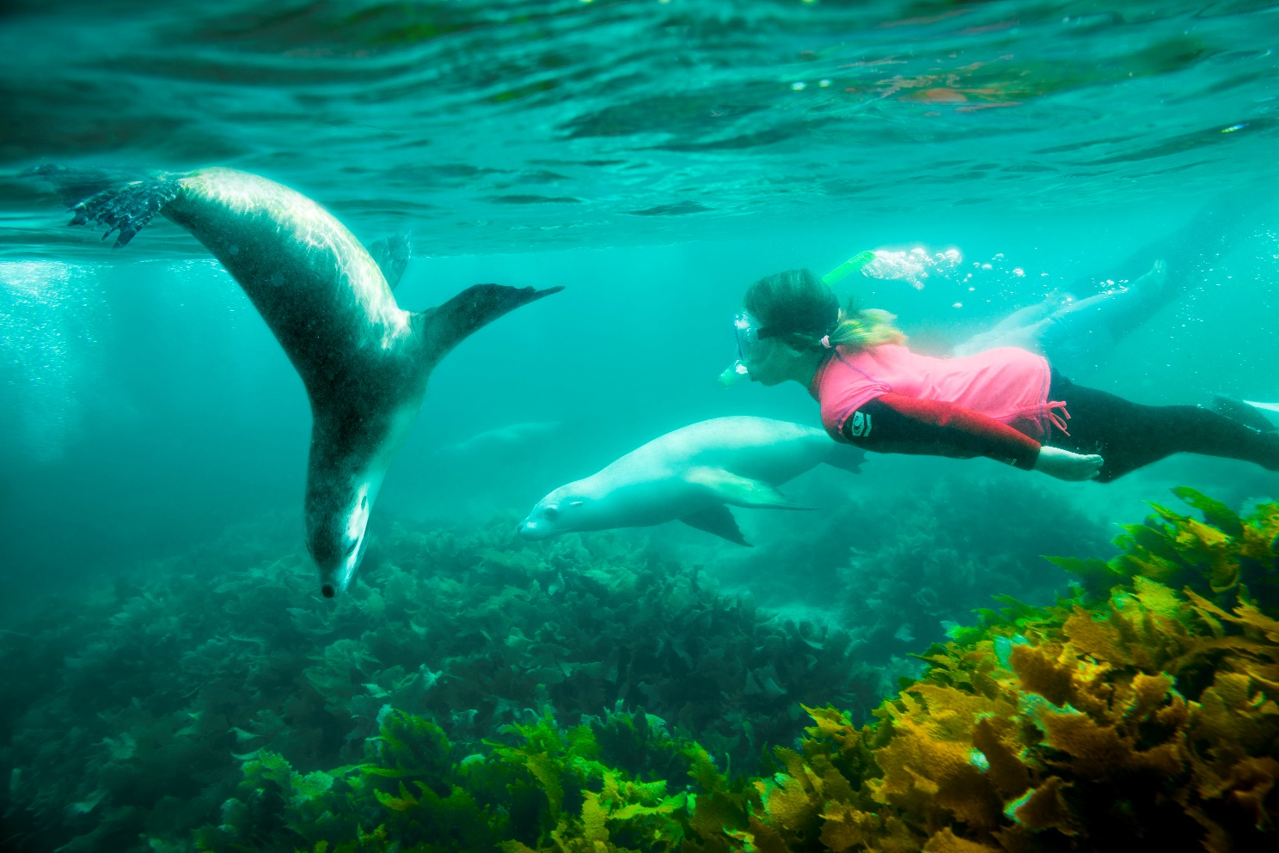
Sea lions and snorkeler (Robert Blackburn)

S2.1 South-west Network overview
The marine parks of the South-west Network were proclaimed under the EPBC Act on 14 December 2013 (Federal Register of Legislation No. F2013L02108) and renamed on 9 October 2017 (Federal Register of Legislation No. F2017L01337).
Table S2.1 Overview of the South-west Network
Marine park name | Zones, IUCN categories and zone area | Marine park IUCN category | Total marine park area
Southern Kangaroo Island | Special Purpose Zone (Mining Exclusion) (VI) 630 km² | VI | 630 km²
Western Kangaroo Island | National Park Zone (II) 120 km²  Special Purpose Zone (Mining Exclusion) (VI) 1435 km²  Special Purpose Zone (VI) 781 km² | VI | 2335 km²
Western Eyre | National Park Zone (II) 17,437 km²  Multiple Use Zone (VI) 16,107 km²  Special Purpose Zone (VI) 24,196 km²  Special Purpose Zone (Trawl) (VI) 204 km² | VI | 57,944 km²
Murat | National Park Zone (II) 938 km² | II | 938 km²
Great Australian Bight | National Park Zone (II) 7728 km²  Multiple Use Zone (VI) 22,578 km²  Special Purpose Zone (Mining Exclusion) (VI) 11,654 km²  Special Purpose Zone (VI) 3861 km² | VI | 45,822 km²
Twilight | National Park Zone (II) 3605 km²  Special Purpose Zone (Mining Exclusion) (VI) 1036 km² | II | 4641 km²
Eastern Recherche | National Park Zone (II) 15,565 km²  Special Purpose Zone (VI) 5010 km² | II | 20,575 km²
South-west Corner | National Park Zone (II) 54,841 km²  Habitat Protection Zone (IV) 95,088 km²  Multiple Use Zone (VI) 106,602 km²  Special Purpose Zone (Mining Exclusion) (VI) 9550 km²  Special Purpose Zone (VI) 5753 km² | VI | 271,833 km²
Bremer | National Park Zone (II) 3172 km²  Special Purpose Zone (Mining Exclusion) (VI) 1300 km² | II | 4472 km²
Geographe | National Park Zone (II) 15 km²  Habitat Protection Zone (IV) 21 km²  Multiple Use Zone (VI) 291 km²  Special Purpose Zone (Mining Exclusion) (VI) 650 km² | VI | 977 km²
Perth Canyon | National Park Zone (II) 1241 km²  Habitat Protection Zone (IV) 4352 km²  Multiple Use Zone (VI) 1816 km² | IV | 7409 km²
Two Rocks | National Park Zone (II) 15 km²  Multiple Use Zone (VI) 867 km² | VI | 882 km²
Jurien | National Park Zone (II) 31 km²  Special Purpose Zone (VI) 1820 km² | VI | 1851 km²
Abrolhos | National Park Zone (II) 2548 km²  Habitat Protection Zone (IV) 23,239 km²  Multiple Use Zone (VI) 56,545 km²  Special Purpose Zone (VI) 5729 km² | VI | 88,060 km²
Note: Each marine park extends from 1000 m below the seabed to 3000 m above sea level.
Note: Zone and total marine park areas are rounded to the nearest km²; therefore, the sum of areas may not equate to the total marine park or network areas in some instances.

S2.2 South-west Network values
This Schedule describes the values represented in each marine park of the South-west Network.
Values are broadly defined as:
- Natural values—habitats, species and ecological communities within marine parks, and the processes that support their connectivity, productivity and function.
- Cultural values—living and cultural heritage recognising Indigenous beliefs, practices and obligations for country, places of cultural significance and cultural heritage sites.
- Heritage values—non-Indigenous heritage that has aesthetic, historic, scientific or social significance.
- Socio-economic values—the benefit of marine parks for people, businesses and the economy.
Values will be used to inform the Director’s decisions when authorising activities in marine parks. Activities will be assessed in relation to their impacts on and risk to values to ensure activities are undertaken in a manner that minimises impacts to as small as reasonably practicable (Section 4.3 Making decisions about activities).
As understanding of park values improves over time, updated information will be available on the Parks Australia website.
Other sources of information on marine park values can be found on the Department’s website, in particular, for protected species (species profile and threats database), wetlands (Australian wetlands directory), heritage places (Australian heritage database), and shipwrecks (Australian national shipwrecks database); and in the Marine bioregional plan for the South-west Marine Region (2012) and the South-west marine bioregional plan: bioregional profile (2008).

Southern Kangaroo Island Marine Park
The Southern Kangaroo Island Marine Park (Figure S2.1) is located approximately 140 km south-west of Adelaide, adjacent to the South Australian Kangaroo Island Marine Park. The Marine Park covers an area of 630 km² extending from the South Australian state water boundary, and water depth ranges between 15 m and 100 m.
The Marine Park was proclaimed under the EPBC Act on 14 December 2013 and renamed Southern Kangaroo Island Marine Park on 9 October 2017. The Marine Park is assigned IUCN category VI and includes one zone assigned under this plan: Special Purpose Zone (Mining Exclusion) (VI). Coordinates for the Southern Kangaroo Island Marine Park and zone are provided in Figure S2.1 and Schedule 4.
Statement of significance
The Southern Kangaroo Island Marine Park is significant because it contains habitats, species and ecological communities associated with the Spencer Gulf Shelf Province. It includes one key ecological feature: the Kangaroo Island Pool, canyons and adjacent shelf break and Eyre Peninsula upwellings (valued for high productivity, aggregations of marine life and unique seafloor features with ecological properties of regional significance).
The Marine Park includes shelf habitats surrounding Kangaroo Island that connect to and complement the adjacent South Australian Southern Kangaroo Island Marine Park.
Natural values
The Marine Park includes examples of ecosystems representative of the Spencer Gulf Shelf. Seasonal winds and ocean currents interact with seafloor features to produce a number of small seasonal upwellings that are important for biological productivity. The area is noted for its diverse seafloor communities, productivity hotspots and aggregations of marine life associated with seasonal upwellings of nutrient-rich water.
A key ecological feature of the Marine Park is the Kangaroo Island Pool, canyons and adjacent shelf break, and Eyre Peninsula upwellings—an area of nutrient-rich upwellings that enhance productivity, supporting seasonal aggregations of marine species.
The Marine Park supports a range of species including species listed as threatened, migratory, marine or cetacean under the EPBC Act. Biologically important areas within the Marine Park include foraging habitat for seabirds, Australian sea lions and white sharks and a calving buffer area for southern right whales.
Cultural values
Sea country is valued for Indigenous cultural identity, health and wellbeing. Across Australia, Indigenous people have been sustainably using and managing their sea country for tens of thousands of years. South Australian Native Title Services is the Native Title Service Provider for South Australian region.
Heritage values
No international, Commonwealth or national heritage listings apply to the Marine Park at commencement of this plan.
Social and economic values
Tourism, commercial fishing and recreation are important activities in the Marine Park. These activities contribute to the wellbeing of regional communities and the prosperity of the nation. The Kangaroo Island community values the island’s unique qualities and character, with its wild and relatively pristine coastal and marine environment a tourism drawcard.
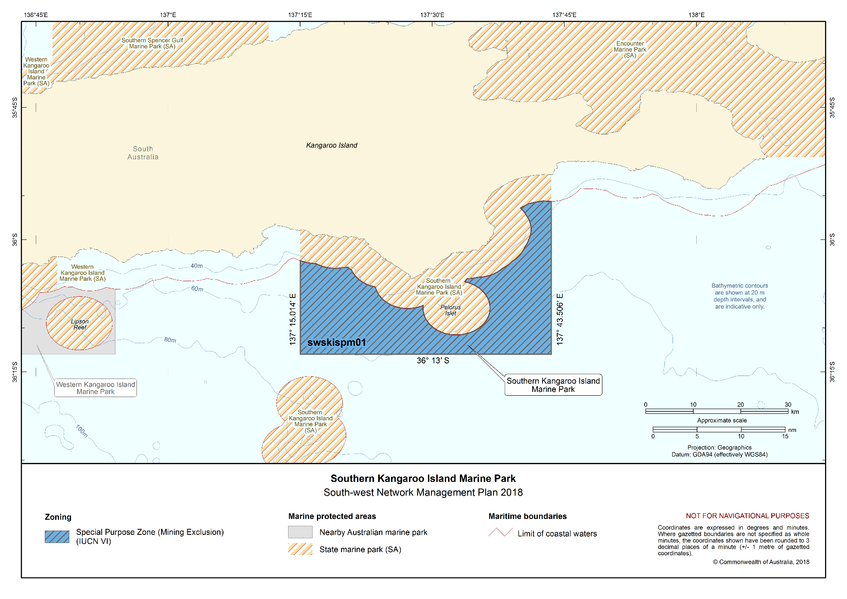
Figure S2.1 Southern Kangaroo Island Marine Park

Western Kangaroo Island Marine Park
The Western Kangaroo Island Marine Park (Figure S2.2) is located approximately 230 km south-west of Adelaide and 110 km south of Port Lincoln, adjacent to the South Australian Western Kangaroo Island Marine Park. The Marine Park covers an area of 2335 km² and water depths range between 15 m and 165 m.
The Marine Park was proclaimed under the EPBC Act on 14 December 2013 and renamed Western Kangaroo Island Marine Park on 9 October 2017. The Marine Park is assigned IUCN category VI and includes three zones assigned under this plan: National Park Zone (II), Special Purpose Zone (Mining Exclusion) (VI) and Special Purpose Zone (VI).
Coordinates for the Western Kangaroo Island Marine Park and zones are provided in Figure S2.2 and Schedule 4.
Statement of significance
The Western Kangaroo Island Marine Park is significant because it contains habitats, species and ecological communities associated with the Spencer Gulf Shelf Province. It includes two key ecological features: the ancient coastline between 90 m and 120 m depth (valued for relatively high productivity, aggregations of marine life and high levels of biodiversity and endemism); and Kangaroo Island Pool, canyons and adjacent shelf break, and Eyre Peninsula upwellings (valued for high productivity, aggregations of marine life and unique seafloor features with ecological properties of regional significance).
The Marine Park includes shelf habitats surrounding Kangaroo Island that connect to and complement the adjacent South Australian Western Kangaroo Island Marine Park.
Natural values
The Marine Park includes examples of ecosystems representative of the Spencer Gulf Shelf. Seasonal winds and ocean currents interact with seafloor features to produce a number of small seasonal upwellings that are important for biological productivity. The area is noted for its diverse seafloor communities, productivity hotspots and aggregations of marine life associated with the seasonal upwellings of nutrient-rich water.
Key ecological features represented in the Marine Park are:
- The ancient coastline between 90 m and 120 m depth— an area of high benthic biodiversity and productivity occur where the ancient coastline forms a prominent escarpment; and
- Kangaroo Island Pool, canyons and adjacent shelf break, and Eyre Peninsula upwellings—an area of nutrient-rich upwellings that enhance productivity, supporting seasonal aggregations of marine species.
The Marine Park supports a range of species, including species listed as threatened, migratory, marine or cetacean under the EPBC Act. Biologically important areas within the Marine Park include foraging habitat for seabirds, Australian sea lions, white sharks and pygmy blue and sperm whales, and a calving buffer area for southern right whales.
Cultural values
Sea country is valued for Indigenous cultural identity, health and wellbeing. Across Australia, Indigenous people have been sustainably using and managing their sea country for tens of thousands of years.
South Australian Native Title Services is the Native Title Service Provider for South Australian region.
Heritage values
No international, Commonwealth or national heritage listings apply to the Marine Park at commencement of this plan.
Social and economic values
Tourism, commercial fishing and recreation are important activities in the Marine Park. These activities contribute to the wellbeing of regional communities and the prosperity of the nation. The Kangaroo Island community values the island’s unique qualities and character, with its wild and relatively pristine coastal and marine environment a tourism drawcard.
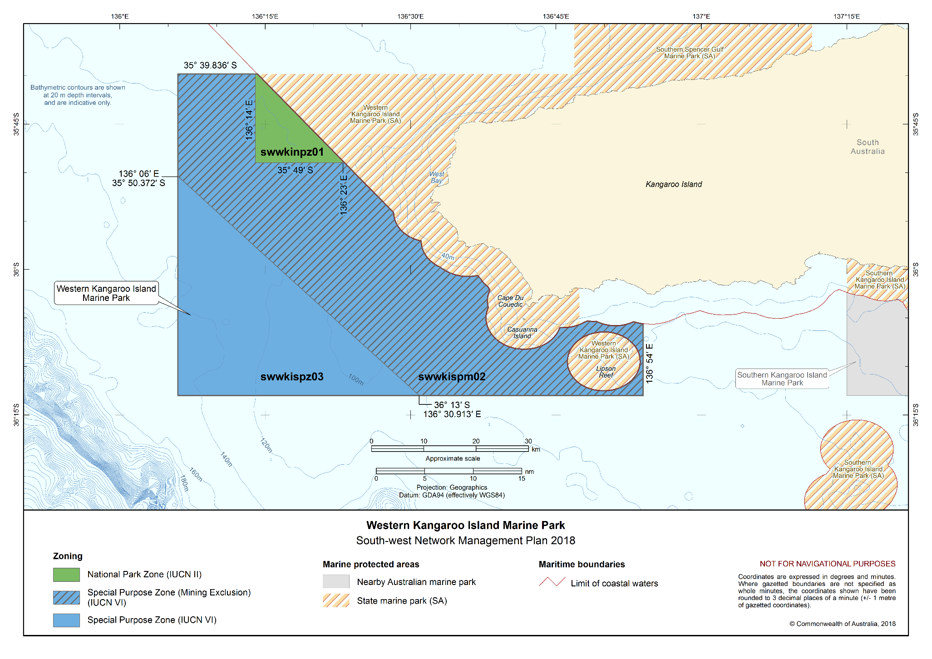
Figure S2.2 Western Kangaroo Island Marine Park

Western Eyre Marine Park
The Western Eyre Marine Park (Figure S2.3) is located approximately 123 km² south-west of Port Lincoln and 28 km west of Streaky Bay, adjacent to South Australia’s Investigator, West Coast Bays and Nuyts Archipelago Marine Parks. The Marine Park covers an area of 57,944 km², extending from the South Australian state water boundary to the edge of Australia’s exclusive economic zone, and water depths range between 15 m and more than 6000 m.
The Marine Park was proclaimed under the EPBC Act on 14 December 2013 and renamed Western Eyre Marine Park on 9 October 2017. The Marine Park is assigned IUCN category VI and includes four zones assigned under this plan: National Park Zone (II), Multiple Use Zone (VI), Special Purpose Zone (VI) and Special Purpose Zone (Trawl) (VI).
Coordinates for the Western Eyre Marine Park and zones are provided in Figure S2.3 and Schedule 4.
Statement of significance
The Western Eyre Marine Park is significant because it contains habitats, species and ecological communities associated with three bioregions: Spencer Gulf Shelf Province; Great Australian Bight Shelf Transition; and Southern Province. It includes five key ecological features: the ancient coastline between 90 m and 120 m depth (valued for relatively high productivity, aggregations of marine life and high levels of biodiversity and endemism); Kangaroo Island Pool, canyons and adjacent shelf break, and Eyre Peninsula upwelling (valued for high productivity, aggregations of marine life and unique seafloor features with ecological properties of regional significance); mesoscale eddies (valued for high productivity and aggregations of marine life); benthic invertebrate communities of the eastern Great Australian Bight (valued as a species group or community that is nationally and regionally important to biodiversity); and small pelagic fish of the South-west Marine Region (valued as a species group that has a regionally important ecological role).
The Marine Park provides connectivity between deeper offshore waters and the adjacent South Australian Investigator, West Coast Bays and Nuyts Archipelago Marine Parks. Waters surrounding the Nuyts Archipelago and Investigator Group form part of the ecologically important offshore islands that protect the coastline. The Marine Park is a hotspot for productivity, with feeding aggregations of marine mammals, sharks and seabirds.
Natural values
The Marine Park includes examples of ecosystems representative of:
- Spencer Gulf Shelf—seasonal winds and ocean currents interact with seafloor features to produce a number of small seasonal upwellings that are important for biological productivity. The area is noted for its very diverse seafloor communities, productivity hotspots and aggregations of marine life associated with seasonal upwellings of nutrient-rich water;
- Great Australian Bight Shelf Transition—a vast and shallow area, characterised by an extensive area of flat continental shelf. The invertebrate communities that inhabit the seafloor are among the most diverse in the world. The inshore areas of the bioregion are globally important for the threatened southern right whale and the Australian sea lion; and
- Southern Province—includes the deepest ocean areas of the Australian exclusive economic zone, reaching depths of around 5900 m, and is characterised by a long continental slope; numerous, well-developed submarine canyons; and extensive mid-slope terraces such as the Ceduna Terrace.
Key ecological features of the Marine Park are:
- Ancient coastline between 90 m and 120 m depth—benthic biodiversity and productivity occur where the ancient coastline forms a prominent escarpment;
- Kangaroo Island Pool, canyons and adjacent shelf break, and Eyre Peninsula upwellings—an area of nutrient-rich upwellings that enhance productivity, supporting seasonal aggregations of marine species;
- Mesoscale eddies—important transporters of nutrients and plankton communities, which form at predictable locations off the western and south-western shelf break;
- Benthic invertebrate communities of the eastern Great Australian Bight—includes soft-sediment benthic invertebrate communities of the eastern Great Australian Bight shelf, which form some of the world’s most diverse soft-sediment ecosystems; and
- Small pelagic fish of the South-west Marine Region—provide an important trophic link between plankton communities and larger fish-eating predators in this area.
The Marine Park supports a range of species including species listed as threatened, migratory, marine or cetacean under the EPBC Act. Biologically important areas within the Marine Park include breeding and foraging habitat for seabirds, foraging habitat for Australian sea lions, white sharks and pygmy blue and sperm whales, and a calving buffer area for southern right whales.
Cultural values
Sea country is valued for Indigenous cultural identity, health and wellbeing. Across Australia, Indigenous people have been sustainably using and managing their sea country for tens of thousands of years.
The far west coast region of South Australia includes over 1000 km of coastline along the Nullarbor Cliffs of the Great Australian Bight and the Nyuts Archipelago, and supports a sea based tradition and culture.
The Mirning people have a strong connection to land and sea country of the Nullarbor, and the Wirangu people have a strong connection to land and sea country across the remainder of the far west coastal region. Fishing is woven into the beliefs and values of this region, through the use of resources such as shell fish, periwinkles, abalone and razorfish; and the sharing of traditional fishing knowledge, catch and meals. The care and protection of these waters, the coastline, marine life and resources correspond directly with cultural stories, sites and knowledge.
South Australian Native Title Services is the Native Title Service Provider for South Australian region.
Heritage values
No international, Commonwealth or national heritage listings apply to the Marine Park at commencement of this plan.
Social and economic values
Tourism, commercial fishing, recreation and mining are important activities in the Marine Park. These activities contribute to the wellbeing of regional communities and the prosperity of the nation.

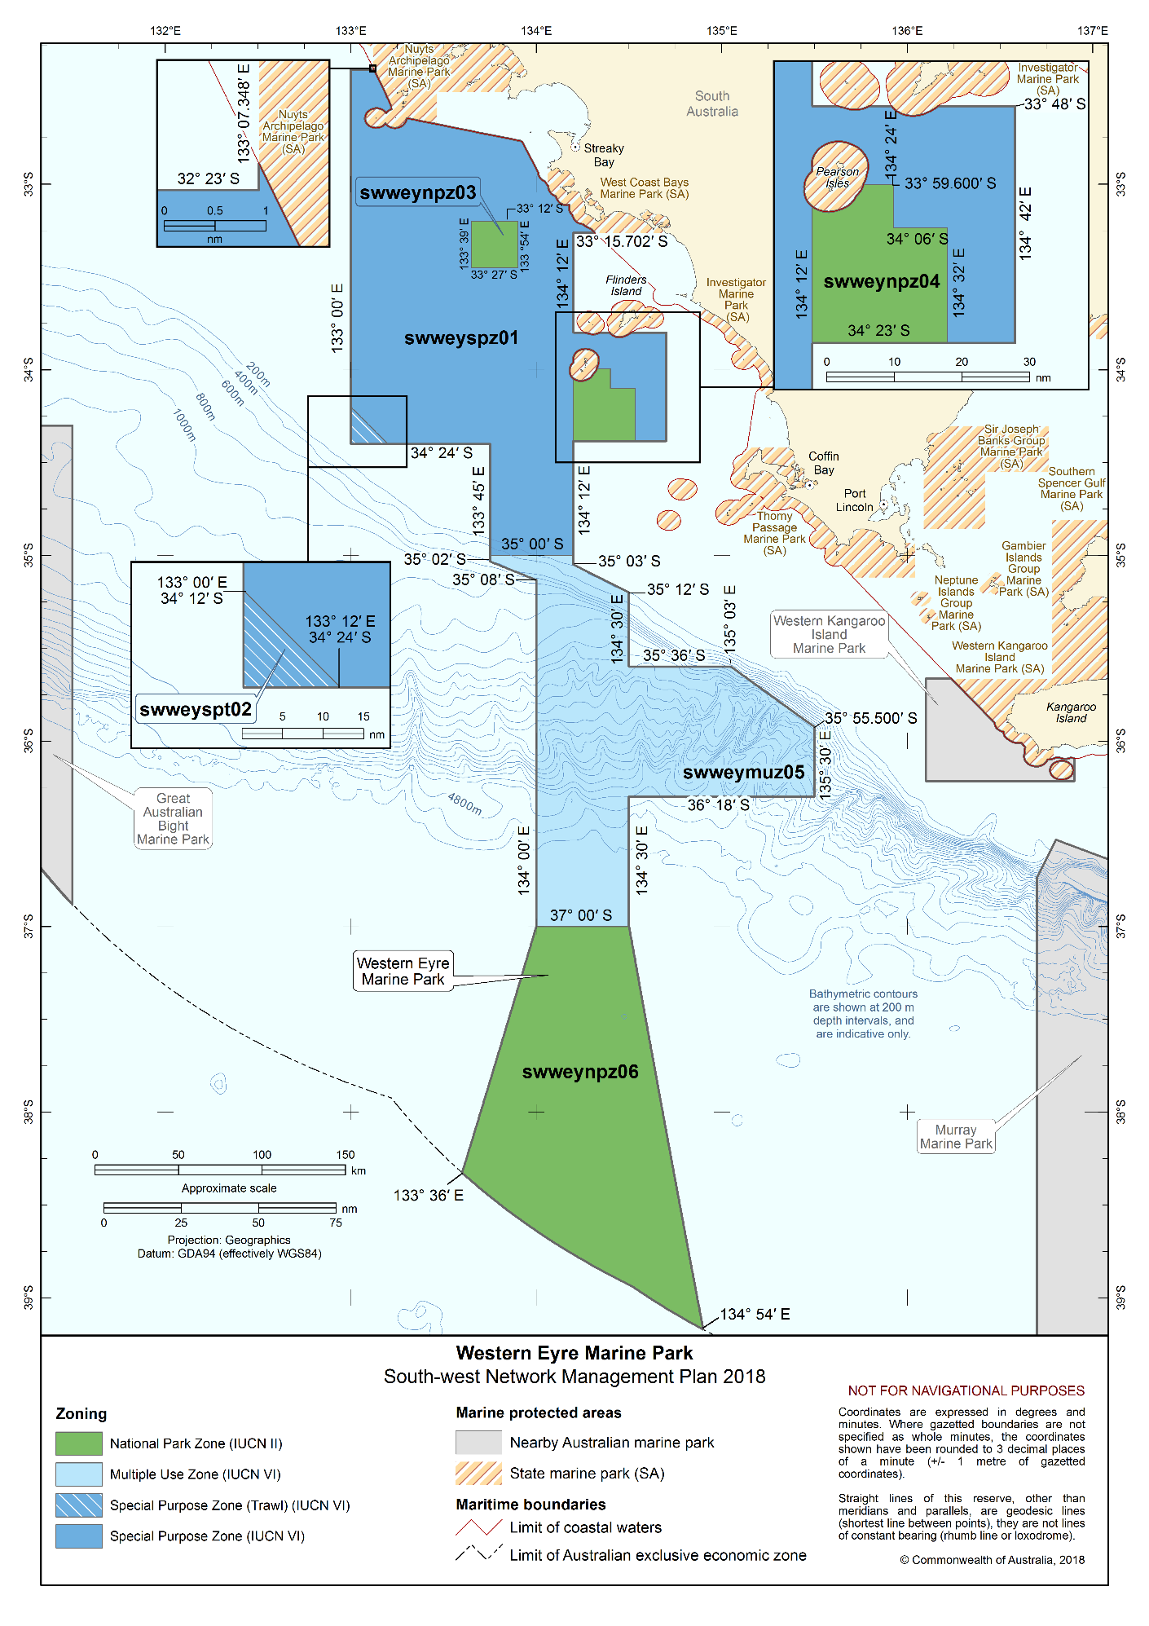Figure S2.3 Western Eyre Marine Park

Murat Marine Park
The Murat Marine Park (Figure S2.4) is located 86 km off the west coast south-west of Ceduna, south of the South Australian Nuyts Archipelago Marine Park. The Marine Park covers an area of 938 km² and is relatively shallow, with water depths between less than 15 m and 70 m.
The Marine Park was proclaimed under the EPBC Act on 14 December 2013 and renamed Murat Marine Park on 9 October 2017. The Marine Park is assigned IUCN category II and includes one zone assigned under this plan: National Park Zone (II).
Coordinates for the Murat Marine Park and zone are provided in Figure S2.4 and Schedule 4.
Statement of significance
The Murat Marine Park is significant because it contains habitats, species and ecological communities associated with the Great Australian Bight Shelf Transition. It includes two key ecological features: benthic invertebrate communities of the eastern Great Australian Bight (valued as a species group or community that is nationally and regionally important to biodiversity); and small pelagic fish of the South-west Marine Region (valued as a species group which has a regionally important ecological role).
The Marine Park includes Yatala Reef, a detached reef located in the south-west corner of the Marine Park about 70 km offshore with depths of less than two meters in places. The Marine Park is a hotspot for productivity, with feeding aggregations for a range of species of marine mammals, sharks and seabirds.
Natural values
The Marine Park includes examples of ecosystems representative of the Great Australian Bight Shelf Transition—a vast and shallow area characterised by an extensive area of flat continental shelf. The invertebrate communities that inhabit the seafloor are among the most diverse in the world. The inshore areas of the bioregion are globally important for the threatened southern right whale and the Australian sea lion.
Key ecological features of the Marine Park are:
- Benthic invertebrate communities of the eastern Great Australian Bight—includes the soft-sediment benthic invertebrate communities of the eastern Great Australian Bight shelf, which form some of the world’s most diverse soft-sediment ecosystems; and
- Small pelagic fish of the South-west Marine Region—provide an important trophic link between plankton communities and larger fish-eating predators in this area.
The Marine Park supports a range of species including species listed as threatened, migratory, marine or cetacean under the EPBC Act. Biologically important areas within the Marine Park include foraging habitat for seabirds and Australian sea lions.
Cultural values
Sea country is valued for Indigenous cultural identity, health and wellbeing. Across Australia, Indigenous people have been sustainably using and managing their sea country for tens of thousands of years.
The Mirning people have a strong attachment to land and sea country of the Nullarbor, while the Wirangu people have a strong attachment to land and sea country across the remainder of the far west coast region. The care and protection of the waters, coastline, marine creatures, marine environments and sea resources correspond directly with cultural stories and important cultural sites and knowledge.
South Australian Native Title Services is the native title service provider for South Australian region.

Heritage values
No international, Commonwealth or national heritage listings apply to the Marine Park at commencement of this plan.
Social and economic values
The South-west Network supports a range of social and economic activities that contribute to the wellbeing of regional communities and the prosperity of the nation. The remoteness of the Marine Park makes access difficult with most recreational and tourism activities confined to state waters. Commercial ships may pass through the Marine Park to and from the port of Ceduna.

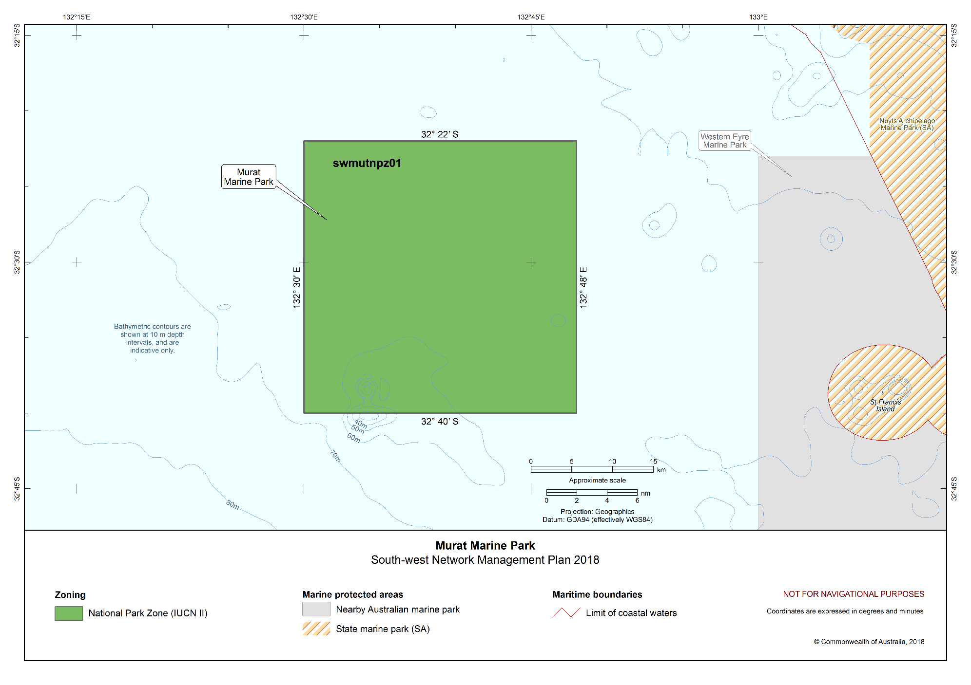Figure S2.4 Murat Marine Park

Great Australian Bight Marine Park
The Great Australian Bight Marine Park (Figure S2.5) is located approximately 12 km south-east of Eucla and 174 km west of Ceduna, adjacent to the South Australian Far West Coast and Nuyts Archipelago Marine Parks. The Marine Park covers an area of 45,822 km², extending from South Australian state water boundary to the edge of Australia’s exclusive economic zone, and a water depth range between less than 15 m and 6000 m.
The Marine Park was proclaimed under the EPBC Act on 14 December 2013 and renamed Great Australian Bight Marine Park on 9 October 2017. It includes the area of the Great Australian Bight Marine Park (Commonwealth Waters) originally proclaimed under the National Parks and Wildlife Conservation Act 1975 on 17 April 1998. The Marine Park is assigned IUCN category VI and includes four zones assigned under this plan: National Park Zone (II), Multiple Use Zone (VI), Special Purpose Zone (Mining Exclusion) (VI) and Special Purpose Zone (VI).
Coordinates for the Great Australian Bight Marine Park and zones are provided in Figure S2.5 and Schedule 4.
Statement of significance
The Great Australian Bight Marine Park is significant because it contains habitats, species and ecological communities associated with two bioregions: Great Australian Bight Shelf Transition; and Southern Province. It includes three key ecological features: ancient coastline between 90 m and 120 m depth (valued for relatively high productivity, aggregations of marine life and high levels of biodiversity and endemism); benthic invertebrate communities of the eastern Great Australian Bight (valued as a species group or community that is nationally and regionally important to biodiversity); and small pelagic fish of the South-west Marine Region (valued as a species group which has a regionally important ecological role).
The Marine Park contains a number of prominent seafloor features including the Ceduna Terrace, an unusually large expanse of terrace that lies between the continental shelf and slope; Nullarbor Canyon, a large elongated canyon that cuts through the terrace; D’Entrecasteaux Reef (also known as Iles des Martins and Iles Montenotte), an emergent reef in the north-east corner of the Marine Park; and Anna’s Pimple, a cone-shaped volcanic pinnacle rising 200 m above the surrounding soft sediments in the southern part of the Marine Park at 1800 m depth.
The Marine Park includes habitats connecting to and complementing the adjacent South Australian Far West Coast and Nuyts Archipelago Marine Parks
Natural values
The Marine Park includes examples of ecosystems representative of:
- Great Australian Bight Shelf Transition—a vast and shallow area, characterised by an extensive area of flat continental shelf. The invertebrate communities that inhabit the seafloor are among the most diverse in the world. The inshore areas of the bioregion are globally important for the threatened southern right whale and the Australian sea lion;
- Southern Province—includes the deepest ocean areas of the Australian EEZ, reaching depths of around 5900 m, and that is characterised by a long continental slope, numerous, well-developed submarine canyons, and extensive mid-slope terraces such as the Ceduna Terrace.
Key ecological features of the Marine Park are:
- Ancient coastline between 90 m and 120 m depth—high benthic biodiversity and productivity occur where the ancient coastline forms a prominent escarpment;
- Benthic invertebrate communities of the eastern Great Australian Bight—includes soft-sediment benthic invertebrate communities of the eastern Great Australian Bight shelf, which form some of the world’s most diverse soft-sediment ecosystems; and
- Small pelagic fish of the South-west Marine Region—provides an important trophic link between plankton communities and larger fish-eating predators in this area.
The Marine Park supports a range of species including species listed as threatened, migratory, marine or cetacean under the EPBC Act. Biologically important areas within the Marine Park include foraging habitat for seabirds, Australian sea lions, white sharks and pygmy blue and sperm whales, and a calving area, migratory pathway and large aggregation area for southern right whales.
Cultural values
Sea country is valued for Indigenous cultural identity, health and wellbeing. Across Australia, Indigenous people have been sustainably using and managing their sea country for tens of thousands of years.
The Kokatha, Mirning, and Wirangu people have responsibilities for sea county in the Marine Park. The far west coast region of South Australia includes over 1000 km of coastline along the Nullarbor Cliffs of the Great Australian Bight and the Nyuts Archipelago, and supports a sea based tradition and culture.
The Mirning people have a strong connection to land and sea country of the Nullarbor, and the Wirangu people have a strong connection to land and sea country across the remainder of the far west coastal region. Fishing is woven into the beliefs and values of this region, through the use of resources such as shell fish, periwinkles, abalone and razorfish; and the sharing of traditional fishing knowledge, catch and meals. The care and protection of these waters, the coastline, marine life and resources correspond directly with cultural stories, sites and knowledge.
South Australian Native Title Services is the native title service provider for South Australian region.
Heritage values
No international, Commonwealth or national heritage listings apply to the Marine Park at commencement of this plan.
Social and economic values
Tourism, commercial fishing, and mining are important activities in the Marine Park. These activities contribute to the wellbeing of regional communities and the prosperity of the nation.

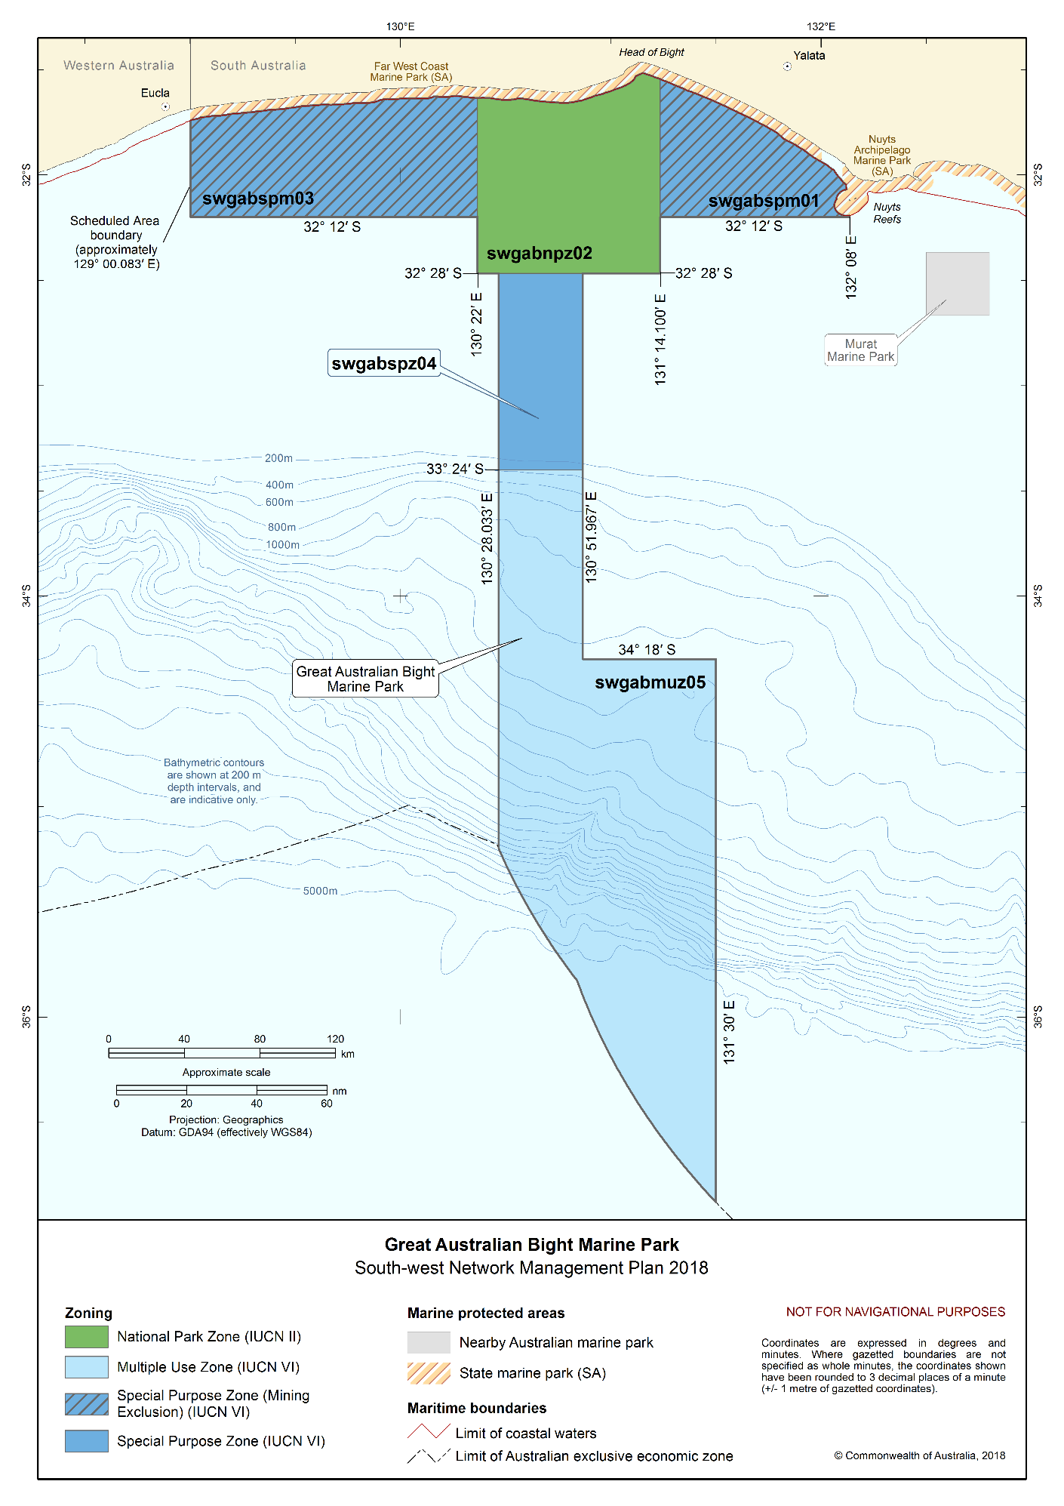Figure S2.5 Great Australian Bight Marine Park

Twilight Marine Park
The Twilight Marine Park (Figure S2.6) is located approximately 245 km south-west of Eucla and 373 km north-east of Esperance, adjacent to the Western Australian state water boundary. The Marine Park covers an area of 4641 km² and water depths between less than 15 m and 70 m.
The Marine Park was proclaimed under the EPBC Act on 14 December 2013 and renamed Twilight Marine Park on 9 October 2017. The Marine Park is assigned IUCN category II and includes two zones assigned under this plan: National Park Zone (II) and Special Purpose Zone (Mining Exclusion) (VI).
Coordinates for the Twilight Marine Park and zones are provided in Figure S2.6 and Schedule 4.
Statement of significance
The Twilight Marine Park is significant because it contains habitats, species and ecological communities associated with the Great Australian Bight Shelf Transition.
The Marine Park includes south coast continental shelf environments, contributing to the connectivity of protected areas across shelf ecosystems. The inshore location of the Marine Park captures shallow depths.
Natural values
The Marine Park includes examples of ecosystems representative of the Great Australian Bight Shelf Transition—a vast and shallow area characterised by an extensive area of flat continental shelf. The invertebrate communities that inhabit the seafloor are among the most diverse in the world. The inshore areas of the bioregion are globally important for the threatened southern right whale and the Australian sea lion.
The Marine Park supports a range of species including species listed as threatened, migratory, marine or cetacean under the EPBC Act. Biologically important areas within the Marine Park include foraging habitat for seabirds, Australian sea lions and white sharks, and a calving buffer area for southern right whales.
Cultural values
Sea country is valued for Indigenous cultural identity, health and wellbeing. Across Australia, Indigenous people have been sustainably using and managing their sea country for tens of thousands of years.
The Mirning and Spinifex people have responsibilities for sea country in the Marine Park. Local traditional owners recognise Kaart, Koort and Waarnginy (head, heart and talking) as bringing together the narratives and protocols that have been practiced for thousands of years and the kinship that influences all stages and cycles of life. Traditional owners have responsibility for cultural values and are focussed on the creation and regeneration of spiritual, ethical, cultural and practical benefits and opportunities for marine systems.
The Goldfields Land and Sea Council is the Native Title Representative Body for the Goldfields region.
Heritage values
No international, Commonwealth or national heritage listings apply to the Marine Park at commencement of this plan.
Social and economic values
Tourism, commercial fishing and recreation including fishing, are important activities in the Marine Park. These activities contribute to the wellbeing of regional communities and the prosperity of the nation.
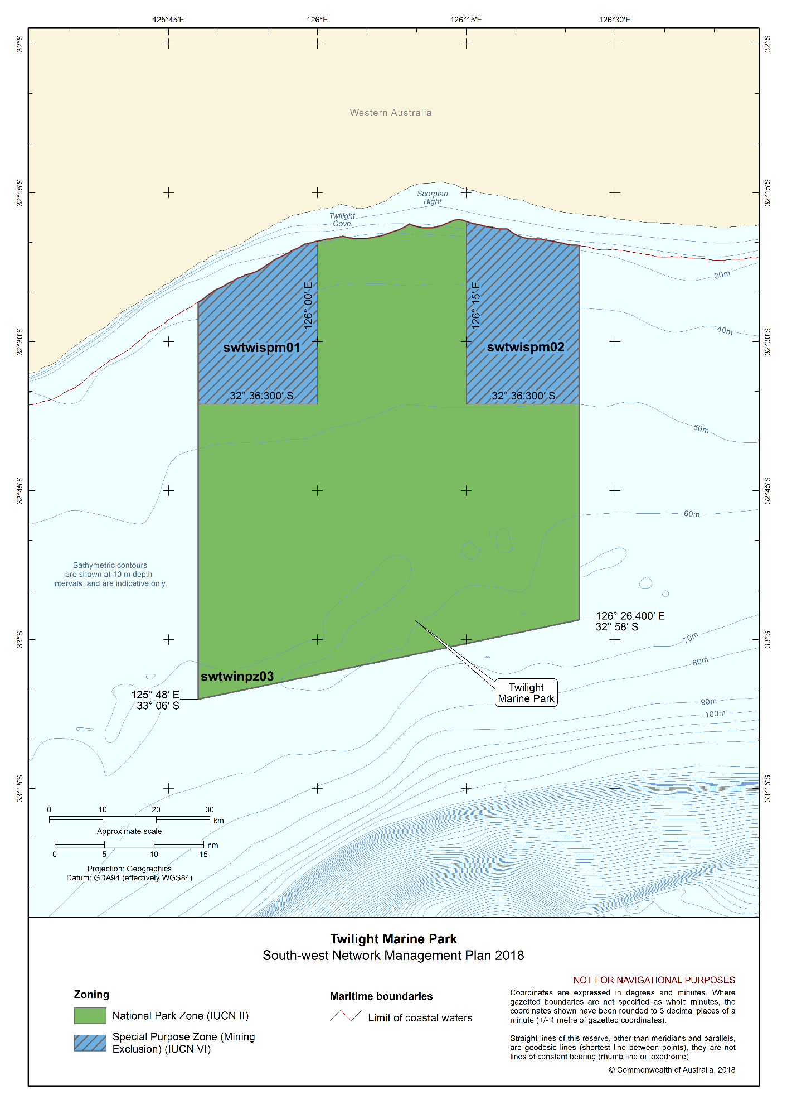Figure S2.6 Twilight Marine Park

Eastern Recherche Marine Park
The Eastern Recherche Marine Park (Figure S2.7) is located approximately 135 km east of Esperance, adjacent to the Recherche Archipelago, close to the Western Australian Cape Arid National Park. The Marine Park covers an area of 20,575 km², extending from the Western Australia state water boundary to the edge of Australia’s exclusive economic zone, and a water depth range from less than 15 m to 6000 m.
The Marine Park was proclaimed under the EPBC Act on 14 December 2013 and renamed Eastern Recherche Marine Park on 9 October 2017. The Marine Park is assigned IUCN category II and includes two zones assigned under this plan: National Park Zone (II) and Special Purpose Zone (VI).
Coordinates for the Eastern Recherche Marine Park and zones are provided in Figure S2.7 and Schedule 4.
Statement of significance
The Eastern Recherche Marine Park is significant because it contains habitats, species and ecological communities associated with three bioregions: South-west Shelf Province; Southern Province; and the Great Australian Bight Shelf Transition. It includes three key ecological features: mesoscale eddies (valued for high productivity and aggregations of marine life); ancient coastline between 90 m and 120 m depth (valued for relatively high productivity, aggregations of marine life and high levels of biodiversity and endemism); and the Commonwealth marine environment surrounding the Recherche Archipelago (valued for aggregations of marine life and high levels of biodiversity and endemism).
The Marine Park includes representative examples of habitats adjacent to the Recherche Archipelago, an area recognised globally for its biodiversity. The Archipelago contains over 150 islands stretching over 200 km² of ocean and represents the most extensive area of rocky reef environments in the region. Its reef and seagrass habitats support a high diversity of warm temperate species. The Marine Park captures one of the few areas where the reef extends into Commonwealth waters and includes Chester and Pollock reefs which are located south of Salisbury Island about 60–70 km offshore.
Natural values
The Marine Park includes examples of ecosystems representative of:
- South-west Shelf Province—marine life in this area is very diverse and clearly influenced by the warm waters of the Leeuwin Current. It includes globally important biodiversity hotspots, such as the waters surrounding the Recherche Archipelago;
- Southern Province—includes the deepest ocean areas of the Australian EEZ, reaching depths of around 5900 m, and is characterised by a long continental slope, numerous, well-developed submarine canyons, and extensive mid-slope terraces; and
- Great Australian Bight Shelf Transition—a vast and shallow area characterised by an extensive area of flat continental shelf. The invertebrate communities that inhabit the seafloor are among the most diverse in the world. The inshore areas of the bioregion are globally important for threatened southern right whale and the Australian sea lion.
Key ecological features of the Marine Park are:
- Mesoscale eddies—important transporters of nutrients and plankton communities that form at predictable locations off the western and south-western shelf break;
- Ancient coastline between 90 m and 120 m depth—high benthic biodiversity and productivity occur where the ancient coastline forms a prominent escarpment; and
- Commonwealth marine environment surrounding the Recherche Archipelago—an area that supports high species biodiversity and provides important breeding and resting areas for marine life.
The Marine Park supports a range of species including species listed as threatened, migratory, marine or cetacean under the EPBC Act. Biologically important areas within the Marine Park include foraging habitat for seabirds, Australian sea lions and white sharks, and a calving buffer area for southern right whales.
Cultural values
Sea country is valued for Indigenous cultural identity, health and wellbeing. Across Australia, Indigenous people have been sustainably using and managing their sea country for tens of thousands of years.
The Ngadju and Esperance Nyungar people have responsibilities for sea country in the Marine Park. Local traditional owners recognise Kaart, Koort and Waarnginy (head, heart and talking) as bringing together the narratives and protocols that have been practiced for thousands of years and the kinship that influences all stages and cycles of life. Traditional owners have responsibility for cultural values and are focussed on the creation and regeneration of spiritual, ethical, cultural and practical benefits and opportunities for marine systems.
The South West Aboriginal Land and Sea Council is the Native Title Service Provider for the South-west region.
Heritage values
No international, Commonwealth or national heritage listings apply to the Marine Park at commencement of this plan.
Historic shipwrecks
The Marine Park contains two known shipwrecks listed under the Historic Shipwrecks Act 1976—Rodondo (wrecked in 1894) and Start (wrecked in 1879).
Social and economic values
Tourism, commercial fishing, mining and recreation, including fishing, are important activities in the Marine Park. These activities contribute to the wellbeing of regional communities and the prosperity of the nation.

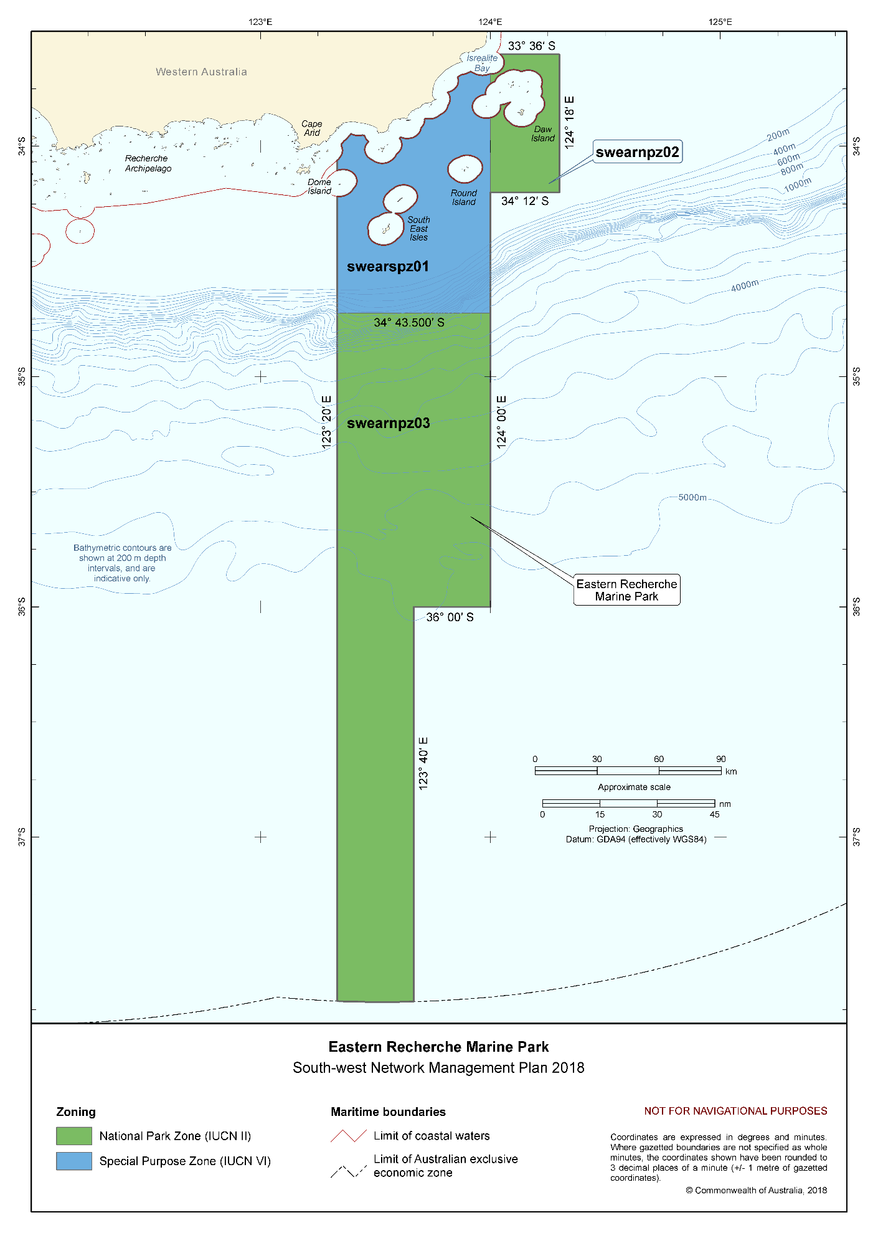Figure S2.7 Eastern Recherche Marine Park

South-west Corner Marine Park
The South-west Corner Marine Park (Figure S2.8) is located adjacent to the Western Australian Ngari Capes Marine Park, covering an extensive offshore area that is closest to Western Australia state waters approximately 48 km west of Esperance, 73 km west of Albany and 68 km west of Bunbury, and extends to the edge of Australia’s exclusive economic zone. The Marine Park covers an area of 271,833 km² and a water depth range from less than 15 m to 6400 m.
The Marine Park was proclaimed under the EPBC Act on 14 December 2013 and renamed South-west Corner Marine Park on 9 October 2017. The Marine Park is assigned IUCN category VI and includes five zones assigned under this plan: National Park Zone (II), Habitat Protection Zone (IV), Multiple Use Zone (VI), Special Purpose Zone (Mining Exclusion) (VI) and Special Purpose Zone (VI).
Coordinates for the South-west Corner Marine Park and zones are provided in Figure S2.8 and Schedule 4.
Statement of significance
The South-west Corner Marine Park is significant because it contains habitats, species and ecological communities associated with three bioregions: Southern Province; South-west Transition; and South-west Shelf Province. It includes six key ecological features: Albany Canyon group and adjacent shelf break (valued for high productivity, aggregations of marine life and unique seafloor features with properties of regional significance); Cape Mentelle upwelling (valued for high productivity and aggregations of marine life); Diamantina Fracture Zone (valued as a unique seafloor feature with ecological properties of regional significance); Naturaliste Plateau (valued as a unique seafloor feature with ecological properties of regional significance); western rock lobster (valued as a species that plays a regionally important ecological role); and ancient coastline between 90 m and 120 m depth (valued for relatively high productivity, aggregations of marine life and high levels of biodiversity and endemism).
As the largest Marine Park in the South-west Network, it contains a wide range of important ecosystems in both shallow and deep water, reaching abyssal depths including the Diamantina Fracture Zone, Naturaliste Plateau and Donnelly Banks, along with many reefs and canyons. The Marine Park contributes to a transect that extends from coastal land (Leeuwin–Naturaliste and D’entrecasteaux National Parks), to coastal waters (Ngari Capes Marine Park) and the deep ocean.
Natural values
The Marine Park includes examples of ecosystems representative of:
- Southern Province—includes the deepest ocean areas of the Australian EEZ, reaching depths of around 5900 m, and is characterised by a long continental slope incised by numerous, well-developed submarine canyons and the Diamantina Fracture Zone, a rugged area of deep seafloor comprising seamounts and many ridges and troughs.
- South-west Transition—the main features of this area are the Naturaliste Plateau, the deepest submarine plateau along Australia’s continental margins. The Plateau supports rich and diverse biological communities. Deep-water mixing results from the dynamics of major ocean currents when these meet the seafloor.
- South-west Shelf Province—marine life in this area is diverse and influenced by the warm waters of the Leeuwin Current. A small upwelling of nutrient-rich water off Cape Mentelle during summer increases productivity locally, attracting aggregations of marine life.
Key ecological features of the Marine Park are:
- Albany Canyon group and adjacent shelf break—a feature consisting of 32 canyons cut deeply into the steep continental slope. The canyons are believed to be associated with small periodic upwellings that enhance productivity and attract aggregations of marine life;
- Cape Mentelle upwelling—draws relatively nutrient-rich water from the base of the Leeuwin Current, up the continental slope and onto the inner continental shelf, where it results in phytoplankton blooms at the surface;
- Diamantina Fracture Zone—a unique seafloor feature consisting of a rugged, deep-water environment of seamounts and many closely spaced troughs and ridges. The ridges and seamounts can affect water dynamics and flow, enhancing productivity, and may act as ‘stepping stones’ for species dispersal and migration across the region and the wider abyssal plain;
- Naturaliste Plateau—the combination of this unique seafloor feature’s structural complexity, mixed water dynamics and relative isolation indicate that it supports deep-water communities with high species diversity and endemism;
- Western rock lobster—plays an important trophic role in many of the inshore ecosystems of the South-west Marine Region. Western rock lobsters are an important part of the food web on the inner shelf, particularly as juveniles; and
- Ancient coastline between 90 m and 120 m depth—high benthic biodiversity and productivity occur where the ancient coastline forms a prominent escarpment.
The Marine Park supports a range of species including species listed as threatened, migratory, marine or cetacean under the EPBC Act. Biologically important areas within the Marine Park include foraging habitat for seabirds, Australian sea lions, white sharks and sperm whales, a migratory pathway for Antarctic blue, pygmy blue and humpback whales, and a calving buffer area for southern right whales.
Cultural values
Sea country is valued for Indigenous cultural identity, health and wellbeing. Across Australia, Indigenous people have been sustainably using and managing their sea country for tens of thousands of years.
The Nyungar/Noongar people have responsibilities for sea country in the Marine Park. Traditional owners have maintained cultural responsibilities for sea country as passed down from elders, to keep the oceans healthy, to support spiritual wellbeing and to uphold and protect obligatory cultural responsibilities for future generations.
The South West Aboriginal Land and Sea Council is the Native Title Service Provider for the South-west region.
Heritage values
No international, Commonwealth or national heritage listings apply to the Marine Park at commencement of this plan.
Historic shipwrecks
The Marine Park contains 10 known shipwrecks listed under the Historic Shipwrecks Act 1976.
Social and economic values
Tourism, commercial fishing, commercial shipping, and recreation, including fishing, are important activities in the Marine Park. These activities contribute to the wellbeing of regional communities and the prosperity of the nation.

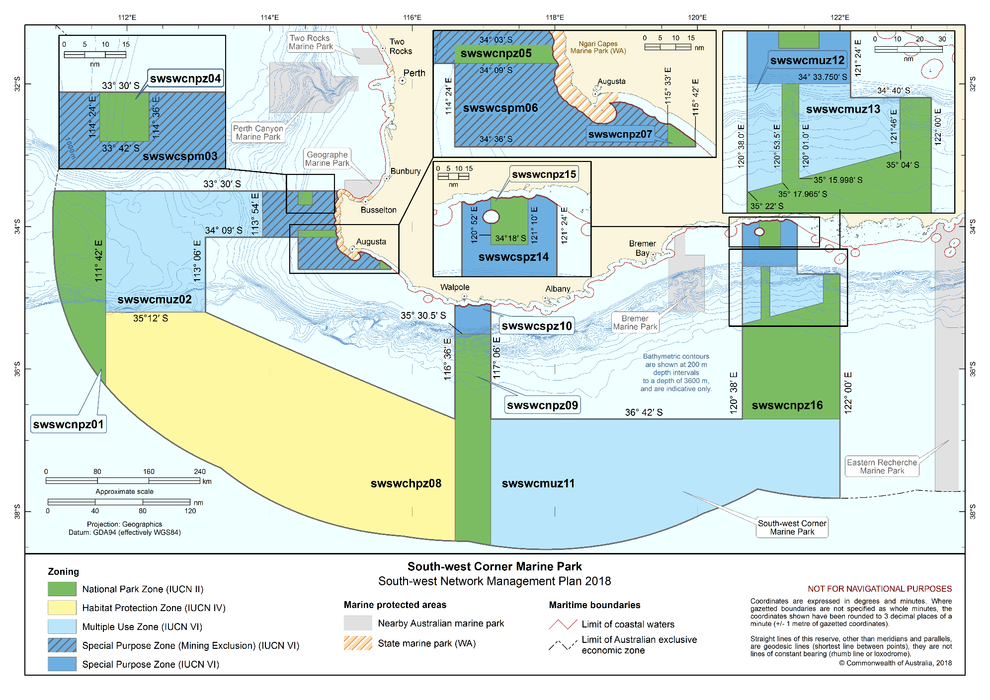Figure S2.8 South-west Corner Marine Park

Bremer Marine Park
The Bremer Marine Park (Figure S2.9) is located approximately half-way between Albany and Esperance, offshore from the Fitzgerald River National Park, extending from the Western Australian state water boundary. The Marine Park covers an area of 4472 km² and water depths from 15 m to 5000 m.
The Marine Park was proclaimed under the EPBC Act on 14 December 2013 and renamed Bremer Marine Park on 9 October 2017. The Marine Park is assigned IUCN category II and includes two zones assigned under this plan: National Park Zone (II) and Special Purpose Zone (Mining Exclusion) (VI).
Coordinates for the Bremer Marine Park and zones are provided in Figure S2.9 and Schedule 4.
Statement of significance
The Bremer Marine Park is significant because it contains habitats, species and ecological communities associated with two bioregions: Southern Province and South-west Shelf Province. It includes two key ecological features: Albany Canyon group and adjacent shelf break (valued for high productivity, aggregations of marine life and unique seafloor features with properties of regional significance); and ancient coastline between 90 m and 120 m depth (valued for relatively high productivity, aggregations of marine life and high levels of biodiversity and endemism).
The Marine Park contains the Bremer Canyon and significant calving and aggregation area for whales as well as important foraging areas for sharks, sea lions, and a range of seabirds.
Natural values
The Marine Park includes examples of ecosystems representative of:
- Southern Province—includes the deepest ocean areas of the Australian EEZ, reaching depths of around 5900 m, and is characterised by a long continental slope incised by numerous, well-developed submarine canyons; and
- South-west Shelf Province—marine life in this area is very diverse and clearly influenced by the warm waters of the Leeuwin Current. The sheltered bays along the south coast are important southern right whale calving areas.
Key ecological features of the Marine Park are:
- Albany Canyon group and adjacent shelf break—a feature consisting of 32 canyons, including Bremer Canyon, cut deeply into the steep continental slope. The canyons are believed to be associated with small periodic upwellings that enhance productivity and attract aggregations of marine life; and
- Ancient coastline between 90 m and 120 m depth—high benthic biodiversity and productivity occur where the ancient coastline forms a prominent escarpment.
The Marine Park supports a range of species including species listed as threatened, migratory, marine or cetacean under the EPBC Act. Biologically important areas within the Marine Park include foraging habitat for seabirds, Australian sea lions, and white sharks, a migratory pathway for humpback whales, and a significant calving area for southern right whales. The Marine Park includes canyons—important aggregation areas for killer whales.
Cultural values
Sea country is valued for Indigenous cultural identity, health and wellbeing. Across Australia, Indigenous people have been sustainably using and managing their sea country for tens of thousands of years.
The Noongar people have responsibilities for sea country in the Marine Park. Local traditional owners recognise Kaart, Koort and Waarnginy (head, heart and talking) as bringing together the narratives and protocols that have been practiced for thousands of years and the kinship that influences all stages and cycles of life. Traditional owners have responsibility for cultural values and are focussed on the creation and regeneration of spiritual, ethical, cultural and practical benefits and opportunities for marine systems.
The South West Aboriginal Land and Sea Council is the Native Title Service Provider for the South-west region.
Heritage values
No international, Commonwealth or national heritage listings apply to the Marine Park at commencement of this plan.
Social and economic values
Tourism, commercial fishing and recreation, including fishing, are important activities in the Marine Park. These activities contribute to the wellbeing of regional communities and the prosperity of the nation.

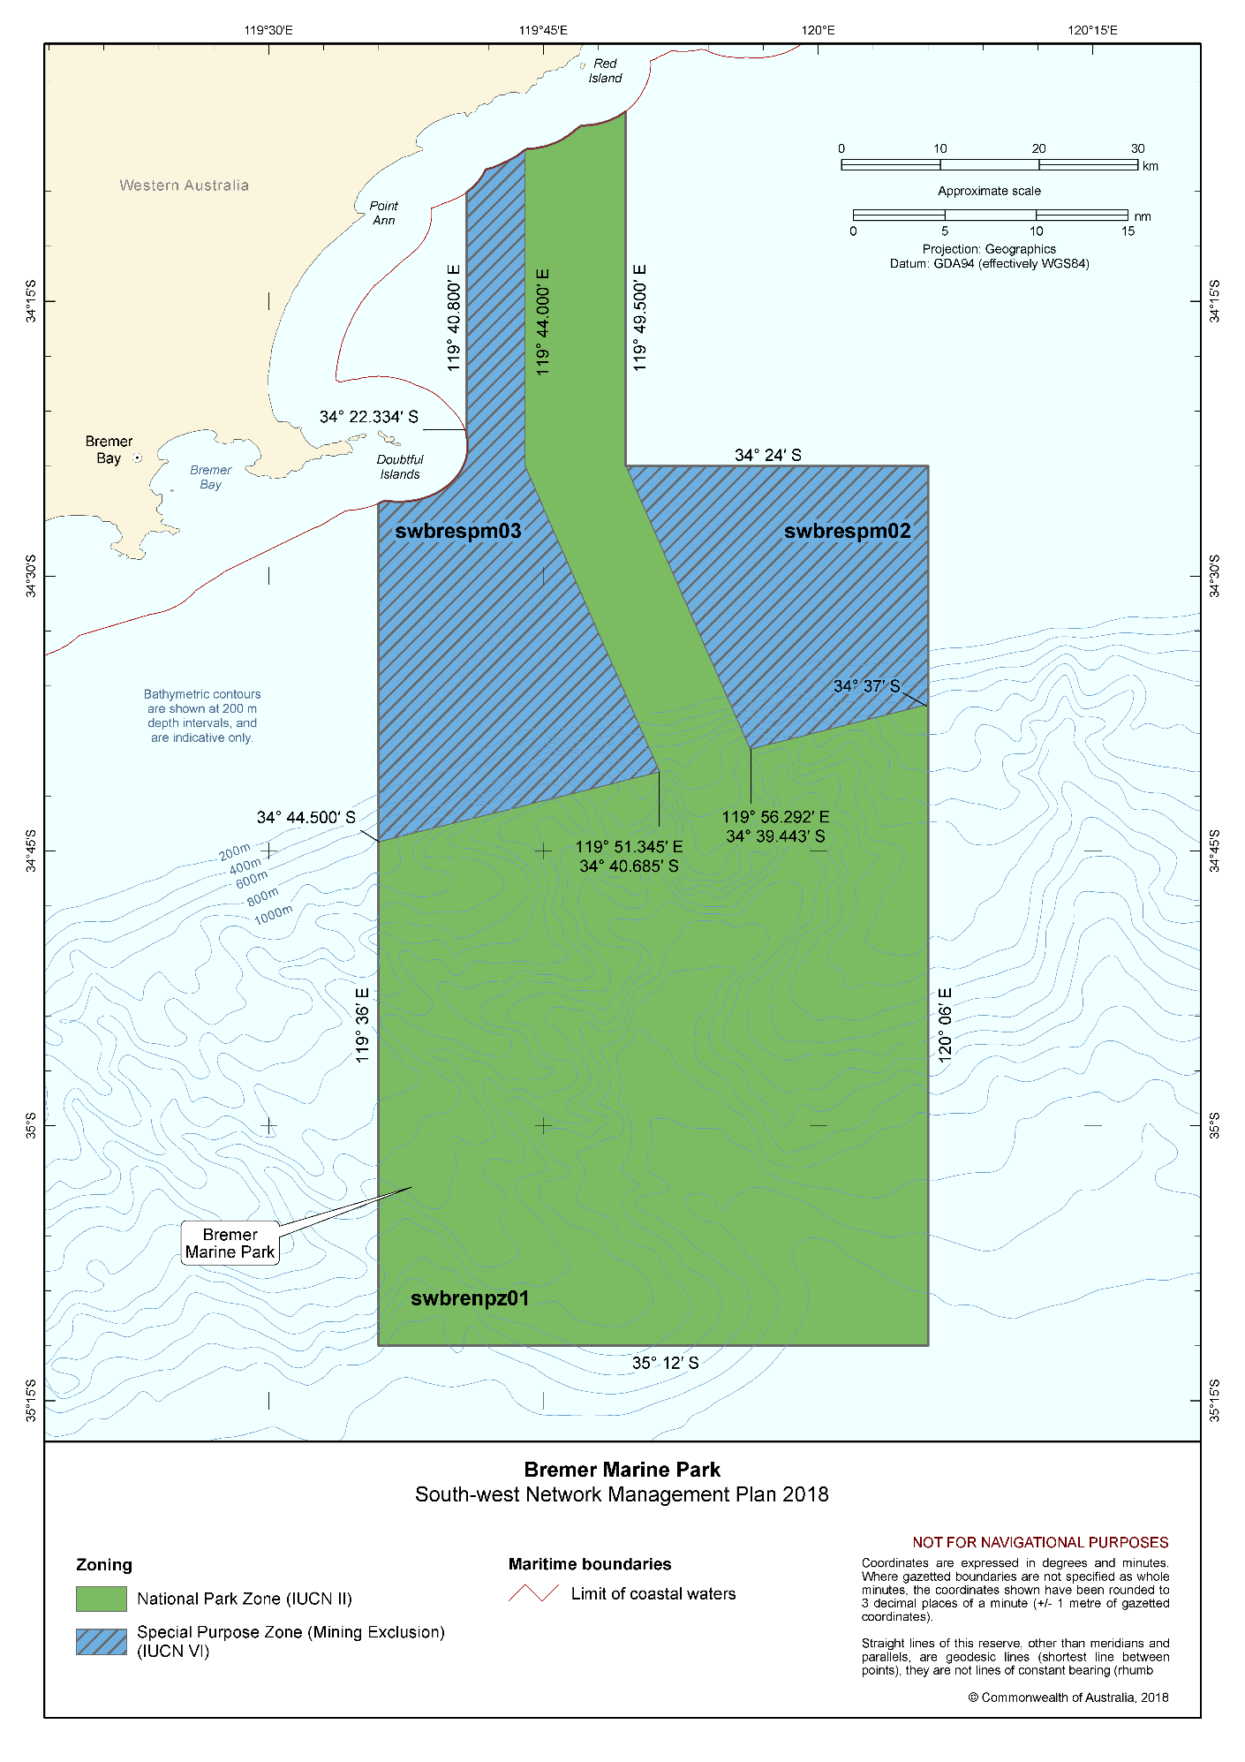Figure S2.9 Bremer Marine Park

Geographe Marine Park
The Geographe Marine Park (Figure S2.10) is located in Geographe Bay, approximately 8 km west of Bunbury and 8 km north of Busselton, adjacent to the Western Australian Ngari Capes Marine Park. The Marine Park covers an area of 977 km², extending from the Western Australian state water boundary, and a water depth range between 15 m and 70 m.
The Marine Park was proclaimed under the EPBC Act on 14 December 2013 and renamed Geographe Marine Park on 9 October 2017. The Marine Park is assigned IUCN category VI and includes four zones assigned under this plan: National Park Zone (II), Habitat Protection Zone (IV), Multiple Use Zone (VI) and Special Purpose Zone (Mining Exclusion) (VI).
Coordinates for the Geographe Marine Park and zones are provided in Figure S2.10 and Schedule 4.
Statement of significance
The Geographe Marine Park is significant because it contains habitats, species and ecological communities associated with the South-west Shelf Province. It includes two key ecological features: the Commonwealth marine environment within and adjacent to Geographe Bay (valued for high productivity and aggregations of marine life, and high levels of biodiversity and endemism); and western rock lobster (valued as a species that plays a regionally important ecological role).
The Marine Park contains an area of high productivity supported by extensive and diverse seagrass beds that cover approximately 60 per cent of Geographe Bay. Tropical and temperate seagrass species account for 80 per cent of the benthic primary production in the area. These meadows provide habitat for fish and invertebrates. Geographe Bay provides important nursery habitat, resting areas and foraging habitats for sharks, whales and seabirds.
The Marine Park includes habitats connecting to and complementing the adjacent Western Australian Ngari Capes Marine Park.
Natural values
The Marine Park includes examples of ecosystems representative of the South-west Shelf Province—an area of diverse marine life, influenced by the warm waters of the Leeuwin Current. The bioregion includes globally important biodiversity hotspots, such as the waters off Geographe Bay.
Key ecological features of the Marine Park are:
- Commonwealth marine environment within and adjacent to Geographe Bay—the sheltered waters of Geographe Bay support extensive seagrass beds that in turn provide important nursery habitat for a range of marine species; and
- Western rock lobster—plays an important trophic role in many of the inshore ecosystems of the South-west Marine Region. Western rock lobsters are an important part of the food web on the inner shelf, particularly as juveniles.
The Marine Park supports a range of species including species listed as threatened, migratory, marine or cetacean under the EPBC Act. Biologically important areas within the Marine Park include foraging habitat for seabirds, a migratory pathway for humpback and pygmy blue whales, and a calving buffer area for southern right whales.
Cultural values
Sea country is valued for Indigenous cultural identity, health and wellbeing. Across Australia, Indigenous people have been sustainably using and managing their sea country for tens of thousands of years.
The Noongar people have responsibility for sea country in the Marine Park. Traditional owners have maintained cultural responsibilities for sea country as passed down from elders, to keep the oceans healthy, to support spiritual wellbeing and to uphold and protect obligatory cultural responsibilities for future generations.
The South West Aboriginal Land and Sea Council is the Native Title Service Provider for the South-west region.
Heritage values
No international, Commonwealth or national heritage listings apply to the Marine Park at commencement of this plan.
Historic shipwrecks
The Marine Park contains eight known shipwrecks listed under the Historic Shipwrecks Act 1976.
Social and economic values
Tourism, commercial fishing and recreation, including fishing, are important activities in the Marine Park. These activities contribute to the wellbeing of regional communities and the prosperity of the nation.

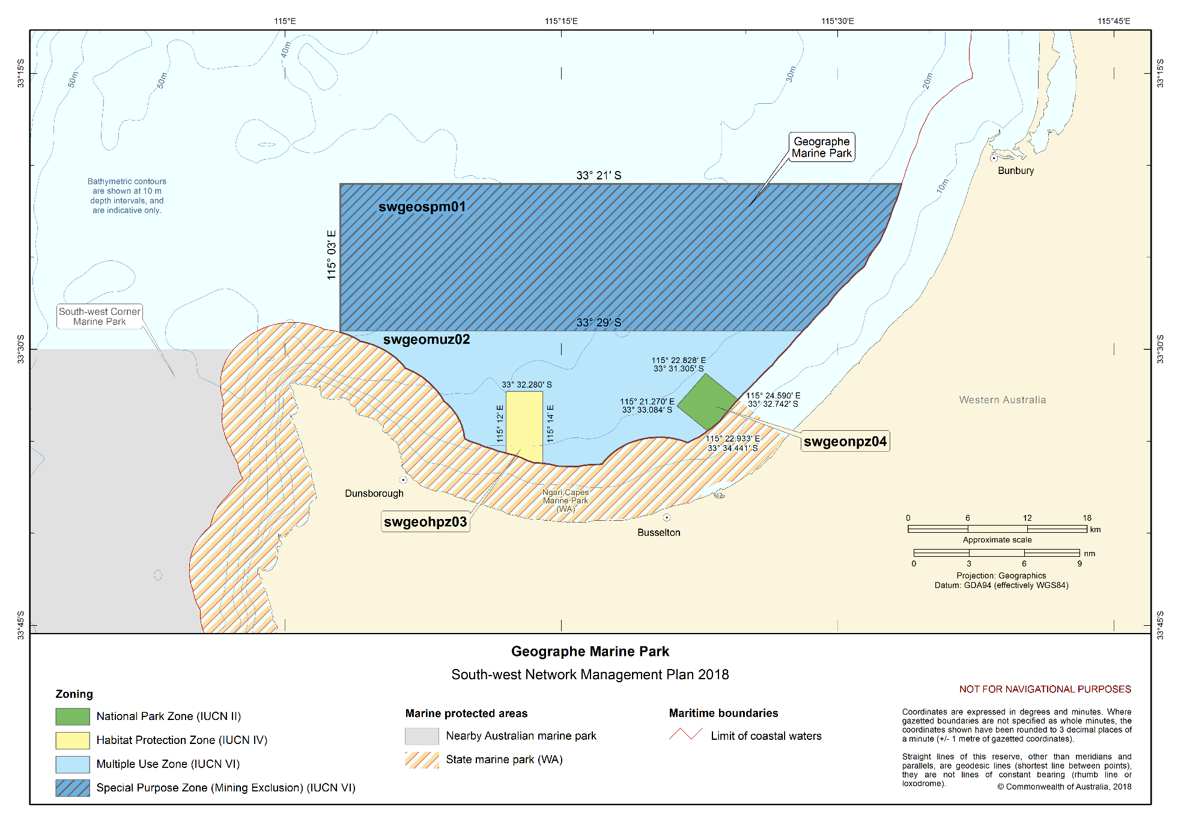
Figure S2.10 Geographe Marine Park

Perth Canyon Marine Park
The Perth Canyon Marine Park (Figure S2.11) is located approximately 52 km west of Perth and approximately 19 km west of Rottnest Island. The Marine Park covers an area of 7409 km² and water depths range between 120 m and 5000 m.
The Marine Park was proclaimed under the EPBC Act on 14 December 2013 and renamed Perth Canyon Marine Park on 9 October 2017. The Marine Park is assigned IUCN category IV and includes three zones assigned under this plan: National Park Zone (II), Habitat Protection Zone (IV) and Multiple Use Zone (VI).
Coordinates for the Perth Canyon Marine Park and zones are provided in Figure S2.11 and Schedule 4.
Statement of significance
The Perth Canyon Marine Park is significant because it includes habitats, species and ecological communities associated with four bioregions: Central Western Province; South-west Shelf Province; South-west Transition; and South-west Shelf Transition. It includes four key ecological features: Perth Canyon and adjacent shelf break, and other west-coast canyons (valued for high biological productivity and aggregations of marine life, and unique seafloor features with ecological properties of regional significance); demersal slope and associated fish communities of the Central Western Province (valued as a species group that are nationally or regionally important to biodiversity); western rock lobster (valued as a species that plays a regionally important ecological role); and mesoscale eddies (valued for high productivity and aggregations of marine life).
The Marine Park includes the majority of the Perth Canyon, Australia’s largest submarine canyon, which is home to the largest feeding aggregations of blue whales in Australia. This unique feature is also of particular significance because it cuts into the continental shelf at approximately 150 m depth west of Rottnest Island, linking the shelf with deeper ecosystems at depths of up to 5000 m.
The Marine Park represents the southern end of the transition area from tropical to temperate marine environments.
Natural values
The Marine Park includes examples of ecosystems representative of:
- Central Western Province—characterised by a narrow continental slope incised by many submarine canyons, including Perth Canyon, and the most extensive area of continental rise in any of Australia’s marine regions. A significant feature within the area are several eddies that form off the Leeuwin Current at predictable locations, including the Perth Canyon;
- South-west Shelf Province—marine life in this area is diverse and influenced by the warm waters of the Leeuwin Current;
- South-west Transition—significant features of this area include the submarine canyons that incise the northern parts of the slope and the deep-water mixing that results from the dynamics of major ocean currents when these meet the seafloor, particularly in the Perth Canyon; and
- South-west Shelf Transition—consists of a narrow continental shelf that is noted for its physical complexity. The Leeuwin Current has a significant influence on the biodiversity of this nearshore area as it pushes subtropical water southward along the area’s western edge. The area contains a diversity of tropical and temperate marine life including a large number of endemic fauna species.
Key ecological features of the Marine Park are:
- Perth Canyon and adjacent shelf break, and other west-coast canyons—unique seafloor features give rise to ecologically important events of localised productivity and aggregations of marine life. The Perth Canyon is prominent among these canyons because of its large size and ecological importance. The upwelling of deep ocean currents in the canyon creates a nutrient-rich cold-water habitat that attracts feeding aggregations of deep-diving mammals, such as pygmy blue whales and large predatory fish that feed on aggregations of small fish, krill and squid;
- Demersal slope and associated fish communities of the Central Western Province—an area that provides important habitat for demersal fish communities and is characterised by high species diversity and endemism;
- Western rock lobster—plays an important trophic role in many of the inshore ecosystems of the South-west Marine Region. Western rock lobsters are an important part of the food web on the inner shelf, particularly as juveniles; and
- Mesoscale eddies—important transporters of nutrients and plankton communities that form at predictable locations off the western and south-western shelf break.
The Marine Park supports a range of species including species listed as threatened, migratory, marine or cetacean under the EPBC Act. Biologically important areas within the Marine Park include foraging habitat for seabirds, Antarctic blue, pygmy blue and sperm whales, a migratory pathway for humpback, Antarctic blue and pygmy blue whales, and a calving buffer area for southern right whales.
Cultural values
Sea country is valued for Indigenous cultural identity, health and wellbeing. Across Australia, Indigenous people have been sustainably using and managing their sea country for tens of thousands of years.
The Swan River traditional owners have responsibilities for sea country in the Marine Park. Traditional owners have maintained cultural responsibilities for sea country as passed down from elders, to keep the oceans healthy, to support spiritual wellbeing and to uphold and protect obligatory cultural responsibilities for future generations.
The South West Aboriginal Land and Sea Council is the Native Title Service Provider for the South-west region.
Heritage values
No international, Commonwealth or national heritage listings apply to the Marine Park at commencement of this plan.
Social and economic values
Tourism, commercial shipping, commercial fishing, recreation, including fishing, and defence training are important activities in the Marine Park. These activities contribute to the wellbeing of regional communities and the prosperity of the nation.

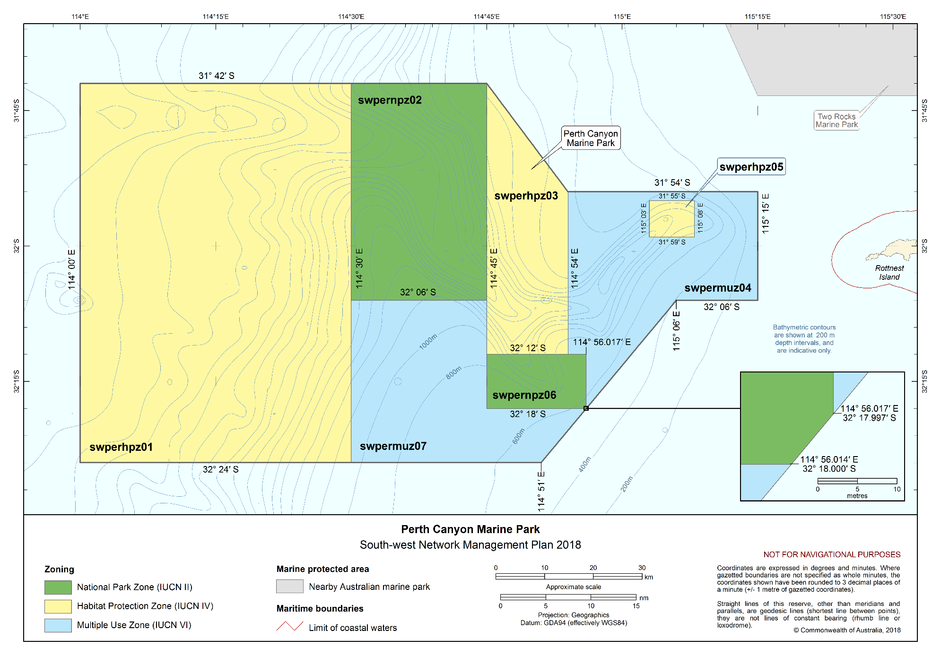Figure S2.11 Perth Canyon Marine Park

Two Rocks Marine Park
The Two Rocks Marine Park (Figure S2.12) is located approximately 25 km north-west of Perth, to the north-west of the Western Australian Marmion Marine Park. The Marine Park covers an area of 882 km², extending from the Western Australian state water boundary, and a water depth range from 15 m to 120 m.
The Marine Park was proclaimed under the EPBC Act on 14 December 2013 and renamed Two Rocks Marine Park on 9 October 2017. The Marine Park is assigned IUCN category VI and includes two zones assigned under this plan: National Park Zone (II) and Multiple Use Zone (VI).
Coordinates for the Two Rocks Marine Park and zones are provided in Figure S2.12 and Schedule 4.
Statement of significance
The Two Rocks Marine Park is significant because it includes habitats, species and ecological communities associated with the South-west Shelf Transition. It includes three key ecological features: the Commonwealth marine environment within and adjacent to the west-coast inshore lagoons (valued for high productivity and aggregations of marine life, and high levels of biodiversity and endemism); western rock lobster (valued as a species that plays a regionally important ecological role); and ancient coastline between 90 m and 120 m depth (valued for relatively high productivity, aggregations of marine life and high levels of biodiversity and endemism).
The Marine Park is shallow and provides connectivity between offshore waters and the west coast inshore lagoons, which are key areas for the recruitment of rock lobster and other commercially and recreationally important fish species.
Natural values
The Marine Park includes examples of ecosystems representative of the South-west Shelf Transition—an area of narrow continental shelf that is noted for its physical complexity. The Leeuwin Current has a significant influence on the biodiversity of this nearshore area as it pushes subtropical water southward along the area’s western edge. The area contains a diversity of tropical and temperate marine life including a large number of endemic fauna species. The inshore lagoons are thought to be important areas for benthic productivity and recruitment for a range of marine species.
Key ecological features of the Marine Park are:
- Commonwealth marine environment within and adjacent to the west-coast inshore lagoons—an area that is regionally important for enhanced benthic productivity, including macroalgae and seagrass communities, and breeding and nursery aggregations for many temperate and tropical marine species;
- Western rock lobster—plays an important trophic role in many of the inshore ecosystems of the South-west Marine Region. Western rock lobsters are an important part of the food web on the inner shelf, particularly as juveniles; and
- Ancient coastline between 90 m and 120 m depth—high benthic biodiversity and productivity occur where the ancient coastline forms a prominent escarpment.
The Marine Park supports a range of species including species listed as threatened, migratory, marine or cetacean under the EPBC Act. Biologically important areas within the Marine Park include foraging habitat for seabirds and Australian sea lions, a migratory pathway for humpback and pygmy blue whales, and a calving buffer area for southern right whales.
Cultural values
Sea country is valued for Indigenous cultural identity, health and wellbeing. Across Australia, Indigenous people have been sustainably using and managing their sea country for tens of thousands of years.
The Swan River traditional owners have responsibilities for sea country in the Marine Park. Traditional owners have maintained cultural responsibilities for sea country as passed down from elders, to keep the oceans healthy, to support spiritual wellbeing and to uphold and protect obligatory cultural responsibilities for future generations.
The South West Aboriginal Land and Sea Council is the Native Title Service Provider for the South-west region.
Heritage values
No international, Commonwealth or national heritage listings apply to the Marine Park at commencement of this plan.
Social and economic values
Tourism, commercial fishing, recreation, including fishing, and scientific research are important activities in the Marine Park. These activities contribute to the wellbeing of regional communities and the prosperity of the nation.

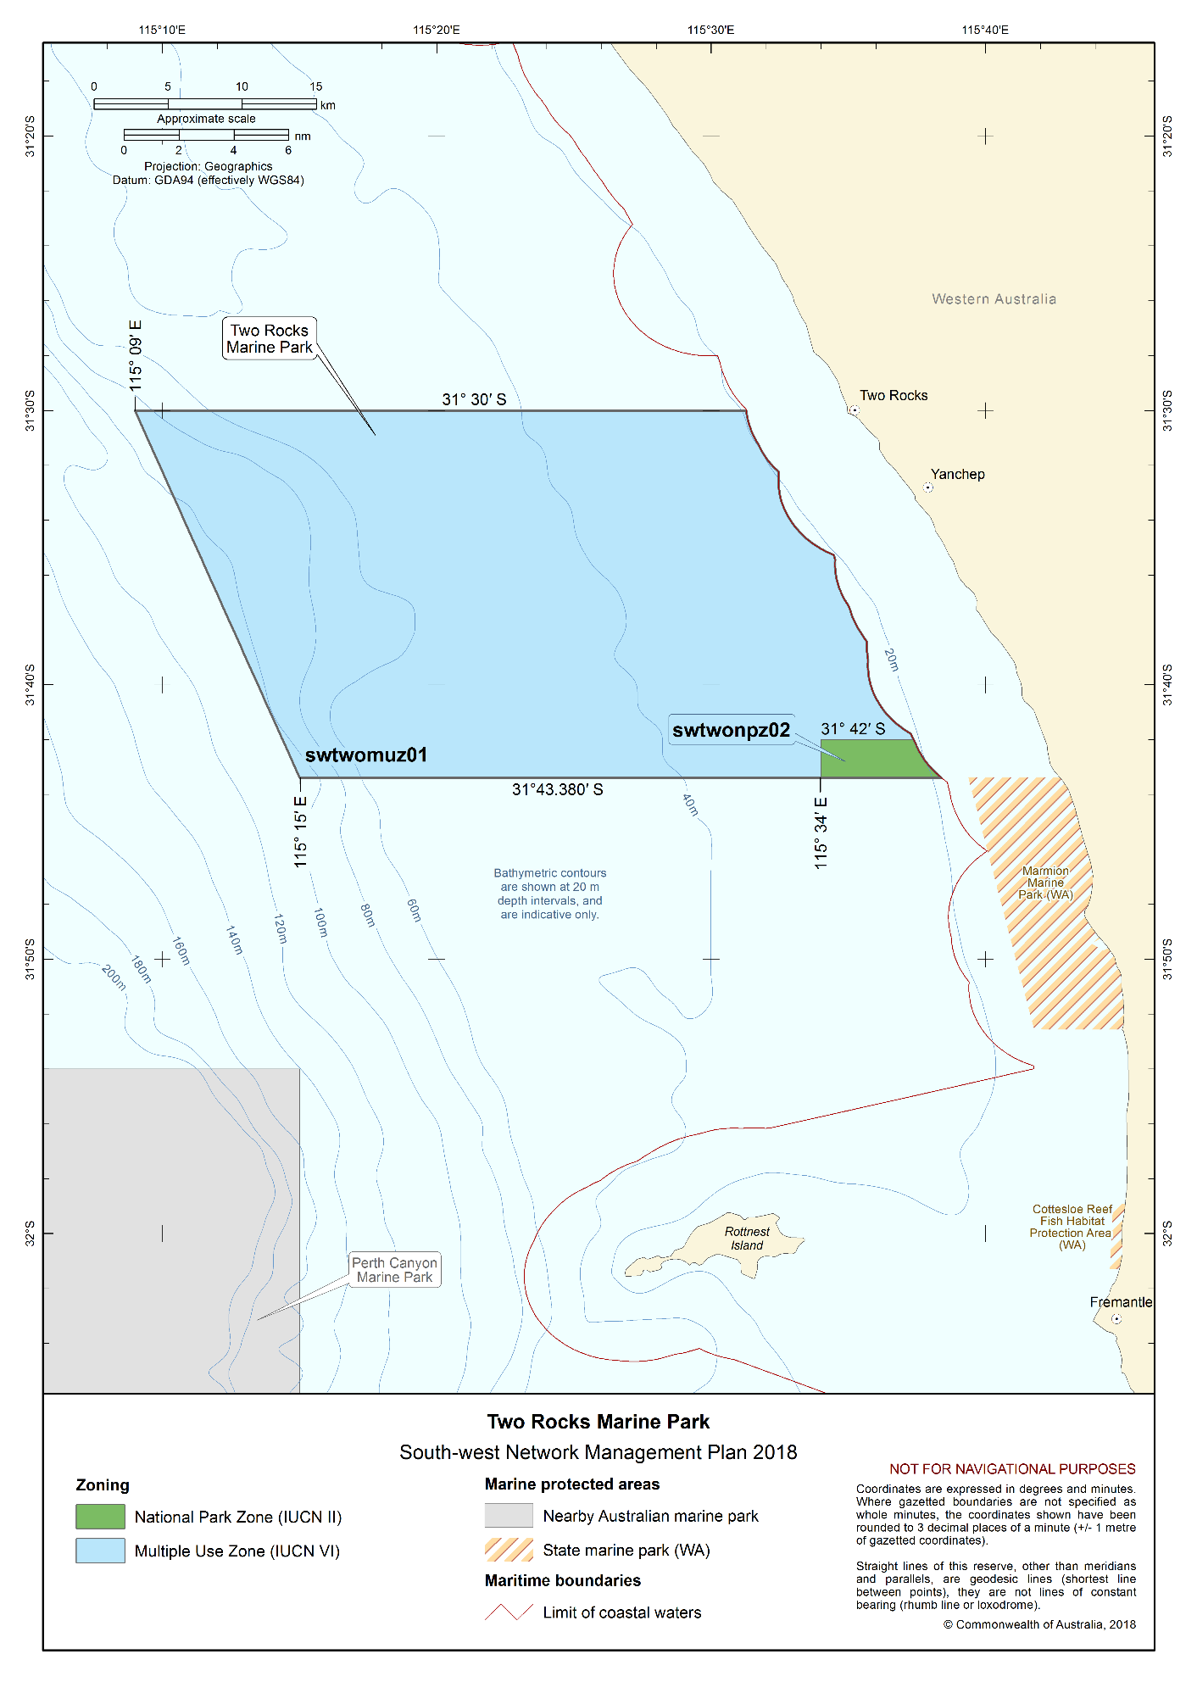Figure S2.12 Two Rocks Marine Park

Jurien Marine Park
The Jurien Marine Park (Figure S2.13) is located approximately 148 km north of Perth and 155 km south of Geraldton, adjacent to the Western Australian Jurien Bay Marine Park. The Marine Park covers an area of 1851 km² of continental shelf, extending from the Western Australian state water boundary, and a water depth range between 15 m and 220 m.
The Marine Park was proclaimed under the EPBC Act on 14 December 2013 and renamed Jurien Marine Park on 9 October 2017. The Marine Park is assigned IUCN category VI and includes two zones assigned under this plan: National Park Zone (II) and Special Purpose Zone (VI).
Coordinates for the Jurien Marine Park and zones are provided in Figure S2.13 and Schedule 4.
Statement of significance
The Jurien Marine Park is significant because it includes habitats, species and ecological communities associated with two bioregions: South-west Shelf Transition; and Central Western Province. It includes three key ecological features: ancient coastline between 90 and 120 m depth (valued for relatively high productivity, aggregations of marine life and high levels of biodiversity and endemism); demersal slope and associated fish communities of the Central Western Province (valued as a species group that are nationally or regionally important to biodiversity); and western rock lobster (valued as a species that plays a regionally important ecological role).
The Marine Park contains a mixture of tropical species carried south by the Leeuwin Current, and temperate species carried north by the Capes Current. The Marine Park’s shelf habitats are defined by distinct ridges of limestone reef with extensive beds of macroalgae. Inshore lagoons are inhabited by a diverse range of invertebrates and fish. Seagrass meadows occur in more sheltered areas as well as in the inter-reef lagoons along exposed sections of the coast.
The Marine Park includes habitats connecting to and complementing the adjacent Western Australian Jurien Bay Marine Park.
Natural values
The Marine Park includes examples of ecosystems representative of:
- South-west Shelf Transition—consists of a narrow continental shelf that is noted for its physical complexity. The Leeuwin Current has a significant influence on the biodiversity of this nearshore area as it pushes subtropical water southward along the bioregion’s western edge. The area contains a diversity of tropical and temperate marine life including a large number of endemic fauna species; and
- Central Western Province—the Marine Park includes a small component of this bioregion, characterised by a narrow continental slope and influenced by the Leeuwin Current.
Key ecological features of the Marine Park are:
- Ancient coastline between 90 m and 120 m depth—high benthic biodiversity and productivity occur where the ancient coastline forms a prominent escarpment;
- Demersal slope and associated fish communities of the Central Western Province—an area that provides important habitat for demersal fish communities and is characterised by high species diversity and endemism; and
- Western rock lobster—plays an important trophic role in many of the inshore ecosystems of the South-west Marine Region. Western rock lobsters are an important part of the food web on the inner shelf, particularly as juveniles.
The Marine Park supports a range of species including species listed as threatened, migratory, marine or cetacean under the EPBC Act. Biologically important areas within the Marine Park include foraging habitat for seabirds, Australian sea lions and white sharks, and a migratory pathway for humpback and pygmy blue whales.
Cultural values
Sea country is valued for Indigenous cultural identity, health and wellbeing. Across Australia, Indigenous people have been sustainably using and managing their sea country for tens of thousands of years.
The Noongar people have responsibilities for sea country in the Marine Park. Traditional owners have strong stories that connect ocean and land. Artefacts from ancestors are abundant on islands in the adjacent state marine park.
The South West Aboriginal Land and Sea Council is the Native Title Service Provider for the South-west region.
Heritage values
No international, Commonwealth or national heritage listings apply to the Marine Park at commencement of this plan.
Historic shipwrecks
The Marine Park contains two known shipwrecks listed under the Historic Shipwrecks Act 1976—SS Cambewarra (wrecked in 1914), Oleander (wrecked in 1884).
Social and economic values
Tourism, commercial fishing, mining and recreation, including fishing, are important activities in the Marine Park. These activities contribute to the wellbeing of regional communities and the prosperity of the nation.

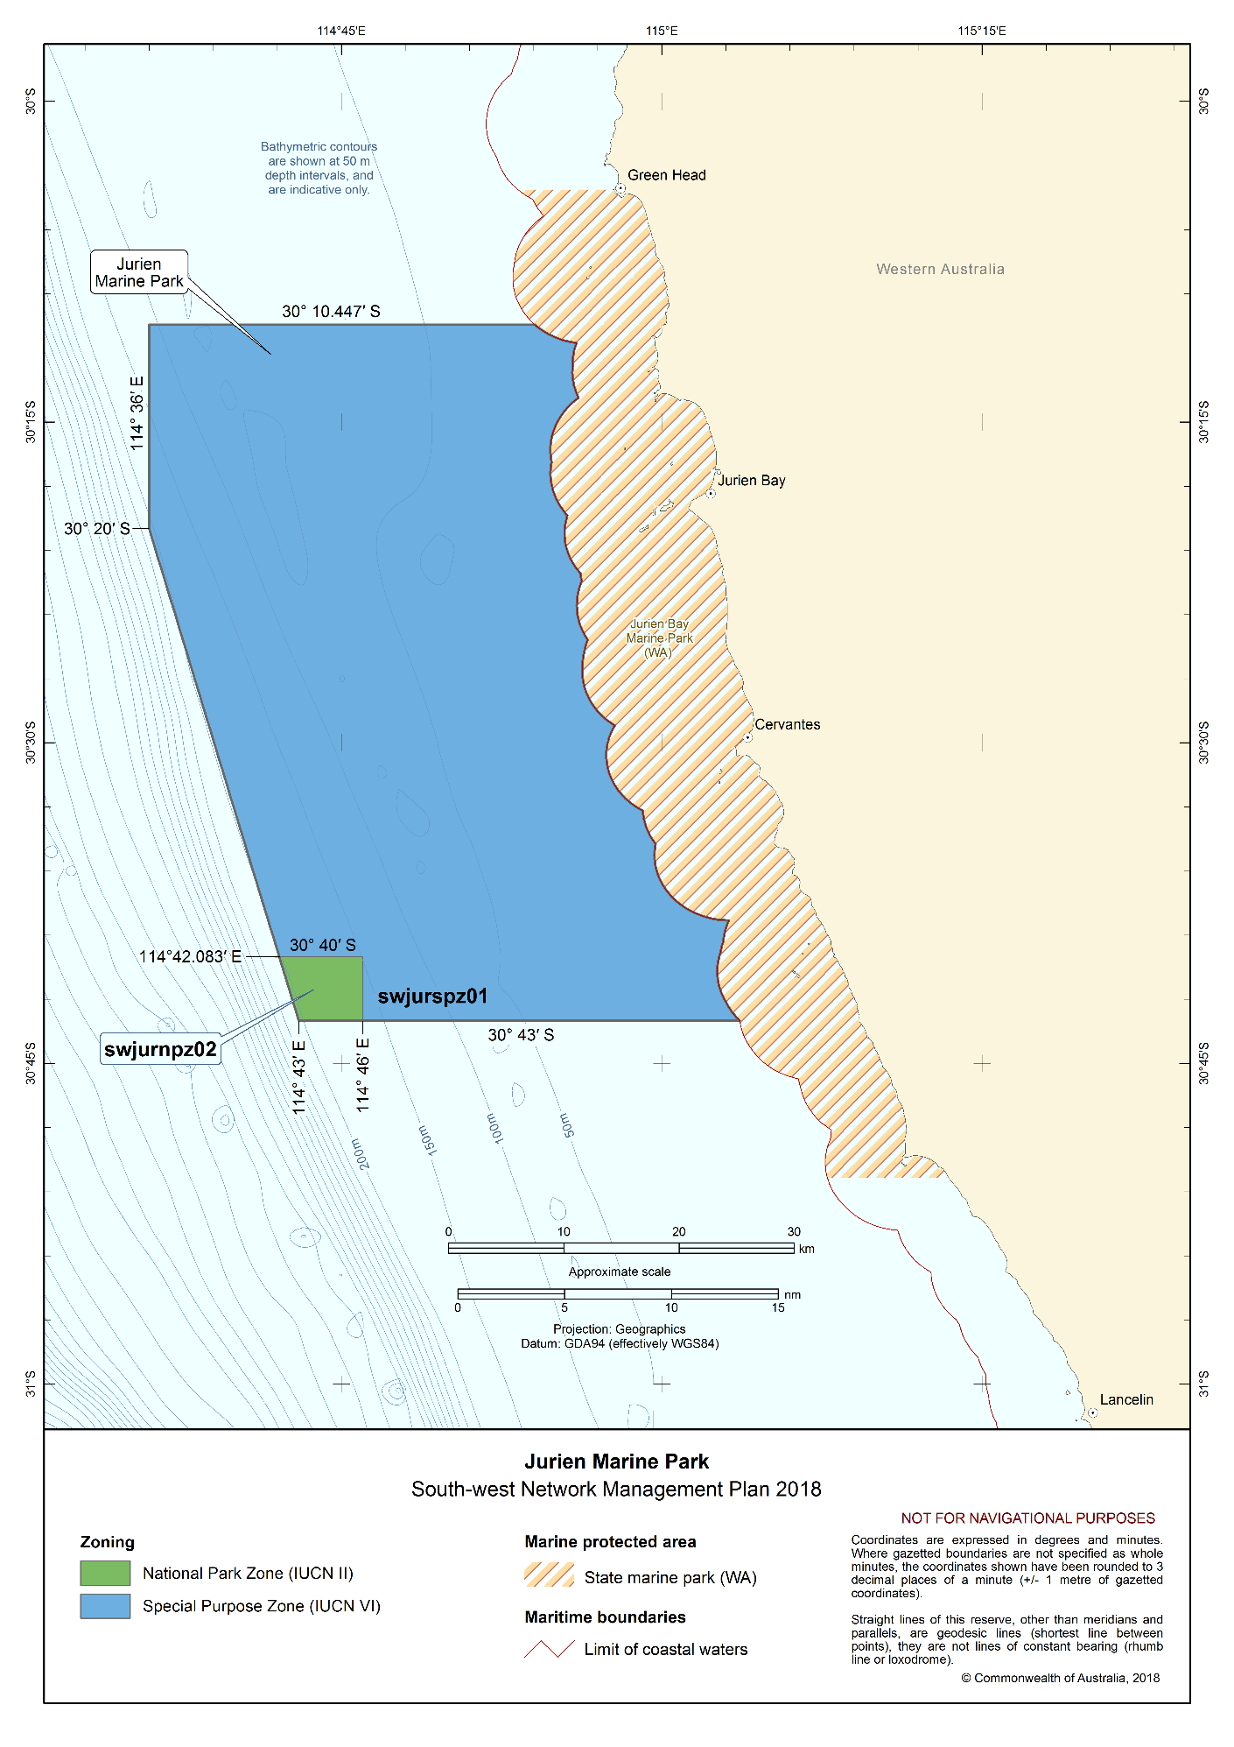Figure S2.13 Jurien Marine Park

Abrolhos Marine Park
The Abrolhos Marine Park (Figure S2.14) is located adjacent to the Western Australian Houtman Abrolhos Islands, covering a large offshore area extending from the Western Australian state water boundary to the edge of Australia’s exclusive economic zone. It is located approximately 27 km south-west of Geraldton and extends north to approximately 330 km west of Carnarvon. The northernmost part of the shelf component of the Marine Park, north of Kalbarri, is adjacent to the Shark Bay World Heritage Area. The Marine Park covers an area of 88,060 km² and a water depth range between less than 15 m and 6000 m.
The Marine Park was proclaimed under the EPBC Act on 14 December 2013 and renamed Abrolhos Marine Park on 9 October 2017. The Marine Park is assigned IUCN category VI and includes four zones assigned under this plan: National Park Zone (II), Habitat Protection Zone (IV), Multiple Use Zone (VI) and Special Purpose Zone (VI).
Coordinates for the Abrolhos Marine Park and zones are provided in Figure S2.14 and Schedule 4.
Statement of significance
The Abrolhos Marine Park is significant because it contains habitats, species and ecological communities associated with four bioregions: Central Western Province; Central Western Shelf Province; Central Western Transition; and South-west Shelf Transition. It includes seven key ecological features: the Commonwealth marine environment surrounding the Houtman Abrolhos Islands (valued for high levels of biodiversity and endemism); demersal slope and associated fish communities of the Central Western Province (valued as a species group that are nationally or regionally important to biodiversity); mesoscale eddies (valued for high productivity and aggregations of marine life); Perth Canyon and adjacent shelf break, and other west-coast canyons (valued for high biological productivity and aggregations of marine life, and unique seafloor features with ecological properties of regional significance); western rock lobster (valued as a species that plays a regionally important ecological role); ancient coastline between 90 m and 120 m depth (valued for relatively high productivity, aggregations of marine life and high levels of biodiversity and endemism); and Wallaby Saddle (valued for high productivity and aggregations of marine life).
The southern shelf component of the Marine Park partially surrounds the Western Australian Houtman Abrolhos Islands Nature Reserve. The islands and surrounding reefs are renowned for their high level of biodiversity, due to the southward movement of species by the Leeuwin Current. The Marine Park contains a number of seafloor features including the Houtman Canyon, the second largest submarine canyon on the west coast (the Perth Canyon being the largest).
Natural values
The Marine Park includes examples of ecosystems representative of:
- Central Western Province—characterised by a narrow continental slope incised by many submarine canyons and the most extensive area of continental rise in any of Australia’s marine regions. A significant feature within the area are several eddies that form off the Leeuwin Current at predictable locations, including west of the Houtman Abrolhos Islands;
- Central Western Shelf Province—a predominantly flat, sandy and low nutrient area, in water depths between 50 and 100 m. Significant seafloor features of this area include a deep hole and associated area of banks and shoals offshore of Kalbarri. The area is a transitional zone between tropical and temperate species;
- Central Western Transition—a deep ocean area characterised by large areas of continental slope, a range of significant seafloor features including the Wallaby Saddle, seasonal and sporadic upwelling, and benthic slope communities comprising tropical and temperate species; and
- South-west Shelf Transition—a narrow continental shelf that is noted for its physical complexity. The Leeuwin Current has a significant influence on the biodiversity of this nearshore area as it pushes subtropical water southward along the area’s western edge. The area contains a diversity of tropical and temperate marine life including a large number of endemic fauna species.
Key ecological features of the Marine Park are:
- Commonwealth marine environment surrounding the Houtman Abrolhos Islands—the islands are among Australia’s most important seabird breeding sites, with extensive foraging grounds in Commonwealth waters. The islands and surrounding reefs support a unique mix of temperate and tropical species, resulting from the southward movement of species by the Leeuwin Current;
- Demersal slope and associated fish communities of the Central Western Province—an area that provides important habitat for demersal fish communities and is characterised by high species diversity and endemism;
- Mesoscale eddies—important transporters of nutrients and plankton communities that form at predictable locations off the western and south-western shelf break;
- Perth Canyon and adjacent shelf break, and other west-coast canyons—unique seafloor features give rise to ecologically important events of localised productivity and aggregations of marine life;
- Western rock lobster—plays an important trophic role in many of the inshore ecosystems of the South-west Marine Region. Western rock lobsters are an important part of the food web on the inner shelf, particularly as juveniles;
- Ancient coastline between 90 m and 120 m depth—high benthic biodiversity and productivity occur where the ancient coastline forms a prominent escarpment; and
- Wallaby Saddle—a unique seafloor feature that is associated with enhanced biological productivity in an area of generally low productivity. The saddle is the site of upwellings of deeper, more nutrient-rich waters and aggregations of marine species including large predators such as sperm whales.
The Marine Park supports a range of species including species listed as threatened, migratory, marine or cetacean under the EPBC Act. Biologically important areas within the Marine Park include foraging and breeding habitat for seabirds, foraging habitat for Australian sea lions and white sharks, and a migratory pathway for humpback and pygmy blue whales. The Marine Park is adjacent to the northernmost Australian sea lion breeding colony in Australia on the Houtman Abrolhos Islands.
Cultural values
Sea country is valued for Indigenous cultural identity, health and wellbeing. Across Australia, Indigenous people have been sustainably using and managing their sea country for tens of thousands of years.
The Nanda and Naaguja People have responsibilities for sea country in the Marine Park. Traditional owners have strong stories that connect ocean and land. Artefacts from ancestors are abundant on islands in the adjacent state marine park.
The Yamatji Marlpa Aboriginal Corporation is the Native Title Representative Body for the Yamatji region.
Heritage values
No international heritage listings apply to the Marine Park at the commencement of this plan, however, the Marine Park is adjacent to the Western Australian Shark Bay World Heritage Property, listed as an area of outstanding universal value under the World Heritage Convention in 1991, meeting world heritage listing criteria vii, viii, ix, and x.
No Commonwealth or national heritage listings apply to the Marine Park at the commencement of this plan; however the Marine Park is adjacent to the Western Australian Shark Bay National Heritage Place.
Historic shipwrecks
The Marine Park contains 11 known shipwrecks listed under the Historic Shipwrecks Act 1976.
The Zuytdorp (wrecked in 1712) historic shipwreck protected zone lies in state waters adjacent to the northernmost part of the shelf component of the Marine Park, north of Kalbarri. The HMAS Sydney II and HSK Kormoran Shipwreck Sites (1941) lie at 2500 m depth about 75 km east of the northern part of the Marine Park. This site is on the National Heritage List and a historic shipwreck protected zone. The Batavia (wrecked on the adjacent Abrolhos Islands in 1629) Shipwreck Site and Survivor Camps Area are on the National Heritage List.
Social and economic values
Tourism, commercial fishing, mining, recreation including fishing, are important activities in the Marine Park. These activities contribute to the wellbeing of regional communities and the prosperity of the nation.

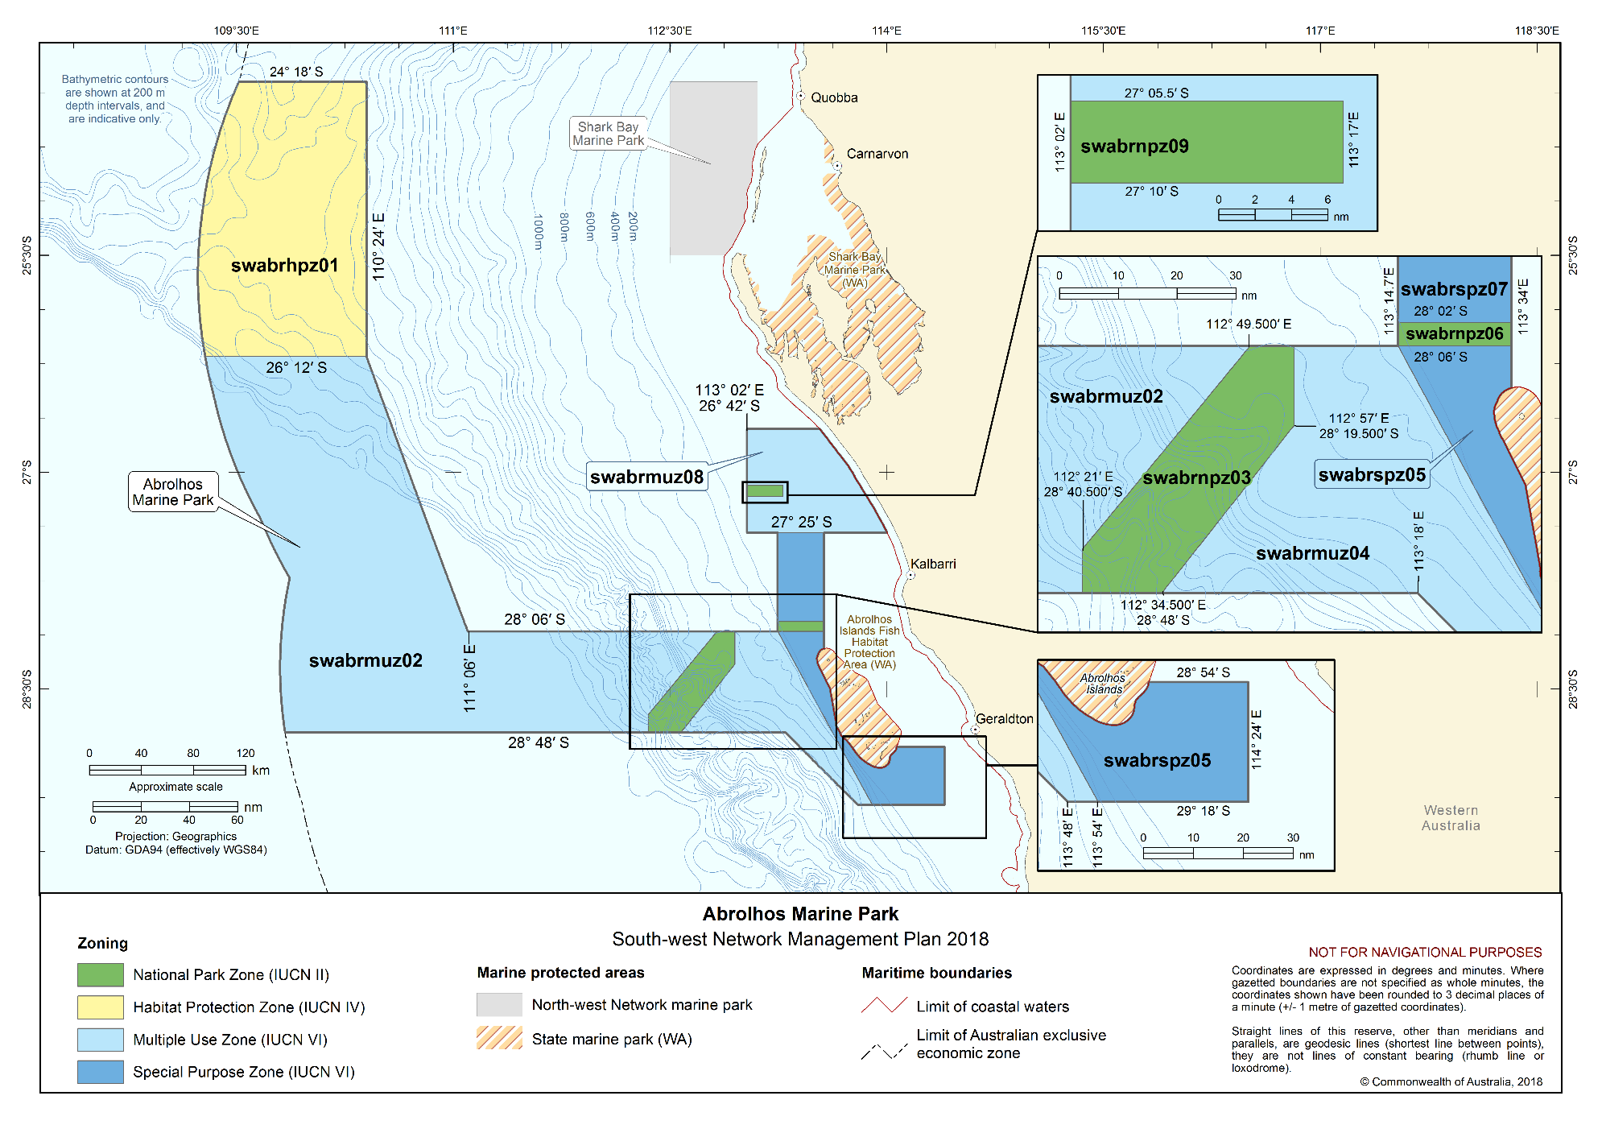Figure S2.14 Abrolhos Marine Park

Schedule 3 Environmental features used in the design of the South-west Network
Four types of environmental features were used in the design of the Marine Parks of the South-west Network to help identify areas for protection. These features were identified based on the scientifically known relationships between biodiversity and the physical environment and include bioregions, water depth, seafloor features and key ecological features. They are identified below.
More information on these features can be found in the Marine bioregional plan for the South-west Marine Region (2012), the South-west marine bioregional plan: bioregional profile (2008), and the conservation values atlas on the Department’s website.
Bioregions
Bioregions are identified in the Integrated Marine and Coastal Regionalisation of Australia (IMCRA) as large areas of ocean with broadly similar characteristics that have been classified by scientists based on the distribution of fish and other marine species, seafloor types and ocean conditions. The South-west Network represents nine bioregions including all seven found in the region—Central Western Province, Southwest Shelf Transition, Southwest Transition, Southwest Shelf Province, Southern Province, Great Australian Bight Shelf Transition, Spencer Gulf Shelf Province—and the Central Western Transition and Central Western Shelf Province of the North-west Marine Region (Figure S3.1).
Depth ranges
The South-west Network represents the full range of depths found in the region, from shallow waters of less than 15 m to abyssal waters of more than 6000 m. Marine biological communities change with depth, and similar depth ranges in different bioregions support different groups of species. The range of ocean depths in each bioregion, represented as bathomes in Figure S3.2, have been included in the Network to ensure that examples of marine biodiversity are represented.
Seafloor features
The landscape-scale physical structure of the seafloor is important in determining where habitats or species occur. There is strong scientific evidence that different types of seafloor features provide different habitats and associated marine species and communities. The Network represents 15 of the 16 seafloor features found in the region—abyssal plain/deep ocean floor, bank/shoal, canyon, continental rise, deep/hole/valley, escarpment, knoll/abyssal hills/hills/mountain/peak, pinnacle, plateau, reef, ridge, saddle, shelf, slope, terrace, trench/trough—and includes a saddle of the North-west Marine Region (Figure S3.3).
Key ecological features
Key ecological features were identified through the marine bioregional planning program as areas or features that support distinct or important ecological communities at a regional scale. The South-west Network represents 14 key ecological features including all 13 key ecological features found in the region—Albany Canyons Group and adjacent shelf break, ancient coastline at the 90–120 m depth contour, areas important for small pelagic fish, benthic invertebrate communities of the eastern Great Australian Bight, Cape Mentelle upwelling, Commonwealth marine environment surrounding the Houtman Abrolhos Islands, Commonwealth marine environment surrounding the Recherche Archipelago, Commonwealth marine environment within and adjacent to Geographe Bay, Commonwealth marine environment within and adjacent to the west-coast inshore lagoons, Diamantina Fracture Zone, Kangaroo Island Pool, canyons and adjacent shelf break, and Eyre Peninsula upwellings, mesoscale eddies, Naturaliste Plateau, Perth Canyon and adjacent shelf break, and other west-coast canyons, western demersal slope and associated fish communities, western rock lobster—and the Wallaby Saddle of the North-west Marine Region (Figure S3.4).
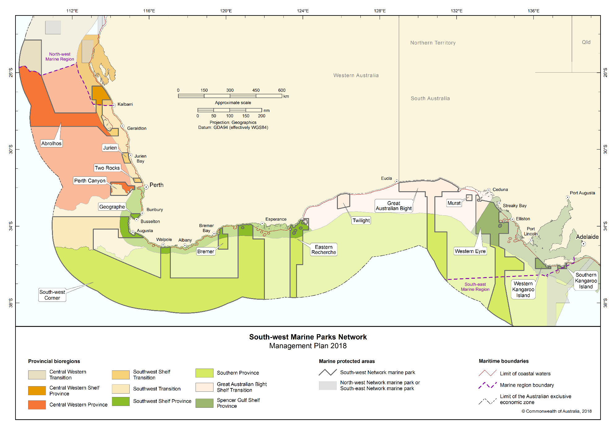Figure S3.1 Bioregions represented in the South-west Network

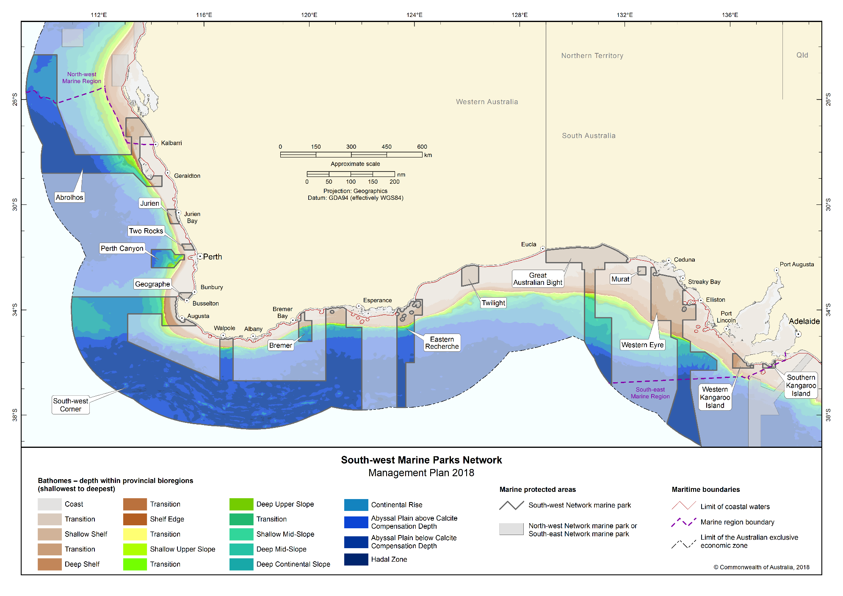Figure S3.2 Bathomes indicating depth ranges represented in the South-west Network

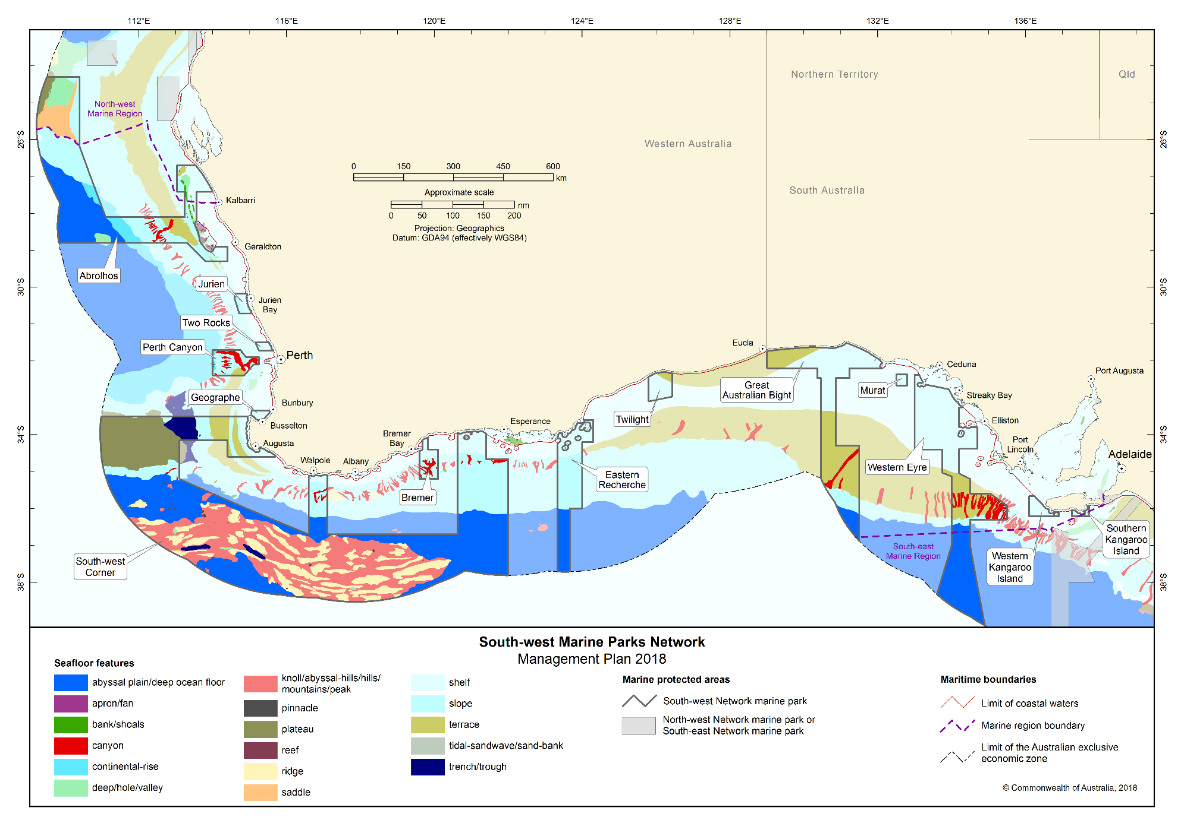Figure S3.3 Seafloor features represented in the South-west Network

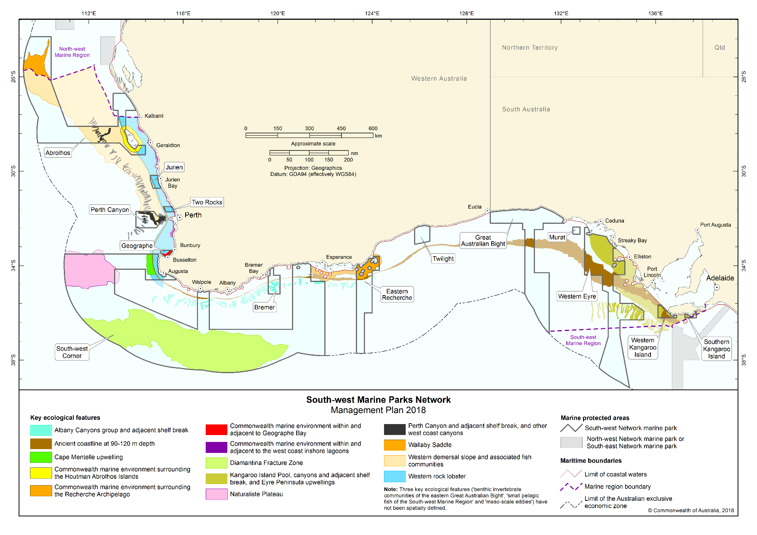Figure S3.4 Key ecological features represented in the South-west Network

Schedule 4 South-west Network marine parks and zone boundary descriptions
In this Schedule:
State waters has the same meaning as coastal waters of the State in subsection 3 (1) of the Coastal Waters (State Powers) Act 1980.
Note: Geographic coordinates are expressed in terms of the Geocentric Datum of Australia 1994.
Note: The Geocentric Datum of Australia 1994 (also known as GDA94) was published in Gazette No. GN 35 of 6 September 1995.

Part 1 — Southern Kangaroo Island Marine Park

1.1 Area of marine park
The Southern Kangaroo Island Marine Park consists of an area in the Southern Ocean bounded by the line commencing at the point described in item 1 of the following table and running progressively as described in the table.
Area of marine park
Item | Description
1 | The point of latitude 36° 13′ 00″ S, longitude 137° 15′ 00.86″ E
2 | North along the meridian of longitude 137° 15′ 00.86″ E to its intersection by the outer limit of the State waters of South Australia
3 | Generally south-easterly and north-easterly along that outer limit to its intersection by the meridian of longitude 137° 43′ 30.36″ E
4 | South along that meridian to its intersection by the parallel of latitude 36° 13′ 00″ S
5 | West along that parallel to the point of commencement

1.2 Zone (swskispm01) for marine park
(1) The Southern Kangaroo Island Marine Park has the following zone:
(a) the Special Purpose Zone (Mining Exclusion) (VI) described in Section 1.1 of this Part.

Part 2 — Western Kangaroo Island Marine Park

2.1 Area of marine park
The Western Kangaroo Island Marine Park consists of an area in the Southern Ocean, excluding any State waters of South Australia, bounded by the line commencing at the point described in item 1 of the following table and running progressively as described in the table.
Area of marine park
Item | Description
1 | The point of latitude 35° 39′ 50.15″ S, longitude 136° 06′ 00″ E
2 | East along the parallel of latitude 35° 39′ 50.15″ S to its intersection by the outer limit of the State waters of South Australia
3 | Generally south-easterly and easterly along that outer limit to its intersection by the meridian of longitude 136° 54′ 00″ E
4 | South along that meridian to its intersection by the parallel of latitude 36° 13′ 00″ S
5 | West along that parallel to its intersection by the meridian of longitude 136° 06′ 00″ E
6 | North along that meridian to the point of commencement

2.2 Zones for marine park
(1) The Western Kangaroo Island Marine Park is divided into the following zones:
(a) the National Park Zone (II) described in Section 2.3 of this Part;
(b) the Special Purpose Zone (Mining Exclusion) (VI) described in Section 2.4 of this Part;
(c) the Special Purpose Zone (VI) described in Section 2.5 of this Part.

2.3 Zone 1 (swwkinpz01) of marine park—National Park Zone (II)
Zone 1 (swwkinpz01) of the marine park consists of an area bounded by the line commencing at the point described in item 1 of the following table and running progressively as described in the table.
Zone 1 (swwkinpz01) of marine park—National Park Zone (II)
Item | Description
1 | The point of latitude 35° 39′ 50.15″ S, longitude 136° 14′ 00″ E
2 | East along the parallel of latitude 35° 39′ 50.15″ S to its intersection by the outer limit of the State waters of South Australia
3 | South-easterly along that outer limit to its intersection by the meridian of longitude 136° 23′ 00″ E
4 | South along that meridian to its intersection by the parallel of latitude 35° 49′ 00″ S
5 | West along that parallel to its intersection by the meridian of longitude 136° 14′ 00″ E
6 | North along that meridian to the point of commencement

2.4 Zone 2 (swwkispm02) of marine park—Special Purpose Zone (Mining Exclusion) (VI)
Zone 2 (swwkispm02) of the marine park consists of an area, excluding any State waters of South Australia, bounded by the line commencing at the point described in item 1 of the following table and running progressively as described in the table.
Zone 2 (swwkispm02) of marine park—Special Purpose Zone (Mining Exclusion) (VI)
Item | Description
1 | The point of latitude 35° 39′ 50.15″ S, longitude 136° 06′ 00″ E
2 | East along the parallel of latitude 35° 39′ 50.15″ S to its intersection by the meridian of longitude 136° 14′ 00″ E
3 | South along that meridian to its intersection by the parallel of latitude 35° 49′ 00″ S
4 | East along that parallel to its intersection by the meridian of longitude 136° 23′ 00″ E
5 | North along that meridian to its intersection by the outer limit of the State waters of South Australia
6 | Generally south-easterly and easterly along that outer limit to its intersection by the meridian of longitude 136° 54′ 00″ E
7 | South along that meridian to its intersection by the parallel of latitude 36° 13′ 00″ S
8 | West along that parallel to its intersection by the meridian of longitude 136° 30′ 54.77″ E
9 | North-westerly along the geodesic to the point of latitude 35° 50′ 22.32″ S, longitude 136° 06′ 00″ E
10 | North along that meridian to the point of commencement

2.5 Zone 3 (swwkispz03) of marine park—Special Purpose Zone (VI)
Zone 3 (swwkispz03) of the marine park consists of an area, excluding any State waters of South Australia, bounded by the line commencing at the point described in item 1 of the following table and running progressively as described in the table.
Zone 3 (swwkispz03) of marine park—Special Purpose Zone (VI)
Item | Description
1 | The point of latitude 36° 13′ 00″ S, longitude 136° 06′ 00″ E
2 | North along the meridian of longitude 136° 06′ 00″ E to its intersection by the parallel of latitude 35° 50′ 22.32″ S
3 | South-easterly along the geodesic to the point of latitude 36° 13′ 00″ S, longitude 136° 30′ 54.78″ E
4 | West along that meridian to the point of commencement

Part 3 — Western Eyre Marine Park

3.1 Area of marine park
The Western Eyre Marine Park consists of an area in the Southern Ocean, excluding any State waters of South Australia, bounded by the line commencing at the point described in item 1 of the following table and running progressively as described in the table.
Area of marine park
Item | Description
1 | The point of latitude 32° 23′ 00″ S, longitude 133° 00′ 00″ E
2 | East along the parallel of latitude 32° 23′ 00″ S to its intersection by the meridian of longitude 133° 07′ 20.89″ E
3 | North along that meridian to its intersection by the outer limit of the State waters of South Australia
4 | Generally south-easterly, westerly, southerly, easterly and south-easterly along that outer limit to its intersection by the parallel of latitude 33° 15′ 42.09″ S
5 | West along that parallel to its intersection by the meridian of longitude 134° 12′ 00″ E
6 | South along that meridian to its intersection by the parallel of latitude 33° 48′ 00″ S
7 | East along that parallel to its westernmost intersection by the outer limit of the State waters of South Australia, adjacent to Ward Islands
8 | Generally easterly along that outer limit to its easternmost intersection by the parallel of latitude 33° 48′ 00″ S
9 | East along that parallel of latitude to its westernmost intersection by the outer limit of the State waters of South Australia, adjacent to Flinders Island
10 | Generally easterly along that outer limit to its easternmost intersection by the parallel of latitude 33° 48′ 00″ S
11 | East along that parallel to its intersection by the meridian of longitude 134° 42′ 00″ E
12 | South along that meridian to its intersection by the parallel of latitude 34° 23′ 00″ S
13 | West along that parallel to its intersection by the meridian of longitude 134° 12′ 00″ E
14 | South along that meridian to its intersection by the parallel of latitude 35° 03′ 00″ S
15 | South-easterly along the geodesic to the point of latitude 35° 12′ 00″ S, longitude 134° 30′ 00″ E
16 | South along the meridian of longitude 134° 30′ 00″ E to its intersection by the parallel of latitude 35° 36′ 00″ S
17 | East along that parallel to its intersection by the meridian of longitude 135° 03′ 00″ E
18 | South-easterly along the geodesic to the point of latitude 35° 55′ 30″ S, longitude 135° 30′ 00″ E
19 | South along the meridian of longitude 135° 30′ 00″ E to its intersection by the parallel of latitude 36° 18′ 00″ S
20 | West along that parallel to its intersection by the meridian of longitude 134° 30′ 00″ E
21 | South along that meridian to its intersection by the parallel of latitude 37° 00′ 00″ S
22 | South-easterly along the geodesic to the intersection of the meridian of longitude 134° 54′ 00″ E by the outer limit of the exclusive economic zone
23 | Generally north-westerly along that outer limit to its intersection by the meridian of longitude 133° 36′ 00″ E
24 | North-easterly along the geodesic to the point of latitude 37° 00′ 00″ S, longitude 134° 00′ 00″ E
25 | North along the meridian of longitude 134° 00′ 00″ E to its intersection by the parallel of latitude 35° 08′ 00″ S
26 | North-westerly along the geodesic to the point of latitude 35° 02′ 00″ S, longitude 133° 45′ 00″ E
27 | North along the meridian of longitude 133° 45′ 00″ E to its intersection by the parallel of latitude 34° 24′ 00″ S
28 | West along that parallel to its intersection by the meridian of longitude 133° 00′ 00″ E
29 | North along that meridian to the point of commencement

3.2 Zones for marine park
(1) The Western Eyre Marine Park is divided into the following zones:
(a) the Special Purpose Zone (VI) described in Section 3.3 of this Part;
(b) the Special Purpose Zone (Trawl) (VI) described in Section 3.4 of this Part;
(c) the National Park Zones (II) described in Sections 3.5, 3.6 and 3.8 of this Part;
(d) the Multiple Use Zone (VI) described in Section 3.7 of this Part.

3.3 Zone 1 (swweyspz01) of marine park—Special Purpose Zone (VI)
Zone 1 (swweyspz01) of the marine park consists of an area, excluding the zone described in Section 3.7 bounded by the line commencing at the point described in item 1 of the following table and running progressively as described in the table.
Zone 1 (swweyspz01) of marine park—Special Purpose Zone (VI)
Item | Description
1 | The point of latitude 32° 23′ 00″ S, longitude 133° 00′ 00″ E
2 | East along the parallel of latitude 32° 23′ 00″ S to its intersection by the meridian of longitude 133° 07′ 20.89″ E
3 | North along that meridian to its intersection by the outer limit of the State waters of South Australia
4 | Generally south-easterly, westerly, southerly, easterly and south-easterly along that outer limit to its intersection by the parallel of latitude 33° 15′ 42.09″ S
5 | West along that parallel to its intersection by the meridian of longitude 134° 12′ 00″ E
6 | South along that meridian to its intersection by the parallel of latitude 33° 48′ 00″ S
7 | East along that parallel to its westernmost intersection by the outer limit of the State waters of South Australia, adjacent to Ward Islands
8 | Generally easterly along that outer limit to its easternmost intersection by the parallel of latitude 33° 48′ 00″ S
9 | East along that parallel of latitude to its westernmost intersection by the outer limit of the State waters of South Australia, adjacent to Flinders Island
10 | Generally easterly along that outer limit to its easternmost intersection by the parallel of latitude 33° 48′ 00″ S
11 | East along that parallel to its intersection by the meridian of longitude 134° 42′ 00″ E
12 | South along that meridian to its intersection by the parallel of latitude 34° 23′ 00″ S
13 | West along that parallel to its intersection by the meridian of longitude 134° 32′ 00″ E
14 | North along that meridian to its intersection by the parallel of latitude 34° 06′ 00″ S
15 | West along that parallel to its intersection by the meridian of longitude 134° 24′ 00″ E
16 | North along that meridian to its intersection by the parallel of latitude 33° 59′ 36″ S
17 | West along that parallel to its intersection by the outer limit of the State waters of South Australia, adjacent to Pearson Isles
18 | Generally south-westerly and north-westerly along that outer limit to its intersection by the meridian of longitude 134° 12′ 00″ E
19 | South along that meridian to its intersection by the parallel of latitude 35° 00′ 00″ S
20 | West along that parallel to its intersection by the meridian of longitude 133° 45′ 00″ E
21 | North along that meridian to its intersection by the parallel of latitude 34° 24′ 00″ S
22 | West along that parallel to its intersection by the meridian of longitude 133° 12′ 00″ E
23 | North-westerly along the geodesic to the point of latitude 34° 12′ 00″ S, longitude 133° 00′ 00″ E
24 | North along the meridian of longitude 133° 00′ 00″ E to the point of commencement

3.4 Zone 2 (swweyspt02) of marine park—Special Purpose Zone (Trawl) (VI)
Zone 2 (swweyspt02) of the marine park consists of an area bounded by the line commencing at the point described in item 1 of the following table and running progressively as described in the table.
Zone 2 (swweyspt02) of marine park—Special Purpose Zone (Trawl) (VI)
Item | Description
1 | The point of latitude 34° 24′ 00″ S, longitude 133° 00′ 00″ E
2 | North along the meridian of longitude 133° 00′ 00″ E to its intersection by the parallel of latitude 34° 12′ 00″ S
3 | South-easterly along the geodesic to the point of latitude 34° 24′ 00″ E, longitude 133° 12′ 00″ E
4 | West along the meridian of longitude 133° 12′ 00″ E to the point of commencement.

3.5 Zone 3 (swweynpz03) of marine park—National Park Zone (II)
Zone 3 (swweynpz03) of the marine park consists of an area bounded by the line commencing at the point described in item 1 of the following table and running progressively as described in the table.
Zone 3 (swweynpz03) of marine park—National Park Zone (II)
Item | Description
1 | The point of latitude 33° 12′ 00″ S, longitude 133° 39′ 00″ E
2 | East along the parallel of latitude 33° 12′ 00″ S to its intersection by the meridian of longitude 133° 54′ 00″ E
3 | South along that meridian to its intersection by the parallel of latitude 33° 27′ 00″ S
4 | West along that parallel to its intersection by the meridian of longitude 133° 39′ 00″ E
5 | North along that meridian to the point of commencement

3.6 Zone 4 of (swweynpz04) marine park—National Park Zone (II)
Zone 4 (swweynpz04) of the marine park consists of an area bounded by the line commencing at the point described in item 1 of the following table and running progressively as described in the table.
Zone 4 (swweynpz04) of marine park—National Park Zone (II)
Item | Description
1 | The point of latitude 33° 59′ 36″ S, longitude 134° 24′ 00″ E
2 | South along the meridian of longitude 134° 24′ 00″ E to its intersection by the parallel of latitude 34° 06′ 00″ S
3 | East along that parallel to its intersection by the meridian of longitude 134° 32′ 00″ E
4 | South along that meridian to its intersection by the parallel of latitude 34° 23′ 00″ S
5 | West along that parallel to its intersection by the meridian of longitude 134° 12′ 00″ E
6 | North along that meridian to its intersection by the outer limit of the State waters of South Australia, adjacent to Pearson Isles
7 | Generally south-easterly and north-easterly along that outer limit to its intersection by the parallel of latitude 33° 59′ 36″ S
8 | East along that parallel to the point of commencement

3.7 Zone 5 (swweymuz05) of marine park—Multiple Use Zone (VI)
Zone 5 (swweymuz05) of the marine park consists of an area bounded by the line commencing at the point described in item 1 of the following table and running progressively as described in the table.
Zone 5 (swweymuz05) of marine park—Multiple Use Zone (VI)
Item | Description
1 | The point of latitude 35° 00′ 00″ S, longitude 133° 45′ 00″ E
2 | East along the parallel of latitude 35° 00′ 00″ S to its intersection by the meridian of longitude 134° 12′ 00″ E
3 | South along that meridian to its intersection by the parallel of latitude 35° 03′ 00″ S
4 | South-easterly along the geodesic to the point of latitude 35° 12′ 00″ S, longitude 134° 30′ 00″ E
5 | South along the meridian of longitude 134° 30′ 00″ E to its intersection by the parallel of latitude 35° 36′ 00″ S
6 | East along that parallel to its intersection by the meridian of longitude 135° 03′ 00″ E
7 | South-easterly along the geodesic to the point of latitude 35° 55′ 30″ S, longitude 135° 30′ 00″ E
8 | South along the meridian of longitude 135° 30′ 00″ E to its intersection by the parallel of latitude 36° 18′ 00″ S
9 | West along that parallel to its intersection by the meridian of longitude 134° 30′ 00″ E
10 | South along that meridian to its intersection by the parallel of latitude 37° 00′ 00″ S
11 | West along that parallel to its intersection by the meridian of longitude 134° 00′ 00″ E
12 | North along that meridian to its intersection by the parallel of latitude 35° 08′ 00″ S
13 | North-westerly along the geodesic to the point of latitude 35° 02′ 00″ S, longitude 133° 45′ 00″ E
14 | North along the meridian of longitude 133° 45′ 00″ E to the point of commencement

3.8 Zone 6 (swweynpz06) of marine park—National Park Zone (II)
Zone 6 (swweynpz06) of the marine park consists of an area bounded by the line commencing at the point described in item 1 of the following table and running progressively as described in the table.
Zone 6 (swweynpz06) of marine park—National Park Zone (II)
Item | Description
1 | The point of latitude 37° 00′ 00″ S, longitude 134° 00′ 00″ E
2 | East along the parallel of latitude 37° 00′ 00″ S to its intersection by the meridian of longitude 134° 30′ 00″ E
3 | South-easterly along the geodesic to the intersection of the meridian of longitude 134° 54′ 00″ E by the outer limit of the exclusive economic zone
4 | Generally north-westerly along that outer limit to its intersection by the meridian of longitude 133° 36′ 00″ E
5 | North-easterly along the geodesic to the point of commencement

Part 4 — Murat Marine Park

4.1 Area of marine park
The Murat Marine Park consists of an area in the Southern Ocean bounded by the line commencing at the point described in item 1 of the following table and running progressively as described in the table.
Area of marine park
Item | Description
1 | The point of latitude 32° 22′ 00″ S, longitude 132° 30′ 00″ E
2 | East along the parallel of latitude 32° 22′ 00″ S to its intersection by the meridian of longitude 132° 48′ 00″ E
3 | South along that meridian to its intersection by the parallel of latitude 32° 40′ 00″ S
4 | West along that parallel to its intersection by the meridian of longitude 132° 30′ 00″ E
5 | North along that meridian to the point of commencement

4.2 Zone (swmutnpz01) for marine park
(1) The Murat Marine Park has the following zone:
(a) the National Park Zone (II) described in Section 4.1 of this Part.

Part 5 — Great Australian Bight Marine Park

5.1 Area of marine park
The Great Australian Bight Marine Park consists of an area in the Southern Ocean bounded by the line commencing at the point described in item 1 of the following table and running progressively as described in the table.
Area of marine park
Item | Description
1 | The point of latitude 32° 12′ 00″ S, longitude 132° 08′ 00″ E
2 | West along the parallel of latitude 32° 12′ 00″ S to its intersection by the meridian of longitude 131° 14′ 06″ E
3 | South along that meridian to its intersection by the parallel of latitude 32° 28′ 00″ S
4 | West along that parallel to its intersection by the meridian of longitude 130° 51′ 58″ E
5 | South along that meridian to its intersection by the parallel of latitude 34° 18′ 00″ S
6 | East along that parallel to its intersection by the meridian of longitude 131° 30′ 00″ E
7 | South along that meridian to its intersection by the outer limit of the exclusive economic zone
8 | Generally north-westerly along that outer limit to its intersection by the meridian of longitude 130° 28′ 02″ E
9 | North along that meridian to its intersection by the parallel of latitude 32° 28′ 00″ S
10 | West along that parallel to its intersection by the meridian of longitude 130° 22′ 00″ E
11 | North along that meridian to its intersection by the parallel of latitude 32° 12′ 00″ S
12 | West along that parallel to its intersection by the boundary between the scheduled areas of Western Australia and South Australia
13 | North along that boundary to the westernmost point on the outer limit of the State waters of South Australia
14 | Generally easterly and south-easterly along that outer limit to its intersection by the meridian of longitude 132° 08′ 00″ E
15 | South along that meridian to the point of commencement

5.2 Zones for marine park
(1) The Great Australian Bight Marine Park is divided into the following zones:
(a) the Special Purpose Zones (Mining Exclusion) (VI) described in Sections 5.3 and 5.5 of this Part;
(b) the Special Purpose Zone (VI) described in Section 5.6 of this Part;
(b) the National Park Zone (II) described in Section 5.4 of this Part;
(c) the Multiple Use Zone (VI) described in Section 5.7 of this Part.

5.3 Zone 1 (swgabspm01) of marine park—Special Purpose Zone (Mining Exclusion) (VI)
Zone 1 (swgabspm01) of the marine park consists of an area bounded by the line commencing at the point described in item 1 of the following table and running progressively as described in the table.
Zone 1 (swgabspm01) of marine park—Special Purpose Zone (Mining Exclusion) (VI)
Item | Description
1 | The point of latitude 32° 12′ 00″ S, longitude 132° 08′ 00″ E
2 | West along the parallel of latitude 32° 12′ 00″ S to its intersection by the meridian of longitude 131° 14′ 06″ E
3 | North along that meridian to its intersection by the outer limit of the State waters of South Australia
4 | Generally south-easterly along that outer limit to its intersection by the meridian of longitude 132° 08′ 00″ E
5 | South along that meridian to the point of commencement

5.4 Zone 2 (swgabnpz02) of marine park—National Park Zone (II)
Zone 2 (swgabnpz02) of the marine park consists of an area bounded by the line commencing at the point described in item 1 of the following table and running progressively as described in the table.
Zone 2 (swgabnpz02) of marine park—National Park Zone (II)
Item | Description
1 | The point of latitude 32° 28′ 00″ S, longitude 130° 22′ 00″ E
2 | North along the meridian of longitude 130° 22′ 00″ E to its intersection by the outer limit of the State waters of South Australia
3 | Generally easterly along that outer limit to its intersection by the meridian of longitude 131° 14′ 06″ E
4 | South along that meridian to its intersection by the parallel of latitude 32° 28′ 00″ S
5 | West along that parallel to the point of commencement

5.5 Zone 3 (swgabspm03) of marine park—Special Purpose Zone (Mining Exclusion) (VI)
Zone 3 (swgabspm03) of the marine park consists of an area bounded by the line commencing at the point described in item 1 of the following table and running progressively as described in the table.
Zone 3 (swgabspm03) of marine park—Special Purpose Zone (Mining Exclusion) (VI)
Item | Description
1 | The point of latitude 32° 12′ 00″ S, longitude 130° 22′ 00″ E
2 | West along the parallel of latitude 32° 12′ 00″ S to its intersection by the boundary between the scheduled areas of Western Australia and South Australia
3 | North along that boundary to the westernmost point on the outer limit of the State waters of South Australia
4 | Generally easterly along that outer limit to its intersection by the meridian of longitude 130° 22′ 00″ E
5 | South along that meridian to the point of commencement

5.6 Zone 4 (swgabspz04) of marine park—Special Purpose Zone (VI)
Zone 4 (swgabspz04) of the marine park consists of an area bounded by the line commencing at the point described in item 1 of the following table and running progressively as described in the table.
Zone 4 (swgabspz04) of marine park—Special Purpose Zone (VI)
Item | Description
1 | The point of latitude 32° 28′ 00″ S, longitude 130° 28′ 02″ E
2 | East along the parallel of latitude 32° 28′ 00″ S to its intersection by the meridian of longitude 130° 51′ 58″ E
3 | South along that meridian to its intersection by the parallel of latitude 33° 24′ 00″ S
4 | West along that parallel to its intersection by the meridian of longitude 130° 28′ 02″ E
5 | North along that meridian to the point of commencement

5.7 Zone 5 (swgabmuz05) of marine park—Multiple Use Zone (VI)
Zone 5 (swgabmuz05) of the marine park consists of an area bounded by the line commencing at the point described in item 1 of the following table and running progressively as described in the table.
Zone 5 (swgabmuz05) of marine park—Multiple Use Zone (VI)
Item | Description
1 | The point of latitude 33° 24′ 00″ S, longitude 130° 28′ 02″ E
2 | East along the parallel of latitude 33° 24′ 00″ S to its intersection by the meridian of longitude 130° 51′ 58″ E
3 | South along that meridian to its intersection by the parallel of latitude 34° 18′ 00″ S
4 | East along that parallel to its intersection by the meridian of longitude 131° 30′ 00″ E
5 | South along that meridian to its intersection by the outer limit of the exclusive economic zone
6 | Generally north-westerly along that outer limit to its intersection by the meridian of longitude 130° 28′ 02″ E
7 | North along that meridian to the point of commencement

Part 6 — Twilight Marine Park

6.1 Area of marine park
The Twilight Marine Park consists of an area in the Southern Ocean bounded by the line commencing at the point described in item 1 of the following table and running progressively as described in the table.
Area of marine park
Item | Description
1 | The point of latitude 33° 06′ 00″ S, longitude 125° 48′ 00″ E
2 | North along the meridian of longitude 125° 48′ 00″ E to its intersection by the outer limit of the State waters of Western Australia
3 | Generally north-easterly and easterly along that outer limit to its intersection by the meridian of longitude 126° 26′ 24″ E
4 | South along that meridian to its intersection by the parallel of latitude 32° 58′ 00″ S
5 | South-westerly along the geodesic to the point of commencement

6.2 Zones for marine park
(1) The Twilight Marine Park is divided into the following zones:
(a) the Special Purpose Zones (Mining Exclusion) (VI) as described in Sections 6.3 and 6.4 of this Part;
(b) the National Park Zone (II) described in Section 6.5 of this Part.

6.3 Zone 1 (swtwispm01) of marine park—Special Purpose Zone (Mining Exclusion) (VI)
Zone 1 (swtwispm01) of the marine park consists of an area bounded by the line commencing at the point described in item 1 of the following table and running progressively as described in the table.
Zone 1 (swtwispm01) of marine park—Special Purpose Zone (Mining Exclusion) (VI)
Item | Description
1 | The point of latitude 32° 36′ 18″ S, longitude 125° 48′ 00″ E
2 | North along the meridian of longitude 125° 48′ 00″ E to its intersection by the outer limit of the State waters of Western Australia
3 | Generally north-easterly along that outer limit to its intersection by the meridian of longitude 126° 00′ 00″ E
4 | South along that meridian to its intersection by the parallel of latitude 32° 36′ 18″ S
5 | West along that parallel to the point of commencement

6.4 Zone 2 (swtwispm02) of marine park—Special Purpose Zone (Mining Exclusion) (VI)
Zone 2 (swtwispm02) of the marine park consists of an area bounded by the line commencing at the point described in item 1 of the following table and running progressively as described in the table.
Zone 2 (swtwispm02) of marine park—Special Purpose Zone (Mining Exclusion) (VI)
Item | Description
1 | The point of latitude 32° 36′ 18″ S, longitude 126° 15′ 00″ E
2 | North along the meridian of longitude 126° 15′ 00″ E to its intersection by the outer limit of the State waters of Western Australia
3 | Generally south-easterly along that outer limit to its intersection by the meridian of longitude 126° 26′ 24″ E
4 | South along that meridian to its intersection by the parallel of latitude 32° 36′ 18″ S
5 | West along that parallel to the point of commencement

6.5 Zone 3 (swtwinpz03) of marine park—National Park Zone (II)
Zone 3 (swtwinpz03) of the marine park consists of an area bounded by the line commencing at the point described in item 1 of the following table and running progressively as described in the table.
Zone 3 (swtwinpz03) of marine park—National Park Zone (II)
Item | Description
1 | The point of latitude 33° 06′ 00″ S, longitude 125° 48′ 00″ E
2 | North along the meridian of longitude 125° 48′ 00″ E to its intersection by the parallel of latitude 32° 36′ 18″ S
3 | East along that parallel to its intersection by the meridian of longitude 126° 00′ 00″ E
4 | North along that meridian to its intersection by the by the outer limit of the State waters of Western Australia
5 | Generally north-easterly along that outer limit to its intersection by the meridian of longitude 126° 15′ 00″ E
6 | South along the meridian of longitude 126° 15′ 00″ E to its intersection by the parallel of latitude 32° 36′ 18″ S
7 | East along that parallel to its intersection by the meridian of longitude 126° 26′ 24″ E
8 | South along that meridian to is intersection by the parallel of latitude 32° 58′ 00″ S
9 | South-westerly along the geodesic to the point of commencement

Part 7 — Eastern Recherche Marine Park

7.1 Area of marine park
The Eastern Recherche Marine Park consists of an area in the Southern Ocean, excluding any State waters of Western Australia, bounded by the line commencing at the point described in item 1 of the following table and running progressively as described in the table.
Area of marine park
Item | Description
1 | The point of latitude 33° 36′ 00″ S, longitude 124° 18′ 00″ E
2 | South along the meridian of longitude 124° 18′ 00″ E to its intersection by the parallel of latitude 34° 12′ 00″ S
3 | West along that parallel to its intersection by the meridian of longitude 124° 00′ 00″ E
4 | South along that meridian to its intersection by the parallel of latitude 36° 00′ 00″ S
5 | West along that parallel to its intersection by the meridian of longitude 123° 40′ 00″ E
6 | South along that meridian to its intersection by the outer limit of the exclusive economic zone
7 | Westerly along that outer limit to its intersection by the meridian of longitude 123° 20′ 00″ E
8 | North along that meridian to its southernmost intersection by the outer limit of the State waters of Western Australia, adjacent to Dome Island
9 | Generally easterly, northerly, and westerly along that outer limit to its northernmost intersection by the meridian of longitude 123° 20′ 00″ E
10 | North along that meridian to its intersection by the outer limit of the State waters of Western Australia
11 | Generally north-easterly along that outer limit to its intersection by the parallel of latitude 33° 36′ 00″ S
12 | East along that parallel to the point of commencement

7.2 Zones for marine park
(1) The Eastern Recherche Marine Park is divided into the following zones:
(a) the Special Purpose Zone (VI) described in Section 7.3 of this Part;
(b) the National Park Zones (II) described in Sections 7.4 and 7.5 of this Part.

7.3 Zone 1 (swearspz01) of marine park—Special Purpose Zone (VI)
Zone 1 (swearspz01) of the marine park consists of an area, excluding any State waters of Western Australia, bounded by the line commencing at the point described in item 1 of the following table and running progressively as described in the table.
Zone 1 (swearspz01) of marine park—Special Purpose Zone (VI)
Item | Description
1 | The point of latitude 34° 43′ 30″ S, longitude 123° 20′ 00″ E
2 | North along the meridian of longitude 123° 20′ 00″ E to its southernmost intersection by the outer limit of the State waters of Western Australia, adjacent to Dome Island
3 | Generally easterly, northerly, and westerly along that outer limit to its northernmost intersection by the meridian of longitude 123° 20′ 00″ E
4 | North along that meridian to its intersection by the outer limit of the State waters of Western Australia
5 | Generally north-easterly along that outer limit to its intersection by the meridian of longitude 124° 00′ 00″ E
6 | South along that meridian to its intersection by the outer limit of the State waters of Western Australia, adjacent to Ford Island
7 | Generally south-westerly and south-easterly along that outer limit to its intersection by the meridian of longitude 124° 00′ 00″ E, adjacent to Rodondo Island
8 | South along that meridian to its intersection by the parallel of latitude 34° 43′ 30″ S
9 | West along that parallel to the point of commencement

7.4 Zone 2 (swearnpz02) of marine park—National Park Zone (II)
Zone 2 (swearnpz02) of the marine park consists of an area bounded by the line commencing at the point described in item 1 of the following table and running progressively as described in the table.
Zone 2 (swearnpz02) of marine park—National Park Zone (II)
Item | Description
1 | The point of latitude 33° 36′ 00″ S, longitude 124° 18′ 00″ E
2 | South along the meridian of longitude 124° 18′ 00″ E to its intersection by the parallel of latitude 34° 12′ 00″ S
3 | West along that parallel to its intersection by the meridian of longitude 124° 00′ 00″ E
4 | North along that meridian to its intersection by the outer limit of the State waters of Western Australia, adjacent to Rodondo Island
5 | Generally easterly, northerly, and westerly along that outer limit to its intersection by the meridian of longitude 124° 00′ 00″ E, adjacent to Ford Island
6 | North along that meridian to its intersection by the outer limit of the State waters of Western Australia
7 | Generally easterly and northerly along that outer limit to its intersection by the parallel of latitude 33° 36′ 00″ S
8 | East along that parallel to the point of commencement

7.5 Zone 3 (swearnpz03) of marine park—National Park Zone (II)
Zone 3 (swearnpz03) of the marine park consists of an area bounded by the line commencing at the point described in item 1 of the following table and running progressively as described in the table.
Zone 3 (swearnpz03) of marine park—National Park Zone (II)
Item | Description
1 | The point of latitude 34° 43′ 30″ S, longitude 123° 20′ 00″ E
2 | East along the parallel of latitude 34° 43′ 30″ S to its intersection by the meridian of longitude 124° 00′ 00″ E
3 | South along that meridian to its intersection by the parallel of latitude 36° 00′ 00″ S
4 | West along that parallel to its intersection by the meridian of longitude 123° 40′ 00″ E
5 | South along that meridian to its intersection by the outer limit of the exclusive economic zone
6 | Westerly along that outer limit to its intersection by the meridian of longitude 123° 20′ 00″ E
7 | North along that meridian to the point of commencement

Part 8 — South-west Corner Marine Park

8.1 Area of marine park
The South-west Corner Marine Park consists of an area in the Indian and Southern Oceans, excluding any State waters of Western Australia, bounded by the line commencing at the point described in item 1 of the following table and running progressively as described in the table.
Area of marine park
Item | Description
1 | The point of latitude 36° 42′ 00″ S, longitude 116° 36′ 00″ E
2 | North along the meridian of longitude 116° 36′ 00″ E to its intersection by the outer limit of the State waters of Western Australia
3 | Generally easterly along that outer limit to its intersection by the meridian of longitude 117° 06′ 00″ E
4 | South along that meridian to its intersection by the parallel of latitude 36° 42′ 00″ S
5 | East along that parallel to its intersection by the meridian of longitude 120° 38′ 00″ E
6 | North along that meridian to its intersection by the outer limit of the State waters of Western Australia
7 | Generally easterly along that outer limit to its intersection by the meridian of longitude 121° 24′ 00″ E
8 | South along that meridian to its intersection by the parallel of latitude 34° 40′ 00″ S
9 | East along that parallel to its intersection by the meridian of longitude 122° 00′ 00″ E
10 | South along that meridian to its intersection by the outer limit of the exclusive economic zone
11 | Generally westerly, north-westerly and northerly along that outer limit to its intersection by the parallel of latitude 33° 30′ 00″ S
12 | East along that parallel to its intersection by the outer limit of the State waters of Western Australia
13 | Generally southerly and south-easterly along that outer limit to its intersection by the meridian of longitude 115° 42′ 00″ E
14 | South along that meridian to its intersection by the parallel of latitude 34° 36′ 00″ S

Area of marine park
Item | Description
15 | West along that parallel to its intersection by the meridian of longitude 114° 24′ 00″ E
16 | North along that meridian to its intersection by the parallel of latitude 34° 09′ 00″ S
17 | West along that parallel to its intersection by the meridian of longitude 113° 06′ 00″ E
18 | South along that meridian to its intersection by the parallel of latitude 35° 12′ 00″ S
19 | South-easterly along the geodesic to the point of commencement

8.2 Zones for marine park
(1) The South-west Corner Marine Park is divided into the following zones:
(a) the National Park Zones (II) described in Sections 8.3, 8.6, 8.7, 8.9, 8.11, 8.17 and 8.18 of this Part;
(b) the Multiple Use Zones (VI) described in Sections 8.4, 8.13, 8.14 and 8.15 of this Part;
(c) the Special Purpose Zones (Mining Exclusion) (VI) described in Sections 8.5 and 8.8 of this Part;
(d) the Habitat Protection Zone (IV) described in Section 8.10 of this Part;
(e) the Special Purpose Zone (VI) described in Sections 8.12 and 8.16 of this Part.

8.3 Zone 1 (swswcnpz01) of marine park—National Park Zone (II)
Zone 1 (swswcnpz01) of the marine park consists of an area in the Indian Ocean bounded by the line commencing at the point described in item 1 of the following table and running progressively as described in the table.
Zone 1 (swswcnpz01) of marine park—National Park Zone (II)
Item | Description
1 | The point of latitude 33° 30′ 00″ S, longitude 111° 42′ 00″ E
2 | South along the meridian of longitude 111° 42′ 00″ E to its intersection by the outer limit of the exclusive economic zone
3 | Generally northerly along that outer limit to its intersection by the parallel of latitude 33° 30′ 00″ S
4 | East along that parallel to the point of commencement

8.4 Zone 2 (swswcmuz02) of marine park—Multiple Use Zone (VI)
Zone 2 (swswcmuz02) of the marine park consists of an area in the Indian Ocean bounded by the line commencing at the point described in item 1 of the following table and running progressively as described in the table.
Zone 2 (swswcmuz02) of marine park—Multiple Use Zone (VI)
Item | Description
1 | The point of latitude 33° 30′ 00″ S, longitude 111° 42′ 00″ E
2 | East along the parallel of latitude 33° 30′ 00″ S to its intersection by the meridian of longitude 113° 54′ 00″ E
3 | South along that meridian to its intersection by the parallel of latitude 34° 09′ 00″ S
4 | West along that parallel to its intersection by the meridian of longitude 113° 06′ 00″ E
5 | South along that meridian to its intersection by the parallel of latitude 35° 12′ 00″ S
6 | West along that parallel to its intersection by the meridian of longitude 111° 42′ 00″ E
7 | North along that meridian to the point of commencement

8.5 Zone 3 (swswcspm03) of marine park—Special Purpose Zone (Mining Exclusion) (VI)
Zone 3 (swswcspm03) of the marine park consists of an area in the Indian Ocean bounded by the line commencing at the point described in item 1 of the following table and running progressively as described in the table.
Zone 3 (swswcspm03) of marine park—Special Purpose Zone (Mining Exclusion) (VI)
Item | Description
1 | The point of latitude 33° 30′ 00″ S, longitude 113° 54′ 00″ E
2 | East along the parallel of latitude 33° 30′ 00″ S to its intersection by the meridian of longitude 114° 24′ 00″ E
3 | South along that meridian to its intersection by the parallel of latitude 33° 42′ 00″ S
4 | East along that parallel to its intersection by the meridian of longitude 114° 36′ 00″ E
5 | North along that meridian to its intersection by the parallel of latitude 33° 30′ 00″ S

Zone 3 (swswcspm03) of marine park—Special Purpose Zone (Mining Exclusion) (VI)
Item | Description
6 | East along that parallel to its intersection by the outer limit of the State waters of Western Australia
7 | Generally southerly along that outer limit to its intersection by the parallel of latitude 34° 03′ 00″ S
8 | West along that parallel to its intersection by the meridian of longitude 114° 24′ 00″ E
9 | South along that meridian to its intersection by the parallel of latitude 34° 09′ 00″ S
10 | West along that parallel to its intersection by the meridian of longitude 113° 54′ 00″ E
11 | North along that meridian to the point of commencement

8.6 Zone 4 (swswcnpz04) of marine park—National Park Zone (II)
Zone 4 (swswcnpz04) of the marine park consists of an area in the Indian Ocean bounded by the line commencing at the point described in item 1 of the following table and running progressively as described in the table.
Zone 4 (swswcnpz04) of marine park—National Park Zone (II)
Item | Description
1 | The point of latitude 33° 30′ 00″ S, longitude 114° 24′ 00″ E
2 | East along the parallel of latitude 33° 30′ 00″ S to its intersection by the meridian of longitude 114° 36′ 00″ E
3 | South along that meridian to its intersection by the parallel of latitude 33° 42′ 00″ S
4 | West along that parallel to its intersection by the meridian of longitude 114° 24′ 00″ E
5 | North along that meridian to the point of commencement

8.7 Zone 5 (swswcnpz05) of marine park—National Park Zone (II)
Zone 5 (swswcnpz05) of the marine park consists of an area in the Indian Ocean bounded by the line commencing at the point described in item 1 of the following table and running progressively as described in the table.
Zone 5 (swswcnpz05) of marine park—National Park Zone (II)
Item | Description
1 | The point of latitude 34° 03′ 00″ S, longitude 114° 24′ 00″ E
2 | East along the parallel of latitude 34° 03′ 00″ S to its intersection by the outer limit of the State waters of Western Australia
3 | Generally southerly along that outer limit to its intersection by the parallel of latitude 34° 09′ 00″ S
4 | West along that parallel to its intersection by the meridian of longitude 114° 24′ 00″ E
5 | North along that meridian to the point of commencement

8.8 Zone 6 (swswcspm06) of marine park—Special Purpose Zone (Mining Exclusion) (VI)
Zone 6 (swswcspm06) of the marine park consists of an area in the Indian Ocean bounded by the line commencing at the point described in item 1 of the following table and running progressively as described in the table.
Zone 6 (swswcspm06) of marine park—Special Purpose Zone (Mining Exclusion) (VI)
Item | Description
1 | The point of latitude 34° 09′ 00″ S, longitude 114° 24′ 00″ E
2 | East along the parallel of latitude 34° 09′ 00″ S to its intersection by the outer limit of the State waters of Western Australia
3 | Generally southerly and south-easterly along that outer limit to its intersection by the meridian of longitude 115° 33′ 00″ E
4 | South along that meridian to its intersection by the parallel of latitude 34° 36′ 00″ S
5 | West along that parallel to its intersection by the meridian of longitude 114° 24′ 00″ E
6 | North along that meridian to the point of commencement

8.9 Zone 7 (swswcnpz07) of marine park—National Park Zone (II)
Zone 7 (swswcnpz07) of the marine park consists of an area in the Indian Ocean bounded by the line commencing at the point described in item 1 of the following table and running progressively as described in the table.
Zone 7 (swswcnpz07) of marine park—National Park Zone (II)
Item | Description
1 | The point of latitude 34° 36′ 00″ S, longitude 115° 33′ 00″ E
2 | North along the meridian of longitude 115° 33′ 00″ E to its intersection by the outer limit of the State waters of Western Australia
3 | Generally south-easterly along that outer limit to its intersection by the meridian of longitude 115° 42′ 00″ E
4 | South along that meridian to its intersection by the parallel of latitude 34° 36′ 00″ S
5 | West along that parallel to the point of commencement

8.10 Zone 8 (swswchpz08) of marine park—Habitat Protection Zone (IV)
Zone 8 (swswchpz08) of the marine park consists of an area in the Indian Ocean bounded by the line commencing at the point described in item 1 of the following table and running progressively as described in the table.
Zone 8 (swswchpz08) of marine park—Habitat Protection Zone (IV)
Item | Description
1 | The point of latitude 35° 12′ 00″ S, longitude 113° 06′ 00″ E
2 | South-easterly along the geodesic to the point of latitude 36° 42′ 00″ S, longitude 116° 36′ 00″ E
3 | South along the meridian of longitude 116° 36′ 00″ E to its intersection by the outer limit of the exclusive economic zone
4 | Generally westerly and north-westerly along that outer limit to its intersection by the meridian of longitude 111° 42′ 00″ E
5 | North along that meridian to its intersection by the parallel of latitude 35° 12′ 00″ S
6 | East along that parallel to the point of commencement

8.11 Zone 9 (swswcnpz09) of marine park—National Park Zone (II)
Zone 9 (swswcnpz09) of the marine park consists of an area in the Southern Ocean bounded by the line commencing at the point described in item 1 of the following table and running progressively as described in the table.
Zone 9 (swswcnpz09) of marine park—National Park Zone (II)
Item | Description
1 | The point of latitude 36° 42′ 00″ S, longitude 116° 36′ 00″ E
2 | North along the meridian of longitude 116° 36′ 00″ E to its intersection by the parallel of latitude 35° 30′ 30″ S
3 | East along that parallel to its intersection by the meridian of longitude 117° 06′ 00″ E
4 | South along that meridian to its intersection by the outer limit of the exclusive economic zone
5 | Generally westerly along that outer limit to its intersection by the meridian of longitude 116° 36′ 00″ E
6 | North along that meridian to the point of commencement.

8.12 Zone 10 (swswcspz10) of marine park—Special Purpose Zone (VI)
Zone 10 (swswcspz10) of the marine park consists of an area in the Southern Ocean bounded by the line commencing at the point described in item 1 of the following table and running progressively as described in the table.
Zone 10 (swswcspz10) of marine park—Special Purpose Zone (VI)
Item | Description
1 | The point of latitude 35° 30′ 30″ S, longitude 116° 36′ 00″ E
2 | North along the meridian of longitude 116° 36′ 00″ E to its intersection by the outer limit of the State waters of Western Australia
3 | Generally easterly along that outer limit to its intersection by the meridian of longitude 117° 06′ 00″ E
4 | South along that meridian to its intersection by the parallel of latitude 35° 30′ 30″ S
5 | West along that parallel to the point of commencement

8.13 Zone 11 (swswcmuz11) of marine park—Multiple Use Zone (VI)
Zone 11 (swswcmuz11) of the marine park consists of an area in the Southern Ocean bounded by the line commencing at the point described in item 1 of the following table and running progressively as described in the table.
Zone 11 (swswcmuz11) of marine park—Multiple Use Zone (VI)
Item | Description
1 | The point of latitude 36° 42′ 00″ S, longitude 117° 06′ 00″ E
2 | South along the meridian of longitude 117° 06′ 00″ E to its intersection by the outer limit of the State waters of Western Australia
3 | Generally easterly along that outer limit to its intersection by the meridian of longitude 122° 00′ 00″ E
4 | North along that meridian to its intersection by the parallel of latitude 36° 42′ 00″ S
5 | West along that parallel to the point of commencement

8.14 Zone 12 (swswcmuz12) of marine park—Multiple Use Zone (VI)
Zone 12 (swswcmuz12) of the marine park consists of an area in the Southern Ocean bounded by the line commencing at the point described in item 1 of the following table and running progressively as described in the table.
Zone 12 (swswcmuz12) of marine park—Multiple Use Zone (VI)
Item | Description
1 | The point of latitude 34° 33′ 45″ S, longitude 120° 38′ 00″ E
2 | East along the parallel of latitude 34° 33′ 45″ S to its intersection by the meridian of longitude 120° 53′ 30″ E
3 | South along that meridian to its intersection by the parallel of latitude 35° 17′ 57.88″ S
4 | South-westerly along the geodesic to the point of latitude 35° 22′ 00″ S, longitude 120° 38′ 00″ E
5 | North along the meridian of longitude 120° 38′ 00″ E to the point of commencement

8.15 Zone 13 (swswcmuz13) of marine park—Multiple Use Zone (VI)
Zone 13 (swswcmuz13) of the marine park consists of an area in the Southern Ocean bounded by the line commencing at the point described in item 1 of the following table and running progressively as described in the table.
Zone 13 (swswcmuz13) of marine park—Multiple Use Zone (VI)
Item | Description
1 | The point of latitude 34° 33′ 45″ S, longitude 120° 01′ 00″ E
2 | East along the parallel of latitude 34° 33′ 45″ S to its intersection by the meridian of longitude 121° 24′ 00″ E
3 | South along that meridian to its intersection by the parallel of latitude 34° 40′ 00″ S
4 | East along that parallel to its intersection by the meridian of longitude 121° 46′ 00″ E
5 | South along that meridian to its intersection by the parallel of latitude 35° 04′ 00″ S
6 | South-westerly along the geodesic to the point of latitude 35° 15′ 59.88″ S, longitude 120° 01′ 00″ E
7 | North along the meridian of longitude 120° 01′ 00″ E to the point of commencement

8.16 Zone 14 (swswcspz14) of marine park—Special Purpose Zone (VI)
Zone 14 (swswcspz14) of the marine park consists of an area in the Southern Ocean bounded by the line commencing at the point described in item 1 of the following table and running progressively as described in the table.
Zone 14 (swswcspz14) of marine park—Special Purpose Zone (VI)
Item | Description
1 | The point of latitude 34° 33′ 45″ S, longitude 120° 38′ 00″ E
2 | North along the meridian of longitude 120° 38′ 00″ E to its intersection by the outer limit of the State waters of Western Australia
3 | Generally easterly along that outer limit to its intersection by the meridian of longitude 120° 52′ 00″ E
4 | South along that meridian to its northernmost intersection by the outer limit of the State waters of Western Australia, adjacent to Investigator Island
5 | Generally westerly, southerly and easterly along that outer limit to its southernmost intersection by the meridian of longitude 120° 52′ 00″ E
6 | South along the meridian of longitude 120° 52′ 00″ E to its intersection by the parallel of latitude 34° 18′ 00″ S
7 | East along that parallel to its intersection by the meridian of longitude 121° 10′ 00″ E
8 | North along that meridian to its intersection by the outer limit of the State waters of Western Australia
9 | Generally easterly along that outer limit to its intersection by the meridian of longitude 121° 24′ 00″ E
10 | South along that meridian to its intersection by the parallel of latitude 34° 33′ 45″ S
11 | West along that parallel to the point of commencement

8.17 Zone 15 (swswcnpz15) of marine park—National Park Zone (II)
Zone 15 (swswcnpz15) of the marine park consists of an area in the Southern Ocean bounded by the line commencing at the point described in item 1 of the following table and running progressively as described in the table.
Zone 15 (swswcnpz15) of marine park—National Park Zone (II)
Item | Description
1 | The point of latitude 34° 18′ 00″ S, longitude 120° 52′ 00″ E
2 | East along the parallel of latitude 34° 18′ 00″ S to its intersection by the meridian of longitude 121° 10′ 00″ E
3 | North along that meridian to its intersection by the outer limit of the State waters of Western Australia
4 | Generally westerly along that outer limit to its intersection by the meridian of longitude 120° 52′ 00″ E
5 | South along the meridian of longitude 120° 52′ 00″ E to its northernmost intersection by the outer limit of the State waters of Western Australia, adjacent to Investigator Island
6 | Generally easterly, southerly and westerly along that outer limit to its southernmost intersection by the meridian of longitude 120° 52′ 00″ E
7 | South along the meridian of longitude 120° 52′ 00″ E to the point of commencement

8.18 Zone 16 (swswcnpz16) of marine park—National Park Zone (II)
Zone 16 (swswcnpz16) of the marine park consists of an area in the Southern Ocean bounded by the line commencing at the point described in item 1 of the following table and running progressively as described in the table.
Zone 16 (swswcnpz16) of marine park—National Park Zone (II)
Item | Description
1 | The point of latitude 34° 40′ 00″ S, longitude 121° 46′ 00″ E
2 | East along the parallel of latitude 34° 40′ 00″ S to its intersection by the meridian of longitude 122° 00′ 00″ E
3 | South along that meridian to its intersection by the parallel of latitude 36° 42′ 00″ S
4 | West along that parallel to its intersection by the meridian of longitude 120° 38′ 00″ E
5 | North along that meridian to its intersection by the parallel of latitude 35° 22′ 00″ S
6 | North-easterly along the geodesic to the point of latitude 35° 17′ 57.9″ S, longitude 120° 53′ 30″ S
7 | North along the meridian of longitude 120° 53′ 30″ S to its intersection by the parallel of latitude 34° 33′ 45″ S
8 | East along that parallel to its intersection by the meridian of longitude 120° 01′ 00″ S
9 | South along that meridian to its intersection by the parallel of latitude 35° 15′ 59.88″ S
10 | North-easterly along the geodesic to the point of latitude 35° 04′ 00″ S, longitude 121° 46′ 00″ S
11 | North along the meridian of longitude 121° 46′ 00″ E to the point of commencement

Part 9 — Bremer Marine Park

9.1 Area of marine park
Bremer Marine Park consists of an area in the Southern Ocean bounded by the line commencing at the point described in item 1 of the following table and running progressively as described in the table.
Area of marine park
Item | Description
1 | The point of latitude 34° 24′ 00″ S, longitude 120° 06′ 00″ E
2 | South along the meridian of longitude 120° 06′ 00″ E to its intersection by the parallel of latitude 35° 12′ 00″ S
3 | West along that parallel to its intersection by the meridian of longitude 119° 36′ 00″ E
4 | North along that meridian to its intersection by the outer limit of the State waters of Western Australia
5 | Generally easterly and northerly along that outer limit to its intersection by the meridian of longitude 119° 40′ 48″ E on, or closest to, the parallel of latitude 34° 22′ 20″ S
6 | North along that meridian to its intersection by the outer limit of the State waters of Western Australia
7 | Generally north-easterly along that outer limit to its intersection by the meridian of longitude 119° 49′ 30″ E
8 | South along that meridian to its intersection by the parallel of latitude 34° 24′ 00″ S
9 | East along that parallel to the point of commencement

9.2 Zones for marine park
(1) The Bremer Marine Park is divided into the following zones:
(a) the National Park Zone (II) described in Section 9.3 of this Part;
(b) the Special Purpose Zones (Mining Exclusion) (VI) described in Sections 9.4 and 9.5 of this Part.

9.3 Zone 1 (swbrenpz01) of marine park—National Park Zone (II)
Zone 1 (swbrenpz01) of the marine park consists of an area bounded by the line commencing at the point described in item 1 of the following table and running progressively as described in the table.
Zone 1 (swbrenpz01) of marine park—National Park Zone (II)
Item | Description
1 | The point of latitude 34° 24′ 00″ S, longitude 119° 44′ 00″ E
2 | North along the meridian of longitude 119° 44′ 00″ E to its intersection by the outer limit of the State waters of Western Australia
3 | Generally north-easterly along that outer limit to its intersection by the meridian of longitude 119° 49′ 30″ E
4 | South along that meridian to its intersection by the parallel of latitude 34° 24′ 00″ S
5 | South-easterly along the geodesic to the point of latitude 34° 39′ 26.58″ S, longitude 119° 56′ 17.52″ E
6 | North-easterly along the geodesic to the point of latitude 34° 37′ 00″ S, longitude 120° 06′ 00″ E
7 | South along the meridian of longitude 120° 06′ 00″ E to its intersection by the parallel of latitude 35° 12′ 00″ S
8 | West along the parallel of latitude 35° 12′ 00″ S to its intersection by the meridian of longitude 119° 36′ 00″ E
9 | North along that meridian to its intersection by the parallel of latitude 34° 44′ 30″ S
10 | North-easterly along the geodesic to the point of latitude 34° 40′ 41″ S, longitude 119° 51′ 20.6″ E
11 | North-westerly along the geodesic to the point of commencement

9.4 Zone 2 (swbrespm02) of marine park—Special Purpose Zone (Mining Exclusion) (VI)
Zone 2 (swbrespm02) of the marine park consists of an area bounded by the line commencing at the point described in item 1 of the following table and running progressively as described in the table.
Zone 2 (swbrespm02) of marine park—Special Purpose Zone (Mining Exclusion) (VI)
Item |  | Description
 | 1 | The point of latitude 34° 37′ 00″ S, longitude 120° 06′ 00″ E
2 |  | South-westerly along the geodesic to the point of latitude 34° 39′ 26.58″ S longitude 119° 56′ 17.52″ E
3 |  | North-westerly along the geodesic to the point of latitude 34° 24′ 00″ S, longitude 119° 49′ 30″ E
4 |  | East along the parallel of latitude 34° 24′ 00″ S to its intersection by the meridian of longitude 120° 06′ 00″ E
5 |  | South along that meridian to the point of commencement

9.5 Zone 3 (swbrespm03) of marine park— Special Purpose Zone (Mining Exclusion) (VI)
Zone 3 (swbrespm03) of the marine park consists of an area bounded by the line commencing at the point described in item 1 of the following table and running progressively as described in the table.
Zone 3 (swbrespm03) of marine park— Special Purpose Zone (Mining Exclusion) (VI)
Item | Description
1 | The point of latitude 34° 44′ 30″ S, longitude 119° 36′ 00″ E
2 | North along the meridian of longitude 119° 36′ 00″ E to its intersection by the outer limit of the State waters of Western Australia
3 | Generally easterly and northerly along that outer limit to its intersection by the meridian of longitude 119° 40′ 48″ E on, or closest to, the parallel of latitude 34° 22′ 20″ S
4 | North along that meridian to its intersection by the outer limit of the State waters of Western Australia
5 | Generally north-easterly along that outer limit to its intersection by the meridian of longitude 119° 44′ 00″ E
6 | South along that meridian to the intersection by the by the parallel of latitude 34° 24′ 00″ E
7 | South-easterly along the geodesic to the point of latitude 34° 40′ 41″ E, longitude 119° 51′ 20.6″ E
8 | South-westerly along the geodesic to the point of commencement.

Part 10 — Geographe Marine Park

10.1 Area of marine park
The Geographe Marine Park consists of an area in the Indian Ocean bounded by the line commencing at the point described in item 1 of the following table and running progressively as described in the table
Area of marine park
Item | Description
1 | The point of latitude 33° 21′ 00″ S, longitude 115° 03′ 00″ E
2 | East along the parallel of latitude 33° 21′ 00″ S to its intersection by the outer limit of the State waters of Western Australia
3 | Generally south-westerly, westerly and north-westerly along that outer limit to its intersection by the meridian of longitude 115° 03′ 00″ E
4 | North along that meridian to the point of commencement

10.2 Zones for marine park
(1) The Geographe Marine Park is divided into the following zones:
(a) the Special Purpose Zone (Mining Exclusion) (VI) described in Section 10.3 of this Part;
(b) the Multiple Use Zone (VI) described in Section 10.4 of this Part;
(c) the Habitat Protection Zone (IV) described in Section 10.5 of this Part;
(d) the National Park Zone (II) described in Section 10.6 of this Part.

10.3 Zone 1 (swgeospm01) of marine park—Special Purpose Zone (Mining Exclusion) (VI)
Zone 1 (swgeospm01) of the marine park consists of an area bounded by the line commencing at the point described in item 1 of the following table and running progressively as described in the table.
Zone 1 (swgeospm01) of marine park—Special Purpose Zone (Mining Exclusion) (VI)
Item | Description
1 | The point of latitude 33° 21′ 00″ S, longitude 115° 03′ 00″ E
2 | East along the parallel of latitude 33° 21′ 00″ S to its intersection by the outer limit of the State waters of Western Australia
3 | Generally south-westerly along that outer limit to its intersection by the parallel of latitude 33° 29′ 00″ S
4 | West along that parallel to its intersection by the meridian of longitude 115° 03′ 00″ E
5 | North along that meridian to the point of commencement

10.4 Zone 2 (swgeomuz02) of marine park—Multiple Use Zone (VI)
Zone 2 (swgeomuz02) of the marine park consists of an area bounded by the line commencing at the point described in item 1 of the following table and running progressively as described in the table.
Zone 2 (swgeomuz02) of marine park—Multiple Use Zone (VI)
Item | Description
1 | The point of latitude 33° 29′ 00″ S, longitude 115° 03′ 00″ E
2 | South along the meridian of longitude 115° 03′ 00″ E to its intersection by the outer limit of the State waters of Western Australia
3 | Generally south-easterly along that outer limit to its intersection by the meridian of longitude 115° 12′ 00″ E
4 | North along that meridian to its intersection by the parallel of latitude 33° 32′ 16.8″ S
5 | East along that parallel to its intersection by the meridian of longitude 115° 14′ 00″ E
6 | South along that meridian to its intersection by the outer limit of the State waters of Western Australia
7 | Generally easterly and north-easterly along that outer limit to its intersection by the meridian of longitude 115° 22′ 55.98″ E
8 | North-westerly along the geodesic to the point of latitude 33° 33′ 05.04″ S, longitude 115° 21′ 16.2″ E
9 | North-easterly along the geodesic to the point of latitude 33° 31′ 18.3″ S, longitude 115° 22′ 49.68″ E
10 | South-easterly along the geodesic to its intersection with the outer limit of the State waters of Western Australia, on, or closest to, the point of latitude 33° 32′ 44.52″ S, longitude 115° 24′ 35.41″ E
11 | Generally north-easterly along that outer limit to its intersection by the parallel of latitude 33° 29′ 00″ S
12 | West along the parallel of latitude 33° 29′ 00″ S to the point of commencement

10.5 Zone 3 (swgeohpz03) of marine park—Habitat Protection Zone (IV)
Zone 3 (swgeohpz03) of the marine park consists of an area bounded by the line commencing at the point described in item 1 of the following table and running progressively as described in the table.
Zone 3 (swgeohpz03) of marine park—Habitat Protection Zone (IV)
Item | Description
1 | The point of latitude 33° 32′ 16.8″ S, longitude 115° 12′ 00″ E
2 | East along the parallel of latitude 33° 32′ 16.8″ S to its intersection by the meridian of longitude 115° 14′ 00″ E
3 | South along that meridian to its intersection by the outer limit of the State waters of Western Australia
4 | Generally westerly along that outer limit to its intersection by the meridian of longitude 115° 12′ 00″ E
5 | North along that meridian to the point commencement

10.6 Zone 4 (swgeonpz04) of marine park—National Park Zone (II)
Zone 4 (swgeonpz04) of the marine park consists of an area bounded by the line commencing at the point described in item 1 of the following table and running progressively as described in the table.
Zone 4 (swgeonpz04) of marine park—National Park Zone (II)
Item | Description
1 | The point of latitude 33° 33′ 05.04″ S, longitude 115° 21′ 16.2″ E
2 | North-easterly along the geodesic to the point of latitude 33° 31′ 18.3″ S, longitude 115° 22′ 49.68″ E
3 | South-easterly along the geodesic to its intersection by the outer limit of the State waters of Western Australia, on, or closest to, the point of latitude 33° 32′ 44.52″ S, longitude 115° 24′ 35.41″ E
4 | Generally south-westerly along that outer limit to its intersection by the meridian of longitude 115° 22′ 55.98″ E
5 | North-westerly along the geodesic to the point of commencement

Part 11 — Perth Canyon Marine Park

11.1 Area of marine park
The Perth Canyon Marine Park consists of an area in the Indian Ocean bounded by the line commencing at the point described in item 1 of the following table and running progressively as described in the table.
Area of marine park
Item | Description
1 | The point of latitude 31° 42′ 00″ S, longitude 114° 00′ 00″ E
2 | East along the parallel of latitude 31° 42′ 00″ S to its intersection by the meridian of longitude 114° 45′ 00″ E
3 | South-easterly along the geodesic to the point of latitude 31° 54′ 00″ S, longitude 114° 54′ 00″ E
4 | East along the parallel of latitude 31° 54′ 00″ S to its intersection by the meridian of longitude 115° 15′ 00″ E
5 | South along that meridian to its intersection by the parallel of latitude 32° 06′ 00″ S
6 | West along that parallel to its intersection by the meridian of longitude 115° 06′ 00″ E
7 | South-westerly along the geodesic to the point of latitude 32° 24′ 00″ S, longitude 114° 51′ 00″ E
8 | West along the parallel of latitude 32° 24′ 00″ S to its intersection by the meridian of longitude 114° 00′ 00″ E
9 | North along that meridian to the point of commencement

11.2 Zones for marine park
(1) The Perth Canyon Marine Park is divided into the following zones:
(a) the Habitat Protection Zones (IV) described in Sections 11.3, 11.5 and 11.7 of this Part;
(b) the National Park Zones (II) described in Sections 11.4 and 11.8 of this Part;
(c) the Multiple Use Zones (VI) described in Section 11.6 and 11.9 of this Part.

11.3 Zone 1 (swperhpz01) of marine park—Habitat Protection Zone (IV)
Zone 1 (swperhpz01) of the marine park consists of an area bounded by the line commencing at the point described in item 1 of the following table and running progressively as described in the table.
Zone 1 (swperhpz01) of marine park—Habitat Protection Zone (IV)
Item | Description
1 | The point of latitude 31° 42′ 00″ S, longitude 114° 00′ 00″ E
2 | East along the parallel of latitude 31° 42′ 00″ S to its intersection by the meridian of longitude 114° 30′ 00″ E
3 | South along that meridian to its intersection by the parallel of latitude 32° 24′ 00″ S
4 | West along that parallel to its intersection by the meridian of longitude 114° 00′ 00″ E
5 | North along that meridian to the point of commencement

11.4 Zone 2 (swpernpz02) of marine park—National Park Zone (II)
Zone 2 (swpernpz02) of the marine park consists of an area bounded by the line commencing at the point described in item 1 of the following table and running progressively as described in the table.
Zone 2 (swpernpz02) of marine park—National Park Zone (II)
Item | Description
1 | The point of latitude 31° 42′ 00″ S, longitude 114° 30′ 00″ E
2 | East along the parallel of latitude 31° 42′ 00″ S to its intersection by the meridian of longitude 114° 45′ 00″ E
3 | South along that meridian to its intersection by the parallel of latitude 32° 06′ 00″ S
4 | West along that parallel to its intersection by the meridian of longitude 114° 30′ 00″ E
5 | North along that meridian to the point of commencement

11.5 Zone 3 (swperhpz03) of marine park—Habitat Protection Zone (IV)
Zone 3 (swperhpz03) of the marine park consists of an area bounded by the line commencing at the point described in item 1 of the following table and running progressively as described in the table.
Zone 3 (swperhpz03) of marine park—Habitat Protection Zone (IV)
Item | Description
1 | The point of latitude 31° 42′ 00″ S, longitude 114° 45′ 00″ E
2 | South-easterly along the geodesic to the point of latitude 31° 54′ 00″ S, longitude 114° 54′ 00″ E
3 | South along the meridian of longitude 114° 54′ 00″ E to its intersection by the parallel of latitude 32° 12′ 00″ S
4 | West along that parallel to its intersection by the meridian of longitude 114° 45′ 00″ E
5 | North along that meridian to the point of commencement

11.6 Zone 4 (swpermuz04) of marine park—Multiple Use Zone (VI)
Zone 4 (swpermuz04) of the marine park, excluding the zone described in Section 11.7 of this Part, consists of an area bounded by the line commencing at the point described in item 1 of the following table and running progressively as described in the table.
Zone 4 (swpermuz04) of marine park—Multiple Use Zone (VI)
Item | Description
1 | The point of latitude 31° 54′ 00″ S, longitude 114° 54′ 00″ E
2 | East along the parallel of latitude 31° 54′ 00″ S to its intersection by the meridian of longitude 115° 15′ 00″ E
3 | South along that meridian to its intersection by the parallel of latitude 32° 06′ 00″ S
4 | West along that parallel to its intersection by the meridian of longitude 115° 06′ 00″ E
5 | South-westerly along the geodesic to the point of latitude 32° 17′ 59.79″ S, longitude 114° 56′ 01″ E
6 | North along the meridian of longitude 114° 56′ 01″ E to its intersection by the parallel of latitude 32° 12′ 00″ S
7 | West along that parallel to its intersection by the meridian of longitude 114° 54′ 00″ E
8 | North along that meridian to the point of commencement

11.7 Zone 5 (swperhpz05) of marine park—Habitat Protection Zone (IV)
Zone 5 (swperhpz05) of the marine park consists of an area bounded by the line commencing at the point described in item 1 of the following table and running progressively as described in the table.
Zone 5 (swperhpz05) of marine park—Habitat Protection Zone (IV)
Item | Description
1 | The point of latitude 31° 55′ 00″ S, longitude 115° 03′ 00″ E
2 | East along the parallel of latitude 31° 55′ 00″ S to its intersection by the meridian of longitude 115° 08′ 00″ E
3 | South along that meridian to its intersection by the parallel of latitude 31° 59′ 00″ S
4 | West along that parallel to its intersection by the meridian of longitude 115° 03′ 00″ E
5 | North along that meridian to the point of commencement

11.8 Zone 6 (swpernpz06) of marine park—National Park Zone (II)
Zone 6 (swpernpz06) of the marine park consists of an area bounded by the line commencing at the point described in item 1 of the following table and running progressively as described in the table.
Zone 6 (swpernpz06) of marine park—National Park Zone (II)
Item | Description
1 | The point of latitude 32° 12′ 00″ S, longitude 114° 45′ 00″ E
2 | East along the parallel of latitude 32° 12′ 00″ S to its intersection by the meridian of longitude 114° 56′ 01″ E
3 | South along that meridian to its intersection by the parallel of latitude 32° 17′ 59.78″ S
4 | South-westerly along the geodesic to the point of latitude 32° 18′ 00″ S, longitude 114° 56′ 0.83″ E
5 | West along the parallel of latitude 32° 18′ 00″ S to its intersection by the meridian of longitude 114° 45′ 00″ E
6 | North along that meridian to the point of commencement

11.9 Zone 7 (swpermuz07) of marine park—Multiple Use Zone (VI)
Zone 7 (swpermuz07) of the marine park consists of an area bounded by the line commencing at the point described in item 1 of the following table and running progressively as described in the table.
Zone 7 (swpermuz07) of marine park— Multiple Use Zone (VI)
Item | Description
1 | The point of latitude 32° 06′ 00″ S, longitude 114° 30′ 00″ E
2 | East along the parallel 32° 06′ 00″ S to its intersection by the meridian of longitude 114° 45′ 00″ E
3 | South along that meridian to its intersection by the parallel of latitude 32° 18′ 00″ S
4 | East along that parallel to its intersection by the meridian of longitude 114° 56′ 0.83″ E
5 | South-westerly along the geodesic to the point of latitude 32° 24′ 00″ S, longitude 114° 51′ 00″ E
6 | West along the parallel of latitude 32° 24′ 00″ S to its intersection by the meridian of longitude 114° 30′ 00″ E
7 | North along that meridian to the point of commencement

Part 12 — Two Rocks Marine Park
12.1 Area of marine park
The Two Rocks Marine Park consists of an area in the Indian Ocean bounded by the line commencing at the point described in item 1 of the following table and running progressively as described in the table.
Area of marine park
Item | Description
1 | The point of latitude 31° 30′ 00″ S, longitude 115° 09′ 00″ E
2 | East along the parallel of latitude 31° 30′ 00″ S to its intersection by the outer limit of the State waters of Western Australia
3 | Generally south-easterly along that outer limit to its intersection by the parallel of latitude 31° 43′ 22.8″ S
4 | West along that parallel to its intersection by the meridian of longitude 115° 15′ 00″ E
5 | North-westerly along the geodesic to the point of commencement

12.2 Zones for marine park
(1) The Two Rocks Marine Park is divided into the following zones:
(a) the Multiple Use Zone (VI) described in Section 12.3 of this Part;
(b) the National Park Zone (II) described in Section 12.4 of this Part.

12.3 Zone 1 (swtwomuz01) of marine park—Multiple Use Zone (VI)
Zone 1 (swtwomuz01) of the marine park consists of an area bounded by the line commencing at the point described in item 1 of the following table and running progressively as described in the table.
Zone 1 (swtwomuz01) of marine park—Multiple Use Zone (VI)
Item | Description
1 | The point of latitude 31° 30′ 00″ S, longitude 115° 09′ 00″ E
2 | East along the parallel of latitude 31° 30′ 00″ S to its intersection by the outer limit of the State waters of Western Australia
3 | Generally south-easterly along that outer limit to its intersection by the parallel of latitude 31° 42′ 00″ S
4 | West along that parallel to its intersection by the meridian of longitude 115° 34′ 00″ E
5 | South along that meridian to its intersection by the parallel of latitude 31° 43′ 22.8″ S
6 | West along that parallel to its intersection by the meridian of longitude 115° 15′ 00″ E
7 | North-westerly along the geodesic to the point of commencement

12.4 Zone 2 (swtwonpz02) of marine park—National Park Zone (II)
Zone 2 (swtwonpz02) of the marine park consists of an area bounded by the line commencing at the point described in item 1 of the following table and running progressively as described in the table.
Zone 2 (swtwonpz02) of marine park—National Park Zone (II)
Item | Description
1 | The point of latitude 31° 42′ 00″ S, longitude 115° 34′ 00″ E
2 | East along the parallel of latitude 31° 42′ 00″ S to its intersection by the outer limit of the State waters of Western Australia
3 | Generally south-easterly along that outer limit to its intersection by the parallel of latitude 31° 43′ 22.8″ S
4 | West along that parallel to its intersection by the meridian of longitude 115° 34′ 00″ E
5 | North along that meridian to the point of commencement

Part 13 — Jurien Marine Park
13.1 Area of marine park
The Jurien Marine Park consists of an area in the Indian Ocean bounded by the line commencing at the point described in item 1 of the following table and running progressively as described in the table.
Area of marine park
Item | Description
1 | The point of latitude 30° 10′ 26.796″ S, longitude 114° 36′ 00″ E
2 | East along the parallel of latitude 30° 10′ 26.796″ S to its intersection by the outer limit of the State waters of Western Australia
3 | Generally south-easterly and southerly along that outer limit to its intersection by the parallel of latitude 30° 43′ 00″ S
4 | West along that parallel to its intersection by the meridian of longitude 114° 43′ 00″ E
5 | North-westerly along the geodesic to the point of latitude 30° 40′ 00″ S, longitude 114° 42′ 05″ E
6 | North-westerly along the geodesic to the point of latitude 30° 20′ 00″ S, longitude 114° 36′ 00″ E
7 | North along the meridian of longitude 114° 36′ 00″ E to the point of commencement

13.2 Zones for marine park
(1) The Jurien Marine Park is divided into the following zones:
(a) the Special Purpose Zone (VI) described in Section 13.3 of this Part;
(b) the National Park Zone (II) described in Section 13.4 of this Part.

13.3 Zone 1 (swjurspz01) of marine park—Special Purpose Zone (VI)
Zone 1 (swjurspz01) of the marine park consists of an area bounded by the line commencing at the point described in item 1 of the following table and running progressively as described in the table.
Zone 1 (swjurspz01) of marine park—Special Purpose Zone (VI)
Item | Description
1 | The point of latitude 30° 10′ 26.796″ S, longitude 114° 36′ 00″ E
2 | East along the parallel of latitude 30° 10′ 26.796″ S to its intersection by the outer limit of the State waters of Western Australia
3 | Generally south-easterly and southerly along that outer limit to its intersection by the parallel of latitude 30° 43′ 00″ S
4 | West along that parallel to its intersection by the meridian of longitude 114° 46′ 00″ E
5 | North along that meridian to its intersection by the parallel of latitude 30° 40′ 00″ S
6 | West along that parallel to its intersection by the meridian of longitude 114° 42′ 05″ E
7 | North-westerly along the geodesic to the point of latitude 30° 20′ 00″ S, longitude 114° 36′ 00″ E
8 | North along the meridian of longitude 114° 36′ 00″ E to the point of commencement

13.4 Zone 2 (swjurnpz02) of marine park—National Park Zone (II)
Zone 2 (swjurnpz02) of the marine park consists of an area bounded by the line commencing at the point described in item 1 of the following table and running progressively as described in the table.
Zone 2 (swjurnpz02) of marine park—National Park Zone (II)
Item | Description
1 | The point of latitude 30° 40′ 00″ S, longitude 114° 46′ 00″ E
2 | South along the meridian of longitude 114° 46′ 00″ E to its intersection by the parallel of latitude 30° 43′ 00″ S
3 | West along that parallel to its intersection by the meridian of longitude 114° 43′ 00″ E
4 | North-westerly along the geodesic to the point of latitude 30° 40′ 00″ S, longitude 114° 42′ 05″ E
5 | East along the parallel of latitude 30° 40′ 00″ S to the point of commencement

Part 14 — Abrolhos Marine Park
14.1 Area of marine park
The Abrolhos Marine Park consists of an area in the Indian Ocean bounded by the line commencing at the point described in item 1 of the following table and running progressively as described in the table.
Area of marine park
Item | Description
1 | The point of latitude 28° 06′ 00″ S, longitude 111° 06′ 00″ E
2 | East along the parallel of latitude 28° 06′ 00″ S to its intersection by the meridian of longitude 113° 14′ 42″ E
3 | North along that meridian to its intersection by the parallel of latitude 27° 25′ 00″ S
4 | West along that parallel to its intersection by the meridian of longitude 113° 02′ 00″ E
5 | North along that meridian to its intersection by the parallel of latitude 26° 42′ 00″ S
6 | East along that parallel to its intersection by the outer limit of the State waters of Western Australia
7 | Generally south-easterly along that outer limit to its intersection by the parallel of latitude 27° 25′ 00″ S
8 | West along that parallel to its intersection by the meridian of longitude 113° 34′ 00″ E
9 | South along that meridian to its intersection by the outer limit of the State waters of Western Australia, adjacent to the Abrolhos Islands
10 | Generally south-westerly, south-easterly and north-easterly along that outer limit to its intersection by the parallel of latitude 28° 54′ 00″S on, or closest to, the meridian of longitude 114° 04′ 09″ E
11 | East along the parallel of latitude 28° 54′ 00″ S to its intersection by the meridian of longitude 114° 24′ 00″ E
12 | South along that meridian to its intersection by the parallel of latitude 29° 18′ 00″ S
13 | West along that parallel to its intersection by the meridian of longitude 113° 48′ 00″ E
14 | North-westerly along the geodesic to the point of latitude 28° 48′ 00″ S, longitude 113° 18′ 00″ E
15 | West along the parallel of latitude 28° 48′ 00″ S to its intersection by the outer limit of the exclusive economic zone
16 | Generally northerly along that outer limit to its intersection by the parallel of latitude 24° 18′ 00″ S
17 | East along that parallel to its intersection by the meridian of longitude 110° 24′ 00″ E
18 | South along that meridian to its intersection by the parallel of latitude 26° 12′ 00″ S
19 | South-easterly along the geodesic to the point of commencement

14.2 Zones for marine park
(1) The Abrolhos Marine Park is divided into the following zones:
(a) the Habitat Protection Zone (IV) described in Section 14.3 of this Part;
(b) the Multiple Use Zones (VI) described in Sections 14.4, 14.6 and 14.10 of this Part;
(c) the National Park Zones (II) described in Sections 14.5, 14.8 and 14.11 of this Part;
(d) the Special Purpose Zones (VI) described in Sections 14.7 and 14.9 of this Part.

14.3 Zone 1 (swabrhpz01) of marine park—Habitat Protection Zone (IV)
Zone 1 (swabrhpz01) of the marine park consists of an area bounded by the line commencing at the point described in item 1 of the following table and running progressively as described in the table.
Zone 1 (swabrhpz01) of marine park—Habitat Protection Zone (IV)
Item | Description
1 | The point of latitude 24° 18′ 00″ S, longitude 110° 24′ 00″ E
2 | South along the meridian of longitude 110° 24′ 00″ E to its intersection by the parallel of latitude of 26° 12′ 00″ S
3 | West along that parallel to its intersection by the outer limit of the exclusive economic zone
4 | Generally northerly along that outer limit to its intersection by the parallel of latitude 24° 18′ 00″ S
5 | East along that parallel to the point of commencement

14.4 Zone 2 (swabrmuz02) of marine park—Multiple Use Zone (VI)
Zone 2 (swabrmuz02) of the marine park consists of an area bounded by the line commencing at the point described in item 1 of the following table and running progressively as described in the table.
Zone 2 (swabrmuz02) of marine park—Multiple Use Zone (VI)
Item | Description
1 | The point of latitude 26° 12′ 00″ S and longitude 110° 24′ 00″ E
2 | South-easterly along the geodesic to the point of longitude 111° 06′ 00″ E, latitude 28° 06′ 00″ S
3 | East along the parallel of latitude 28° 06′ 00″ S to its intersection by the meridian of longitude 112° 49′ 30″ E
4 | South-westerly along the geodesic to the point latitude 28° 40′ 30″ S, longitude 112° 21′ 00″ E
5 | South along the meridian of longitude 112° 21′ 00″ E to its intersection by the parallel of latitude 28° 48′ 00″ S
6 | West along that parallel to its intersection by the outer limit of the exclusive economic zone
7 | Generally northerly along that outer limit to its intersection by the parallel of latitude 26° 12′ 00″ S
8 | East along that parallel to the point of commencement

14.5 Zone 3 (swabrnpz03) of marine park—National Park Zone (II)
Zone 3 (swabrnpz03) of the marine park consists of an area bounded by the line commencing at the point described in item 1 of the following table and running progressively as described in the table.
Zone 3 (swabrnpz03) of marine park—National Park Zone (II)
Item | Description
1 | The point of latitude 28° 06′ 00″ S, longitude 112° 49′ 30″ E
2 | East along the parallel of latitude 28° 06′ 00″ S to its intersection by the meridian of longitude 112° 57′ 00″ E
3 | South along that meridian to its intersection by the parallel of latitude 28° 19′ 30″ S
4 | South-westerly along the geodesic to the point of latitude 28° 48′ 00″ S, longitude 112° 34′ 30″ E
5 | West along the parallel of latitude 28° 48′ 00″ S to its intersection by the meridian of longitude 112° 21′ 00″ E
6 | North along that meridian to its intersection by the parallel of latitude 28° 40′ 30″ S
7 | North-easterly along the geodesic to the point of commencement

14.6 Zone 4 (swabrmuz04) of marine park—Multiple Use Zone (VI)
Zone 4 (swabrmuz04) of the marine park consists of an area bounded by the line commencing at the point described in item 1 of the following table and running progressively as described in the table.
Zone 4 (swabrmuz04) of marine park—Multiple Use Zone (VI)
Item | Description
1 | The point of latitude 28° 48′ 00″ S and longitude 113° 18′ 00″ E
2 | South-easterly along the geodesic to the point of latitude 29° 18′ 00″ S, longitude 113° 48′ 00″ E
3 | East along the parallel of latitude 29° 18′ 00″ S to its intersection by the meridian of longitude 113° 54′ 00″ E
4 | North-westerly along the geodesic to the point latitude 28° 06′ 00″ S, longitude 113° 14′ 42″ E
5 | West along the parallel of latitude 28° 06′ 00″ S to its intersection by the meridian of longitude 112° 57′ 00″ E
6 | South along that meridian to its intersection by the parallel of latitude 28° 19′ 30″ S
7 | South-westerly along the geodesic to the point of latitude 28° 48′ 00″ S, longitude 112° 34′ 30″ E
8 | East along the parallel of latitude 28° 48′ 00″ S to the point of commencement

14.7 Zone 5 (swabrspz05) of marine park—Special Purpose Zone (VI)
Zone 5 (swabrspz05) of the marine park consists of an area bounded by the line commencing at the point described in item 1 of the following table and running progressively as described in the table.
Zone 5 (swabrspz05) of marine park—Special Purpose Zone (VI)
Item | Description
1 | The point of latitude 28° 06′ 00″ S, longitude 113° 14′ 42″ E
2 | East along the parallel of latitude 28° 06′ 00″ S to its intersection by the meridian of longitude 113° 34′ 00″ E
3 | South along that meridian to its intersection by the outer limit of the State waters of Western Australia, adjacent to the Abrolhos Islands
4 | Generally south-westerly, south-easterly and north-easterly along that outer limit to its intersection by the parallel of latitude 28° 54′ 00″ S on, or closest to, the meridian of longitude 114° 04′ 09″ E
5 | East along that parallel to its intersection by the meridian of longitude 114° 24′ 00″ E
6 | South along that meridian to its intersection by the parallel of latitude 29° 18′ 00″ S
7 | West along that parallel to its intersection by the meridian of longitude 113° 54′ 00″ E
8 | North-westerly along the geodesic to the point of commencement

14.8 Zone 6 (swabrnpz06) of marine park—National Park Zone (II)
Zone 6 (swabrnpz06) of the marine park consists of an area bounded by the line commencing at the point described in item 1 of the following table and running progressively as described in the table.
Zone 6 (swabrnpz06) of marine park—National Park Zone (II)
Item | Description
1 | The point of latitude 28° 02′ 00″ S, longitude 113° 14′ 42″ E
2 | East along the parallel of latitude 28° 02′ 00″ S to its intersection by the meridian of longitude 113° 34′ 00″ E
3 | South along that meridian to its intersection by the parallel of latitude 28° 06′ 00″ S
4 | West along that parallel to its intersection by the meridian of longitude 113° 14′ 42″ E
5 | North along that meridian to the point of commencement

14.9 Zone 7 (swabrspz07) of marine park—Special Purpose Zone (VI)
Zone 7 (swabrspz07) of the marine park consists of an area bounded by the line commencing at the point described in item 1 of the following table and running progressively as described in the table.
Zone 7 (swabrspz07) of marine park—Special Purpose Zone (VI)
Item | Description
1 | The point of latitude 27° 25′ 00″ S, longitude 113° 14′ 42″ E
2 | East along the parallel of latitude 27° 25′ 00″ S to its intersection by the meridian of longitude 113° 34′ 00″ E
3 | South along that meridian to its intersection by the parallel of latitude 28° 02′ 00″ S
4 | West along that parallel to its intersection by the meridian of longitude 113° 14′ 42″ E
5 | North along that meridian to the point of commencement

14.10 Zone 8 (swabrmuz08) of marine park—Multiple Use Zone (VI)
Zone 8 (swabrmuz08) of the marine park consists of an area bounded by the line commencing at the point described in item 1 of the following table and running progressively as described in the table.
Zone 8 (swabrmuz08) of marine park—Multiple Use Zone (VI)
Item | Description
1 | The point of latitude 26° 42′ 00″ S, longitude 113° 02′ 00″ E
2 | East along the parallel of latitude 26° 42′ 00″ S to its intersection by the outer limit of the State waters of Western Australia
3 | Generally south-easterly along that outer limit to its intersection by the parallel of latitude 27° 25′ 00″ S
4 | West along that parallel to its intersection by the meridian of longitude 113° 02′ 00″ E
5 | North along that meridian to its intersection by the parallel of latitude 27° 10′ 00″ S
6 | East along that parallel to its intersection by the meridian of longitude 113° 17′ 00″ E
7 | North along that meridian to its intersection by the parallel of latitude 27° 05′ 30″ S
8 | West along that parallel to its intersection by the meridian of longitude 113° 02′ 00″ E
9 | North along that meridian to the point of commencement

14.11 Zone 9 (swabrnpz09) of marine park—National Park Zone (II)
Zone 9 (swabrnpz09) of the marine park consists of an area bounded by the line commencing at the point described in item 1 of the following table and running progressively as described in the table.
Zone 9 (swabrnpz09) of marine park—National Park Zone (II)
Item | Description
1 | The point of latitude 27° 10′ 00″ S, longitude 113° 02′ 00″ E
2 | East along the parallel of latitude 27° 10′ 00″ S to its intersection by the meridian of longitude 113° 17′ 00″ E
3 | North along that meridian to its intersection by the parallel of latitude 27° 05′ 30″ S
4 | West along that parallel to its intersection by the meridian of longitude 113° 02′ 00″ E
5 | South along that meridian to the point of commencement

Schedule 5 Supporting information
ANZECC (Australian and New Zealand Environment and Conservation Council) (1998) Guidelines for establishing the National Representative System of Marine Protected Areas. ANZECC Task Force on Marine Protected Areas, Canberra.
ANZECC (Australian and New Zealand Environment and Conservation Council) (1999) Strategic plan of action for the National Representative System of Marine Protected Areas: a guide for action for Australian governments. ANZECC Task Force on Marine Protected Areas, Canberra.
Beeton RJS, Buxton CD, Cochrane P, Dittmann S, Pepperell JG (2015) Commonwealth marine reserves review: report of the expert scientific panel. Department of the Environment, Canberra.
Buxton CD, Cochrane P (2015) Commonwealth marine reserves review: report of the bioregional advisory panel. Department of the Environment, Canberra. 341 pp.
Commonwealth of Australia (1976) Historic Shipwrecks Act 1976.
Commonwealth of Australia (1999) Environment Protection and Biodiversity Conservation Act 1999. Environment Australia, Canberra.
Commonwealth of Australia (2000) Environment Protection and Biodiversity Conservation Regulations 2000. Environment Australia, Canberra.
Commonwealth of Australia (2006) A guide to the Integrated Marine and Coastal Regionalisation of Australia Version 4.0. Department of the Environment and Heritage, Canberra.
Commonwealth of Australia (2008) South-west marine bioregional plan: bioregional profile. Department of Sustainability, Environment, Water, Population and Communities, Canberra.
Commonwealth of Australia (2009) Threat abatement plan for the impacts of marine debris on vertebrate marine life. Department of the Environment, Water, Heritage and the Arts, Canberra.
Commonwealth of Australia (2012) Marine bioregional plan for the South-west Marine Region. Department of Sustainability, Environment, Water, Population and Communities, Canberra.
Day J, Dudley N, Hockings M, Holmes G, Laffoley D, Stolton S, Wells S (2012) Guidelines for applying the IUCN protected area management categories to marine protected areas. International Union for the Conservation of Nature, Gland, Switzerland. 36pp.
Jackson WJ, Argent RM, Bax NJ, Clark GF, Coleman S, Cresswell ID, Emmerson KM, Evans K, Hibberd MF, Johnston EL, Keywood MD, Klekociuk A, Mackay R, Metcalfe D, Murphy H, Rankin A, Smith DC, Wienecke B (2017) Australia state of the environment 2016: overview. Independent report to the Australian Government Minister for the Environment and Energy, Australian Government Department of the Environment and Energy, Canberra.

Map data sources
Aeronautical Information Services – Airforce (2016): Danger and restricted airspace regions over Australia.
Australian Fisheries Management Authority (2014): Commonwealth Fishing Activity (Status Report).
Australian Maritime Safety Authority (2015): Automatic Identification System (Shipping).
Department of the Environment and Energy (2018): Australia's Network of Marine Parks.
Department of the Environment and Energy (2015): Key Ecological Features.
Department of the Environment and Energy (2016): Collaborative Australian Protected Areas Database.
Department of the Environment and Energy (2012): Commonwealth Marine Regions.
Department of the Environment and Energy (2011): Bathomes within Australian waters.
Department of the Environment and Energy (2006): Integrated Marine and Coastal Regionalisation of Australia v.4.0 Provincial Bioregions.
Department of Prime Minister and Cabinet (Environment branch-Indigenous Employment and Recognition Division) (2017): Indigenous Protected Areas – dedicated.
ESRI Australia Pty Ltd (1992): ARCWORLD World Dataset 1:3 million.
Geoscience Australia (2014): Australian Maritime Boundaries (AMB) v3.
Geoscience Australia (2006): GEODATA TOPO 250K.
Geoscience Australia (2006): GEODATA TOPO 2.5 M.
Geoscience Australia (2005): Australian Bathymetry and Topography.
Geoscience Australia (2004): Geomorphic Features of the EEZ.
Geoscience Australia (2004): GEODATA TOPO 100k – Coastline.
National Geospatial – Intelligence Agency (2012): World Port Index.
PBEncom Petroleum Information (2017): GPInfo petroleum exploration database.

