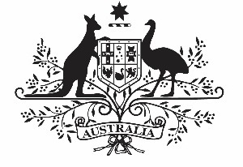

COMMONWEALTH OF AUSTRALIA

Environment Protection and Biodiversity Conservation Act 1999

APPROVAL OF THE CORAL SEA MARINE PARK MANAGEMENT PLAN 2018

I, JOSH FRYDENBERG, Minister for the Environment and Energy, acting pursuant to section 370 of the Environment Protection and Biodiversity Conservation Act 1999, hereby approve the Coral Sea Marine Park Management Plan 2018.

Dated this …….....25.............. day of …………January……………., 2018

Josh Frydenberg
Minister for the Environment and Energy

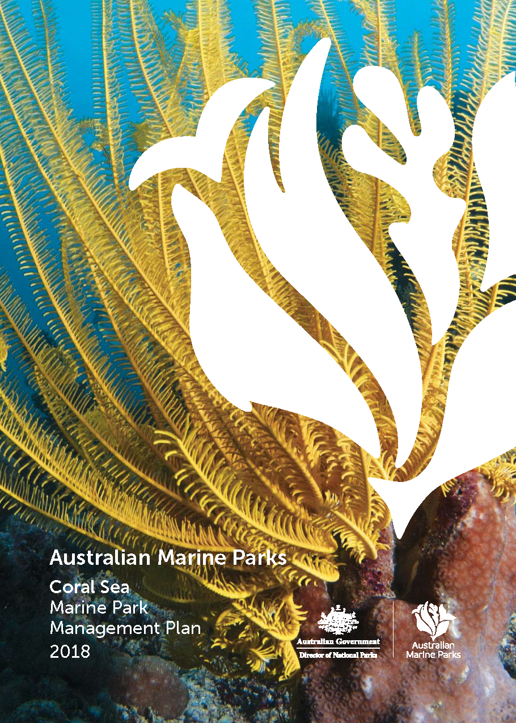
© Director of National Parks 2018
This document may be cited as:
Director of National Parks 2018, Coral Sea Marine Park Management Plan 2018, Director of National Parks, Canberra.
ISBN:
This management plan is copyright. Apart from any use permitted under the Copyright Act 1968, no part may be reproduced by any process without prior written permission from the Director of National Parks. Requests and enquires concerning reproduction and rights should be addressed to the:
Manager
Coral Sea Marine Park
203 Channel Highway
Hobart TAS 7050

Photography credits
Front cover
Noble feather star, Marion Reef (Nigel Marsh)
Table of Contents
Chapter 1 Introduction 4
Part 1. Managing Australian Marine Parks 5
1.1 Introductory provisions 5
1.2 Australian Marine Parks 5
1.3 Australian Marine Parks vision and objectives 6
1.4 Management plan 6
1.5 Legislation and policy supporting marine park management 7
1.6 Approach to managing Australian Marine Parks 9
1.7 Ways of working 9
1.8 Partnerships 10
1.9 Management programs and actions 12
1.10 Zones 12
1.11 Implementation plans 13
1.12 Adaptive management 13
Part 2. The Coral Sea Marine Park 14
2.1 The Coral Sea Marine Park 15
2.2 Values of the Coral Sea Marine Park 17
2.3 Pressures in the Coral Sea Marine Park 19
2.4 Management programs and actions in the Coral Sea Marine Park 22
Chapter 2 Management and prescriptions 29
Part 3. Zoning 30
3.1 Zone categories, names and objectives 31
Part 4. Managing activities 33
4.1 Outline of Part 4 34
4.2 Rules for activities 34
4.2.1 General use, access, and waste management 36
4.2.2 Commercial shipping (other than commercial fishing and aquaculture vessels) 37
4.2.3 Commercial fishing 38
4.2.4 Commercial aquaculture 42
4.2.5 Commercial media 43
4.2.6 Commercial tourism (includes charter fishing tours, scuba diving, nature watching tours) 44
4.2.7 Recreational fishing 45
4.2.8 Mining operations (includes exploration) 46
4.2.9 Structures and works 47
4.2.10 Research and monitoring 49
4.2.11 National security and emergency response 51
4.2.12 New activities and authorisations 52
4.3 Making decisions about activities 53
4.3.1 Decision-making 53
4.3.2 Assessments under other processes 53
4.3.3 Review of decisions 54
4.4 Authorisation of allowable activities 54
4.4.1 Permits 54
4.4.2 Class approvals 55
4.4.3 Activity licences and leases 57
4.4.4 Publication of authorisations 58
Glossary 59
Schedule 1 Summary of legislative and policy contexts 65
S1.1 The EPBC Act and EPBC Regulations 65
S1.2 Other relevant legislation 72
S1.3 International agreements 73
Schedule 2 Coral Sea Marine Park overview and values 76
S2.1 Coral Sea Marine Park overview 77
S2.2 Coral Sea Marine Park values 78
Coral Sea Marine Park 78
Schedule 3 Environmental features used in the design of the Coral Sea Marine Park 100
Schedule 4 Coral Sea Marine Park and zone boundary descriptions 106
Schedule 5 Supporting information 123
Map data sources 124

Chapter 1
Introduction

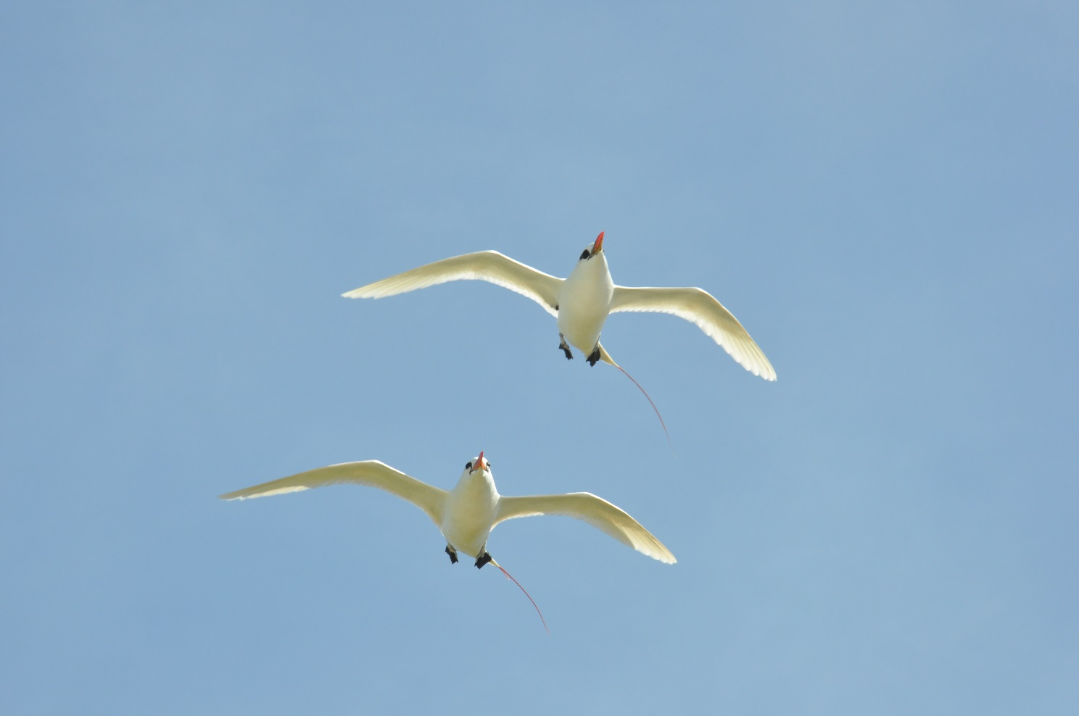
Red-tail tropic birds (Parks Australia)

Managing Australian Marine Parks

Introductory provisions
Name
This management plan (plan) is the Coral Sea Marine Park Management Plan 2018.
Commencement
This plan commences on 1 July 2018.
Interpretation
The Glossary provides the meaning of certain words and expressions used, and includes references to certain words and expressions that are defined in the Environment Protection and Biodiversity Conservation Act 1999 (EPBC Act).
Authority
This plan is made under Section 370 of the EPBC Act. This plan replaces all previous approvals under s.359B of the EPBC Act that authorised a range of activities in the Coral Sea Marine Park in the period from proclamation of the Marine Park to the commencement of this plan.

Australian Marine Parks
Australia is surrounded by ocean extending from the tropics to the sub-Antarctic, providing a home to a wealth of plants and animals, many of them found nowhere else in the world. Australia’s oceans help to support our way of life by providing beautiful places to enjoy, supporting businesses and jobs, and contributing to Australia’s food and energy needs.
Marine protected areas are recognised as one of the best ways to conserve and protect marine habitats and species in our oceans. In light of this, the Australian, state and territory governments agreed in 1998 to establish a National Representative System of Marine Protected Areas (NRSMPA). The NRSMPA was designed to create a comprehensive, adequate and representative (CAR) system of marine protected areas, to contribute to the long-term viability of the marine environment and protect biodiversity. To identify areas to protect in the NRSMPA, the Australian Government undertook scientific research and consolidated the best available information on the natural, social and economic characteristics of Australia’s marine environment.
On the basis of this work, in 2012, the Australian Government expanded the total coverage of Australia’s National Representative System of Marine Protected Areas to 3.3 million km². This included new marine parks in the North, North-west, South-west, and Temperate East marine regions, and in the Coral Sea. This is in addition to marine parks already established in the South-east Network, the Great Barrier Reef and at Heard and McDonald Islands.
Australian Marine Parks (Commonwealth reserves proclaimed under the EPBC Act in 2007 and 2013) are located in Commonwealth waters that start at the outer edge of state and territory waters, generally three nautical miles (approximately 5.5 km) from the shore, and extend to the outer boundary of Australia’s exclusive economic zone, 200 nautical miles (approximately 370 km) from the shore. Marine parks have also been established by state and territory governments in their respective waters under the NRSMPA. Many other countries have moved to establish marine protected areas in their waters and are implementing a range of legislative, policy and management tools to manage these important places.

Australian Marine Parks vision and objectives
Management of Australian Marine Parks requires a balance between protection of our marine environment, and opportunities for sustainable use and enjoyment of these special places.
The vision of the Director of National Parks (the Director) is that marine parks are healthy, resilient and well-managed to enhance Australia’s wellbeing. This means ensuring that:
- their natural, cultural, socio-economic and heritage values are understood, appreciated and conserved;
- marine parks support jobs and businesses, providing multiple benefits to regional communities and the economy;
- people have opportunities to enjoy marine parks;
- visitors and tourists can enjoy world-class nature-based experiences in marine parks; and
- Indigenous people and marine park users are partners in managing marine parks.
The objectives of this plan are to provide for:
- the protection and conservation of biodiversity and other natural, cultural and heritage values of the Coral Sea Marine Park; and
- ecologically sustainable use and enjoyment of the natural resources within the Marine Park, where this is consistent with objective (a).

Management plan
This plan is structured into two chapters and five schedules (Table 1.1). Chapter 1 provides an introduction to how Australian Marine Parks are managed, and Chapter 2 provides for the management of the Coral Sea Marine Park.
Several inputs have contributed to the preparation of this plan, including:
- public consultation during the preparation of this plan;
- knowledge and expertise of marine park users and traditional owners;
- the independent Commonwealth marine reserves review (publicly released in 2016);
- the best available science and information on marine parks and approaches to marine park management, including insights from management of the South-east Network, the Great Barrier Reef Marine Park, and state and territory marine parks;
- the Integrated Marine and Coastal Regionalisation of Australia (IMCRA) framework;
- the East marine bioregional plan: bioregional profile (2009); and
- Government policies and commitment to competitive and sustainable fisheries.

Legislation and policy supporting marine park management
The EPBC Act is Australia’s primary environmental legislation. In recognition of the importance of the marine environment, it is listed as a matter of national environmental significance under the EPBC Act. Under the EPBC Act, the Director is responsible for managing marine parks (supported by Parks Australia), and is required to make management plans for marine parks. Other parts of the Australian Government must not perform functions or exercise powers in relation to these parks that are inconsistent with management plans (s.362 of the EPBC Act).
This plan complements a range of Commonwealth, state and territory laws, as well as international conventions and agreements that relate to protection of the marine environment (Schedule 1). Some of the ways in which the Australian Government protects the marine environment through national environmental law include management plans for Australian Marine Parks; marine bioregional plans for the Commonwealth marine environment; recovery plans for threatened species; and threat abatement plans for key threats, such as invasive species and marine debris.
Other Australian, state and territory government agencies also have statutory roles in managing fisheries, tourism, oil and gas activities, shipping, maritime pollution and biosecurity threats.
Australia also has international responsibility under the World Heritage Convention and Ramsar Convention on Wetlands of International Importance, to manage the Coringa–Herald and Lihou Reefs and Cays Ramsar sites.

Table 1.1 Structure of this plan
Chapter 1
Introduction
Part 1  Managing Australian Marine Parks | Outlines the context and approach to managing marine parks.
Part 2  The Coral Sea Marine Park | Provides a summary of the Coral Sea Marine Park including natural, cultural, heritage, social and economic values, the pressures facing the Marine Park and the management actions to protect values and manage pressures.
Chapter 2
Management and prescriptions (the rules)
Part 3  Zoning | Explains the International Union for the Conservation of Nature (IUCN) categories assigned to each marine park and zone, and provides zone objectives.
Part 4  Managing activities | Provides the rules about what activities can and cannot occur within zones, and outlines the assessment and decision-making processes, and the types of authorisations (permits, class approvals, activity licences and leases).
Glossary | Lists terms and words used in this plan.
Schedules
Supporting information
Schedule 1  Summary of legislation and policy contexts | Includes the legislative and policy context for managing marine parks with respect to the EPBC Act and EPBC Regulations, and other relevant legislation and international agreements.
Schedule 2  Coral Sea Marine Park overview and values | Provides a summary of the Coral Sea Marine Park proclamation, a description of values and a map for the Marine Park.
Schedule 3  Environmental features used in design of the Coral Sea Marine Park | Describes the environmental features used to identify zones in the Coral Sea Marine Park. These include bioregions, depth ranges, seafloor features and key ecological features.
Schedule 4  Coral Sea Marine Park and zone boundary descriptions | Lists the coordinates of the Coral Sea Marine Park and zones.
Schedule 5  Supporting information | Lists references used in preparing this plan.

Approach to managing Australian Marine Parks
To achieve the best outcomes from Australian Marine Parks, the different uses of parks must be balanced with protecting important habitats and features. This plan outlines the Director’s approach to managing Australian Marine Parks. This approach includes:
- A vision for Australian Marine Parks and management objectives.
- Partnerships with traditional owners, marine park users, stakeholders and governments to manage marine parks.
- Management programs and actions to protect the marine environment, improve scientific understanding, support tourism, improve awareness and appreciation of marine parks, work with Indigenous people to manage parks, assess and authorise activities, and ensure that people comply with the rules.
- Zones that set out what activities can be undertaken where and how.
- Outcome-based decision-making where each decision made balances enabling use with the need to protect natural, cultural and heritage values of marine parks.
- Implementation plans to support each management plan that set out the specific actions in the foundation phase (years 1–4), consolidation phase (years 5–8), and finalisation and review phase (years 9–10).
- Adaptive management including monitoring, evaluation and reporting to keep track of our progress and change our approach when necessary.

Ways of working
In managing Australian Marine Parks, the Director will seek to be:
- Respectful of the traditional owners of the sea, marine park users, stakeholders and other government agencies.
- Collaborative—seeking to co-design management programs and systems wherever possible, and manage in consultation with marine park users.
- Balanced—focused on protecting natural, cultural and heritage values, while facilitating sustainable use and enjoyment of marine parks.
- Outcomes based—considering outcomes for natural, social-economic, cultural and heritage values of marine parks when making decisions about activities.
- Adaptive—encouraging innovation, accommodating new information about values, pressures and technologies, and allowing for continual improvement in management.
- Evidence and risk-based—using information to guide management and decision-making, including evidence gathered through monitoring, research, evaluation and reporting.
- Proactive—taking proactive action to protect marine parks from pressures, to minimise damage, and to improve resilience, wherever possible.
- Efficient and effective—minimising regulatory burden and costs on businesses and individuals, including by using assessment and approval mechanisms of other government agencies, while enforcing the rules established in this plan.

Partnerships
Effective management of Australian Marine Parks will be achieved by working with traditional owners, marine park users and stakeholders, and other government agencies through the following:
Partnerships with government agencies
The Director will build on existing partnerships with Commonwealth government agencies with critical roles in managing and understanding Australia’s marine environment, including the Australian Fisheries Management Authority, Australian Maritime Safety Authority, Defence, Geosciences Australia, Great Barrier Reef Marine Park Authority, Australian Border Force and the National Offshore Petroleum Safety and Environmental Management Authority. The Director will also build on partnerships with the Queensland fisheries and marine park agencies, and research institutions that provide support to the day-to-day management of the Coral Sea Marine Park, while ensuring a consistent approach to managing marine parks around Australia.
Advisory arrangements
To support collaborative management and achieve the vision for marine parks, the Director will establish an advisory forum for the Coral Sea Marine Park that complements existing stakeholder engagement arrangements for the Great Barrier Reef Marine Park. The Director will work closely with stakeholders to develop an appropriate format for the advisory forum and implement management programs and actions for the Marine Park.
The role of the advisory forum will be to support and collaborate with the Director to manage marine parks by:
- helping to develop and deliver implementation plans, including assisting to prioritise management actions and develop performance measures;
- providing information about stakeholder and park user views, knowledge and needs; and
- contributing to the periodic evaluation and review of implementation plans.
Members will represent the broad range of users, interests and knowledge about marine parks and may represent sectors such as commercial fishing, energy, Indigenous people, infrastructure, non-government organisations, recreational fishing, science, tourism, transport and the broader community. Membership and terms of reference for the advisory forum will be developed in consultation with stakeholders as soon as practicable after the commencement of this plan.
Partnerships with traditional owners and Indigenous people
In implementing this plan, the Director acknowledges the national and international rights and cultural interests of Indigenous people and the deep understanding and experience that Indigenous people can contribute to the management of Australian Marine Parks. This includes international rights as detailed in the United Nations Declaration on the Rights of Indigenous People. The Director also acknowledges that Indigenous people have been sustainably using and managing their sea country, including areas now in marine parks, since time immemorial.
The Director is committed to working with Indigenous people to manage sea country within marine parks and will achieve this through the Indigenous engagement program (Section 2.4). This includes building partnerships with traditional owners and Indigenous people with responsibilities for sea country.
The Director also acknowledges that traditional owners are the primary source of information on the value of their heritage. For this reason, the Director will seek the active participation of Indigenous people in the identification and management of cultural values in marine parks.
To inform our approach to managing marine parks, the Director has worked with representatives from land councils, native title representative bodies and Indigenous ranger groups to develop a set of collaborative management principles (Table 1.2) to support Indigenous involvement in the management of Australian Marine Parks. These principles will inform the approach to implementing this plan, as well as the development and implementation of actions in each marine park (Part 2).
Table 1.2 Principles supporting Indigenous people to engage in management of Australian Marine Parks
Principle 1:
It is recognised that Indigenous people have been sustainably using and managing their sea country, including areas now included within Australian Marine Parks, for thousands of years—in some cases since before rising sea levels created these marine environments.
Principle 2:
Management of Australian Marine Parks should be undertaken on the basis that native title exists in sea country within Commonwealth waters.
Principle 3:
Indigenous people should be engaged in planning and managing Australian Marine Parks on the basis of their nationally and internationally recognised rights and cultural interests, not as a ’stakeholder‘ group.
Principle 4:
Maximise opportunities for Indigenous people to enjoy the management and use of their sea country.
Principle 5:
Maximise opportunities for the development of Indigenous livelihoods, consistent with national ‘closing the gap’ commitments.
Principle 6:
Governance and management activities within Australian Marine Parks should respect and complement local Indigenous governance arrangements, plans, capacities and activities.
Principle 7:
Indigenous engagement in managing Australian Marine Parks should be undertaken through good faith negotiations, seeking to build on the common ground that exists between Indigenous people and the Australian Government to protect and sustainably use Australia’s sea country environments and resources.
Principle 8:
Third party investment in management activities in Australian Marine Parks (e.g. through environmental offset investments) should include support for Indigenous people’s interests, capacity-building and development of livelihoods, consistent with all other principles outlined above; such third party investments must not impact on native title compensation negotiations or on the right to compensation.

Management programs and actions
The Director will implement management programs and actions to protect marine parks from threats and pressures, to minimise damage, and to rehabilitate and improve the resilience of marine parks. Management programs and actions may be adapted over the life of this plan, and include:
- Communication, education and awareness—actions that improve awareness, understanding and support for marine parks and park management.
- Tourism and visitor experience—actions that provide for and promote a range of environmentally appropriate, high-quality recreation and tourism experiences and contribute to Australia’s visitor economy.
- Indigenous engagement—actions that recognise and respect the ongoing cultural responsibilities of Indigenous people to care for sea country and support multiple benefits for traditional owners.
- Marine science—actions to provide necessary scientific knowledge and understanding of marine park values, pressures, and adequacy of responses for effective management.
- Assessments and authorisations—actions that provide for efficient, effective, transparent and accountable assessment, authorisation and monitoring processes to support sustainable use and protection of marine park values.
- Park protection and management—timely and appropriate preventative and restorative actions to protect natural, cultural and heritage values from impacts.
- Compliance—actions that ensure appropriate and high levels of compliance by marine parks users with the rules set out in this plan.
The specific actions that will be undertaken in each marine park will be determined in partnership with stakeholders and set out in implementation plans.

Zones
Zoning and related rules for managing activities are important tools for managing marine parks to ensure protection of marine habitats and species, while enabling use. Parts 3 and 4 of this plan set out the zones and rules for activities in the Coral Sea Marine Park.
In determining the zones and rules, the Director has considered the best available science, the advice of stakeholders, Indigenous people and the general public, the goals and principles of the NRSMPA and the Australian IUCN reserve management principles (Schedule 1). Zones established by this plan (Part 3) in the Coral Sea Marine Park are summarised in Table 1.3.
Table 1.3 Summary of zones in the Coral Sea Marine Park
Special Purpose Zone (IUCN category VI)—managed to allow specific activities though special purpose management arrangements while conserving ecosystems, habitats and native species. The zone allows or prohibits specific activities.
Habitat Protection Zone (IUCN category IV)—managed to allow activities that do not harm or cause destruction to seafloor habitats while conserving ecosystems, habitats and native species in as natural a state as possible.
National Park Zone (IUCN category II)—managed to protect and conserve ecosystems, habitats and native species in as natural a state as possible. The zone only allows non-extractive activities, unless authorised for research and monitoring.

Implementation plans
The Director will work closely with stakeholders and the advisory forum to develop detailed implementation plans. Three stages of implementation plans will be developed to set out the management actions that will occur in the Coral Sea Marine Park and identify performance indicators.
- Implementation plan 1—Foundation (years 1–4). To be developed in the first year and include foundational management actions and development of robust natural, social and economic baselines.
- Implementation plan 2—Consolidation (years 5–8). To be developed following a review of the first implementation plan, and considering lessons learnt. To continue any ongoing foundational management actions.
- Implementation plan 3—Finalisation and review (years 9–10). To set out arrangements to review the lessons learnt from implementing the management plan over the first eight years, and inform the development of the next management plan for the Coral Sea Marine Park.

Adaptive management
Regular monitoring, evaluation, reporting and review of the implementation of this plan will be essential to achieve the vision for Australian Marine Parks and the objectives for this plan. The Director will undertake periodic monitoring, evaluation, review and reporting on the implementation of this plan to:
- evaluate the effectiveness of this plan in achieving its objectives;
- track progress in meeting performance indicators identified in implementation plans;
- review the effectiveness of zoning and other management arrangements to protect and conserve marine park values;
- identify changes in management context and priorities;
- consider the adequacy of knowledge of marine park values, uses, pressures, social and economic benefits and impacts;
- consider the effectiveness of monitoring and evaluation, and the appropriateness of key indicators and performance measures;
- identify and prioritise future management actions;
- provide information to enable adaptive management; and
- inform the development of a new management plan for the Coral Sea Marine Park at the conclusion of this plan.

The Coral Sea Marine Park

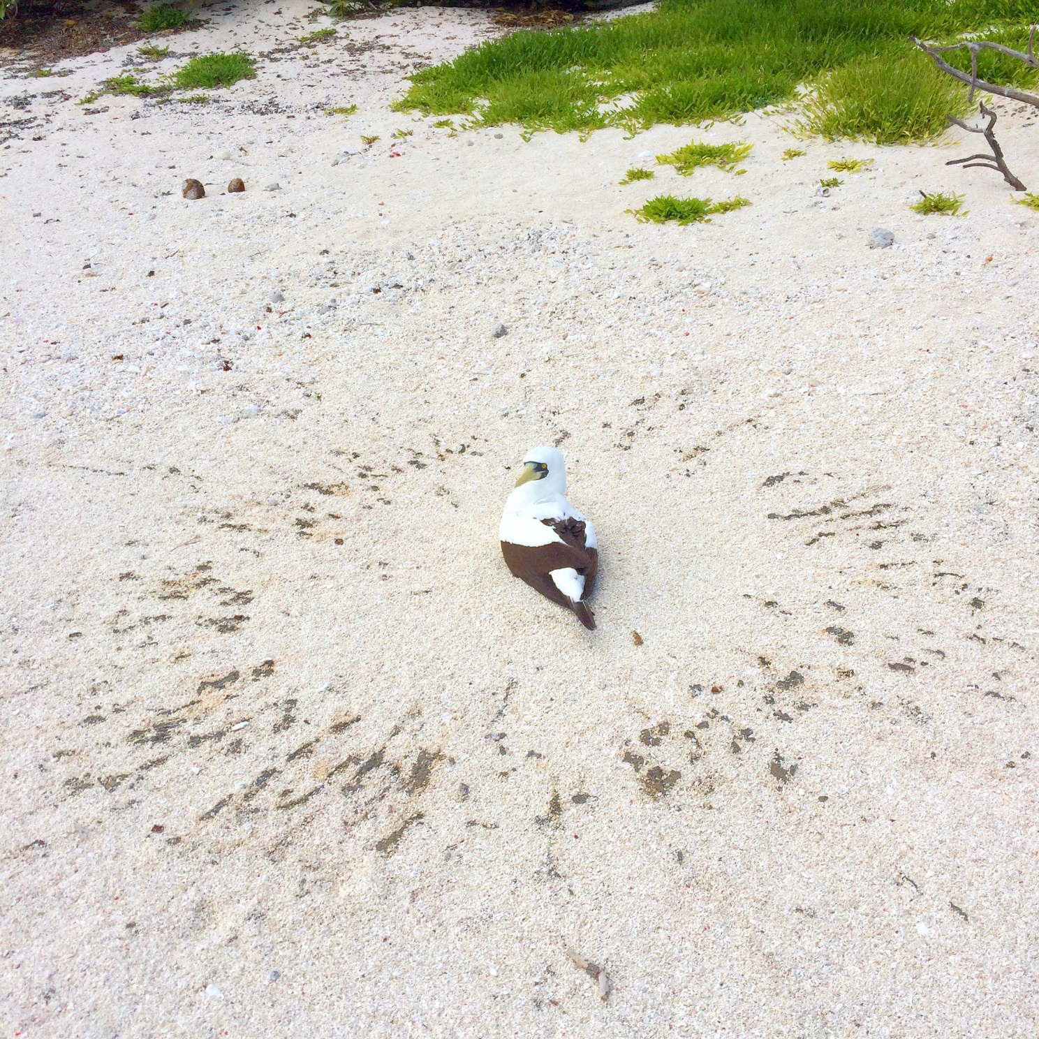
Booby nesting on sand cay (Martin Russell)

The Coral Sea Marine Park
The Coral Sea Marine Park covers 989 836 km² and extends from Cape York Peninsula to an east–west line approximately 40 km north of Bundaberg in Queensland. The nearest point of the Marine Park to mainland Australia is approximately 60 km and it extends to approximately 1100 km from the coast (Figure 2.1). An overview of the Marine Park and its values is provided in Schedule 2.
Traditional owners have managed and used sea country within the Coral Sea Marine Park for tens of thousands of years. The Marine Park is popular for activities such as fishing, snorkelling, diving and boating. Tourism operators offer unique experiences for visitors to enjoy the offshore reefs, islands, cays and deep-water environments. Although the Marine Park is remote and far offshore, opportunities exist for recreational use, particularly around offshore atolls and reefs.
There are significant industries in the Coral Sea Marine Park, including commercial fishing and shipping that contribute to economic growth, employment and social wellbeing in coastal towns and communities. Activities and businesses that support these industries such as marine industry suppliers and repair yards are also important sources of employment for coastal communities.
The marine environment of the Coral Sea Marine Park is characterised by shallow-water tropical marine ecosystems, a large area of continental shelf and continental slope, two areas of abyssal plain with depths to 6000 m, high incidence of cyclones, high species diversity and globally significant populations of internationally threatened species. A small number of species are found nowhere else. There are approximately 34 reefs, and 56 cays and islets in the Marine Park, with a total reef area of approximately 15,024 km². Most of the species in the Marine Park are tropical and are also found in other parts of the Pacific Ocean; many of them are shared with the North and Temperate East Marine Regions. The seafloor features of the Marine Park are diverse and include coral reefs, soft sediments and canyons that support high species diversity. A key example is Bligh Canyon in the north of the Marine Park, which is 200 km long, 10 km wide and cuts 300 m into the seafloor.
The Coral Sea Marine Park is influenced by a complex system of ocean currents that change seasonally and between years. Currents have also influenced the composition of reef species. The east–west-flowing South Equatorial Current cuts through the centre of the Marine Park before dividing to form the north-flowing Hiri Current and the south-flowing East Australian Current. These currents create a barrier reducing the mixing of species between the north and south of the Marine Park, forming distinct communities. The southern part of the Marine Park transitions between tropical and temperate waters and includes the northern extent of the range of some temperate species typical of the Temperate East Marine Region.
The Coral Sea Marine Park includes iconic black marlin (Istiompax indica) spawning aggregations near Osprey Reef, and every year humpback whales (Megaptera novaeangliae) migrate through the Marine Park from Antarctica. Six of the world’s seven species of marine turtle occur in the Marine Park; all have threatened conservation status.
The Coral Sea Marine Park lies immediately to the east of the Great Barrier Reef Marine Park, which is managed by the Great Barrier Reef Marine Park Authority in collaboration with the Queensland Government. The Great Barrier Reef is a recognised World Heritage Area on the basis of its outstanding universal value. Given the connectivity between the ecosystems and species of the Great Barrier Reef and the Coral Sea, and their importance to local jobs and coastal economies, these marine parks need to be managed in a collaborative way.
Further information about the Coral Sea Marine Park can be found in the East marine bioregional plan: bioregional profile (2009) (available on the Department’s website), and the marine park values in Section 2.2 and Schedule 2 of this plan.
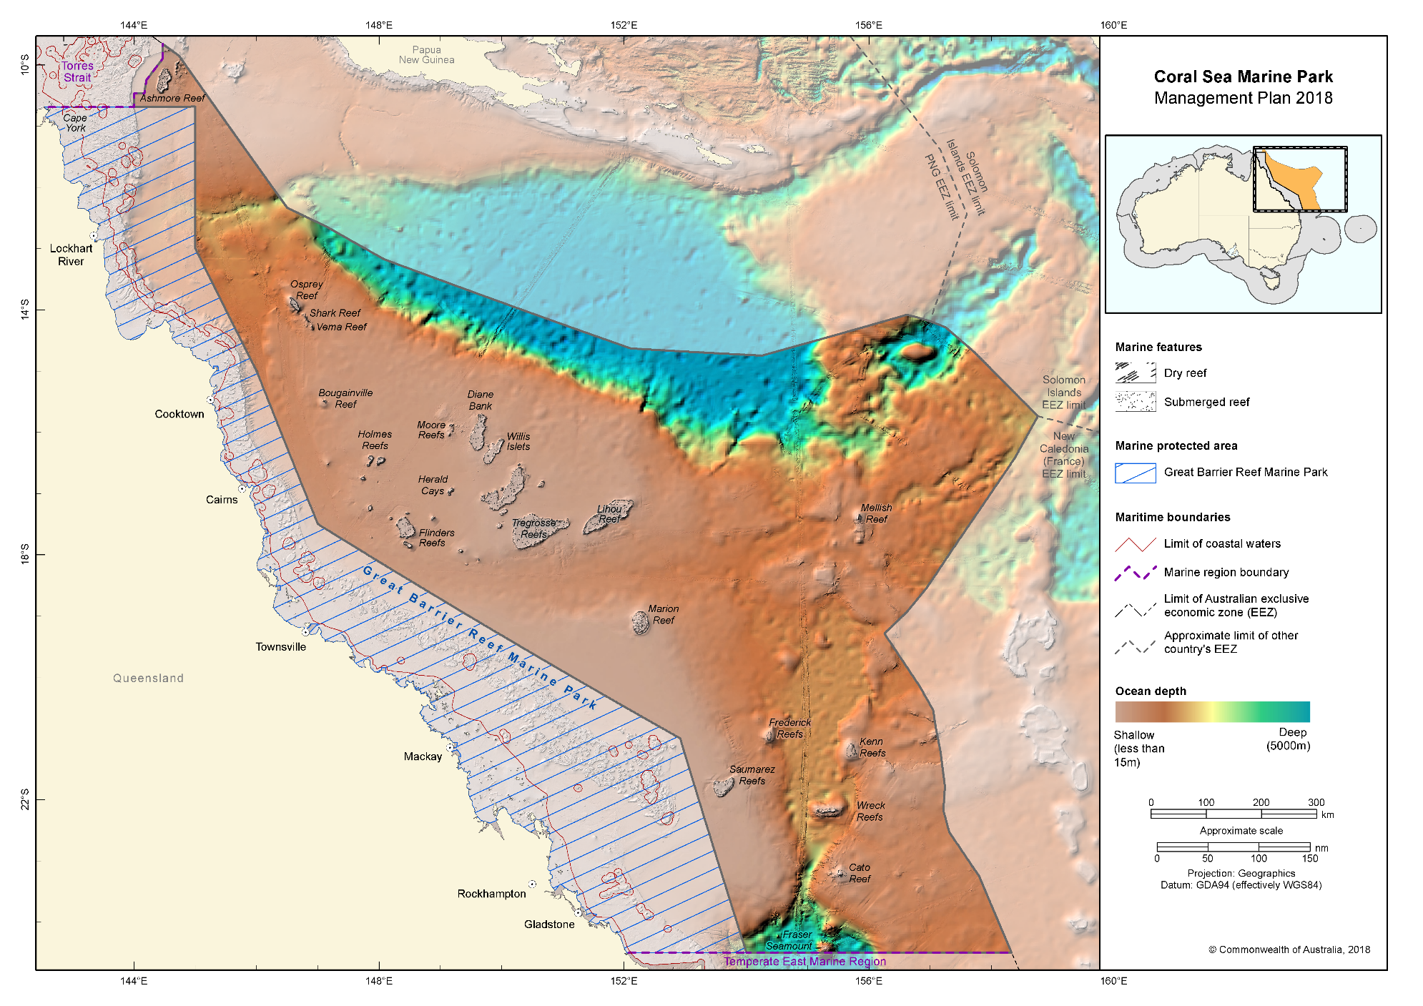Figure 2.1 Coral Sea Marine Park

Values of the Coral Sea Marine Park
Values are broadly defined as:
- Natural values—habitats, species and ecological communities within marine parks, and the processes that support their connectivity, productivity and function.
- Cultural values—living and cultural heritage recognising Indigenous beliefs, practices and obligations for country, places of cultural significance and cultural heritage sites.
- Heritage values—non-Indigenous heritage that has aesthetic, historic, scientific or social significance.
- Socio-economic values—the benefit of marine parks for people, businesses and the economy.
As outlined in Part 1, in managing marine parks, the Director will need to make decisions about what activities can occur in the marine parks and what actions to take to manage them. This will involve the Director making decisions that carefully balance the need to protect natural, cultural, heritage and socio-economic values of marine parks with enabling use and managing pressures.
In making these decisions, the Director will carefully consider the impacts and risks to natural, cultural, heritage or socio-economic values for the relevant marine park/s. The values of the Coral Sea Marine Park are set out in Schedule 2 and Figure 2.2 shows Indigenous Protected Areas established near the Coral Sea Marine Park. The Director will also consider any positive impacts associated with allowing an activity, such as socio-economic or cultural benefits, and ensure that activities are undertaken in a manner that minimises negative impacts.
For some areas, such as the Coringa–Herald and Lihou Reefs, there is a relatively strong understanding of values. Where there is less information, environmental features are used as indicators for the types of species and habitats likely to occur. These include bioregions, water depth, seafloor features and key ecological features (Schedule 3).
As understanding of marine park values improves over the life of this plan, the Director will make new information about values available on the Parks Australia website. Other important sources of information on values (also on the Department’s website) include:
- Species profile and threats database for protected species;
- Directory of important wetlands in Australia;
- Australian heritage database for natural, historic and Indigenous heritage places;
- Australian national shipwreck database for known shipwrecks;
- National Conservation Values Atlas; and
- East marine bioregional plan: bioregional profile (2009).
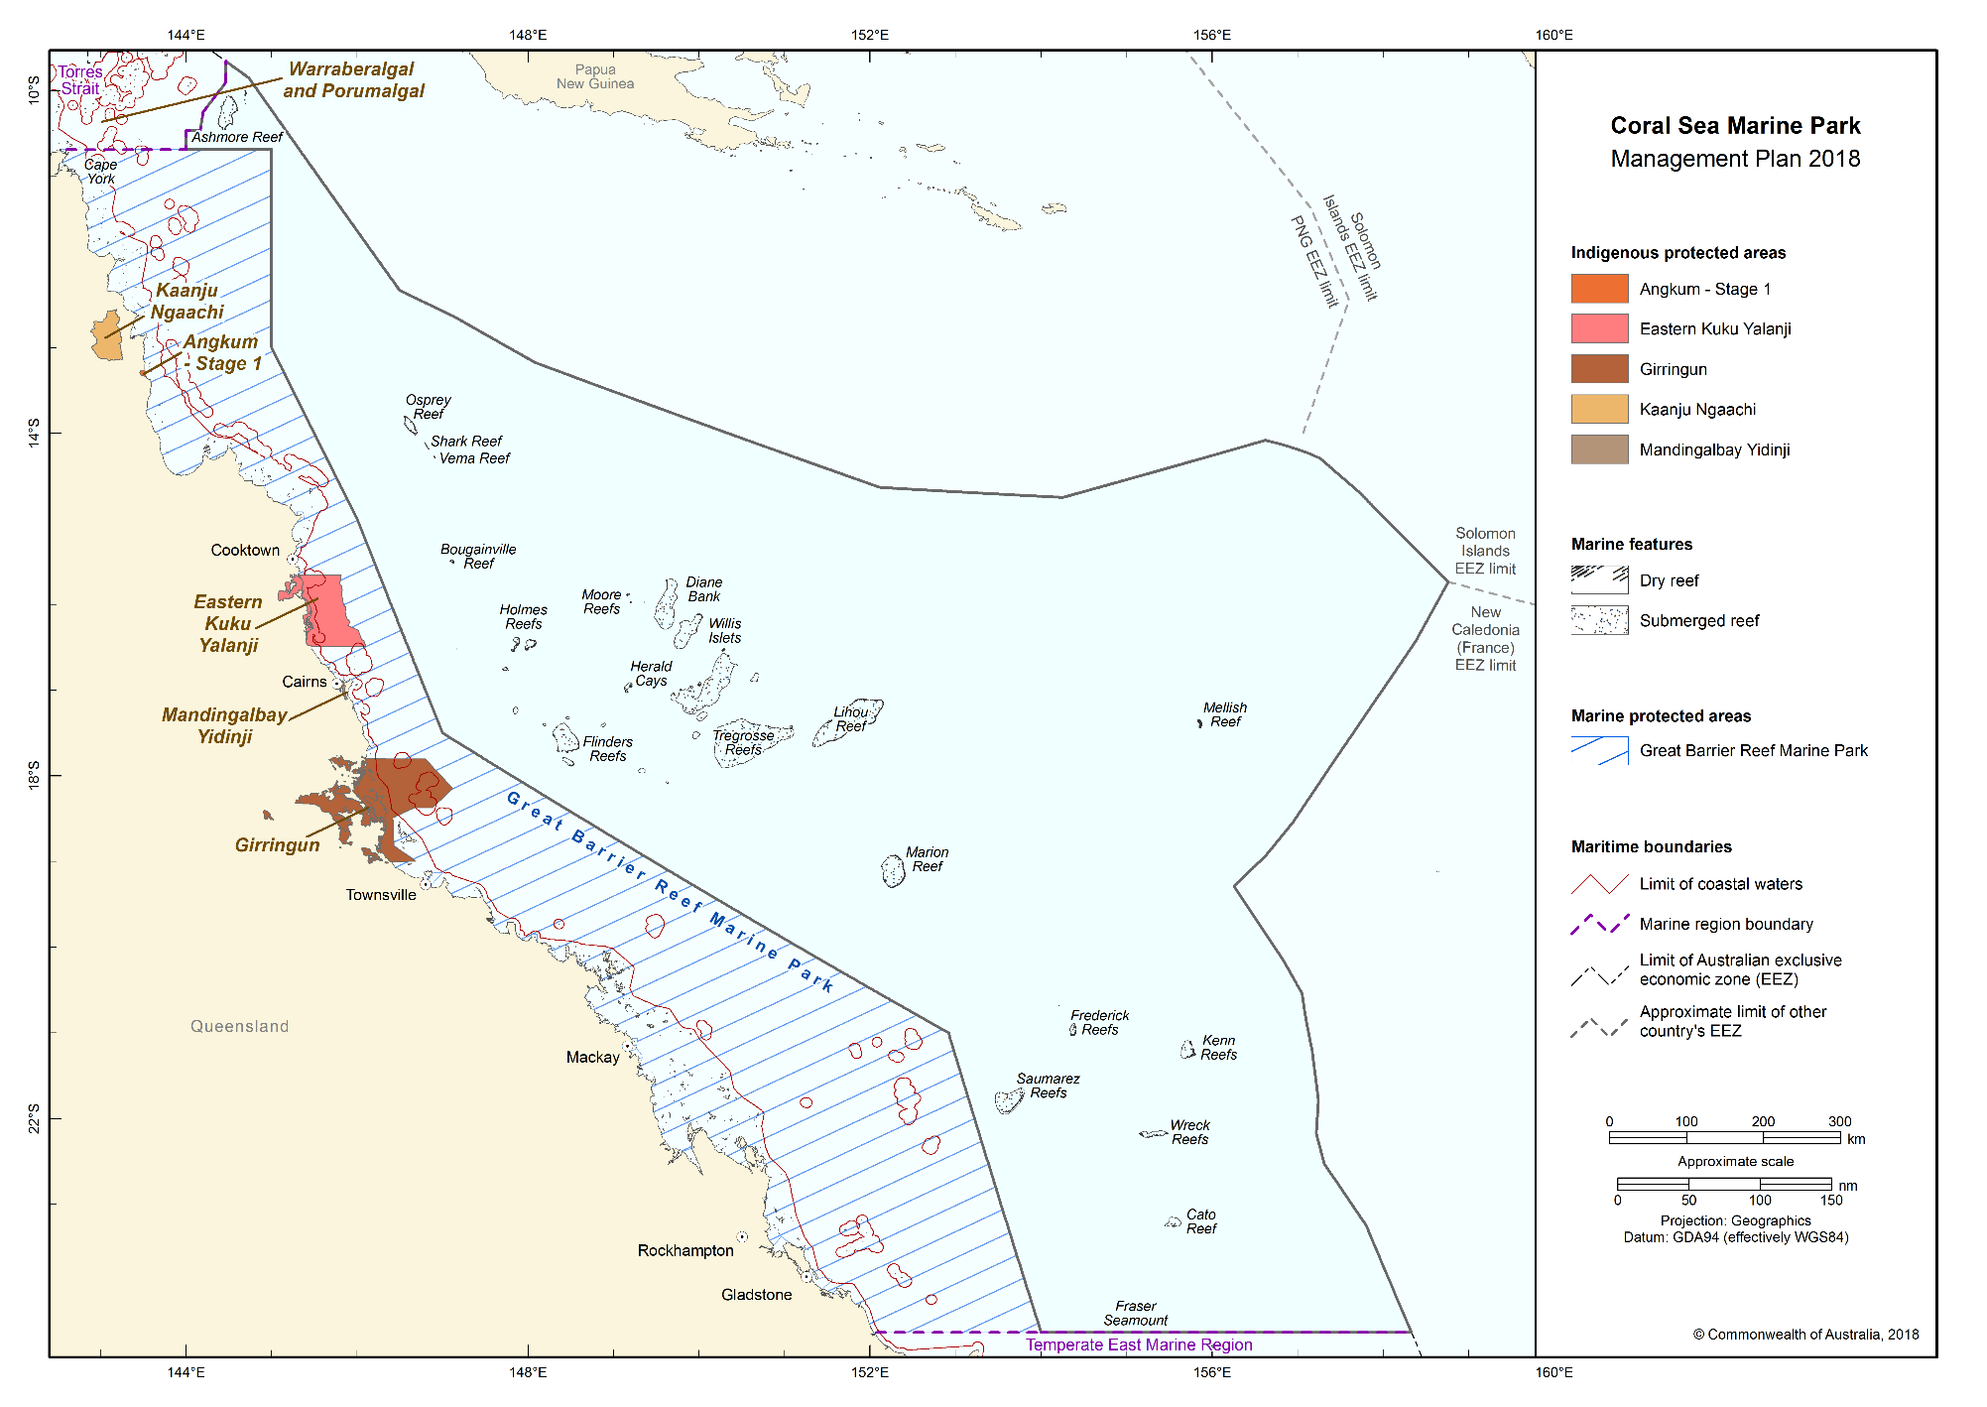
Figure 2.2 Indigenous Protected Areas established near the Coral Sea Marine Park

Pressures in the Coral Sea Marine Park
Pressures are human-driven processes, events and activities that, if left unchecked, may impact on marine park values. Contemporary drivers of environmental change in the marine environment include population growth and economic activity, and related pressures such as increased vessel activity, marine debris, climate extremes and ocean warming. Figure 2.3 shows the types of uses occurring in the Coral Sea Marine Park. These present key challenges for biodiversity conservation and sustainable management of our marine resources.
Australia’s 2016 State of the environment report reviewed pressures on Australia’s marine environment and determined that they were low by global standards. However, given that more than 85 per cent of Australians live within 50 km of the sea, and with Australia’s population of approximately 24.4 million projected to grow to 39.7 million by 2055, pressures on the marine environment are likely to increase.
Although pressures on marine ecosystems and biodiversity in the Coral Sea Marine Park may change over time, examples of pressures on marine ecosystems and biodiversity in the Marine Park are outlined in Table 2.1. Research in the Great Barrier Reef Marine Park and elsewhere in the world has demonstrated that effective management of marine parks, helps to maintain the resilience of marine ecosystems and their ability to withstand and recover from such pressures.
In determining the management actions to be taken in the Coral Sea Marine Park and in making decisions about the activities that will be allowed to occur within the Marine Park, the Director will carefully consider how the values outlined in Section 2.2 and in Schedule 2 will be impacted by these pressures now and in the future.
Pressures such the extraction of living resources by fishing, and habitat modification through installation of infrastructure and anchoring will be managed in part through the zones and rules set out in Parts 3 and 4 of this plan.
Table 2.1 Summary of pressures in the Coral Sea Marine Park
Climate change
The impacts of climate change on the marine environment are complex and may include changes in sea temperature, sea level, ocean acidification, sea currents, increased storm frequency and intensity, species range extensions or local extinctions, all of which have the potential to impact on marine park values. The International Panel on Climate Change recognises climate change as a major contributor to Australian marine ecosystem changes since 2007. Examples of habitats, key ecological features and species vulnerable to the effects of climate change include reef, cay and seamount habitats, and species of shark, dolphin, marine turtle, sea snake, sea cucumber and fish.
Extraction of living resources
Australia’s world class fisheries management led by Commonwealth, state and territory governments is important for ensuring sustainable fishing practices. Fishing, including illegal, unregulated and unreported fishing (including illegal foreign fishing), can modify natural populations of target species. Bycatch of non-target species and/or physical disturbance to habitats can result from certain fishing methods, and may therefore impact on marine park values. Examples of habitats, key ecological features and species vulnerable to such impacts include reef, cay and seamount habitats, and species of shark, dolphin, marine turtle, sea snake, sea cucumber and fish.

Habitat modification
Commonwealth, state and territory governments play an important role in managing activities in the marine environment. Impacts on habitat in marine parks can occur directly through physical disturbance or indirectly through the presence of infrastructure. For example, benthic communities are vulnerable to human influenced modifications to the quality and quantity of light received at the seabed. Examples of habitats and species vulnerable to habitat modification pressures include reef, cay and seamount habitats, and species of shark, dolphin, marine turtle, sea snake, sea cucumber and fish.
Human presence
Activities such as wildlife watching are a drawcard for people visiting marine parks. While enjoying the wildlife experience, it is important to be aware of the potential impacts of human presence on the natural behaviour of wildlife. Activities such as boating, camping, diving and snorkelling have the potential to impact marine park values directly through contact from collision or indirectly through changes in behaviour from disturbance. These activities may result in changes to wildlife behaviour such as nesting, breeding, feeding or resting, or damage to fragile marine environments. Examples of habitats and species vulnerable to human disturbance include reef, cay and seamount habitats, and species of seabirds, shark, dolphin, marine turtle and fish.
Invasive species
Invasive species have the potential to impact on marine park values directly and indirectly. Potential sources of invasive species include vessel ballast and bilge water discharge, vessel biofouling, accidental or deliberate transport of species and land-based activities. Islands, reefs and other shallow-water ecosystems and native species are vulnerable to invasive species, from direct impacts such as predation or damage to important habitat e.g. nesting habitat, or indirect impacts such as competition with native species for habitat and food. Examples of habitats, key ecological features and species vulnerable to the impacts of invasive species include reef and island habitats, and nesting seabirds and marine turtles such as those at Coringa–Herald and Lihou Reefs.
Marine pollution
Marine and land-based activities have potential to result in marine pollution which may impact on marine park values. Pollution includes the emission of noise or light, marine debris (for example, plastics and lost fishing gear), and discharge of oil, chemicals or waste. Pollution can be detrimental to marine life, causing contamination of ecosystems, entanglement, or can be ingested by marine species. Examples of habitats and species vulnerable to marine pollution include reef, cay and seamount habitats, and species of shark, dolphin, marine turtle, sea snake, sea cucumber and fish.
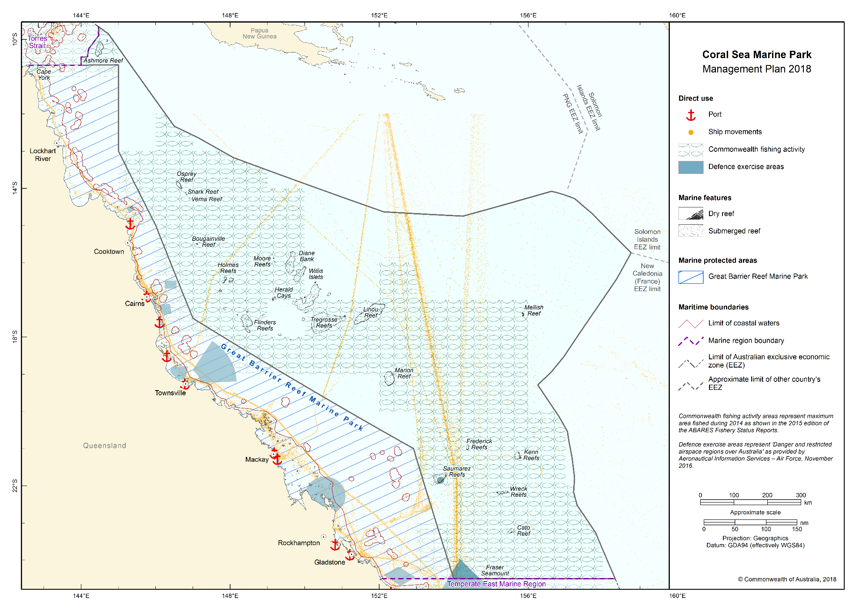Figure 2.3 Direct use in the Coral Sea Marine Park

Management programs and actions in the Coral Sea Marine Park
As outlined in Part 1, the Director will proactively implement management programs and actions to protect marine parks from threats and pressures, to minimise damage, and to rehabilitate and improve the resilience of marine parks.
These management programs and actions will be implemented on a national scale across all Australian Marine Parks. In addition, specific actions will be undertaken in the Coral Sea Marine Park. Table 2.2 outlines the management programs and actions likely to be undertaken in the Coral Sea Marine Park. These programs and actions may change during the life of this plan as new information and approaches become available. Additional actions will be developed in partnership with stakeholders through advisory forum/s and in implementation plans.
Table 2.2 Management programs, outcomes and actions in the Coral Sea Marine Park
Communication, education and awareness program
Actions to improve awareness, understanding and support for marine parks and park management.
Outcome
- Increased awareness, understanding and support for marine parks.
Actions—the Director will
under a national program:
- develop a marketing and communication strategy for Australian Marine Parks to raise awareness and understanding of marine park values and the contribution marine parks make to enhancing Australia’s wellbeing,
- develop online information resources to facilitate awareness of marine park values, management arrangements and visitor opportunities,
- maximise the use of new technologies and partnerships (including with schools, universities, museums and non-government organisations) to inspire people of all ages to become involved in marine park management and protection,
- establish network advisory committees to ensure users and interested stakeholders have on-going input to the management of Australian Marine Parks, and
- develop a customer focussed approach to tracking the aspirations and concerns of stakeholders in relation to marine parks.
in the Coral Sea Marine Park:
- develop information on the Marine Park to encourage increased awareness and understanding of values and management arrangements,
- provide infrastructure in and adjacent to the Marine Park, such as signs and marker buoys, to increase understanding of marine park values and rules, particularly at sites that are regularly visited,
- work with the Great Barrier Reef Marine Park Authority, and other Commonwealth and state government agencies, through their communication activities, to increase understanding, and
- establish a Coral Sea Marine Park advisory forum/s or other engagement mechanisms to support and collaborate with the Director in management.

Tourism and visitor experience program
Actions to provide for and promote a range of environmentally appropriate, high-quality recreation and tourism experiences and contribute to Australia’s visitor economy.
Outcomes
- High-quality visitor experiences that are appealing, engaging and raise awareness of the natural and cultural values of marine parks.
- Increased visitation to marine parks.
- Social and economic benefits from the contribution of marine parks to Australia's visitor economy.
Actions—the Director will
under a national program:
- develop a sustainable tourism and visitor experience strategy for Australian Marine Parks,
- work with national, state and local tourism authorities and operators to maximise the value of sustainable ecotourism opportunities associated with marine parks,
- develop a commercial tourism authorisation system to encourage best-practice and eco-accredited businesses operating in Australian Marine Parks,
- work with Tourism Australia and state and regional tourism authorities and the fishing industry to market and promote Australian Marine Parks, including opportunities to promote locally caught and sustainably caught seafood,
- monitor visitor trends and levels of satisfaction with marine park experiences and products,
- promote culturally sensitive tourism by encouraging tourism operators to liaise with traditional owners, and
- work with tourism operators and Indigenous people to recognise and promote cultural values and cultural tourism opportunities.
in the Coral Sea Marine Park:
- promote visitor experiences that foster curiosity and appreciation of natural and heritage values in the Marine Park, for example diving at Osprey Reef, and
- work with the Great Barrier Reef Marine Park Authority, and other Commonwealth and state government agencies and the tourism industry to support tourism initiatives, events and attractions that promote visitor experiences in the Marine Park.

Indigenous engagement program
Actions to recognise and respect the ongoing cultural responsibilities of Indigenous people to care for sea country and support multiple benefits for traditional owners.
Outcomes
- Social, cultural and economic benefits for traditional owners.
- Partnerships with traditional owners and Indigenous groups to manage sea country in marine parks.
Actions—the Director will
under a national program:
- develop an Australian Marine Parks Indigenous engagement and cultural heritage strategy, to improve understanding of cultural heritage, link management with sea country plans and maximise employment and enterprise opportunities for traditional owners,
- develop agreements to support Indigenous ranger programs to deliver management in marine parks, and
- provide information to Indigenous people about marine park management.
in the Coral Sea Marine Park:
- collaborate with traditional owners, Indigenous ranger groups, relevant partners and Indigenous advisory committees to undertake marine park management such as surveillance, monitoring, threat mitigation, marine debris removal, and implement actions identified in sea country plans where applicable,
- identify opportunities and mechanisms to engage traditional owners and Indigenous rangers in the management of the Marine Park,
- increase understanding of traditional knowledge and cultural values,
- implement cultural awareness training for Parks Australia staff in association with traditional owners, and
- establish protocols for researchers working with Parks Australia to guide engagement with traditional owners.

Marine science program
Actions to provide necessary scientific knowledge and understanding of marine park values, pressures, and adequacy of responses for effective management.
Outcomes
- Increase understanding of marine park values, pressures and adequacy of responses.
- Improve understanding of the effectiveness of marine park management in protecting park values.
- Informed decision-making and improved evidence-based decisions.
Actions—the Director will
under a national program:
- establish ecological, social and economic baselines to support evidence-based decision-making and adaptive management,
- develop an Australian Marine Parks science strategy to prioritise and encourage research and monitoring of park values, pressures and management effectiveness, and foster science communication and knowledge uptake,
- encourage and facilitate knowledge brokering to support collaboration and partnerships with the science community, private enterprise, citizen science organisations and other Commonwealth, state and territory agencies,
- establish an authorisation system for scientific research and monitoring by third parties, and encourage data to be made publicly available through appropriate information portals such as the Australian Ocean Data Network,
- collaborate with the science community (including through the National Marine Science Plan Committee and National Environmental Science Program) and other marine park users to assist in improving the understanding of marine park values, pressures and management effectiveness, and
- collaborate with the science community and other government agencies to increase the use of innovative and effective technology and systems including sensor technology.
in the Coral Sea Marine Park:
- monitor social and economic uses and their benefits and impacts on the Marine Park,
- monitor the condition of important habitats such as reef systems at Osprey, Coringa-Herald and Lihou Reefs, and their vulnerability to climate change,
- monitor the impact of invasive species on marine park values and the effectiveness of management,
- collaborate with the Great Barrier Reef Marine Park Authority, other Commonwealth and state government agencies, marine park users and the science sector to support long-term monitoring. For example, monitoring of coral reefs, protected species and effects of fishing on marine parks, and
- investigate opportunities to extend citizen science programs.
Assessments and authorisations program
Actions to provide for efficient, effective, transparent and accountable assessment, authorisation and monitoring processes to enable sustainable use and protection of marine park values.
Outcome
- Assessments and authorisations ensure ongoing protection of marine park values through the management of activities in marine parks.
Actions—the Director will
under a national program:
- develop and apply best-practice approaches to regulation and decision-making in the authorisation of activities within marine parks. This includes developing policy to ensure assessment and authorisation requirements are clearly articulated and that decision making is robust, consistently applied, and transparent to all marine park users,
- collaborate with industry to investigate innovative technologies and systems (including vessel monitoring systems) that can assist businesses and individuals to comply with regulatory requirements,
- develop an effective and efficient process to assess new technologies and gear types to allow for the use of new equipment during the life of this plan if appropriate,
- develop a guarantee of service for the regulated community that includes a commitment to work with key marine park users and interest groups whose interests are likely to be affected by regulatory decisions, and
- develop a customer focused online authorisation system for marine park users that includes publishing authorisations issued by Parks Australia on its website.
in the Coral Sea Marine Park:
- issue authorisations—a permit, class approval, activity licence or lease—for activities in the Marine Park assessed as acceptable either by the Director or another government or industry policy, plan or program accepted by the Director, and
- work with the Great Barrier Reef Marine Park Authority and Queensland government agencies to improve experiences and consistency of approaches for people seeking authorisations.

Park protection and management program
Timely and appropriate preventative and restorative actions to protect natural, cultural and heritage values from impacts.
Outcome
- Impact of pressures on marine park values are minimised as far as reasonably practicable.
Actions—the Director will
under a national program:
- apply a risk-based assessment process to prioritise park protection and management actions,
- develop an Australian Marine Parks critical incident strategy in collaboration with the Australian Maritime Safety Authority and other responsible agencies to respond to critical incidents,
- develop a mooring and anchoring strategy to protect marine park values and improve visitor experience,
- support the removal of marine debris and ghost nets from marine parks through partnerships with Commonwealth, state and territory government agencies and other organisations involved in the management of marine debris, and
- contribute to actions, where appropriate, that support Australia’s obligations under international agreements and national environmental law. This includes the World Heritage Convention, Ramsar Convention, recovery plans, wildlife conservation plans and threat abatement plans.
in the Coral Sea Marine Park:
- enable infrastructure such as moorings to protect coral reefs and enhance visitor safety, such as at Osprey Reef,
- collaborate with and support other agencies that undertake invasive and protected species management and marine debris removal. For example, this may include biosecurity assessments, research, or removal of ghost nets,
- work with the Great Barrier Reef Marine Park Authority and other Commonwealth and state government agencies to respond to environmental incidents and accidents, and
- collaborate with traditional owners and Indigenous ranger groups to undertake management actions.

Compliance program
Actions to support appropriate and high level compliance by marine park users with the rules set out in this plan.
Outcomes
- Improved user awareness of marine park rules.
- Increased levels of voluntary compliance and self-regulation by marine park users.
- High overall levels of compliance with the rules by marine park users.
- A decrease in the number of non-compliances.
Actions—the Director will
under a national program:
- apply a risk-based approach to compliance planning, targeted enforcement and compliance auditing,
- collaborate with Australian, state and territory government agencies by sharing assets and information,
- investigate the use of new technologies and warning systems to assist in the detection of potential illegal activities, and
- work with marine park users to promote understanding of the rules for activities and how to comply.
in the Coral Sea Marine Park:
- work with the Great Barrier Reef Marine Park Authority and other Commonwealth and state government agencies in compliance planning, including implementing actions to deter illegal activities and encourage voluntary compliance, and
- collaborate with the Great Barrier Reef Marine Park Authority and other Commonwealth and state government agencies in surveillance, including water and aerial patrols.

