Glossary
action | Has the meaning given by Subdivision A of Division 1 of Part 23 of the EPBC Act.
artificial reef | Has the meaning given by the Environment Protection (Sea Dumping) Act 1981, namely, a structure or formation placed on the seabed:  (a) for the purpose of increasing or concentrating populations of marine plants and animals; or  (b) for the purpose of being used in human recreational activities.
Australian Government or the Government | The Government of the Commonwealth of Australia.
Australian Marine Parks or Marine Park | Commonwealth reserves, named as Marine Parks, comprising the South-west, North-west, North and Temperate East Networks of Marine Parks and the Coral Sea Marine Park declared by the Environment Protection and Biodiversity Conservation (Commonwealth Marine Reserves) Proclamation 2013, and the reserves comprising the South-east Commonwealth Network of Marine Parks declared by the Proclamations made under the EPBC Act on 28 June 2007.
authorisation | As described in Section 4.4 (Authorisation of activities) of this plan.
biodiversity or biological diversity | Has the meaning given by s.528 of the EPBC Act.
biologically important areas | Areas where a protected species displays a biologically important behaviour such as breeding, foraging, resting or migration. These areas serve to highlight the parts of a marine region that are particularly important for the conservation of protected species.
bioregion | A large area that has similar types of plants, animals and ocean conditions compared with other similarly sized areas, and, in this document, those bioregions as defined in the Integrated Marine and Coastal Regionalisation of Australia Version 4.0.
bioregional plan | Has the meaning given by s.528 of the EPBC Act.
CAR | Comprehensiveness—includes the full range of ecosystems recognised at an appropriate scale within and across each bioregion;  Adequacy—the maintenance of the ecological viability and integrity of populations, species and communities; and  Representativeness—those marine areas that are selected for inclusion in reserves should reasonably reflect the biotic diversity of the marine ecosystems from which they derive.
class approval | As described in Section 4.4.2 (Class approvals) of this plan.
commercial aquaculture | Farming and culturing of aquatic organisms, such as fish, crustaceans and molluscs.
commercial fishing | Has the meaning given by s.390SC(1A) of the EPBC Act: a fishing activity that is engaged in for a commercial purpose, and, to avoid doubt, does not include an activity that constitutes recreational fishing.
Commonwealth marine area | Has the meaning given by s.24 of the EPBC Act.
Commonwealth marine environment | The environment in the Commonwealth marine area.
Commonwealth reserve | A reserve established and managed under Division 4 of Part 15 of the EPBC Act, including Australian Marine Parks.
Coral Sea Marine Park | The area described in Schedule 2 to the Environment Protection and Biodiversity Conservation (Commonwealth Marine Reserves) Proclamation 2013, and declared to be a Commonwealth reserve by Section 6 of the proclamation.
Department | The Department responsible for administering the EPBC Act.
Director | The Director of National Parks established under s.514A of the EPBC Act, including any person to whom the Director has delegated powers and functions under the EPBC Act in relation to the Coral Sea Marine Park.
dropline | A line that is vertically set or suspended in the water column between a weight (normally in contact with the seabed) and a vessel or a buoy on the water surface. Baited hooks are attached to the main line via smaller lines (branch-lines or snoods).
ecologically sustainable use | Has the meaning given by s.528 of the EPBC Act.
ecosystem | Has the meaning given by s.528 of the EPBC Act.
endemic/endemism | Native to or confined to a certain region.
environment | Has the meaning given by s.528 of the EPBC Act.
EPBC Act | Environment Protection and Biodiversity Conservation Act 1999, including any Act amending, repealing or replacing the Act.
EPBC Regulations | Environment Protection and Biodiversity Conservation Regulations 2000, including any Regulations amending, repealing or replacing the Regulations.
fish aggregating device | Has the meaning given by the Sea Installation Act 1987, namely:  (a) a man-made structure that, when in, or brought into, physical contact with the seabed or when floating, is used solely for the purpose of attracting populations of fish so as to facilitate the taking of those fish; or  (b) any electronic or other equipment designed or intended to be ancillary to, or associated with, such a structure while it is being used, or in order to facilitate the use of the structure, for that purpose;  and do not include a net, trap or other equipment for taking, catching or capturing fish.
hand collection | Removing species from rocks, crevices, the seafloor or other benthic substrate by hand using dive hookah, self-contained underwater breathing apparatus (scuba) or snorkel.
hand net (hand, barrier, skimmer, cast, scoop, drag, lift) | A small mesh net that is operated by hand to trap fish including a hand net, barrier net, skimmer net, cast net, scoop net, drag net, lift net.
Indigenous Protected Area (IPA) | An Indigenous Protected Area (IPA) is an area voluntarily dedicated for protection by Indigenous groups on Indigenous owned or managed land or sea country. IPAs are recognised by the Australian Government as part of the National Reserve System, protecting the nation’s biodiversity for the benefit of all Australians. Most IPAs are dedicated to promote a balance between conservation and other sustainable uses to deliver social, cultural and economic benefits for local Indigenous communities. IPAs combine traditional and contemporary knowledge into a framework to leverage partnerships with conservation and commercial organisations and provide employment, education and training opportunities for Indigenous people.
Integrated Marine and Coastal Regionalisation of Australia (IMCRA) | A spatial framework for classifying Australia’s marine environment into bioregions that forms the basis for the development of a National Representative System of Marine Protected Areas.
IUCN | International Union for the Conservation of Nature.
key ecological feature | Elements of the Commonwealth marine environment that, based on best available scientific understanding, are considered to be of regional importance for either the region's biodiversity or ecosystem function and integrity.
longline (demersal, auto-longline) | A line that is horizontally set along the seafloor between weights to maintain contact with the seafloor. The main line has a vertical line attached at each end which is connected to buoys on the water surface. Baited hooks are attached to the main line via smaller lines (branch-lines or snoods). An auto-longline is a longline where the hooks are baited by a machine rather than manually.
longline (pelagic) | A line that is horizontally set near the surface of the water and avoids contact with the seafloor. The main line has a vertical line attached at each end which is connected to buoys on the surface of the water. Baited hooks are attached to the main line via smaller lines (branch-lines or snoods). Buoys are generally used intermittently along the main line to help maintain buoyancy in the water column. The line may be left to drift in the water or be anchored by vertical lines to the seafloor.
management category | An IUCN category prescribed by Schedule 8 of the EPBC Regulations.
management plan or the plan or this plan | This management plan unless otherwise stated.
management principles | Australian IUCN reserve management principles prescribed by r.10.04 and Schedule 8 of the EPBC Regulations.
MARPOL | The International Convention for the Prevention of Pollution from Ships (MARPOL) is the International Maritime Organisation (IMO) convention covering prevention of pollution of the marine environment by ships from operational or accidental causes. This is the main international convention for the prevention of ship-sourced pollution in the marine environment. MARPOL addresses pollution that might result from accidents such as collisions or groundings, as well as all types of waste generated during the normal operation of a ship. Ships are permitted to discharge small quantities of certain wastes, subject to very strict controls.
mining operations | Has the meaning given by s.355(2) of the EPBC Act.
Minister | The Minister responsible for administering the EPBC Act.
minor line (handline, rod & reel, trolling, squid jig, poling) | Any line fishing with a small number of hooks, often just one (i.e. handline, rod and reel, squid jigging and pole fishing). Trolling is dragging a lure or baited hook behind a moving vessel and reeling it in (either by hand, reel or winches). Poling is dragging a lure or baited hook on a fixed length of line behind a vessel and flicking or gaffing the fish into the boat. Squid jigging involves vertical lines with several barbless lures being mechanically jigged up and down to attract squid.
National Representative System of Marine Protected Areas (NRSMPA) | Australia’s comprehensive, adequate and representative system of marine protected areas that contributes to the long-term ecological viability of marine and estuarine systems, maintains ecological processes and systems, and protects Australia's biological diversity at all levels.
native title | Has the meaning given by s.223 of the Native Title Act 1993.
net (demersal) | A rectangular mesh net anchored to the seafloor with weights. The net may have small floats along the upper line to maintain its shape in the water. Each end has a vertical line that is connected to buoys on the surface of the water.
net (pelagic) | A rectangular mesh net set near the surface of the water that is not in contact with the seafloor. The net generally has floats along the upper line to maintain buoyancy. Each end is connected to a buoy on the surface of the water. The net can be left to drift or connected to a boat.
news of the day | The reporting by newspaper, television, radio or other electronic media, of unanticipated events that happen from time to time, such as rescue events. It does not include general items about a marine park or planned activities in the park.
Parks Australia | The Division of the Department that supports the Director of National Parks.
pelagic fishing gear | Fishing gear that does not come in contact with the seabed during use.
permit | As described in Section 4.4.1 (Permits) of this plan.
prescription | Mandatory rules for managing marine parks.
protected species | Species listed under the EPBC Act as threatened, migratory or marine species and/or cetaceans (whales, dolphins and porpoises).
purse seine | A semi-rectangular mesh net with floats along the top and a weighted line along the bottom. A vessel or buoy is used to anchor one end of the net while it is set around a fish aggregation in a circular pattern. The bottom of the net has a cable threaded through it which, when pulled, brings the bottom of the net together like a purse trapping the fish inside. The net is then pulled toward the vessel and the fish are either lifted or pumped on board the vessel.
recreational fishing | Taking marine species, including shells, not for commercial purposes and that is not commercial fishing.
sea country | Sea country refers to the areas of the sea that Aboriginal and Torres Strait Islander groups are particularly affiliated with through their traditional lore and customs.
stowed and secured | All fishing apparatus, including nets and lines, are rendered inoperative in zones where fishing is not permitted, including that the apparatus is inboard the vessel and otherwise completely out of the water or as determined by the Director.
traditional owners | A local descent group of Indigenous persons who have common spiritual affiliations to an area of sea country and are entitled by Indigenous traditions to fish and hunt in an area of sea country.
transit | Continuous and expeditious passage through an area. However, passage includes stopping and anchoring, but only in so far as rendered necessary by force majeure or distress or for the purpose of rendering assistance to persons, ships or aircraft in danger or distress.
trap, pot | Traps and pots are made in a variety of shapes and sizes from various materials. They are generally baited to attract fish or crustaceans through one or more entrances or openings. Traps and pots are set on the seafloor and connected to a vertical line with a buoy on the surface of the water.
trawl (demersal) | A cone-shaped mesh net towed through the water column on or near the seabed that comes into contact with the seabed during use. The net is held open horizontally by otter boards or trawl doors while towing. The bottom of the net opening generally has chains, rubber or steel bobbins and spacers threaded along its length to help reduce snagging by slightly lifting the net off the seafloor. The last section of the net is a cod end where the catch is retained. Long metal cables connect the net and boards to a vessel. The cable length and mesh size varies depending on the species being targeted (fish or prawns). These nets can be towed by one vessel in various configurations such as one or four nets.
trawl (midwater) | A cone-shaped mesh net towed through the water column that does not come into contact with the seabed at any stage during use. The net is held open horizontally by otter boards or trawl doors while towing. The bottom of the net opening is weighted. The last section of the net is a cod end where the catch is retained. Long metal cables connect the net and boards to a vessel. The cable length and mesh size varies depending on the species being targeted (fish or prawns). These nets can be towed by one vessel in various configurations, such as one or four nets.
trotline | A trotline is very similar to a demersal longline. It is a line that is horizontally set along the seafloor. The main line has a vertical line attached at each end which is connected to buoys on the surface of the water. Baited hooks are attached to the main line via smaller lines (branch-lines or snoods). Buoys are used intermittently along the main line to lift baited hooks away from the seafloor.
UNCLOS | United Nations Convention on the Law of the Sea, concluded at Montego Bay on 10 December 1982.
values | As defined in Part 2 of this plan.
vessel identification and monitoring system | A system whereby vessels are fitted with an electronic device that can transmit or provide information to a central management agency about the vessel’s course or position, or other such information.

Schedule 1 Summary of legislative and policy contexts

S1.1 The EPBC Act and EPBC Regulations
The objects of the EPBC Act (s.3) are:
- to provide for the protection of the environment, especially those aspects of the environment that are matters of national environmental significance;
- to promote ecologically sustainable development through the conservation and ecologically sustainable use of natural resources;
- to promote the conservation of biodiversity;
ca) to provide for the protection and conservation of heritage;
- to promote a co-operative approach to the protection and management of the environment involving governments, the community, landholders and Indigenous peoples;
- to assist in the co-operative implementation of Australia’s international environmental responsibilities;
- to recognise the role of Indigenous people in the conservation and ecologically sustainable use of Australia’s biodiversity; and
- to promote the use of Indigenous people’s knowledge of biodiversity with the involvement of, and in cooperation with, the owners of the knowledge.
Director of National Parks
The Director of National Parks is a corporation under the EPBC Act (s.514A) and a Commonwealth corporate entity for the purposes of the Public Governance Performance and Accountability Act 2013. The corporation is controlled by the person appointed by the Governor-General to the office that is called the Director of National Parks (s.514F of the EPBC Act).
The functions of the Director (s.514B) include the administration, management and control of Commonwealth reserves, including Australian Marine Parks, established under the EPBC Act. The Director generally has power to do all things necessary or convenient for performing the Director’s functions (s.514C). The Director has a number of specified powers under the EPBC Act and EPBC Regulations, including to prohibit or control some activities, and to issue permits for activities that are otherwise prohibited. The Director performs functions and exercises powers in accordance with this plan.
Establishment of Commonwealth reserves
Commonwealth reserves, including Australian Marine Parks, are declared by proclamation by the Governor-General under the EPBC Act. The EPBC Act and the EPBC Regulations provide the legal basis and framework for management of Commonwealth reserves.
Commonwealth reserves can be declared over areas specified in s.344 of the EPBC Act, including the Commonwealth marine area as defined in s.24 of the Act (which extends generally from the three nautical mile limit of the coastal waters of the states and territories to the outer limit of Australia’s exclusive economic zone). The Commonwealth marine area is also a matter of national environmental significance protected from significant impacts to the environment by Part 3 of the EPBC Act.

IUCN categories and management principles
The International Union for the Conservation of Nature (IUCN) sets out guidelines for categorising protected areas, which Australia and many other countries have adopted as a national standard. The EPBC Act requires Commonwealth reserves, and any zones into which a reserve is divided, to be assigned to one of the seven categories prescribed by the EPBC Regulations (r. 10.03H), which correspond to the categories identified by the IUCN:
- strict nature reserve (category Ia);
- wilderness area (category Ib);
- national park (category II);
- natural monument (category III);
- habitat/species management area (category IV);
- protected landscape/seascape (category V); or
- managed resource protected area (category VI).
Reserve management must be consistent with the relevant Australian IUCN reserve management principles prescribed for each category by Schedule 8 to the EPBC Regulations and set out below:
General administrative principles
Part 1 of Schedule 8 of the EPBC Regulations sets out general administrative principles applicable to all Commonwealth reserves. These principles underpin management approaches with regard to:
- community participation—management arrangements should, to the extent practicable, provide for broad and meaningful participation by the community, public organisations and private interests in designing and carrying out the functions of a reserve or zone;
- effective and adaptive management—management arrangements should be effective and appropriate to the biodiversity objectives and the socio-economic context of the reserve or zone. They should be adaptive in character to ensure a capacity to respond to uncertainty and change;
- the precautionary principle—a lack of full scientific certainty should not be used as a reason for postponing measures to prevent degradation of the natural and cultural heritage of a reserve or zone where there is a threat of serious or irreversible damage;
- minimising impacts—the integrity of a reserve or zone is best conserved by protecting it from disturbance and threatening processes. Potential adverse impacts on the natural, cultural and social environment and surrounding communities should be minimised as far as practicable;
- ecologically sustainable use—if resource use is consistent with the management principles that apply to a reserve or zone, it should be based on the principle (the principle of ecologically sustainable use) that:
- natural resources should only be used within their capacity to sustain natural processes while maintaining the life-support systems of nature, and
- the benefit of the use to the present generation should not diminish the potential of the reserve or zone to meet the needs and aspirations of future generations;
- transparency of decision-making—the framework and processes for decision-making for management of the reserve or zone should be transparent. The reason for making decisions should be publicly available, except to the extent that information, including information that is culturally sensitive or commercial-in-confidence, needs to be treated as confidential; and
- joint management—if the reserve or zone is wholly or partly owned by Aboriginal people, continuing traditional use of the reserve or zone by resident Indigenous people, including the protection and maintenance of cultural heritage, should be recognised.
Principles for each IUCN category represented in the Coral Sea Marine Park
Part 2 of Schedule 8 of the EPBC Regulations sets out the management principles applicable to each category in the Coral Sea Marine Park. The principles provide guidance on the purposes for which an area should be used and the general types of activities that may be conducted. They underpin decisions and prescriptions for each IUCN category.
- Strict nature reserve (IUCN category Ia)
  - The reserve or zone should be managed primarily for scientific research or environmental monitoring based on the following principles.
  - Habitats, ecosystems and native species should be conserved in as undisturbed a state as possible.
  - Genetic resources should be maintained in a dynamic and evolutionary state.
  - Established ecological processes should be maintained.
  - Structural landscape features or rock exposures should be safeguarded.
  - Examples of the natural environment should be secured for scientific studies, environmental monitoring and education, including baseline areas from which all avoidable access is excluded.
  - Disturbance should be minimised by careful planning and execution of research and other approved activities.
  - Public access should be limited to the extent it is consistent with these principles.
- National park (IUCN category II)
  - The reserve or zone should be protected and managed to preserve its natural condition according to the following principles.
  - Natural and scenic areas of national and international significance should be protected for spiritual, scientific, educational, and recreational or tourist purposes.
  - Representative examples of physiographic regions, biotic communities, genetic resources and native species should be perpetuated in as natural a state as possible to provide ecological stability and diversity.
  - Visitor use should be managed for inspirational, educational, cultural and recreational purposes at a level that will maintain the reserve or zone in a natural or near-natural state.
  - Management should seek to ensure that exploitation or occupation inconsistent with these principles does not occur.
  - Respect should be maintained for the ecological, geomorphologic, sacred and aesthetic attributes for which the reserve or zone was assigned to this category.
  - The needs of Indigenous people should be taken into account, including subsistence resource use, to the extent that they do not conflict with these principles.
  - The aspirations of traditional owners of land within the reserve or zone, their continuing land management practices, the protection and maintenance of cultural heritage and the benefit the traditional owners derive from enterprises, established in the reserve or zone, consistent with these principles should be recognised and taken into account.
- Habitat/species management area (IUCN category IV)
  - The reserve or zone should be managed primarily, including (if necessary) through active intervention, to ensure the maintenance of habitats or to meet the requirements of collections or specific species based on the following principles.
  - Habitat conditions necessary to protect significant species, groups or collections of species, biotic communities or physical features of the environment should be secured and maintained, if necessary through specific human manipulation.
  - Scientific research and environmental monitoring that contribute to reserve management should be facilitated as primary activities associated with sustainable resource management.
  - The reserve or zone may be developed for public education and appreciation of the characteristics of habitats, species or collections, and of the work of wildlife management.
  - Management should seek to ensure that exploitation or occupation inconsistent with these principles does not occur. People with rights or interests in the reserve or zone should be entitled to benefits derived from activities in the reserve or zone that are consistent with these principles.
  - If the reserve or zone is proclaimed for the purpose of a botanic garden, it should also be managed for the increase of knowledge, appreciation and enjoyment of Australia’s plant heritage by establishing, as an integrated resource, a collection of living and herbarium specimens of Australian and related plants for study, interpretation, conservation and display.
- Managed resource protected area (IUCN category VI)
  - The reserve or zone should be managed mainly for the sustainable use of natural ecosystems based on the following principles.
  - The biological diversity and other natural values of the reserve or zone should be protected and maintained in the long term.
  - Management practices should be applied to ensure ecologically sustainable use of the reserve or zone.
  - Management of the reserve or zone should contribute to regional and national development to the extent that this is consistent with these principles.
Management plans
The EPBC Act requires the Director to prepare a management plan for a Commonwealth reserve. When prepared, a plan is given to the Minister administering the EPBC Act for approval. A management plan is a ‘legislative instrument’ for the purposes of the Legislative Instruments Act 2003 and must be registered under that Act. Following registration, the plan is tabled in each House of the Commonwealth Parliament and may be disallowed by either House on a motion moved within 15 sitting days of the House after tabling.
A management plan for a Commonwealth reserve has effect for ten years, subject to being revoked or amended earlier by another management plan for the reserve. The Director must give effect to a management plan in operation for a Commonwealth reserve. The Commonwealth and Commonwealth agencies must also not perform functions or exercise powers in relation to the reserve inconsistently with the plan (s.362).
Under the EPBC Act (s.367) a management plan for a Commonwealth reserve must provide for the protection and conservation of the reserve.
A management plan for a Commonwealth reserve may divide the reserve into zones and assign each zone to an IUCN category (whether or not a proclamation has assigned the reserve or each zone of the reserve to that IUCN category). The category to which a zone is assigned may differ from the category to which the reserve is assigned.
The provisions of a management plan for a Commonwealth reserve that relate to the reserve or a particular zone of the reserve must not be inconsistent with the Australian IUCN reserve management principles for the IUCN category to which the reserve or zone is assigned by the plan.
If the management plan for a Commonwealth reserve assigns the reserve to one IUCN category and assigns a zone of the reserve to a different IUCN category, disregard the IUCN category to which the reserve is assigned for the purposes of the application of subsection (3) in relation to the zone.
A single management plan may be the management plan for more than one Commonwealth reserve.
A management plan for a Commonwealth reserve may include provisions relating to an area that is proposed to be included in the reserve, but they do not have effect until the area is included in the reserve.
Under the EPBC Act (s.368), in preparing a management plan for a Commonwealth reserve, the Director must take account of:
(a) any report considered by the Minister under Section 351 before a proclamation declaring the reserve was made; and
(b) the regulation of the use of the reserve for the purpose for which it was declared; and
(c) the interests of:
(i) any owner of any land or seabed in the reserve; and
(ii) the traditional owners of any Indigenous people’s land in the reserve; and
(iii) any other Indigenous persons interested in the reserve; and
(iv) any person who has a usage right relating to land, sea or seabed in the reserve that existed (or is derived from a usage right that existed) immediately before the reserve was declared; and
(d) the protection of the special features of the reserve, including objects and sites of biological, historical, palaeontological, archaeological, geological and geographical interest; and
(e) the protection, conservation and management of biodiversity and heritage within the reserve; and
(f) the protection of the reserve against damage; and
(g) Australia’s obligations under agreements between Australia and one or more other countries relevant to the protection and conservation of biodiversity and heritage.
Control of actions in Commonwealth reserves
The EPBC Act (ss.354 and 354A) prohibits certain actions being taken in Commonwealth reserves except in accordance with a management plan in operation for the reserve:
- kill, injure, take trade, keep or move a member of a native species; or
- damage heritage; or
- carry out an excavation; or
- erect a building or other structure; or
- carry out works; or
- take an action for commercial purposes.
Mining operations are also prohibited (ss.355 and 355A of the EPBC Act) except in accordance with a management plan. Section 355(2) defines mining operations as follows:
a) operations or activities connected with, or incidental to, the mining or recovery of minerals or the production of material from minerals, including:
(i) prospecting and exploration for minerals; and
(ii) milling, refining, treatment and processing of minerals; and
(iii) storage and disposal of minerals and materials produced from minerals;
b) the construction and use of towns, camps, dams, pipelines power lines or other structures for the purposes of operations or activities described in paragraph (a); and
c) the performance of any other work for the purposes of operations or activities described in paragraph (a).
Section 358 of the EPBC Act allows the Director to grant a lease or a licence relating to land or seabed in a Commonwealth reserve in accordance with a management plan.
The EPBC Regulations control, or allow the Director to control, a range of activities in Commonwealth reserves. The Director applies the Regulations subject to and in accordance with the EPBC Act and management plan. The Regulations do not apply to the Director or to wardens or rangers appointed under the EPBC Act. Activities that are prohibited or restricted by the EPBC Act may be carried on if they are authorised by a permit issued by the Director and/or they are carried on in accordance with a management plan or if another exception prescribed by r.12.06(1) of the Regulations applies.
Access to biological resources in Commonwealth areas is regulated under Part 8A of the EPBC Regulations. Access to biological resources is also covered by ss.354 and 354A of the EPBC Act if the resources are members of a native species and/or if access is for commercial purposes.
Environmental assessment and approval
Actions that are likely to have a significant impact on matters of national environmental significance are subject to the referral, assessment and approval provisions of Chapters 2 to 4 of the EPBC Act (irrespective of where the action is taken).
At commencement of this plan, the matters of national environmental significance identified in the EPBC Act are:
- world heritage properties;
- national heritage places;
- wetlands of international importance (Ramsar wetlands);
- listed threatened species and communities;
- listed migratory species;
- protection of the environment from nuclear actions (including uranium mining);
- marine environment (Commonwealth marine areas);
- the Great Barrier Reef Marine Park; and
- protection of water resources from coal seam gas development and large coal mining development.
The referral, assessment and approval provisions also apply to actions on Commonwealth land that are likely to have a significant impact on the environment and to actions taken outside Commonwealth land that are likely to have a significant impact on the environment on Commonwealth land.
Responsibility for compliance with the assessment and approvals provisions of the EPBC Act lies with persons taking relevant ‘controlled’ actions. A person proposing to take an action that the person thinks may be or is a controlled action should refer the proposal to the Minister. The Minister will decide whether or not the action is a controlled action. The Director of National Parks may also refer proposed actions to the Minister.
Wildlife protection
Part 13 of the EPBC Act contains provisions that prohibit and regulate actions in relation to listed threatened species and ecological communities, listed migratory species, listed marine species and cetaceans (whale, dolphin and porpoise).
Actions taken in accordance with a Commonwealth reserve in accordance with a management plan in relation to any native species listed under Part 13 of the EPBC Act are exempt from prohibitions in Part 13 of the Act.

Heritage protection
The EPBC Act world heritage protection provisions (s.12–15A, ss.320–324) provide:
- that the primary purpose of management of natural heritage and cultural heritage of a declared world heritage property must be, in accordance with Australia’s obligations under the World Heritage Convention, to identify, protect, conserve, present, transmit to future generations and, if appropriate, rehabilitate the world heritage values of the property;
- that at least one management plan should be prepared for each declared world heritage property;
- that the Commonwealth and each Commonwealth agency must take all reasonable steps to ensure it exercises its powers and performs its functions in relation to the property in a way that is not inconsistent with the World Heritage Convention, the Australian world heritage management principles; and if the property is on the World Heritage List and a plan for managing the property has been prepared as described in s.321—that plan;
- that an action should not be approved if it would be inconsistent with the protection, conservation, presentation or transmission to future generations of the world heritage values of the property.
The EPBC Act national and Commonwealth heritage protection provisions (ss.324A to 324ZC and ss.341A to 341ZH) provide:
- for the establishment and maintenance of a National Heritage List and a Commonwealth Heritage List, criteria and values for inclusion of places in either list and heritage management principles for places that are included in the two lists;
- that Commonwealth agencies must not take an action that is likely to have an adverse impact on the heritage values of a place included in either list unless there is no feasible and prudent alternative to taking the action and all measures that can reasonably be taken to mitigate the impact of the action on those values are taken and that Commonwealth agencies that own or control places must—
- prepare a written heritage strategy for managing those places to protect and conserve their Commonwealth heritage values. The strategy must address any matters required by the EPBC Regulations, and not be inconsistent with the Commonwealth heritage management principles, and
- identify Commonwealth heritage values for each place, and produce a register that sets out the Commonwealth heritage values (if any) for each place (and do so within the timeframe set out in the place’s heritage strategy).
The prescriptions in this plan are consistent with the Commonwealth heritage and national heritage management principles and other relevant obligations under the EPBC Act for protecting and conserving the heritage values for which the reserve has been listed on the National Heritage List.
Wetlands of international importance
The EPBC Act management of wetlands of international importance provisions (ss.325 to 336) provide:
- that the Commonwealth may designate a wetland for inclusion in the List of Wetlands of International Importance kept under the Ramsar Convention only after seeking the agreement of relevant states, self-governing territories and land holders;
- that the Minister must make plans for managing wetlands listed under the Ramsar Convention that are entirely in Commonwealth areas other than Commonwealth reserves. The Commonwealth and Commonwealth agencies must not contravene such plans;
- that the Commonwealth must try to prepare and implement management plans for other wetlands listed under the Ramsar Convention, in cooperation with the relevant states and self-governing territories;
- that the Commonwealth and Commonwealth agencies have duties relating to declared Ramsar wetlands in states and territories; and
- that the Commonwealth can provide assistance for the protection or conservation of declared Ramsar wetlands.
The prescriptions in this plan are consistent with the Australian Ramsar management principles prescribed in Schedule 6 of the EPBC Regulations and other relevant obligations under the EPBC Act for the management of wetlands included in the List of Wetlands of International Importance kept under the Ramsar Convention.
EPBC Act and Indigenous traditional rights and native title rights
Native title rights may exist in offshore waters within Australia’s jurisdiction. Native title determinations need not have been made in order for native title rights to exist.
The EPBC Act does not affect the operation of the Native Title Act 1993 and s.211 in particular, which in certain circumstances allows native title holders to hunt (and undertake other activities) in the exercise of native title rights without a permit or licence (s.8 EPBC Act). Prohibitions and other provisions of the EPBC Act and EPBC Regulations dealing with activities in Commonwealth reserves do not prevent Indigenous people from continuing their traditional use of an area in a reserve for hunting or gathering (except for purposes of sale), or for ceremonial and religious purposes, in accordance with the EPBC Act s.359A.
Access to biological resources
Access to biological resources in Commonwealth areas is regulated under the EPBC Regulations Part 8A and a permit from the Minister is required. Access to biological resources is defined in the EPBC Regulations and broadly means the taking of biological resources of native species for research and development on any genetic resources, or biochemical compounds, comprising or contained in the biological resources. Biological resources are defined by the EPBC Act as genetic resources, organisms, parts of organisms, populations and any other biotic component of an ecosystem with actual or potential use or value for humanity. Genetic resources are defined by the EPBC Act as any material of plant, animal, microbial or other origin that contains functional units of heredity, and that has actual or potential value for humanity.
Penalties
Civil and criminal penalties may be imposed for breaches of the EPBC Act and criminal penalties may be imposed for breaches of the EPBC Regulations.

S1.2 Other relevant legislation
The Environment Protection (Sea Dumping) Act 1981 (Sea Dumping Act) regulates the loading for the purpose of dumping and dumping of controlled material at sea (including certain wastes and other matter), and the placement of artificial reefs. The Act gives effect to Australia’s obligations under the 1996 Protocol to the Convention on the Prevention of Marine Pollution by Dumping of Wastes and Other Matter, 1972 (London Protocol). Under the Sea Dumping Act, dumping at sea is prohibited, except for possibly acceptable wastes or other matter that may be considered under a permit.
The Fisheries Act 1994 and Fisheries Regulation 2008 are the regulatory framework for the management of Queensland fisheries resources. The Torres Strait Fisheries Act 1984 is the regulatory framework for fisheries in certain waters between Australia and Papua New Guinea.
The Fisheries Management Act 1991 regulates fishing activities in the Australian Fishing Zone, from the Australian coastline to 200 nm, including waters surrounding external territories.
The Historic Shipwrecks Act 1976 provides for the protection of historic shipwrecks and associated relics and the establishment of protected zones around historic shipwrecks from the lowest astronomical tide mark to the exclusive economic zone. All shipwrecks and associated relics more than 75 years old whether located or not are protected under the Act by Ministerial declaration. A wreck less than 75 years old may also be protected by a declaration of the Minister.
The Historic Shipwrecks Act 1976 prohibits conduct in relation to historic shipwrecks and relics without a permit, which includes conduct that destroys or causes damage to a historic shipwreck or relic, causes interference with a historic shipwreck or relic, causes the disposal of a historic shipwreck or relic, or causes a historic shipwreck or relic to be removed from Australia.
The most current information about the status of discovered shipwrecks, protected shipwrecks or shipwrecks that have a declared protected zone is in the Australian national shipwrecks database (www.environment.gov.au).
The Offshore Minerals Act 1994 establishes the regulatory framework for offshore exploration and recovery of minerals beyond the three nautical mile limit of the coastal waters of states and territories. Management of these activities within coastal waters is the responsibility of the relevant state or territory governments.
The Offshore Petroleum and Greenhouse Gas Storage Act 2006 is the regulatory framework for offshore exploration and production of petroleum, and greenhouse gas storage activities, beyond the three nautical mile limit of the coastal waters of states and territories. Management of these activities within coastal waters is the responsibility of the relevant state or territory governments.
The Protection of the Sea (Prevention of Pollution from Ships) Act 1983 and the Navigation Act 2012 address the protection of the marine environment from ship-sourced pollution. The Prevention of Pollution from Ships Act implements the International Convention for the Prevention of Pollution from Ships (MARPOL), and regulates normal or routine operational discharges from ships. MARPOL annexes regulate the discharge of oil (Annex I), noxious liquid substances (Annex II), the disposal of sewage from ships (Annex IV) and garbage (Annex V), harmful substances carried by sea in packaged forms (Annex III) and air pollution from ships (Annex VI). The Australian Maritime Safety Authority (AMSA) is responsible for the application and enforcement of MARPOL in areas of Commonwealth jurisdiction, that is, to the limit of the 200 nautical mile exclusive economic zone. State and territory governments give effect to MARPOL Annexes in coastal waters out to three nautical miles (approximately 5.5 km) from land.

S1.3 International agreements
This plan takes into account Australia’s obligations under international agreements that are relevant to the Coral Sea Marine Park. These include:
Agreement between the Government of Australia and the Government of Japan for the Protection of Migratory Birds and Birds in Danger of Extinction and their Environment (JAMBA)
JAMBA provides for Australian and Japanese cooperation on the protection of migratory birds and birds in danger of extinction (listed in the annex to the agreement) and the management and protection of their environments. It requires both countries to take appropriate measures to preserve and enhance the environment of birds protected under the provisions of the agreement.
Agreement between the Government of Australia and the Government of the People’s Republic of China for the Protection of Migratory Birds and their Environment (CAMBA)
CAMBA provides for Australian and Chinese cooperation on the protection of migratory birds (listed in the annex to the agreement) and their environment. It requires both countries to take appropriate measures to preserve and enhance the environment of migratory birds.
Agreement between the Government of Australia and the Government of the Republic of Korea for the Protection of Migratory Birds 2007 (ROKAMBA)
ROKAMBA provides for Australian and Korean cooperation on the protection of migratory birds (listed in the annex to the agreement) and their habitat and the prevention of the extinction of certain birds. It requires both countries to take appropriate measures to conserve and improve the environment of birds protected under the provisions of the agreement.
Agreement on the Conservation of Albatrosses and Petrels (ACAP)
This agreement provides for parties to conserve highly migratory and threatened seabirds over their normal range by protecting critical habitat, controlling non-native species detrimental to albatrosses and petrels, introducing measures to reduce the incidental catch of seabirds in fisheries, and supporting research into the effective conservation of albatrosses and petrels.
Convention Concerning the Protection of World Cultural and Natural Heritage (World Heritage Convention)
The World Heritage Convention was adopted to ensure the proper identification, protection, conservation and presentation of cultural and natural heritage with outstanding universal value. Australian world heritage management principles are prescribed in Schedule 5 of the EPBC Regulations.
Convention on Biological Diversity (CBD)
Australia is a signatory to the CBD, which requires parties to pursue the conservation of biological diversity, the sustainable use of its components, and the fair and equitable sharing of the benefits arising out of the use of genetic resources. Article 8 of the convention identifies that parties should ‘establish a system of protected areas or areas where special measures need to be taken to conserve biodiversity’. The establishment and management of the Coral Sea Marine Park assists Australia in meeting its obligations under the CBD.
In 2010, the Conference of Parties to the CBD adopted a Strategic plan for biodiversity. It includes Target 11 relevant to protected areas:
By 2020, at least 17 per cent of terrestrial and inland water, and 10 per cent of coastal and marine areas, especially areas of particular importance for biodiversity and ecosystem services, are conserved through effectively and equitably managed, ecologically representative and well connected systems of protected areas and other effective area-based conservation measures, and integrated into the wider landscapes and seascapes.
The strategic plan complements, but does not replace, the commitment to establish representative networks of marine protected areas by 2012, made at the 2002 World Summit on Sustainable Development. Australia has met and exceeded this target.
Convention on International Trade in Endangered Species of Wild Fauna and Flora (CITES)
CITES aims to ensure that the international trade of wild fauna and flora specimens does not threaten the survival of the species from which they are derived. It places controls on the international trade of specimens of certain species. At the time of preparing this plan, several marine mammal species found in the Coral Sea Marine Park were listed under CITES Annex II.
Convention on the Conservation of Migratory Species of Wild Animals (Bonn Convention)
The Convention on the Conservation of Migratory Species of Wild Animals (Bonn Convention) aims to conserve terrestrial, marine and avian migratory species throughout their range. Parties to this convention work together to conserve migratory species and their habitats. Species that are listed under the above migratory agreements and conventions are listed species under Part 13 of the EPBC Act.
Convention on Wetlands of International Importance especially as Waterfowl Habitat 1971 (Ramsar Convention)
This international agreement is more commonly known as the Ramsar Convention on Wetlands, and originally aimed to conserve and wisely use wetlands primarily as habitat for waterbirds. Over the years, the Ramsar Convention’s scope has broadened to cover all aspects of wetland conservation and wise use, recognising that wetland ecosystems are important for both biodiversity conservation and the wellbeing of human communities.
To achieve its aims, the Ramsar Convention requires international cooperation, policy-making, capacity-building and technology transfer from its members. Under the Ramsar Convention, a wide variety of natural and human-made habitat types can be classified as wetlands, including features in the marine environment.
All wetlands listed under the Ramsar Convention are recognised as matters of national environmental significance under the EPBC Act. As such, approval is required for actions that will have, or are likely to have a significant impact on the ecological character of a Ramsar-listed wetland.
International Convention for the Prevention of Pollution from Ships (MARPOL)
MARPOL deals with preventing and minimising the discharge of ship-generated pollution into the sea. This is the main international convention for the prevention of ship-sourced pollution in the marine environment. The International Maritime Organization (IMO), a specialised agency of the United Nations, administers this convention and related conventions. MARPOL is given effect in Australia by the Commonwealth Protection of the Sea (Prevention of Pollution from Ships) Act 1983 and the Navigation Act 2012. It is the basis for Australian, state and territory government regulation of pollution from all ships, including fishing vessels, in Australian waters. The Australian Maritime Safety Authority (AMSA) and state and territory governments are responsible for the application and enforcement of MARPOL in Australian waters.
International Convention for the Regulation of Whaling
Australia is a member of the International Whaling Commission, which supports the conservation of whales and the management of whaling under the International Convention for the Regulation of Whaling. Through its membership of the Commission, Australia promotes international collaboration and research that helps to protect whales in Commonwealth waters and internationally. This includes initiatives to support the growing whale watching industry, better understand where and why collisions occur between whales and ships, and coordinate actions to protect the most at-risk populations of whales and dolphins. All Commonwealth waters are assigned as the Australian Whale Sanctuary.
United Nations Convention on the Law of the Sea (UNCLOS)
UNCLOS defines the rights and responsibilities of nations in their use of the world’s oceans. It establishes guidelines for businesses, the environment and the management of marine natural resources. It provides foreign vessels with a right of innocent passage through territorial seas.
UN Declaration on the Rights of Indigenous Peoples
On 3 April 2009 the Australian Government announced its support for the UN Declaration on the Rights of Indigenous Peoples. Although the Declaration is non-binding and does not affect existing Australian law, it does set important international principles for nations to aspire to and many of its provisions are grounded in the core human rights treaties to which Australia is a party.
1996 Protocol to the Convention on the Prevention of Marine Pollution by Dumping of Wastes and Other Matter, 1972 (the London Protocol)
Australia is a party to the London Protocol, the objective of which is to protect and preserve the marine environment from all sources of pollution and prevent pollution caused by dumping or incineration at sea of wastes or other matter. The London Protocol limits the type of materials that can be considered for ocean disposal, and bans the incineration of wastes at sea. In Australia, the London Protocol is administered by the Australian Government under the Sea Dumping Act.
2030 Agenda for Sustainable Development and the Sustainable Development Goals (2030 Agenda)
The 2030 Agenda for Sustainable Development (2030 Agenda) aims to integrate the social, environmental and economic dimensions of sustainable development. The 2030 Agenda was agreed by 193 Member States at the United Nations Sustainable Development Summit in New York in September 2015. It includes 17 Sustainable Development Goals (SDGs) – a roadmap for sustainable development efforts to 2030 and beyond. Australian Marine Parks contribute to five SDGs: SDG 8 – Decent Work and Economic Growth; SDG 12 – Responsible Production and Consumption; SDG 13 – Climate Action; SDG 14 – Life below Water; and Goal 15 – Life on Land.

Schedule 2 Coral Sea Marine Park overview and values

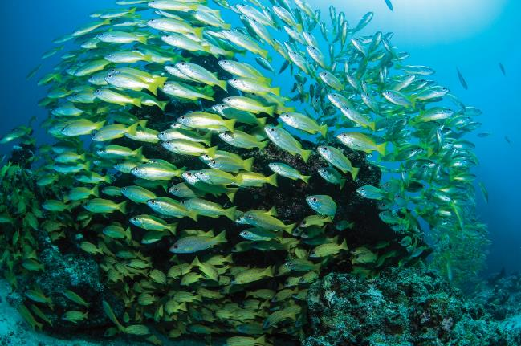
Yellow-lined snapper (Nigel Marsh)

S2.1 Coral Sea Marine Park overview
The Coral Sea Marine Park was proclaimed under the EPBC Act on 14 December 2013 (Federal Register of Legislation No. F2013L02108) and renamed on 9 October 2017 (Federal Register of Legislation No. F2017L01337).
Table S2.1. Overview of the Coral Sea Marine Park
Marine park name | Zones, IUCN categories and zone area | Marine park IUCN category | Total marine park area
Coral Sea | National Park Zone (II) 238,400 km²  Habitat Protection Zone (IV) 655,129 km²  Habitat Protection Zone (Reefs) (IV) 29,827 km²  Special Purpose Zone (Trawl) (VI) 66,480 km² | IV | 989,836 km²
Note: The Coral Sea Marine Park extends from 1000 m below the seabed to 3000 m above sea level.
Note: Zone and total marine park areas are rounded to the nearest km².

S2.2 Coral Sea Marine Park values
This Schedule describes the values represented in the Coral Sea Marine Park.
Values are broadly defined as:
- Natural values—habitats, species and ecological communities within marine parks, and the processes that support their connectivity, productivity and function.
- Cultural values—living and cultural heritage recognising Indigenous beliefs, practices and obligations for country, places of cultural significance and cultural heritage sites.
- Heritage values—non-Indigenous heritage that has aesthetic, historic, scientific or social significance.
- Socio-economic values—the benefit of marine parks for people, businesses and the economy.
Values will be used to inform the Director’s decisions when authorising activities in marine parks. Activities will be assessed in relation to their impacts and risk to values, to ensure activities are undertaken in a manner that minimises impacts to as low as reasonably practicable (Section 4.3 Making decisions about activities).
As understanding of marine park values improves over time, updated information will be available on the Parks Australia website.
Other sources of information on marine park values can be found on the Department’s website, in particular, for protected species (species profile and threats database), wetlands (Australian wetlands directory), heritage places (Australian heritage database), and shipwrecks (Australian national shipwrecks database), and in the East marine bioregional plan: bioregional profile (2009).

Coral Sea Marine Park
The Coral Sea Marine Park (Figure S2.1) is located east of the Great Barrier Reef adjacent to the Great Barrier Reef Marine Park, extending from Cape York Peninsula, to approximately 40 km north of Bundaberg in Queensland. The Marine Park starts between 60 km and 1100 km from the coast of Australia and extends to the limit of Australia’s exclusive economic zone.
The Marine Park covers an area of 989,836 km², with waters down to 6000 m deep.
The Marine Park was proclaimed under the EPBC Act on 14 December 2013 and renamed Coral Sea Marine Park on 9 October 2017. It includes the areas of the Coral Sea Conservation Zone originally proclaimed under the EPBC Act on 14 May 2009 and the Coringa-Herald and Lihou Reef National Nature Reserves originally proclaimed under the National Parks and Wildlife Conservation Act 1975 on 16 August 1982. The Marine Park is assigned IUCN category IV and includes four zones assigned under this plan: National Park Zone (II), Habitat Protection Zone (IV), Habitat Protection Zone (Reefs) (IV) and Special Purpose Zone (Trawl) (VI).
Coordinates for the Coral Sea Marine Park and zones are provided in Figures S2.1 to S2.18 and Schedule 4.
Statement of significance
The Coral Sea Marine Park was designed to protect representative examples of the region’s ecosystems and biodiversity in accordance with the Goals and principles for the establishment of the National Representative System of Marine Protected Areas in Commonwealth waters (ANZECC, 1998),
The Marine Park is significant because it contains habitats, species and ecological communities associated with the Cape Province, Northeast Transition, Northeast Province, Central Eastern Transition, Kenn Province and Kenn Transition bioregions. It includes three key ecological features: reefs, cays and herbivorous fish of the Marion Plateau; reefs, cays and herbivorous fish of the Queensland Plateau; and the Tasmantid Seamount Chain.
The Coringa-Herald and Lihou Reefs and Cays Ramsar site is located in the Marine Park. The site was listed under the Ramsar Convention in 2002 and is a wetland of international importance under the EPBC Act. An Ecological Character Description that sets out the Ramsar listing criteria met by the site, the key threats and knowledge gaps, is available on the Department’s website. The site comprises near-pristine oceanic islet and reef habitats that are representative of the Coral Sea. The undisturbed sandy habitats at several islets are nesting sites for globally endangered green and hawksbill turtles, while foreshores, forest and shrubland support important breeding populations of seabirds including terns, boobies, and tropicbirds.
Coral reef habitat supports distinct communities of marine flora and fauna, including a relatively rich diversity of crustacean and hydroid fauna, and significant feeding habitat for migratory seabirds. Black marlin aggregate to spawn in the north-west of the Marine Park. Marine algal communities are a particularly important feature, frequently covering a greater area than the corals.
The Marine Park includes habitats connecting to and complementing the adjacent Great Barrier Reef Marine Park.
Natural values
The Marine Park includes examples of ecosystems representative of:
- Cape Province—a deep-water valley and ridge feature in the north of the Marine Park, with water depths of between 1000 and 4000 m.
- Northeast Transition—a deep-water feature consisting of troughs, plateau, reefs and carbonate mud in the north of the Marine Park, in waters deeper than 1000 m.
- Northeast Province—a large area of reefs, trenches, troughs, terraces and aprons in the central part of the Marine Park. It contains cays, atolls, islets and associated reef communities.
- Central Eastern Transition—an area in the south of the Marine Park featuring slope, canyon, and terrace, in waters between 3000 and 4000 m deep.
- Kenn Province—an area in the south-west of the Marine Park featuring seamounts and plateaux, in waters between 1000 and 3000 m deep.
- Kenn Transition—an area in the south-west of the Marine Park featuring seamounts.
Key ecological features of the Marine Park are:
- Reefs, cays and herbivorous fish of the Queensland Plateau—this is the largest marginal plateau in Australia. Ancient reefs have formed broad limestone platforms that extend over about half of the plateau forming 21 reefs and cays, the largest of which are Tregrosse and Lihou Reefs. Other significant reefs include Coringa–Herald, Moore, Flinders, Holmes, Shark and Osprey Reefs. Osprey Reef differs from the other platform reefs of the plateau in that it is an isolated pinnacle more similar to the seamount reefs found further south.
- Reefs, cays and herbivorous fish of the Marion Plateau—this area contains three major reef systems: Marion Reef, Saumarez Reef and Frederick Reefs. Marion and Saumarez reefs are built on carbonate platforms that make up half the surface area of the plateau. Both reefs are ancient, dating back to the Pliocene drowning of the platforms. Frederick Reefs rise up to sea level from the Cato Basin at 3000 m depth off the eastern edge of the plateau.
- The Tasmantid Seamount Chain—these seamounts provide shallow reef and deep-water habitats that differ from the more southerly seamounts in that they are older and they break the sea surface forming Kenn, Cato, Wreck and Mellish Reefs.
Ecosystems and species composition within the Marine Park are influenced by the east–west-flowing South Equatorial Current, the north-flowing Hiri Current and the south-flowing East Australian Current. These currents create a barrier reducing the mixing of species between the north and south of the Marine Park, forming distinct ecological communities.
There are about 34 reefs and 56 cays and islets in the Marine Park, with a total reef area of approximately 15 024 km². Most of the islets and cays are composed of sand, rocks and coral rubble. Some have grassland, herbfield, shrubland and forest habitats. Two islets of the Coringa–Herald group support communities of Pisonia grandis, a species of flowering tree in the bougainvillea family, which is relatively uncommon in Australia and globally. The only known spawning aggregation of black marlin in the Pacific Ocean occurs near Osprey Reef.
The Marine Park supports a range of species including species listed as threatened, migratory, marine or cetacean under the EPBC Act. Biologically important areas within the Marine Park include breeding and or foraging habitat for seabirds, internesting habitat for marine turtles, and a migratory pathway for humpback whales.
The Marine Park also supports species listed under international agreements such as the Convention on the Conservation of Migratory Species of Wild Animals 1979 (CMS or Bonn Convention), the Agreement between the Government of Australia and the Government of Japan for the Protection of Migratory Birds in Danger of Extinction and their Environment 1974 (JAMBA), the Agreement between the Government of Australia and the Government of the People’s Republic of China for the Protection of Migratory Birds and their Environment 1986 (CAMBA), and the Agreement between the Government of Australia and the Government of the Republic of Korea on the Protection of Migratory Birds 2007 (ROKAMBA).
Coringa-Herald and Lihou Reefs and Cays Ramsar site
The Coringa-Herald and Lihou Reefs and Cays Ramsar site includes representative examples of coral reef in near-pristine condition. The Ramsar site also includes the forested reef cays, making it an outstanding breeding site for several key waterbird species. It has breeding sites for the nationally threatened green turtle and hawksbill turtle. Species diversity includes at least 390 species of coral reef fish, 29 waterbird species, 128 crustaceans, 140 hard corals, 745 marine molluscs, and various starfish, brittle stars, feather stars, and sea urchins.
Cultural values
Sea country is valued for Indigenous cultural identity, health and wellbeing. Across Australia, Indigenous people have been sustainably using and managing their sea country for tens of thousands of years. Torres Strait Islanders and coastal Aboriginal people of the east coast of Cape York have sea country responsibilities for parts of the Marine Park.
The Meriam People’s sea country extends over the Ashmore Reef region of the Coral Sea Marine Park. Under traditional (Malo’s) law, Ashmore Reef is a significant cultural area for the Meriam People and they must be consulted by people wanting to access Ashmore Reef. The Mer Gedkem Le Prescribed Body Corporate represents the native title holders of Meriam land and sea country. The Mer Gedkem Le Prescribed Body Corporate is the point of contact for Ashmore Reef. The Torres Strait Regional Authority and the Cape York Land Council are the Native Title Representative Bodies for the Torres Strait and Cape York regions, with native title responsibilities for the Ashmore Reef area.
Heritage values
Protected places (world, national and Commonwealth heritage, historic shipwrecks)
The EPBC Act protects matters of national environmental significance that are classified as protected places, including world heritage properties and national heritage places. Places on the Commonwealth Heritage List or shipwrecks listed under the Historic Shipwrecks Act 1976 are also protected places.
No international, Commonwealth or national heritage listings apply to the Marine Park at commencement of this plan, however, the Marine Park is adjacent to the Great Barrier Reef World Heritage Area.
Historic shipwrecks
The Marine Park contains over 45 known shipwrecks listed under the Historic Shipwrecks Act 1976. The oldest known shipwrecks are the Cato (wrecked in 1803), HMS Porpoise, (wrecked in 1803), and Echo (wrecked in 1820). There are also three United States of America navy ships sunk in 1942 during the Battle of the Coral Sea: the USS Lexington (aircraft carrier), USS Neosho (aviation fuel supplier), and USS Sims (destroyer).
There are likely to be hundreds of historic shipwrecks in the Marine Park, the precise locations of which remain unknown.
Social and economic values
Tourism, commercial fishing, and recreation, including fishing, are important activities in the Marine Park. These activities contribute to the wellbeing of regional communities and the prosperity of the nation.
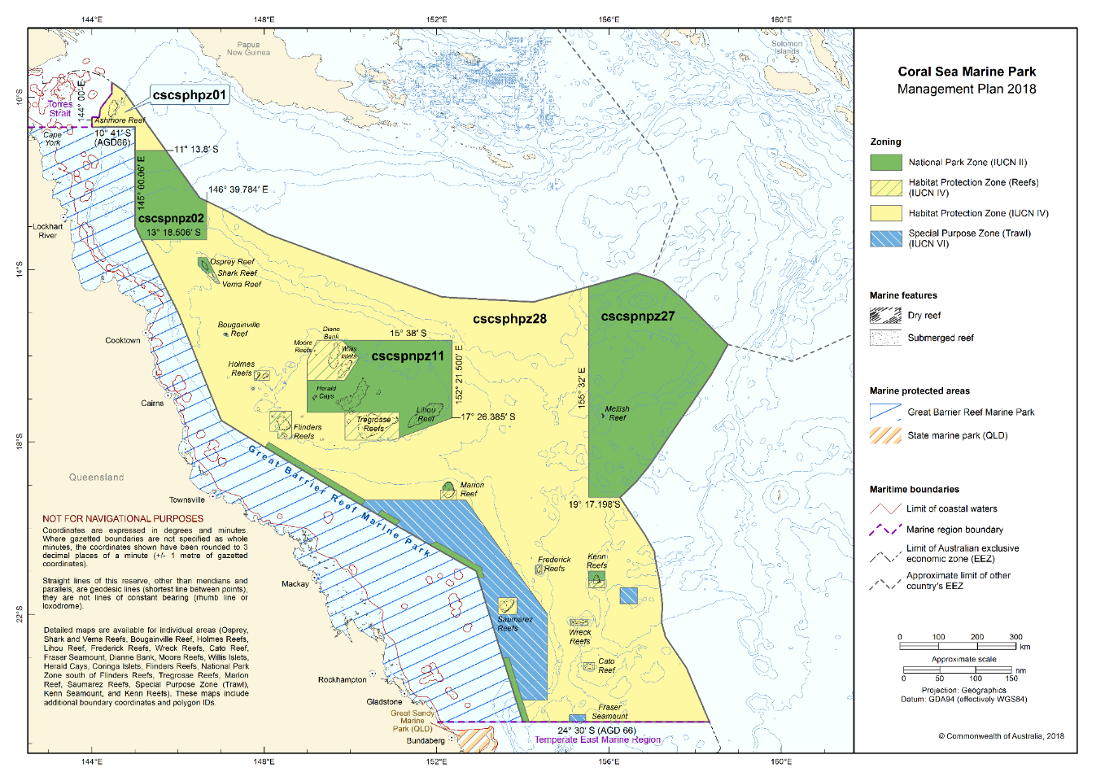Figure S2.1 Coral Sea Marine Park
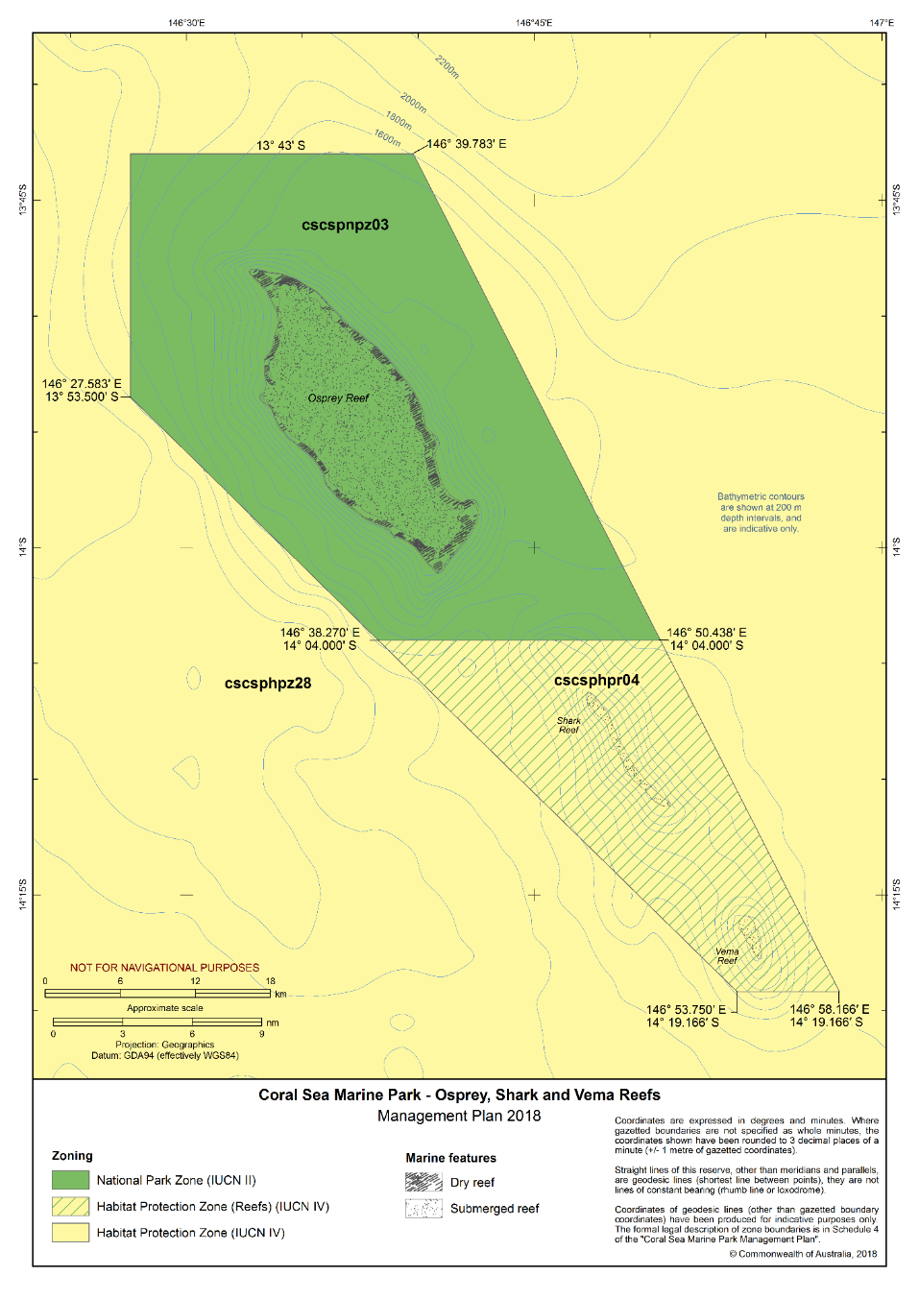
Figure S2.2 Coral Sea Marine Park – Osprey, Shark and Vema Reefs
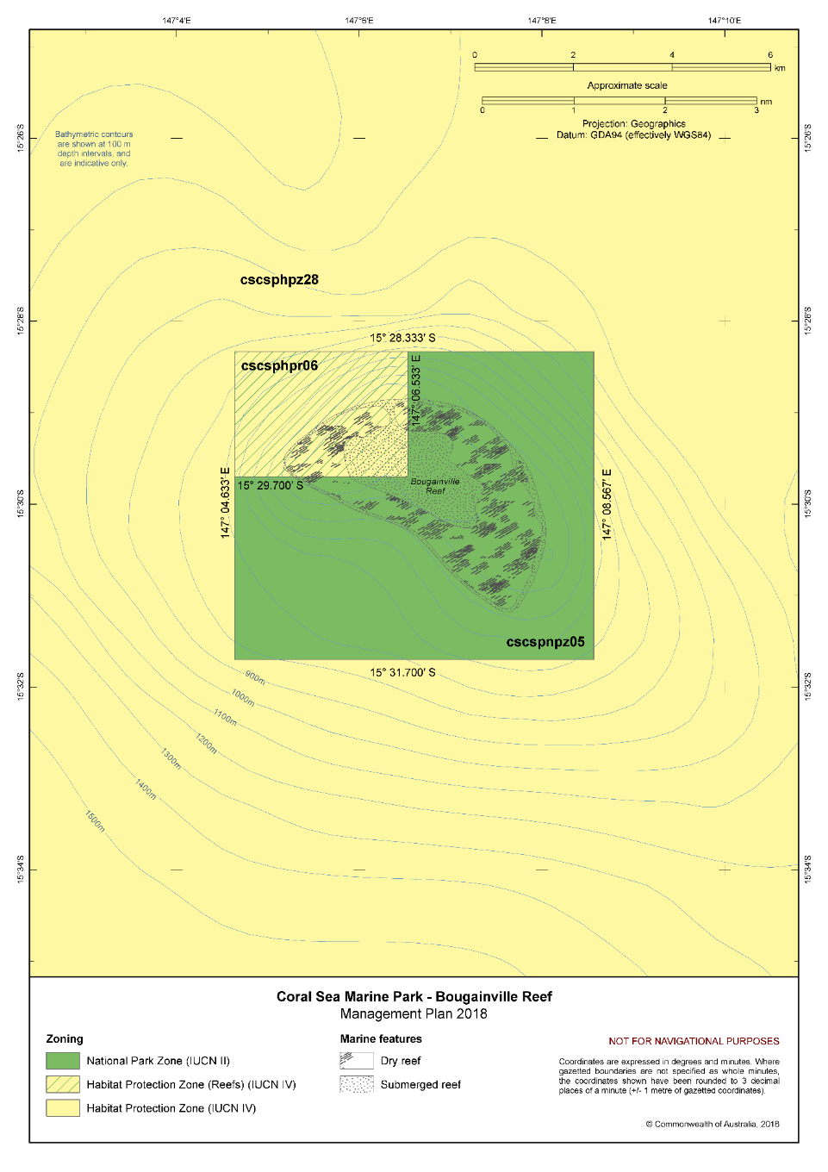Figure S2.3 Coral Sea Marine Park – Bougainville Reef
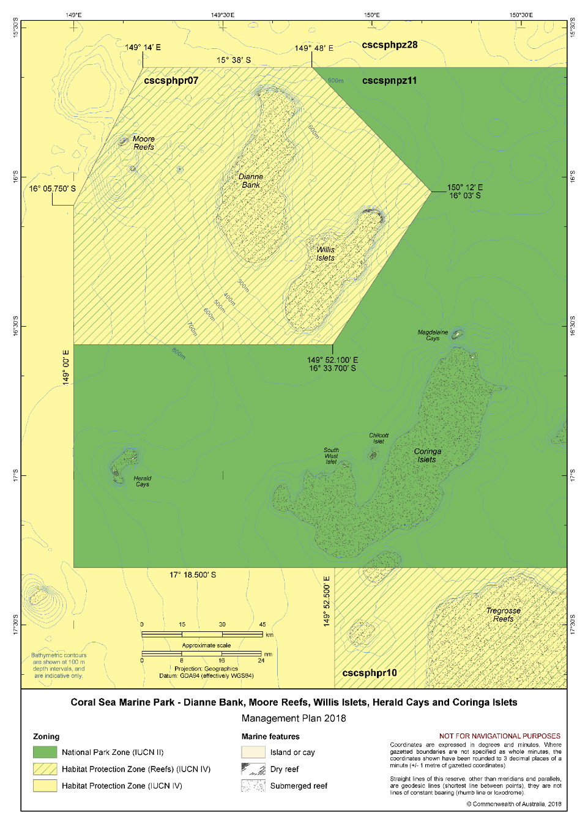Figure S2.4 Coral Sea Marine Park – Dianne Bank, Moore Reefs, Willis Islets, Herald Cays and Coringa Islets
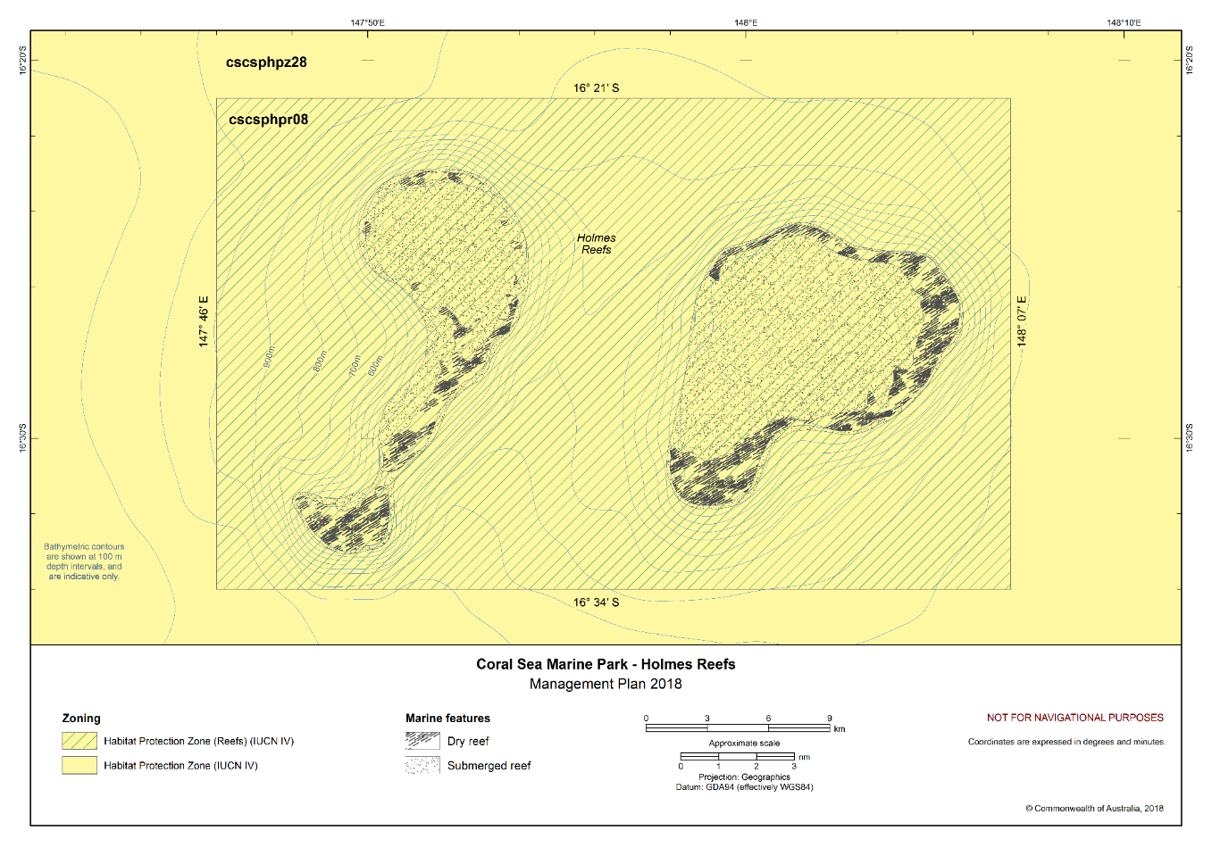
Figure S2.5 Coral Sea Marine Park – Holmes Reefs
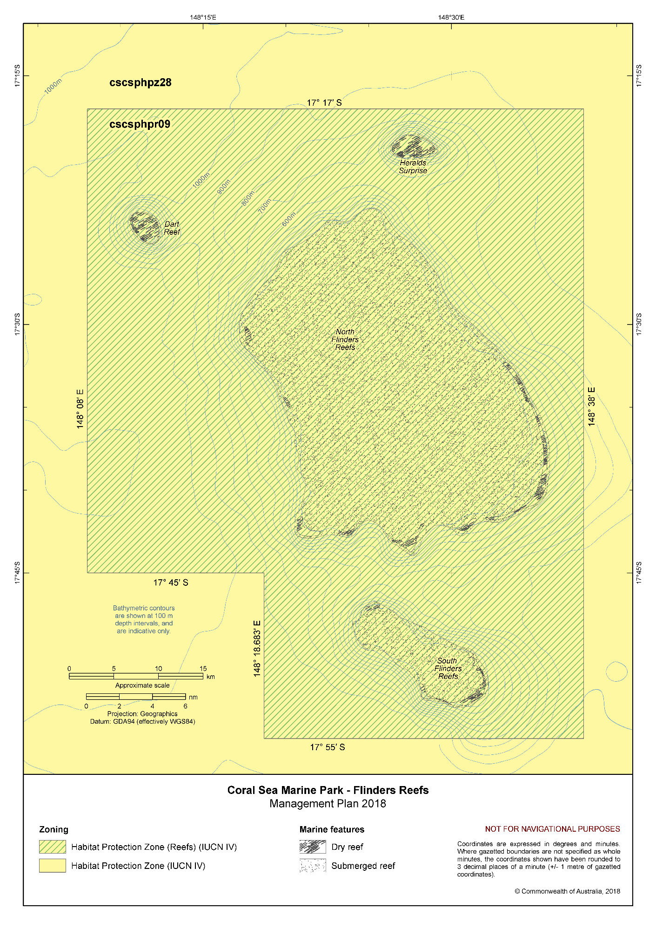Figure S2.6 Coral Sea Marine Park – Flinders Reefs
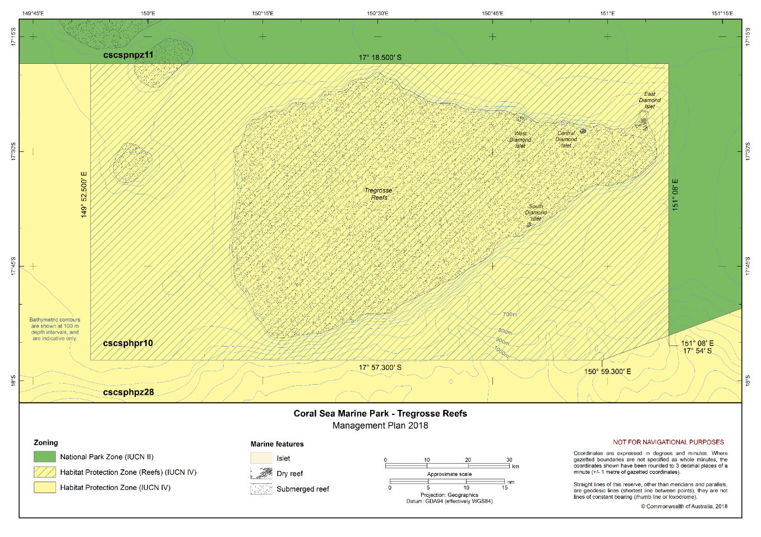Figure S2.7 Coral Sea Marine Park – Tregrosse Reefs
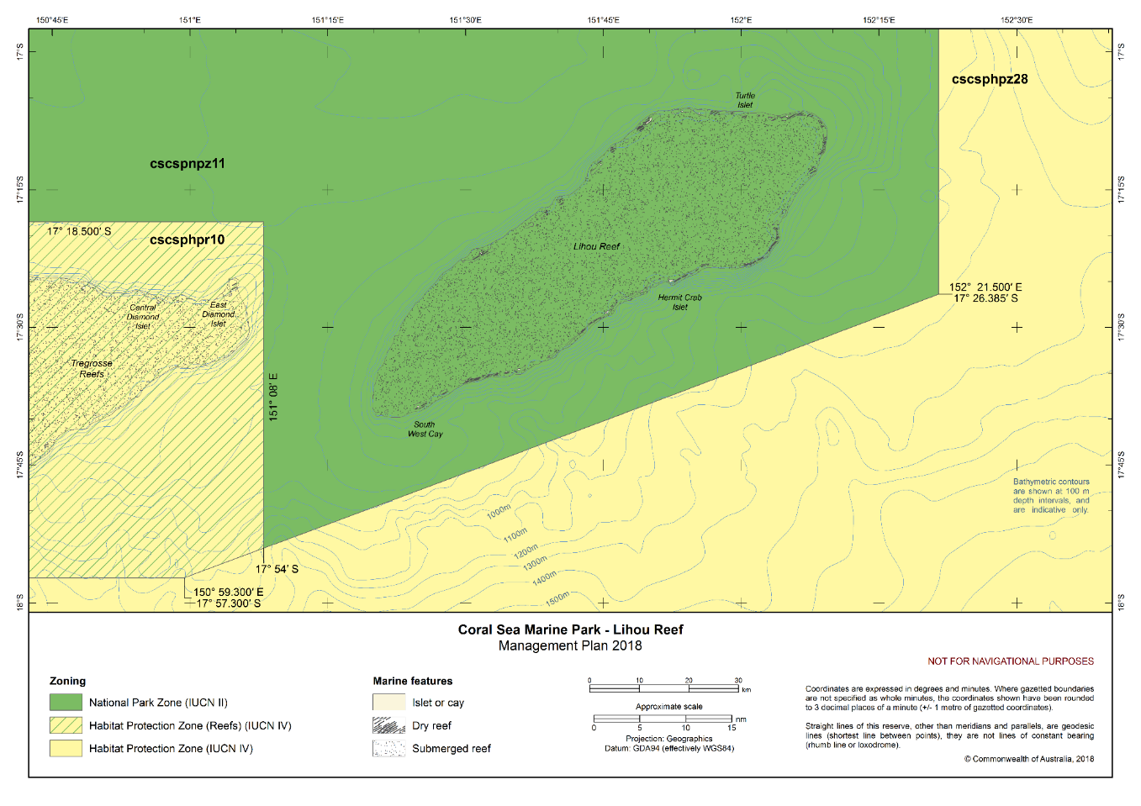Figure S2.8 Coral Sea Marine Park – Lihou Reef
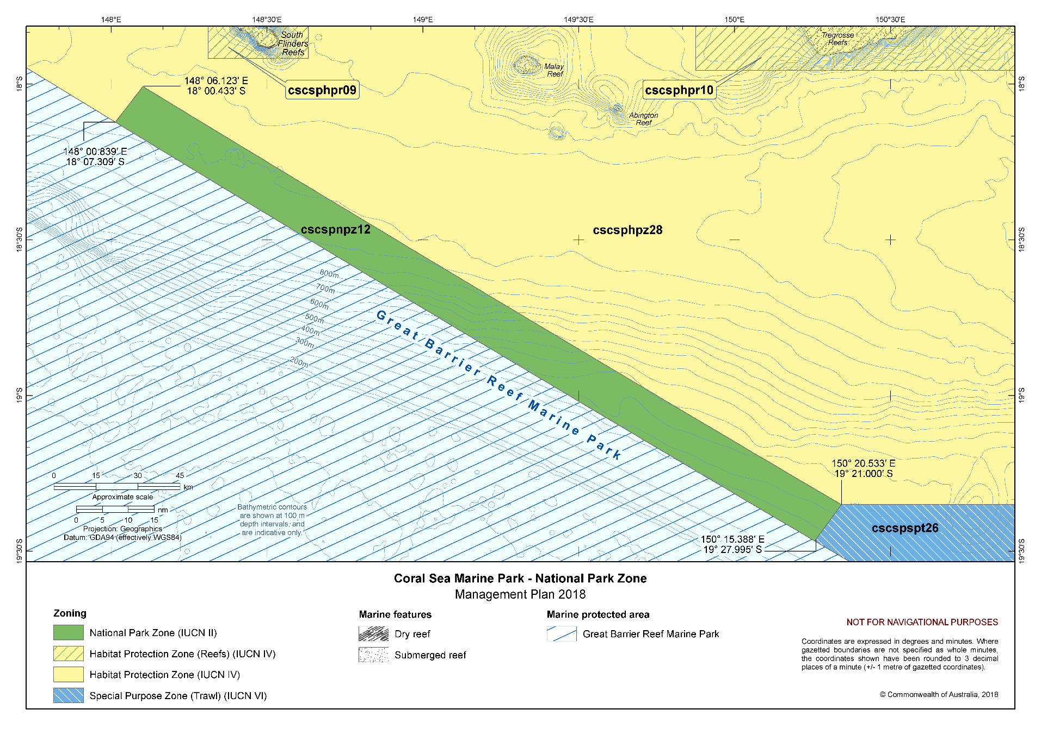
Figure S2.9 Coral Sea Marine Park – National Park Zone south from Flinders Reefs
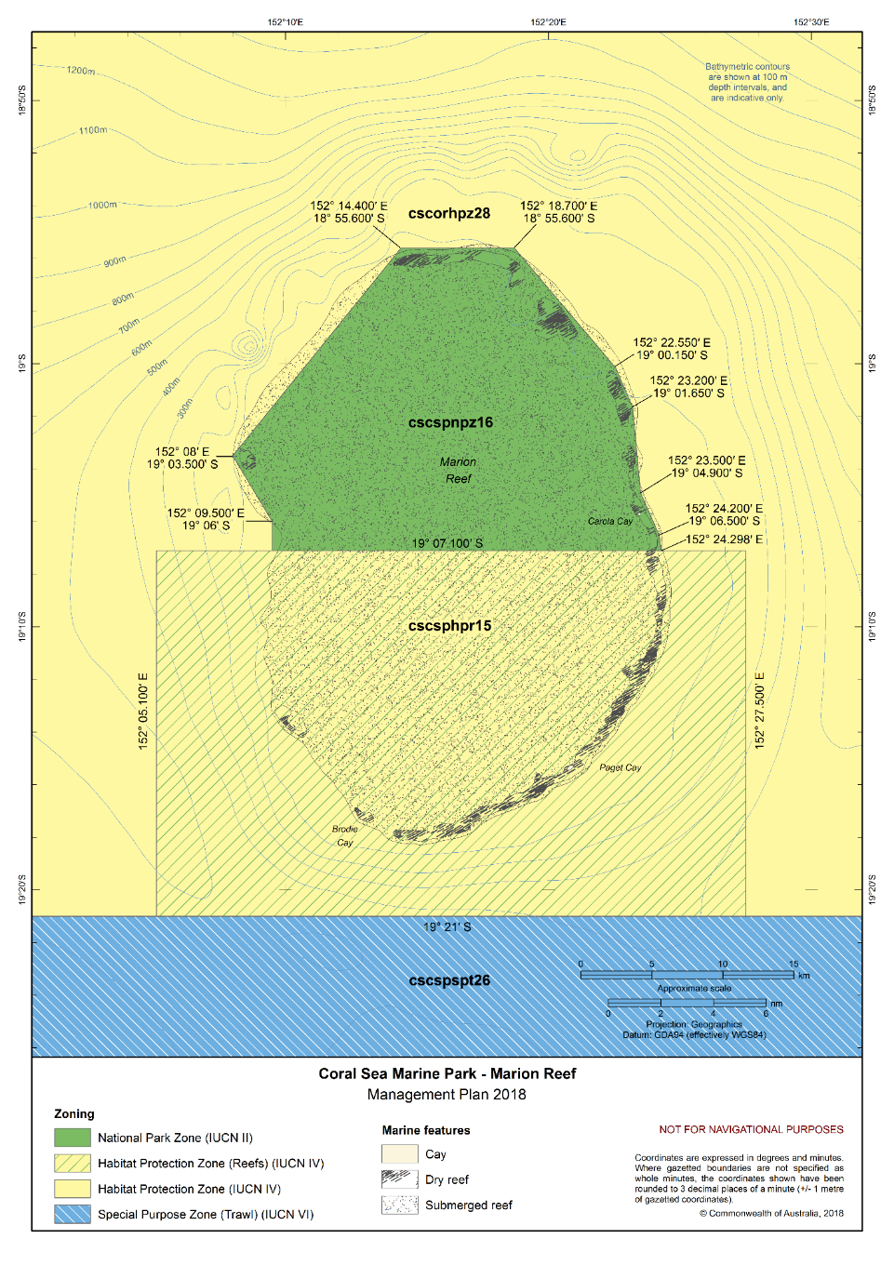Figure S2.10 Coral Sea Marine Park – Marion Reef
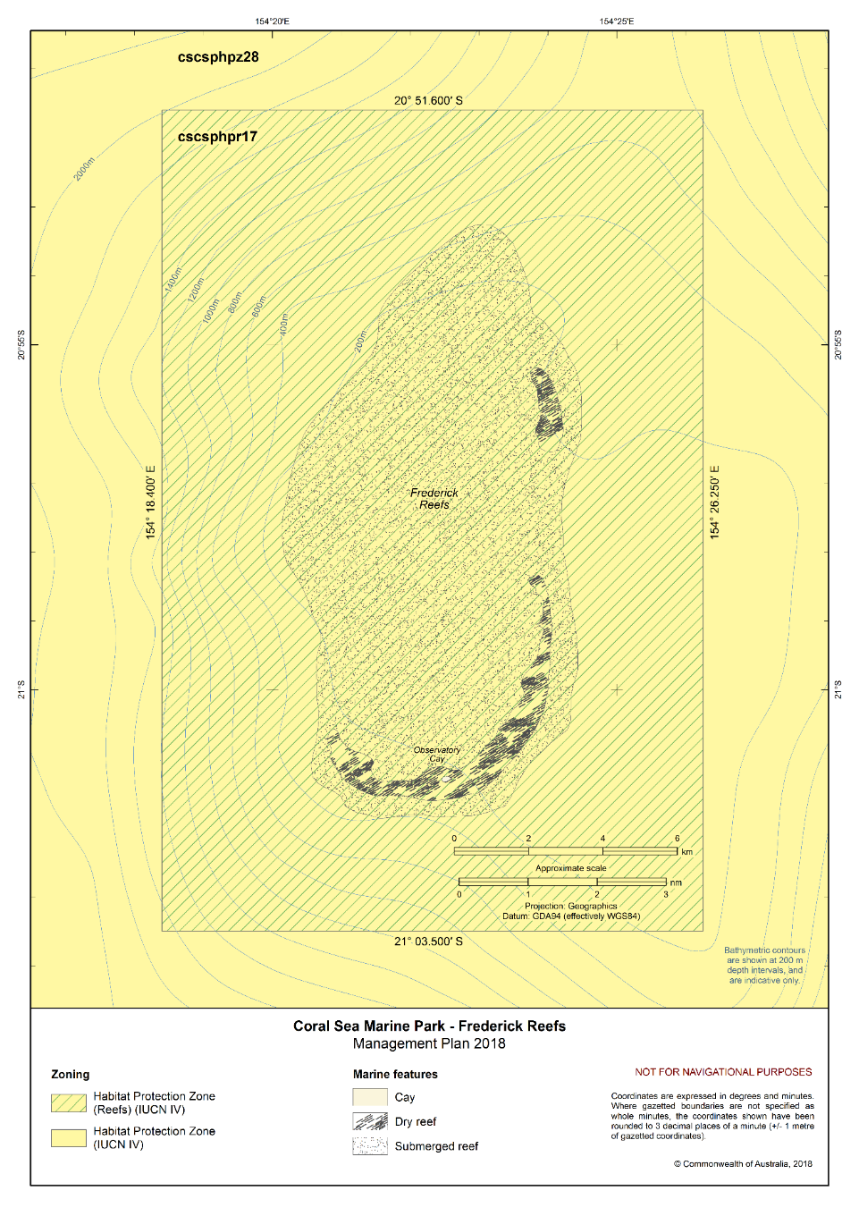Figure S2.11 Coral Sea Marine Park – Frederick Reefs
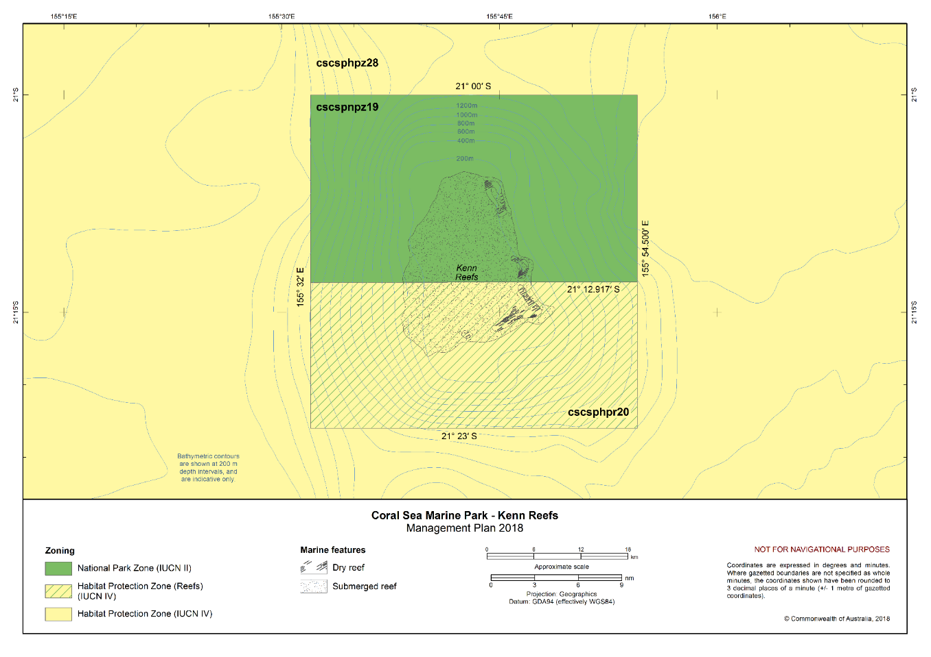Figure S2.12 Coral Sea Marine Park – Kenn Reefs
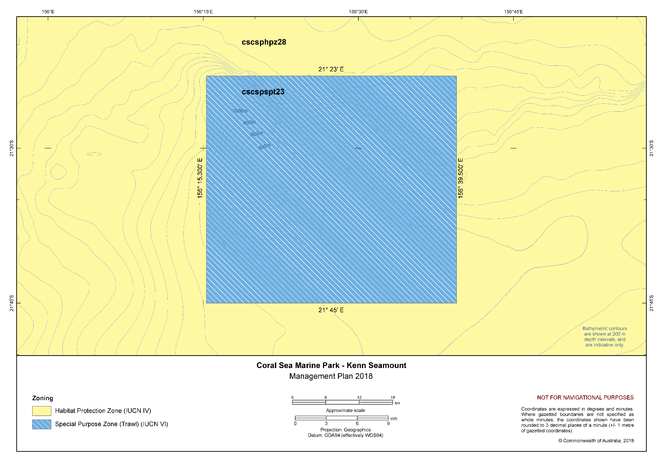
Figure S2.13 Coral Sea Marine Park – Kenn Seamount
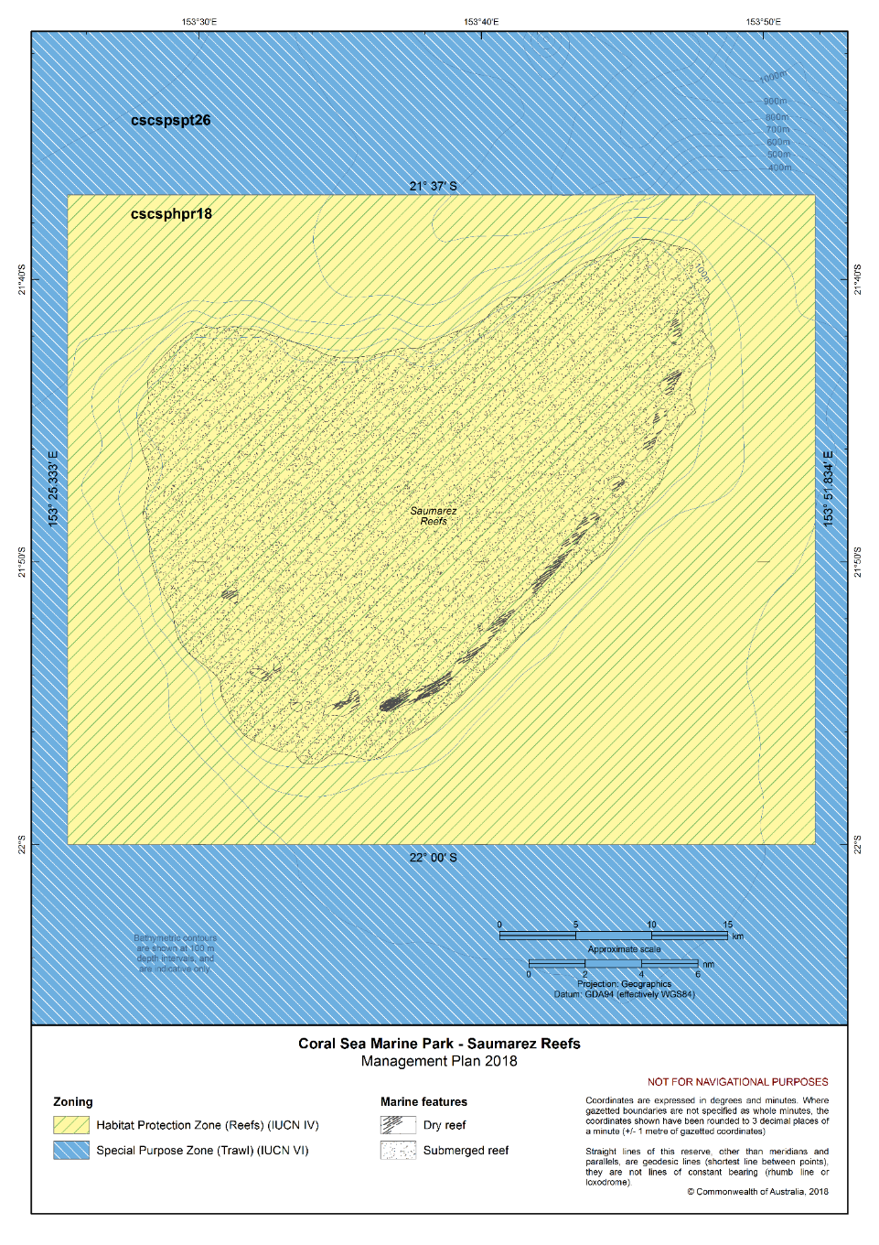Figure S2.14 Coral Sea Marine Park – Saumarez Reefs
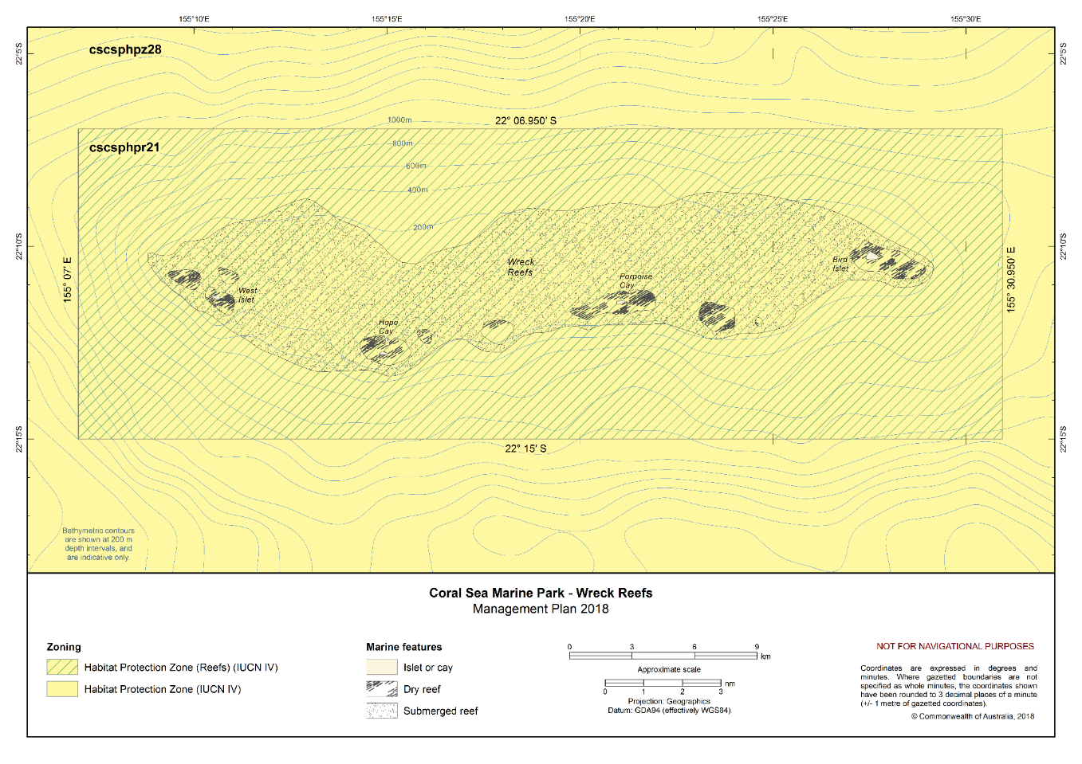Figure S2.15 Coral Sea Marine Park – Wreck Reefs
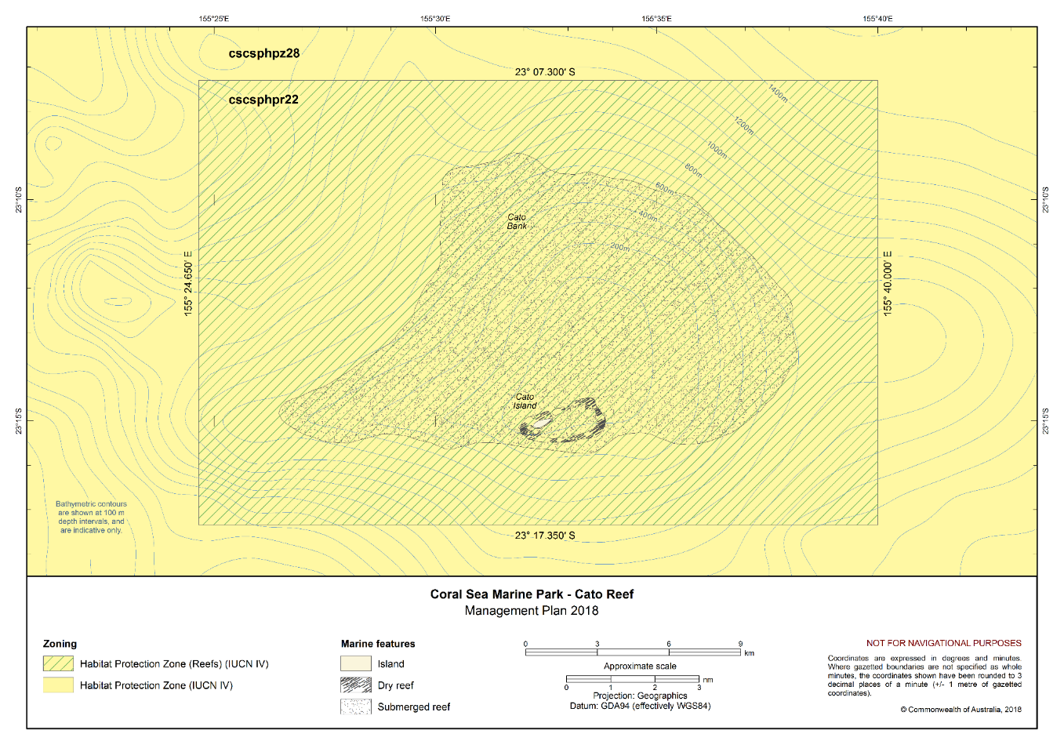Figure S2.16 Coral Sea Marine Park – Cato Reef
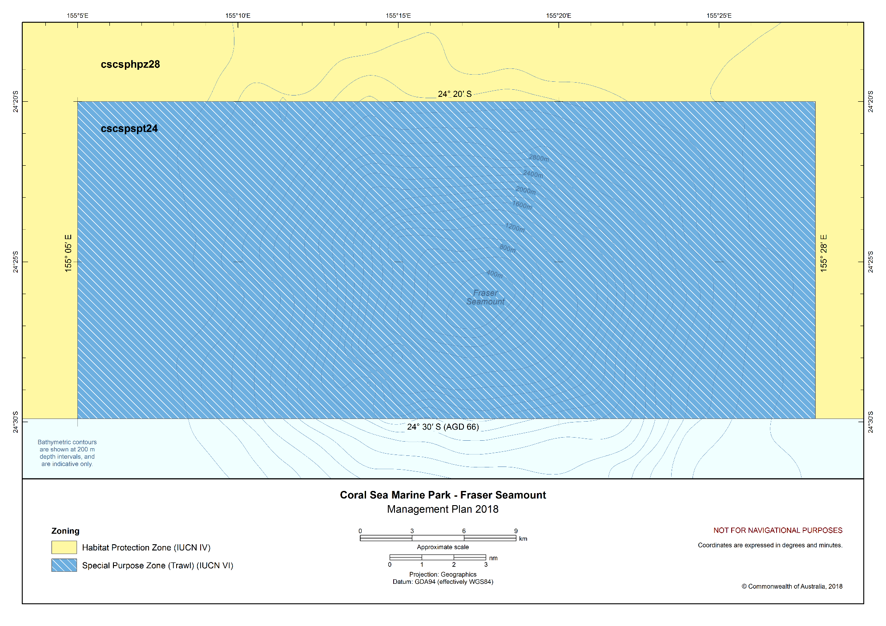Figure S2.17 Coral Sea Marine Park – Fraser Seamount
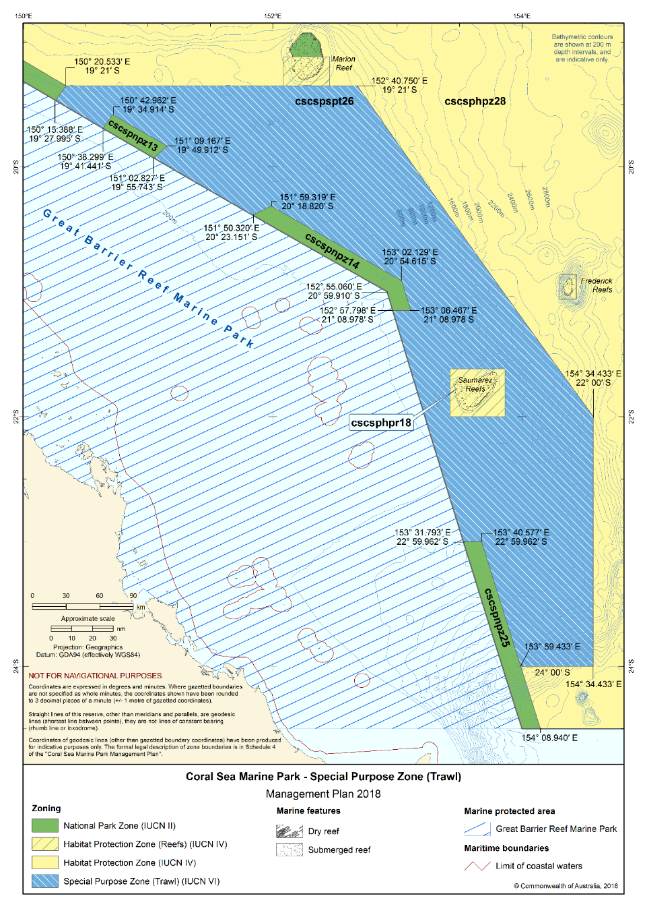Figure S2.18 Coral Sea Marine Park – Special Purpose Zone (Trawl)

