Schedule 3 Environmental features used in the design of the Coral Sea Marine Park

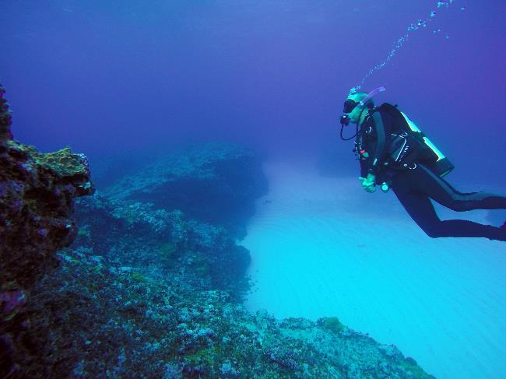
Diver (Martin Russell) surveying Tregrosse Reefs (Alyssa Giannoni)

Four types of environmental features were used in the design of the Coral Sea Marine Park to help identify areas for protection. These features were identified based on the scientifically known relationships between biodiversity and the physical environment and include bioregions, water depth, seafloor features and key ecological features. They are identified below.
More information on these features can be found in the East marine bioregional plan: bioregional profile (2009), and the conservation values atlas on the Department’s website.
Bioregions
Bioregions are identified in the Integrated Marine and Coastal Regionalisation of Australia (IMCRA) as large areas of ocean with broadly similar characteristics that have been classified by scientists based on the distribution of fish and other marine species, seafloor types and ocean conditions. The Coral Sea Marine Park represents six bioregions: Cape Province, Central Eastern Transition, Kenn Province, Kenn Transition, Northeast Province, and Northeast Transition (Figure S3.1).

Depth ranges
The Coral Sea Marine Park represents depths from shallow waters of less than 15 m to abyssal waters of approximately 6000 m. Marine biological communities change with depth, and similar depth ranges in different bioregions support different groups of species. The range of ocean depths in each bioregion, represented as bathomes in Figure S3.2, have been included in the Marine Park to ensure that examples of marine biodiversity are represented.
Seafloor features
The landscape-scale physical structure of the seafloor is important in determining where habitats or species occur. There is strong scientific evidence that different types of seafloor features provide different habitats and associated marine species and communities. The seafloor of the Coral Sea Marine Park comprises 16 seafloor features: abyssal plain/deep ocean floor, apron/fan, basin, canyon, continental rise, deep/hole/valley, knoll/abyssal hills/hills/mountain/peak, pinnacle, plateau, reef, ridge, saddle, seamount/guyot, slope, terrace, and trench/trough (Figure S3.3).
Key ecological features
Key ecological features were identified through the marine bioregional planning program as areas or features that support distinct or important ecological communities at a regional scale. The Coral Sea Marine Park represents three key ecological features: reefs, cays and herbivorous fish of the Marion Plateau; reefs, cays and herbivorous fish of the Queensland Plateau; and the Tasmantid Seamount Chain (Figure S3.4).

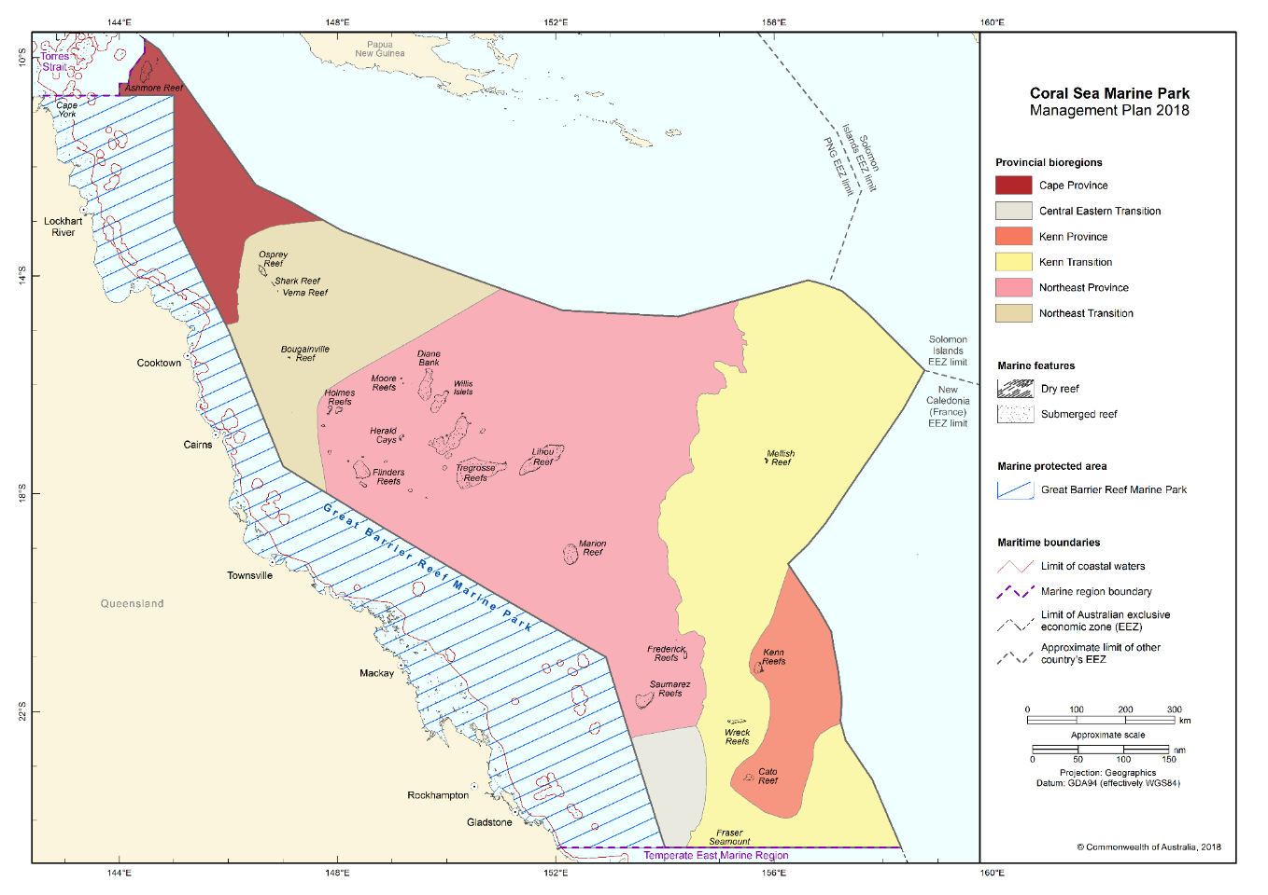Figure S3.1 Bioregions represented in the Coral Sea Marine Park

Map showing the bathomes represented in marine parks of the North-west Network.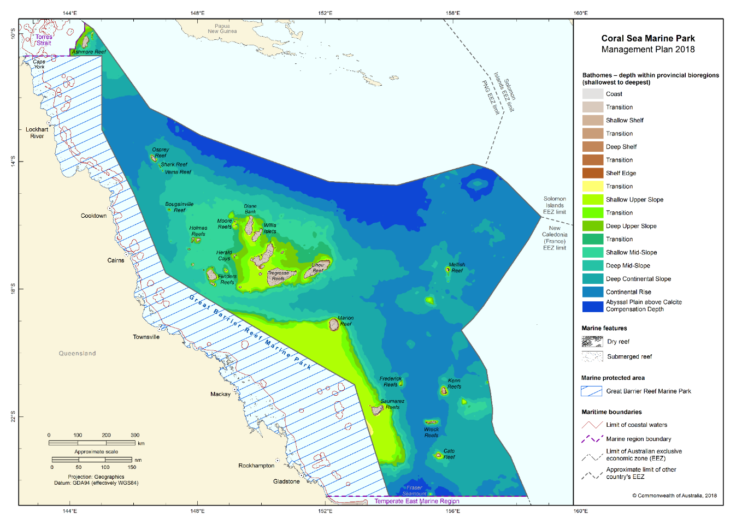Figure S3.2 Bathomes indicating depth ranges represented in the Coral Sea Marine Park
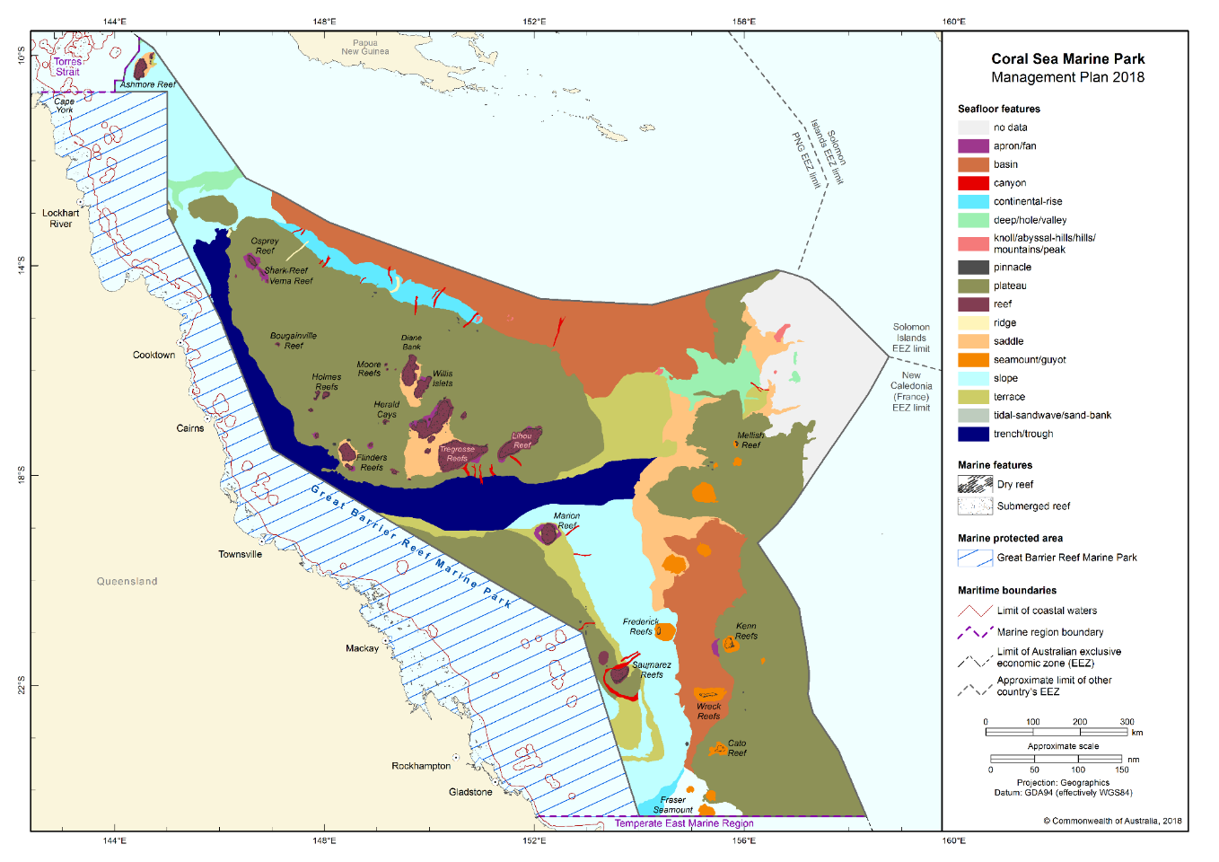Figure S3.3 Seafloor features represented in the Coral Sea Marine Park

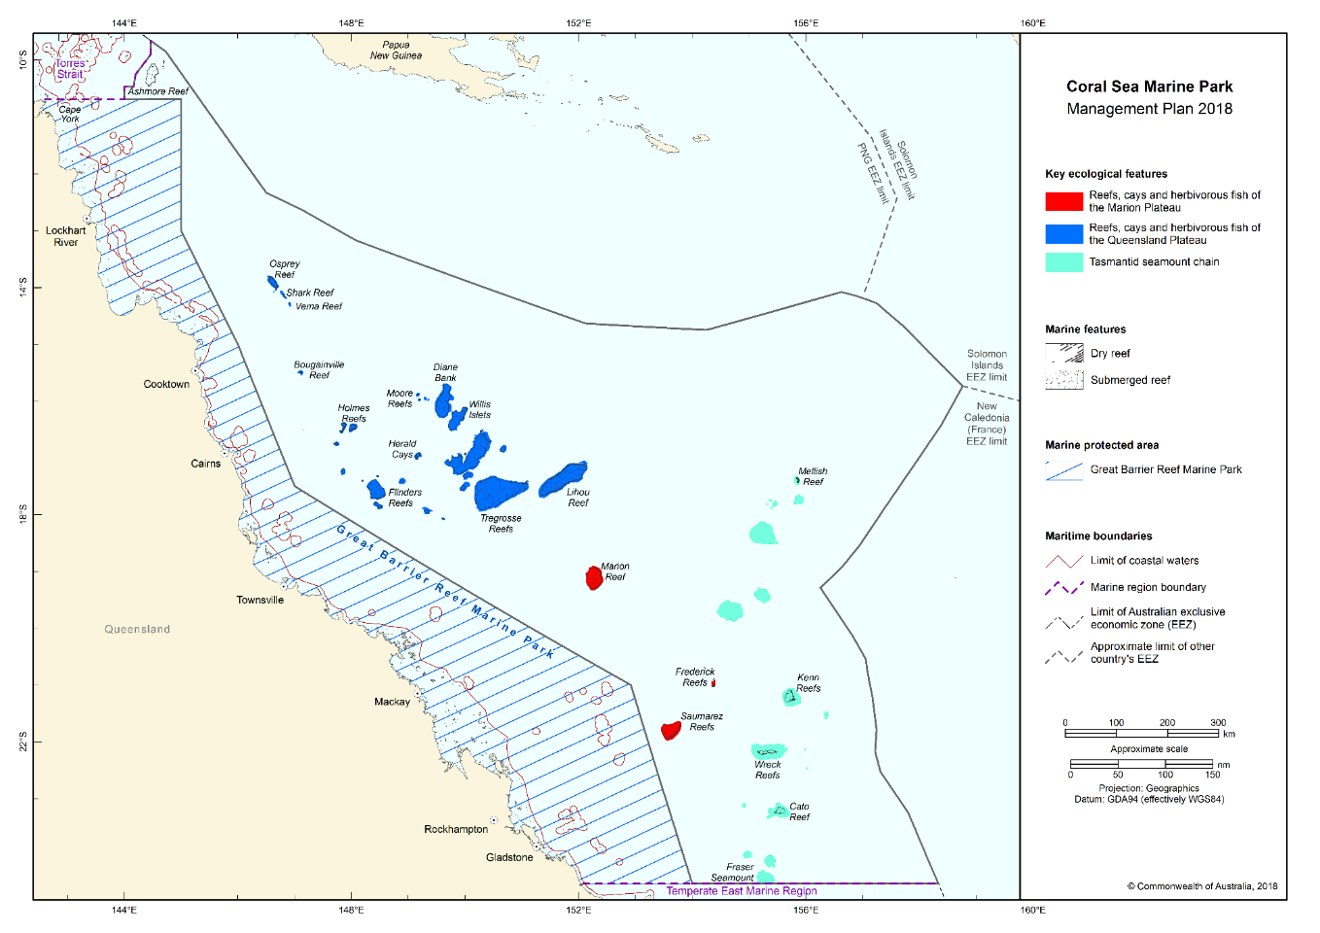Figure S3.4 Key ecological features represented in the Coral Sea Marine Park

Schedule 4 Coral Sea Marine Park and zone boundary descriptions

In this Schedule:
Fisheries Jurisdiction Line means the line described in annex 8 of the Torres Strait Treaty.
Maritime boundary (French Republic) Agreement means the Agreement on Maritime Delimitation between the Government of Australia and the Government of the French Republic, done at Melbourne on 4 January 1982. The Agreement is in Australian Treaty Series 1983 No. 3 ([1983] ATS 3) and could in 2013 be viewed in the Australian Treaties Library on the AustLII website (http://www.austlii.edu.au).
Maritime boundary (Solomon Islands) Agreement means the Agreement between the Government of Australia and the Government of Solomon Islands establishing Certain Sea and Seabed Boundaries, done at Honiara on 13 September 1988. The Agreement is in Australian Treaty Series 1989 No. 12 ([1989] ATS 12) and could in 2013 be viewed in the Australian Treaties Library on the AustLII website (http://www.austlii.edu.au).

Protected Zone means the zone established under article 10 of the Torres Strait Treaty. The Protected Zone is bounded by the line described in annex 9 of the Torres Strait Treaty.
State waters has the same meaning as coastal waters of the State in subsection 3(1) of the Coastal Waters (State Powers) Act 1980.

Torres Strait Treaty means the Treaty between Australia and the Independent State of Papua New Guinea concerning Sovereignty and Maritime Boundaries in the area between the two Countries, including the area known as Torres Strait, and Related Matters, done at Sydney on 18 December 1978. The Treaty is in Australian Treaty Series 1985 No. 4 ([1985] ATS 4) and could in 2013 be viewed in the Australian Treaties Library on the AustLII website (http://www.austlii.edu.au).
Note: Geographic coordinates are expressed in terms of the Geocentric Datum of Australia 1994.
Note: The Geocentric Datum of Australia 1994 (also known as GDA94) was published in Gazette No. GN 35 of 6 September 1995.
However, the geographic coordinates in the following items in the tables of this Schedule are expressed in terms of the Australian Geodetic Datum 1966:
- items 1 and 2 of Section 1.1;
- items 1 and 2 of Section 1.3;
- item 1 and 2 of Section 1.4 ;
- item 3 of Section 1.26;
- item 3 and 4 of Section 1.27;
- items 24, 25 and 28 of Section 1.30.

1.1 Area of marine park

The Coral Sea Marine Park consists of an area in the Coral Sea bounded by the line commencing at the point described in item 1 of the following table and running progressively as described in the table.
Area of marine park
Item | Description
1 | The point of latitude 24° 30′ 00″ S, longitude 154° 00′ 00″ E
2 | East along the parallel of latitude 24° 30′ 00″ S to its intersection by the line described by article 1 of the Maritime boundary (French Republic) Agreement
3 | Generally north-westerly and north-easterly along that line to the southernmost point on the line described by article 1 of the Maritime boundary (Solomon Islands) Agreement
4 | Generally north-westerly along that line to its intersection by the outer limit of the exclusive economic zone
5 | Generally north-westerly along that outer limit to its intersection by the Fisheries Jurisdiction Line
6 | Generally westerly and north-westerly along that line to its intersection by the outer limit of the Protected Zone
7 | South, generally south-westerly, and west along that outer limit to its intersection by the meridian of longitude 144° 00′ 00″ E
8 | South along that meridian to its intersection by the outer limit of the Great Barrier Reef Marine Park
9 | Easterly, southerly and generally south-easterly along that outer limit to the point of commencement
Note: AGD66 applies to the coordinates described in items 1 and 2 of this table.

1.2 Zones for marine park
(1) The Coral Sea Marine Park is divided into the following zones:
(a) the National Park Zones (II) described in Sections 1.4, 1.5, 1.7, 1.13, 1.14, 1.15, 1.16, 1.18, 1.21, 1.27, and 1.29 of this Schedule;
(b) the Habitat Protection Zones (IV) described in Sections 1.3 and 1.30 of this Schedule;
(c) the Habitat Protection Zones (Reefs) (IV) described in Sections 1.6, 1.8, 1.9, 1.10, 1.11, 1.12, 1.17, 1.19, 1.20, 1.22, 1.23 and 1.24 of this Schedule;
(d) the Special Purpose Zones (Trawl) (VI) described in Section 1.25, 1.26, and 1.28 of this Schedule.

1.3 Zone 1 (cscsphpz01) of marine park—Habitat Protection Zone (IV) (Figure S2.1)

Zone 1 (cscsphpz01) of the marine park consists of an area bounded by the line commencing at the point described in item 1 of the following table and running progressively as described in the table.
Zone 1 (cscsphpz01) of marine park—Habitat Protection Zone (IV)
Item | Description
1 | The point of latitude 10° 41′ 00″ S, longitude 145° 00′ 03.78″ E
2 | South along the meridian of longitude 145° 00′ 03.78″ E to its intersection by the parallel of latitude 11° 13′ 48″ S
3 | East along that parallel to its intersection by the Fisheries Jurisdiction Line
4 | Generally north-westerly along that line to its intersection by the outer limit of the Protected Zone
5 | South, generally south-westerly, and west along that outer limit to its intersection by the meridian of longitude 144° 00′ 00″ E
6 | South along that meridian to its intersection by the outer limit of the Great Barrier Reef Marine Park
7 | Easterly along that outer limit to the point of commencement
Note: AGD66 applies to the latitude described in items 1 and 2 of this table.
1.4 Zone 2 (cscspnpz02) of marine park—National Park Zone (II) (Figure S2.1)
Zone 2 (cscspnpz02) of the marine park consists of an area bounded by the line commencing at the point described in item 1 of the following table and running progressively as described in the table.
Zone 2 (cscspnpz02) of marine park—National Park Zone (II)
Item | Description
1 | The point of latitude 11° 13′ 48″ S, longitude 145° 00′ 03.78″ E
2 | East along the parallel of latitude 11° 13′ 48″ S to its intersection by the Fisheries Jurisdiction line
3 | Generally south-easterly along that line to its intersection by the meridian of longitude 146° 39′ 47″ E
4 | South along that meridian to its intersection by the parallel of latitude 13° 18′ 30.36″ S
5 | West along that parallel to its intersection by the outer limit of the Great Barrier Reef Marine Park
6 | Generally north-westerly and northerly along that outer limit to the point of commencement
Note: AGD66 applies to the latitude described in items 1 and 2 of this table.
1.5 Zone 3 (cscspnpz03) of marine park—National Park Zone (II) (Figure S2.2)
Zone 3 (cscspnpz03) of the marine park consists of an area bounded by the line commencing at the point described in item 1 of the following table and running progressively as described in the table.
Zone 3 (cscspnpz03) of marine park—National Park Zone (II)
Item | Description
1 | The point of latitude 13° 43′ 00″ S, longitude 146° 27′ 35″ E
2 | East along the parallel of latitude 13° 43′ 00″ S to its intersection by the meridian of longitude 146° 39′ 47″ E
3 | South-easterly along the geodesic to the point of latitude 14° 04′ 00″ S, longitude 146° 50′ 26.66″ E
4 | West along the parallel of latitude 14° 04′ 00″ S to its intersection by the meridian of longitude 146° 38′ 16.21″ E
5 | North-westerly along the geodesic to the point of latitude 13° 53′ 30″ S, longitude 146° 27′ 35″ E
6 | North along the meridian of longitude 146° 27′ 35″ E to the point of commencement
1.6 Zone 4 (cscsphpr04) of marine park—Habitat Protection Zone (Reefs) (IV) (Figure S2.2)
Zone 4 (cscsphpr04) of the marine park consists of an area bounded by the line commencing at the point described in item 1 of the following table and running progressively as described in the table.
Zone 4 (cscsphpr04) of marine park—Habitat Protection Zone (Reefs) (IV)
Item | Description
1 | The point of latitude 14° 04′ 00″ S, longitude 146° 50′ 26.66″ E
2 | South-easterly along the geodesic to the point of latitude 14° 19′ 10″ S, longitude 146° 58′ 10″ E
3 | West along the parallel of latitude 14° 19′ 10″ S to its intersection by the meridian of longitude 146° 53′ 45″ E
4 | North-westerly along the geodesic to the point of latitude 14° 04′ 00″ S, longitude 146° 38′ 16.21″ E
5 | East along the parallel of latitude 14° 04′ 00″ S to the point of commencement
1.7 Zone 5 (cscspnpz05) of marine park—National Park Zone (II) (Figure S2.3)
Zone 5 (cscspnpz05) of the marine park consists of an area bounded by the line commencing at the point described in item 1 of the following table and running progressively as described in the table.
 | Zone 5 (cscspnpz05) of marine park—National Park Zone (II)
 | Item |  | Description
1 |  | The point of latitude 15° 28′ 20″ S, longitude 147° 08′ 34″ E
2 |  | South along the meridian of longitude 147° 08′ 34″ E to its intersection by the parallel of latitude 15° 31′ 42″ S
3 |  | West along that parallel to its intersection by the meridian of longitude 147° 04′ 38″ E
4 |  | North along that meridian to its intersection by the parallel of latitude 15° 29′ 42″ S
5 |  | East along the parallel of latitude 15° 29′ 42″ S to its intersection by the meridian of longitude 147° 06′ 32″ E
6 |  | North along that meridian to its intersection by the parallel of latitude 15° 28′ 20″ S
7 |  | East along that parallel to the point of commencement
1.8 Zone 6 (cscsphpr06) of marine park—Habitat Protection Zone (Reefs) (IV) (Figure S2.3)
Zone 6 (cscsphpr06) of the marine park consists of an area bounded by the line commencing at the point described in item 1 of the following table and running progressively as described in the table.
Zone 6 (cscsphpr06) of marine park—Habitat Protection Zone (Reefs) (IV)
Item | Description
1 | The point of latitude 15° 28′ 20″ S, longitude 147° 04′ 38″ E
2 | East along the parallel of latitude 15° 28′ 20″ S to its intersection by the meridian of longitude 147° 06′ 32″ E
3 | South along that meridian to its intersection by the parallel of latitude 15° 29′ 42″ S
4 | West along that parallel to its intersection by the meridian of longitude 147° 04′ 38″ E
5 | North along that meridian to the point of commencement
1.9 Zone 7 (cscsphpr07) of marine park—Habitat Protection Zone (Reefs) (IV) (Figure S2.4)
Zone 7 (cscsphpr07) of the marine park consists of an area bounded by the line commencing at the point described in item 1 of the following table and running progressively as described in the table.
Zone 7 (cscsphpr07) of marine park—Habitat Protection Zone (Reefs) (IV)
Item | Description
1 | The point of latitude 15° 38′ 00″ S, longitude 149° 14′ 00″ E
2 | East along the parallel of latitude 15° 38′ 00″ S to its intersection by the meridian of longitude 149° 48′ 00″ E
3 | South-easterly along the geodesic to the point of latitude 16° 03′ 00″ S, longitude 150° 12′ 00″ E
4 | South-westerly along the geodesic to the point of latitude 16° 33′ 42″ S, longitude 149° 52′ 06″ E
5 | West along the parallel of latitude 16° 33′ 42″ S to its intersection by the meridian of longitude 149° 00′ 00″ E
6 | North along that meridian to its intersection by the parallel of latitude 16° 05′ 45″ S
7 | North-easterly along the geodesic to the point of commencement
1.10 Zone 8 (cscsphpr08) of marine park—Habitat Protection Zone (Reefs) (IV) (Figure S2.5)
Zone 8 (cscsphpr08) of the marine park consists of an area bounded by the line commencing at the point described in item 1 of the following table and running progressively as described in the table.
Zone 8 (cscsphpr08) of marine park—Habitat Protection Zone (Reefs) (IV)
Item | Description
1 | The point of latitude 16° 21′ 00″ S, longitude 147° 46′ 00″ E
2 | East along the parallel of latitude 16° 21′ 00″ S to its intersection by the meridian of longitude 148° 07′ 00″ E
3 | South along that meridian to its intersection by the parallel of latitude 16° 34′ 00″ S
4 | West along that parallel to its intersection by the meridian of longitude 147° 46′ 00″ E
5 | North along that meridian to the point of commencement
1.11 Zone 9 (cscsphpr09) of marine park—Habitat Protection Zone (Reefs) (IV) (Figure S2.6)
Zone 9 (cscsphpr09) of the marine park consists of an area bounded by the line commencing at the point described in item 1 of the following table and running progressively as described in the table.
Zone 9 (cscsphpr09) of marine park—Habitat Protection Zone (Reefs) (IV)
Item | Description
1 | The point of latitude 17° 17′ 00″ S, longitude 148° 08′ 00″ E
2 | East along the parallel of latitude 17° 17′ 00″ S to its intersection by the meridian of longitude 148° 38′ 00″ E
3 | South along that meridian to its intersection by the parallel of latitude 17° 55′ 00″ S
4 | West along that parallel to its intersection by the meridian of longitude 148° 18′ 41″ E
5 | North along that meridian to its intersection by the parallel of latitude 17° 45′ 00″ S
6 | West along that parallel to its intersection by the meridian of longitude 148° 08′ 00″ E
7 | North along that meridian to the point of commencement
1.12 Zone 10 (cscsphpr10) of marine park—Habitat Protection Zone (Reefs) (IV) (Figure S2.7)
Zone 10 (cscsphpr10) of the marine park consists of an area, bounded by the line commencing at the point described in item 1 of the following table and running progressively as described in the table.
Zone 10 (cscsphpr10) of marine park—Habitat Protection Zone (Reefs) (IV)
Item | Description
1 | The point of latitude 17° 18′ 30″ S, longitude 149° 52′ 30″ E
2 | East along the parallel of latitude 17° 18′ 30″ S to its intersection by the meridian of longitude 151° 08′ 00″ E
3 | South along that meridian to its intersection by the parallel of latitude 17° 54′ 00″ S
4 | South-westerly along the geodesic to the point of latitude 17° 57′ 18″ S, longitude 150° 59′ 18″ E
5 | West along the parallel of latitude 17° 57′ 18″ S to its intersection by the meridian of longitude 149° 52′ 30″ E
6 | North along that meridian to the point of commencement
1.13 Zone 11 (cscspnpz11) of marine park—National Park Zone (II) (Figure S2.1)
Zone 11 (cscspnpz11) of the marine park consists of an area bounded by the line commencing at the point described in item 1 of the following table and running progressively as described in the table.
Zone 11 (cscspnpz11) of marine park—National Park Zone (II)
Item | Description
1 | The point of latitude 15° 38′ 00″ S, longitude 149° 48′ 00″ E
2 | East along the parallel of latitude 15° 38′ 00″ S to its intersection by the meridian of longitude 152° 21′ 30″ E
3 | South along that meridian to its intersection by the parallel of latitude 17° 26′ 23.10″ S
4 | South-westerly along the geodesic to the point of latitude 17° 54′ 00″ S, longitude 151° 08′ 00″ E
5 | North along the meridian of longitude 151° 08′ 00″ E to its intersection by the parallel of latitude 17° 18′ 30″ S
6 | West along that parallel to its intersection by the meridian of longitude 149° 00′ 00″ E
7 | North along that meridian to its intersection by the parallel of latitude 16° 33′ 42″ S
8 | East along that parallel to its intersection by the meridian of longitude 149° 52′ 06″ E
9 | North-easterly along the geodesic to the point of latitude 16° 03′ 00″ S, longitude 150° 12′ 00″ E
10 | North-westerly along the geodesic to the point of commencement

1.14 Zone 12 (cscspnpz12) of marine park—National Park Zone (II) (Figure S2.9)
Zone 12 (cscspnpz12) of the marine park consists of an area bounded by the line commencing at the point described in item 1 of the following table and running progressively as described in the table.
Zone 12 (cscspnpz12) of marine park—National Park Zone (II)
Item | Description
1 | The point of latitude 18° 00′ 26″ S, longitude 148° 06′ 07.37″ E
2 | South-easterly along the geodesic to the point of latitude 19° 21′ 00″ S, longitude 150° 20′ 32″ E
3 | South-westerly along the geodesic to its intersection by the outer limit of the Great Barrier Reef Marine Park, closest to, the point of latitude 19° 27′ 59.67″ S, longitude 150° 15′ 23.50″ E
4 | Generally north-westerly along that outer limit to its intersection by the parallel of latitude 18° 07′ 18.54″ S
5 | North-easterly along the geodesic to the point of commencement
1.15 Zone 13 (cscspnpz13) of marine park—National Park Zone (II) (Figure S2.18)
Zone 13 (cscspnpz13) of the marine park consists of an area bounded by the line commencing at the point described in item 1 of the following table and running progressively as described in the table.
Zone 13 (cscspnpz13) of marine park—National Park Zone (II)
Item | Description
1 | The point of latitude 19° 34′ 54.82″ S, longitude 150° 42′ 57.70″ E
2 | South-easterly along the geodesic to the point of latitude 19° 49′ 54.70″ S, longitude 151° 09′ 10″ E
3 | South-westerly along the geodesic to its intersection by the outer limit of the Great Barrier Reef Marine Park, closest to the point of latitude 19° 55′ 44.58″ S, longitude 151° 02′ 49.55″ E
4 | Generally north-westerly along that outer limit to its intersection by the parallel of latitude 19° 41′ 26.46″ S
5 | North-easterly along the geodesic to the point of commencement
1.16 Zone 14 (cscspnpz14) of marine park—National Park Zone (II) (Figure S2.18)
Zone 14 (cscspnpz14) of the marine park consists of an area bounded by the line commencing at the point described in item 1 of the following table and running progressively as described in the table.
Zone 14 (cscspnpz14) of marine park—National Park Zone (II)
Item | Description
1 | The point of latitude 20° 18′ 49.19″ S, longitude 151° 59′ 19.14″ E
2 | South-easterly along the geodesic to the point of latitude 20° 54′ 36.90″ S, longitude 153° 02′ 07.76″ E
3 | South-easterly along the geodesic to the point of latitude 21° 08′ 58.68″ S, longitude 153° 06′ 28″ E
4 | West along the parallel of latitude 21° 08' 58.68" S to its intersection by the outer limit of the Great Barrier Reef Marine Park, closest to the point of latitude 21° 08′ 58.68″ S, longitude 152° 57′ 47″ E
5 | Generally northerly and north-westerly along that outer limit to its intersection by the parallel of latitude 20° 23′ 09.03″ S
6 | North-easterly along the geodesic to the point of commencement
1.17 Zone 15 (cscsphpr15) of marine park—Habitat Protection Zone (Reefs) (IV) (Figure S2.10)
Zone 15 (cscsphpr15) of the marine park consists of an area bounded by the line commencing at the point described in item 1 of the following table and running progressively as described in the table.
Zone 15 (cscsphpr15) of marine park—Habitat Protection Zone (Reefs) (IV)
Item | Description
1 | The point of latitude 19° 07′ 06″ S, longitude 152° 05′ 06″ E
2 | East along the parallel of latitude 19° 07′ 06″ S to its intersection by the meridian of longitude 152° 27′ 30″ E
3 | South along that meridian to its intersection by the parallel of latitude 19° 21′ 00″ S
4 | West along that parallel to its intersection by the meridian of longitude 152° 05′ 06″ E
5 | North along that meridian to the point of commencement
1.18 Zone 16 (cscspnpz16) of marine park—National Park Zone (II) (Figure S2.10)
Zone 16 (cscspnpz16) of the marine park consists of an area bounded by the line commencing at the point described in item 1 of the following table and running progressively as described in the table.
Zone 16 (cscspnpz16) of marine park—National Park Zone (II)
Item | Description
1 | The point of latitude 18° 55′ 36″ S, longitude 152° 14′ 24″ E
2 | East along the parallel of latitude 18° 55′ 36″ S to its intersection by the meridian of longitude 152° 18′ 42″ E
3 | South-easterly along the geodesic to the point of latitude 19° 00′ 09″ S, longitude 152° 22′ 33″ E
4 | South-easterly along the geodesic to the point of latitude 19° 01′ 39″ S, longitude 152° 23′ 12″ E
5 | Southerly along the geodesic to the point of latitude 19° 04′ 54″ S, longitude 152° 23′ 30″ E
6 | South-easterly along the geodesic to the point of latitude 19° 06′ 30″ S, longitude 152° 24′ 12″ E
7 | Southerly along the geodesic to the point of latitude 19° 07′ 06″ S, longitude 152° 24′ 17.88″ E
8 | West along the parallel of latitude 19° 07′ 06″ S to its intersection by the meridian of longitude 152° 09′ 30″ E
9 | North along the meridian of longitude 152° 09′ 30″ E to its intersection by the parallel of latitude 19° 06′ 00″ S
10 | North-westerly along the geodesic to the point of latitude 19° 03′ 30″ S, longitude 152° 08′ 00″ E
11 | North-easterly along the geodesic to the point of commencement
1.19 Zone 17 (cscsphpr17) of marine park—Habitat Protection Zone (Reefs) (IV) (Figure S2.11)
Zone 17 (cscsphpr17) of the marine park consists of an area bounded by the line commencing at the point described in item 1 of the following table and running progressively as described in the table.
Zone 17 (cscsphpr17) of marine park—Habitat Protection Zone (Reefs) (IV)
Item | Description
1 | The point of latitude 20° 51′ 36″ S, longitude 154° 18′ 24″ E
2 | East along the parallel of latitude 20° 51′ 36″ S to its intersection by the meridian of longitude 154° 26′ 15″ E
3 | South along that meridian to its intersection by the parallel of latitude 21° 03′ 30″ S
4 | West along that parallel to its intersection by the meridian of longitude 154° 18′ 24″ E
5 | North along that meridian to the point of commencement

1.20 Zone 18 (cscsphpr18) of marine park—Habitat Protection Zone (Reefs) (IV) (Figure S2.14)
Zone 18 (cscsphpr18) of the marine park consists of an area bounded by the line commencing at the point described in item 1 of the following table and running progressively as described in the table.
Zone 18 (cscsphpr18) of marine park—Habitat Protection Zone (Reefs) (IV)
Item | Description
1 | The point of latitude 21° 37′ 00″ S, longitude 153° 25′ 20″ E
2 | East along the parallel of latitude 21° 37′ 00″ S to its intersection by the meridian of longitude 153° 51′ 50″ E
3 | South along that meridian to its intersection by the parallel of latitude 22° 00′ 00″ S
4 | West along that parallel to its intersection by the meridian of longitude 153° 25′ 20″ E
5 | North along that meridian to the point of commencement
1.21 Zone 19 (cscspnpz19) of marine park—National Park Zone (II) (Figure S2.12)
Zone 19 (cscspnpz19) of the marine park consists of an area bounded by the line commencing at the point described in item 1 of the following table and running progressively as described in the table.
Zone 19 (cscspnpz19) of marine park—National Park Zone (II)
Item | Description
1 | The point of latitude 21° 00′ 00″ S, longitude 155° 32′ 00″ E
2 | East along the parallel of latitude 21° 00′ 00″ S to its intersection by the meridian of longitude 155° 54′ 30″ E
3 | South along that meridian to its intersection by the parallel of latitude 21° 12′ 55″ S
4 | West along that parallel to its intersection by the meridian of longitude 155° 32′ 00″ E
5 | North along that meridian to the point of commencement
1.22 Zone 20 (cscsphpr20) of marine park—Habitat Protection Zone (Reefs) (IV) (Figure S2.12)
Zone 20 (cscsphpr20) of the marine park consists of an area bounded by the line commencing at the point described in item 1 of the following table and running progressively as described in the table.
Zone 20 (cscsphpr20) of marine park— Habitat Protection Zone (Reefs) (IV)
Item | Description
1 | The point of latitude 21° 23′ 00″ S, longitude 155° 32′ 00″ E
2 | North along the meridian of longitude 155° 32′ 00″ E to its intersection by the parallel of latitude 21° 12′ 55″ S
3 | East along that parallel to its intersection by the meridian of longitude 155° 54′ 30″ E
4 | South along that meridian to its intersection by the parallel of latitude 21° 23′ 00″ S
5 | West along that parallel to the point of commencement
1.23 Zone 21 (cscsphpr21) of marine park—Habitat Protection Zone (Reefs) (IV) (Figure S2.15)
Zone 21 (cscsphpr21) of the marine park consists of an area bounded by the line commencing at the point described in item 1 of the following table and running progressively as described in the table.
Zone 21 (cscsphpr21) of marine park— Habitat Protection Zone (Reefs) (IV)
Item | Description
1 | The point of latitude 22° 06′ 57″ S, longitude 155° 07′ 00″ E
2 | East along the parallel of latitude 22° 06′ 57″ S to its intersection by the meridian of longitude 155° 30′ 57″ E
3 | South along that meridian to its intersection by the parallel of latitude 22° 15′ 00″ S
4 | West along that parallel to its intersection by the meridian of longitude 155° 07′ 00″ E
5 | North along that meridian to the point of commencement
1.24 Zone 22 (cscsphpr22) of marine park—Habitat Protection Zone (Reefs) (IV) (Figure S2.16)
Zone 22 (cscsphpr22) of the marine park consists of an area bounded by the line commencing at the point described in item 1 of the following table and running progressively as described in the table.
Zone 22 (cscsphpr22) of marine park—Habitat Protection Zone (Reefs) (IV)
Item | Description
1 | The point of latitude 23° 07′ 18″ S, longitude 155° 24′ 39″ E
2 | East along the parallel of latitude 23° 07′ 18″ S to its intersection by the meridian of longitude 155° 40′ 00″ E
3 | South along that meridian to its intersection by the parallel of latitude 23° 17′ 21″ S
4 | West along that parallel to its intersection by the meridian of longitude 155° 24′ 39″ E
5 | North along that meridian to the point of commencement
1.25 Zone 23 (cscspspt23) of marine park—Special Purpose Zone (Trawl) (VI) (Figure S2.13)
Zone 23 (cscspspt23) of the marine park consists of an area, bounded by the line commencing at the point described in item 1 of the following table and running progressively as described in the table.
Zone 23 (cscspspt23) of marine park—Special Purpose Zone (Trawl) (VI)
Item | Description
1 | The point of latitude 21° 23′ 00″ S, longitude 156° 15′ 18″ E
2 | East along the parallel of latitude 21° 23′ 00″ S to its intersection by the meridian of longitude 156° 39′ 30″ E
3 | South along that meridian to its intersection by the parallel of latitude 21° 45′ 00″ E
4 | West along that parallel to its intersection by the meridian of longitude 156° 15′ 18″ E
5 | North along that meridian to the point of commencement
1.26 Zone 24 (cscspspt24) of marine park—Special Purpose Zone (Trawl) (VI) (Figure S2.17)
Zone 24 (cscspspt24) of the marine park consists of an area bounded by the line commencing at the point described in item 1 of the following table and running progressively as described in the table.
Zone 24 (cscspspt24) of marine park—Special Purpose Zone (Trawl) (VI)
Item | Description
1 | The point of latitude 24° 20′ 00″ S, longitude 155° 05′ 00″ E
2 | East along the parallel of latitude 24° 20′ 00″ E to its intersection by the meridian of longitude 155° 28′ 00″ S
3 | South along that meridian to its intersection by the parallel of latitude 24° 30′ 00″ S
4 | West along that parallel to its intersection by the meridian of longitude 155° 05′ 00″ E
5 | North along that meridian to the point of commencement
Note: AGD66 applies to the latitude described in item 3 of this table.
1.27 Zone 25 (cscspnpz25) of marine park—National Park Zone (II) (Figure S2.18)
Zone 25 (cscspnpz25) of the marine park consists of an area bounded by the line commencing at the point described in item 1 of the following table and running progressively as described in the table.
Zone 25 (cscspnpz25) of marine park—National Park Zone (II)
Item | Description
1 | The point of latitude 22° 59′ 57.72″ S, longitude 153° 40′ 34.60″ E
2 | South-easterly along the geodesic to the point of latitude 24° 00′ 00″ S, longitude 153° 59′ 26″ E
3 | South-easterly along the geodesic to the point of latitude 24° 30′ 00″ S, longitude 154° 08′ 56.40″ E
4 | West along the parallel of latitude 24° 30′ 00″ S to its intersection by the outer limit of the Great Barrier Reef Marine Park
5 | Generally north-westerly along that outer limit to its intersection by the parallel of latitude 22° 59′ 57.72″ S
6 | East along that parallel to the point of commencement
Note: AGD66 applies to the latitude described in items 3 and 4 of this table.
1.28 Zone 26 (cscspspt26) of marine park—Special Purpose Zone (Trawl) (VI) (Figure S2.18)
Zone 26 (cscspspt26) of the marine park consists of an area, excluding the zone described in Section 1.20 bounded by the line commencing at the point described in item 1 of the following table and running progressively as described in the table.
Zone 26 (cscspspt26) of marine park—Special Purpose Zone (Trawl) (VI)
Item | Description
1 | The point of latitude 19° 21′ 00″ S, longitude 152° 40′ 45″ E
2 | South-easterly along the geodesic to the point of latitude 22° 00′ 00″ S, longitude 154° 34′ 26″ E
3 | South along that meridian to its intersection by the parallel of latitude 24° 00′ 00″ S
4 | West along that parallel to its intersection by the meridian of 153° 59′ 26″ E
5 | North-westerly along the geodesic to the point of latitude 22° 59′ 57.72″ S, longitude 153° 40′ 34.60″ E
6 | West along the parallel of latitude 22° 59′ 57.72″ S to its intersection by the outer limit of the Great Barrier Reef Marine Park
7 | Generally north-westerly along that outer limit to its intersection by the parallel of latitude 21° 08′ 58.68″ S
8 | East along the parallel of latitude 21° 08′ 58.68″ S to its intersection by the meridian of longitude 153° 06′ 28″ E
9 | Northerly along the geodesic to the point of latitude 20° 54′ 36.90″ S, longitude 153° 02′ 07.76″ E
10 | North-westerly along the geodesic to the point of latitude 20° 18′ 49.19″ S, longitude 151° 59′ 19.14″ E
11 | South-westerly along the geodesic to its intersection by the outer limit of the Great Barrier Reef Marine Park, closest to the point of latitude 20° 23′ 09.03″ S, longitude 151° 50′ 19.22″ E
12 | Generally north-westerly along that outer limit to its intersection by the parallel of latitude 19° 55′ 44.48″ S
13 | North-easterly along the geodesic to the point of latitude 19° 49′ 54.70″ S, longitude 151° 09′ 10″ E
14 | North-westerly along the geodesic to the point of latitude 19° 34′ 54.82″ S, longitude 150° 42′ 57.70″ E
15 | South-westerly along the geodesic to its intersection by the outer limit of the Great Barrier Reef Marine Park, closest to the point of latitude 19° 41′ 26.46″ S, longitude 150° 38′ 17.94″ E
16 | Generally north-westerly along that outer limit to its intersection by the parallel of latitude 19° 27′ 59.67″ S
17 | North-easterly along the geodesic to the point of latitude 19° 21′ 00″ S, longitude 150° 20′ 32″ E
18 | East along the parallel of latitude 19° 21′ 00″ S to the point of commencement
1.29 Zone 27 (cscspnpz27) of marine park—National Park Zone (II) (Figure S2.1)
Zone 27 (cscspnpz27) of the marine park consists of an area bounded by the line commencing at the point described in item 1 of the following table and running progressively as described in the table.
Zone 27 (cscspnpz27) of marine park—National Park Zone (II)
Item | Description
1 | The point of latitude 19° 17′ 11.872″ S, longitude 155° 32′ 00″ E
2 | East along the parallel of latitude 19° 17′ 11.872″ S to its intersection by the line described by article 1 of the Maritime boundary (French Republic) Agreement
3 | Generally north-easterly along that line to the southernmost point on the line described by article 1 of the Maritime boundary (Solomon Islands) Agreement
4 | Generally north-westerly along that line to its intersection by the outer limit of the exclusive economic zone
5 | Generally north-westerly along that outer limit to its intersection by the Fisheries Jurisdiction Line
6 | Generally westerly along that line to its intersection by the meridian of longitude 155° 32′ 00″ E
7 | South along that meridian to the point of commencement

1.30 Zone 28 (cscsphpz28) of marine park—Habitat Protection Zone (IV) (Figure S2.1)
Zone 28 (cscsphpz28) of the marine park consists of an area, excluding the zones described in Sections 1.5, 1.6, 1.7, 1.8, 1.9, 1.10, 1.11, 1.12, 1.13, 1.19, 1.21, 1.22, 1.23, 1.24 and 1.25 bounded by the line commencing at the point described in item 1 of the following table and running progressively as described in the table.
Zone 28 (cscsphpz28) of marine park—Habitat Protection Zone (IV)
Item | Description
1 | The point of latitude 13° 18′ 30.36″ S, longitude 146° 39′ 47″ E
2 | West along the parallel of latitude 13° 18′ 30.36″ S to its intersection by the outer limit of the Great Barrier Reef Marine Park
3 | Generally south-easterly along that outer limit to its intersection by the parallel of latitude 18° 07′ 18.54″ S
4 | North-easterly along the geodesic to the point of latitude 18° 00′ 26″ S, longitude 148° 06′ 07.37″ E
5 | South-easterly along the geodesic to the point of latitude 19° 21′ 00″ S, longitude 150° 20′ 32″ E
6 | East along the parallel of latitude 19° 21′ 00″ S to its intersection by the meridian of longitude 152° 05′ 06″ E
7 | North along that meridian to its intersection by the parallel of latitude 19° 07′ 06″ S
8 | East along that parallel to its intersection by the meridian of longitude 152° 09′ 30″ E
9 | North along the meridian of longitude 152° 09′ 30″ E to its intersection by the parallel of latitude 19° 06′ 00″ S
10 | North-westerly along the geodesic to the point of latitude 19° 03′ 30″ S, longitude 152° 08′ 00″ E
11 | North-easterly along the geodesic to the point of latitude 18° 55′ 36″ S, longitude 152° 14′ 24″ E
12 | East along the parallel of latitude 18° 55′ 36″ S to its intersection by the meridian of longitude 152° 18 ′ 42″ E
13 | South-easterly along the geodesic to the point of latitude 19° 00′ 09″ S, longitude 152° 22′ 33″ E
14 | South-easterly along the geodesic to the point of latitude 19° 01′ 39″ S, longitude 152° 23′ 12″ E
15 | Southerly along the geodesic to the point of latitude 19° 04′ 54″ S, longitude 152° 23′ 30″ E
16 | South-easterly along the geodesic to the point of latitude 19° 06′ 30″ S, longitude 152° 24′ 12″ E
17 | Southerly along the geodesic to the point of latitude 19° 07′ 06″ S, longitude 152° 24′ 17.88″ E
18 | East along the parallel of latitude 19° 07′ 06″ S to its intersection by the meridian of longitude 152° 27′ 30″ E
19 | South along that meridian to its intersection by the parallel of latitude 19° 21′ 00″ S
20 | East along that parallel to its intersection by the meridian of longitude 152° 40′ 45″ E
21 | South-easterly along the geodesic to the point of latitude 22° 00′ 00″ S, longitude 154° 34′ 26″ E
22 | South along that meridian to its intersection by the parallel of latitude 24° 00′ 00″ S
23 | West along that parallel to its intersection by the meridian of 153° 59′ 26″ E
24 | South-easterly along the geodesic to the point of latitude 24° 30′ 00″ S, longitude 154° 08′ 56.40″ E
25 | East along the parallel of latitude 24° 30′ 00″ S to its intersection by the meridian of longitude 155° 05′ 00″ E
26 | North along that meridian to its intersection by the parallel of latitude 24° 20′ 00″ E
27 | East along that parallel to its intersection by the meridian of longitude 155° 28′ 00″ S
28 | South along that meridian to its intersection by the parallel of latitude 24° 30′ 00″ S
29 | East along that parallel to its intersection by the line described by article 1 of the Maritime boundary (French Republic) Agreement
30 | Generally northerly and north-westerly along that line its intersection by the parallel of latitude 19° 17′ 11.872″ S
31 | West along the parallel of latitude 19° 17′ 11.872″ S to its intersection by the meridian of longitude 155° 32′ 00″ E
32 | North along that meridian to its intersection by the Fisheries Jurisdiction Line
33 | Generally westerly and north–westerly along that line to its intersection by the meridian of longitude 146° 39′ 47″ E
34 | South along the meridian of longitude 146° 39′ 47″ E to the point of commencement
Note: AGD66 applies to the latitude described in items 24, 25 and 28 of this table.

Schedule 5 Supporting information
ANZECC (Australian and New Zealand Environment and Conservation Council) (1998) Guidelines for establishing the National Representative System of Marine Protected Areas. ANZECC Task Force on Marine Protected Areas, Canberra.
ANZECC (Australian and New Zealand Environment and Conservation Council) (1999) Strategic plan of action for the National Representative System of Marine Protected Areas: a guide for action for Australian Governments. ANZECC Task Force on Marine Protected Areas, Canberra.
Beeton RJS, Buxton CD, Cochrane P, Dittmann S, Pepperell JG (2015) Commonwealth marine reserves review: report of the expert scientific panel. Department of the Environment, Canberra.
Buxton CD, Cochrane P (2015) Commonwealth marine reserves review: report of the bioregional advisory panel. Department of the Environment, Canberra, 341 pp.
Commonwealth of Australia (1976) Historic Shipwrecks Act 1976.
Commonwealth of Australia (1999) Environment Protection and Biodiversity Conservation Act 1999. Environment Australia, Canberra.
Commonwealth of Australia (2000) Environment Protection and Biodiversity Conservation Regulations 2000. Environment Australia, Canberra.
Commonwealth of Australia (2006) A guide to the Integrated Marine and Coastal Regionalisation of Australia Version 4.0. Department of the Environment and Heritage, Canberra.
Commonwealth of Australia (2006) Threat abatement plan to reduce the impacts of tramp ants on biodiversity in Australia and its territories. Department of the Environment, Water, Heritage and the Arts, Canberra.
Commonwealth of Australia (2009) East marine bioregional plan: bioregional profile. Department of Sustainability, Environment, Water, Population and Communities, Canberra.
Commonwealth of Australia (2009) Threat abatement plan for the impacts of marine debris on vertebrate marine life. Department of the Environment, Water, Heritage and the Arts, Canberra.
Day J, Dudley N, Hockings M, Holmes G, Laffoley D, Stolton S, Wells S (2012) Guidelines for applying the IUCN protected area management categories to marine protected areas. International Union for the Conservation of Nature, Gland, Switzerland, 36pp.
Jackson WJ, Argent RM, Bax NJ, Clark GF, Coleman S, Cresswell ID, Emmerson KM, Evans K, Hibberd MF, Johnston EL, Keywood MD, Klekociuk A, Mackay R, Metcalfe D, Murphy H, Rankin A, Smith DC, Wienecke B (2017) Australia state of the environment 2016: overview. Independent report to the Australian Government Minister for the Environment and Energy, Australian Government Department of the Environment and Energy, Canberra.

Map data sources
Aeronautical Information Services – Airforce (2016): Danger and restricted airspace regions over Australia.
Australian Fisheries Management Authority (2014): Commonwealth Fishing Activity (Status Report).
Australian Maritime Safety Authority (2015): Automatic Identification System (Shipping).
Beaman, R.J., 2010. Project 3DGBR: A high-resolution depth model for the Great Barrier Reef and Coral Sea. Marine and Tropical Sciences Research Facility (MTSRF) Project 2.5i.1a Final Report, MTSRF, Cairns, Australia, pp. 13 plus Appendix 1.
Department of the Environment and Energy (2018): Australia's Network of Marine Parks.
Department of the Environment and Energy (2015): Key Ecological Features.
Department of the Environment and Energy (2016): Collaborative Australian Protected Areas Database.
Department of the Environment and Energy (2012): Commonwealth Marine Regions.
Department of the Environment and Energy (2011): Bathomes within Australian waters.
Department of the Environment and Energy (2006): Integrated Marine and Coastal Regionalisation of Australia v.4.0 Provincial Bioregions.
Department of Prime Minister and Cabinet (Environment branch-Indigenous Employment and Recognition Division) (2017): Indigenous Protected Areas – dedicated.
ESRI Australia Pty Ltd (1992): ARCWORLD World Dataset 1:3 million.
Geoscience Australia (2014): Australian Maritime Boundaries (AMB) v3.
Geoscience Australia (2006): GEODATA TOPO 250K.
Geoscience Australia (2006): GEODATA TOPO 2.5 M.
Geoscience Australia (2005): Australian Bathymetry and Topography.
Geoscience Australia (2004): Geomorphic Features of the EEZ.
Geoscience Australia (2004): GEODATA TOPO 100k – Coastline.
Great Barrier Reef Marine Park Authority (2004): Great Barrier Reef Marine Park Zoning Boundaries.
National Geospatial – Intelligence Agency (2012): World Port Index.
PBEncom Petroleum Information (2017): GPInfo petroleum exploration database.

