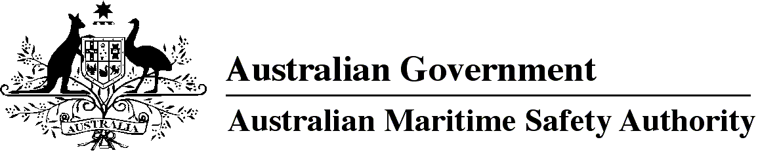

AMSA MO 2018/3

Marine Order 91 (Marine pollution prevention — oil) Amendment Order 2018

I, Michael Kinley, Chief Executive Officer of the Australian Maritime Safety Authority, make this Order under subsection 342(1) of the *Navigation Act 2012* and subsection 34(1) of the *Protection of the Sea (Prevention of Pollution from Ships) Act 1983*.

15 March 2018

Michael Kinley  
Chief Executive Officer

1 Name of Order

This Order is *Marine Order 91 (Marine pollution prevention — oil) Amendment Order 2018*.

2 Commencement

This Order commences on 1 April 2018.

3 Amendment of *Marine Order 91 (Marine pollution prevention — oil) 2014*

Schedule 1 amends *Marine Order 91 (Marine pollution prevention — oil) 2014*.

Schedule 1 Amendment

[1] Section 4, definitions of *certificate of competency* and *management level*

omit

[2] Section 4, note 2

*omit*

AMSA

*insert*

Australian nationality

[3] Section 5

omit

For this Order:

insert

(1) For this Order:

[4] Section 5, after the note for paragraph (a)

insert

(2) In this Order, a term that is used but is not defined for this Order, and is defined in MARPOL, the STCW Convention or the STCW Code has the meaning given by MARPOL, the STCW Convention or the STCW Code.

*Examples*

1   Definition of ***management level*** in section A-I/1 of Chapter I of Part A of the STCW Code.

2   Definition of ***certificate of competency*** in Regulation I/1 of the Annex to the STCW Convention.

[5] Section 6

substitute

6 Application

1. This Order applies to a vessel that is:

(a) a regulated Australian vessel; or

(b) a foreign vessel; or

(c) a recreational vessel; or

(d) a domestic commercial vessel.

1. However, this Order does not apply to a vessel that is owned or operated by a country other than Australia and used, for the time being, on government non-commercial service.
2. Also, Division 3 does not apply to a vessel that is:

(a) a foreign vessel; or

(b) a recreational vessel that does not have Australian nationality.

(4) For this Order, Annex I is taken to apply to a vessel that is owned and operated by the Commonwealth and is used, for the time being, on government non-commercial service.

*Note*   The application of this Order is subject to subsection 33(2) of the Pollution Prevention Act and section 12 of the Navigation Act. Those provisions have the effect that parts of this Order that give effect to parts of MARPOL do not apply to certain vessels in an area if a law of a State or the Northern Territory or the Marine Safety (Domestic Commercial Vessel) National Law gives effect to the same parts of MARPOL for vessels in the area.

[6] Subsection 7(3)

omit

3.4 and 3.5

insert

3.4, 3.5, 3.6 or 14.5

[7] Paragraph 13(d)

omit

AMSA

insert

an issuing body

[8] Section 18

omit

the issuing body

insert

each issuing body that issued the IOPP certificate for the vessel

[9] Section 19

substitute

19 Requirements for foreign vessels

(1) A foreign vessel to which regulation 7.1 of Annex I applies must have a certificate issued in accordance with that regulation.

(2) A foreign vessel to which Annex I does not apply but to which Regulation 7.1 of Annex I would apply if the country in which the vessel is registered were a party to MARPOL must carry and comply with any certificate or other document that:

(a) is issued for the vessel by or for the administration of the country in which it is registered; and

(b) deals with the prevention of oil pollution by the vessel.

[10] Paragraph 21(1)(b)

omit

[11] Paragraph 21(1)(d)

substitute

(d) HF DSC MMSI 005030001.

[12] Paragraph 21(1)(e)

omit

[13] After heading to Division 6

insert

22A Ship board oil pollution emergency plan — foreign ships

For subsection 32(1A) of the Pollution Prevention Act, section 11A of the Act applies to a foreign ship, as if it were an Australian ship, when it is in:

(a) a port in Australia; or

(b) the territorial sea of Australia; or

(c) the sea on the landward side of the territorial sea of Australia.

[14] After section 25

insert

25A Transfer of oil cargo involving a foreign ship — prescribed operation

For subsection 32(1) of the Pollution Prevention Act:

(a) the transfer of oil cargo with another oil tanker that has a gross tonnage of 150 or more is a prescribed operation; and

(b) sections 11D and 11E of the Act apply to a foreign ship, as if it were an Australian ship, when it is in:

(i) a port in Australia; or

(ii) the territorial sea of Australia; or

(iii) the sea on the landward side of the territorial sea of Australia while on its way to or from a port in Australia.

*Note* Sections 11B, 11C and 11F of the Pollution Prevention Act also apply to foreign ships — see sections 11B, 11C and 11F.

[15] After section 29

insert

29A Oil record book — foreign ships

For subsection 32(1) of the Pollution Prevention Act, section 12 of the Act applies to a foreign ship, as if it were an Australian ship, when it is in:

(a) a port in Australia; or

(b) the territorial sea of Australia; or

(c) the sea on the landward side of the territorial sea of Australia.

*Note*Section 13 (False entries in oil record book) of the Pollution Prevention Act also applies to foreign ships because that section applies to ships to which section 12 applies.

[16] Subsection 37(1)

after

if

insert

it is

**Note**

1. All legislative instruments and compilations of legislative instruments are registered on the Federal Register of Legislation under the *Legislation Act 2003.* See https://www.legislation.gov.au.