

Broadcasting Services Local Programming Determination 2018

The Australian Communications and Media Authority makes the following determination under subsection 61CZ(1) of the *Broadcasting Services Act 1992*.

Dated: 22 March 2018

Nerida O’Loughlin

[signed]

Member

James Cameron

[signed]

Member/~~General Manager~~

Australian Communications and Media Authority

Part 1—Preliminary

1 Name

This is the *Broadcasting Services Local Programming Determination 2018*.

2 Commencement

This determination commences at the start of whichever is the later of the following days:

1. the day after it is registered on the Federal Register of Legislation; or
2. 17 April 2018.

Note 1: The Federal Register of Legislation may be accessed at [www.legislation.gov.au](http://www.legislation.gov.au).

Note 2: Both of the events referred to in this section must occur before this determination commences.

3 Authority

This determination is made under subsection 61CZ(1) of the *Broadcasting Services Act 1992*.

4 Definitions

In this determination:

***Act*** means *Broadcasting Services Act 1992*.

***file footage*** means any footage other than:

(a) live footage; or

(b) footage that has been specifically obtained for the purpose of accompanying the broadcast of the news material in question.

***licensee*** means, for a licence to which this determination relates, the holder of the licence.

Note: A number of other expressions used in this instrument are defined in the Act, including the following:

1. licence area;
2. licence area plan;

(c) regional aggregated commercial television broadcasting licence;

(d) regional non-aggregated commercial television broadcasting licence; and

(e) timing period.

(See sections 6 and 61CU of the Act).

5 References to other instruments

In this determination, unless the contrary intention appears:

(a) a reference to any other legislative instrument is a reference to that other legislative instrument as in force from time to time; and

(b) a reference to any other kind of instrument is a reference to that other instrument as in force at the commencement of this determination.

Note 1: For references to Commonwealth Acts, see section 10 of the *Acts Interpretation Act 1901*; and see also subsection 13(1) of the *Legislation Act 2003* for the application of the *Acts Interpretation Act 1901* to legislative instruments.

Note 2: All Commonwealth Acts and legislative instruments are registered on the Federal Register of Legislation.

Part 2—Material of local significance

6 Material of local significance

(1) Subject to subsections (2) and (3), material that is broadcast to a local area is material of local significance if it relates directly to:

(a) the local area; or

(b) the licensee’s licence area.

Note: Material of local significance may accumulate 1, 2 or 3 points per minute, depending on the characteristics of the material. See subsection 61CY(3) if the Act and section 9 of this determination.

(2) Material in the form of advertising or sponsorship matter, whether or not of a commercial kind, is not material of local significance unless it is a community service announcement.

Note: Subsections 61CY(7) and (8) of the Act limit the way community service announcements may be counted towards points accumulated for a licence during a timing period.

(3) Material (including a station promotion) that constitutes an announcement that material of local significance will appear later is not material of local significance.

Part 3—Local area

7 Local area for regional aggregated commercial television broadcasting licences

The local area for a regional aggregated commercial television broadcasting licence specified in column 1 of the following table is the area referred to in column 2 of the corresponding row.

|  |  |
| --- | --- |
| **Column 1 – Service Licence Number** | **Column 2 – Local area** |
| 113, 115 or 116 | 5 of the 7 areas set out in Part 1 of Schedule 1, chosen by the licensee |
| 94, 95 or 96 | 4 of the 5 areas set out in Part 2 of Schedule 1, chosen by the licensee |
| 85, 90 or 99 | Each of the areas set out in Part 3 of Schedule 1 |
| 103 or 107 | Each of the areas set out in Part 4 of Schedule 1 |
| 104 | The areas set out in Part 4 of Schedule 1 and entitled ‘North Central Victoria’ and ‘South West Victoria’ |
| 106 | The areas set out in Part 4 of Schedule 1 and entitled ‘Upper Murray & Goulburn Valley’ and ‘Gippsland’ |
| 132, 133 or 1150806 | The area identical to the licence area for that licence  Note: The licence area for licences 132, 133 and 1150806 is set out in the *Television Licence Area Plan (Tasmania) 2012* |

8 Local area for regional non-aggregated commercial television broadcasting licences

(1) Subject to subsection (2), the local area for a regional non-aggregated commercial television broadcasting licence is the area identical to the licence area for that licence.

Note 1: The licence area for a regional non-aggregated commercial television broadcasting licence is set out in the relevant licence area plan made under subsection 26(1B) of the Act.

Note 2: The licence area for a regional non-aggregated commercial television broadcasting licence covered by subsection (1) is, at the time of making this instrument, set out in whichever is applicable of the following instruments:

* *Television Licence Area Plan (Broken Hill) 2011*
* *Television Licence Area Plan (Darwin) 2012*
* *Television Licence Area Plan (Griffith and the Murrumbidgee Irrigation Area) 2012*
* *Television Licence Area Plan (Mildura/Sunraysia) 2012*
* *Television Licence Area Plan (Mount Gambier/South East) 2011*
* *Television Licence Area Plan (Remote and Regional Western Australia) 2013*
* *Television Licence Area Plan (Remote Central and Eastern Australia) 2013*
* *Television Licence Area Plan (Riverland) 2011*
* *Television Licence Area Plan (Spencer Gulf) 2011*

(2) Subsection (1) does not apply to a regional non-aggregated commercial television broadcasting licence for the licence area Remote and Regional WA TV1. The local area for such a licence is the combined area of the following licence areas:

(a) Geraldton TV1;

(b) Kalgoorlie TV1; and

(c) South West and Great Southern TV1.

Part 4—Additional requirements for certain material of local significance

9 Additional requirements to accumulate 3 points per minute

For the purposes of paragraph (d) of item 1 in the table in subsection 61CY(3) of the Act, the following additional requirements are specified:

(a) the news item must relate directly to the local area; and

(b) the depiction of people, places or things must predominantly consist of moving images; and

1. when considering the news item as a whole, file footage, if used, must:
   1. not be the only kind of footage used;
   2. be visually relevant to the news item;
   3. be recently obtained or provide a different perspective to the news item; and
   4. not be extensively used unless it is directly relevant to the news item.

Schedule 1 Local areas of regional aggregated commercial television broadcasting licences

(section 7)

Part 1 Regional Queensland Licence Area

**(service licence numbers 113, 115 and 116)**

*101 Area — Far North Queensland*

The Area, in terms of areas defined by the Australian Bureau of Statistics at the Census of 7 August 2001, is:

the Local Government Areas of **Atherton** (S); **Cairns** (C); **Cardwell** (S); **Eacham** (S) and **Johnstone** (S); Collection District Numbers 010805, 010806, 010810, 010901, 010902, 010903, 010904, 010905, 010906, 010907, 010908, 010909, 010910, 010911, 010912, 010913, 010914, 010915, 010916, 010917 and 010918 within the Local Government Area of **Douglas** (S); Collection District Numbers 030801, 030802, 030803, 030806, 030807, 030809, 030810 and 030811 within the Local Government Area of **Herberton** (S); Collection District Numbers 030303, 030304, 030305, 030306, 030307, 030308, 030309, 030311, 030312, 030313, 030314, 030316, 030317, 030318, 030401, 030402, 030403, 030404, 030405, 030406, 030407, 030408, 030409, 030410, 030411 and 030412 within the Local Government Area of **Mareeba** (S) in the State of **Queensland**.

*102 Area — North Queensland*

The Area, in terms of areas defined by the Australian Bureau of Statistics at the Census of 7 August 2001, is:

the Local Government Areas of **Burdekin** (S); **Charters Towers** (C); **Hinchinbrook** (S); **Thuringowa** (C) and **Townsville** (C); Collection District Numbers 050401, 050402, 050403, 050404, 050405, 050406, 050407, 050408, 050409, 050410, 050501, 050502, 050503, 050504, 050505, 050506, 050507, 050508, 050509, 050510, 050511 and 050512 within the Local Government Area of **Bowen** (S); Collection District Numbers 040109, 040111, 040205, 040206 and 040207 within the Local Government Area of **Cardwell** (S); Collection District Number 031305 within the Local Government Area of **Dalrymple** (S) in the State of **Queensland**.

*103 Area — Capricornia*

The Area, in terms of areas defined by the Australian Bureau of Statistics at the Census of 7 August 2001, is:

the Local Government Areas of **Calliope** (S); **Fitzroy** (S); **Gladstone** (C); **Mount Morgan** (S) and **Rockhampton** (C); Collection District Numbers 061701, 061702, 061703, 061704, 061705, 061706, 061707, 061708, 061801, 061803, 061804, 061805, 061808, 061809, 061811, 061812, 061901, 061902, 061903, 061904, 061905, 061906, 061907, 061908, 061909, 061910, 061911, 061912, 061913 and 061914 within the Local Government Area of **Banana** (S); Collection District Numbers 080603, 080604, 080605, 080606 and 080607 within the Local Government Area of **Bauhinia** (S); Collection District Numbers 080402, 080403, 080404, 080405, 080406, 080407, 080408, 080409, 080410, 080411, 080502, 080503, 080504, 080505, 080506, 080507, 080508, 080509 and 080512 within the Local Government Area of **Duaringa** (S); Collection District Numbers 080201, 080203, 080204, 080205, 080206, 080207, 080208, 080209, 080210, 080211, 080212, 080213, 080214, 080215, 080216, 080217, 080301, 080302, 080303, 080306, 080307, 080308 and 080310 within the Local Government Area of **Emerald** (S); Collection District Numbers 060102, 060103, 060104, 060105, 060106, 060107, 060108, 060109, 060110, 060201, 060202, 060203, 060204, 060205, 060206, 060207, 060208, 060209, 060210, 060211, 060212, 060213, 060214, 060215, 060301, 060302, 060303, 060304, 060305, 060306, 060307, 060308, 060309, 060310, 060311, 060312, 060313, 060314, 060315, 060316, 060317, 060318, 062001, 062002, 062003, 062004, 062005, 062006, 062007, 062008, 062009, 062010, 062011 and 062012 within the Local Government Area of **Livingstone** (S); Collection District Numbers 070701, 070703, 070708, 070709, 070710, 070713, 070714 and 070715 within the Local Government Area of **Miriam Vale** (S); Collection District Numbers 080102 and 080104 within the Local Government Area of **Peak Downs** (S) in the State of **Queensland**.

*104 Area — Central Coast & Whitsundays*

The Area, in terms of areas defined by the Australian Bureau of Statistics at the Census of 7 August 2001, is:

the Local Government Areas of **Mackay** (C); **Mirani** (S); **Sarina** (S) and **Whitsunday** (S); Collection District Numbers 031502, 031503, 031504, 031505, 031506, 031507, 031508, 031509, 031601, 031604, 031605, 031606, 031607, 031608, 031609, 031610, 031611, 031612 and 031613 within the Local Government Area of **Belyando** (S); Collection District Numbers 050602, 050603, 050604, 050605, 050606 and 050607 within the Local Government Area of **Bowen** (S); Collection District Numbers 052301, 052302, 052303, 052304, 052305, 052306, 052308, 052309, 052310 and 052311 within the Local Government Area of **Broadsound** (S); Collection District Numbers 052001, 052003, 052004, 052005 and 052006 within the Local Government Area of **Nebo** (S); Collection District Numbers 080101, 080103, 080105 and 080106 within the Local Government Area of **Peak Downs** (S) in the State of **Queensland**.

*105 Area — Wide Bay*

The Area, in terms of areas defined by the Australian Bureau of Statistics at the Census of 7 August 2001, is:

the Local Government Areas of **Biggenden** (S); **Bundaberg** (C); **Burnett** (S); **Gayndah** (S); **Hervey Bay** (C); **Isis** (S); **Kilkivan** (S); **Kolan** (S); **Maryborough** (C); **Perry** (S); **Tiaro** (S) and **Woocoo** (S); Collection District Numbers 101101, 101102, 101103, 101104, 101105, 101106, 101107, 101108, 101109, 101110, 101111, 101113, 101114, 101115, 101117, 101118 and 101201 within the Local Government Area of **Cooloola** (S); Collection District Numbers 072103 and 072104 within the Local Government Area of **Eidsvold** (S); Collection District Numbers 070702, 070704, 070705, 070706, 070707, 070711, 070712, 070716, 070717 and 070811 within the Local Government Area of **Miriam Vale** (S); Collection District Numbers 071802, 071803, 071804, 071805, 071806, 071807, 071808 and 071809 within the Local Government Area of **Monto** (S); Collection District Numbers 072002, 072003 and 072008 within the Local Government Area of **Mundubbera** (S); Collection District Numbers 101601, 101602 and 101603 within the Local Government Area of **Murgon** (S); Collection District Number 101703 within the Local Government Area of **Wondai** (S) in the State of **Queensland**.

*106 Area — Sunshine Coast*

The Area, in terms of areas defined by the Australian Bureau of Statistics at the Census of 7 August 2001, is:

the Local Government Areas of **Maroochy** (S) and **Noosa** (S); Collection District Numbers 111301, 111302, 111303, 111304, 111305, 111306, 111307, 111308, 111309, 111310, 111311, 111312, 111313, 111314, 111315, 111316, 111317, 111318, 111319, 111320, 111321, 111322, 111323, 111324, 111325, 111326, 111327, 111328, 111329, 111401, 111402, 111403, 111404, 111405, 111406, 111407, 111408, 111409, 111410, 111411, 111412, 111413, 111414, 111415, 111501, 111502, 111503, 111504, 111505, 111506, 111507, 111508, 111509, 111510, 111511, 111512, 111513, 111514, 111515, 111516, 111601, 111602, 111603, 111604, 111605, 111606, 111607, 111608, 111609, 111610, 111611, 111612, 111613, 111614, 111615, 111616, 111617, 111618, 111619, 111620, 111701, 111702, 111703, 111704, 111705, 111706, 111707, 111708, 111709, 111710, 111711, 111712, 111713, 111714, 111715, 111801, 111802, 111803, 111804, 111805, 111806, 111807, 111808, 111809, 111810, 111811, 111812, 111813, 111814, 120301, 120302, 120303, 120304, 120305, 120306, 120308, 120309, 120310, 120311, 120312 and 120313 within the Local Government Area of **Caloundra** (C); Collection District Numbers 100901, 100902, 100903, 100904, 100905, 100906, 100907, 100908, 100909, 100910, 101001, 101002, 101003, 101004, 101005, 101006, 101007, 101008, 101009, 101010, 101011, 101112, 101116, 101202, 101203, 101204, 101205, 101206, 101207, 101208, 101209, 101210, 101211, 101212, 101213, 101214, 101301, 101302, 101303, 101304, 101305, 101306, 101307, 101308, 101309, 101310, 101311, 101312 and 101313 within the Local Government Area of **Cooloola** (S) in the State of **Queensland**.

*107 Area — Darling Downs*

The Area, in terms of areas defined by the Australian Bureau of Statistics at the Census of 7 August 2001, is:

Collection District Numbers 050102, 050103 and 050105 within the Local Government Area of **Inverell** (A); Collection District Number 041509 within the Local Government Area of **Moree Plains** (A); Collection District Numbers 052501, 052505, 052506 and 052511 within the Local Government Area of **Tenterfield** (A) in the State of **New South Wales**; the Local Government Areas of **Cambooya** (S); **Clifton** (S); **Crow's Nest** (S); **Dalby** (T); **Gatton** (S); **Goondiwindi** (T); **Inglewood** (S); **Jondaryan** (S); **Kingaroy** (S); **Laidley** (S); **Millmerran** (S); **Murgon** (S); **Nanango** (S); **Pittsworth** (S); **Rosalie** (S); **Stanthorpe** (S); **Toowoomba** (C); **Wambo** (S) and **Warwick** (S); Collection District Numbers 081001, 081002, 081003, 081004, 081005, 081006, 081007, 081008, 081009, 081012, 081013, 081014 and 081015 within the Local Government Area of **Chinchilla** (S); Collection District Numbers 081103, 081104, 081105, 081106, 081107, 081108, 081111 and 081112 within the Local Government Area of **Murilla** (S); Collection District Numbers 081404, 081405, 081406, 081411, 081412, 081413 and 081414 within the Local Government Area of **Tara** (S); Collection District Numbers 081809, 081810 and 081811 within the Local Government Area of **Waggamba** (S); Collection District Numbers 101701, 101702, 101704, 101705, 101706, 101707, 101708, 101709, 101710 and 101711 within the Local Government Area of **Wondai** (S) in the State of **Queensland**.

Note: The following map shows the relevant areas:

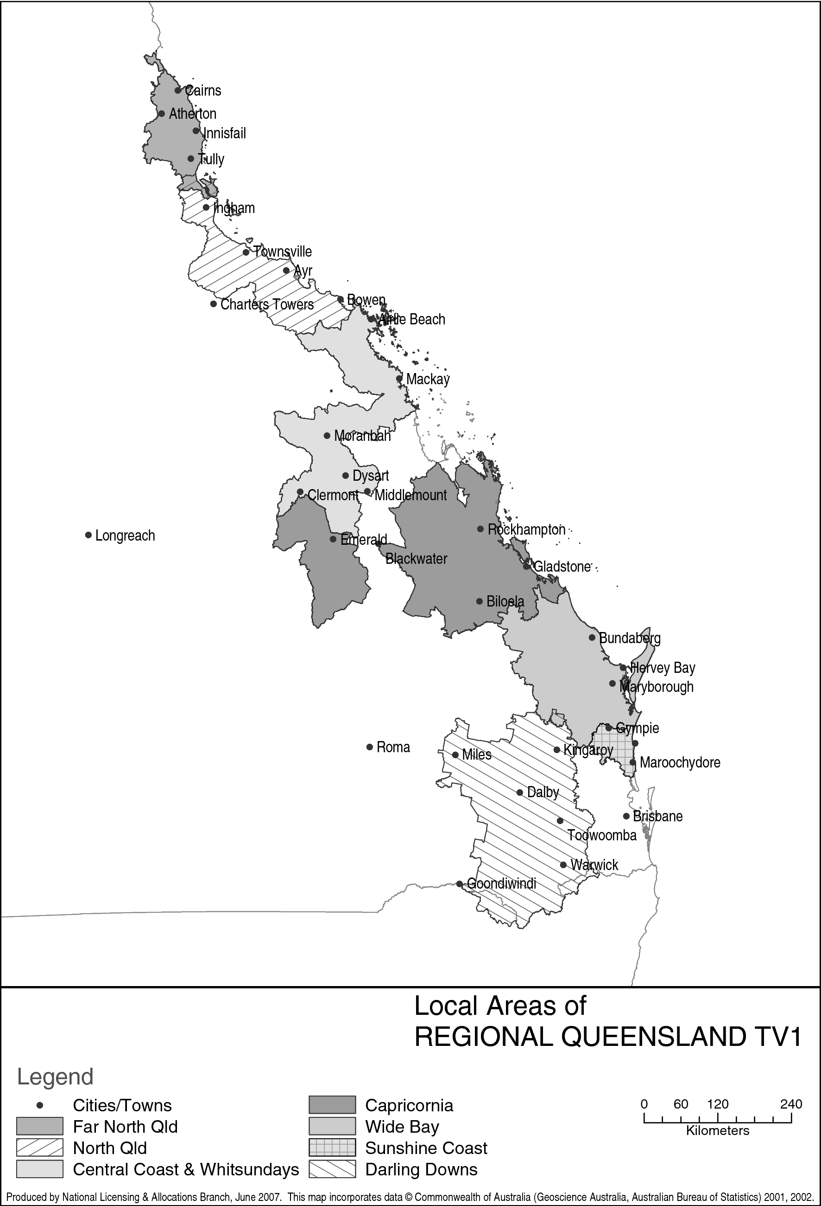

Part 2 Northern NSW Licence Area

**(service licence numbers 94, 95 and 96)**

*201 Area — Richmond/Tweed*

The Area, in terms of areas defined by the Australian Bureau of Statistics at the Census of 7 August 2001, is:

the Local Government Areas of **Ballina** (A); **Byron** (A); **Kyogle** (A); **Lismore** (C); **Richmond Valley** (A) and **Tweed** (A); Collection District Numbers 052404, 052405, 052406, 052503, 052507, 052510, 052511, 052601, 052602, 052603, 052604, 052605, 052606 and 052607 within the Local Government Area of **Tenterfield** (A) in the State of **New South Wales**; Collection District Numbers 160105, 160106, 160107, 160108, 160111, 160113, 160114, 160115, 160116, 160305, 160311, 160312, 160324, 160325, 160401, 160402, 160403, 160404, 160405, 160406, 160407, 160408, 160409, 160410, 160411, 160412, 160413, 160414, 160415, 160416, 160417, 160418, 160419, 160420, 160501, 160502, 160503, 160504, 160505, 160506, 160507, 160508, 160509, 160510, 160511, 160512, 160513, 160514, 160515, 160601, 160602, 160603, 160604, 160605, 160606, 160607, 160608, 160609, 160610, 160611, 160612, 160613, 160614, 160615, 160616, 160617, 160701, 160702, 160703, 160704, 160705, 160706, 160707, 160708, 160709, 160710, 160711, 160712, 160713, 160714, 160715, 160716, 160717, 160801, 160802, 160803, 160804, 160805, 160806, 160807, 160808, 160809, 160810, 160811, 160812, 160813, 160814, 160815, 160816, 160817, 160901, 160902, 160903, 160904, 160905, 160906, 160907, 160908, 160909, 160910, 160911, 160912, 160913, 160914, 160915, 160916, 160917, 160918, 160919, 161001, 161002, 161003, 161004, 161005, 161006, 161007, 161008, 161009, 161010, 161011, 161012, 161013, 161101, 161102, 161103, 161104, 161105, 161106, 161107, 161108, 161109, 161110, 161111, 161201, 161202, 161203, 161204, 161205, 161206, 161207, 161208, 161209, 161210, 161211, 161212, 161213, 161214, 161215, 161301, 161302, 161303, 161304, 161305, 161306, 161307, 161308, 161309, 161310, 161311, 161312, 161313, 161401, 161402, 161403, 161404, 161405, 161406, 161407, 161408, 161409, 161410, 161501, 161502, 161503, 161504, 161505, 161506, 161507, 161508, 161509, 161510, 161511, 161512, 161513, 161514, 161601, 161602, 161603, 161604, 161605, 161606, 161607, 161608, 161609, 161610, 161611, 161612, 161613, 161701, 161702, 161703, 161704, 161705, 161706, 161707, 161708, 161709, 161710, 161711, 161712, 161713, 161714, 161715, 161716, 161717, 161718, 161801, 161802, 161803, 161804, 161805, 161806, 161807, 161808, 161809, 161810, 161811, 161812, 161813, 161814, 161901, 161902, 161903, 161904, 161905, 161906, 161907, 161908, 161909, 161910, 161911, 161912, 162001, 162002, 162003, 162004, 162005, 162006, 162007, 162008, 162009, 162010, 162011, 162101, 162102, 162103, 162104, 162105, 162106, 162107, 162108, 162109, 162110, 162111, 162112, 162113, 162114, 162201, 162202, 162203, 162204, 162205, 162206, 162207, 162208, 162209, 162210, 162211, 162212, 162213, 162214, 162215, 162216, 162301, 162302, 162303, 162304, 162305, 162306, 162307, 162308, 162309, 162310, 162311, 162312, 162313, 162314, 162315, 162401, 162402, 162403, 162404, 162405, 162406, 162407, 162408, 162409, 162410, 162411, 162412, 162413, 162414, 162415, 162416, 162417, 162501, 162502, 162503, 162504, 162505, 162506, 162507, 162508, 162509, 162510, 162511, 162512, 162513, 162514, 162515, 162601, 162602, 162603, 162604, 162605, 162606, 162607, 162608, 162609, 162610, 162611, 162612, 162613, 162614, 162615, 170101, 170102, 170103, 170104, 170105, 170106, 170107, 170108, 170109, 170110, 170111, 170112, 170113, 170201, 170202, 170203, 170204, 170205, 170206, 170207, 170208, 170209, 170210, 170211, 170212, 170213, 170214, 170215, 170216, 170217, 170218, 170219, 170220, 170221, 170222, 170223, 170301, 170302, 170303, 170304, 170305, 170306, 170307, 170308, 170309, 170310, 170311, 170312, 170313, 170314, 170315, 170316, 170317, 170401, 170402, 170403, 170404, 170405, 170406, 170407, 170408, 170409, 170410, 170411, 170412, 170413, 170414, 170415, 170416, 170417, 170418, 170419, 170420, 170421, 170422, 170423, 170424, 170425, 170426, 170427, 170428, 170429, 170501, 170502, 170503, 170504, 170505, 170506, 170507, 170508, 170509, 170510, 170511, 170512, 170513, 170601, 170602, 170603, 170604, 170605, 170606, 170607, 170608, 170609, 170610, 170611, 170612, 170613, 170614, 170615, 170616, 170701, 170702, 170703, 170704, 170705, 170706, 170707, 170708, 170709, 170710, 170711, 170712, 170713, 170714, 170715, 170801, 170802, 170803, 170804, 170805, 170806, 170807, 170808, 170809, 170810, 170811, 170812, 170813, 170901, 170902, 170903, 170904, 170905, 170906, 170907, 170908, 170909, 170910, 170911, 170912, 170913, 170914, 170915, 171001, 171002, 171003, 171004, 171005, 171006, 171007, 171008, 171009, 171010, 171011, 171012, 171013, 171014, 171101, 171102, 171103, 171104, 171105, 171106, 171107, 171108, 171109, 171110, 171111, 171112, 171113, 171114, 171115, 171201, 171202, 171203, 171204, 171205, 171206, 171207, 171208, 171209, 171210, 171211, 171212, 171213, 171214, 171301, 171302, 171303, 171304, 171305, 171306, 171307, 171308, 171309, 171310, 171311, 171312, 171313, 171314, 171315, 171401, 171402, 171403, 171404, 171405, 171406, 171407, 171408, 171409, 171410, 171411, 171412, 171413, 171414, 171415, 171416, 171501, 171502, 171503, 171504, 171505, 171506, 171507, 171508, 171509, 171510, 171511, 171512, 171513, 171514, 171601, 171602, 171603, 171604, 171605, 171606, 171607, 171608, 171609, 171610, 171611, 171612, 171613, 171701, 171702, 171703, 171704, 171705, 171706, 171707, 171708, 171709, 171710, 171711, 171712, 171713, 171801, 171802, 171803, 171804, 171805, 171806, 171807, 171808, 171809, 171810, 171811, 171812, 171813, 171814, 171815, 171816, 171901, 171902, 171903, 171904, 171905, 171906, 171907, 171908, 171909, 171910, 171911, 171912, 171913, 171914, 171915, 171916, 171917, 171918, 172001, 172002, 172003, 172004, 172005, 172006, 172007, 172008, 172009, 172010, 172011, 172012, 172013, 172014, 172015, 172101, 172102, 172103, 172104, 172105, 172106, 172107, 172108, 172109, 172110, 172111, 172112, 172113, 172114, 172115, 172116, 172117, 172118, 172119, 172120 and 172121 within the Local Government Area of **Gold Coast** (C) in the State of **Queensland**.

*202 Area — North West Slopes & Plains*

The Area, in terms of areas defined by the Australian Bureau of Statistics at the Census of 7 August 2001, is:

the Local Government Areas of **Barraba** (A); **Bingara** (A); **Glen Innes** (A); **Manilla** (A); **Narrabri** (A); **Nundle** (A); **Parry** (A); **Tamworth** (C) and **Uralla** (A); Collection District Numbers 051701, 051702, 051705, 051706, 051707, 051801, 051802, 051803, 051804, 051805, 051806, 051807, 051808, 051809, 051810, 051901, 051902, 051903, 051904, 051905, 051906, 051907, 051908, 051909, 051910, 051911, 051912, 052001, 052002, 052003, 052004, 052005, 052006, 052007, 052008, 052009, 052010, 052011, 052012, 052013 and 052014 within the Local Government Area of **Armidale Dumaresq** (A); Collection District Numbers 042301, 042302, 042303, 042304, 042305, 042306, 042307, 042308, 042309, 042310, 042401, 042402, 042403, 042404, 042408, 042501, 042502, 042503, 042504, 042505, 042506, 042507, 042508, 042509, 042510, 042511, 042512, 042601, 042602, 042603, 042604 and 042605 within the Local Government Area of **Gunnedah** (A); Collection District Numbers 050501, 050502, 050503, 050504, 050505, 050506, 050604, 050606 and 050607 within the Local Government Area of **Guyra** (A); Collection District Numbers 050101, 050104, 050107, 050109, 050201, 050202, 050203, 050204, 050205, 050206, 050207, 050208, 050209, 050301, 050302, 050303, 050304, 050305, 050306, 050307, 050308, 050401, 050402, 050403, 050404, 050405, 050406, 050407, 050408, 050409, 050410, 050411, 050412, 050413, 050414, 050415 and 050416 within the Local Government Area of **Inverell** (A); Collection District Numbers 041402, 041403, 041404, 041405, 041406, 041407, 041504, 041505, 041506, 041507, 041508, 041601, 041602, 041603, 041604, 041605, 041606, 041607, 041608, 041801, 041802, 041803, 041804, 041805, 041806, 041807, 041808, 041809, 041810, 041811, 042801, 042802, 042803, 042804, 042805, 042806 and 042807 within the Local Government Area of **Moree Plains** (A); Collection District Numbers 130101, 130102 and 130104 within the Local Government Area of **Murrurundi** (A); Collection District Numbers 041701, 041702, 041703, 041704, 041705, 041706, 042703, 042704, 042705, 042706, 042707, 042708 and 042709 within the Local Government Area of **Quirindi** (A); Collection District Numbers 052205, 052206 and 052207 within the Local Government Area of **Severn** (A); Collection District Numbers 051601, 051602, 051604, 051606, 051607, 051608 and 051609 within the Local Government Area of **Walcha** (A); Collection District Numbers 040302, 040304, 040305 and 040309 within the Local Government Area of **Walgett** (A); Collection District Numbers 041901, 041903, 041904, 041905, 041906, 041907, 041908, 041909, 041910, 041911, 041912, 041913 and 041914 within the Local Government Area of **Yallaroi** (A) in the State of **New South Wales**.

*203 Area — Northern Rivers & Mid North Coast*

The Area, in terms of areas defined by the Australian Bureau of Statistics at the Census of 7 August 2001, is:

the Local Government Areas of **Bellingen** (A); **Coffs Harbour** (C); **Grafton** (C); **Kempsey** (A); **Maclean** (A); **Nambucca** (A) and **Pristine Waters** (A); Collection District Numbers 060403, 060405, 060406, 060407, 060408, 060409, 060410, 060411, 060412 and 060413 within the Local Government Area of **Copmanhurst** (A); Collection District Numbers 110103, 110104, 110105, 110106, 110107, 110108, 110109, 110110, 110111, 110112, 110113 and 110114 within the Local Government Area of **Gloucester** (A); Collection District Numbers 091601, 091602, 091603, 091604, 091605, 091606, 091607, 091608, 091609, 091610, 091611, 091701, 091702, 091703, 091704, 091705, 091706, 091707, 091708, 091709, 091710, 091801, 091802, 091803, 091804, 091805, 091806, 091807, 091808, 091809, 091810, 091811, 091903, 092006, 092013, 092401, 092402, 092403, 092404, 092405, 092406, 092407, 092408, 092409, 092410, 092411, 092412, 092601, 092602, 092603, 092604, 092605, 092606, 092607, 092608, 092609 and 092610 within the Local Government Area of **Great Lakes** (A); Collection District Numbers 090903, 090904, 090905, 090906, 090907, 090908, 090909, 090910, 090911, 090913, 091001, 091002, 091003, 091004, 091005, 091006, 091007, 091008, 091009, 091010, 091011, 091012, 091013, 091101, 091102, 091103, 091104, 091105, 091106, 091107, 091108, 091109, 091110, 091111, 091112, 091201, 091202, 091203, 091204, 091205, 091206, 091207, 091208, 091209, 091210, 091211, 091212, 091213, 091301, 091302, 091303, 091304, 091305, 091306, 091307, 091401, 091402, 091403, 091404, 091405, 091406, 091407, 091408, 091409, 091410, 091411, 091501, 091502, 091503, 091504, 091505, 091506, 091507, 091508, 091509, 091510, 091511, 091512, 092301, 092302, 092303, 092304, 092305, 092306, 092307, 092308, 092309 and 092310 within the Local Government Area of **Greater Taree** (C); Collection District Numbers 090101, 090104, 090105, 090106, 090107, 090108, 090109, 090110, 090111, 090201, 090202, 090203, 090204, 090205, 090206, 090207, 090208, 090209, 090210, 090211, 090212, 090213, 090301, 090302, 090303, 090304, 090305, 090306, 090307, 090308, 090309, 090310, 090311, 090312, 090313, 090401, 090402, 090403, 090404, 090405, 090406, 090407, 090408, 090409, 090410, 090411, 090501, 090502, 090503, 090504, 090505, 090506, 090507, 090508, 090509, 090510, 090511, 090512, 090601, 090602, 090603, 090604, 090605, 090606, 090607, 090608, 090609, 090610, 090611, 090612, 090701, 090702, 090703, 090704, 090705, 090706, 090707, 090708, 090709, 090710, 090711, 090712, 090713, 090714, 090715, 090716, 090802, 090805, 090806, 090807, 090809, 090810, 092201, 092202, 092203, 092204, 092205, 092206, 092207, 092208, 092209, 092501, 092502, 092503, 092504, 092505, 092506, 092507, 092508, 092509, 092510 and 092511 within the Local Government Area of **Hastings** (A) in the State of **New South Wales**.

*204 Area — Hunter*

The Area, in terms of areas defined by the Australian Bureau of Statistics at the Census of 7 August 2001, is:

the Local Government Areas of **Cessnock** (C); **Dungog** (A); **Lake Macquarie** (C); **Maitland** (C); **Muswellbrook** (A); **Newcastle** (C); **Port Stephens** (A); **Scone** (A) and **Singleton** (A); Collection District Numbers 091901, 091902, 091904, 091905, 091906, 091907, 091908, 091909, 091910, 091911, 092001, 092002, 092003, 092004, 092005, 092007, 092008, 092009, 092010, 092011, 092012 and 092014 within the Local Government Area of **Great Lakes** (A); Collection District Numbers 130201, 130202, 130203, 130204, 130205, 130206, 130207 and 130209 within the Local Government Area of **Merriwa** (A); Collection District Numbers 130103, 130105, 130106, 130107 and 130108 within the Local Government Area of **Murrurundi** (A) in the State of **New South Wales**.

*205 Area — Central Coast*

The Area, in terms of areas defined by the Australian Bureau of Statistics at the Census of 7 August 2001, is:

the Local Government Areas of **Gosford** (C) and **Wyong** (A) in the State of **New South Wales**.

Note: The following map shows the relevant areas:

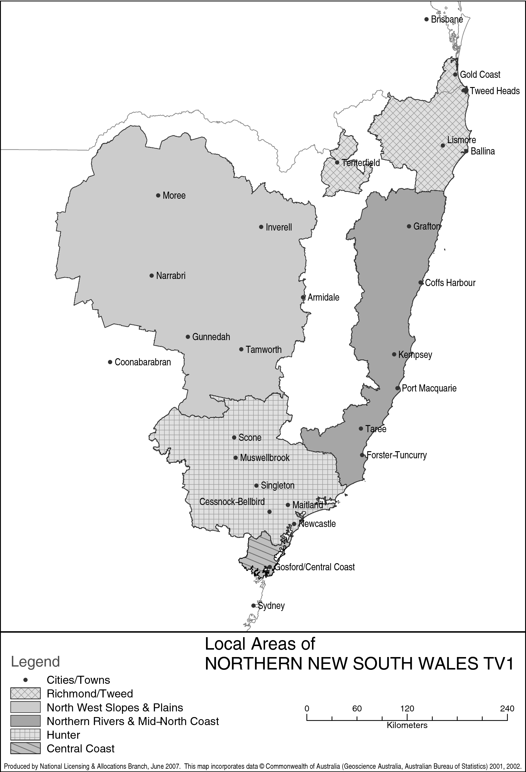

Part 3 Southern NSW Licence Area

**(service licence numbers 85, 90 and 99)**

*301 Area — Central Tablelands & Central Western Slopes*

The Area, in terms of areas defined by the Australian Bureau of Statistics at the Census of 7 August 2001, is:

the Local Government Areas of **Bathurst** (C); **Blayney** (A); **Cabonne** (A); **Coolah** (A); **Coonabarabran** (A); **Coonamble** (A); **Cowra** (A); **Dubbo** (C); **Evans** (A); **Forbes** (A); **Gilgandra** (A); **Narromine** (A); **Orange** (C); **Parkes** (A); **Weddin** (A) and **Wellington** (A); Collection District Numbers 150104, 150201, 150202, 150301, 150302, 150303, 150304, 150305, 150306, 150307, 150308, 150309 and 150310 within the Local Government Area of **Bland** (A); Collection District Numbers 030102, 030103, 030109 and 030110 within the Local Government Area of **Bogan** (A); Collection District Numbers 151601, 151602, 151603, 151605, 151606, 151607, 151608 and 151610 within the Local Government Area of **Boorowa** (A); Collection District Numbers 021201, 021203, 021204, 021205, 021206, 021207, 021208 and 021209 within the Local Government Area of **Cobar** (A); Collection District Numbers 151901, 151902, 151903, 151904, 151906, 151907 and 151908 within the Local Government Area of **Crookwell** (A); Collection District Numbers 142101, 142102, 142103, 142104, 142105, 142108, 142109, 142201, 142202, 142204, 142205, 142207, 142208, 142209, 142210, 142211, 142212, 142301, 142302, 142303, 142304, 142305, 142306, 142307, 142308, 142309, 142310, 142311, 142312, 142313, 142401, 142402, 142403, 142404, 142405, 142406, 142407, 142408, 142409, 142410 and 142411 within the Local Government Area of **Greater Lithgow** (C); Collection District Numbers 030205, 030303, 030304, 030305, 030306, 030401, 030402, 030403, 030404, 030405 and 030406 within the Local Government Area of **Lachlan** (A); Collection District Number 130208 within the Local Government Area of **Merriwa** (A); Collection District Numbers 032401, 032402, 032403, 032404, 032405, 032406, 032407, 032408, 032409, 032501, 032502, 032503, 032504, 032505, 032506, 032507, 032508, 032509, 032510, 032511, 032512, 032513, 032514, 032515, 032516, 032601, 032604, 032605, 032608, 032609, 032801, 032802, 032803, 032804, 032805, 032806, 032807, 032808 and 032809 within the Local Government Area of **Mudgee** (A); Collection District Numbers 142001, 142002, 142003, 142004, 142005, 142006, 142007, 142010 and 142011 within the Local Government Area of **Oberon** (A); Collection District Numbers 142504, 142507, 142508, 142509, 142510, 142511, 142512 and 142513 within the Local Government Area of **Rylstone** (A); Collection District Numbers 031401, 031403, 031404, 031405, 031501, 031502, 031503, 031504, 031505, 031506 and 031507 within the Local Government Area of **Warren** (A); Collection District Numbers 150603, 150604, 150605, 150607, 150608, 150609 and 150610 within the Local Government Area of **Young** (A) in the State of **New South Wales**.

*302 Area — South Western Slopes & Eastern Riverina*

The Area, in terms of areas defined by the Australian Bureau of Statistics at the Census of 7 August 2001, is:

the Local Government Areas of **Coolamon** (A); **Cootamundra** (A); **Gundagai** (A); **Harden** (A); **Junee** (A); **Lockhart** (A); **Temora** (A); **Tumut** (A); **Wagga Wagga** (C) and **Weddin** (A); Collection District Numbers 150104, 150106, 150107, 150201, 150202, 150203, 150204, 150205, 150206, 150302, 150303, 150304, 150305, 150306, 150307, 150308, 150309 and 150310 within the Local Government Area of **Bland** (A); Collection District Numbers 151604, 151606, 151607, 151608 and 151609 within the Local Government Area of **Boorowa** (A); Collection District Numbers 012001, 012002, 012003, 012004, 012005, 012006, 012007, 012008, 012009, 012101, 012102, 012104, 012105 and 012106 within the Local Government Area of **Narrandera** (A); Collection District Numbers 152801, 152802, 152901, 152902 and 152903 within the Local Government Area of **Tumbarumba** (A); Collection District Numbers 160102 and 160108 within the Local Government Area of **Urana** (A); Collection District Numbers 152201, 152202, 152203, 152204, 152205, 152206, 152207, 152208, 152301, 152302, 152303, 152304, 152305, 152306, 152307 and 152308 within the Local Government Area of **Yass** (A); Collection District Numbers 150601, 150602, 150603, 150604, 150605, 150606, 150608, 150609, 150610, 150611, 150612, 150613, 150701, 150702, 150703, 150704, 150705, 150706, 150707, 150708, 150709, 150710, 150711 and 150712 within the Local Government Area of **Young** (A) in the State of **New South Wales**.

*303 Area — Illawarra & South Coast*

The Area, in terms of areas defined by the Australian Bureau of Statistics at the Census of 7 August 2001, is:

the Local Government Areas of **Bega Valley** (A); **Eurobodalla** (A); **Kiama** (A); **Shellharbour** (C); **Shoalhaven** (C) and **Wollongong** (C); Collection District Numbers 200101 and 200102 within the Local Government Area of **Mulwaree** (A); Collection District Number 170703 within the Local Government Area of **Tallaganda** (A); Collection District Numbers 200601, 200602, 200605, 200606, 200607, 200608, 200609, 200610, 200611, 200612, 200613, 200614, 200701, 200702, 200704, 200705, 200706, 200707, 200708, 200709, 200710, 200711, 200712, 200713, 200714, 200715, 200801, 200802, 200803, 200804, 200805, 200806, 200807, 200808, 200809, 200810, 200811, 200812, 200813, 200814, 200815, 200816, 200817, 200901, 200902, 200903, 200904, 200905, 200906, 200907, 200908, 200909, 201001, 201002, 201003, 201004, 201005, 201006, 201007, 201008, 201009, 201010, 201011, 201012, 201013, 201014, 201101, 201102, 201103, 201104, 201105, 201106, 201107, 201108, 201109, 201110, 201111 and 201112 within the Local Government Area of **Wingecarribee** (A) in the State of **New South Wales**; Collection District Numbers 030101, 030102 and 030103 within the Local Government Area of **Unincorp. Other Territories** in **Australia's Other Territories**.

*304 Area — ACT & Southern Tablelands*

The Area, in terms of areas defined by the Australian Bureau of Statistics at the Census of 7 August 2001, is:

the Local Government Areas of **Bombala** (A); **Cooma‑Monaro** (A); **Goulburn** (C); **Gunning** (A); **Queanbeyan** (C); **Snowy River** (A); **Yarrowlumla** (A) and **Yass** (A); Collection District Numbers 200105, 200106, 200107, 200108, 200207 and 200208 within the Local Government Area of **Mulwaree** (A); Collection District Numbers 170701, 170702, 170704, 170708 and 170709 within the Local Government Area of **Tallaganda** (A) in the State of **New South Wales**; the Local Government Area of **Unincorporated ACT** in the **Australian Capital Territory**.

Note: The following map shows the relevant areas:

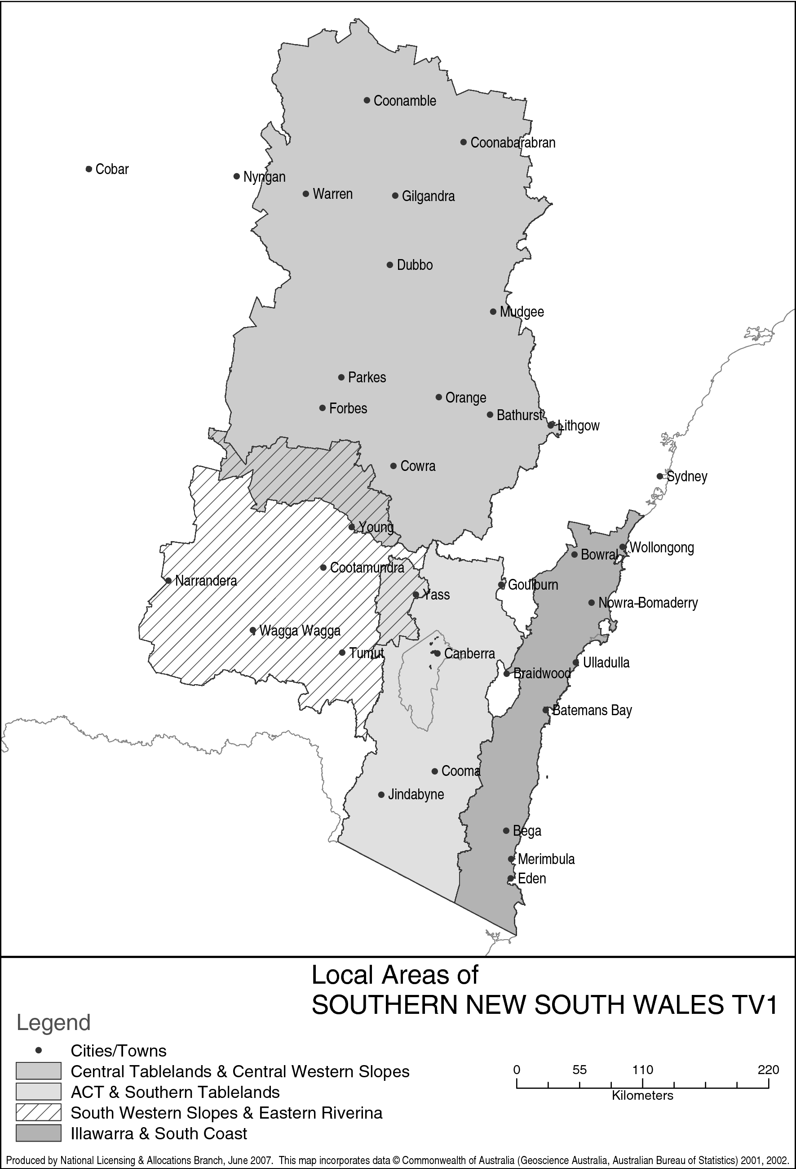

Part 4 Regional Victoria Licence Area

**(service licence numbers 103, 104, 106 and 107)**

*401 Area — Upper Murray & Goulburn Valley*

The Area, in terms of areas defined by the Australian Bureau of Statistics at the Census of 7 August 2001, is:

the Local Government Areas of **Albury** (C); **Berrigan** (A); **Corowa** (A); **Culcairn** (A); **Deniliquin** (A); **Holbrook** (A) and **Hume** (A); Collection District Numbers 010902, 010903, 010904 and 010905 within the Local Government Area of **Conargo** (A); Collection District Numbers 011203, 011204 and 011205 within the Local Government Area of **Jerilderie** (A); Collection District Number 152907 within the Local Government Area of **Tumbarumba** (A); Collection District Numbers 160105, 160106 and 160107 within the Local Government Area of **Urana** (A) in the State of **New South Wales**; the Local Government Areas of **Indigo** (S); **Towong** (S); **Wangaratta** (RC) and **Wodonga** (RC); Collection District Numbers 032001, 032002, 032003, 032004, 032005, 032006, 032007, 032008, 032009, 032010, 032011, 032012, 032013, 032101, 032102, 032103, 032104, 032105, 032106, 032107, 032108, 032109, 032110, 032111, 032201, 032202, 032203, 032204, 032205, 032206, 032208, 032209 and 032210 within the Local Government Area of **Alpine** (S); Collection District Numbers 050401, 050402, 050403, 050404, 050405, 050406, 050407, 050408, 050409, 050410, 050411, 050412, 050413, 050501, 050502, 050503, 050504, 050505, 050506, 050507, 050508, 050509, 050510, 050511, 050512, 050513, 050701, 050702, 050703, 050704, 050705, 050706, 050707, 050708, 050709, 050710, 050711, 050801, 050802, 050804, 050805, 050806, 050807, 050808, 050809, 050810, 050811 and 050812 within the Local Government Area of **Delatite** (S); Collection District Numbers 021214, 021301, 021302, 021303, 021304, 021305, 021306, 021307, 021308, 021309, 021310, 021401, 021402, 021403, 021404, 021405, 021406, 021407, 021408, 021409, 021410, 021411, 021412, 021413, 021414, 021501, 021502, 021503, 021504, 021505, 021506, 021507, 021508, 021509, 021510, 021601, 021602, 021603, 021604, 021605, 021606, 021607, 021608, 021609, 021610, 021701, 021702, 021703, 021704, 021705, 021706, 021707, 021708, 021709, 021710, 021711, 021712, 021801, 021802, 021803, 021804, 021805, 021806, 021807, 021808, 021809, 021810, 021811 and 021812 within the Local Government Area of **Greater Shepparton** (C); Collection District Numbers 030101, 030102, 030103, 030104, 030105, 030106, 030107, 030108, 030109, 030201, 030202, 030203, 030204, 030205, 030206, 030207, 030208, 030209, 030210, 030301, 030302, 030303, 030304, 030305, 030306, 030307, 030308, 030309, 030310, 030311, 030312, 030313, 031201, 031202, 031203, 031204, 031205, 031206, 031207, 031208, 031209, 031210, 031211, 032310, 032311 and 032312 within the Local Government Area of **Moira** (S); Collection District Numbers 050206, 050901, 050903, 050904, 050905, 050907, 050908, 050909, 050911, 051001, 051002, 051003, 051004, 051005, 051006, 051007, 051008, 051009, 051010, 051101, 051102, 051103, 051104, 051105, 051106, 051107, 051108, 051109, 051110, 051111, 051112, 051113 and 051114 within the Local Government Area of **Murrindindi** (S); Collection District Numbers 050105, 050207, 050208, 050209, 050302, 050303, 050304, 050305 and 050308 within the Local Government Area of **Strathbogie** (S) in the State of **Victoria**.

*402 Area — North Central Victoria*

The Area, in terms of areas defined by the Australian Bureau of Statistics at the Census of 7 August 2001, is:

the Local Government Area of **Wakool** (A); Collection District Numbers 010101, 010102 and 010109 within the Local Government Area of **Balranald** (A); Collection District Numbers 010702, 010703, 010704, 010705, 010706, 010707, 010708, 010709, 010710, 010711, 010712, 010713, 010714, 010715 and 010716 within the Local Government Area of **Murray** (A) in the State of **New South Wales**; the Local Government Areas of **Buloke** (S); **Campaspe** (S); **Central Goldfields** (S); **Gannawarra** (S); **Greater Bendigo** (C); **Hepburn** (S); **Loddon** (S) and **Mount Alexander** (S); Collection District Numbers 020411, 020412, 021101, 021102, 021103, 021104, 021105, 021106, 021107, 021108, 021109, 021110, 021111, 021112, 021113, 021114, 021201, 021202, 021203, 021204, 021205, 021206, 021207, 021208, 021209, 021210, 021211, 021212, 021213 and 021215 within the Local Government Area of **Greater Shepparton** (C); Collection District Numbers 060301, 060302, 060303, 060304, 060305, 060306, 060307, 060308, 060309, 060310, 060311, 060401, 060403, 060404, 060405, 060406, 060410, 060801, 060802, 060803, 060804, 060805, 060806, 060807 and 060808 within the Local Government Area of **Macedon Ranges** (S); Collection District Numbers 050602, 050604, 050606, 050607, 050611, 051201, 051202, 051203, 051204, 051205, 051206, 051207, 051208, 051301, 051302, 051303, 051304, 051305, 051306, 051307, 051308, 051309, 051401, 051403, 051404, 051405 and 051407 within the Local Government Area of **Mitchell** (S); Collection District Numbers 032301, 032302, 032303, 032304, 032305, 032306, 032307, 032308 and 032309 within the Local Government Area of **Moira** (S); Collection District Numbers 071901, 071902, 071903, 071904, 071905, 072001, 072002, 072003, 072004 and 072005 within the Local Government Area of **Northern Grampians** (S); Collection District Numbers 082301, 082302, 082303, 082304, 082305, 082306 and 082307 within the Local Government Area of **Pyrenees** (S); Collection District Numbers 050101, 050102, 050103, 050104, 050106, 050107, 050108, 050109, 050201, 050202, 050203, 050204, 050205, 050301, 050306 and 050307 within the Local Government Area of **Strathbogie** (S); Collection District Numbers 010707, 010801, 010802, 010803, 010804, 010805, 010806, 010807, 010808, 010809, 010810, 010901, 010902, 010903, 010904, 010905, 010906, 010907, 010908, 010909, 010910, 010911, 010912, 011001, 011002, 011003, 011004, 011005, 011006, 011007, 011008, 012201, 012202, 012203, 012204, 012205, 012206, 012207 and 012208 within the Local Government Area of **Swan Hill** (RC); Collection District Numbers 011302, 011304, 011306, 011307 and 011309 within the Local Government Area of **Yarriambiack** (S) in the State of **Victoria**.

*403 Area — South West Victoria*

The Area, in terms of areas defined by the Australian Bureau of Statistics at the Census of 7 August 2001, is:

the Local Government Areas of **Ararat** (RC); **Ballarat** (C); **Colac‑Otway** (S); **Corangamite** (S); **Golden Plains** (S); **Hindmarsh** (S); **Horsham** (RC); **Moyne** (S); **Southern Grampians** (S) and **Warrnambool** (C); Collection District Numbers 091101, 091102, 091103, 091104, 091105, 091106, 091107, 091108, 091202, 091203, 091204, 091205, 091301, 091302, 091303, 091305, 091306, 091307, 091308, 091309, 091310, 091311, 091312, 091313, 091314, 091401, 091402, 091403, 091404, 091405, 091406, 091407, 091408, 091501, 091502, 091503, 091504, 091505, 091506, 091507, 091508 and 091509 within the Local Government Area of **Glenelg** (S); Collection District Number 111301 within the Local Government Area of **Greater Geelong** (C); Collection District Numbers 080501, 080502, 080503, 080504, 080505, 080506, 080507, 080508, 080509, 080510, 080511, 080512, 081101, 081102, 081103, 081104, 081105, 081106, 081107, 081108, 081109, 081110, 081111 and 081112 within the Local Government Area of **Moorabool** (S); Collection District Numbers 070201, 070202, 070203, 070204, 070205, 070206, 070207, 070208, 070209, 070210, 070211, 070212, 070801, 070802, 070803, 070804, 070805, 070806, 070807, 070808, 070809, 070810 and 070811 within the Local Government Area of **Northern Grampians** (S); Collection District Numbers 080401, 080402, 080403, 080404, 080405, 080406, 080407, 080408, 080409, 082308, 082309, 082310 and 082311 within the Local Government Area of **Pyrenees** (S); Collection District Numbers 100104, 100105, 100106, 100107, 100108, 100109, 100112, 101401, 101402, 101403, 101404, 101406 and 101407 within the Local Government Area of **Surf Coast** (S); Collection District Number 091808 within the Local Government Area of **Unincorporated Vic**; Collection District Numbers 090101, 090103, 090105, 090106, 090107, 090108, 090109, 090110, 090111, 090201, 090202, 090203, 090204, 090205, 090206, 090207, 090208, 090209, 090210 and 090211 within the Local Government Area of **West Wimmera** (S); Collection District Numbers 012003, 012004, 012005, 012006, 012007, 012008, 012009, 012010, 012011, 012012, 012101, 012102, 012103, 012104, 012105, 012106, 012107 and 012108 within the Local Government Area of **Yarriambiack** (S) in the State of **Victoria**.

*404 Area — Gippsland*

The Area, in terms of areas defined by the Australian Bureau of Statistics at the Census of 7 August 2001, is:

the Local Government Area of **Latrobe** (C); Collection District Numbers 200201, 200205, 200206, 200207, 200208, 200209, 200210, 200211, 200212 and 200213 within the Local Government Area of **Bass Coast** (S); Collection District Numbers 180201, 180202, 180203, 180204, 180205, 180206, 180207, 180208, 180209, 180402, 180403, 180404, 180405, 180406, 180407, 180408, 180409, 180410, 180411, 180501, 180502, 180503, 180504, 180505, 180506, 180507, 180508, 180509, 180510, 180511, 180512, 180513, 180801, 180802, 180803, 180804, 180805, 180806, 180807, 180808, 180809, 180810, 180811, 180901, 180902, 180903, 180904, 180905, 180906, 180907, 180908, 180909 and 180910 within the Local Government Area of **Baw Baw** (S); Collection District Numbers 040202, 040205, 040206, 040207, 040208, 040209, 040210, 040211, 040301, 040302, 040303, 040304, 040305, 040306, 040307, 040308, 040309, 040310, 040311, 040312, 040313, 040314, 040315, 040401, 040402, 040403, 040404, 040405, 040406, 040407, 040408, 040501, 040502, 040503, 040504, 040505, 040506, 040601, 040602, 040603, 040604, 040605, 040606, 040607, 040608, 040609, 040610, 040701, 040702, 040703, 040704, 040705, 040706, 040707, 040708, 040709, 040710, 040801, 040802, 040803, 040804, 040805, 040806, 040807, 040808, 040809, 040901, 040902, 040903, 040904, 040905, 040906, 040907, 040908, 040909, 040910 and 040911 within the Local Government Area of **East Gippsland** (S); Collection District Numbers 200202, 200203, 200204, 200214, 200215, 200301, 200302, 200304, 200305, 200306, 200307, 200308, 200309, 200310, 200311, 200312, 200401, 200402, 200403, 200404, 200405, 200406, 200407, 200408, 200409, 200410, 200411, 200412, 200413, 200501, 200502, 200503, 200504, 200505, 200506, 200507, 200508, 200509, 200601, 200602, 200603, 200604, 200605, 200606, 200607, 200608, 200609 and 200610 within the Local Government Area of **South Gippsland** (S); Collection District Numbers 041001, 041002, 041003, 041004, 041005, 041006, 041007, 041008, 041101, 041102, 041103, 041104, 041105, 041106, 041107, 041108, 041109, 041110, 041111, 041202, 041204, 041205, 041206, 041207, 041208, 041209, 041210, 041301, 041302, 041303, 041304, 041305, 041306, 041307, 041308, 041309, 041310, 041311, 041312, 041401, 041402, 041403, 041404, 041405, 041406, 041407, 041408, 041409, 041410, 041411, 041412, 041413, 041501, 041502, 041503, 041504, 041505, 041506, 041507, 041508, 041509, 041601, 041602, 041603, 041604, 041605, 041606, 041607, 041608, 041609, 041610, 041611, 041612, 041613, 041701, 041702, 041703, 041704, 041705, 041706, 041707, 041708, 041709, 041710, 041711, 041712 and 041713 within the Local Government Area of **Wellington** (S) in the State of **Victoria**.

Note: The following map shows the relevant areas:

