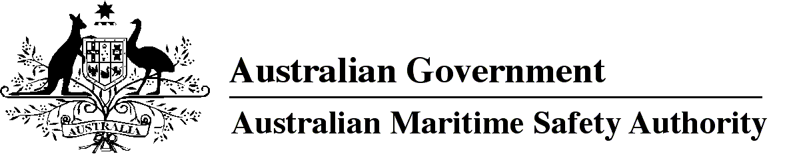

AMSA MO 2018/6

Marine Order 501 (Administration — national law) Amendment Order 2018

I, Gary Prosser, Acting Chief Executive Officer of the Australian Maritime Safety Authority (the National Marine Safety Regulator under section 9 of the *Marine Safety (Domestic Commercial Vessel) National Law*), make this Order under subsection 163(1) of the *Marine Safety (Domestic Commercial Vessel) National Law.*

7 June 2018

Gary Prosser  
Acting Chief Executive Officer

1 Name of Order

This Order is *Marine Order 501 (Administration — national law) Amendment Order 2018*.

2 Commencement

This Order commences on 1 July 2018.

3 Amendment of *Marine Order 501 (Administration — national law) 2013*

Schedule 1 amends *Marine Order 501 (Administration — national law) 2013*.

Schedule 1 Amendment

[1] Section 5

omit

[2] Section 6, provision unit and heading

substitute

5 Criteria for *fit and proper person*

[3] Section 6A

substitute

6 Standards

For subsection 159(2) of the national law, the following standards are prescribed:

(a) National Law – Marine Surveyors Accreditation Guidance Manual 2014;

(b) NSCV Parts B, C, D, F and G;

(c) USL Code.

[4] Section 7, definition of *NSAMS*

substitute

***National Law – Marine Surveyors Accreditation Guidance Manual 2014*** means the National Law – Marine Surveyors Accreditation Guidance Manual 2014 that is published by AMSA*.*

[5] Subsection 8(1), note

substitute

*Note*A Marine Order may require compliance with provisions of a prescribed standard. The National Law – Marine Surveyors Accreditation Guidance Manual 2014, USL Code and NSCV Parts B, C, D, F and G are prescribed standards — see section 6.

[6] Subparagraphs 9(a)(iv) and (v)

substitute

(iv) be accompanied by any prescribed fee charged by the National Regulator for assessing the application.

[7] Section 9, note 1

substitute

*Note 1*For the prescribed fees that may be charged by the National Regulator — see the *Marine Safety (Domestic Commercial Vessel) National Law Regulation 2013.*

[8] Schedule 1, Division 2

substitute

Division 2 Marine orders

| Item | Marine order and section | Description | Penalty units — individual | Penalty units — body corporate |
| --- | --- | --- | --- | --- |
| 1 | *Marine Order 502 (Vessel identifiers — national law) 2017*, s 6(1) | Fail to tell National Regulator of transfer of ownership | 10 | 50 |
| 2 | *Marine Order 502 (Vessel identifiers — national law) 2017*, s 6(1) | Fail to tell National Regulator when vessel is withdrawn, sunk or scrapped | 10 | 50 |
| 3 | *Marine Order 507 (Load line certificates — national law) 2018*, s 13(1) | Breach condition of certificate (master) | 10 | 50 |
| 4 | *Marine Order 507 (Load line certificates — national law) 2018*, s 14(1) | Breach condition of certificate (owner) | 10 | 50 |
| 5 | *Marine Order 507 (Load line certificates — national law) 2018*, s 15(1) | Operating vessel without certificate, without displaying load lines or marks, or if load lines are marks are submerged (master) | 10 | 50 |
| 6 | *Marine Order 507 (Load line certificates — national law) 2018,* s 16(1) | Operating vessel without certificate, without displaying load lines or marks, or if load lines are marks are submerged (owner) | 10 | 50 |

**Note**

1. All legislative instruments and compilations of legislative instruments are registered on the Federal Register of Legislation under the *Legislation Act 2003.* See https://www.legislation.gov.au.