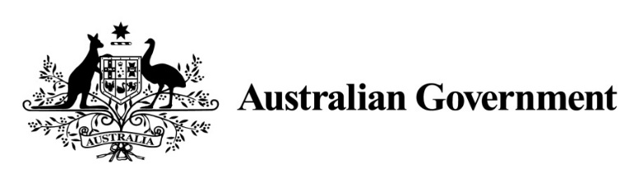

National Land Transport Act 2014

VARIATION OF THE ROADS TO RECOVERY LIST 2014

Instrument No. 2018/1
I, SARAH LEEMING, General Manager, South East Infrastructure Investment, Department of Infrastructure, Regional Development and Cities, under section 88(2A) of the National Land Transport Act 2014, vary the Roads to Recovery List 2014 which was made by the Minister on 12 September 2014, and amended by Instrument No. 2015/1 made on 24 March 2015, Instrument No. 2015/2 made on 2 April 2015, Instrument No. 2015/3 made on 12 August 2015, Instrument No. 2016/1 made on 12 July 2016, Instrument No. 2016/2 made on 31 August 2016, Instrument No. 2016/3 made on 14 October 2016, Instrument No. 2017/1 made on 20 March 2017, Instrument No. 2017/2 made on 31 May 2017 and Instrument No. 2017/3 made on 1 September 2017 as follows:

- Name of variation
This variation instrument is the Roads to Recovery List 2014 Variation Instrument No. 2018/1.

- Variation
(a) In Schedule 1 of the List, in the part relating to South Australia:
omit the name specified in Column 1 of Schedule 1 for the funding recipient name ‘District Council of Barunga West’ and replace the omitted name with ‘Barunga West Council’.

- Commencement
This instrument commences on 1 August 2018.

Dated: 6 July 2018

Signed 6 July 2018

SARAH LEEMING
General Manager
South East Infrastructure Investment
Infrastructure Investment Division
Department of Infrastructure, Regional Development and Cities

