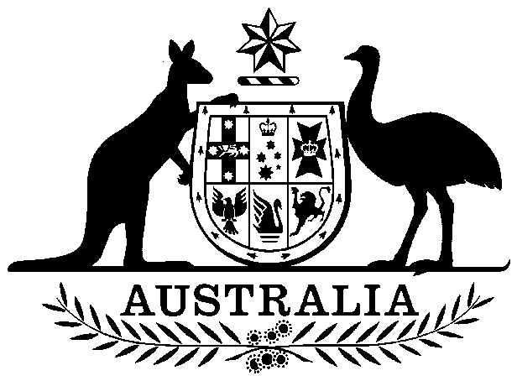

**COMMONWEALTH OF AUSTRALIA**

##### *Environment Protection and Biodiversity Conservation Act 1999*

**Amendment of List of Exempt Native Specimens – NT Demersal and NT Timor Reef fisheries, July 2018**

I, PAUL MURPHY, Assistant Secretary, Wildlife Trade and Biosecurity Branch, as Delegate of the Minister for the Environment and Energy, pursuant to subsection303DC(1)(a) of the *Environment Protection and Biodiversity Conservation Act 1999* (EPBC Act), hereby amend the list of exempt native specimens established under section 303DB of the EPBC Act by **deleting** from the list specimens and any associated restrictions or conditions as set out in **Schedule 1**, and by **including** in the list specimens and associated restrictions or conditions as set out in **Schedule 2**.

This instrument is a legislative instrument for the purposes of the *Legislation Act 2003*.

The instrument commences the day after it is registered.

All state and territory legislation referred to in Schedule 2 to the instrument is incorporated as in force at the time this instrument commences.

# Dated this 2nd day of July 2018

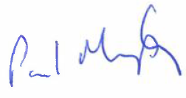

Delegate of the Minister for the Environment and Energy

**SCHEDULE 1**

Under the heading Freshwater and Marine Animals delete from the list the following items and any associated notations:

|  |  |  |  |
| --- | --- | --- | --- |
| **Taxon/Item** | | **Common Name** | **Notation** |
| Specimens that are or are derived from fish or invertebrates taken in the Northern Territory Demersal Fishery as defined in the management regime in force under the Fisheries Act 1988 (NT) and the Fisheries Regulations 1993 (NT), but not including:   1. specimens that belong to eligible listed threatened species, as define under section 303BC of the EPBC Act, or 2. specimens that belong to taxa listed under section 303CA of the EPBC Act (Australia’s CITES List). | Northern Territory Demersal Fishery | | The specimen, or the fish or invertebrate from which it is derived, was taken lawfully, and  The specimens are included in the list until 9 August 2018. |
| Specimens that are or are derived from fish or invertebrates, other than specimens that belong to species listed under Part 13 of the EPBC Act, taken in the Northern Territory Timor Reef  Fishery, as defined in the management regime in force under the Northern Territory *Fisheries Act 1988* and Northern TerritoryFisheries Regulations 1993. | | Northern Territory Timor Reef Fishery | The specimen, or the fish or invertebrate from which it is derived, was taken lawfully, and  The specimens are included in the list until 9 August 2018. |

**SCHEDULE 2**

Under the heading Freshwater and Marine Animals include in the list the following items and associated notations:

|  |  |  |  |
| --- | --- | --- | --- |
| **Taxon/Item** | | **Common Name** | **Notation** |
| Specimens that are or are derived from fish or invertebrates taken in the Northern Territory Demersal Fishery as defined in the management regime in force under the *Fisheries Act 1988* (NT) and the Fisheries Regulations 1993 (NT), but not including:   1. specimens that belong to eligible listed threatened species, as define under section 303BC of the EPBC Act, or 2. specimens that belong to taxa listed under section 303CA of the EPBC Act (Australia’s CITES List). | Northern Territory Demersal Fishery | | The specimen, or the fish or invertebrate from which it is derived, was taken lawfully, and  The specimens are included in the list until 29 March 2019. |
| Specimens that are or are derived from fish or invertebrates taken in the Northern Territory Timor Reef Fishery as defined in the management regime in force under the *Fisheries Act 1988* (NT) and the Fisheries Regulations 1993 (NT), but not including:   1. specimens that belong to eligible listed threatened species, as define under section 303BC of the EPBC Act, or 2. specimens that belong to taxa listed under section 303CA of the EPBC Act (Australia’s CITES List). | | Northern Territory Timor Reef Fishery | The specimen, or the fish or invertebrate from which it is derived, was taken lawfully, and  The specimens are included in the list until 29 March 2019. |