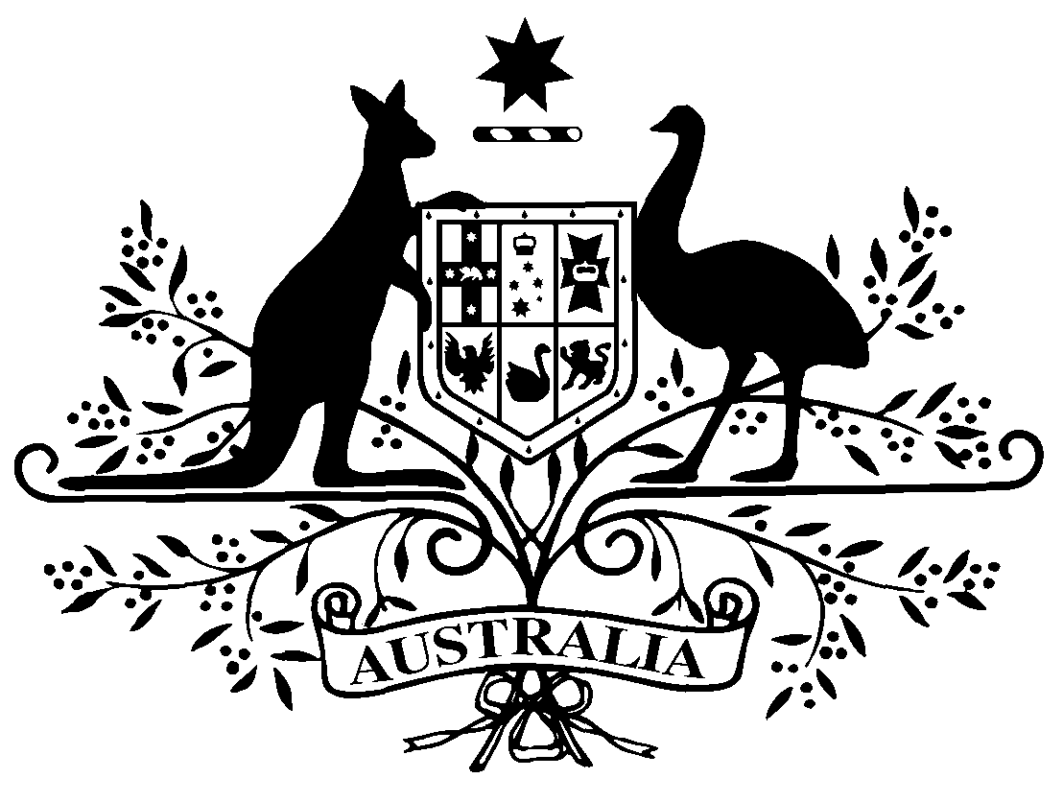

PB 72 of 2018
National Health (Pharmaceutical Benefits Scheme- Exempt items - Section 84AH) Amendment Determination 2018 (No. 3)
National Health Act 1953
I, LISA LA RANCE, Assistant Secretary, Pricing and PBS Policy Branch, Technology Assessment and Access Division, Department of Health, delegate of the Minister for Health, make this Determination under section 84AH of the National Health Act 1953.
Dated 27 July 2018

LISA LA RANCE

Assistant Secretary
Pricing and PBS Policy Branch
Technology Assessment and Access Division
Department of Health

1 Name of Instrument
- This instrument is the National Health (Pharmaceutical Benefits Scheme-Exempt items - Section 84AH) Amendment Determination 2018 (No. 3).
- This instrument may also be cited as PB 72 of 2018.
2 Commencement
This instrument commences on 1 August 2018.
3 Amendments to PB 81 of 2017
Schedule 1 amends the legislative instrument titled National Health (Pharmaceutical Benefits Scheme – Exempt items – Section 84AH) Determination 2017 (PB 81 of 2017) (as amended)
Schedule 1 Amendments

- Schedule 1, after entry for Clonazepam, Injection 1 mg in 2 mL (set containing solution 1 mg in 1 mL and 1 mL diluent)
Omit:

Clozapine | Oral liquid 50 mg per mL, 100 mL | Oral

- Schedule 1, after entry for Indometacin, Suppository 100 mg
Omit:

Levodopa with Carbidopa | Tablet 200 mg-50 mg (anhydrous) (modified release) | Oral
Mercaptopurine | Oral suspension 20 mg per mL, 100 mL | Oral
Insert:

Levodopa with carbidopa | Tablet (modified release) 200 mg-50 mg (as monohydrate) | Oral
Mercaptopurine | Oral suspension containing mercaptopurine monohydrate 20 mg per mL, 100 mL | Oral

