EXPLANATORY STATEMENT
Issued by the Authority of the Minister for Indigenous Affairs
Aboriginal Land Grant (Jervis Bay Territory) Act 1986
Aboriginal Land Grant (Jervis Bay Territory) (Aboriginal Land) Declaration 2018
Purpose
- This instrument declares Block 151, Deposited Plan 9271, and Block 152, Deposited Plan 9271 in the Jervis Bay Territory (JBT) is Aboriginal Land. Both blocks are in the Jervis Bay Village.
Background
- The Aboriginal Land Grant (Jervis Bay Territory) Act 1986 (ALG(JBT) Act) provides for the grant of inalienable freehold title to a portion of the JBT to the Wreck Bay Aboriginal Community Council (WBACC)

- Part III of the ALG(JBT) Act provides for an initial grant and later grants of Aboriginal Land within the JBT to the WBACC (sections 8, 9 and 9A of the ALG(JBT) Act). Aboriginal Land is land that is Aboriginal Land because of a declaration under Part III of the ALG(JBT) Act (see the definition of Aboriginal Land in subsection 2(1) of the ALG(JBT) Act).

- Where land becomes Aboriginal Land, all rights, title and interests to that land is vested in the WBACC (section 10 of the ALG(JBT Act)). Where land vests in the WBACC, all buildings and improvements in that land vest also vest in the WBACC (section 12 of the ALG(JBT) Act), unless the Commonwealth continues to its use of those buildings or amenities (section 13 of the ALG(JBT) Act).

- The WBACC holds title to Aboriginal Land in the JBT for the benefit of members of the Wreck Bay Aboriginal Community (see paragraphs 6(a) and (b) of the ALG(JBT) Act).

- Approximately 92 per cent of the land in the JBT has been granted to the WBACC under the ALG(JBT) Act.
Regulatory Impact Statement
- The Office of Best Practice Regulation has advised that a Regulatory Impact Statement is not required for this instrument (OBPR reference: 24160).
Consultation
- The WBACC was consulted on the declaration of land under the ALG(JBT) Act. The following Commonwealth departments were also consulted: Department of Defence; Department of Finance; Department of Infrastructure, Regional Development and Cities; Department of the Environment and Energy.
Statement of Compatibility with Human Rights
- The statement of compatibility with human rights for this instrument appears at the end of this explanatory statement.

Aboriginal Land Grant (Jervis Bay Territory) (Aboriginal Land) Declaration 2018
Explanation of provisions
Clause 1 – Name
- Clause 1 sets out the name of the instrument, being the Aboriginal Land Grant (Jervis Bay Territory) (Aboriginal Land) Declaration 2018.
Clause 2 – Commencement
- Clause 2 provides that the instrument commences in accordance with subsection 9(5) of the ALG(JBT) Act. Subsection 9(5) of the ALG(JBT) Act provides that the instrument takes effect on the day immediately following the last day upon which a resolution disallowing the instrument could have been passed.
- The instrument may be disallowed in accordance with sections 42 to 48 of the Legislation Act 2003. Under subsection 57(2) of the Legislation Act 2003, sections 42 to 48 of the Legislation Act 2003 displace the disallowance provisions in subsections 9(3) and (4) of the ALG(JBT) Act.
Clause 3 – Authority
- Clause 3 specifies that the instrument is made under the authority of subsection 9(1) of the ALG(JBT) Act.
- Subsection 9(1) of the ALG(JBT) Act provides that the Minister may make later grants of Aboriginal Land to the WBACC by declaration if the Minister becomes satisfied that:
  - The land is ‘vacant Crown land’ that ‘adjoins’ Aboriginal Land and is of ‘significance’ to the members of the WBACC
  - It would be appropriate to grant the land to the WBACC.
- Blocks 151 and 152 are unalienated Crown land of the Commonwealth. Block 151 adjoins Aboriginal Land Block 122, Deposited Plan 9350 in the JBT (Booderee National Park (East)). Block 152 adjoins Aboriginal Land Block 121, Deposited Plan 9351 in the JBT (Booderee National Park (West)). Blocks 121 and 122 were declared Aboriginal Land in the Declaration of Aboriginal Land dated 11 October 1995 made under subsection 9A(1) of the ALG(JBT) Act. These blocks subsequently vested in the WBACC under section 10 of the ALG(JBT) Act.
- The Minister relies on the report of Dr James F Weiner on the Aboriginal Significance of Land in the Jervis Bay Territory (August 2002) and consultations with the WBACC to satisfy himself Blocks 151 and 152 are of significance to members of the WBACC.
- The Minister relies on consultations with the WBACC and Commonwealth departments, and advice from his department, to satisfy himself that it is appropriate to grant Blocks 151 and 152 to the WBACC.
Clause 4 – Definitions
- Clause 4 defines key terms contained in the instrument. It explains that the term ‘Aboriginal Land’ used in the instrument is defined in section 2 of the ALG(JBT) Act.
Clause 5 – Declaration of Aboriginal Land
- Clause 5 declares land described in Schedule 1 is Aboriginal Land.
- The note to clause 5 explains that for paragraph 9(1)(a) of the ALG(JBT) Act, the land described in Schedule 1 is vacant Crown land in the JBT that adjoins Aboriginal Land.

Schedule 1 – Description of land in the Jervis Bay Territory
- Schedule 1 of the instrument describes the land in the JBT that is declared is Aboriginal Land under subsection 9(1) of the ALG(JBT) Act:
  - Item 1 of the table describes the land in the JBT that is known as Block 151, Deposited Plan 9271, and has an area of 1.786 hectares.
  - Item 2 of the table describes the land in the JBT that is known as Block 152, Deposited Plan 9271, and has an area of 28.260 hectares.
- This land is depicted on the following map:
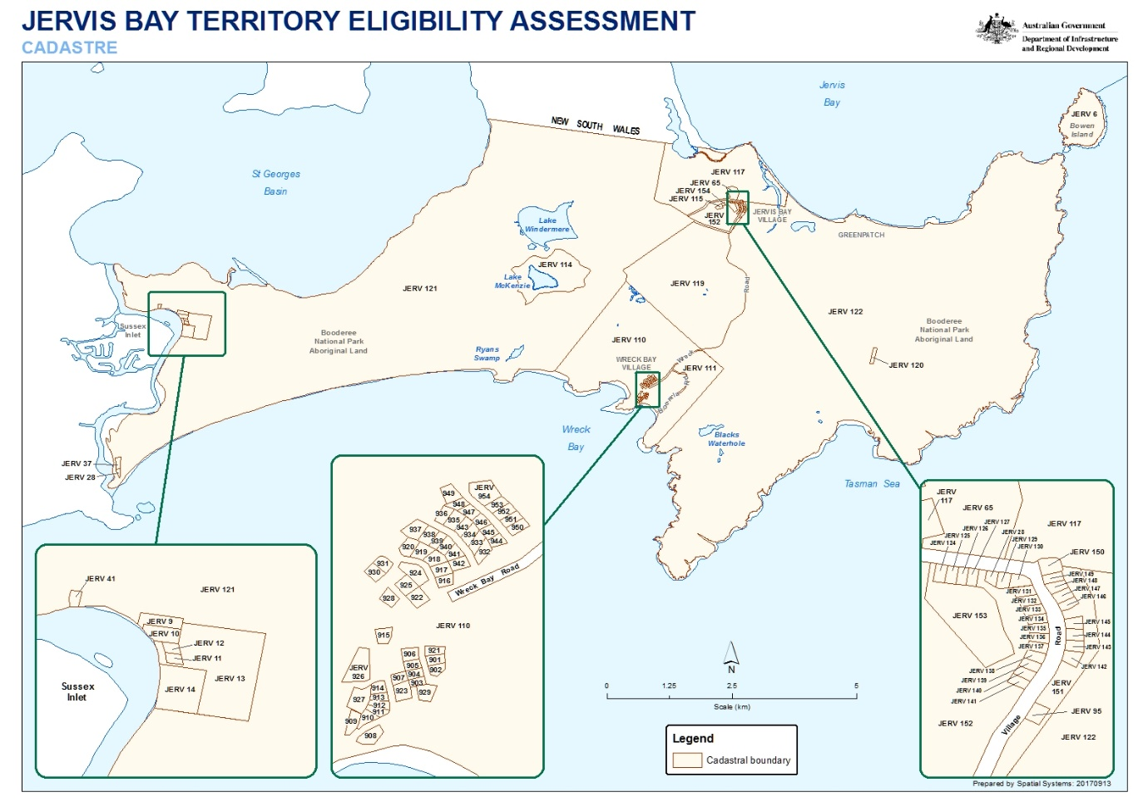
Statement of Compatibility with Human Rights
Prepared in accordance with Part 3 of the Human Rights (Parliamentary Scrutiny) Act 2011
Aboriginal Land Grant (Jervis Bay Territory) (Aboriginal Land) Declaration 2018
- The Aboriginal Land Grant (Jervis Bay Territory) (Aboriginal Land) Declaration 2018 is compatible with the human rights and freedoms recognised or declared in the international instruments listed in section 3 of the Human Rights (Parliamentary Scrutiny) Act 2011.
Overview of the Legislative Instrument
- This instrument declares Block 151, Deposited Plan 9271, and Block 152, Deposited Plan 9271 in the Jervis Bay Territory (JBT) is Aboriginal Land. Both blocks are in the Jervis Bay Village.
Human rights implications
- This instrument is administrative in nature. If it commences, the instrument triggers the vesting of declared land in the Wreck Bay Aboriginal Community Council (WBACC) under section 10 of the Aboriginal Land Grant (Jervis Bay Territory) Act 1986 (ALG(JBT) Act). The instrument does not commence until the disallowance period expires (subsection 9(5) of the ALG(JBT) Act).
- On its commencement, the instrument will trigger the promotion of the right to self-determination, and the right to enjoy and benefit from culture, and will trigger the engagement of rights to equality and non-discrimination.
Right to self-determination
- The right to self-determination is contained in article 1 of the International Covenant on Civil and Political Rights (ICCPR) and article 1 of the International Covenant on Economic, Social and Cultural Rights (ICESCR). The right is also contained in Article 3 of the UN Declaration on the Rights of Indigenous Peoples (UNDRIP). UNDRIP does not create legally binding obligations, but informs the way governments engage with and protect the rights of Indigenous people.
- The UN Committee on the Elimination of Racial Discrimination has stated that the right to self-determination involves 'the rights of all peoples to pursue freely their economic, social and cultural development without outside interference.' The right is understood widely to be exercisable in a manner that preserves territorial integrity, political unity and sovereignty of a country.
- If the land described in the instrument vests in the WBACC, members of the Wreck Bay Aboriginal Community will gain responsibility for managing the land, and facilitate the aim of the community to become self-sufficient and able to freely determine its future and lifestyle by protecting its interests and values within the parameters set by the ALG(JBT) Act.
Right to enjoy and benefit from culture
- The right to enjoy and benefit from culture is contained in article 27 of the ICCPR and article 15 of the ICESCR.
- Article 27 of the ICCPR protects the rights of individuals belonging to ethnic, religious and linguistic minorities in a country to enjoy their own culture, practice their own religion and use their own language. The UN Human Rights Committee has noted that one or other aspect of the rights of individuals protected under article 27 may consist in a way of life that is closely associated with territory (land and water) and use of its resources. The Committee has also stated that ‘the enjoyment of those rights may require positive legal measures of protection and measures to ensure the effective participation of members of minority communities in decisions which affect them.’
- Article 15 of the ISESCR protects the right of all persons to take part in cultural life and to enjoy the benefits of scientific progress and its applications. The UN Committee on Economic Social and Cultural Rights has interpreted this right to include a right to traditional land, territories and resources, as it relates to Indigenous Peoples.
- If the land described in the instrument vests in the WBACC, the grant of Aboriginal Land will enhance the ability of the members of the Wreck Bay Aboriginal Community to practice their own culture in respect of the land, and preserve for future generations its unique identity, heritage and culture.
Rights of equality and non-discrimination
- The rights of equality and non-discrimination are contained in articles 2, 16 and 26 of the ICCPR, article 2 of the ICESCR and article 5 of the Convention on the Elimination of All Forms of Racial Discrimination (CERD). These rights recognise that all human beings have the right to be treated equally and to not be discriminated against.
- Of particular relevance in the context of the instrument and the ALG(JBT) Act, CERD establishes a general prohibition on racial discrimination. The Racial Discrimination Act 1975 implements this prohibition in Australian domestic law.
- In providing for the grant of inalienable freehold title to the WBACC to hold for the benefit of members of the Wreck Bay Aboriginal Community, the ALG(JBT) Act makes a clear distinction based on race. This arrangement means persons other than Aboriginal persons cannot obtain freehold title to land under the ALG(JBT) Act.
- The instrument only itself discriminates on the basis of race to the extent it triggers, on its commencement, the vesting of land in the WBACC. To that extent, the declaration may be characterized as a component of a broader ‘special measure’, being the ALG(JBT) Act. ‘Special measures’ are provided for in article 1(4) of the CERD and subsection 8(1) of the Racial Discrimination Act 1975. They are an exception to the general prohibition on racial discrimination, and are designed to ‘secure to disadvantaged groups the full and equal enjoyment of human rights and fundamental freedoms.’ For a measure to be characterised as a ‘special measure’ it must:
- be for a particular group or individuals;
- be taken for the sole purpose of securing the adequate advancement of that group or those individuals;
- be ‘necessary’; and
- not continue after its objectives have been achieved.
- The ALG(JBT) Act is enacted for the members of the WBACC, being Aboriginal persons in the Wreck Bay Aboriginal Community. The ALG(JBT) Act is for the sole purpose of conveying freehold title to land to the WBACC to hold for the benefit of members of the Wreck Bay Aboriginal Community. The ongoing need for this arrangement is evident in the continuing levels of disadvantage confronting Aboriginal persons compared to other Australians, including in relation to economic self-sufficiency, positive cultural identity and social and emotional well-being. The ALG(JBT) Act remains necessary to facilitate the return of land to Aboriginal persons to assist address this continuing disadvantage.
- The mechanisms in the ALG(JBT) Act, including the instrument, are appropriate, adapted and proportionate, as they facilitate the return of land to control of Aboriginal persons with minimal impact on the broader community. Only land that is vacant Crown land can be granted under the ALG(JBT) Act, meaning the grant of Aboriginal Land under the ALG(JBT) Act can have no impact on the property rights of other persons.
- The ALG(JBT) Act, and the instrument, may also be regarded as legitimate differential treatment. The principle of legitimate differential treatment allows countries to treat particular groups differently, provided particular criteria are met. The justification for differentiation must be reasonable and objective. There must also be a clear and reasonable relationship of proportionality between the aim sought and the measure and its effects.
- The rationale for the ALG(JBT) Act is to establish an institutional arrangement to return land to Aboriginal persons. This role is proportionate to the aim of addressing historical dispossession and promoting self-management and self-sufficiency, with minimal impact on other persons.
Conclusion
- The instrument is compatible with human rights because if it commences, it will:
  - facilitate promotion of the right to self-determination and the right to enjoy and benefit from culture; and
  - trigger engagement of rights to equality and non-discrimination under a scheme that may be characterized as a special measure and as legitimate differential treatment.

CERD, General Recommendation 21, The right to self-determination (Forty-eighth session, 1996), UN Doc A/51/18, annex VIII (1996), [125]
HRC, General Comment 23, Article 27, UN Doc CCPR/C/21/Rev.1/Add.5 (8 April 1994), [3.2].
Ibid, [7]
ICESCR, General Comment 21, Right of everyone to take part in cultural life (art 15, para 1a), UN Doc E/C.12/GC/21 (21 December 2009, [36].
CESCR, General Comment No 20, Non-discrimination in economic, social and cultural rights (art 2, para 2), UN Doc E/C.12/GC/20, 2 July 2009, [13].

