Food Standards (Application A1137 – Polysorbate 20 as a Food Additive) Variation

The Board of Food Standards Australia New Zealand gives notice of the making of this variation under section 92 of the Food Standards Australia New Zealand Act 1991. The variation commences on the date specified in clause 3 of the variation.

Dated 19 November 2018

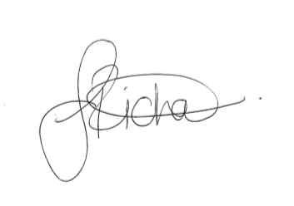
Standards Management Officer
Delegate of the Board of Food Standards Australia New Zealand

Note:

This variation will be published in the Commonwealth of Australia Gazette No. FSC 123 on 29 November 2018. This means that this date is the gazettal date for the purposes of the above notice.

1 Name
This instrument is the Food Standards (Application A1137 – Polysorbate 20 as a Food Additive) Variation.
2 Variation to a Standard in the Australia New Zealand Food Standards Code
The Schedule varies a standard in the Australia New Zealand Food Standards Code.
3 Commencement
The variation commences on the date of gazettal.
Schedule
[1] Schedule 8 is varied by

[1.1] omitting the following from the table to section S8—2,

Polyoxyethylene (40) stearate | 431
substituting

Polyoxyethylene (40) stearate | 431
Polysorbate 20 or Polyoxyethylene (20) sorbitan monolaurate | 432

[1.2] omitting the following from the table to section S8—2,

431 | Polyoxyethylene (40) stearate
substituting
431 | Polyoxyethylene (40) stearate
432 | Polysorbate 20 or Polyoxyethylene (20) sorbitan monolaurate

[2] Schedule 15 is varied by

[2.1] omitting the following from item 8.2 of the table to section S15—5,

280 281 282 283 | Propionic acid and sodium and potassium and calcium propionates | GMP
substituting

280 281 282 283 | Propionic acid and sodium and potassium and calcium propionates | GMP
432 | Polyoxyethylene (20) sorbitan monolaurate | 500

[2.2] omitting the following from item 8.3 of the table to section S15—5,

280 281 282 283 | Propionic acid and sodium and potassium and calcium propionates | GMP
substituting
280 281 282 283 | Propionic acid and sodium and potassium and calcium propionates | GMP
432 | Polyoxyethylene (20) sorbitan monolaurate | 500

[2.3] omitting the following from item 9.2 of the table to section S15—5,

Colourings permitted to a maximum level

substituting

 | Colourings permitted to a maximum level
432 | Polyoxyethylene (20) sorbitan monolaurate | 500

