|  |  |
| --- | --- |
| AASB Standard | AASB 2018-5  October 2018 |

Amendments to Australian Accounting Standards – Deferral of AASB 1059

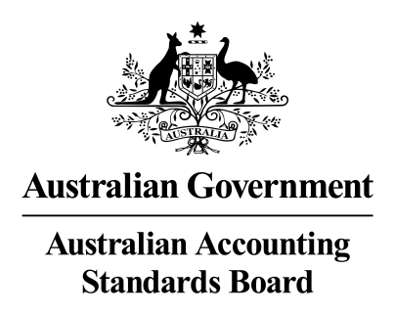

# Obtaining a copy of this Accounting Standard

This Standard is available on the AASB website: www.aasb.gov.au.

Australian Accounting Standards Board

PO Box 204

Collins Street West

Victoria 8007

AUSTRALIA

Phone: (03) 9617 7600

E-mail: standard@aasb.gov.au

Website: www.aasb.gov.au

# Other enquiries

Phone: (03) 9617 7600

E-mail: standard@aasb.gov.au

COPYRIGHT

© Commonwealth of Australia 2018

This work is copyright. Apart from any use as permitted under the *Copyright Act 1968*, no part may be reproduced by any process without prior written permission. Requests and enquiries concerning reproduction and rights should be addressed to The National Director, Australian Accounting Standards Board, PO Box 204, Collins Street West, Victoria 8007.

ISSN 1036-4803

# Contents

PREFACE

ACCOUNTING STANDARD

AASB 2018-5 *AMENDMENTS TO AUSTRALIAN ACCOUNTING STANDARDS – DEFERRAL OF AASB 1059*

from paragraph

**OBJECTIVE 1**

**APPLICATION 2**

**AMENDMENTS TO AASB 1059 4**

**COMMENCEMENT OF THE LEGISLATIVE INSTRUMENT** **5**

Australian Accounting Standard AASB 2018-5 *Amendments to Australian Accounting Standards – Deferral of AASB 1059* is set out in paragraphs 1 – 5. All the paragraphs have equal authority.

# Preface

## Standards amended by AASB 2018-5

This Standard makes amendments to AASB 1059 *Service Concession Arrangements: Grantors* (July 2017).

AASB 1059 applies to public sector entities that are grantors of service concession arrangements. The Board considered comments from stakeholders preparing for the implementation of AASB 1059, some of whom requested a deferral of the mandatory effective date. The Board noted the issues raised and decided to defer the effective date to assist stakeholders with their implementation efforts.

## Main features of this Standard

Main requirements

This Standard amends the mandatory effective date (application date) of AASB 1059 so that AASB 1059 is required to be applied for annual reporting periods beginning on or after 1 January 2020 instead of 1 January 2019. Therefore, this Standard also defers the consequential amendments to other pronouncements set out in AASB 1059 (Appendix D).

Application date

This Standard applies to annual periods beginning on or after 1 January 2019, which was the original mandatory effective date of AASB 1059.

# Accounting Standard AASB 2018-5

The Australian Accounting Standards Board makes Accounting Standard AASB 2018-5 *Amendments to Australian Accounting Standards – Deferral of AASB 1059*under section 334 of the *Corporations Act 2001*.

|  |  |
| --- | --- |
|  | Kris Peach |
| Dated 31 October 2018 | Chair – AASB |

# Accounting Standard AASB 2018-5

Amendments to Australian Accounting Standards – Deferral of AASB 1059

## Objective

1. This Standard amends AASB 1059 *Service Concession Arrangements: Grantors* (July 2017) in order to defer its effective date. This also defers the consequential amendments to other pronouncements set out in Appendix D of AASB 1059.

## Application

The amendments set out in this Standard apply to entities and financial statements in accordance with the application of AASB 1059 set out in AASB 1057 *Application of Australian Accounting Standards* (as amended).

This Standard applies to annual periods beginning on or after 1 January 2019.

## Amendments to AASB 1059

1. Paragraph C1 is amended as follows (new text is underlined and deleted text is struck through):

C1 An entity shall apply this Standard for annual reporting periods beginning on or after 1 January ~~2019~~ 2020. Earlier application is permitted for periods beginning before 1 January ~~2019~~ 2020. If an entity applies this Standard for an earlier period, it shall disclose that fact.

## Commencement of the legislative instrument

For legal purposes, this legislative instrument commences on 31 December 2018.