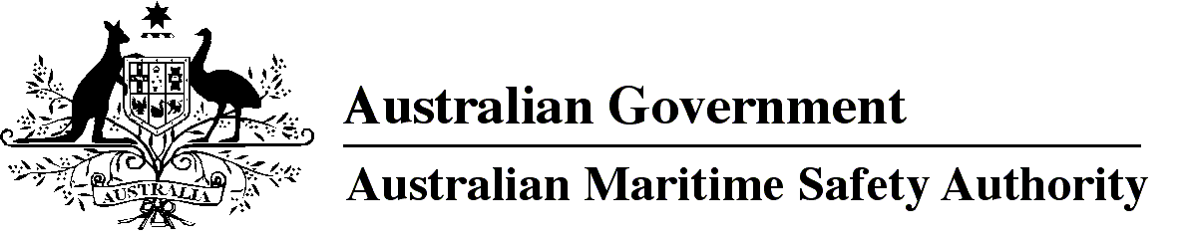

AMSA MO 2018/11

Marine Order 503 (Certificates of survey — national law) Amendment Order 2018

I, Gary Prosser, Acting Chief Executive Officer of the Australian Maritime Safety Authority, (the National Marine Safety Regulator under section 9 of the *Marine Safety (Domestic Commercial Vessel) National Law*), make this Order under subsection 163(1) of the *Marine Safety (Domestic Commercial Vessel) National Law*.

30 November 2018

Gary Prosser  
Acting Chief Executive Officer

1 Name of Order

This Order is *Marine Order 503 (Certificates of survey — national law) Amendment Order 2018*.

2 Commencement

This Order commences on 1 January 2019.

3 Amendment of *Marine Order 503 (Certificates of survey — national law) 2018*

Schedule 1 amends *Marine Order 503 (Certificates of survey — national law) 2018.*

Schedule 1 Amendment

[1] Subsection 7(2)

substitute

(2) For an existing vessel — the standards are:

(a) for arrangement, accommodation and personal safety, watertight and weathertight integrity, construction, fire safety, engineering, stability, equipment (other than the equipment mentioned in paragraph (b) or (c)) and associated systems:

(i) if the vessel operated before 1 July 2013 — the standards that applied to the vessel on 30 June 2013; and

(ii) if the vessel did not operate before 1 July 2013 — the standards that applied to the vessel when design approval was approved; and

(b) for a Class 4 vessel — the standards for safety equipment that apply to the vessel in accordance with the NSCV Part F2; and

(c) for a Class 1, 2 or 3 vessel — the standards for safety equipment and the EPIRB requirements that apply to the vessel in accordance with NSCV Parts C and F.

*Note for paragraph (a)*   Associated systems include fuel, bilge, exhaust and ventilation systems.

*Note for paragraph (b)*   NSCV Part F2 applies to vessels that are Class 4. In NSCV Part F2, the term ‘safety equipment’ means appliances for saving or protecting life, including communications equipment (including EPIRB requirements), navigation equipment, fire equipment and anchoring systems.

*Note for paragraph (c)*   NSCV Part C applies to vessels that are Class 1, 2 or 3. NSCV Part F1 applies to vessels that are fast craft. In NSCV Parts C7 and F1, the term ‘safety equipment’ does not include communication, navigation or anchoring equipment.

*Note*The NSCV provides that, from 1 January 2021, certain kinds of vessels must carry a class 2 EPIRB fitted in a category 1 bracket. The EPIRB also needs to be registered with AMSA.

[2] Subsection 7(5)

substitute

(5) However, for a new vessel, the standards (other than the standards for the equipment mentioned in paragraph 7(2)(b) and paragraph 7(2)(c)) are those standards that applied to the vessel when it was first issued a certificate of survey or other approval to operate unless:

(a) a change mentioned in Schedule 1 has occurred; or

(b) the vessel has not had a certificate of survey or other approval to operate in force for at least 2 years.

*Note 1*For arrangement, accommodation and personal safety, watertight and weathertight integrity, construction, fire safety, engineering, stability, equipment (other than the equipment mentioned in paragraph 7(2)(b) and paragraph 7(2)(c), being safety equipment and EPIRB requirements) and associated systems, the standards for a new vessel are those standards that applied to the vessel when it was first issued a certificate of survey unless a circumstance in paragraph (a) or (b) has occurred. For safety equipment and EPIRB requirements, the standards are the standards mentioned in subsection 7(3), as existing from time to time.

*Note 2*The NSCV provides that, from 1 January 2021, certain kinds of vessels must carry a class 2 EPIRB fitted in a category 1 bracket. The EPIRB also needs to be registered with AMSA.

[3] Subsection 21(1), after definition of *being constructed*

insert

***category 1 bracket*** means a bracket for a class 2 EPIRB that is designed to automatically deploy the EPIRB when submerged at depth.

***class 2 EPIRB*** means an EPIRB that has a manual and water activation switch.

[4] Subsection 21(1), after definition of *EIAPP*

insert

***EPIRB*** means emergency position indicating radio beacon*.*

**Note**

1. All legislative instruments and compilations of legislative instruments are registered on the Federal Register of Legislation under the *Legislation Act 2003.* See https://www.legislation.gov.au.