EXPLANATORY STATEMENT
Issued by the authority of the Minister for Industry, Science and Technology
Trans-Tasman Mutual Recognition Act 1997
Trans-Tasman Mutual Recognition Amendment (NSW Container Deposit Scheme) Regulations 2018
Purpose and Operation
The Trans-Tasman Mutual Recognition Act 1997 (the Act) gives effect to the mutual recognition principles adopted by the Commonwealth, State and Territory Governments of Australia and the Government of New Zealand relating to the sale of goods and the registration of occupations. By way of example, with respect to goods, the mutual recognition principles apply such that a good that can be sold legally in New Zealand may be imported and sold legally in New South Wales (NSW) despite the regulatory standards that would otherwise apply to the good in NSW.
The Act overrides any laws that regulate the manufacture or sale of goods in the jurisdiction of sale where the requirements of the jurisdiction of origin are met. The Act does provide, however, for circumstances where the mutual recognition principle will not apply. These circumstances are covered by exceptions to the principle, as well as provisions for permanent and temporary exemptions.
The Trans-Tasman Mutual Recognition Amendment (NSW Container Deposit Scheme) Regulations 2018 allow for the permanent exemption of the NSW laws regarding the Container deposit scheme from the operation of the Act.
Under the NSW Container Deposit Scheme legislation, an approval to supply beverage containers in NSW requires the container to bear the approved refund marking and an effective waste management arrangement is in place for the container. A waste management arrangement for approved containers is an arrangement made by participants in the scheme for the collection, sorting and aggregation of the containers and their reuse, recycling or other appropriate disposal. Under the scheme, empty containers bearing the approved refund marking can be delivered to an approved collection depot for the consumer to receive a 10¢ refund per container.
As provided for under section 47 of the Act, NSW invoked a continuation of temporary exemption for their container deposit scheme for a period of 12 months from 16 November 2017. A continuation of a temporary exemption can only operate for a maximum period of 12 months under the Act and, as such, a permanent exemption is required to continue the operation of the container deposit scheme.
The Regulations amend Schedule 2 of the Act, which lists laws relating to goods that are permanently exempt from the operation of the Act. This means that containers that are imported into NSW from New Zealand will have to comply with the NSW Container Deposit Scheme legislation. The following are permanently exempted from the operation of the Act:

(a) Part 5 of the Waste Avoidance and Resource Recovery Act 2001 (NSW);
(b) all other provisions of that Act, to the extent that they relate to the container deposit scheme established by that Part;
(c) instruments made under that Act, to the extent that they relate to that scheme.

Subsection 45(1) of the Act, which relates to permanent exemptions, sets out that Part 2 of the Act (Goods) does not affect the operation of laws described in Schedule 2 (that is, the laws listed in Schedule 2 are not subject to the mutual recognition principle).
Authority
Subsection 45(3) of the Act provides that the Governor-General may make regulations to amend Schedule 2. Subsection 45(4) provides that a regulation may not be made for the purposes of section 45 unless all of the participating jurisdictions have endorsed the regulations. This condition has been met in respect to these Regulations: as at 7 November 2018 all of the participating jurisdictions (the Australian State and Territory Governments and the New Zealand Government) have endorsed the Regulations and published an official notice to that effect in their gazettes.
Consultation
The Regulations implement the decision of all jurisdictions to permanently exempt the NSW Container Deposit Scheme legislation from the operation of the Act.
The Department of Industry, Innovation and Science consulted closely with the NSW Government, the Commonwealth Department of Prime Minister and Cabinet and with all jurisdictions on the gazettal of the regulations.
Regulatory Impact
As part of this process, the NSW Environment Protection Authority have developed a Consultation Regulation Impact Statement (RIS) and a Decision RIS, which have been approved by the Office of Best Practice Regulation. The Decision RIS is included in this Explanatory Statement.

New South Wales Container Deposit Scheme
(NSW CDS)

Decision Regulation Impact Statement
© 2017 State of NSW and Environment Protection Authority
With the exception of photographs, the State of NSW and Environment Protection Authority are pleased to allow this material to be reproduced in whole or in part for educational and non-commercial use, provided the meaning is unchanged and its source, publisher and authorship are acknowledged. Specific permission is required for the reproduction of photographs.
The Environment Protection Authority (EPA) has compiled this regulation impact statement in good faith, exercising all due care and attention. No representation is made about the accuracy, completeness or suitability of the information in this publication for any particular purpose. The EPA shall not be liable for any damage which may occur to any person or organisation taking action or not on the basis of this publication. Readers should seek appropriate advice when applying the information to their specific needs.
All content in this publication is owned by the EPA and is protected by Crown Copyright, unless credited otherwise. It is licensed under the Creative Commons Attribution 4.0 International (CC BY 4.0), subject to the exemptions contained in the licence. The legal code for the licence is available at Creative Commons.
The EPA asserts the right to be attributed as author of the original material in the following manner: © State of New South Wales and the Environment Protection Authority 2017.
Published by:
Environment Protection Authority
59 Goulburn Street, Sydney NSW 2000
PO Box A290, Sydney South NSW 1232
Phone: +61 2 9995 5000 (switchboard)
Phone: 131 555 (NSW only – environment information and publications requests)
Fax: +61 2 9995 5999
TTY users: phone 133 677, then ask for 131 555
Speak and listen users: phone 1300 555 727, then ask for 131 555
Email: info@environment.nsw.gov.au
Website: www.epa.nsw.gov.au
Report pollution and environmental incidents
Environment Line: 131 555 (NSW only) or info@environment.nsw.gov.au
See also www.epa.nsw.gov.au
ISBN 978-1-76039-810-1
EPA 2017/0280
July 2017

Contents
List of figures iv
List of tables iv
Executive summary vi
1 Statement of the problem 1
1.1 Market failure 1
1.2 Beverage container litter in NSW 2
1.3 Mutual recognition principles 3
1.4 The scope of the proposed mutual recognition exemptions 4
2 Objectives of government action 5
3 Options to address the problem 6
3.1 Option 1 – No exemption for the NSW Container Deposit Scheme 6
3.2 Option 2 – A permanent exemption of the NSW Container Deposit Scheme under mutual recognition legislation 6
3.3 Other approaches considered 9
4 Impact analysis 11
4.1 Summary findings 11
4.2 Cost–benefit analysis 12
4.3 Limitations 19
4.4 Sensitivity tests 20
4.5 Litter volume impacts 24
4.6 Distributional impacts and regulatory burden measurement 26
4.7 Qualitative consideration of effects outside NSW 30
4.8 Competition analysis 32
5 Consultation 33
5.1 Consultation undertaken for this Regulation Impact Statement 33
5.2 Consultation undertaken prior to this Regulation Impact Statement 35
6 Evaluation and conclusion 38
7 Implementation and review 39
7.1 Commencement 39
7.2 Review 39
References 40
Acronyms and abbreviations 43
Technical Annex 44
Introduction 44
Technical detail on selected inputs 44
Material flows analysis 54

List of figures
Figure 1: Litter in NSW by category 2
Figure 2: Financial and material flows, CDS options 7
Figure 3: NSW CDS zones 9
Figure 4: Summary of cost outcomes ($ million NPV) 13
Figure 5: Summary of benefit outcomes ($ million NPV) 16
Figure 6: Litter volume, 2016 to 2036 (cubic metres) 26
Figure 7: Distributional analysis ($ million NPV) 28

List of tables
Table 1: Containers to be covered by the NSW CDS (FY2016 figures) 8
Table 2: Cost–benefit analysis results 12
Table 3: Description of cost and benefit assumptions 14
Table 4: Description of benefit assumptions 17
Table 5: Discount rate sensitivity test 20
Table 6: Analysis period sensitivity test 21
Table 7: Number of containers sensitivity test 21
Table 8: Consumption split (at home/away from home) sensitivity test 21
Table 9: Kerbside diversion rate sensitivity test 22
Table 10: WTP sensitivity test 22
Table 11: Number of RVMs sensitivity test 23
Table 12: Propensity to litter sensitivity test 24
Table 13: Stakeholder groups – impacts 27
Table 14: Timeline of CDS and consultation activities to date 35
Table 15: Packaging litter by volume and tonnes, NLI sites South Australia and Australia, 2011-2012 45
Table 16: Cost of landfill ($/tonne) 46
Table 17: Externality costs of air emissions ($/tonne) 47
Table 18: Externality costs of disamenity ($/tonne) 47
Table 20: Annual household participation cost ($ million, 2021) 48
Table 21: Business participation cost estimates ($ million, 2021) 49
Table 22: Key limitations identified in the original PwC study and how we have addressed them 50
Table 23: Value-transfer based willingness to pay to reduce public space litter, NSW households ($2015) 52
Table 24: Value-transfer based willingness to pay to increase waste packaging recycling, NSW households ($2015) 54
Table 25: Costs and benefits 55

Executive summary
In February 2015, the NSW Premier set a target to reduce the volume of litter in NSW by 40% by 2020. The Premier also made an election commitment to investigate the introduction of a beverage container deposit scheme (CDS) in New South Wales (NSW). The Premier’s Priority for ‘Keeping our environment clean’ by reducing the volume of litter in NSW by 40% by 2020 is one of 12 Premier’s Priorities and 18 State Priorities for NSW.
The NSW Government undertook extensive consultation and analysis on a range of options to achieve the policy objective. The consultation included two discussion papers, a range of community forums, policy advice provided by independent consultants and advice from an advisory committee. The CDS design has benefited from the feedback received during this consultation and the submissions confirmed that NSW residents are concerned that littering is a very important issue facing NSW. For instance, a 2016 survey identified that ‘86% of us think littering is a very important issue facing NSW’.
As a result of this work, the NSW Government has found that a CDS is an appropriate strategy to achieve the litter target. Notably it was the only litter reduction mechanism identified that would achieve the target, because it positively incentivises behaviour change.
The NSW Parliament passed amendments to the Waste Avoidance and Resource Recovery Act 2001 (NSW) (WARR Act) in October 2016 to establish the CDS and the Waste Avoidance and Resource Recovery (Container Deposit Scheme) Regulation 2017 was published in March 2017. It is intended that the CDS will commence operation on 1 December 2017.
NSW has designed the CDS to be low cost and to align with existing schemes in the Northern Territory and South Australia as well as proposed schemes in Queensland and the Australian Capital Territory. The proposed CDS has been assessed to deliver a net benefit to the NSW economy and will have negligible impacts outside the state.
The distribution analysis of the economic costs and benefits shows that the environment would be the major beneficiary of the scheme and that the costs would be borne by beverage consumers, at an average cost of 29 cents per person per week, although consumers will also be the primary beneficiaries from the improved environment. Some benefits, such as to the marine environment, are expected to be substantial but are not quantified here.
For the scheme to be implemented, an exemption is required under the Mutual Recognition Act 1992 (Cwlth) and the Trans-Tasman Mutual Recognition Act 1997 (Cwlth) with respect to the provisions of the WARR Act and regulations relating to the CDS. Temporary one-year exemptions are currently in place, and the NSW Government has prepared this Decision Regulation Impact Statement to outline a proposal to permanently exempt the scheme under section 14 of the Mutual Recognition Act and section 45 of the Trans-Tasman Mutual Recognition Act.
This exemption for the CDS under the two Acts would follow the precedent set by the exemption for the Northern Territory CDS. This exemption was necessary in the Northern Territory because a beverage industry court challenge resulted in the suspension of the CDS until this exemption was implemented.
The NSW Government previously prepared a Consultation Regulation Impact Statement which received four responses. Comments received have been incorporated into this Decision Regulation Impact Statement.

Statement of the problem
Litter in NSW is damaging the environment, affecting our ability to enjoy the outdoors and is associated with antisocial behaviour. The volume of litter in NSW is significantly above the national average. According to an annual litter survey across Australia, the volume of litter in NSW in 2015–16 was 5.7 litres per 1000 square metres (EPA 2016a, p.3). This value is significantly above the national average of 4.1 litres per 1000 square metres (KAB 2016, p.21).
This Decision Regulation Impact Statement (RIS) examines the cost and benefit implications of a proposed beverage container deposit scheme (CDS) intended to reduce the volume of litter in NSW.

Market failure
Litter is defined as waste that is improperly disposed of outside of the regular disposal system and is best described in an economic context as a side-effect of producing goods and services.
The need for policy intervention on littering arises because a number of social costs associated with littering are imperfectly or inadequately considered by the producers and consumers of beverage containers and, as a consequence, are borne by society.
Littering imposes a number of costs on the economy and community, including the following:
- Economic costs – A 2015 survey of local government, state agencies, private land managers and community groups found that more than $162 million a year is currently being spent on managing all forms of litter in NSW (MRA Consulting Group 2015). This is money that could be spent on other things.
- Environmental damage – Litter damages natural environments and harms terrestrial and marine wildlife.
- Visual costs – Litter makes places look unsightly and uncared for, and attracts more litter.
- Human costs – Litter such as broken glass can injure people. The presence of litter is associated with other antisocial behaviours, including graffiti and property damage.
- Resource costs – Easily recyclable and valuable resources, such as drink containers, are lost when people litter. Even if littered items are subsequently collected, they are often too contaminated to be recycled.
The cost of litter removal to minimise the harm is borne largely by governments, particularly local governments, as well as volunteer community groups. Importantly, the costs of littering are not borne by producers of packaged goods, except to a limited extent, and producers of packaged goods do not have a direct incentive to design their packaging to minimise its impact when littered. This is an example of a market failure.
Market failures are an important consideration when assessing the case for government intervention. Markets take many of the costs and benefits of managing waste into account and thereby provide incentives to reduce waste generation and undertake recycling; but ‘market failures’ can result in these incentives not being as strong as they should be.
Where litter is concerned a number of market failures are present:
- Consumers of packaged products (not covered by the CDS) do not have a strong financial incentive to recycle their residual packaging or dispose of it via the regular disposal systems (split incentive).
- Producers of packaged goods on the whole do not bear the costs of disposal of the packaging once the product has been consumed. Equally, they do not benefit from any values that arise from recycling instead of landfilling. This means that producers are often faced with incentives to increase the use of non-recyclable materials to enhance attractiveness and presentation (split incentive).
- Littering harms social amenity, negatively affects human health (for example, toxins and broken glass) and negatively affects the environment (for example, through animals’ ingestion of plastic). The cost of cleaning up litter is mostly borne by governments. This means that the costs are not borne by the producers of packaged goods, so they do not have a financial incentive to minimise impacts when packaging is littered. Likewise, the incentives faced by consumers are mixed (externalities).

Beverage container litter in NSW
The National Litter Index found that beverage containers make up the largest proportion (43%) of litter volume in NSW (Figure 1) (EPA 2016a, p.3).
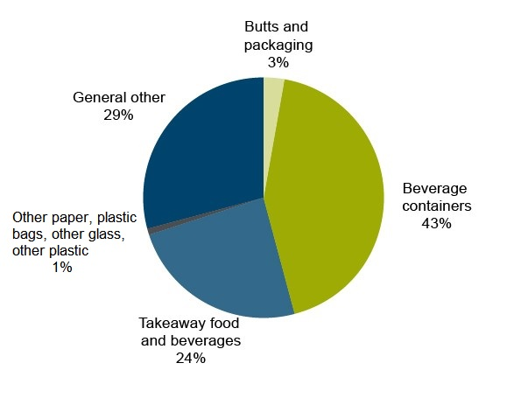
Figure 1: Litter in NSW by category
Note: Based on the volume in litres of litter per square kilometre and excludes illegal dumping.
Source: Analysis of National Litter Index data for NSW, 2015–16.
Beverage container litter in NSW is a function of beverage container consumption and the rate at which used containers are disposed of other than as litter.
Approximately 4.2 billion beverage containers are estimated to have been used in 2016 in NSW, requiring an estimated 442,000 tonnes of container packaging. Of those containers, 2.23 billion (or 53%) are likely to have been recycled, 1.8 billion (43%) are estimated to have ended up in landfill, and the remaining 156 million (4%) are directly entering the litter stream, based on analysis of the National Litter Index.
Hence, while most beverage containers are disposed of appropriately, the extremely large number of containers used results in a significant litter problem. Allowing for the continuation and stabilisation of trends in litter reduction evidenced in recent years, analysis indicates that more than 3.1 billion additional beverage containers will have entered the litter stream by the end of 2036.
In 2006, the Productivity Commission’s Inquiry into Waste Management found that:
Regulation and enforcement for litter and illegal dumping are necessary but not sufficient to achieve the best result for the community. Accompanying measures, such as education, community involvement and moral suasion, can make regulation more effective.
Thus, without intervention littering will be an ongoing problem that is best addressed using a range of policy initiatives, with a CDS being a critical aspect.

Mutual recognition principles
The Mutual Recognition Act 1992 (Cwlth) (MRA) and the Trans-Tasman Mutual Recognition Act 1997 (Cwlth) (TTMRA) apply as laws of NSW by virtue of the Mutual Recognition (New South Wales) Act 1992 (NSW) and the Trans-Tasman Mutual Recognition (New South Wales) Act 1996 (NSW), respectively.
In relation to goods, the MRA and TTMRA apply the ‘mutual recognition principle’. The principle, as explained in section 9 of the MRA, provides that goods produced in or imported into one state, that may be lawfully sold in that state, may, by virtue of the MRA, be sold in another state.
The Trans-Tasman mutual recognition principle as explained in section 10 of the TTMRA is that goods produced in or imported into New Zealand, that may be lawfully sold in New Zealand, may be lawfully sold in an Australian jurisdiction.
These Acts provide that sales of goods to which the principle applies do not require compliance with ‘further requirements’ of a type set out in the Acts that might otherwise be required under the laws of the importing jurisdiction. These include quality or performance standards, inspection requirements and labelling standards.
When the NSW CDS commences, the NSW CDS component of the Waste Avoidance and Resource Recovery Act 2001 (WARR Act), as amended by the Waste Avoidance and Resource Recovery Amendment (Container Deposit Scheme) Act 2016, will require all beverages sold in NSW to carry a label that meets the requirements prescribed in the regulations. Further, beverage suppliers will need to obtain an approval for their beverage containers, and suppliers who first supply containers into NSW will need to enter into a supply arrangement with the CDS scheme coordinator appointed by the Government. These requirements, and some other elements of the scheme, may be considered to impose ‘further requirements’ under the MRA or TTMRA. For this reason, an exemption is required under the MRA and TTMRA.
The MRA and TTMRA make provision for specific goods or laws to be permanently exempted from their scope by their inclusion in schedules to the MRA or TTMRA. The process for adding permanent exemptions requires the relevant ministerial council to seek the unanimous agreement of the Council of Australian Governments (COAG) to the exemption, the making of regulations by the Commonwealth to amend the relevant schedules to the MRA/TTMRA and the prior signification of consent to the amendments by all jurisdictions by gazette notice.
Because the permanent exemption process is lengthy, the mutual recognition schemes also allow individual jurisdictions to unilaterally invoke temporary exemptions from the application of the mutual recognition principle. Temporary exemptions have a limited life of 12 months and cannot be extended.
Regulations have been enacted in NSW to temporarily exempt Part 5 of the WARR Act as well as other provisions of that Act and regulations made under that Act that relate to the CDS.
The permanent exemption of the NSW CDS under the MRA and TTMRA would follow the precedent set by the Northern Territory CDS, which was exempted in 2013.

The scope of the proposed mutual recognition exemptions
The wording of the exemptions is yet to be determined, but it is proposed that the exemptions from the mutual recognition schemes will apply to:
  - Part 5 of the WARR Act
  - Division 3 of Part 5 to the WARR Act (currently set out in Schedule 1 of the Waste Avoidance and Resource Recovery (Container Deposit Scheme) Amendment Act 2016) most provisions of which are to commence on 1 December 2017
  - all other provisions of that Act, to the extent that they relate to the container deposit scheme established by that part
  - regulations made under that Act, to the extent that they relate to that scheme.
Links to this legislation can be found on the EPA consultation website.

Objectives of government action
The policy objective of the NSW Government is to keep our environment clean and beautiful by reducing the prevalence of litter.
In 2015, the NSW Premier set a target of reducing the volume of litter in NSW by 40% by 2020 (NSW Government 2016). The most recent National Litter Index indicated that the state is part way to meeting this objective:
The total reduction in litter volume in NSW from the base year of the Premier’s Priority in 2013–14 to 2015–16 is 19%. This is just under halfway to meeting the Premier’s 40% reduction target. (EPA 2016a, p.3)
However, the target will not be achieved without further policy intervention.
Recognising that beverage containers are the largest single waste type by volume and made up 43% of total litter volume in NSW in 2015–16 (EPA 2016a, p.3), the Premier’s commitment included consideration of an appropriately designed CDS to reduce the litter from this waste stream.
A beverage CDS is a scheme in which ‘typically empty’ beverage containers are returned to a redemption point for recycling and a refund is provided to the redeemer. However, there are some variants in which the redemption point provides other ‘non-financial’ incentives. A CDS is recognised as an effective way to increase the rate of beverage container recycling and reduce the propensity to litter, because it creates a financial incentive to motivate behaviour change. Container deposit schemes are currently in operation in South Australia and the Northern Territory and have been demonstrated to reduce littering behaviour.
When designing the CDS, the NSW Government expanded this commitment and developed the following criteria to assess policy alternatives. The Government sought to ensure that the proposed CDS:
- is cost efficient
- gives people an incentive to return their drink containers
- targets drink containers used away from home
- complements, rather than competes with, existing kerbside services
- uses modern technology such as reverse vending machines (RVMs) where appropriate.

Options to address the problem
Through the policy development and consultation processes, the NSW Government identified and assessed a broad range of options to reduce litter and littering behaviour. As outlined in Section 1, littering is a public problem resulting in negative externalities.
The two options considered in detail in this Regulation Impact Statement (RIS) represent the decision faced by COAG members:
- Option 1 – No exemption for the NSW CDS, resulting in the scheme not being implemented
- Option 2 – Granting a permanent exemption of the NSW CDS under mutual recognition legislation.
In arriving at these options, the NSW Government considered a number of alternative approaches. The range of options considered included non-regulatory options proposed by industry, a national harmonised approach and an alternative configuration of the CDS. However, as set out below, only Option 2 is considered viable.
Of the alternatives, an industry-proposed alternative was found to be either inadequate or not cost-effective in meeting the NSW Government’s litter reduction objectives. A national CDS is not currently on the national policy agenda and so was not considered feasible. Finally, a variation of the CDS requiring retailers to put in place arrangements to support the redemption of containers was found to deliver similar benefits to Option 2, but at a much higher cost. These alternatives are discussed further in Section 3.3.

Option 1 – No exemption for the NSW Container Deposit Scheme
Option 1 is that COAG members do not grant an exemption for the NSW CDS under the MRA and TTMRA. As this would result in the scheme not being implemented, this option also forms the base (business-as-usual) case against which Option 2 can be assessed. Because Option 1 maintains the status quo, it would not achieve the reform objective, but would also not impose any additional costs.

Option 2 – A permanent exemption of the NSW Container Deposit Scheme under mutual recognition legislation
Option 2 is that COAG members grant a permanent exemption of the NSW CDS under the MRA and TTMRA. This would allow NSW to implement the CDS under the amended WARR Act.

NSW Container Deposit Scheme
The NSW Government has worked with the South Australian and Northern Territory governments to align the scope of the scheme, wherever possible, with the schemes in operation in those jurisdictions. The NSW CDS will allow anyone who returns an empty eligible beverage container to an approved NSW collection depot or RVM to receive a 10 cent refund.
Features of the scheme are briefly outlined as follows:
- Beverage containers of between 150 millilitres and three litres in volume purchased in NSW will be eligible for a refund, with some exceptions (which are outlined below). The exceptions are similar to the exceptions in the South Australian and Northern Territory container deposit schemes, to aid consistency.
- Beverage suppliers (manufacturers, importers, wholesalers or retailers) that bring eligible containers into NSW will be responsible for funding the refund as well as associated costs.
- It is proposed that the CDS will be delivered through a two-part structure:
  - A single scheme coordinator will be responsible for the financial management of the scheme, and for ensuring that the scheme achieves its statewide access and recovery targets.
  - Network operators will set up and run a statewide network of collection points. They can build and operate the collection points themselves or contract for other organisations to do this.
- The Minister for the Environment will appoint the scheme coordinator and network operators through a competitive selection process.
- Eligible containers in kerbside recycling will be able to be redeemed. The proposed scheme will allow material recovery facilities (MRFs) to use an EPA-approved method for accurately estimating the number of containers recovered in the facility and to claim the refund from the scheme coordinator. Under this proposed approach, an MRF would receive only the refund amount. It would not be able to claim a handling fee, but would also not need to separate out containers or substantially change its existing recovery processes. The proposed scheme would also provide a regulatory incentive for MRFs and local governments to share any benefits that may result from these arrangements.
Figure 2 illustrates the financial and material (beverage container) flows for the CDS options.
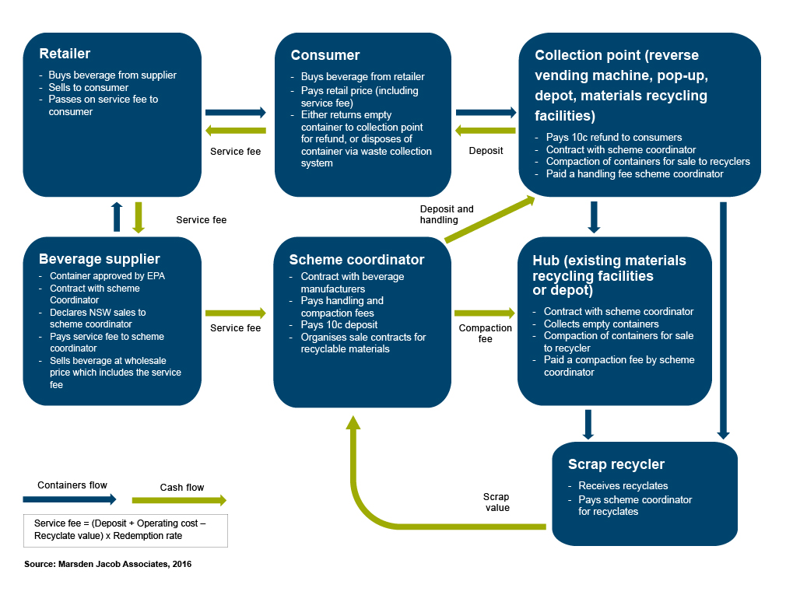
Figure 2: Financial and material flows, CDS options
Source: Marsden Jacob Associates 2016.

Containers covered
The CDS will apply to most beverage containers between 150 millilitres and three litres in size. The scope of containers that will be covered by the CDS will be defined in the Regulations and largely consistent with the scope of containers covered by the South Australian and Northern Territory container deposit schemes. Containers excluded from the CDS include:
- plain milk (or milk substitute) containers
- flavoured milk containers of one litre or more
- pure fruit or vegetable juice containers of one litre or more
- glass containers for wine and spirits
- casks (plastic bladders in boxes) for wine and casks for water of one litre or more
- sachets for wine of 250 millilitres or more
- containers for cordials and concentrated fruit/vegetable juices
- registered health tonics.
Notwithstanding these exclusions, Table 1 shows that regardless of the type of material, the vast majority of containers used in NSW in 2016 are proposed to be covered by the scheme.
Table 1: Containers to be covered by the NSW CDS (FY2016 figures)
Container material | Number of containers in CDS (150mL – 3L) | Proportion of total number of containers covered by CDS (150mL – 3L) | Weight (tonnes) of containers to be covered by CDS (150mL – 3L) | Proportion of total weight of containers covered by CDS (150mL – 3L)
Liquid paperboard | 445,233,000 | 99.7% | 9,276 | 99.7%
Glass | 1,653,380,000 | 99.9% | 367,418 | 99.9%
PET | 930,360,000 | 99.8% | 32,083 | 99.8%
HDPE | 419,649,000 | 94.8% | 20,974 | 94.8%
Aluminium | 717,003,000 | 100.0% | 10,243 | 100.0%
Total | 4,165,625,000 | 99.3% | 439,994 | 99.6%
Source: Marsden Jacob Associates analysis 2016.

Collection points and infrastructure requirements
The CDS will make use of the existing network of community recycling centres, depots and MRFs in NSW; however, some additional depots and RVMs will open to receive the empty containers. This will result in at least 433 collection sites distributed across the state.
NSW has been divided into seven regions, which are referred to as zones (Figure 3). In Zones 1 to 6, there will be one network operator that works with collection sites in its region. In Zone 7 (which includes the Hunter Valley, Central Coast, Sydney, Wollongong and Shoalhaven) there may be multiple network operators, but this will be determined through the tendering process currently being undertaken.
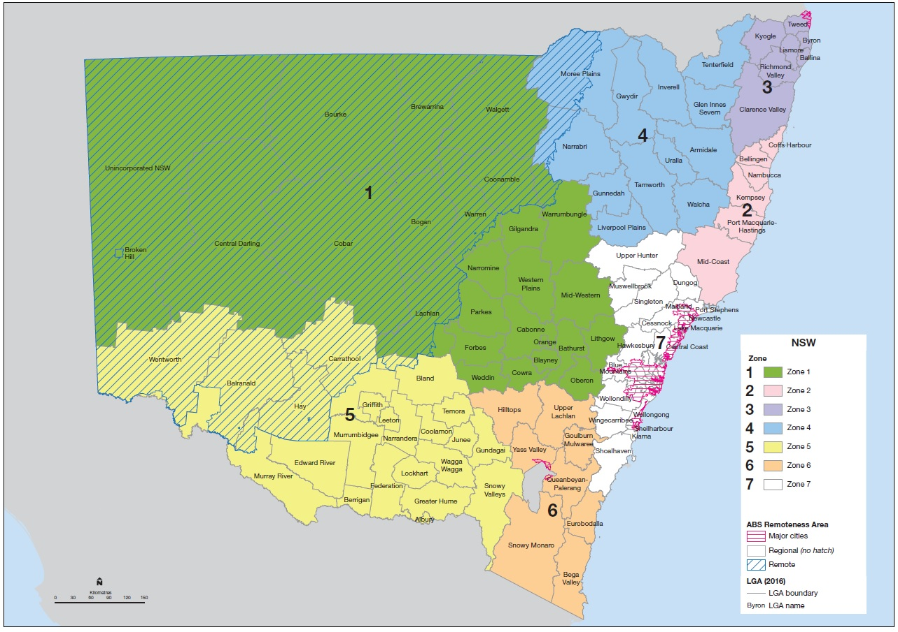
Figure 3: NSW CDS zones

Other approaches considered
A range of other alternatives was previously considered:
- an industry proposal
- a national packaging recovery scheme
- retailer obligations.
However, these are non-viable options for the reasons detailed in this section.

Industry proposal
As part of consultation on the CDS, the beverage industry proposed an alternative litter collecting approach. The industry-proposed approach was constrained to geographic zones that cover Greater Sydney, Newcastle and Wollongong. The five key elements in the proposal were:
- one trailer for container collection per council
- employment of litter collectors (100)
- additional (2000) litter bins
- installation of 100 RVMs
- a community education program.
Where litter reduction is concerned the litter collectors are the key litter reduction element of the proposal. Litter collectors would pick up litter on major roads, highways and industrial roads.
As part of a review of the proposal, road access and the suitability of locations for litter collection were reviewed. The review found a number of issues:
- Litter collectors were unlikely to be granted access to urban motorways, urban freeways and rural freeways. Discussions with Roads and Maritime Services confirmed that litter collectors would not be granted access to those roads. Litter pickers would be able to access other roads, but traffic control plans would first need to be developed and approved.
- Accessing a number of other roads would be conditional on traffic management requirements being met, including reducing the speed limit to 40 kilometres per hour (which would result in travel time impacts). Multiple vehicles may be needed to slow down or alert drivers to maintenance activity ahead, and workers would need to be appropriately trained to mitigate occupational health and safety risks, such as vehicle-related, environmental, hazardous litter and other hazards. Hazards include exposure to a harsh climate; slips, trips and falls; hazardous litter, such as asbestos; hazardous wildlife, such as snakes and spiders; and risk relating to passing vehicles.
- Depots would be needed to store the vehicles and equipment, because the vehicles in particular would require specialised signage and lighting. Moreover, additional time and resources would need to be allocated to the litter disposal task.
Independent consultants considered the potential to scale up the litter collectors element to provide statewide litter reduction outcomes. The consultants estimated that the collection task would need to be significantly scaled up if the NSW Premier’s litter reduction target was to be achieved.
This option was considered in detail in previous consultation documents and in a cost–benefit analysis.
This alternative is considered non-viable, and is not considered quantitatively in this RIS.

National packaging recovery scheme
A nationally harmonised approach to packaging (whether a CDS or an alternative strategy) would be an alternative to the proposed state-operated CDS.
A national packaging strategy was previously considered by COAG and was the subject of a Consultation RIS and a Decision RIS (NEPC 2014). The RIS was considered by environment ministers in April and December 2014, but no consensus was reached on suitable reforms (NEPC n.d.).
A national scheme will not be introduced in the foreseeable future. For this reason, this alternative is considered non-viable, and is not considered quantitatively in this RIS.

Retailer obligations
A variation to the proposed CDS was the introduction of retailer obligations. Under this option, large retail outlets (such as supermarkets) would need to establish redemption points. This option would result in twice the number of collection points, with 529 depots in metropolitan areas, 333 depots in regional areas and 15 depots in remote areas.
It was assumed that this alternative would result in a slightly higher diversion rate. While this would capture slightly increased benefits over the proposed CDS, the costs would be substantially higher (roughly double the costs of the proposed scheme), and so the depot-based CDS has been determined to be the preferred alternative.
This alternative is considered to be less cost-effective than alternative options, and is not considered quantitatively in this RIS.

Impact analysis
The purpose of an impact analysis is to present information relating to:
- the estimated net economic impacts of the reform options
- the impacts on different groups within the community that are likely to be affected by the options
- the risks associated with each option
- any effects that the reforms may have on competition.
This section presents the findings from the cost–benefit analysis (CBA) and distributional impacts assessment undertaken by independent consultants in 2016.
Results are presented in present value (PV) terms based on a 20-year assessment period (2016 to 2036) and converted to 2015 dollars ($2015) using the standard discount rate of 7% per annum (real), with sensitivity testing applied at 3% and 10%. Assumptions and sensitivity tests are also presented in $2015 and discounted to PVs unless otherwise indicated.
Modelling assumed a development period for the CDS of two years from 2015 to 2017, with the scheme commencing operation in 2017–18. The base year for appraisal is FY2016.
These general assumptions reflected current information at the time the assessment was completed. Since the assessment, the NSW Government has announced a five-month delay in the implementation of the CDS, and the scheme will now commence on 1 December 2017 (subject to mutual recognition agreement being reached with COAG). However, this five-month delay does not materially affect the results of the analysis.

Summary findings
The results indicate that the NSW CDS will deliver significant benefits to the NSW and Australian economies. Key findings of the analysis are as follows.
Key finding 1: Implementation of the NSW CDS is expected to significantly reduce litter by motivating changed littering behaviour
The NSW CDS is expected to change littering behaviour and thus have a more significant impact on littering.
By 2036, the CDS will have resulted in:
- 1685 million fewer beverage containers being littered
- 10,985 million fewer beverage containers ending up in landfill
- 12,671 million more beverage containers being recycled.
Key finding 2: The NSW CDS will be economically beneficial
Based on the results of the CBA, the NSW CDS will deliver positive benefits of $282 million to the NSW and Australian economies. The benefit:cost ratio (BCR) of 1.33 indicates that $1.33 of benefits will result for every $1 of cost.
Key finding 3: Estimates of willingness to pay are important because changes to key assumptions can materially change the CBA results
The willingness-to-pay value for litter and the willingness-to-pay value for recycling are key inputs for the CBA and affect whether the analysis produces a positive net present value and a BCR greater than 1.
Key finding 4: Consumers will experience the highest negative distributional impact, whereas the environment, service providers and the government will be positively affected
The key conclusions from the distributional analysis are as follows:
- Consumers experience the highest negative impact of $1030 million (PV).
- Environment receives the highest benefit from the scheme of $820 million – a benefit that is experienced (indirectly) by consumers.
- Service providers and governments also benefit from the introduction of a CDS.

Cost–benefit analysis
A CBA was undertaken to assess the net economic impacts of the NSW CDS. The CBA compared the base case (no reform) scenario against the introduction of the CDS as described as Option 2 in Section 3.2.

Introduction
General assumptions underlining the analysis were as follows:
- The base year of the appraisal is FY2016.
- Prices are in $2015.
- The evaluation period is 20 years from 2016 to 2036.
- The discount rate applied is 7% (real), with sensitivity testing applied at 3% and 10%.
- The development period for the scheme is 2015 to 2017, and the scheme commences in 2017–18.
The CBA was undertaken using a geographic scope of NSW; however, some broader impacts identified in the distribution analysis (Section 4.6) and the qualitative consideration of effects outside NSW (Section 4.7) were considered.
The results of the CBA are presented using two key metrics:
- the net present value (NPV), which is the PV of economic benefits delivered by the CDS less the PV of the economic costs incurred
- the BCR, which is the ratio of the PV of economic benefit to the PV of economic costs.
The NPV measures the expected benefit (or cost) to society of implementing the policy and is expressed in monetary terms, whereas the BCR identifies the option that provides the highest benefit per unit of cost.
The CBA results indicate that the NSW CDS will deliver NPV benefits of $282 million to the Australian economy. The BCR result is 1.33, indicating that for every $1 of cost, $1.33 of benefits will result (Table 2).
Table 2: Cost–benefit analysis results
Variable | Present value results ($ million)
Incremental cost (PV) | $857 million
Incremental benefit / avoided cost (PV) | $1,139 million
NPV | $282 million
BCR | 1.33

Costs
Cost outcomes from the CBA are divided into a number of broad categories:
- scheme design and administration costs, including avoided costs (government)
- scheme administration and coordination (scheme and network operators)
- business compliance costs (beverage industry)
- household participation costs
- business participation costs
- container redemption infrastructure costs (collection depots, RVMs and pop-up trailer operators).
Figure 4 shows the magnitude of the each of the cost outcomes. Table 3 provides a brief description of each cost or benefit item, with reference to underpinning assumptions. A discussion of each of the costs is in Table 3.
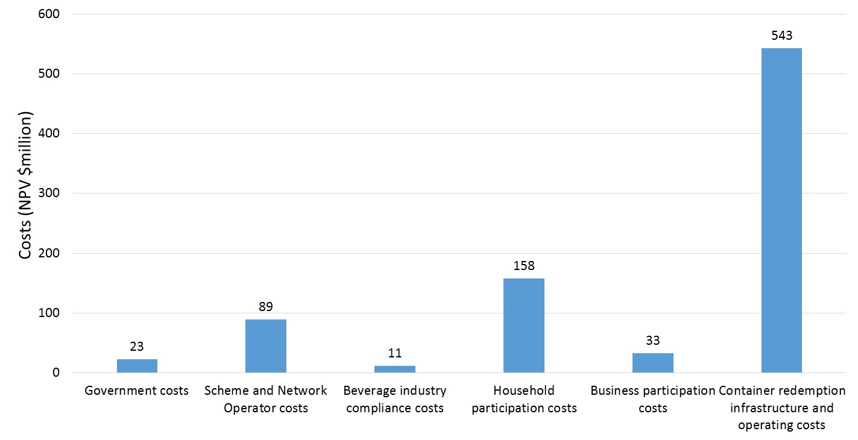
Figure 4: Summary of cost outcomes ($ million NPV)
Source: Marsden Jacob Associates analysis 2016.

Table 3: Description of cost and benefit assumptions
Cost category | Description of item | Basis of estimate
Scheme design and administration, including avoided costs | Government costs associated with the design and administration of the CDS include regulation design and implementation, government participation costs, communications costs, and government costs to administer regulations (including compliance and enforcement). | The assumed government scheme design and implementation costs are based on discussions with NSW EPA.
Scheme administration and coordination | One scheme coordinator is assumed to be required to report to the Government on return rates.  The coordinator will also manage contracts with collection points, manage and coordinate the collection network, achieve service and system efficiency targets, receive and verify collection data from redemption points, make refund, handling and other payments to redemption points and manage the contracting of materials recycling.  Costs include business set-up costs, information technology system set-up costs, and ongoing staff and operating costs. | Estimates are based on information provided by Statewide Recycling Services Pty Ltd and Marine Stores Pty Ltd.
Business compliance costs – beverage industry | Business compliance costs include transitional and ongoing compliance costs:  - Transitional costs include costs for label design, EPA approval, plates, printing and write-offs.  - Ongoing costs are based on one additional hour per month required for:  - data reconciliation and reporting to the scheme coordinator  - checking and processing of entities’ notices of assessment / invoices  - occasional audit management and dispute resolution  - periodic review/renewal of the commercial relationship with the scheme coordinator. | Estimates are based on previous analysis undertaken for the National Packaging Scheme and consultation with the beverage industry in the preparation of the CBA.  Estimates are considered conservative, as industry may face lower costs where it is able to draw on experience from the Northern Territory and South Australian schemes.
Household participation | Households face participation costs due to the time it takes to accumulate beverage containers and transport them to collection points.  The material flow analysis used in the CBA assumes that 5% of containers that are consumed at home are diverted from kerbside recycling at the start of the scheme and that this proportion increases to 40% by the end of the scheme.  Cost categories include vehicle operating costs, in-vehicle travel time and container deposit redemption time. The time is costed at $30 per hour.  Households are already involved in current waste management practices, so the accumulation time spent collecting empty containers is assumed to be nil. | Value of time based on NSW LLS (2015).  Vehicle operating costs and vehicle travel time based on the Transport for NSW guidelines, Nolan ITU (2003) and ISF–UTS (2001).
Business participation | Businesses are assumed to incur some costs to participate in the scheme in accumulating and returning empty beverage containers.  Business/workplace participation costs are defined as costs incurred by employees taking beverage containers to temporary storage infrastructure and cleaners or other staff consolidating this in larger storage infrastructure, such as skip bins.  Additional cleaner costs are assumed for businesses with a turnover of more than $2 million per annum. | Number of commercial businesses based on Australian Bureau of Statistics data.  Value of time for cleaners and costs for trips to transfer containers based on previous analysis.
Container redemption infrastructure costs | Collection depots  The analysis assumes that no new collection points need to be built because existing community recycling centres (190 centres), MRFs (48), regional hubs (14) and one central hub are available. As a result, only variable operating costs for the collection depots/points were estimated.  Variable cost estimates included changes in operating costs at the collection depots and additional costs for the transport of containers from collection depots to the scheme coordinator, including costs of additional baling for transport. | NSW EPA analysis
 | Reverse vending machines  The analysis assumes that 157 small to medium-sized RVMs are installed only in metropolitan areas. The RVMs are assumed to be cleared when required and have an asset life of seven years.  The RVMs are all assumed to be installed as new. Capital costs (including for installation), fixed operating costs (computer replacements and vandalism) as well as variable operating costs (container collection, cleaning and maintenance) are included in the analysis.  The RVMs are co-located in retail and commercial areas, similarly to standard vending machines, so the redemption throughput does not change in sensitivity tests. | Consultation with RVM industry in the preparation of the CBA.
 | Pop-up trailers  Pop-up trailers cater for public place containers not redeemed via RVMs in the metropolitan region, in particular glass containers, but also a proportion (25%) of all other materials.  The analysis assumes that pop-up trailers will be located at convenient locations, such as sports fields, popular beaches and shopping malls, within the metropolitan region on weekends.  The cost to purchase a pop-up trailer is estimated at $5000, and the asset life is assumed to be three years. Operating costs are estimated at $4400 per trailer to cover ongoing expenses, including labour costs and the hire cost for a vehicle to transport the trailer to collection points. | Marsden Jacob Associates (2016) analysis
.

Benefits (avoided costs)
Benefit outcomes from the CBA include:
- avoided waste collection and transport costs (incurred by local government and passed through to consumers)
- processing or recycling at MRFs
- avoided landfill costs
- avoided litter costs
- the value of resources recovered through recycling.
Figure 5 shows the magnitude of each of the benefit outcomes. Table 4 provides a brief description of the underpinning assumptions used in estimating benefits.
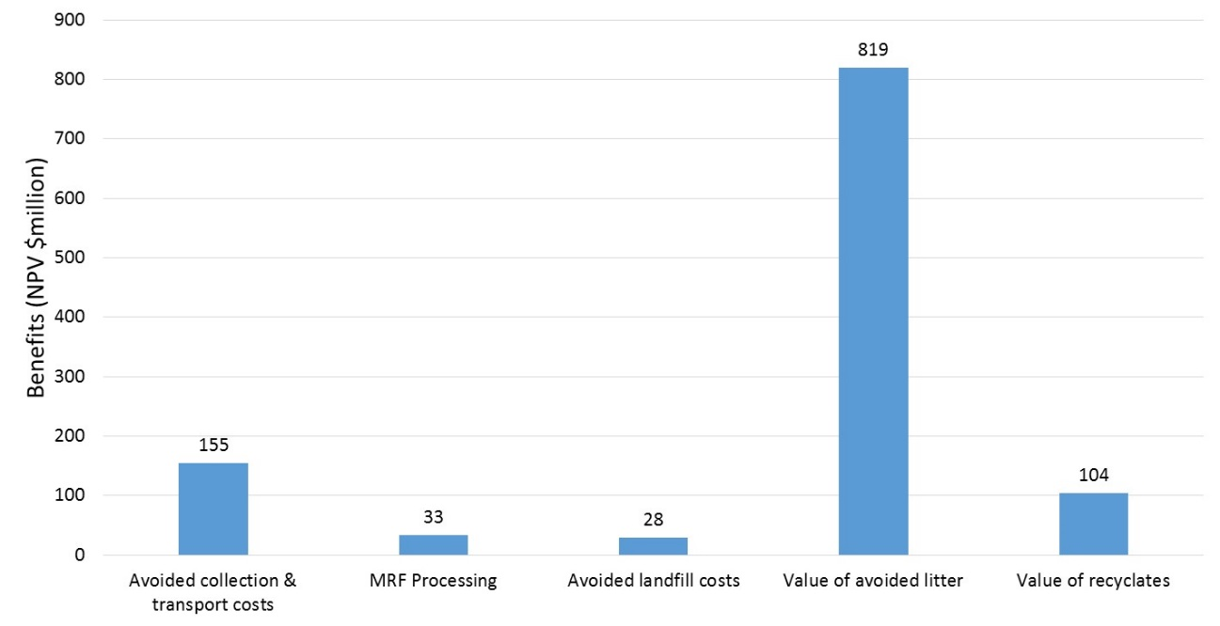
Figure 5: Summary of benefit outcomes ($ million NPV)
Source: Marsden Jacob Associates analysis 2016.

Table 4: Description of benefit assumptions
Type | Description of item | Basis of estimate
Collection and transport costs | Collection and transport costs are incurred by local government (and passed through to residents) for existing waste management kerbside collection services (garbage and recyclates).  The CDS is expected to divert some of the existing costs of providing these services. Estimates used in the analysis distinguish between recyclables and garbage collection, as well as costs for metropolitan and regional areas. | Estimates based on previous transport analysis by Marsden Jacob Associates.  This is described in further detail in section 2.3 of the Technical Annex to this RIS
Processing of recycling at MRFs | Although the CDS is expected to increase recyclates, MRFs are expected to see marginally reduced volumes as empty beverage containers are diverted away from traditional collection processes (such as kerbside collection) that feed through to MRFs.  Contamination rates are applied in the material flows analysis to containers going through the recycling stream, and the CBA modelling automatically applies the prevailing assumptions relating to landfill operating costs and externalities for this portion of the containers. | Estimates based on prior work undertaken for the national Packaging Impacts RIS, adjusted for inflation.  Material flows are described in further detail in section 3 of the Technical Annex to this RIS
Avoided landfill externalities | One of the impacts from the NSW CDS will be to divert a portion of beverage containers away from landfill and into recycling streams. Avoided landfill costs attributable to the CDS include reduced landfill capital and operating costs and the value of avoided landfill externalities (greenhouse gases), noting that the greenhouse gas potential of most beverage containers is very low.  The average cost of landfill by state/territory and by metropolitan/non-metropolitan area has been determined using information on the size distribution of Australian landfills and level of controls in Australian landfills (WCS 2010), and an assumption that the metropolitan region typically has large landfills, while non-metropolitan regions contain a mix of medium and small landfills.  The average externality costs of greenhouse gas emissions reductions for the NSW metropolitan and non-metropolitan regions are based on a number of variable factors:  - the extent of landfill gas capture at landfills  - the average efficiency rate of landfill gas capture  - the ‘emissions factor’ of the material being deposited in landfill  - the monetary value of environmental damage caused by greenhouse gases. | Landfill capital and operating cost estimates draw on data available in BDA–WCS (2009) and WCS (2010) and our previous project analyses on landfills to estimate the avoided landfill costs.  This is described in further detail in section 2.2 of the Technical Annex to this RIS
Avoided litter costs | The avoided costs of litter are estimated based on willingness to pay (WTP) to avoid litter.  WTP to avoid litter reflects the value that households and the broader community place on litter avoidance.  The avoided damage costs of litter were also considered. Avoided damage can be measured in terms of the impact that paid litter collectors would have on minimising damage costs. However, the use of both the WTP and the avoided damage costs has the potential to double count benefits. This estimate was found to be lower than the WTP because using litter collectors does not avoid litter but merely reduces the length of time that litter is on the ground. Therefore, only the WTP values were used in the CBA. | Estimates of WTP to avoid litter are based on an analysis of costs associated with voluntary litter clean-up activities, from Clean Up Australia (2010), MRA Consulting Group (2015)
Value of resources recovered through recycling | The value of resources recovered through recycling reflects the use value of beverage container materials. Projections of market values were developed for recoverable beverage container materials including glass, aluminium cans, plastics and liquid paperboard.  A premium for materials recovered from the CDS was also estimated for each type of material. Premiums reflect that under the CDS the different container types are separated at the point of redemption so the materials are less contaminated compared to kerbside recycling collection, for example, where broken glass and other waste may be incorrectly placed in bins, and thus their recycling potential is higher. | Estimates for aluminium cans, plastics and liquid paperboard align with those used in the national Packaging Impacts RIS.  Discussions with stakeholders indicated a wide range of values for glass; the estimates used reflect recycling industry sources for material not yet processed.

Limitations
In the analysis, it has not been possible to quantify all of the benefits and costs. Also, as in all projection-based analysis, there are uncertainties in the data and projections.

Unquantified benefits
A number of potential economic benefits of implementing options are not directly valued in markets. Because of this, it can be difficult to ascribe dollar values to those benefits, or at least values that provide a true reflection of their economic value. In the CBA, it has not been possible to assign values to:
- reduced resource depletion
- avoided environmental externalities due to reduced resource depletion
- specific reductions in marine litter, because there is a lack data on this issue
- broader behaviour change benefits.
Broader behaviour change benefits include flow-on benefits to other litter sources as a result of reduced beverage container litter. While the financial incentive (the redeemable deposit) will drive behaviour change where beverage containers are concerned, this incentive may also flow through to other litter sources and thus reduce littering of other material.
The absence of full valuation of non-market benefits restricts the analysis, since it is possible to make definitive statements about the efficiency of options only when all costs and benefits have been fully valued. Where data assumptions have the potential to significantly affect outcomes, the consultants preparing the CBA tested uncertainties using sensitivity analysis (described in Section 4.4). However, we note that inclusion of these unquantified issues would only improve the CBA outcome.

Costs are passed on to consumers
The CBA assumes that container deposits and any additional costs will be passed on to consumers by the beverage manufacturing industry, and this is reflected in the distributional analysis set out in Section 4.6. While the cost burden has been modelled to fall on consumers, it may not always be possible for the food and beverage industry to pass costs on to consumers.

Data and projection uncertainties
Although considerable background analysis has been used to assign suitable values to the variables, in practice there are still uncertainties in a number of the variables. Even variables that are directly valued in the market (such as the value of recovered material) are subject to uncertainty caused, for example, by fluctuations in market values over time and differences in market values from region to region and internationally.
Furthermore, all options are subject to uncertainty because of the inherent difficulty of projecting any variable over a 20-year analysis period. The impacts of the following factors may be subject to change in the future:
- recycling levels and decisions of various parties, including local governments, households and businesses, which are also influenced by the use-value of recycling in the absence of additional regulation
- packaging consumption trends, which are affected by factors such as technology, logistical innovations, trade agreements and food and beverage prices
- the value of the Australian dollar
- unknown future impacts that may affect the ability of the options to achieve the outcomes specified
- unintended consequences arising from regulatory intervention and incentives, based on human and market responses that are not always predictable.

Sensitivity tests
The CBA is necessarily based on a series of assumptions, which means that there is a degree of uncertainty in the results. Sensitivity testing can help to identify those input values and assumptions that can materially change the results. For this CBA, sensitivity tests were undertaken by adjusting the following input values:
- discount rates
- the analysis period
- the number of containers
- alternative home and away consumption splits
- the kerbside diversion rate
- willingness to pay to avoid litter and increase recycling
- willingness-to-pay threshold analysis
- the number of RVMs
- propensity to litter.

Discount rate
In accordance with the NSW Government Guide to Cost–Benefit Analysis (NSW Treasury 2017), the stream of costs and benefits (in real terms) has been discounted using a real discount rate of 7%, with sensitivity testing using real discount rates of 3% and 10%. These values also align with the discount rates proposed by the Australian Government’s Office of Best Practice Regulation (OBPR 2016). The results are set out in Table 5, from which it can be seen that the BCR result is not highly dependent on the assumed discount rate. The NPV result is somewhat sensitive to the discount rate, because some capital assets (such as RVMs) need to be replaced every seven years and scheme participation (particularly regarding redemption) is assumed to ramp up over the first several years.
Table 5: Discount rate sensitivity test
Variable | NPV | BCR
Discount rate 7% | $281.7 million | 1.33
Discount rate 3% (sensitivity) | $393.1 million | 1.31
Discount rate 10% (sensitivity) | $225.5 million | 1.34

Analysis period
A 20-year period is used in the analysis because it is assumed that the CDS will take several years to be established and for participation to develop.
This analysis period accords with the NSW Government Guide to Cost–Benefit Analysis and the Office of Best Practice Regulation’s Cost-benefit Analysis Guidance Note.
Table 6 reports the results when the analysis period is reduced to 10 years. The shorter analysis period reduces the NPV from $281.7 million to $183.9 million, whereas the BCR outcome improves from 1.33 to 1.45.
Table 6: Analysis period sensitivity test
Variable | NPV | BCR
Analysis period: 20 years | $281.7 million | 1.33
Analysis period: 10 years (sensitivity) | $183.9 million | 1.45

Number of containers
The business-as-usual case assumes a ‘container universe’ of 4194 million beverage containers. Discussions with the CDS Ministerial Advisory Committee confirmed that there is some uncertainty about the container universe, so sensitivity testing (+/–5%) has been undertaken on this assumption (Table 7).
The CBA results are not particularly sensitive to this assumption. A 5% increase in the number of containers leads to a decrease in NPV from $281.7 million to $263.6 million, whereas the BCR remains stable. Conversely, a decrease in the container universe improves the NPV (to $299.9 million).
Table 7: Number of containers sensitivity test
Variable | NPV | BCR
Number of containers: 4.2 billion | $281.7 million | 1.33
Number of containers +5% (sensitivity) | $263.6 million | 1.30
Number of containers –5% (sensitivity) | $299.9 million | 1.36

Alternative home and away consumption splits
The analysis assumes that 67% of beverage containers are consumed at home and that the balance are consumed away from home. Discussions with the advisory committee confirmed that there is considerable uncertainty about this split, so a range of sensitivity tests have been undertaken (Table 8).
Varying the consumption split does not change the number of containers recycled, because the number of containers recycled is reasonably certain. However, changing the consumption split does affect the propensity to litter and the number of containers redeemed in public place locations.
The NPV result is somewhat sensitive to the consumption split. For instance, shifting from a 67:33 to a 50:50 consumption split improves the NPV result by $73.2 million, from $281.7 million to $354.9 million.
Table 8: Consumption split (at home/away from home) sensitivity test
Variable | NPV | BCR
Consumption split (50/50) (sensitivity) | $354.9 million | 1.41
Consumption split (60/40) (sensitivity) | $312.4 million | 1.36
Consumption split (67/33) | $281.7 million | 1.33
Consumption split (80/20) (sensitivity) | $251.3 million | 1.30

Kerbside diversion rate
The volume of containers diverted from the kerbside depends largely on the scheme design and accompanying advertising and education campaigns. Therefore, there is some uncertainty about the kerbside diversion rate. The analysis assumes that kerbside diversion increases over the first 10 years of the scheme, peaking at 40%. Sensitivity testing examined the impact of 30% and 50% diversion peaks (Table 9).
The result is sensitive to this assumption, which confirms the importance of careful scheme design to minimise the diversion rate from kerbside collection. Reducing the assumed diversion rate from kerbside recycling to 30% improves the NPV by about 21%.
Table 9: Kerbside diversion rate sensitivity test
Variable | NPV | BCR
Kerbside diversion: max. 40% | $281.7 million | 1.33
Kerbside diversion: max. 30% (sensitivity) | $342.6 million | 1.45
Kerbside diversion: max. 50% (sensitivity) | $220.8 million | 1.23

Willingness to pay to avoid litter and increase recycling
Some non-market benefits of recycling and litter reduction may not have been fully captured in the CBA. Non-market benefits will include (but are not limited to) environmental, amenity and existence values.
Two willingness-to-pay (WTP) measures were considered in the analysis of the CDS:
- WTP to avoid litter is assumed to be $17,584 per tonne in the metropolitan region (and $1822 per tonne in the regional areas) based on revealed preference valuation.
- WTP for recycling ($692 per tonne), based on stated preference valuation, has also been included in the sensitivity tests (Table 10).
The WTP for recycling and the WTP to avoid litter are mutually exclusive. When applying the WTP for recycling, the WTP to avoid litter and the landfill externalities are excluded (to avoid any double counting of benefits that may have already been included in recycling WTP estimates).
Based on the analysis, the WTP value for avoiding litter and the WTP value for recycling are key inputs for the CBA and affect whether the analysis produces a positive NPV and a BCR greater than one. Further discussion of the WTP is provided in section 2.6 of the Technical Annex to this RIS.
These results need to be interpreted with caution because a full assessment of WTP has not been undertaken in this analysis and projects referenced to identify WTP estimates are subject to significant qualifications.
Table 10: WTP sensitivity test
Variable | NPV | BCR
WTP to avoid litter: $17,584 | $281.7 million | 1.33
WTP for recycling: $692 (alternative scenario) | –$177.3 million | 0.79
Note that the high value for WTP to avoid litter is used in the CBA. This value was selected from well-conducted studies in the literature; however, it does not necessarily reflect the WTP to avoid marine litter.

WTP threshold analysis
Threshold analysis was also undertaken on the values for WTP to avoid litter. The analysis identified the value at which the NPVs of the costs and the benefits are equal. The threshold analysis found that either:
- the WTP to avoid litter would need to be around $8575 per tonne across NSW
or
- the WTP to avoid litter would need to be around $11,300 per tonne in the metropolitan region (with a lower WTP value of $1822 applying to regional areas).

Number of RVMs
The analysis assumes that up to 158 RVMs are installed under the CDS. The number of installed RVMs is assumed to build up over time in line with the increase in scheme participation rates.
The installation of RVMs is expected to be market led, depending on RVM operators’ expected financial returns. Due to this uncertainty, a sensitivity test in which the number of installed RVMs is doubled was undertaken (Table 11).
This analysis found the following:
- Doubling the number of RVMs marginally reduces the NPV outcome, from $281.7 million to $269.8 million. The result is not particularly sensitive to the number of RVMs because there is a trade-off between capital and operating costs. For instance, fewer RVMs mean the per unit operating cost increases, as they have to be cleared and maintained more often to achieve the same redemption rates.
- Increasing the number of RVMs to 800 reduces the BCR and NPV results materially because the capital cost increases significantly and is only partially offset by the operating cost reduction that eventuates from the RVMs being cleaned less often.
Table 11: Number of RVMs sensitivity test
Variable | NPV | BCR
Number of RVMs: 158 | $281.7 million | 1.33
Number of RVMs: 316 (sensitivity) | $269.8 million | 1.31
Number of RVMs: 800 (sensitivity) | $189.0 million | 1.20
In the 800 RVM sensitivity test, it is assumed that:
- the majority of the RVMs are co-located, because it is difficult to identify new locations that would be viable and so total redemption throughput is assumed to remain unchanged
- the capital cost increases and the operating cost decreases (the operating cost for each RVM decreases because the RVMs do not need to be cleaned as often, as the throughput per RVM falls)
- pop-up trailers are no longer required
- all assumptions about asset life remain the same.

Propensity to litter
Discussions with the expert advisory committee confirmed that there is some uncertainty about the estimates for propensity to litter, so sensitivity tests (+/–20%) were undertaken on this assumption (Table 12).
This analysis reveals that changing the propensity to litter by 20% changes the NPV result by around 50%, so the result is quite sensitive to changes in this assumption.
Table 12: Propensity to litter sensitivity test
Variable | NPV | BCR
Propensity to litter | $281.7 million | 1.33
Propensity to litter +20% (sensitivity) | $442.8 million | 1.52
Propensity to litter –20% (sensitivity) | $120.7 million | 1.14

Litter volume impacts

Beverage consumption projections
Beverage container consumption for the base year, 2016, was estimated using data sourced from Industry Edge and Equilibrium (2013). The approach to estimating the total number of containers accords with the methodology that was used by Marsden Jacob Associates in the national CBA for the Packaging Impacts Decision Regulation Impact Statement (MJA 2013).
The beverage container universe in 2016 consisted of approximately 4200 million containers. Projections of beverage container consumption for the analysis period were developed assuming an annual growth in consumption of 0.73% over the period from FY2016 to FY2021, falling gradually to annual growth of 0.54% by the 2032–2036 period. This means that per capita consumption falls, albeit slightly, over the period of the analysis.
Acknowledging that the propensity to litter is higher in commercial and industrial locations as well as in public places, the analysis considered the consumption of beverage containers split across three locations:
- at home (67%)
- away from home – public places (23%)
- away from home – non-public places (10%).
Finally, regional analysis considered beverage container consumption split between three regions: the Sydney metropolitan area, an extended regulated area and a regional regulated area. The proportion of consumption by region was estimated based on the NSW Local Government Waste and Resource Recovery Data Report (2012–13):
- metropolitan area (71.2%)
- regional levy-paying area (12.8%)
- regional non-levy-paying area (16.0%).
Under the base case, of the beverage containers used in 2016, 2.23 billion containers (or 53%) were recycled, 1.8 billion (43%) are estimated to have ended up in landfill and the remaining 156 million (4%) are likely to have directly entered the litter stream.

Changes in disposal methods
Following use, beverage containers are disposed via one of three main disposal streams. They may:
- be recycled
- enter the litter stream
or
- be directly disposed of as landfill.
The CBA uses estimates of the current and future recycling rates and changes in the propensity to litter under the business-as-usual option and the NSW CDS option. The number of containers that move directly into the landfill stream then becomes a balancing item (based on total beverage consumption projections).

Projected impact of the CDS on litter
Based on the effectiveness of similar container deposit schemes in South Australia and the Northern Territory, the NSW CDS is expected to steadily reduce the proportion of beverage containers littered.
The estimated impact of the CDS on litter volumes uses the same framework, assumptions and data sources that were utilised in the Packaging Impacts Decision Regulation Impact Statement (NEPC, 2014). The Packaging Impacts Decision Regulation Impact Statement (Packaging Impact Decision RIS) is available online and specifically Section 3.3 of Attachment K (MJA, 2013) details the approach, assumptions and sources that were used. The apparent impact of the South Australian CDS on beverage container litter is described in detail in section 2.1 of the Technical Annex to this RIS.
When applying this approach to the cost-benefit analysis of the NSW CDS, the only key change was to ensure that the propensity to litter reflects NSW circumstances, instead of the national propensity in the Packaging Impact Decision RIS. It should be noted that these changes also introduce a degree of conservatism to the analysis when compared to the Packaging Impact Decision RIS analysis.
Figure 6 shows the impact of the business-as-usual and CDS options on the proportion of beverage containers littered, by volume.
By 2036 the CDS is estimated to result in:
- 1685 million fewer beverage containers being littered
- 10,985 million fewer beverage containers ending up in landfill
- 12,671 million more beverage containers being recycled.
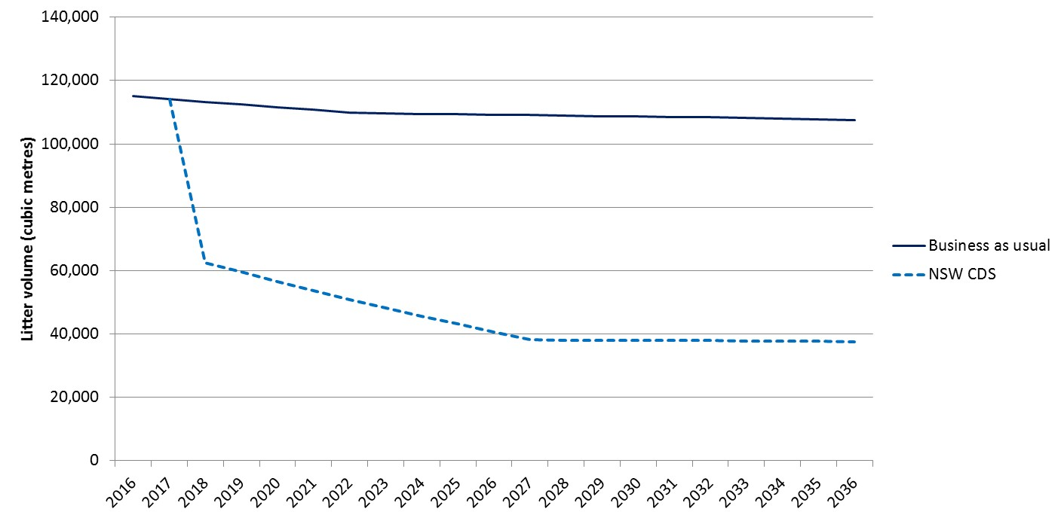
Figure 6: Litter volume, 2016 to 2036 (cubic metres)
Source: Marsden Jacob Associates analysis 2016
Analysis conducted by independent consultants on the effectiveness of the CDS compared to other litter reduction policies in NSW shows that the scheme is the most effective means by which to reduce beverage container litter.
Based on the reduction in the litter by volume, it is anticipated that the CDS will contribute 26.6% of the 40% target for litter reduction once at full capacity. Other initiatives that are expected to contribute to the target include Hey Tosser! campaigns (5.9%), residential newspaper, magazine and junk mail litter initiatives (6.7%), additional litter bins (0.4%) and other a number of other smaller initiatives (0.4%).

Distributional impacts and regulatory burden measurement
In addition to assessing the impact of the proposed reform on the NSW economy as a whole, it is useful to consider the distribution of the costs and benefits among stakeholder groups.

Stakeholder groups considered
The stakeholder groups considered for the distribution analysis are consistent with previous distributional impact assessments of container and packaging deposit schemes. The analysis focuses on the following stakeholders:
- NSW Government
- Australian Government and other state and territory governments
- local governments
- service providers (MRFs and collection point and RVM operators)
- the food and beverage industry
- beverage consumers
- environment.
Table 13 summarises the impacts of the CDS, both positive and negative, on each of the stakeholder groups.
Table 13: Stakeholder groups – impacts
Stakeholder | CDS impacts
NSW Government | The development and implementation of a CDS will affect the NSW Government.  Cost impacts are assumed to include costs for:  - scheme development, including regulation and oversight mechanisms  - approval responsibilities for container labelling  - ongoing administration of the scheme  - monitoring and enforcement.  The CDS will increase beverage container prices, because scheme- and deposit-related costs will be passed on to consumers, which will mean that goods and services tax (GST) revenue increases. The analysis assumes that 32% of additional GST revenue that results from the price rise would benefit the NSW Government.ª
Australian Government and other state and territory governments | The Australian Government will benefit from an increase in income tax payments if the scheme coordinator is established using a ‘for profit’ corporate structure.  If a not-for-profit structure is used, the Australian Government will not benefit from any increase in income tax.  It is assumed that 68% of any additional GST revenue that results from the price rise would benefit the other state and territory governments.
Local governments | Benefits to local governments will result from reduced kerbside collection costs and extended landfill life. The analysis assumes that these benefits are directly passed on to local residents and businesses.
Service providers (MRFs and collection point and RVM operators) | MRF impacts include:  - reduced processing and lost value of recyclates  - benefit from increased revenue (handling fees and deposit redemptions) over and above additional operating costs.  In the short term, benefits to MRFs may be elevated unless contracts are renegotiated with suppliers.  Collection point and RVM operators will incur capital and operating cost impacts, but those costs are more than offset by handling fees.
Food and beverage Industry | The food and beverage industry will incur costs associated with the transition and implementation of the scheme. This cost could be partially offset by revenue from the scrap value of recyclates.  Based on consultation with the industry in the preparation of this report, it is assumed that the vast majority of these costs will be passed on to consumers. However, the analysis assumes that some costs, particularly producer surplus-related impacts that result from reductions in beverages sold, cannot be passed on to consumers.
Beverage consumers, including consumers at home and consumers in commercial/business locations | Consumer-related impacts include:  - price increases when scheme operation costs, deposits, handling fees and taxation are passed on  - participation costs  - reduced waste management charges.
Environment | Environmental impacts include:  - reduced landfill externalities  - reduced litter externalities  - increased recycling.
Other | Change in harm to others (externality impacts) from a reduction in alcohol consumption (sensitivity test).  Change in employment opportunities for long-term involuntarily unemployed, resulting from social enterprise initiatives at beverage container redemption points.
ª 2015 GST Review, Commonwealth Grants Commission, Australian Government, www.cgc.gov.au/index.php?option=com_content&view=article&id=219&Itemid=318.
Source: Marsden Jacob Associates analysis 2016.

Overview of the results
The CDS requires additional expenditure in order to fund litter and recycling outcomes. The outcomes of the distribution analysis are summarised in Figure 7. The analysis highlights where stakeholder groups benefiting from the scheme differ from the stakeholder groups that ultimately bear the costs of additional expenditure.
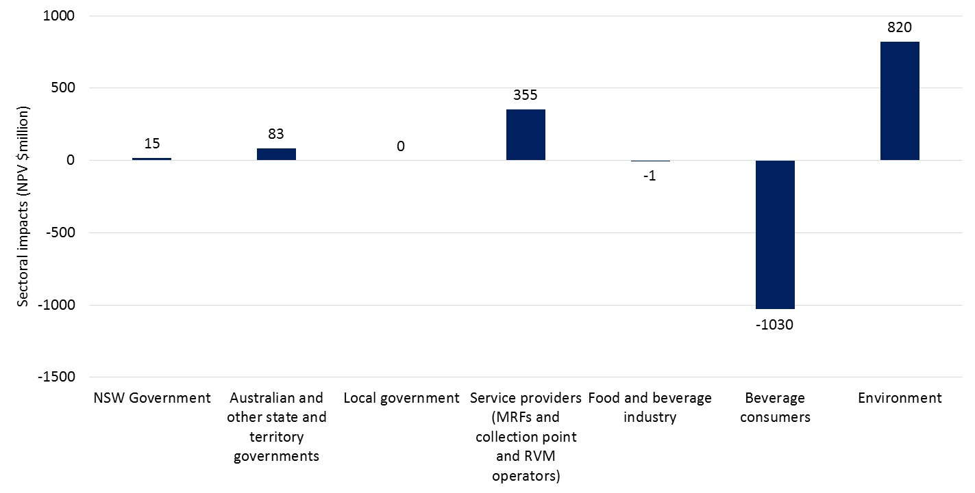
Figure 7: Distributional analysis ($ million NPV)
Source: Marsden Jacob Associates analysis 2016.
The key conclusions from the distributional analysis are as follows:
- Consumers experience the highest negative impact of $1,030 million (PV).
- The environment receives the highest benefit of $820 million – a benefit that is (indirectly) experienced by consumers.
- Service providers and governments also benefit from the introduction of a CDS.
The distributional impact on consumers is an annuity of $116 million or 29 cents per person per week although consumers will also be the primary beneficiaries from the improved environment. Community and charitable organisations may also benefit from the scheme by using the scheme as another way to raise funds or receive donations, or by partnering with a network operator to operate collection points.
The drivers of overall results for each sector are discussed in this section.

NSW Government
The net impact to the NSW Government is +$15 million. While the state government incurs development and ongoing costs for the scheme, the benefits from increased GST revenue outweigh those costs. The CBA assumes that the NSW Government receives 32% of the GST revenue from the sale of beverage containers under the CDS.

Australian Government and other state and territory governments
Benefits to the Commonwealth and other states and territories are driven by corporate tax received from the scheme coordinator as well as increased GST revenue. The CBA assumes that 68% of GST revenue from the sale of beverage containers is distributed to the Australian Government and other state and territory governments (Dale 2014). The net benefit for those governments is $83 million.

Local governments
The net impact of the CDS on local government is zero. This result is driven by the assumption that all cost savings from the reduced collection and transport of kerbside rubbish as well as reduced landfill costs are passed through to residents and other customers. The CBA benefits transferred from local government to customers are estimated to be $272 million over the life of the scheme.

Service providers
Service providers (MRFs and collection point and RVM operators) will benefit from expanded business opportunities and a reduction in net processing costs. In addition, MRFs will benefit from the redemption of deposits on containers that are returned through kerbside recycling. It is also anticipated that community not-for-profit and charitable organisations may partner with a network operator to operate collection points.

Beverage manufacturing industry
The net impact on the beverage manufacturing industry is estimated to be marginally negative (NPV of $500,000 over the 20-year analysis period). This cost results from the implementation and compliance with requirements of the CDS.

Beverage consumers
Beverage consumers will receive benefits from cost savings passed through from local governments for reduced waste management service costs and from MRFs in the form of reduced fees. In addition, those people who deposit beverage containers at depots will receive the scheme refund of 10 cents per container.
Consumers will face higher prices for beverages covered by the scheme, as the scheme costs and increased compliance costs incurred by beverage manufacturers will ultimately be passed on to them.
The impact of the scheme on consumers of beverages covered by the scheme is $1030 million (NPV) over the 20-year period. As noted above, this equates to an annualised cost of $116 million or 29 cents per person per week although consumers are ultimately the primary beneficiaries from environmental benefits delivered by the scheme.

The environment
The main beneficiary from the NSW CDS will be the environment As noted above, the community will be the primary beneficiaries from environmental improvement. The scheme is expected to enable $820 million that would otherwise have been borne as costs by the environment to be retained by the environment.
Benefits to the environment have been quantified as:
- avoided landfill externalities of $1.2 million
- reduced litter clean-up costs of $819 million.
As noted above, this assessment omits any consideration of the benefits arising from reduced marine litter because they could not be quantified in this analysis.

Regulatory burden measurement
COAG’s decision on whether to grant a permanent exemption for the NSW CDS under the MRA and TTMRA would impose minimal regulatory burden on businesses, community organisations or individuals. For this reason, a full analysis of the regulatory burden measurement is not required to be set out here. However, the CBA does include consideration of administrative compliance costs, substantive compliance costs and delay costs.

Qualitative consideration of effects outside NSW
The CBA set out above considers the impact of the proposed reform on the economy and community of NSW.
While the quantitative analysis is focused on NSW, the impact on other jurisdictions is expected to be small due to the alignment of the currently operating and proposed container deposit schemes in Australia and the limited opportunity to import containers into NSW to collect refunds.

Neighbouring jurisdictions have container deposit schemes or plan to implement them
Two neighbouring jurisdictions already have container deposit schemes, and two other neighbouring jurisdictions have indicated that they will introduce container deposit schemes.
South Australia and the Northern Territory have container deposit schemes that have been in place since 1977 and 2012, respectively (Commonwealth of Australia 2012). The Queensland Government has announced that it intends to introduce a CDS in 2018 (Miles 2016). The Australian Capital Territory Government’s parliamentary agreement commits to implementing a CDS in the ACT (Barr 2016) and the ACT Government is working towards implementing a CDS in early 2018. Based on this information, it appears likely that apart from Victoria, all jurisdictions that border NSW will have container deposit schemes in the near future (by the end of 2018).

Alignment with other jurisdictions to minimise red tape
The NSW Government has worked with the South Australian and Northern Territory governments to align the container deposit schemes wherever possible. This has included agreeing on a common refund mark that suppliers will be able to use in all states and territories. In addition, both Queensland and the Australian Capital Territory have stated that their container deposit schemes will align to the NSW scheme. Consistency across all jurisdictions will simplify the process for industry, minimise red tape and reduce the need for any future label changes (NSW Legislative Assembly 2016).

Limited opportunity for cross-border movement of empty containers
As outlined above, it is unlikely that empty containers would be imported into NSW from the Northern Territory or South Australia or (following the introduction of their container deposit schemes) from Queensland or the Australian Capital Territory.
The second NSW CDS discussion paper acknowledged that there is a risk that containers could be imported from Victoria into NSW. For this reason, the amended WARR Act makes it an offence for any person to redeem an empty container that was purchased outside of NSW and also gives collection point operators the right to refuse to pay refunds on containers they reasonably believe to be from outside the state (EPA 2016b).
However, analysis of the population in and around regional centres along the Victorian – NSW border indicates that the population that lives close to the border is relatively small. For example, it is estimated that fewer than 120,000 people live within a 30-minute drive of the border. Of those people, the vast majority live in two centres: Mildura and Wodonga. This total population represents only 1.6% of the estimated residential population of NSW.

GST and corporate tax
As noted in the distribution analysis (Section 4.6), the Australian Government and other jurisdictions will benefit from additional GST that would be collected under the scheme. This would arise because the GST would apply to the deposit on each container.
In addition, the implementation of the CDS will create a role for the scheme coordinator, which (unless it is run as a not-for-profit business) is likely to accrue corporate tax that would be paid to the Australian Government. The CBA estimates the NPV of those benefits at $83 million over the initial 20-year period of the scheme.

Impacts on beverages that are manufactured in NSW and exported to other jurisdictions
There will be negligible impact on beverages that are manufactured in NSW and exported to other jurisdictions that do not have a CDS (such as New Zealand, Victoria and Tasmania).
The deposit will not be applied to beverage containers that are produced in NSW but are sold in jurisdictions that do not have a CDS.

Impacts on beverages manufactured in other jurisdictions and sold in NSW
It is recognised that NSW imports a range of beverages from other jurisdictions that are covered by the MRA or TTMRA and do not currently plan to have a CDS (such as New Zealand, Victoria and Tasmania).
Many beverages that are imported and sold in NSW will be excluded from the CDS – as per the list in section 3.2 (such as wine).
For beverages that are not captured in the CDS, the proposed reform will have no impact.
For beverages that are captured in the CDS, the key costs to any beverage that is imported are:
- An approval of the container and label
- The price of all beverages included in the scheme will likely increase- it is anticipated that this cost will be passed through to consumers.
- The distributor/importer will contribute to scheme costs – which will be based on market share (to cover handling fees) – it is anticipated that this cost will be passed through to consumers.
- Refund marking on container – note that beverages that are already exported from New Zealand for the Australian market may need to amend the refund marking that is specific to South Australian and Northern Territory container deposit schemes (Note companies have two years to change the label). For products that are imported in small volumes a sticker that is added to the label may be the easiest solution.
NSW consider that these requirements would have a small impact on beverage manufacturers and importers and would have an equal application to all other jurisdictions that do not have a CDS.
For beverages that are imported across national borders (such as from New Zealand) it is anticipated that the exporting company will not bear compliance costs directly – but these would be incurred by the importer/distributer.

Competition analysis
The NSW Government has considered whether the proposed reform would restrict competition. This analysis included consideration of impacts on:
- buyer power
- supplier power
- barriers to entry or exit
- the availability of substitutes
- internal levels of competition in the market.
It was noted that the requirement to gain container approval could impose a delay and a small barrier to entry. However, the NSW EPA has committed that such approvals will be rapid for the vast majority of beverage containers due to the uniform materials used in beverage packaging.
The analysis concluded that the proposed CDS would not restrict competition in the market for beverages sold in sealed disposable containers.

Consultation

Consultation undertaken for this Regulation Impact Statement
Following on from the extensive consultation that had been undertaken during the development of the CDS, the Consultation RIS that preceded this Decision RIS was released for public consultation for a period of three weeks, with submissions closing on Wednesday 21 June 2017.
Four responses were received. These were from:
- Newsagents Association of NSW and ACT Ltd.
- Total Environment Centre
- Distilled Spirits Industry Council of Australia (DSICA)
- Australian Beverages Council.
In summary, two responses were supportive and two submissions were not supportive of the implementation of the CDS and related request for an exemption under the MRA and TTMRA.
Several specific comments were accepted and have been incorporated into the Decision RIS, however, these comments do not alter the substantive conclusions of the RIS. Additional comments and suggested amendments are discussed below.

Benefit cost ratio
The DSICA was concerned that the Benefit Cost Ratio (BCR) in the Consultation RIS was substantially different from that in the Packaging Impacts Decision RIS (2014) undertaken by COAG.
There are several reasons why the BCR for the proposed CDS delivers better economic results than the packaging impacts.
The NSW CDS was developed using the lessons arising from the National Packaging RIS and so focused only on beverage containers rather than a broad range of packaging. Focussing only on beverage containers directly focuses on the higher value products, noting that the Total Environment Centres argues that the environmental impacts of plastics are higher and thus higher values should be attributed to the benefits that result from reductions in plastic container litter. In addition, the CDS proposes to utilise a much lower cost redemption approach that involved depots while also supporting the retention of containers in the kerbside collection system. These changes materially lower the cost of the NSW proposed CDS, and overcomes a key criticism of the National Packaging proposal.
DSICA also notes that a higher WTP is used in the current RIS than in the National Packaging RIS. As reported in the technical annex, NSW EPA has reviewed and recalibrated the WTP estimates obtained from 2010 PwC results. The WTP values were recalibrated and adjusted downwards to correct for sample self-selection and hypothetical bias in the original study.

Who bears the costs
The Australian Beverages Council was concerned about a perceived contradiction in the RIS in relation to who is impacted by the costs. The Australian Beverages Council arguments is unclear, but for clarity the EPA considers that:
- beverage suppliers (manufacturers, importers, wholesalers or retailers) that bring eligible containers into NSW will be responsible for funding the refund as well as associated costs
- the vast majority of costs of the scheme will be passed on to consumers – but there may be some instances where beverage suppliers are not able to pass the full cost on to customers
- the cost benefit analysis uses a simplifying assumption that all costs are passed on to consumers – but the EPA acknowledges this may not be accurate for all circumstances.
The Total Environment Centre (TEC) comments that for many beverages the price does not align perfectly to the cost, as some product lines may have higher or lower margins and some may be discounted.
The EPA does note that currently prices for beverages targeted for the ‘take home’ market are priced differently to beverages targeted for immediate consumption. If these pricing practices are continued then it is unlikely you would observe a uniform price rise across all beverages for all market segments.

Impact on producers
The DSICA commented that the RIS did not include the impact of reduced demand arising from any increase in retail prices. DSICA outlined that the analysis considered the direct costs of participation in the scheme, not the impact on demand. In developing the CDS the NSW EPA did consider the impact of price rises on consumer demand. However, the analysis found that prices vary both geographically and temporally and no clear evidence was identified that confirmed that the implementation of the CDS would result in a noticeable impact on consumer demand.

Impact on consumers
The Total Environment Centre suggested that the impact on consumers should be qualified – as not all the consumers are equally impacted as implied by the RIS. The TEC noted that the greatest impact would be on those consumers who did not redeem beverage containers and therefore not obtain the refund.
This point is noted, however, we consider it is more appropriate to identify the average cost, as the actual cost will vary from one consumer to another depending on both consumption habits and disposal habits.

Specifics of exemptions sought
The Australian Beverages Council expressed concern that the exact wording of the exemptions is yet to be determined. The Australian Beverages Council should be assured that the vast majority of RISs undertaken at a Commonwealth or State level are undertaken and assessed on the basis of a policy intention, rather than the exact wording proposed to be included in legislation. This approach avoids the RIS process from curtailing the role of either Parliamentary Counsel – who draft the legislation; or Parliament – who have the right to accept, amend or vote down any legislation.
The Australian Beverages Council also suggest that the proposed scope of the exemption outlined in section 1.4 of the Consultation RIS (and repeated in this Decision RIS) is excessively broad. However, the NSW Government consider that the proposed scope of the exemption is consistent with previous exemptions under Schedule 2 of the MRA and TTMRA.

Consensus and coordination between states
The Australian Beverages Council express support for the stated intention to align the requirements of the NSW CDS with those of other jurisdictions. However, the Australian Beverages Council also expresses concern that this stated intention may not eventuate. The Australian Beverages Council raised a range of hypothetical situations that they claim could arise if alignment does not occur.
The concerns raised by the Australian Beverages Council are real, but cannot be resolved by the MRA or the TTMRA. Instead the concerns around alignment will need to be managed in each jurisdiction’s legislative process – through the amendment of Acts of Parliament and the tabling of Regulations.
If any jurisdiction starts to divert from the existing aligned process (without good reason), or seeks to subvert the process, then this could be controlled through parliamentary and inter-governmental engagement processes.

Consultation undertaken prior to this Regulation Impact Statement
During the development of the proposal for a CDS, the NSW Government consulted extensively with a broad range of stakeholders.
The formal consultation included the publication of two discussion papers, a number of public forums and submissions of written responses. In addition, the Government commissioned independent consultants to review and advise on the scheme, including to estimate the costs and benefits, and to conduct further discussions with industry stakeholders.
As set out in Section 3 of this RIS, the consultation process identified a range of alternative approaches that were considered in detail.
Table 14 summarises the activities undertaken to design, consult on and consider the CDS. Key activities are then discussed.
Table 14: Timeline of CDS and consultation activities to date
Date | Activity
21 February 2015 | The then Premier, the Hon. Mike Baird MP, made a pre-election announcement that the NSW Government would implement a CDS if elected.ª
June 2015 | The CDS Advisory Committee was appointed under section 29 of the Protection of the Environment Administration Act 1991.  The nine committee members have expertise spanning environmental matters, recycling, innovation and litter management. The committee was tasked with providing advice on:  - incentives for community participation  - the scope of containers to be redeemable under the scheme  - the involvement of local government and the recycling industry in the scheme  - suitable locations for RVMs.  After the release of a discussion paper and the passing of the Bill by the NSW Parliament, the advisory committee focused on matters related to the scheme, such as:  - the appointment of the scheme coordinator and network operators  - the ongoing administration and management of the agreements with key delivery partners, such as the scheme coordinator and network operators  - the review of the scheme's delivery and operation.
June to October 2015 | NSW EPA commissioned a number of research studies to help the advisory committee to develop informed advice on scheme design and implementation.  The studies included:  - reviews of schemes in other jurisdictions  - audits of drink containers in NSW households and public places  - assessments of potential impacts on the recycling industry and existing kerbside services  - evaluations of collection infrastructure and the current costs of managing litter.  The results of this research were presented in the CDS discussion paper released in December 2015.  The EPA also invited more than 100 stakeholders to participate in six working groups to address key issues and to provide further input for the advisory committee.  The working groups covered:  - resource recovery and industry engagement  - environmental protection  - retailer engagement  - community and local government engagement  - business and financial model development  - technology and innovation.
December 2015 to 26 February 2016 | The advisory committee’s CDS discussion paper was released, inviting submissions commenting on the discussion of CDS design elements as well as on two models – a CDS and an alternative, industry-proposed model focused predominantly on expanding existing infrastructure and programs.^{b}
8 May 2016 | NSW commits to a refund container deposit scheme.^{c}
June 2016 | The CDS Implementation Working Group was established to provide advice to the Minister on the implementation of a refund container deposit scheme including:  - ensuring efficient and cost-effective state-wide coverage  - community engagement  - criteria to be applied when redeeming used drink container)  - use of technology  - the redemption of containers from material recovery facilities  - targets and the metrics for measuring them  - monitoring, reporting and evaluation of the scheme.  As with the advisory committee, the members of the Implementation Working Group were selected to represent a broad range of expertise but was more focussed on implementation issues. The group was supported by 6 stakeholder advisory groups on:  - collection network  - resource recovery  - technology and innovation  - beverage and retail industry  - local Government and community engagement  - inter-jurisdictional issues.  The advice given by the group directly supported the development of the legislative framework to establish a refund container deposit scheme.
23 August 2016 to September 2016 | Two documents outlining the Government’s views on the regulatory framework of the NSW CDS were released and public comments sought:  - Container Deposit Scheme (CDS) Regulatory Framework Discussion Paper  - Draft Waste and Resource Recovery Amendment (Container Deposit Scheme) Bill 2016.  During the consultation period, the EPA hosted seven public forums across NSW.^{d}  More than 300 people attended forums around the state, and 138 submissions providing detailed comments on all aspects of the draft bill and the proposed regulatory framework were received.^{e}
19 October 2016 | - The Waste Avoidance and Resource Recovery Amendment (Container Deposit Scheme) Act 2016 was passed by the NSW Parliament.^{f}
30 November 2016 to 23 December 2016 | Draft regulations were released and submissions sought.^{g}  The regulations prescribed some of the operational details for the day-to-day running of the NSW CDS. The details included:  - the types of beverage containers that will be excluded from the scheme (the exclusions are largely consistent with the South Australian and Northern Territory schemes)  - the amount that will be refunded  - the process for the approval of collection point arrangements  - the considerations for the Minister in determining whether an applicant for a scheme administration agreement is a fit and proper person  - the reporting requirements for the scheme coordinator.  The procedure for MRF operators to make refund claims on containers they process that were collected through the kerbside recycling system, and incentives for MRFs to negotiate the sharing of those refunds with councils.
1 December 2016 | The CDS Ministerial Advisory Committee, chaired by Tony Wilkins, was appointed under new section 36 of the Waste Avoidance and Resource Recovery Act 2001. ^{h}  The Committee was established to provide advice to the Minister as requested in connection with:  - the appointment of the Scheme Coordinator and Network Operators  - the ongoing administration and management of the agreements with key delivery partners such as the Scheme Coordinator and Network Operators  - the review of the scheme's delivery and operation.  The members of this second advisory committee represent areas of expertise relevant to the successful implementation of the NSW CDS including environmental, community, legal, finance, commercial supply chains, local government, resource recovery, regional and government.
16 February 2017 | The Minister for the Environment announced an extension to the original proposed rollout date for the CDS from 1 July 2017 to 1 December 2017, following requests from environment groups and industry bodies.^{j}
10 March 2017 | The Waste Avoidance and Resource Recovery (Container Deposit Scheme) Regulation 2017 was published.
a Mike Baird MP, ‘Getting bottles and cans out of our streets, beaches and waterways’, media release, 21 February 2015, www.epa.nsw.gov.au/resources/MinMedia/EPAMinMedia15022101.pdf .
b Environment Protection Authority, Container Deposit Scheme: Discussion Paper, December 2015, www.epa.nsw.gov.au/resources/waste/container/150286-CDS-discussion-paper.pdf.
c Mike Baird, Premier of NSW Media Release, Container Deposit Scheme to Combat Litter in NSW, 8 May 2016, http://epa.nsw.gov.au/resources/MinMedia/EPAMinMedia16050801.pdf.
d Forums were held in the Sydney CBD (26 August and 12 September 2016), Ballina (31 August 2016), Tamworth (2 September 2016), Dubbo (5 September 2016), Queanbeyan/Canberra (8 September 2016) and Newcastle (9 September 2016).
e NSW Legislative Assembly (2016).
f Parliament of NSW, Waste Avoidance and Resource Recovery Amendment (Container Deposit Scheme) Bill 2016, webpage, www.parliament.nsw.gov.au/bills/Pages/Profiles/waste-avoidance-and-resource-recovery-amendment-.aspx.
g The Waste Avoidance and Resource Recovery (Container Deposit Scheme) Regulation 2017, www.epa.nsw.gov.au/waste/container-deposit-scheme-regulation.htm.
h The advisory committee’s membership and terms of reference are at www.epa.nsw.gov.au/waste/cds-committee.htm.
i Gabrielle Upton MP, ‘Container Deposit Scheme deadline extension’, media release, 16 February 2017, www.epa.nsw.gov.au/resources/MinMedia/EPAMinMedia17021601.pdf.

Evaluation and conclusion
As demonstrated through this Decision RIS, Option 2 – the permanent exemption of the NSW CDS under the MRA and TTMRA – is the only option that will allow NSW to achieve its commitment to reduce litter by 40%.
As set out in Sections 3 and 4, the NSW Government has undertaken significant assessment of alternative strategies and, as detailed in Section 5, has consulted extensively on these policies.
Importantly, the Government has designed the scheme to minimise costs and to work with existing schemes, such as kerbside recycling. As a result, the program is expected to deliver a net benefit to NSW, although it is noted that the results of the cost–benefit analysis are dependent on some key inputs. The economic analysis is detailed in Section 4 of this RIS.
The economic analysis also demonstrates that the program will have minimal impacts outside of NSW and the net outcome is expected to be positive.
Based on this analysis, it is recommended that COAG progress the permanent exemption of the NSW CDS under the MRA and the TTMRA.
The introduction of the proposed reform under the amended Waste Avoidance and Resource Recovery Act 2001 and the granting of a permanent exemption from the MRA and the TTMRA are the only option that will achieve the policy objective.

Implementation and review

Commencement
The NSW CDS is planned to commence on 1 December 2017, and preparation for the commencement of the scheme is well underway.
The legislation to establish the NSW CDS has been passed by the NSW Parliament and has mostly commenced on 17 November 2016. The remaining provisions will commence in line with the staged implementation of the NSW CDS up to 1 December 2017 and beyond.
In addition, the NSW Government is carrying out a two-stage tendering process to select the scheme coordinator and network operators.. The first prequalification stage commenced on 16 November 2016 and was completed on 21 December 2016. Twenty-seven prequalified applicants were invited to tender for the scheme coordinator and network operators roles in the second tender stage. The second tender stage is expected to be completed in the next few months.
Once appointed, the scheme coordinator and network operators will then put in place the necessary systems and infrastructure for the CDS, in time for the 1 December commencement.

Review
The amended Act requires that a review be undertaken four years after the date of assent to the legislation. The review is to be tabled in the NSW Parliament within 12 months of completion and is to:
determine whether the policy objectives of the Part remain valid and whether the terms of the Part remain appropriate for securing those objectives.
At the operational level, the legislation sets out requirements for auditing and annual reporting on the performance of key roles in the CDS, such as the scheme coordinator and the network operators.

References
ABARES (Australian Bureau of Agricultural and Resource Economics), 2010, Review of the PricewaterhouseCoopers ‘Estimating consumers’ willingness to pay for improvements to packaging and beverage container waste management’, Final Draft Report, prepared for the Environment Protection and Heritage Council, June 2010.
Australian Bureau of Statistics (ABS), 2015, Count of Australian Businesses, cat no. 8165
Australian Treasury, 2011, Strong growth low pollution: modelling a carbon price (SGLP). Commonwealth of Australia.
Baker, R., & Ruting, B., 2014, Environmental Policy Analysis: A Guide to Non-Market Valuation. Canberra: Productivity Commission Staff Working Paper.
Barr A 2016, ‘Parliamentary Agreement for the 9th Legislative Assembly for the Australian Capital Territory’ www.cmd.act.gov.au/__data/assets/pdf_file/0005/1013792/Parliamentary-Agreement-for-the-9th-Legislative-Assembly.pdf.
BDA–WCS 2009, Beverage Container Investigation: Final report, prepared for the Environment Protection and Heritage Council Beverage Container Working Group, BDA Group and Wright Corporate Strategy Pty Ltd, pca.org.au/application/files/4214/3769/1439/00760.pdf.
Clean Up Australia 2010, Rubbish Report 2010, Clean Up Australia Ltd.
Dale T 2014, Distributing GST revenue to the states: Where is the revenue raised and what is a ‘relativity’?, Parliament of Australia, www.aph.gov.au/about_parliament/parliamentary_departments/parliamentary_library/flagpost/2014/july/gst-relativities-where-is-revenue-raised.
Department of Climate Change and Energy Efficiency (DCCEE), July 2012. Australian National Greenhouse Accounts - National Greenhouse Account Factors, Commonwealth of Australia, Canberra.
EPA (Environment Protection Authority) 2016a, 2015–16 National Litter Index Results for New South Wales, NSW Environment Protection Authority, Sydney.
EPA (Environment Protection Authority) 2016b, NSW Container Deposit Scheme: Regulatory framework discussion paper, NSW Environment Protection Authority, Sydney.
EPA (Environment Protection Authority) 2017, Scheme Coordinator and Network Operator Appointment Process, NSW Environment Protection Authority, Sydney, www.epa.nsw.gov.au/waste/cds-scheme-coordinator.htm.
Gillespie, R., & Bennett, J., 2011, Willingness to pay for kerbside recycling the Brisbane Region. Canberra: Environmental Economics Research Hub Research Report No. 97.
Harrison Research, 2012, CDL Awareness and Support Research Report, EPA South Australia and Zero Waste SA, Adelaide.
Industry Edge and Equilibrium 2013, Compilation of Contestable Data for 2011–12 on the Consumption and Recycling of Glass, Aluminium, LPB, HPDE and PET Beverage Containers and in addition Aluminium Aerosol Containers, report for the Packaging Stewardship Forum of the Australian Food and Grocery Council.
ISF–UTS (Institute for Sustainable Futures and University of Technology Sydney), 2001, Independent Review of CDL for NSW, prepared for the Minister for the Environment, NSW.
KAB (Keep Australia Beautiful) 2016, National Litter Index 2015–2016 – Overview report, Keep Australia Beautiful National Association Ltd, Newtown NSW.
Miles S 2016, ‘Container deposit scheme for Queensland’, media release, 22 July 2016, Minister for Environment and Heritage Protection and Minister for National Parks and the Great Barrier Reef, statements.qld.gov.au/Statement/2016/7/22/container-deposit-scheme-for-queensland.
MJA (Marsden Jacob Associates) 2013, Distributional and Cost Benefit Analysis for the Packaging Impacts Decision Regulation Impact Statement: Data assumptions, Attachment K to the Packaging Impacts Decision Regulation Impact Statement, Marsden Jacob Associates, Melbourne, www.environment.gov.au/system/files/resources/0d61a8da-4263-4844-928c-e4f9e07472ef/files/attachmentk-data-assumptions-report.docx.
MRA Consulting Group 2015, ‘Cost of Litter – Master Litter Survey Analysis’, spreadsheet prepared for the NSW Environment Protection Authority, MRA Consulting Group, Drummoyne NSW.
NEPC (National Environment Protection Council) n.d., Packaging Impacts, National Environment Protection Council Service Corporation, Canberra, nepc.gov.au/projects/packaging-impacts.
New South Wales, Legislative Assembly 2016, Debates, 12 October 2016, (2016-10-12), (Mr Mark Speakman, Minister for the Environment, Minister for Heritage and Assistant Minister for Planning).
Nolan-ITU 2003, Victorian CDL Financial Impact Analysis, EPA Victoria, Southbank VIC.
NSW Government 2016, Premier's Priorities: Keeping our environment clean, Department of Premier and Cabinet, Sydney, available from www.nsw.gov.au/improving-nsw/premiers-priorities/keeping-our-environment-clean
NSW LLS (Local Land Services) 2015, Volunteer Co-ordinators Network Manual: A guide for managing environmental volunteer programs, 4th edition, NSW Local Land Services Greater Sydney, Penrith Westfield NSW.
NSW Treasury, 2007, NSW Government Guidelines for Economic Appraisal. Sydney: TPP07-5.
OBPR (Office of Best Practice Regulation) 2016, Regulation Cost–benefit Analysis Guidance Note, Department of the Prime Minister and Cabinet, Canberra, www.dpmc.gov.au/resource-centre/regulation/cost-benefit-analysis-guidance-note.
OBPR (Office of Best Practice Regulation), 2014, Research Report: Environmental valuation and uncertainty. Canberra: OPBR, Department of Prime Minister and Cabinet.
PC (Productivity Commission) 2006, Waste Management, Report no. 38, Productivity Commission, Canberra.
PwC (PricewaterhouseCoopers) 2010, Estimating consumers’ willingness to pay for improvements to packaging and beverage container waste management, report prepared for the Environment Protection and Heritage Council (EPHC)
Senate Environment and Communications References Committee 2012, Operation of the South Australian and Northern Territory container deposit schemes, Senate Environment and Communications References Committee, Canberra.
Stern, N. H. 2006. The Economics of Climate Change: the Stern review. Cambridge, UK: Cambridge University Press.
Treasury 2017, NSW Government Guide to Cost–Benefit Analysis, TPP 17–03, NSW Treasury, Sydney, arp.nsw.gov.au/tpp17-03-nsw-government-guide-cost-benefit-analysis.
Wardman, M., Bristow, A., & Shires, J., 2011, Estimating the Value of a Range of Local Environmental Impacts, report prepared for the Department for Environment, Food and Rural Affairs (UK), University of Leeds and Loughborough University, April.
WCS (Wright Corporate Strategy Pty Ltd) 2010, Review of the Application of Landfill Standards, report prepared for the Department of the Environment, Water, Heritage and the Arts, Wright Corporate Strategy Pty Ltd, North Sydney, www.environment.gov.au/system/files/resources/81bc0f7f-bd53-403d-9c9d-32c861d1f166/files/landfill-standards.pdf.

Acronyms and abbreviations
BCR | benefit:cost ratio
CBA | cost–benefit analysis
CDS | container deposit scheme
COAG | Council of Australian Governments
EPA | NSW Environment Protection Authority
GST | goods and services tax
MRA | Mutual Recognition Act 1992 (Cwlth)
MRF | material recovery facility
NPV | net present value
PV | present value
RIS | regulation impact statement
RVM | reverse vending machine
TTMRA | Trans-Tasman Mutual Recognition Act 1997 (Cwlth)
WARR Act | Waste Avoidance and Resource Recovery Act 2001 (NSW)
WTP | willingness to pay

Technical Annex

Introduction
This technical annex accompanies the Decision Regulation Impact Statement (RIS) on the NSW Container Deposit Scheme (CDS). It provides background for selected assumptions presented in the main document including, reflecting clarifications requested by the Office of Best Practice Regulation (OBPR):
- Avoided landfill costs and avoided landfill externalities
- Avoided transport and collection costs; and
- Willingness to Pay (WTP).
The framework for the material flows analysis underpinning the cost-benefit analysis (CBA) is also briefly discussed.

Technical detail on selected inputs

Data on the impact of container deposit schemes based on other schemes
The likely impact of the proposed CDS in NSW can be estimated based on the litter data for South Australia – as an example of an existing scheme. The following text has been adapted from page 37 of Attachment K (MJA, 2013) to the Packaging Impacts Decision Regulation Impact Statement (NEPC, 2014).
A detailed breakdown of NLI data from two years (2011 and 2012) was undertaken for this study separating beverage container, non-beverage container packaging and non-packaging litter data for South Australia and the rest of Australia. That data was used to develop estimates of beverage container and other packaging litter rates in South Australia compared to the rest of Australia. The estimates, presented in Table 15, indicate that the over the two years for which disaggregated data is available beverage container litter rates were only 41% of beverage container litter rates Australia wide (on a weight basis). Litter rates of other packaging were similar in South Australia to the rest of Australia.
Table 15: Packaging litter by volume and tonnes, NLI sites South Australia and Australia, 2011-2012
 | Volume (litres) |  |  | Weight (tonnes)
 | Beverage containers | Other packaging | Total | Beverage containers | Other packaging | Total
Australia
Glass | 1109.7 | 129.4 | 1239.1 | 385.1 | 44.9 | 430.0
Metal | 2083.1 | 422.7 | 2505.8 | 81.2 | 16.5 | 97.7
Paper | 555.0 | 3393.9 | 3948.9 | 55.5 | 339.4 | 394.9
Plastic | 2734.9 | 2366.5 | 5101.4 | 35.6 | 30.8 | 66.3
Total | 6482.7 | 6312.5 | 12795.2 | 557.4 | 431.5 | 988.9
South Australia
Glass | 79.6 | 22.2 | 101.8 | 27.6 | 7.7 | 35.3
Metal | 125.9 | 59.5 | 185.4 | 4.9 | 2.3 | 7.2
Paper | 30.9 | 482.1 | 513.0 | 3.1 | 48.2 | 51.3
Plastic | 144.1 | 551.3 | 695.4 | 1.9 | 7.2 | 9.0
Total | 380.5 | 1115.1 | 1495.6 | 37.5 | 65.4 | 102.9
National survey area (m²) | 1,499,791 | 1,499,791 | 1,499,791 | 1,499,791 | 1,499,791 | 1,499,791
South Australian survey area (m²) | 247,052 | 247,052 | 247,052 | 247,052 | 247,052 | 247,052
Ratio of litter South Australia/ Australia - survey area weighted | 36% | 107% | 71% | 41% | 92% | 63%
Source: Reworked from Macgregor Tan Research 2011, 2012

Avoided landfill costs and avoided landfill externalities
Two types of avoided landfill costs are included in the cost-benefit analysis (CBA):
- avoided cost of landfill
- avoided landfill externalities.

Avoided landfill costs
The introduction of the CDS will divert containers away from landfills. To estimate the economic benefit associated with reduced landfilling the CBA has drawn on data available in BDA-WCS (2009) and WCS (2010) and stakeholder consultation to estimate the avoided landfill cost.
The average cost of landfill for NSW and by metro/non-metro has been determined through information on the size distribution of landfills (WCS, 2010), level of controls in landfills (WCS, 2010) and an assumption that the metro region typically has large landfills while non-metro regions contain a mix of medium and small landfills.
The relevant information for NSW drawn from these reports is shown below. It should be noted that the operating costs do not include transport to landfill, which has been included under collection and transport costs. Further, the operating costs do not include landfill levies. Landfill levies are a transfer from one stakeholder group (waste producers/managers) to another stakeholder group (state governments) and, as such, do not constitute an economic cost. As a result these costs are significantly lower than the financial costs of landfilling that may be witnessed in the market.
Table 16: Cost of landfill ($/tonne)
Variable | Metro | Non-metro
Capital cost | 12 | n/a
Operating cost | 46 | 62
The avoided cost of landfill operating costs are calculated in the CBA as the product of the operating costs on a per tonne basis by the tonnage of containers that are expected to be diverted away from landfill and into recycling stream for metro and non-metro areas.
Avoided landfill capital costs are only included for the metro area, because there is considerable surplus capacity in non-metro areas but in metropolitan areas landfill capacity is constrained. Like the calculation for avoided operating costs, the material flows analysis supporting the CBA provides the estimate for the avoided tonnage of materials, and the capital cost estimate included in the table above is used to establish an avoided costs of future landfill development.

Avoided landfill externalities
Two types of avoided landfill externalities were included in the analysis:
- avoided greenhouse gas emissions
- other avoided landfill externalities including other air emissions and disamenity.

Greenhouse gas emissions reductions
The average externality costs of greenhouse gas emissions reductions for a given region depends on several factors:
- the extent of landfill gas capture of landfills
- average efficiency rate of landfill gas (LFG) capture
- the ‘emissions factor’ (EF) of the material being deposited in landfill
- the monetary value of environmental damage caused by GHGs.
The CBA drew previous analysis (MJA 2013) which derived a specific externality cost for GHGs based on the region in which a given tonne of material is being deposited and the material type. In NSW, it is assumed that the proportion of GHGs to which emissions factors and environmental values should apply is 40% for metropolitan NSW and 96% for non-metropolitan NSW.
Valuing the environmental benefit of reductions in GHGs is a highly contested issue and there are several possible approaches. On one end of the spectrum, it is argued that Australia’s GHG emissions represent a miniscule contribution to global emissions and the latter are more important when considering global warming and associated welfare losses. At the other end of the spectrum, preliminary estimates of the marginal social cost of carbon in Stern (2006) were US $85/tCO2_{e}. However, the review’s methodology drew some criticism, notably the use of a very low discount rate. The forecast cost of abatement and the traded market price of carbon permits in Australia may also serve as proxies for the value of changes to GHG emissions. The former is expected to increase in line with increasingly stringent pollution caps, ranging from approximately $30 per tCO2_{e} to approximately $150 per tCO2_{e} (Australian Treasury, 2011). The latter will be heavily influenced by the expected price of carbon in European Union Emissions Trading Scheme (EU ETS), which is uncertain, although current EU ETS permits are trading at approximately $10 per tCO2_{e} or less.
The estimate used in the CBA, consistent with Australian Treasury (2011) is a value of $30 per tCO2_{e}.
The analysis also assumed that only liquid paper board (LPB) containers would emit GHGs if they were landfilled, as all other container types are inert from a GHG perspective. As a result the incremental GHG benefit from the diversion of containers under the CDS is very small because LPB reflects only 2% of the beverage container universe (by tonnage).

Other air emissions
The CBA assumed that diversion of waste from landfills will also delivery air emission benefits. The following externality costs for other air emissions (excluding GHGs) were derived from WCS (2010).
Table 17: Externality costs of air emissions ($/tonne)
Variable | Metro | Non-metro
Other air emissions | 0.23 | 0.27
Note: Note that the metro externality costs are lower because the greater proportion of large landfills in metro areas generate lower air emissions per tonne of waste.

Leachate
Consistent with previous analysis leachate costs are assumed to be negligible. In part this stems from the generally low level of hazardous materials susceptible to causing leachate in beverage container materials. In any case, leachate control is now generally well established in NSW landfills, especially in metropolitan areas. Therefore, the CBA model assumes no externality cost for leachate.

Disamenity
The diversion of waste from landfills is also assumed to resulted in avoided disamenity benefits that range from $1.14 per tonne (metro NSW) to $1.60 per tonne (non-metro NSW). These estimates were derived by considering litter and odour management practices in NSW landfills derived from WCS (2010) analysis.
Table 18: Externality costs of disamenity ($/tonne)
Variable | Metro | Non-metro
Disamenity | 1.14 | 1.60

Avoided transportation and collection cost
The introduction of the CDS will result in avoided transportation and collection costs associated with:
- kerbside collection going to material recovery facilities (MRF)
- kerbside collection going to landfills
- commercial and Industrial (C&I) collection going to MRF
- commercial and Industrial (C&I) collection going to landfill
- public place collection going to MRF
- public place collection going to landfill.
The following collection and transport cost estimates are used in the analysis:
- Recyclables: $106 (metro) and $187 (non-metro) per tonne.
- Garbage: $143 (metro) and $191 (non-metro) per tonne.
These values have been derived from previous recycling transport analysis (MJA 2013).
The avoided transportation and collection costs are calculated based on changes in the tonnage of waste that is transported to MRF and landfill operations, because households are now assumed to be redeeming these containers and deposit redemption points (such as depots and reverse vending machines). It should be noted that these avoided costs are more than offset by the household participation costs and infrastructure development costs assumed in the CBA.

Household participation
The material flow analysis assumes that 5% of containers that are consumed at home are diverted from kerbside recycling at the start of the CDS (in 2017–18), increasing to 40% by 2026–27.
In the CBA households face participation costs due to the time it takes to accumulate beverage containers and transport them to collection points. These costs are divided into four main sub-categories – accumulation time, vehicle operating costs (VOCs), in-vehicle travel (IVT) time and container deposit redemption time. The estimated values are summarised in Table 19.
Table 19: Consumer participation cost elements
Cost element | Assumption | Source(s)
Value of time | $30/hour | NSW Local Land Services (2015)
Accumulation time | Nil | Households already involved in current waste management practices
VOCs and in-vehicle travel time | 2km for urban trips, 11.6 km for rural trips, with fuel and maintenance costs being 15.4c/km | South Australia data, Nolan ITU, (2003) and ISF-UTS (2001)
Container deposit redemption time | 1.6 minutes for RVMs and 10 minutes for non-RVMs | Based on assumed throughput of RVM, Harrison Research (2012)
Based on the assumptions outlined above, annual household participation costs were estimated (see Table 20). Over time the cost increases reflecting increased redemption rates and therefore increased redemption times.
Costs are greater for households in non-metropolitan areas than in metropolitan areas because it is assumed that they have to travel greater distances to CDS infrastructure. In addition, non-metropolitan areas are assumed to have different recycling infrastructure configurations compared with metropolitan areas, which affects travel frequency and redemption time.
Table 20: Annual household participation cost ($ million, 2021)
Variable | Total | metro | regional
Household participation | 10.22 | 6.73 | 3.49
Households and the broader community place a value on recycling that includes a range of market and non-market values. These values are separately accounted for in the CBA analysis, refer to WTP section.

Business participation costs
As with household accumulation time, time incurred by employees taking packaging to temporary storage infrastructure is assumed to be zero, as employee time spent taking containers to storage is likely to be no greater than the time that is already involved in current waste management practices.
Instead business/workplace participation costs are defined as costs incurred by employees taking beverage containers to temporary storage infrastructure and cleaners/other staff consolidating this in larger storage infrastructure such as skip bins.
Clean-up costs are based on the following assumptions:
- an additional trip every four days to transfer containers to larger storages (averaged over all participating businesses
- the number of commercial businesses with a turnover of more $2 million per annum was estimated to be 20,740 based on ABS data (2015)
- value of time is assumed to be $44.70 per hour for cleaning costs (including salaries, on-costs and normal margins). This function could be completed by existing staff or could be out-sourced without affecting the economic outcome.
Drawing on these assumptions business participation costs are estimated for each year (for example see Table 21).
Table 21: Business participation cost estimates ($ million, 2021)
Variable | Total | metro | regional
Business participation | 3.50 | 2.50 | 1.01

Non-market values – Willingness to pay (WTP)
As with recycling, households and the broader community place a value on litter avoidance. This value is not fully reflected in observable market values (or costs). Willingness to pay (WTP) is an all-encompassing measure of consumer surplus to measure, which identifies the value of a good or services including both market and non-market values.
To inform the economic analysis of the CDS a review of previous WTP studies was undertaken. Two forms of WTP were considered:
- WTP to avoid litter represents the economic value (or WTP) of reduced packaging waste litter in public spaces in NSW
- WTP to increase recycling represents NSW households’ willingness to pay to increase packaging waste recycling and thus reduce packaging waste going to landfill in NSW.
Sources of utility underpinning WTP to reduce visual litter in public places and WTP to increase recycling overlap and can include:
- avoided environmental and social externalities associated with the operation of landfills (e.g. pollution)
- avoided environmental externalities due to reduced resource depletion
- a sense of ‘civic duty’ that accompanies recycling and waste avoidance
- general disutility from visual litter in public spaces (unsightly, negative environmental impacts)
- avoided damage cost of litter in public spaces (e.g. stepping on syringes)
- avoided landfill externality costs (leachate, smell)
- avoided land cost from waste disposal in landfill
- preservation of resources for future generations (option values).
As recycling and reduction in visual litter may have common sources of utility, the values placed on each form of WTP are strictly non-separable. For this reason, results of the CBA consider only one form of WTP at any one time (to avoid any potential double counting).
The approach for valuing packaging waste recycling and public litter reductions follows the frameworks and approaches set out in the OBPR Cost–benefit Analysis Guidance Note (2016) and Australian Government existing best practice regulation requirements for environmental valuation (OBPR 2014).
The approach is consistent with NSW Treasury recommendations for incorporating environmental and social values into economic analyses (NSW Treasury 2007). The approach also draws on recommendations approaches for best-practice value transfer from the Productivity Commission (Baker & Ruting 2014) and UK Government recommended values for including local environmental factors in economic analyses.

Willingness to pay to avoid litter
Where willingness to pay to avoid litter is concerned two key studies were identified for the purpose of value transfer:
- PwC, 2010, Estimating consumers’ willingness to pay for improvements to packaging and beverage container waste management.
- Wardman, Bristow, & Shires, 2011, Estimating the Value of a Range of Local Environmental Impacts.

PricewaterhouseCoopers Australia (PwC) study
In 2010 PwC was commissioned by the Environment Protection and Heritage Council (EPHC) to undertake a study of households’ willingness to pay for recycling.
This study was reviewed and recalibrated to correct for sample self-selection and hypothetical bias in the original study. The PwC approach to sample recruitment and the way the survey was designed mean that the original willingness to pay estimates are likely upwardly inflated by self-selection and hypothetical bias (refer to Table 22).
Table 22: Key limitations identified in the original PwC study and how we have addressed them
Issue | Initially identified by | Expected impact on WTP estimates | Conclusion and Remedy (where possible)
Aggregation factor: the aggregation factor of 80%, which indicates the proportion of the Australian population to which the sample estimates may be extrapolated, needs to be viewed, as stated in the report, as an upper bound with the most appropriate aggregation factor unknown and lower than 80%. Further effort to elicit reasons for non-participation could have reduced this uncertainty. | ABARES 2010 | Over-inflate | The aggregation factors were checked for protest responses – include as true zeros. The approach used in the original study was deemed to be appropriate.
Protest responses: A total of 478 responses (14% of sample) were classed as ‘protests’ or invalid bids and were removed from the sample prior to estimating the choice models. ABARES view the approach as aggressive the test for protest responses, which were then excluded from the analysis. This analysis found that the removal of protests/invalid bids resulted in significantly different models for at least some of the population samples, including the model estimated using the national pooled responses. | ABARES 2010 | Over-inflate | We agree with ABARES that the approach is likely over-aggressive and some respondents with true zero willingness to pay may have been excluded from the model estimation. Excluding these respondents with true zero WTP will result in aggregate WTP being overstated.  However, without the original dataset and coding block it was not possible to re-examine protest responses and re-calculate the model. This issue is therefore not addressed and the model likely remains overstated due to this limitation.
Selection bias: The survey invite indicated that the survey was about litter and recycling. Best practice in survey invites is not to tell respondents what the survey is about to reduce self-selection issues. The PwC invitation will result in over-recruitment of people who are interested in recycling (for and against, but likely more for). Those people are also more likely to be willing to pay for litter reduction and recycling (self-selection bias). | ABARES 2010 | Over-inflate | Data collection for economic valuation using Internet surveys and prerecruited Internet panels has limitations. Representation errors may occur since people can choose whether to be part of an Internet panel and subsequently whether they wish to participate in the survey, thereby introducing two elements of potential self-selection.  Self-selection is very likely to have biased WTP estimates in the PwC survey. The survey invite (Appendix A, pp50) clearly stated that the survey was ‘an important survey being conducted about recycling in Australia, and that the survey results would be used to shape recycling policy in the future’.  Subject matter specific survey invitations are known to result in non-representative survey recruitment. In this case we expect people who supported recycling would be more likely to participate than people who were ambivalent about the topic.  The willingness to pay estimates were recalibrated downwards to reflect this.
Hypothetical bias: the survey used a number of approaches that are likely to increase the risk of hypothetical bias. Key design principles to minimise hypothetical bias are discussed in the Appendix D. | Marsden Jacob | Over-inflate | There is a very strong likelihood that the original WTP were heavily influenced by hypothetical bias.  The survey was deficient on a number of fronts that are known to lead to hypothetical bias. These include the environmental goods being valued were not well specified, provision rules were not specified, the survey was lacking in clear consequentiality and the payment mechanism was not incentive compatible. All of these factors, and others, will have contributed towards hypothetical bias in this study.  We subsequently calibrated the willingness to pay estimates downwards to ameliorate the influence of hypothetical bias on WTP estimates.
Litter is a causally dependant attribute. The survey description was ‘depending on how much waste is collected, increased recycling could reduce the amount of litter in public places’.  This wording means packaging waste litter reduction in public places is dependent on increased recycling. This means litter is a causally dependent attribute. Causal dependency in stated preference studies should be avoided wherever possible. It means the valuation estimates for litter reduction are only accurate if the goods are recycled. They are not separable values, they should be interpreted as a joint good. | Marsden Jacob | Unclear | No remedy
Reporting of estimates: the report uses point estimates. The preferred approach is to use confidence intervals that specify the range that the values are likely to fall between | Marsden Jacob | Inaccurate understanding of range of potential values | Confidence intervals used instead of point estimates.

Based on the revised estimates, Table 23 presents the benefit-transfer based willingness to pay to reduce public space litter. The conversion of the willingness to pay of NSW households to a $ per household and $ per tonne estimate is based on the number of households and tonnes of materials recycled.
Table 23: Value-transfer based willingness to pay to reduce public space litter, NSW households ($2015)
 | Value of litter reduction | Lower 95% CI | Upper 95% CI
10% reduction in public place litter | 36,130,000 | 19,950,000 | 66,000,000
NSW Sydney households | 36,130,000 | 19,950,000 | 66,000,000
NSW non-metro households | N/A | N/A | N/A
Litter reduction ($ per NSW Sydney household per year) | 210 | 115 | 383
Litter reduction ($/tonne) – NSW Sydney households only | 17,584 | 9,711 | 32,120
For the purposed of the Decision RIS the mean value of litter reduction, $17,584 per tonne, has been used.

Wardman, Bristow, & Shires study for UK DEFRA
The 2011 study undertaken by Wardman, Bristow & Shires was commissioned by the UK DEFRA (Department of Environment, Food and Rural Affairs). The purpose of the study was to estimate the economic value of local environmental amenity factors. Factors were:
- urban quiet areas
- fly-tipping
- litter
- fly-posting
- graffiti
- dog-fouling
- chewing gum
- trees
- light pollution
- odour.
This study was selected for value transfer because of similarities in sites and populations with standing, and features of the survey. Of note, the willingness to pay values from this study (using value transfer technique) range from $67,602 to $81,160 per tonne per annum for NSW households. As such, the current values used in the CBA and sensitivity tests are not the highest possible WTP values. However, these values were not used in order to be as realistic as possible and to maintain a degree of conservatism with regard to benefit transfer estimates.

Willingness to pay to increase recycling
Households and the broader community place a value on recycling that includes a range of market and non-market values. Market values have been fully captured in the main analysis. Non-market values only partly so. Potential non-market values of recycling include:
- avoided environmental and social externalities associated with the operation of landfills (e.g. pollution and noise)
- avoided environmental externalities due to reduced resource depletion
- a sense of ‘civic duty’ that accompanies recycling and waste avoidance.
A previous literature review of Australian and overseas willingness to pay studies undertaken for the Packaging Impacts Decision Regulation Impact Statement (MJA 2013) was extend for the sensitivity testing on willingness to pay estimates. NSW households’ willingness to pay reflects their desire to see increased recycling and thus reduce packaging waste going to landfill in NSW.
Using the value benefit transfer technique (where value estimates from previous studies are applied to this cost-benefit analysis) the preferred study is Gillespie & Bennett (2011) WTP for kerbside recycling in the Brisbane Region. The survey investigated respondents’ willingness to pay for an existing household kerbside recycling scheme in the Brisbane Region and the amount of waste that goes to landfill or is recycled. Materials recycled are paper, cardboard, glass, plastic and aluminium. Table 24 presents the value transfer estimates for NSW.
Table 24: Value-transfer based willingness to pay to increase waste packaging recycling, NSW households ($2015)
Willingness to pay | Value of recycling | Lower 95% CI | Upper 95% CI
Kerbside recycling (1% change in waste packaging) ($ per year) | 4,210,000 | 3,370,000 | 5,140,000
Kerbside recycling (10% change in waste packaging) ($ per year) | 42,100,000 | 33,700,000 | 51,400,000
Kerbside recycling ($ per household per year) | 147 | 118 | 179
Kerbside recycling ($/tonne recycled) | 692 | 554 | 845
The estimated willingness to pay of $692 per tonne has been used in sensitivity tests in the CBA. Because this value overlaps with the willingness to pay to avoid litter, the two willingness to pay values have not been used at the same time as this would result in double counting. We have therefore excluded the willingness to pay to avoid litter when the willingness to pay for increased recycling is used in sensitivity tests.
However, we note that the value overlap between the two willingness to pay measures is not absolute and thus the results of both sensitivity tests have a degree of conservatism.

Material flows analysis
The CBA presented in the Decision RIS considered both the economic impacts (costs and benefits) as well as relevant subset of financial (distributional) impacts. This approach reflects the fact that all costs and all market benefits associated with options will have a financial impact on one or more stakeholder group. However, financial transfers between stakeholder groups have been excluded from the CBA because they do not result in a net economic cost or benefit.
To achieve this disaggregation required integration of the CBA model with a material flows analysis, noting that the physical flow of packaging waste ultimately drives many (although not all) of the costs, benefits and distributional impacts of the options (see Figure 8).
Costs and benefits that have been assessed in the CBA are set out in Table 25. Categorisation of costs and benefits is not rigid and, in practice, a number of the variables listed as costs will present in the analysis as avoided costs (i.e. benefits) for at least some options.

Table 25: Costs and benefits
Costs | Benefits
Administration costs  - government regulation development, administration and enforcement  - scheme administration  - avoided administration costs  Recycling and litter infrastructure and operating costs  - recycling infrastructure and operations  - recycling and waste collection and transport  - MRF processing  - litter programs  Participation costs  - households engaged in recycling  - businesses engaged in recycling  - community engaged in cash for cans  - beverage and retail industry costs  - compliance and transition costs  - producer surplus impacts  Consumption related consumer surplus costs | Avoided landfill costs  - garbage collection and transport  - landfill operating costs  - landfill externalities  Avoided costs of litter  Value of recovered material/recyclates  - paper/cardboard  - glass  - plastics  - steel cans (Thirst for Good only)  - aluminium cans  Employment benefits  Health and harm to others

Figure 8: Chain of ‘physical flows’ and associated costs and benefits
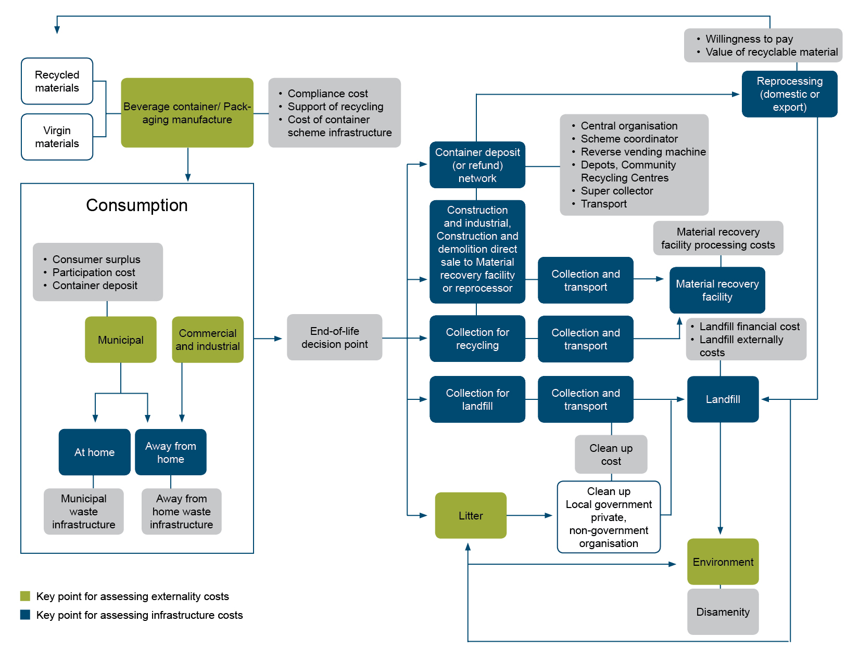

Details of the Trans-Tasman Mutual Recognition Amendment (NSW Container Deposit Scheme) Regulations 2018
Section 1 – Name of Instrument
This section specifies the name of the instrument as the Trans-Tasman Mutual Recognition Amendment (NSW Container Deposit Scheme) Regulations 2018 (the Regulations).
Section 2 – Commencement
This section provides that the Regulations commenced the day after registration on the Federal Register of Legislation.
Section 3 – Authority
This section sets out that the Regulations are made under section 45 of the Trans-Tasman Mutual Recognition Act 1997.
Section 4 – Schedules
This section is a machinery clause that enables the Schedule to amend the Trans-Tasman Mutual Recognition Act 1997.
Schedule 1—Amendments
Item 1
Item 1 of the Schedule adds to clause 4 of Schedule 2 of the Trans-Tasman Mutual Recognition Act 1997. The addition provides that the listed NSW legislation is permanently exempted from the operation of the Trans-Tasman Mutual Recognition Act 1997, so far as they relate to the NSW container deposit scheme.

Statement of Compatibility with Human Rights
Prepared in accordance with Part 3 of the Human Rights (Parliamentary Scrutiny) Act 2011
Trans-Tasman Mutual Recognition Amendment (NSW Container Deposit Scheme) Regulations 2018
These Regulations are compatible with the human rights and freedoms recognised or declared in the international instruments listed in section 3 of the Human Rights (Parliamentary Scrutiny) Act 2011.
Overview of the Legislative Instrument
The purpose of the Trans-Tasman Mutual Recognition Amendment (NSW Container Deposit Scheme) Regulations 2018 is to permanently exempt the New South Wales (NSW) Waste Avoidance and Resource Recovery Act 2001, to the extent that it relates to the NSW Container Deposit Scheme, from the operation of the Trans-Tasman Mutual Recognition Act 1997.
The purpose of the Container Deposit Scheme legislation is to prohibit in NSW the supply of beverages in containers unless the containers are approved or specifically excluded. Under the NSW Container Deposit Scheme legislation, an approval to supply beverage containers in the NSW is subject to requirements that the container bear the approved refund marking and an effective waste management arrangement is in place for the container. A waste management arrangement for approved containers is an arrangement made by participants in the scheme for the collection, sorting and aggregation of the containers and their reuse, recycling or other appropriate disposal. Under the scheme, empty containers bearing the approved refund marking can be delivered to an approved collection depot for the consumer to receive a 10¢ refund per container.
Human rights implications
These Regulations do not engage any of the applicable rights or freedoms.
Conclusion
These Regulations are compatible with human rights as it does not raise any human rights issues.

The Hon Karen Andrews MP, Minister for Industry, Science and Technology

www.nsw.gov.au/making-it-happen
www.nsw.gov.au/improving-nsw/premiers-priorities/keeping-our-environment-clean/
Kees Keizer, Lindenberg Siegwart, Steg Linda, The spreading of disorder in Science 322 1681, 2008
Market failure is a concept in economic theory in which the allocation of goods and resources by existing (or free) markets is not efficient. Where there is market failure, markets will not achieve the best outcomes for the community. Market failure can result from five general factors: public good, externalities, lack of property rights, asymmetric information, and split incentives.
Based on primary data as sourced from Industry Edge and Equilibrium (2013) and using the same estimation process as applied for the national Packaging Impacts Decision Regulation Impact Statement in 2013. Note that steel containers have been excluded from this analysis because only a small proportion of steel containers are used as beverage containers.
Landfill accounts for the balance of all beverage containers consumed that are not recycled or littered.
PC (2006), Finding 8.5, p.xlix.
Mutual Recognition (New South Wales) Temporary Exemptions Regulation 2016, www.legislation.nsw.gov.au/regulations/2016-676.pdf; Trans-Tasman Mutual Recognition (New South Wales) Temporary Exemptions Regulation 2016, legislation.nsw.gov.au/regulations/2016-677.pdf.
Reverse vending machines are machines that receive empty drink containers and give a reward to the user in return.
Waste Avoidance and Resource Recovery (Container Deposit Scheme) Regulation 2017, www.legislation.nsw.gov.au/#/view/regulation/2017/66.
By encouraging consumers to think about the disposal of packaging.
WTP refers to the intrinsic value of knowing that other people are recycling or reducing litter.
Public places include streets, recreation reserves and public parks and gardens as well as ‘commercial public places’, such as shopping centres, hotels, bars and restaurants.
Non-public places include commercial sites, such as office buildings, industrial sites and other workplaces.
This resulted in a downward adjustment from the Packaging Impact Decision RIS, because the public place propensity which is based on the total amount of public place beverage container consumption and the proportion of this waste that is actually littered (approximately 12,360 tonnes in 2015–16), producing a propensity to litter estimate for public place consumption of 15.9% in 2015–16. The propensity to litter for other beverage container consumption, i.e. at-home and away-from-home at non-public places, is calculated using the same approach, producing an estimate of 0.2% in 2015–16.
The increase in GST income arises from any increase in retail prices for beverages. This is likely to include the 10 cent deposit as well as any increase in price due to administration.
Based on estimated residential populations for 2015 or 2016 for the regions of Mallacoota, the City of Wodonga, Yarrawonga, Cobram, Echuca and Mildura.
As implemented under the amended WARR Act.
As implemented under the amended WARR Act.
Waste Avoidance and Resource Recovery Act 2001 as amended by the Waste Avoidance and Resource Recovery Amendment (Container Deposit Scheme) Act 2016.
NSW EPA, Scheme Coordinator and Network Operator Appointment Process, 16 February 2017, www.epa.nsw.gov.au/waste/cds-scheme-coordinator.htm.
Waste Avoidance and Resource Recovery Amendment (Container Deposit Scheme) Act, section 48.
The Act was assented to on 25 October 2016; www.parliament.nsw.gov.au/bills/Pages/bill-details.aspx?pk=3341.
Beverage containers as defined under the SA container refund scheme.
Beverage container litter were also compared between South Australia and individual jurisdictions. Beverage container litter rates in South Australia are lower than all other jurisdictions.
The emissions factor refers to the amount of carbon dioxide equivalent (tCO2_{e}) that are released by a tonne of that material deposited to landfill.
All materials except for paper/cardboard have an EF of zero (DCCEE, 2012) therefore do not result in any GHG externality cost.
Value Transfer: In an ideal world, environmental values would be estimated for each proposed policy, taking into account all of the particular details of the specific policy. However, the use of primary research to estimate environmental values can be costly and time consuming, and in real world policy processes the time and money required often is not available. Value transfer is the process of estimating environmental values in a location of interest (the policy site) by transferring values from studies already completed in another location (the study site). This removes the need for primary research.
One of the major criticisms of SC data is that the choices are made in hypothetical markets. The different choices made by individuals in hypothetical settings as opposed to those made in real life situations is often described as resulting from hypothetical bias.

