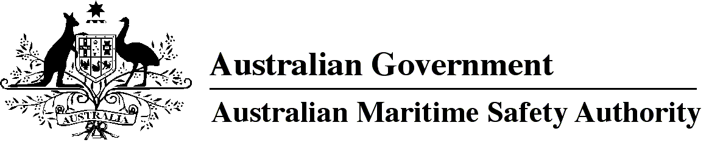

AMSA MO 2018/12

Marine Order 11 (Living and working conditions on vessels) Amendment Order 2018

I, Michael Kinley, Chief Executive Officer of the Australian Maritime Safety Authority, make this Order under subsection 342(1) of the *Navigation Act 2012*.

5 December 2018

Michael Kinley  
Chief Executive Officer

1 Name of Order

This Order is *Marine Order 11 (Living and working conditions on vessels) Amendment Order 2018*.

2 Commencement

This Order commences on 8 January 2019.

3 Amendment of *Marine Order*

Schedule 1 amends *Marine Order 11 (Living and working conditions on vessels) 2015*.

Schedule 1 Amendment

[1] Subsection 8(2)

substitute

(2) AMSA may approve use of an equivalent if satisfied that:

(a) the vessel has adequate arrangements to protect the working and living conditions of its seafarers; and

(b) approving the use of the equivalent would not contravene paragraph 4 of Article VI of the Maritime Labour Convention.

*Note 1*For definitions of ***use*** and***equivalent*** — see *Marine Order 1 (Administration) 2013.*

*Note 2*Paragraph 4 of Article VI of the Maritime Labour Convention provides that an arrangement is equivalent if conducive to the full achievement of the general object and purpose of the MLC standard concerned.

[2] Section 38

substitute

38 Small vessels

This Division does not apply to a vessel <200 GT that:

(a) complies with Section C1 of the NSCV in effect on 1 January 2016; and

(b) is proceeding on a voyage other than an overseas voyage.

*Note*The effect of this section is that a vessel <200 GT complying with NSCV Section C1 is not subject to the requirements in this Division if the vessel only undertakes voyages to the outer limits of the EEZ*.*

[3] Paragraph 52(2)(a)

omit

*of*

substitute

*on*

[4] Paragraph 52(2)(b)

omit first mention of

*of*

substitute

*on*

[5] Section 79

substitute

79 Declaration of maritime labour compliance

AMSA may issue a declaration of maritime labour compliance in accordance with paragraph 10 of MLC standard A5.1.3.

*Note 1*The form of a declaration of maritime labour compliance is available on the AMSA website at http://www.amsa.gov.au. Part II of the declaration is to be completed by the vessel owner.

*Note 2*A person may apply for a declaration whether or not the vessel is required to have a maritime labour certificate (MLC).

[6] Paragraph 80(1)(b)

substitute

(b) the maritime labour certificate (MLC) has attached a declaration of maritime labour compliance in accordance with paragraph 10 of MLC standard A5.1.3; and

(c) a copy of the certificate carried on the vessel, and declaration if required by paragraph (b), is:

(i) written in English; and

(ii) displayed so that it is easily read by seafarers; and

(iii) made available on request to any seafarer, inspector, authorised officer in a port state or representative of the owner or of a seafarer.

Penalty: 50 penalty units.

[7] Section 83

substitute

83 Duration of maritime labour certificate (MLC)

(1) A maritime labour certificate (MLC) is in force for a period, of no more than 5 years, determined by the issuing body.

(2) However, for section 45 of the Navigation Act, an issuing body may vary the time a certificate ceases to be in force if:

(a) a renewal inspection has been completed before the expiry of the existing certificate; and

(b) the renewal inspection demonstrates compliance with the Maritime Labour Convention and this Order; and

(c) the new certificate cannot be issued and made available on board the vessel before the expiry of the existing certificate.

(3) For subsection (2), a further period not exceeding 5 months from the expiry date of the existing certificate may be endorsed by the issuing body on the certificate.

*Note*Subsection 85(3) sets out the time when a new maritime labour certificate (MLC) comes into force after the renewal inspection.

[8] Subparagraph 88(a)(iii)

substitute

(iii) the owner has assumed responsibility for the operation of the vessel which is new to that owner; and

[9] Section 92, note

substitute

*Note*The seafarer may take action under the *Fair Work Act 2009* to stop being bullied at work. *Guidance on Eliminating Shipboard Harassment and Bullying* published by the International Chamber of Shipping and International Transport Workers' Federation is on the ICS website at www.ics-shipping.org.

Note

1. All legislative instruments and compilations of legislative instruments are registered on the Federal Register of Legislation under the *Legislation Act 2003.* See https://www.legislation.gov.au.