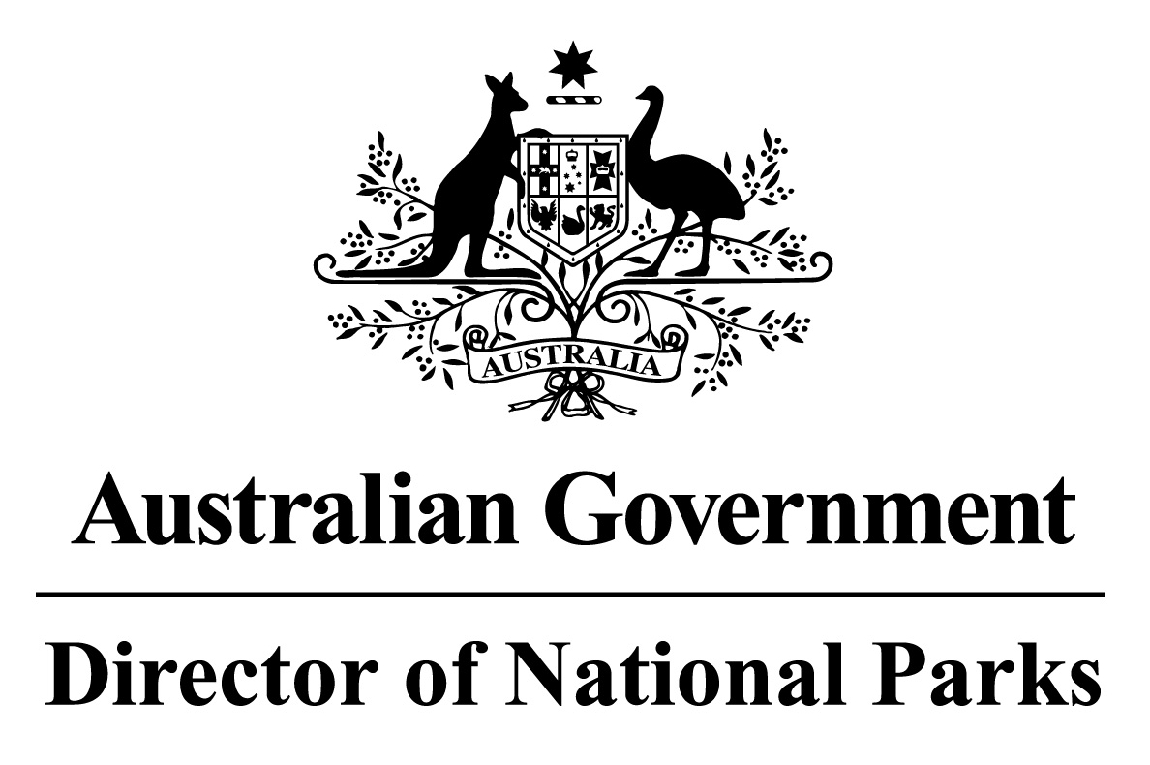

*Environment Protection and Biodiversity Conservation Regulations 2000*

Sub-regulation 12.56 (2)

**SOUTH-EAST NETWORK OF MARINE PARKS**

**DETERMINATION PROHIBITING USE OF VESSELS ENGAGED IN CAGE TOWING**

I, DR ANDREW READ, Acting Assistant Secretary, Marine Protected Areas Branch, Parks Australia Division, Department of the Environment and Energy, delegate of the power of the Director of National Parks under sub-regulation 12.56(2) of the *Environment Protection and Biodiversity Conservation Regulations 2000* and, in accordance with Section 5.3.1 of the South-east Commonwealth Marine Reserve Network Management Plan, HEREBY DETERMINE that all Sanctuary (IUCN Ia) and Marine National Park (IUCN II) network management zones in each of the Marine Parks in the Network, being the marine parks listed in the Schedule to this determination, are areas of water where the use of vessels engaged in cage towing is prohibited unless done in accordance with a permit or approval issued by the Director.

AND I HEREBY REVOKE the previous determination prohibiting the use of vessels engaging in cage towing in the area, notified in the *Gazette* (C2015G00180) and published on 4 February 2015.

In this determination:

**cage towing** means a vessel towing a cage that is suitable for caging fish.

**network management zone** means a network management zone prescribed by the South-east Commonwealth Marine Reserve Network Management Plan.

Dated this 2nd day of February 2018

Dr Andrew Read

A/g Assistant Secretary

Marine Protected Areas Branch

Parks Australia Division

Department of the Environment and Energy

**SCHEDULE**

**SOUTH-EAST NETWORK OF MARINE PARKS**

Apollo Marine Park

Beagle Marine Park

Boags Marine Park

East Gippsland Marine Park

Flinders Marine Park

Franklin Marine Park

Freycinet Marine Park

Huon Marine Park

Macquarie Island Marine Park

Murray Marine Park

Nelson Marine Park

South Tasman Rise Marine Park

Tasman Fracture Marine Park

Zeehan Marine Park