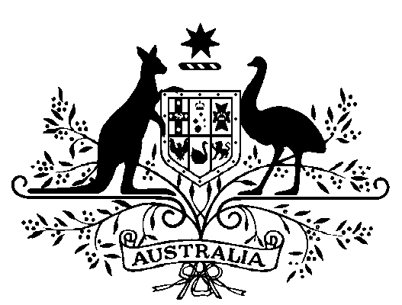

Treasury Laws Amendment (Putting Consumers First—Establishment of the Australian Financial Complaints Authority) Commencement Instrument (No. 1 of 2018)

I, Kelly O’Dwyer, Minister for Revenue and Financial Services, Minister for Women and Minister Assisting the Prime Minister for the Public Service, hereby specify for the purposes of subitem 44(2) of Schedule 1 to the *Treasury Laws Amendment (Putting Consumers First—Establishment of the Australian Financial Complaints Authority) Act 2018* that the amendments made by Part 3 of Schedule 1 to that Act apply from 21 September 2018.

Dated: 23rd April 2018

Kelly O’Dwyer

Minister for Revenue and Financial Services, Minister for Women and Minister Assisting the Prime Minister for the Public Service